FIRE EXTINGUISHER ROBOT
============================================================
FIRE EXTINGUISHER ROBOT
Autonomous Flame Detection & Suppression Vehicle
Technical Design & Circuit Report

Prepared by: Muhammad Ahmad
Student ID: 70177776
Degree: BS Robotics and Artificial Intelligence (4th Semester)
Institution: University of Lahore
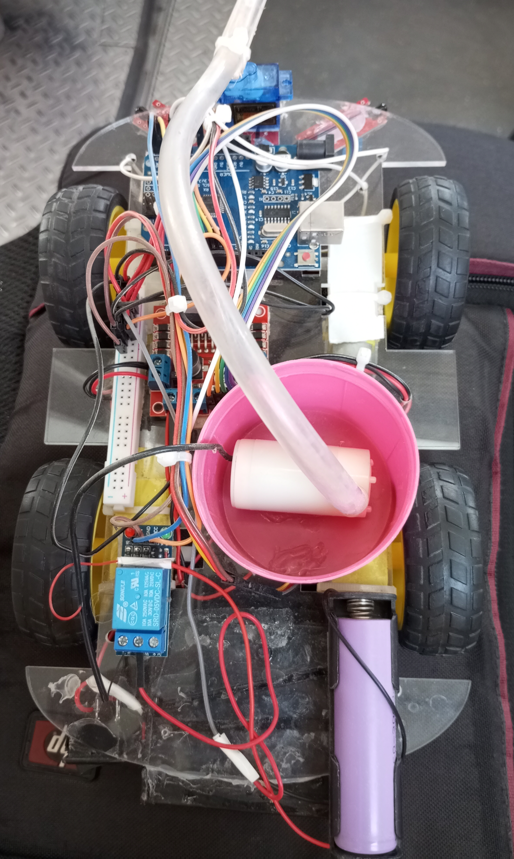
Figure 1: Physical prototype of the Fire Extinguisher Robot

1. Project Overview

The Fire Extinguisher Robot is an autonomous ground vehicle designed to detect and suppress small fires without human intervention. Using three infrared (IR) flame sensors, the robot locates the direction of a fire, navigates toward it, and activates a water pump to extinguish the flame. A servo-controlled nozzle sweeps horizontally to improve water coverage.

This report documents the hardware components, circuit connections, power architecture, and operational logic of the system.

2. Project Objectives

- Autonomously detect flame direction using three IR flame sensors.
- Navigate a 4-wheel DC motor chassis toward the detected fire.
- Activate a submersible water pump via a relay to extinguish the fire.
- Sweep the nozzle using a servo motor for wider suppression coverage.
- Operate entirely on battery power without external connections.

3. Hardware Components

The table below lists all hardware components used in the project, their quantity, and their functional role within the system.

Component | Qty | Role / Function
Arduino Uno (ATmega328P) | ×1 | Main microcontroller — runs all logic, reads sensors, controls motors and pump
IR Flame Sensor Module | ×3 | Detects infrared radiation from flames (Right A0, Front A1, Left A2)
L298N H-Bridge Motor Driver | ×1 | Drives 4 DC gear motors — accepts PWM for variable speed
DC Gear Motor 5V–9V | ×4 | Chassis locomotion motors (2 left, 2 right)
Rubber Wheels | ×4 | Mounted on DC motors for traction
Micro Servo SG90 | ×1 | Sweeps water nozzle horizontally to aim at flame
5V Submersible Water Pump | ×1 | Pumps water through tube to nozzle for fire suppression
5V Single-Channel Relay | ×1 | Electronically switches pump on/off via Arduino (Active-Low)
3-Cell Li-Ion Battery Pack | ×1 | 11.1V — powers L298N and DC gear motors
1-Cell Li-Ion Battery | ×1 | 3.7–4.2V — powers Arduino, sensors, servo, and pump

Flexible Tubing | ×1 | Carries water from pump reservoir to nozzle
Mini Water Reservoir | ×1 | Bucket holding water supply for the pump

4. Pin Configuration & Wiring

The following table details every connection between the Arduino Uno and its peripheral modules. All analog sensor lines run at 5V logic; the relay is active-low (logic LOW = pump ON).

Component | Component Pin | Arduino Pin | Pin Type | Description
Right Flame Sensor | AO (Analog Out) | A0 | Analog Input | Reads right flame intensity
Front Flame Sensor | AO (Analog Out) | A1 | Analog Input | Reads front flame intensity
Left Flame Sensor | AO (Analog Out) | A2 | Analog Input | Reads left flame intensity
Micro Servo SG90 | PWM Signal (Yellow) | A4 | PWM Output | Controls nozzle sweep angle
5V Relay Module | IN (Trigger) | A5 | Digital Output | LOW = Pump ON / HIGH = Pump OFF
L298N Motor Driver | ENA | 10 | PWM Output | Right motor speed (PWM)
L298N Motor Driver | IN1 | 9 | Digital Output | Right motor direction A
L298N Motor Driver | IN2 | 8 | Digital Output | Right motor direction B
L298N Motor Driver | IN3 | 7 | Digital Output | Left motor direction A
L298N Motor Driver | IN4 | 6 | Digital Output | Left motor direction B
L298N Motor Driver | ENB | 5 | PWM Output | Left motor speed (PWM)

5. Power Architecture

5.1 11.1 V Rail — 3-Cell Lithium-Ion Pack
- Connected directly to the L298N 12 V input terminal.
- Drives all four DC gear motors through the H-bridge.
- This rail is kept separate from logic to avoid voltage spikes.

5.2 3.7–4.2 V Rail — 1-Cell Lithium-Ion
- Powers the Arduino Uno via the VIN / 5V pin.
- Supplies the three IR flame sensor modules.
- Supplies the SG90 servo motor.
- Powers the isolated side of the submersible water pump through the relay NO contact.

5.3 Common Ground
The negative terminals of both battery packs and the Arduino GND pin are all connected together to form a single common ground reference. This is essential to ensure that all voltage levels are measured relative to the same reference, preventing erratic sensor readings and logic errors.

6. Circuit Schematic

The schematic below illustrates all electrical connections between the Arduino Uno, motor driver, flame sensors, relay, servo, water pump, and power supplies.

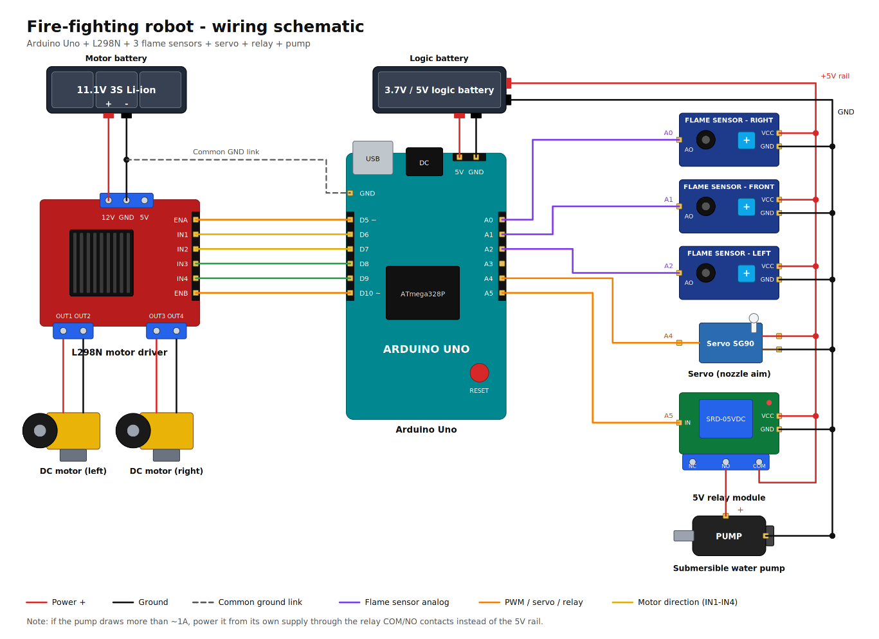
Figure 2: Circuit schematic — Fire Extinguisher Robot

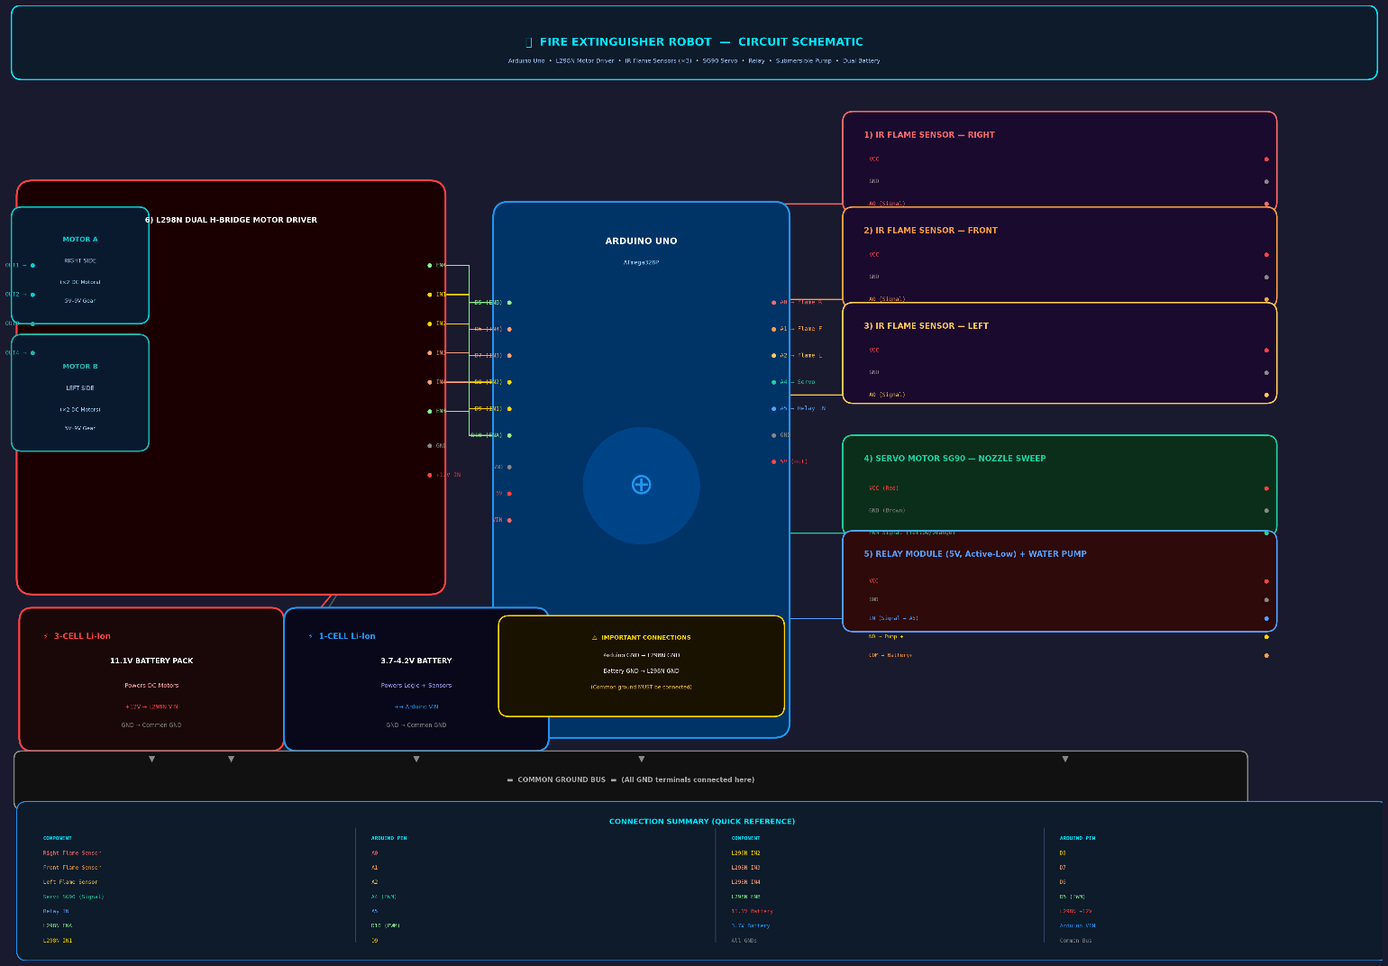

7. System Operation Logic

The Arduino firmware continuously polls the three IR flame sensors (A0, A1, A2). Lower analog readings indicate a stronger flame signal. The control logic proceeds as follows:

- If only the right sensor detects flame → turn right.
- If only the left sensor detects flame → turn left.
- If the front sensor (or both side sensors simultaneously) detects flame → move forward.
- When the robot is close enough (sensor value below threshold) → stop motors, activate relay (pump ON), sweep servo.
- When no flame is detected → stop all actuators and wait.

8. Safety Considerations

- Keep the water reservoir sealed to prevent spills onto electronics.
- Do not operate near voltages higher than rated values — L298N is rated for max 46 V, 2 A per channel.
- Lithium-ion cells must never be discharged below 3.0 V to prevent cell damage.
- Ensure all wires are securely insulated to avoid short circuits.
- Test in a controlled environment with small, contained flames only.

9. Conclusion

The Fire Extinguisher Robot successfully integrates sensing, motion control, and actuation into a compact autonomous system. The three-sensor array provides directional awareness, while the relay-controlled pump and servo-swept nozzle deliver effective fire suppression. The dual-battery architecture cleanly separates high-current motor loads from sensitive logic circuitry, ensuring reliable operation.

Future improvements could include ultrasonic obstacle avoidance, a larger water reservoir, PID-based motor speed control, and wireless monitoring via Bluetooth or Wi-Fi.

