v

**COMSATS University Islamabad (CUI)**

**Assignment-02**

**CLO-2**

Software Requirement Specification  
(SRS DOCUMENT)

for

**Depression Detector Chat Bot**

Version 1.0

**Submitted By:**

**Khan Sharjeel Khan SP20-BCS-041**

**Muhammad Ahmed Raza SP21-BCS-003**

**BCS-4-A**

***Supervisor*Mr. Tehseen Riaz Abbasi**

***Bachelor of Science in Computer Science (2021-2025)***

**Table of Contents**

1. Introduction 1

**1.1** **Purpose** 1

**1.2** **Scope** 1

**1.3** **Modules** 1

**1.4** **Overview** 1

2. Overall Description 2

**2.1** **Product Perspective** 2

**2.2** **User classes and characteristics** 2

**2.3** **Operating Environment** 2

**2.4** **Design and Implementation Constraints** 2

3. Requirement Identifying Technique 3

**3.1.** **Use Case(s) Diagram:** 3

4. Functional Requirements 8

**4.1.** **Use Case:** 8

4.1.2 Module 2: User Profiling 8

4.1.3 Module 3: Emotion Detection 8

4.1.4 Module 4: Psychological Test 9

4.1.5 Module 4: Self-Care Toolkit 9

4.1.6 Module 6: Appointment Management 9

4.1.7 Module 7: Psychological Test 10

4.1.8 Module 8: Feedback 10

**4.2.** **Use Case(s):** 10

**4.3.** **Functional Requirement of Stress Detector Chatbot** 31

1. Non-Functional Requirements 57

**a.** **Reliability** 57

**b.** **Usability** 57

**c. Performance** 57

**d. Security** 58

2. External Interface Requirements 58

**a.** **User Interfaces Requirements** 58

**b.** **Software interfaces** 65

**c.** **Hardware interfaces** 65

**d.** **Communications interfaces** 65

3. Conclusion 66

4. References 67

6. Plaragism Report Error! Bookmark not defined.

# Introduction

Throughout the human history, the concept of the depression is being caused by the evil spirits and demons which causes the physical disease like mental illness. Greek and Roman doctors and philosopher use different therapy to cure their patient from this illness. Today’s modern world has shown that technology can be used to detect the depression level so that his/her treatment would be easy. A philosopher MOHR ET AL suggest that behavioral intervention technologies (BITs) that help chatbot to address the mental health condition. Depression chatbot detector are the computer programs that uses chat and images to detect the depression level. The depression chat bot help doctors and philosopher to detect the depression level so that they can start their treatment.

## **Purpose**

The reason for this project is to provide a reliable way to combat depression by identifying people who are inflicted by it using chat bot. Currently, mental issues including depression are a topic that is heavily criticized and not dealt with properly. Such issues are not met with the level of urgency that is suitable to manage them. A substantial portion of public suffer from depression without a clear cure.

The common folk suffer from mental and physical stress from their daily struggles. Our project will provide a way to assist such individuals instead of shunning them. Our application will function as a source of stress relief. It will provide emotional support to people ailing from depression. It will provide an AI partner to unload all your mental stress. Our main goal is to help individuals facing such issues come forth and seek help instead of falling deeper into a pit of depression and loneliness.

## **Scope**

The system is designed for the patient who have mental disease (depression), but they did not realize that weather it is a depression or something else. The aim here is to develop a system that enables the patient to detect his/her depression level and make an appointment to a doctor if needed. This system is used on the web and the smartphone application as well.

## **Modules**

|  |  |
| --- | --- |
| **M1** | Administration |
| **M2** | User Profiling |
| **M3** | Psychological Test |
| **M4** | Emotion Detection |
| **M5** | Self-Care Toolkit |
| **M6** | Appointment Management |
| **M7** | Activity |
| **M8** | Feedback |

## **Overview**

The system is designed for the patient who have mental disease (depression), but they did not realize that weather it is a depression or something else. This application will function as a source of stress relief. It will provide emotional support to people ailing from depression. It will provide an AI partner to unload all your mental stress. Our main goal is to help individuals facing such issues come forth and seek help instead of falling deeper into a pit of depression and loneliness.

# Overall Description

This product is based around online services thus including the general login/signup requirements. It also provides privacy control thus having such functionalities as well. The product is a development-related app targeted the depressed community of patient; thus, the functionalities and requirements are related towards it.

## **Product Perspective**

For a patient or doctor who wants to check their depression level through software, the Depression detector chat bot system is web and smartphone application that helps the user to diagnose their depression state(mental health) and suggest a suitable treatment for the disease unlike you go to the doctor and give your family history about the disease and arrange several appointments ,our product will provide us the efficient result without wasting any time and reduce financial burden.

## **User classes and characteristics**

Main functions of this system are:

* The user will be able to sign up and login on the app.
* The user will be able to connect with administrators using online platform to get help in any inconsistency.
* The user will be able to auto generate their progress in the form of charts, graphs and identify shortcomings.
* The user will be able to schedule therapy meeting with physicians.
* The user will be able to communicate with physicians in case of prescriptions generation.

## **Operating Environment**

The system has two version like app and web application, and they will operate on the following operating system.

**OE-1:** The app is available as both smartphone application and web application. The smartphones with Android and iOS are also supported.

**OE-2:** The web application of this system will operate correctly with the following web browsers: Windows Internet Explorer versions 7, 8, and 9; Firefox versions 12 through 26; Google Chrome (all versions); and Apple Safari versions 4.0 through 8.0.

## **Design and Implementation Constraints**

The system requires the following constraints.

CON-1: The system will need email and google account apps on smartphone to login and signup.

CON-2: The system will store all the information in the form of xml files.

CON-3: The system will need smartphone with Android and iOS.

CON-4: The system will PC / Laptop with internet browsers e.g., Firefox, Chrome, Safari.

CON-5: The system will need reliable internet connection.

# Requirement Identifying Technique

The following are the requirements identifying techniques which we used to gather required information.

1. **Brainstorming**:

The requirements gathered using brainstorming. Ideas related to the app noted down, analyzed, and then added to the requirements specifications.

1. **Observation:**

Another technique used is observing the general needs of project developers to gather requirements and observation of similar app. The observed requirements added to the requirements specification of the product.

## **Use Case(s) Diagram:**

The following are the use case diagrams of this system.

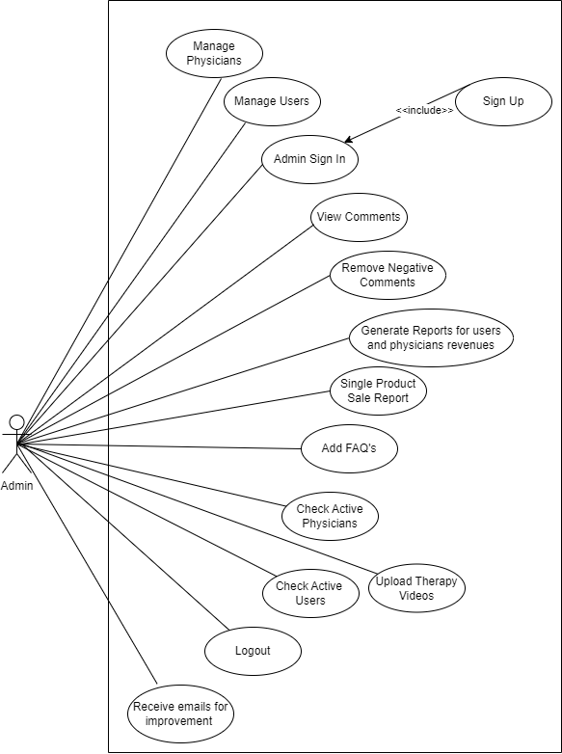

Figure ‑: Use case diagram of admin

Figure ‑ Use case diagram of Users

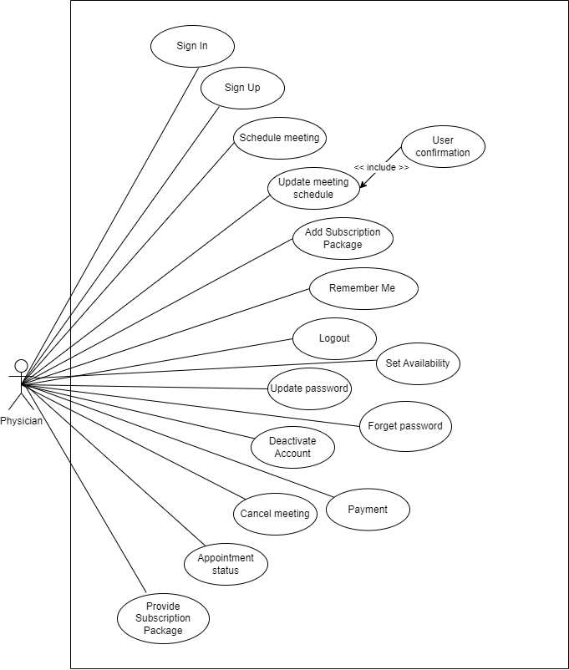

Figure ‑ Use case diagram of Users

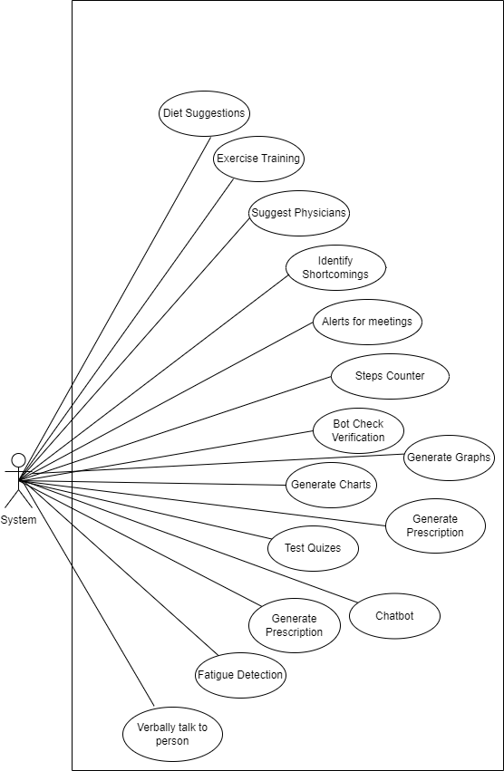

Figure ‑ Use case diagram of system

# Functional Requirements

## **Use Case:**

The following are the use cases.

* + 1. **Module 1: Administration**

|  |  |
| --- | --- |
| **M1-UC1** | User’s Management |
| **M1-UC2** | Physicians Management |
| **M1-UC3** | Reports generation |
| **M1-UC4** | Payment management |
| **M1-UC5** | Committee |
| **M1-UC6** | Active physician |
| **M1-UC7** | Active user |
| **M1-UC8** | Upload therapy videos |
| **M1-UC9** | Comments Management |
| **M1-UC10** | Deactivate account |

### Module 2: User Profiling

|  |  |
| --- | --- |
| **M2-UC1** | User signup |
| **M2-UC2** | User sign in |
| **M2-UC3** | Update password |
| **M2-UC4** | Forgot password |
| **M2-UC5** | Remember me |
| **M2-UC6** | Logout |
| **M2-UC7** | Deactivate account |
| **M2-UC8** | Update profile |
| **M2-UC9** | Admin sign in |
| **M2-UC10** | Setup Profile |
| **M2-UC11** | Update Profile |
| **M2-UC12** | Physicians sign up |

### Module 3: Emotion Detection

|  |  |
| --- | --- |
| **M3-UC1** | Camera |
| **M3-UC2** | Fatigue detection |
| **M3-UC3** | Talk to the person verbally |
| **M3-UC4** | Talk to the person non-verbally |
| **M3-UC5** | Detect heartbeat |
| **M3-UC6** | Detect motion of eyes |
| **M3-UC7** | Detect body language |
| **M3-UC8** | Muscle tension detection |
| **M3-UC9** | Photo from camera, gallery |
| **M3-UC10** | Result of depression from the given picture |

### Module 4: Psychological Test

|  |  |
| --- | --- |
| **M4-UC1** | Test questions/quiz’s |
| **M4-UC2** | Chat bot |
| **M4-UC3** | Scenario handling |
| **M4-UC4** | Stress detection |
| **M4-UC5** | Personality test |
| **M4-UC6** | Mental Health test |
| **M4-UC7** | Result of quiz’s, scenario handling, stress detection, personality test |
| **M4-UC8** | Depression meter |
| **M4-UC9** | Rate mental health |
| **M4-UC10** | Prescription |

### Module 5 Self-Care Toolkit

|  |  |
| --- | --- |
| **M5-UC1** | Sleep routine |
| **M5-UC2** | Exercise routine |
| **M5-UC3** | Healthy Diet Suggestions |
| **M5-UC4** | Diet routine |
| **M5-UC5** | Get Inspired |
| **M5-UC6** | Analyze Progress |
| **M5-UC7** | Identify Shortcomings |
| **M5-UC8** | Alerts for meeting |
| **M5-UC9** | Customize Plans |
| **M5-UC10** | Steps Counter |

### Module 6: Appointment Management

|  |  |
| --- | --- |
| **M6-UC1** | Suggest physician |
| **M6-UC2** | Schedule meeting |
| **M6-UC3** | Cancel Appointment |
| **M6-UC4** | Payment |
| **M6-UC5** | Update Appointment detail |
| **M6-UC6** | Check Availability |
| **M6-UC7** | Appointment Status |
| **M6-UC8** | Subscription Package |
| **M6-UC9** | Bot check |

### Module 7: Activity

|  |  |
| --- | --- |
| **M7-UC1** | Save Activity |
| **M7-UC2** | See recent Activity |
| **M7-UC3** | Compare Activities |
| **M7-UC4** | Generate Charts |
| **M7-UC5** | Generate Reports |
| **M7-UC6** | Generate prescription |
| **M7-UC7** | Manage Appointment |
| **M7-UC8** | Availability |
| **M7-UC9** | Manage Activity |

### Module 8: Feedback

|  |  |
| --- | --- |
| **M8-UC1** | Add reviews |
| **M8-UC2** | Satisfaction survey |
| **M8-UC3** | FAQs |
| **M8-UC4** | Improvement |
| **M8-UC5** | Negative comments |
| **M8-UC6** | Rating |
| **M8-UC7** | Positive comments |
| **M8-UC8** | Suggestion Emails |

## **Use Case(s):**

The following are the use cases of each module of this system.

**4.2.1 Module 1: Administration**

Below are the use cases for module one

**4.2.1.1 User** **Management**

**Table 1 Show the detail use case of User Management**

|  |  |
| --- | --- |
| **Use Case ID:** | **M1-UC1** |
| **Use Case Name:** | User management |
| **Actors:** | User/ admin |
| **Description:** | In this use case admin will manage the user account for example add account data, delete data, and update data of the user |
| **Trigger:** | This use case will appear on the administration page to manage all the accounts and it is held in the form of Dropbox |
| **Level:** | High |
| **Preconditions:** | PRE-1. You need administration to manage the management system |
| **Postconditions:** | POST-1. Admin will manage to add delete or update the user information or account details |
| **Normal Flow:** | 1. Admin will be aired in the user management system 2. Admin will manage all the account details 3. Admin will manage and delete all the account details and information 4. Admin can also update all the information and account details |
| **Exceptions:** | 1. In step Three of the normal flow the user can only update its information detailed her account detail when it has had an account on the system |
| **Assumptions:** | User must have strong internet connection  Using must have strong security on the management system |

**4.2.1.2 Physician Management**

**Table 2 Show the detail use case of Physician Management**

|  |  |
| --- | --- |
| **Use Case ID:** | **M1-UC2** |
| **Use Case Name:** | Physician management |
| **Actors:** | User/ physician /admin |
| **Description:** | This user case is used only by admin that will manage their physician account such as to delete an account or add an account how to update any information or account details |
| **Trigger:** | This use case is for the physician to make his or her profile on the system |
| **Level:** | High |
| **Preconditions:** | PRE-1. First physician must sign up for his profile and then he can sign-in in the system |
| **Postconditions:** | POST-1. Once the physician profile is made then it can manage all the patient and appointments  POST-2. Physician overview all the results and then predicted that whether the patient must go to the doctor or not |
| **Normal Flow:** | 1. Admin will manage the physician account 2. Physician first must sign up for his profile 3. Then he or she would be able to sign in in their account |
| **Assumptions:** | User must have strong internet connection  Users should have Strong and reliable security |

**4.2.1.3 Report Generation**

**Table 3 Show the detail use case of Report Management**

|  |  |
| --- | --- |
| **Use Case ID:** | **M1-UC3** |
| **Use Case Name:** | The report generation |
| **Actors:** | User/ physician/ admin |
| **Description:** | This use case is used to generate the reports however the admin generates these reports for weekly monthly and yearly revenues for the physician and for the users as well |
| **Trigger:** | At the end, the result would be given in the soft copy in the form of report it will be generated from the report generation use case |
| **Level:** | High |
| **Preconditions:** | PRE-1. report is made through the required test quizzes chatting with the bot  PRE-2. The report generation use case will compare all the quizzes and reports and Chat |
| **Postconditions:** | POST-1. Based on this report the physician will advise the user whether to go to the doctor or not |
| **Normal Flow:** | 1. Physician would generate the reports 2. Fashion gave advice to the user whether they go to the doctor or not 3. Doctor will give prescription based on these reports |
| **Assumptions:** | User must have strong internet connection  Administration must have security for these reports |

**4.2.1.4 Payment Management**

**Table 4 Show the detail use case of Payment Management**

|  |  |
| --- | --- |
| **Use Case ID:** | **M4-UC4** |
| **Use Case Name:** | Payment management |
| **Actors:** | User/ admin |
| **Description:** | In this use case the user must pay the required dues of his or her treatment. This is managed by the payment management system |
| **Trigger:** | It is generated after the report generation the payment slip will be available before the prescription |
| **Level:** | High |
| **Preconditions:** | PRE-1. After all testing and treatment is completed  PRE-2. The system would give user the bill before the prescription |
| **Postconditions:** | POST-1. When user pay the bill through different kind of payment method  POST-2. After the payment, the admin give prescription to the user |
| **Normal Flow:** | Use it will get the prescription after he or she will pay his or her dues  The usual can have different payment method such as from credit card, easy paisa bank payment |
| **Assumptions:** | User must have strong internet connection |

**4.2.1.5 Comment Management**

**Table 5 Show the detail use case of Comment Management**

|  |  |
| --- | --- |
| **Use Case ID:** | **M1-UC9** |
| **Use Case Name:** | Comment management |
| **Actors:** | User/ admin |
| **Description:** | This use git will manage all the comment section that will be provided from the user |
| **Trigger:** | This use case is present at the end of the page in which the admin will manage all the reviews and comments and writing date are in the comment management |
| **Level:** | medium |
| **Preconditions:** | PRE-1. The user had to appoint doctor first |
| **Postconditions:** | POST-1. The admin had to submit all the comments and reviews on the feedback  POST-2. Through this they can improve their management |
| **Normal Flow:** | 1. The user had to did Nate its prescription 2. At the end, the feedback will be required 3. In which the user can gave it positive or negative feedback through it the administration can improve its comment management |
| **Assumptions:** | User must have strong internet connection |

**4.2.2 Module 2: User Profiling**

Below are the uses cases for Module-2.

**4.2.2.1 Sign up**

Table 1 Show the detail use case of Sign Up

|  |  |
| --- | --- |
| **Use Case ID:** | UC-2.1 |
| **Use Case Name:** | Sign up |
| **Actors:** | User/Physicians/Developer |
| **Description:** | User will sign up and creates an account by providing the system details like name, username, email, and password. It will create an account for the respective user on this system. |
| **Trigger:** | On the welcome page of this system, there will be a get started button which will trigger this signup action. |
| **Level:** | High |
| **Preconditions:** | PRE-1. User will have a valid email.  PRE-2. User will already not have account on same email on this system. |
| **Postconditions:** | POST-1. User will have a secure account for using and exploring this system. |
| **Normal Flow:** | 1. User will open the Sign-up page using trigger and then he will have.  2. User will open the web/mobile application.  3. User will click on the sign-up button on the welcome screen.  4. A sign-up form will be shown to the user.  5. The user will enter a valid email and password in the sign-up form along with personal info i.e., Name, age, and gender.  6. User will click sign-up button.  7. Sign-up successful message will be shown to the user. |
| **Exceptions:** | In step 4 of the normal flow, if the user enters invalid email address, password, or personal information.   * Appropriate error message will be shown, and user will be asked to enter data again. * User enters correct data.   Use Case resumes on step 5 of normal flow. Otherwise, signup will be cancelled. |
| **Assumptions:** | User will have strong internet connection. |

**4.2.2.2 Sign in**

Table 2 Show the detail use case of Sign In

|  |  |
| --- | --- |
| **Use Case ID:** | UC-2.2 |
| **Use Case Name:** | Sign in |
| **Actors:** | User/Physicians |
| **Description:** | This use case will enable registered users/physicians to sign into their account on the app for using this system. |
| **Trigger:** | Clicking Sign in button given on welcome screen will trigger the action. |
| **Level:** | High |
| **Preconditions:** | PRE-1. User will have a valid email.  PRE-2. User will already not have account on same email on this system. |
| **Postconditions:** | POST-1. User will be logged in to his/her account. |
| **Normal Flow:** | 1. User will open the web/mobile application.   1. User will click on the sign in button on the welcome screen. 2. A sign in form will be shown to the user. 3. The user will enter registered email address and password. 4. User will click sign in button. 5. Sign in successful message will be shown to the user and user will be logged into the app. |
| **Exceptions:** | 4 In step 4 of the normal flow, if the user enters invalid email address or password.   * Appropriate error message will be shown, and user will be asked to enter credentials again. * User enters correct data.   Use Case resumes on step 5 of normal flow, otherwise sign in will be cancelled |
| **Assumptions:** | User will log in his/her account. |

**4.2.2.3 Setup Profile**

Table 3 Show the detail use case of Setup Profile

|  |  |
| --- | --- |
| **Use Case ID:** | UC-2.3 |
| **Use Case Name:** | Setup profile |
| **Actors:** | User |
| **Description:** | This use case will enable registered users to setup their profile and enter their bios, description, and profile picture |
| **Trigger:** | There will be a setting icon on the home page after clicking on that user will have multiple options out of which user will click on the setup profile option to trigger this use case. |
| **Level:** | Medium |
| **Preconditions:** | PRE-1. User will already log in to the system. |
| **Postconditions:** | POST-1. User will have a good profile appearance. |
| **Normal Flow:** | 1. User will select edit bio.  2. User will enter his/her bio.  3. User will select edit description.  4. User will enter his/her description.  5. User will select edit profile picture.  6. User will add his/her profile picture. |
| **Assumptions:** | User will have strong have profile then for physicians to be visited. |

**4.2.2.4 Update Profile**

Table 4 Show the detail use case of Update Profile

|  |  |
| --- | --- |
| **Use Case ID:** | UC-2.4 |
| **Use Case Name:** | Update Profile |
| **Actors:** | User |
| **Description:** | Users will be able to update their profile like their bio, username, and profile picture. |
| **Trigger:** | There will be a setting icon on the home page after clicking on that user will have multiple options out of which user will click on the update profile option to trigger this use case. |
| **Level:** | low |
| **Preconditions:** | PRE-1. User will already login to their accounts. |
| **Postconditions:** | POST-1. User will update their profile. |
| **Normal Flow:** | 1. User will select update bio.  2. User will enter his/her bio.  3. User will select update username.  4. User will enter his/her username.  5. User will select update profile picture.  6. User will add his/her profile picture. |
| **Exceptions:** | In step 3 of the normal flow, if the user enters invalid username, then he will not be able to update his/her username. |
| **Assumptions:** | User will have strong have profile then for physicians to be visited. |

**4.2.2.5 Deactivate Account**

Table 5 Show the detail use case of deactivate account

|  |  |
| --- | --- |
| **Use Case ID:** | UC-2.5 |
| **Use Case Name:** | Deactivate Account |
| **Actors:** | User |
| **Description:** | Users will be able to deactivate their account. |
| **Trigger:** | There will be a setting icon on the home page after clicking on that user will have multiple options out of which user will click on the deactivate account option to trigger this use case. |
| **Level:** | low |
| **Preconditions:** | PRE-1. User will already login to their accounts. |
| **Postconditions:** | POST-1. User will deactivate their account. |
| **Normal Flow:** | 1. User will select deactivate account option.  2. User will select “yes” from pop up for confirmation of their deactivation.  3. User will show a notification of deactivation within 30 days if user will not login again within 30 days. |
| **Business Rule:** | BR-1. Account will be deactivated within 30 days after confirmation of users if they will not login again within 30 days, otherwise it will continue. |
| **Assumptions:** | User will have strong have profile then for physicians to be visited. |

**4.2.2.3 Module 3: Emotion detector**

Below are the use cases for module three

**4.2.2.3.1 Camera**

**Table 1 Show the detail use case of Camera**

|  |  |
| --- | --- |
| **Use Case ID:** | M3-UC1 |
| **Use Case Name:** | Test questions/quiz’s |
| **Actors:** | User |
| **Description:** | User will be able to detect his /her emotion through the image from camera |
| **Trigger:** | On the page of emotion detector there will be camera button to click the picture of the user so that the system can detect the emotions through the pic |
| **Level:** | High |
| **Preconditions:** | PRE-1. User must login through valid email |
| **Postconditions:** | POST-1. Camera will click the picture  POST-2. Picture will see by the system through emotion point of view  POST-3. picture is sent to the different use cases |
| **Normal Flow:** | 1. Use it used to capture a picture from the camera 2. Now this picture is used for the further treatment of the user |
| **Assumptions:** | User must have strong internet connection  User must have nice camera setup |

**4.2.2.3.2 Detect Motion of Eye**

**Table 2 Show the detail use case of Detect Eye’s Motion**

|  |  |
| --- | --- |
| **Use Case ID:** | M3-UC2 |
| **Use Case Name:** | Detect motion of the eye |
| **Actors:** | User |
| **Description:** | User would be able to detect the motion of the eye through this the movement of the eyes is used to detect the emotional detection |
| **Trigger:** | On the page called emotional detector there is the camera in which the eye motion button is available through this the system are going to capture the users eye motion |
| **Level:** | level |
| **Preconditions:** | PRE-1. User will first turn on the camera  PRE-2. Then the user captured the picture of their eyes |
| **Postconditions:** | POST-1. Through detection of motion of the eye the user can find the movement of their eyes |
| **Normal Flow:** | 1. Usually, must turn on the camera on the home page 2. User will click on the eyes motion detector to capture the image of an eye 3. Then the camera will take the picture of an eye and send it to the different use cases |
| **Assumptions:** | User must have strong internet connection  User must have nice camera setup |

**4.2.2.3.3 Detect Heartbeat**

**Table 3 Show the detail use case of Detect Heartbeat**

|  |  |
| --- | --- |
| **Use Case ID:** | M3-UC3 |
| **Use Case Name:** | Detect heartbeat |
| **Actors:** | User |
| **Description:** | This use case would simply detect the user’s heartbeat during the chatting with the chat bot |
| **Level:** | medium |
| **Preconditions:** | PRE-1. Users must chat with the bot so that the sensor will detect the heartbeat of the user |
| **Postconditions:** | POST-1. The heartbeat detection results would we send to the other use cases so that they can predict the emotion of the user |
| **Normal Flow:** | 1. Once the user starts conversating with the chat bot 2. The sensor will detect the heartbeat of the user |
| **Assumptions:** | User must have strong internet connection  Users must have proper mic |

**4.2.2.3.4 Photo from Camera Gallery**

**Table 4 Show the detail use case of photo from Camera and Gallery**

|  |  |
| --- | --- |
| **Use Case ID:** | M3-UC4 |
| **Use Case Name:** | Photo from camera gallery |
| **Actors:** | User |
| **Description:** | If the user wants to check the emotion of another person which is currently not present add the location so dead person send his or her picture to the user, so the user uploads his or her picture from their gallery photos |
| **Trigger:** | The option to upload the photo from the gallery is present in the camera button |
| **Level:** | High |
| **Preconditions:** | PRE-1. Users need to open the camera  PRE-2. Then select the photo from the gallery |
| **Postconditions:** | POST-1. Camera will click the picture  POST-2. Picture will see by the system through emotion point of view  POST-3. Picture is sent to the different use cases |
| **Normal Flow:** | 1. Use it used to capture a picture from the camera 2. Now this picture is used for the further treatment of the user |
| **Assumptions:** | User must have strong internet connection  User must have nice camera setup |

**4.2.2.3.5 Result of Depression from the Given Picture**

**Table 5 Show the detail use case of Result of Depression from Given Picture**

|  |  |
| --- | --- |
| **Use Case ID:** | M3-UC5 |
| **Use Case Name:** | Result of depression from the camera |
| **Actors:** | User |
| **Description:** | This will give you the result of the emotional detected through the required pictures |
| **Trigger:** | They used to have to choose the picture or click the picture and at the final the system shows the result of depression from the given picture |
| **Level:** | High |
| **Preconditions:** | PRE-1. You did not need to open his system camera  PRE-2. And the user should click his or her pick from the camera so that it will give you the specific result |
| **Postconditions:** | POST-1. Camera will click the picture  POST-2. Picture will see by the system through emotion point of view  POST-3. The camera will show you the state of depression level through your picture |
| **Normal Flow:** | 1. Use it used to capture a picture from the camera 2. Now this picture is used for the further treatment of the user |
| **Assumptions:** | User must have strong internet connection  User must have nice camera setup |

**4.2.4 Module 4: Physiological Test**

Below are the use cases for module four

**4.2.4.1 Test** **Questions/Quiz’s**

**Table 1 Show the detail use case of Test** **Questions/Quiz’s**

|  |  |
| --- | --- |
| **Use Case ID:** | **M4-UC1** |
| **Use Case Name:** | Test questions/quiz’s |
| **Actors:** | User |
| **Description:** | System will ask question from the user which are generated by the physiologist with the help of doctor. This use case is the basic factor for the detection of depression |
| **Trigger:** | This use case will appear after you sign-in in the home page by giving required details, this will appear after the welcome page |
| **Level:** | High |
| **Preconditions:** | PRE-1. User must login through valid email |
| **Postconditions:** | POST-1. Test result will save in the database  POST-2. Test will be use for the further treatment |
| **Normal Flow:** | 1. User will open home page by simply sign in  2. User will open the Test and Quiz section  3. User will read instruction related to quiz.  4. Specific time will be given to the user.  5. User will click on the Start Quiz and then the quiz begins.  6. User must answer all the given question  7. No question is optional  8. If the time is over, the quiz will automatically submit  9. Message will be pop up to the user that your quiz is successfully summited |
| **Exceptions:** | 1.In step 4 of the normal flow, if user started the test and accidentally go to the previous page than the test is cancelled and no test will be update.  2.If the user does not attempt all question than the quiz will not submitted  3.The unattempt question would be marked in red color. |
| **Assumptions:** | User must have strong internet connection |

**4.2.4.2 Chatbot**

**Table 2 Show the detail use case of Chatbot**

|  |  |
| --- | --- |
| **Use Case ID:** | **M4-UC2** |
| **Use Case Name:** | Chat bot |
| **Actors:** | User |
| **Description:** | System will start conversating with the user to understand his/her personality and ask about their history |
| **Trigger:** | This use case will appear on home page by giving required details (sign-up, sign-in), this will appear after the welcome page. There will a button of start chatting with bot |
| **Level:** | High |
| **Preconditions:** | PRE-1. User must login through valid email |
| **Postconditions:** | POST-1. Bot asked you question about your previous history  POST-2. Through these questions user will get efficient result |
| **Normal Flow:** | 1. User will open home page by simply sign in  2. User will open the chat bot section  3. Bot will start chatting to the user.  4.Either the user can type or can speak also.  5. After question bot will simply send its result to the depression meter |
| **Exceptions:** | 1.In the four step of the normal flow, user give answer in the specific language either in typing or in speaking.   1. If the user does not speak the specific language which is required by the bot than the chat bot would simply answer “I DON’T UNDERSTAND, WHAT ARE YOU SAYING” 2. The bot will allow you to speak/write again |
| **Assumptions:** | 1.User must have strong internet connection  2.Speaker should be working properly.  3. Mic should be working properly. |

**4.2.4.4 Stress Detection**

**Table 3 Show the detail use case of Stress Detection**

|  |  |
| --- | --- |
| **Use Case ID:** | **M4-UC4** |
| **Use Case Name:** | Stress detection |
| **Actors:** | User |
| **Description:** | When the user will go through all the test, quiz is, chatting process. now the system will compare these queries to predict the stress level weather it is present or not |
| **Trigger:** | This use case will appear after you give all the tests and exam. now you simply click the stress detection button, which will show you the stress level |
| **Level:** | High |
| **Preconditions:** | PRE-1. User must give all the test and quizzes  PRE-2. User must conversate to the chat bot |
| **Postconditions:** | POST-1. User will get their level of stress  POST-1. This level will be use in the prescription weather u consult a doctor or not. |
| **Normal Flow:** | 1.User select the stress detection button after conducting the test  2. This will show the user their stress level in percentage  3.User will show a notification weather the user has to consult a doctor or not |
| **Assumptions:** | 1.User must have strong internet connection  2. User will have strong have profile then for psychologist to be visited. |

**4.2.4.3 Scenario Handling**

**Table 4 Show the detail use case of Scenario Handling**

|  |  |
| --- | --- |
| **Use Case ID:** | **M4-UC3** |
| **Use Case Name:** | Scenario handling |
| **Actors:** | User |
| **Description:** | System will ask question from the user which are generated by the physiologist with the help of doctor. This is the scenario-based use case, |
| **Trigger:** | This use case will appear after you sign-in in the home page by giving required details, this will appear after the welcome page and scenario questions button would be present on the home page |
| **Level:** | High |
| **Preconditions:** | PRE-1. User must login through valid email |
| **Postconditions:** | POST-1. Test result will save in the database of the scenario handling questions  POST-2. This test will be use for the further treatment of the user |
| **Normal Flow:** | 1. User will open home page by simply sign in  2. User will open the scenario question button  3. User will read instruction related to scenario handling.  4. Specific time will be given to the user to complete that scenario.  5. User will click on the Start and then it will begin.  6. User must answer all the given scenario  7. No question is optional  8. If the time is over, the question will automatically submit  9. Message will be pop up to the user that your questions are successfully summited |
| **Exceptions:** | 1. In step 4 of the normal flow, if user started the test and accidentally go to the previous page than the test is cancelled and no test will be update.  2. If the user does not attempt all question than the questions will not submitted. The unattempt question would be marked in red color. |
| **Assumptions:** | User must have strong internet connection |

**4.2.4.9 Rate Mental Health**

**Table 5 Show the detail use case of Rate Mental Health**

|  |  |
| --- | --- |
| **Use Case ID:** | **M4-UC9** |
| **Use Case Name:** | Rate mental health |
| **Actors:** | User/psychologist/doctor |
| **Description:** | When the user will go through all the test, quiz is, chatting process and the question answer section. now the system will compare all these queries to give the rate of your mental health. |
| **Trigger:** | This use case will appear after you give all the tests and exam. now you simply click the rate mental health, which will show how the user mental health |
| **Level:** | Low |
| **Preconditions:** | PRE-1. User must give all the test and quizzes  PRE-2. User must conversate to the chat bot  PRE-3. User must give the scenario handling |
| **Postconditions:** | POST-1. User will be rated their heath mentally  POST-1. This level will be use in the prescription weather u consult a doctor or not. |
| **Normal Flow:** | 1.User select the rate my mental health button after conducting the test  2. This will show the user their mental health on the meter  3.User will show a notification weather the user has to consult a doctor or not |
| **Assumptions:** | 1.User must have strong internet connection  2. User will have strong have profile then for psychologist to be visited. |

**Module 5: Self-Care Toolkit**

Below are the uses cases for Module-5.

**4.5.1. Sleep Routine**

Table 1 Show the detail use case of Sleep Routine

|  |  |
| --- | --- |
| **Use Case ID:** | UC-5.1 |
| **Use Case Name:** | Sleep Routine |
| **Actors:** | User |
| **Description:** | Users will setup their sleep routine according to provided healthy sleep routine. |
| **Trigger:** | On the home page of this system, there will be a selfcare toolkit button which will trigger this action. |
| **Level:** | High |
| **Preconditions:** | PRE-1. User will have login to the system. |
| **Postconditions:** | POST-1. User will have a good sleep cycle. |
| **Normal Flow:** | 1. User will select sleep routine.  2.The system will suggest different healthy sleep routine options.  3. User will select one of the given routines according to his/her daily routine. |
| **Assumptions:** | User will have strong internet connection. |

**4.5.2. Exercise Routine**

Table 2 Show the detail use case of Exercise Routine

|  |  |
| --- | --- |
| **Use Case ID:** | UC-5.2 |
| **Use Case Name:** | Exercise Routine |
| **Actors:** | User |
| **Description:** | Users will follow exercise routine given by the system. This system also provides exercise training videos and pictures for best exercise postures. |
| **Trigger:** | On the page of selfcare toolkit, there will be exercise routine button which will trigger this action. |
| **Level:** | Medium |
| **Preconditions:** | PRE-1. User will have login to the system. |
| **Postconditions:** | POST-1. User will have a good daily exercise cycle. |
| **Normal Flow:** | 1. User will select exercise routine.  2.The system will suggest best time for exercise  3. User will select one of the given routines according to his/her daily routine.  4. System will suggest videos and pictures for good posture exercises. |
| **Assumptions:** | User will have strong internet connection. |

**4.5.3. Analyze Progress**

Table 3 Show the detail use case of Analyze Progress

|  |  |
| --- | --- |
| **Use Case ID:** | UC-5.3 |
| **Use Case Name:** | Analyze Progress |
| **Actors:** | User |
| **Description:** | This use case will enable users to analyze their progress for last days according to their selected span of time. |
| **Trigger:** | On the page of selfcare toolkit, there will be analyze progress button which will trigger this action. |
| **Level:** | Medium |
| **Preconditions:** | PRE-1. User will already log in to the system. |
| **Postconditions:** | POST-1. User will have come to know about progress of past few days. |
| **Normal Flow:** | 1. User will select specific span of time.  2. User will select the mode from which he/she want to see progress.  3. System will show the progress according to data. |
| **Assumptions:** | User will have come to know about strong and weak zone. |

**4.5.4. Meetings Alerts**

Table 4 Show the detail use case of Meetings Alert

|  |  |
| --- | --- |
| **Use Case ID:** | UC-5.4 |
| **Use Case Name:** | Meeting Alerts |
| **Actors:** | User/Physicians |
| **Description:** | Users and physicians will be able to get alerts for meeting about their therapy. |
| **Level:** | High |
| **Preconditions:** | PRE-1. Users and physicians will already have scheduled meeting. |
| **Postconditions:** | POST-1. Users and physicians will never miss their therapy meetings. |
| **Normal Flow:** | 1. User will go and scheduled for therapy meetings.  2. Physicians and users will set the time of meeting.  3. System will send alerts for meeting before the time of meeting.  . |
| **Exceptions:** | In step 1 of the normal flow, if the user and physician did not schedule the meeting then there will be no meeting alerts. |
| **Assumptions:** | Users and physicians will never miss their therapy meetings. |

**4.5.5. Identify Shortcomings**

Table 5 Show the detail use case of Identify Shortcomings

|  |  |
| --- | --- |
| **Use Case ID:** | UC-5.5 |
| **Use Case Name:** | Identify Shortcomings |
| **Actors:** | User |
| **Description:** | This use case will enable users to analyze their shortcomings after followed regular routines like sleep routine, exercise routines and diet routine. for last some days according to their selected span of time. |
| **Trigger:** | On the page of selfcare toolkit, there will be Shortcomings button which will trigger this action. |
| **Level:** | Medium |
| **Preconditions:** | PRE-1. User will already follow one the routine for minimum 7 days. |
| **Postconditions:** | POST-1. User will have come to know about his/her shortcomings of past few days. |
| **Normal Flow:** | 1. User will select specific span of time.  2. User will select the mode from which he/she want to see progress like graphs, charts, and percentile.  3. System will show the progress according to data. |
| **Assumptions:** | User will have come to know about strong and weak zone. |

**Module 6: Appointment Management**

Below are the uses cases for Module-6.

**4.6.1. Suggest Physician**

Table 1 Show the detail use case of Suggest Physician

|  |  |
| --- | --- |
| **Use Case ID:** | UC-2.1 |
| **Use Case Name:** | Sign up |
| **Actors:** | System/User |
| **Description:** | System will suggest physicians to the users from the available physicians. |
| **Level:** | High |
| **Preconditions:** | PRE-1. User will have less points in the depression test then the required marks. |
| **Postconditions:** | POST-1. User will have a therapy meeting with a qualified physician. |
| **Normal Flow:** | 1. System will go and search for available physicians for the respective user.  2. Then system will match the time zone of both physician and user.  3. Then system will show all the physicians list which pass both point one and point two |
| **Business Rule:** | BR-1. Physicians will only be provided between specific span of time.  BR-2. Time of availability is between 8AM to 11PM according to every time zone. |
| **Assumptions:** | User will have strong internet connection. |

**4.6.2. Schedule Meeting**

Table 2 Show the detail use case of Schedule Meeting

|  |  |
| --- | --- |
| **Use Case ID:** | UC-6.2 |
| **Use Case Name:** | Schedule Meeting |
| **Actors:** | User/Physicians |
| **Description:** | This use case will enable registered users/physicians to select mode and time of the therapy meeting. |
| **Trigger:** | From the home page web/app, clicking on schedule meeting button will trigger the action of this use case. |
| **Level:** | High |
| **Postconditions:** | POST-1. User will have a therapy meeting with physician. |
| **Normal Flow:** | 1. User will select the physician from the suggested physicians.  2. Then user will select time according to the available slot given by physician.  3. User will select the mode of meeting (online/offline).  4. User will select payment according to mode that selected for meeting.  5. Then user will confirm the meeting. |
| **Exceptions:** | In step 4 of the normal flow, user will only select offline mode for meeting if user and physician both are from the same region. |
| **Assumptions:** | After the therapy meeting, user will feel stress free. |

**4.6.3. Subscription Package**

Table 3 Show the detail use case of Subscription Package

|  |  |
| --- | --- |
| **Use Case ID:** | UC-6.3 |
| **Use Case Name:** | Subscription Package |
| **Actors:** | User |
| **Description:** | This use case will enable registered users to setup subscription package for therapy meetings. |
| **Trigger:** | After every meeting, there is a notification for the user to subscribe the service which will trigger this action. |
| **Level:** | High |
| **Preconditions:** | PRE-1. User will already take therapy from the physician at least one time. |
| **Postconditions:** | POST-1. User will have a good profile appearance. |
| **Normal Flow:** | 1. User will select subscribe.  2. Then user will select subscription package according to number of meetings and price offered by the physician.  3. Then user will confirm it. |
| **Assumptions:** | User will have strong bond with the physician and feel comfortable throughout the therapies. |

**4.6.4. Cancel Appointment**

Table 4 Show the detail use case of Cancel Appointment

|  |  |
| --- | --- |
| **Use Case ID:** | UC-6.4 |
| **Use Case Name:** | Cancel Appointment |
| **Actors:** | User/Physician |
| **Description:** | Users and physicians will be able to cancel their already placed therapy appointment in case of any unpredictable situation. |
| **Trigger:** | From the home page web/app, clicking on schedule meeting and which gives option for cancel meeting will trigger the action of this use case. |
| **Level:** | High |
| **Preconditions:** | PRE-1. User will already login to their accounts.  PRE-2. User will already have scheduled therapy meeting. |
| **Postconditions:** | POST-1. User will cancel the meeting and that slot will be free from physician for other users. |
| **Normal Flow:** | 1. User will select the cancel meeting.  2. Then select the meeting which he wants to cancel.  3. Then user confirm the cancellation of meeting.  5. System will automatically cut 20% fine for cancellation. |
| **Business Rule:** | BR-1. User will only cancel meeting before 6 hours of meeting scheduled otherwise, he/she will not cancel it.  BR-2. If user will cancel the meeting h/she will have to pay 20% of the total amount of meeting. |

**4.6.5. Appointment Status**

Table 5 Show the detail use case of Appointment Status

|  |  |
| --- | --- |
| **Use Case ID:** | UC-6.5 |
| **Use Case Name:** | Appointment Status |
| **Actors:** | User |
| **Description:** | Users will be able to see their future appointment status. |
| **Trigger:** | There will be Appointment status button on the home page of users, which will trigger the action of this use case. |
| **Level:** | Medium |
| **Preconditions:** | PRE-1. Users will already login to their account.  PRE-2. Users must have already scheduled appointment with physician. |
| **Postconditions:** | POST-1. Users will successfully manage their meeting/appointment according to their life cycle. |
| **Normal Flow:** | 1. User will select appointment status.  2. Users will select the date, and day of meeting.  3. After selecting the respective info, user will see the status of appointment. |
| **Assumptions:** | Users will not have any appointment scheduled. |

**Module 7: Activity**

Below are the uses cases for Module-7.

**4.7.1. Save Activity**

Table 1 Show the detail use case of Save Activity

|  |  |
| --- | --- |
| **Use Case ID:** | UC-7.1 |
| **Use Case Name:** | Save Activity |
| **Actors:** | User/System |
| **Description:** | Users will their activities after every depression test. |
| **Trigger:** | After every depression, there will be a pop-up message to save this activity before exiting the test. |
| **Level:** | High |
| **Preconditions:** | PRE-1. User will have login to the system.  PRE-2. User will already attempt any depression test. |
| **Postconditions:** | POST-1. System will save this activity in the database.  POST-2. User will the see the recent activities. |
| **Normal Flow:** | 1. User will select save activity.  2. Then user confirm it.  3. System will save all the information in the database for future use. |
| **Alternate Flow:** | 1. User will select Activity section.  2. System will show all the options provided.  3. User will select the save most recent activity. |
| **Assumptions:** | User will not save the activity. |

**4.7.2. Compare Activities**

Table 2 Show the detail use case of Compare Activity

|  |  |
| --- | --- |
| **Use Case ID:** | UC-7.2 |
| **Use Case Name:** | Compare Activities |
| **Actors:** | User/System |
| **Description:** | Users will compare previous activities to see change in his/her mental health. |
| **Trigger:** | On the page of activity, there will be the option of compare activities, which will trigger this action. |
| **Level:** | Medium |
| **Preconditions:** | PRE-1. User will have login to the system.  PRE-2. User will already have at least two previous activities. |
| **Normal Flow:** | 1. User will select compare activities.  2.The system will show all the recent activities.  3. User will select how activities could be compared.  4. System will compare the data and show results in the form of figures. |
| **Exception:** | User will must have at least two activities to be compared. |
| **Assumptions:** | 1. User will not any previous activities for comparison.  2. User will not save activities for comparison. |

**4.7.3. Manage Appointments**

Table 3 Show the detail use case of Manage Appointments

|  |  |
| --- | --- |
| **Use Case ID:** | UC-7.3 |
| **Use Case Name:** | Appointment Status |
| **Actors:** | Physician |
| **Description:** | Physicians will be able to see their future appointment status, update it, cancel it, and reschedule it. |
| **Trigger:** | There will be Appointment status button on the home page of physician dashboard, after clicking on that physicians will have multiple options out of which user will click on the respective option to trigger this use case. |
| **Level:** | High |
| **Preconditions:** | PRE-1. Physicians will already login to their account.  PRE-2. Physicians must have already scheduled meetings with users. |
| **Postconditions:** | POST-1. Physicians will successfully manage their meeting/appointment. |
| **Normal Flow:** | 1. Physicians will select appointment status.  2. Physicians will cancel, update and view appointment schedule |
| **Assumptions:** | Physicians will have managed their activities according to them. |

**4.7.4. Generate Prescription**

Table 4 Show the detail use case of Generate Prescription

|  |  |
| --- | --- |
| **Use Case ID:** | UC-7.4 |
| **Use Case Name:** | Generate Prescription |
| **Actors:** | User/System |
| **Description:** | Users will be able to generate prescription provided by the physician during or after the therapy. |
| **Level:** | High |
| **Preconditions:** | PRE-2. Users will already have login to their account.  PRE-1. Users will already have scheduled meeting. |
| **Postconditions:** | POST-1. Users will get prescription slip in the form of pdf. |
| **Normal Flow:** | 1. User will go to activity section and select generate prescription.  2. Then user select from which meeting.  3. System will generate prescription in the form of pdf.  4. If user selects the meeting where physician did not provide any prescription.  5. System will not provide any prescription.  . |
| **Exceptions:** | In step 2 of the normal flow, if the user selects the meeting where physician did not provide any prescription. Then system will not provide prescription. |
| **Assumptions:** | User will have not attended any appointment yet. |

**4.7.5. Availability**

Table 5 Show the detail use case of Availability

|  |  |
| --- | --- |
| **Use Case ID:** | UC-7.5 |
| **Use Case Name:** | Availability |
| **Actors:** | Physician |
| **Description:** | This use case will enable physician to manage schedule of availability for appointment |
| **Trigger:** | On the page of activity, there will be the option of set availability, which will trigger this action. |
| **Level:** | High |
| **Preconditions:** | PRE-1. Physician will already login to the system. |
| **Postconditions:** | POST-1. System will allow to suggest this physician to the users according to this availability. |
| **Normal Flow:** | 1. Physician will select availability option.  2. Physician will select the number of hours for daily available for appointment  3. Physician will select the time zone according to his/her country.  4. Then confirm this availability status. |
| **Assumptions:** | Physician will not know about his/her time zone. |

## **Functional Requirement of Stress Detector Chatbot**

The following are the functional requirements of this system.

4.3.2. User Profiling

Table 1: Description of Sign Up (FR-2.1.1)

|  |  |
| --- | --- |
| **Identifier** | FR-2.1.1 |
| **Title** | Enter username |
| **Requirement** | The user will enter username. |
| **Source** | User |
| **Rationale** | The username is necessary for the user on the time of sign in. Without username the user will not get his/her account login in future. |
| **Business Rule** | The user will enter a valid username which is not in anyone use yet. |
| **Priority** | High |

Table 2: Description of Sign Up (FR-2.1.2)

|  |  |
| --- | --- |
| **Identifier** | FR-2.1.2 |
| **Title** | Enter email |
| **Requirement** | The user will enter a valid email. |
| **Source** | User |
| **Rationale** | The email is necessary for the user on the time of sign in. Without username or email the user will not get his/her account login in future. |
| **Business Rule** | The user will enter a valid email which is not in anyone use yet it should be valid like it should be exist. |
| **Priority** | High |

Table 3: Description of Sign Up (FR-2.1.3)

|  |  |
| --- | --- |
| **Identifier** | FR-2.1.3 |
| **Title** | Enter phone number |
| **Requirement** | The user will enter his/her phone number. |
| **Source** | User |
| **Rationale** | The username is necessary for the user to get notified for meeting if he/she will allow us to send notification messages on the number. |
| **Business Rule** | The user will enter a valid username which is not in anyone use yet. |
| **Priority** | Medium |

Table 4: Description of Sign Up (FR-2.1.4)

|  |  |
| --- | --- |
| **Identifier** | FR-2.1.4 |
| **Title** | Enter password |
| **Requirement** | The user will enter password. |
| **Source** | User |
| **Rationale** | The password is necessary for the user on the time of sign in. Without username and password, the user will not get his/her account login in future. |
| **Business Rule** | The user will enter a valid username which is not in anyone use yet. |
| **Priority** | High |

Table 5: Description of Sign In (FR-2.2.1)

|  |  |
| --- | --- |
| **Identifier** | FR-2.2.1 |
| **Title** | Enter username |
| **Requirement** | The user will enter username. |
| **Source** | User |
| **Rationale** | The username is necessary for the user to login his/her account. The system will match this if it is correct then the account will be logged in. |
| **Business Rule** | The user will enter a valid username which will match it is original. |
| **Dependencies** | FR-2.2.2 |
| **Priority** | High |

Table 6: Description of Sign In (FR-2.2.2)

|  |  |
| --- | --- |
| **Identifier** | FR-2.2.2 |
| **Title** | Enter password |
| **Requirement** | The user will enter password. |
| **Source** | User |
| **Rationale** | The password is necessary for the user to login his/her account. The system will match this if it is correct then the account will be logged in. |
| **Business Rule** | The user will enter a valid password which will match it is original. |
| **Dependencies** | FR-2.2.1 |
| **Priority** | High |

Table 7: Description of Setup Profile (FR-2.3.1)

|  |  |
| --- | --- |
| **Identifier** | FR-2.3.1 |
| **Title** | Enter bio |
| **Requirement** | The user will enter a bio. |
| **Source** | User |
| **Rationale** | This will allow physicians to judge about the condition of the user. It allows user to maintain his/her profile. |
| **Priority** | low |

Table 8: Description of Setup Profile (FR-2.3.2)

|  |  |
| --- | --- |
| **Identifier** | FR-2.3.2 |
| **Title** | Add Profile Pic |
| **Requirement** | The user will add his/her personal picture. |
| **Source** | User |
| **Rationale** | It is always helpful to any online person to communicate you after seeing you. So, profile picture is necessary for you in terms of that. |
| **Priority** | Medium |

Table 9: Description of Setup Profile (FR-2.3.3)

|  |  |
| --- | --- |
| **Identifier** | FR-2.3.3 |
| **Title** | Enter description |
| **Requirement** | The user will enter description. |
| **Source** | User |
| **Rationale** | This will allow physicians to judge about the condition of the user. It will also allow user to maintain his/her profile. |
| **Priority** | Low |

Table 10: Description of Update Profile (FR-2.4.1)

|  |  |
| --- | --- |
| **Update Profile** | FR-2.4.1 |
| **Title** | Update bio |
| **Requirement** | The user will enter a bio. |
| **Source** | User |
| **Rationale** | This will allow physicians to judge about the condition of the user. It allows user to maintain his/her profile. |
| **Priority** | low |

Table 11: Description of Update Profile (FR-2.4.2)

|  |  |
| --- | --- |
| **Setup Profile** | FR-2.4.2 |
| **Title** | Update username |
| **Requirement** | The user will add his/her personal picture. |
| **Source** | User |
| **Rationale** | The username is necessary for the user to login his/her account. The system will match this if it is correct then the account will be logged in. So, if the user entered a username which will be difficult for him to remember then he will change it to that username which is easier. |
| **Business Rule** | The user will enter a valid username which will not match its previous username. |
| **Priority** | Medium |

Table 12: Description of Update Profile (FR-2.4.3)

|  |  |
| --- | --- |
| **Setup Profile** | FR-2.4.3 |
| **Title** | Update Profile Picture |
| **Requirement** | The user will add his/her personal picture. |
| **Source** | User |
| **Rationale** | It is always helpful to any online person to communicate you after seeing you. So, profile picture is necessary for you in terms of that. If user added a random picture, then he/she will update it to good picture. |
| **Priority** | Medium |

Table 13: Description of Deactivate Account (FR-2.5.1)

|  |  |
| --- | --- |
| **Deactivate Account** | FR-2.5.1 |
| **Title** | Confirmation |
| **Requirement** | The user must confirm it. |
| **Source** | User |
| **Rationale** | This is necessary to take confirmation before deleting the account of user. |
| **Priority** | Medium |

Table 14: Description of Deactivate Account (FR-2.5.2)

|  |  |
| --- | --- |
| **Setup Profile** | FR-2.5.2 |
| **Title** | Deleting Message |
| **Requirement** | The user will send a message of deleting account. |
| **Source** | System |
| **Rationale** | The system will send a message to user that this account will be delete in next 30 days. Because sometime user will delete under any kind of pressure. |
| **Business Rule** | The user will not login account within 30 days. Otherwise, it will not delete. |
| **Priority** | High |

Table 15: Description of Deactivate Account (FR-2.5.3)

|  |  |
| --- | --- |
| **Setup Profile** | FR-2.5.3 |
| **Title** | Unsubscribe of email services |
| **Requirement** | The user unsubscribes all the services including email. |
| **Source** | User |
| **Rationale** | It is good for user to unsubscribe the services to remain free of spam in terms of that. |
| **Priority** | Medium |

**4.3.2.** **Emotion detection**

**Table 1: Description of FR-1**

|  |  |
| --- | --- |
| **Identifier** | 3.1.1 |
| **Title** | Front camera |
| **Requirement** | User can use the front camera of the device |
| **Source** | User |
| **Rationale** | The thing that the user wants to capture is shown by the front camera |
| **Priority** | High |

**Table 2: Description of FR-2**

|  |  |
| --- | --- |
| **Identifier** | 3.1.2 |
| **Title** | Back camera |
| **Requirement** | User can use the back camera of the device |
| **Source** | User |
| **Rationale** | The thing that the user wants to capture is shown by the back camera |
| **Priority** | High |

**Table 3: Description of FR-3**

|  |  |
| --- | --- |
| **Identifier** | 3.1.3 |
| **Title** | Flash |
| **Requirement** | User can use the flash in dark |
| **Source** | User |
| **Rationale** | Flash is used to capture picture more clearly |
| **Priority** | High |

**Table 4: Description of FR-1**

|  |  |
| --- | --- |
| **Identifier** | 3.2.1 |
| **Title** | Blood pressure |
| **Requirement** | User can detect the emotion simply by clicking the blood pressure button |
| **Source** | User |
| **Rationale** | Blood pressure is directly proportional to the tension in the muscular system |
| **Priority** | High |

**Table 5: Description of FR-2**

|  |  |
| --- | --- |
| **Identifier** | 3.2.2 |
| **Title** | Enter age |
| **Requirement** | User should his/her age in the dialogue box |
| **Source** | User |
| **Rationale** | Blood pressure is based on the age factor |
| **Priority** | High |

**Table 6: Description of FR-3**

|  |  |
| --- | --- |
| **Identifier** | 3.1.1 |
| **Title** | Enter gender |
| **Requirement** | User should enter his /her age |
| **Source** | User |
| **Rationale** | Age is also the factor for detect the muscle tension |
| **Priority** | High |

**Table 7: Description of FR-1**

|  |  |
| --- | --- |
| **Identifier** | 3.3.1 |
| **Title** | Pulse |
| **Requirement** | User can click on the button to check heartbeat |
| **Source** | User |
| **Rationale** | Rate of heartbeat can be detected |
| **Priority** | High |

**Table 8: Description of FR-2**

|  |  |
| --- | --- |
| **Identifier** | 3.3.2 |
| **Title** | Beat missing |
| **Requirement** | Admin can inform the user if the beat is missing |
| **Source** | Admin |
| **Rationale** | User miss heartbeat can be detected by the admin |
| **Priority** | High |

**Table 9: Description of FR-3**

|  |  |
| --- | --- |
| **Identifier** | 3.3.3 |
| **Title** | Beat per minute |
| **Requirement** | User can check the heartbeat per minute by clicking on the button |
| **Source** | User |
| **Rationale** | Beat per minute shown to the user |
| **Priority** | High |

**Table 10: Description of FR-1**

|  |  |
| --- | --- |
| **Identifier** | 3.4.1 |
| **Title** | Pulse |
| **Requirement** | User can click on the button to check heartbeat |
| **Source** | User |
| **Rationale** | Rate of heartbeat can be detected |
| **Priority** | High |

**Table 11: Description of FR-1**

|  |  |
| --- | --- |
| **Identifier** | 3.4.2 |
| **Title** | Pulse |
| **Requirement** | User can click on the button to check heartbeat |
| **Source** | User |
| **Rationale** | Rate of heartbeat can be detected |
| **Priority** | High |

**Table 12: Description of FR-1**

|  |  |
| --- | --- |
| **Identifier** | 3.4.3 |
| **Title** | Pulse |
| **Requirement** | User can click on the button to check heartbeat |
| **Source** | User |
| **Rationale** | Rate of heartbeat can be detected |
| **Priority** | High |

4.3.4. Physiological Test

**Table 1: Description of FR-1**

|  |  |
| --- | --- |
| **Identifier** | 4.1.1 |
| **Title** | Enter name |
| **Requirement** | User should enter his or her name to perform an action |
| **Source** | User |
| **Rationale** | Users give its information to the admin |
| **Business Rule (if required)** | New user should not enter any character or integer |
| **Priority** | High |

**Table 2: Description of FR-2**

|  |  |
| --- | --- |
| **Identifier** | 4.1.2 |
| **Title** | Enter age |
| **Requirement** | User should enter his age to perform an action volume |
| **Source** | User music give us information yes enter |
| **Rationale** | Users give its information to the admin |
| **Business Rule (if required)** | New user should not enter any character |
| **Priority** | Medium |

**Table 3: Description of FR-3**

|  |  |
| --- | --- |
| **Identifier** | 4.1.3 |
| **Title** | Select your profile |
| **Requirement** | User should select here is a high profile whether it is a doctor physician admin. |
| **Source** | User/ admin/ physician |
| **Rationale** | Users give its information to the admin |
| **Priority** | High |

**Table 4: Description of FR-1**

|  |  |
| --- | --- |
| **Identifier** | 4.2.1 |
| **Title** | Select the language |
| **Requirement** | User are used to select the language which is understandable by the system |
| **Source** | User/system |
| **Rationale** | Selection of language will be visible to the system |
| **Priority** | High |

**Table 5: Description of FR-2**

|  |  |
| --- | --- |
| **Identifier** | 4.2.2 |
| **Title** | Voice recognition |
| **Requirement** | If the user needs to speak with the bot |
| **Source** | User |
| **Rationale** | Bot can understand your voice |
| **Priority** | High |

**Table 6: Description of FR-3**

|  |  |
| --- | --- |
| **Identifier** | 4.2.3 |
| **Title** | Write to chat |
| **Requirement** | User should select conservation through chat |
| **Source** | User |
| **Rationale** | Users give its information to the admin |
| **Priority** | High |

**Table 7: Description of FR-1**

|  |  |
| --- | --- |
| **Identifier** | 4.3.1 |
| **Title** | Sensor device |
| **Requirement** | Device is used to detect the stress |
| **Source** | User |
| **Rationale** | Users need to detect from the devices |
| **Business Rule (if required)** | New user should not enter any character or integer |
| **Dependencies** | 1.5 |
| **Priority** | High |

**Table 8: Description of FR-2**

|  |  |
| --- | --- |
| **Identifier** | 4.3.2 |
| **Title** | Chatting |
| **Requirement** | User should chat to the system |
| **Source** | User |
| **Business Rule (if required)** | New user should not enter any character |
| **Priority** | Medium |

**Table 9: Description of FR-3**

|  |  |
| --- | --- |
| **Identifier** | 4.3.3 |
| **Title** | select your profile |
| **Requirement** | User should select here is a high profile whether it is a doctor physician admin. |
| **Source** | User/ admin/ physician |
| **Rationale** | Users give its information to the admin |
| **Priority** | High |

**Table 10: Description of FR-1**

|  |  |
| --- | --- |
| **Identifier** | 4.4.1 |
| **Title** | Doctor advice |
| **Requirement** | Admin should conclude best treatment to user |
| **Source** | Admin |
| **Rationale** | Admin gave advice on the bases of health in meter |
| **Priority** | High |

**Table 11: Description of FR-2**

|  |  |
| --- | --- |
| **Identifier** | 4.4.2 |
| **Title** | Download result |
| **Requirement** | User will click the download button to download the report in pdf |
| **Source** | User |
| **Rationale** | Users view the report |
| **Priority** | medium |

**Table 12: Description of FR-3**

|  |  |
| --- | --- |
| **Identifier** | 4.4.3 |
| **Title** | **Select the recipient** |
| **Requirement** | User should select the report whom they are sending report to |
| **Source** | User |
| **Rationale** | Report will be sent to the attached recipient |
| **Priority** | medium |

**Table 13: Description of FR-1**

|  |  |
| --- | --- |
| **Identifier** | 4.5.1 |
| **Title** | Select Doctor |
| **Requirement** | User should select the doctor of his choice |
| **Source** | User |
| **Rationale** | The user selects doctor |
| **Business Rule (if required)** | The one who have high rating would be the most popular doctor |
| **Priority** | High |

**Table 14: Description of FR-2**

|  |  |
| --- | --- |
| **Identifier** | 4.5.2 |
| **Title** | Print the report |
| **Requirement** | Users click on the print button to report |
| **Source** | User |
| **Rationale** | Report created by the doctor is generated |
| **Priority** | High |

**Table 15: Description of FR-3**

|  |  |
| --- | --- |
| **Identifier** | 4.5.3 |
| **Title** | Second opinion |
| **Requirement** | Users select the second opinion button to approach another doctor |
| **Source** | User |
| **Rationale** | More than one doctor can examine patient |
| **Priority** | High |

4.3.5. Self-Care Toolkit

Table 1: Description of Sleep Routine (FR-5.1.1)

|  |  |
| --- | --- |
| **Identifier** | FR-5.1.1 |
| **Title** | Suggest different sleep routines |
| **Requirement** | The system will suggest different routines. |
| **Source** | System |
| **Rationale** | The system will suggest different routines, because every user has different daily routines, he/she will choose sleep routine according to their life routine. |
| **Priority** | High |

Table 2: Description of Sleep Routine (FR-5.1.2)

|  |  |
| --- | --- |
| **Identifier** | FR-5.1.2 |
| **Title** | Select sleep routine. |
| **Requirement** | The user will select one sleep routine from given. |
| **Source** | User |
| **Rationale** | The user will select one sleep routine from the suggested sleep routines, because every user has different daily routines, he/she will choose sleep routine according to their life routine. |
| **Business Rule** | The user will only choose one sleep routine at a time. |
| **Priority** | Low |

Table 3: Description of Sleep Routine (FR-5.1.3)

|  |  |
| --- | --- |
| **Identifier** | FR-5.1.3 |
| **Title** | Save the selected sleep routine |
| **Requirement** | The system will save the sleep routine of every specific user. |
| **Source** | System |
| **Rationale** | The system will save the sleep routine of every specific user. So that the system send notification to user that you should sleep now and ring the alarm for awakening. |
| **Priority** | Medium |

Table 4: Description of Exercise Routine (FR-5.2.1)

|  |  |
| --- | --- |
| **Identifier** | FR-5.2.1 |
| **Title** | Suggest different exercise routines |
| **Requirement** | The system will suggest different routines. |
| **Source** | System |
| **Rationale** | The system will suggest different routines, because every user has different daily routines, he/she will choose exercise routine according to their life routine. |
| **Priority** | High |

Table 5: Description of Exercise Routine (FR-5.2.2)

|  |  |
| --- | --- |
| **Identifier** | FR-5.2.2 |
| **Title** | Select exercise routine. |
| **Requirement** | The user will select one exercise routine from given. |
| **Source** | User |
| **Rationale** | The user will select one exercise routine from the suggested exercise routines, because every user has different daily routines, he/she will choose exercise routine according to their life routine. |
| **Business Rule** | The user will only choose one exercise routine at a time. |
| **Priority** | Low |

Table 6: Description of Exercise Routine (FR-5.2.3)

|  |  |
| --- | --- |
| **Identifier** | FR-5.2.3 |
| **Title** | Save the selected exercise routine |
| **Requirement** | The system will save the exercise routine of every specific user. |
| **Source** | System |
| **Rationale** | The system will save the exercise routine of every specific user. So that the system send notification to user that you should exercise now and ring the alarm for alert. |
| **Priority** | Medium |

Table 7: Description of Identify Shortcomings (FR-5.3.1)

|  |  |
| --- | --- |
| **Identifier** | FR-5.3.1 |
| **Title** | Shows the user data. |
| **Requirement** | The system will show the user facts to identify his/her shortcomings. |
| **Source** | System |
| **Rationale** | The system will show the user facts to identify his/her shortcomings, to make user overcome on that. |
| **Priority** | High |

Table 8: Description of Identify Shortcomings (FR-5.3.2)

|  |  |
| --- | --- |
| **Identifier** | FR-5.3.2 |
| **Title** | Select time interval. |
| **Requirement** | The user will select time interval from which and to which date you want to compare shortcomings. |
| **Source** | User |
| **Rationale** | The user will select time interval from which and to which date you want to compare activities and system will give results to users in the form of shortcomings. |
| **Business Rule** | The user will only choose valid time interval. |
| **Priority** | Medium |

Table 9: Description of Identify Shortcomings (FR-5.3.3)

|  |  |
| --- | --- |
| **Identifier** | FR-5.3.3 |
| **Title** | Save the generated shortcomings. |
| **Requirement** | The system will save generated shortcomings for future use. |
| **Source** | System |
| **Rationale** | The system will save the generated shortcomings every time of specific user. |
| **Priority** | Medium |

Table 10: Description of Analyze Progress (FR-5.4.1)

|  |  |
| --- | --- |
| **Identifier** | FR-5.4.1 |
| **Title** | Shows the user data. |
| **Requirement** | The system will show the user data to analyze his/her progress. |
| **Source** | System |
| **Rationale** | The system will show the user data to identify his/her  progress, to make user feel good for that. |
| **Priority** | High |

Table 11: Description of Analyze Progress (FR-5.4.2)

|  |  |
| --- | --- |
| **Identifier** | FR-5.4.2 |
| **Title** | Select time interval. |
| **Requirement** | The user will select time interval from which and to which date you want to analyze progress. |
| **Source** | User |
| **Rationale** | The user will select time interval from which and to which date you want to compare activities and system will give results to users in the form of progress. |
| **Business Rule** | The user will only choose valid time interval. |
| **Priority** | Medium |

Table 12: Description of Analyze Progress (FR-5.4.3)

|  |  |
| --- | --- |
| **Identifier** | FR-5.4.3 |
| **Title** | Save the generated progress report. |
| **Requirement** | The system will save generated progress report for future use. |
| **Source** | System |
| **Rationale** | The system will save the generated progress report every time of specific user. |
| **Priority** | Medium |

Table 13: Description of Meeting Alerts (FR-5.5.1)

|  |  |
| --- | --- |
| **Identifier** | FR-5.5.1 |
| **Title** | System will send SMS alerts notifications. |
| **Requirement** | The system will send alerts notifications for appointment scheduling to user and physician. |
| **Source** | System |
| **Rationale** | The system will send alerts notifications for appointment scheduling to user and physician. So that they both will not be late for meeting. |
| **Priority** | High |

Table 14: Description of Meeting Alerts (FR-5.5.2)

|  |  |
| --- | --- |
| **Identifier** | FR-5.5.2 |
| **Title** | System will send email alerts notifications. |
| **Requirement** | The system will send email alert notifications for appointment scheduling to user and physician. |
| **Source** | System |
| **Rationale** | The system will send email alert notifications for appointment scheduling to user and physician. So that they both will not be late for meeting. |
| **Priority** | High |

Table 15: Description of Meeting Alerts (FR-5.5.3)

|  |  |
| --- | --- |
| **Identifier** | FR-5.5.3 |
| **Title** | System will application alerts notifications. |
| **Requirement** | The system will send application alert notifications for appointment scheduling to user and physician. |
| **Source** | System |
| **Rationale** | The system will send application alert notifications for appointment scheduling to user and physician. So that they both will not be late for meeting. |
| **Priority** | High |

4.3.6. Appointment Management

Table 1: Description of Suggest Physician (FR-6.1.1)

|  |  |
| --- | --- |
| **Identifier** | FR-6.1.1 |
| **Title** | Suggest physician |
| **Requirement** | The system will suggest different physicians to the users. |
| **Source** | System |
| **Rationale** | The system will suggest different physicians, because every user and every physician are from different region, so the system will apply algorithms to suggest physicians to every user. |
| **Priority** | High |

Table 2: Description of Suggest Physician (FR-6.1.2)

|  |  |
| --- | --- |
| **Identifier** | FR-6.1.2 |
| **Title** | Pick Physicians. |
| **Requirement** | The user will select physician from all the given physicians. |
| **Source** | System |
| **Rationale** | The user will select physician from all the given physicians. It will select according to availability of physician and time zone of user. |
| **Priority** | High |

Table 3: Description of Suggest Physician (FR-6.1.3)

|  |  |
| --- | --- |
| **Identifier** | FR-6.1.3 |
| **Title** | Show the list of Physician |
| **Requirement** | The system will show the selected physician on the user’s page. |
| **Source** | System |
| **Rationale** | The system will show the selected physicians on the user’s page which are available in users time zone and region. |
| **Priority** | Medium |

Table 4: Description of Schedule Meeting (FR-6.2.1)

|  |  |
| --- | --- |
| **Identifier** | FR-6.2.1 |
| **Title** | Meeting Mode |
| **Requirement** | The user will select the mode of meeting. |
| **Source** | User |
| **Rationale** | The user will select mode of meeting whether it will be online or offline. |
| **Priority** | High |

Table 5: Description of Schedule Meeting (FR-6.2.2)

|  |  |
| --- | --- |
| **Identifier** | FR-5.2.2 |
| **Title** | Select Time. |
| **Requirement** | The user will select time of meeting. |
| **Source** | User |
| **Rationale** | The user will select time of meeting whether it will be from the given slots. |
| **Business Rule** | The user will only choose one exercise routine at a time. |
| **Priority** | Low |

Table 6: Description of Schedule Meeting (FR-6.2.3)

|  |  |
| --- | --- |
| **Identifier** | FR-6.2.3 |
| **Title** | Display Time Slots |
| **Requirement** | The system will show time slots available for meeting. |
| **Source** | System |
| **Rationale** | The system will show time slots available for meeting by physicians to users. |
| **Business Rule** | The slot will only be available from 8 AM to 11 PM. |
| **Priority** | High |

Table 8: Description of Cancel Appointment (FR-6.3.1)

|  |  |
| --- | --- |
| **Identifier** | FR-6.3.1 |
| **Title** | Select meeting |
| **Requirement** | The user will select meeting to be cancel. |
| **Source** | User |
| **Rationale** | The user will select meeting to be cancel from all the meetings which are scheduled. |
| **Business Rule** | The user will only have one meeting scheduled. |
| **Priority** | Medium |

Table 7: Description of Cancel Appointment (FR-6.3.2)

|  |  |
| --- | --- |
| **Identifier** | FR-6.3.2 |
| **Title** | Confirmation |
| **Requirement** | The user will confirm for the cancellation. |
| **Source** | User |
| **Rationale** | The user will confirm for the cancellation because sometimes a user accidently clicks on cancel button. |
| **Priority** | High |

Table 9: Description of Cancel Appointment (FR-6.3.3)

|  |  |
| --- | --- |
| **Identifier** | FR-5.3.3 |
| **Title** | Cancelled |
| **Requirement** | The system will delete it from records. |
| **Source** | System |
| **Rationale** | The system will delete selected meetings from records so that they will not pay for it. |
| **Priority** | Medium |

Table 10: Description of Appointment Status (FR-6.4.1)

|  |  |
| --- | --- |
| **Identifier** | FR-6.4.1 |
| **Title** | Search meeting |
| **Requirement** | The user will select date. |
| **Source** | User |
| **Rationale** | The user will select date to which meetings he wants to select for preview. |
| **Priority** | The user will only choose valid time interval. |

Table 11: Description of Appointment Status (FR-6.4.2)

|  |  |
| --- | --- |
| **Identifier** | FR-6.4.2 |
| **Title** | Select meeting |
| **Requirement** | The user will select date. |
| **Source** | User |
| **Rationale** | The user will select date to which meetings he wants to select for preview. |
| **Business Rule** | The user will only choose valid time interval. |
| **Priority** | Medium |

Table 12: Description of Appointment Status (FR-6.4.3)

|  |  |
| --- | --- |
| **Identifier** | FR-6.4.3 |
| **Title** | Preview Status |
| **Requirement** | The system will show the appointment status. |
| **Source** | System |
| **Rationale** | The system will display the information of user to whom and when this meeting will be going to happen. |
| **Priority** | Medium |

Table 13: Description of Subscription Package (FR-6.5.1)

|  |  |
| --- | --- |
| **Identifier** | FR-6.5.1 |
| **Title** | Display Subscription Plans |
| **Requirement** | The system will show all the plans to user. |
| **Source** | System |
| **Rationale** | The system will show all the plans to user that are already planned from physicians. |
| **Priority** | High |

Table 14: Description of Subscription Package (6.5.2)

|  |  |
| --- | --- |
| **Identifier** | FR-6.5.2 |
| **Title** | Select plan. |
| **Requirement** | The user will select plan. |
| **Source** | User |
| **Rationale** | The user will select plan according to his/her needs. |
| **Priority** | High |

Table 15: Description of Subscription Package (FR-6.5.3)

|  |  |
| --- | --- |
| **Identifier** | FR-6.5.3 |
| **Title** | Notify |
| **Requirement** | The system will send email notifications for package subscription to user and physician. |
| **Source** | System |
| **Rationale** | The system will send email notifications for package subscription to user and physician. So that they both will not be late for meeting. |
| **Priority** | High |

4.3.7. Activity

Table 1: Description of Save Activity (FR-7.1.1)

|  |  |
| --- | --- |
| **Identifier** | FR-7.1.1 |
| **Title** | Select Activity |
| **Requirement** | The user will select activity to which save activities. |
| **Source** | System |
| **Rationale** | The user will select activity to which save activities. |
| **Priority** | High |

Table 2: Description of Save Activity (FR-7.1.2)

|  |  |
| --- | --- |
| **Identifier** | FR-7.1.2 |
| **Title** | Confirmation. |
| **Requirement** | The user will confirm to save the selected activity. |
| **Source** | User |
| **Rationale** | The user will select activity and save it in the system by confirming it for future use. |
| **Priority** | High |

Table 3: Description of Save Activity (FR-7.1.3)

|  |  |
| --- | --- |
| **Identifier** | FR-7.1.3 |
| **Title** | Saving Records |
| **Requirement** | The system will save data into record. |
| **Source** | System |
| **Rationale** | The system will save data into records. So, the user will generate reports, shortcomings, analyze progress, and generate charts/graphs in near future. |
| **Priority** | High |

Table 4: Description of Compare Activity (FR-7.2.1)

|  |  |
| --- | --- |
| **Identifier** | FR-7.2.1 |
| **Title** | Select Mode |
| **Requirement** | The user will select mode of activities. |
| **Source** | User |
| **Rationale** | The user will select mode of activities like it could be depression test, chatbot result. |
| **Priority** | High |

Table 5: Description of Compare Activity (FR-7.2.2)

|  |  |
| --- | --- |
| **Identifier** | FR-7.2.2 |
| **Title** | Select meeting. |
| **Requirement** | The user will select activity to which will be compared. |
| **Source** | user |
| **Rationale** | The user will select activity to which will be compared. It must select at least two activities. |
| **Business Rule** | High |
| **Priority** | The user will select activity to which will be compared. |

Table 6: Description of Compare Activity (FR-7.2.3)

|  |  |
| --- | --- |
| **Identifier** | FR-7.2.3 |
| **Title** | Display Results |
| **Requirement** | The system will display results. |
| **Source** | System |
| **Rationale** | The system will display tables of all the selected activities and show comparison between them. |
| **Business Rule** | The user will only choose one exercise routine at a time. |
| **Priority** | Low |

Table 7: Description of Manage Appointment (FR-7.3.1)

|  |  |
| --- | --- |
| **Identifier** | FR-7.3.1 |
| **Title** | Select Appointment |
| **Requirement** | The physician will select the respective appointment. |
| **Source** | Physician |
| **Rationale** | The physician will select the respective appointment. |
| **Priority** | High |

Table 8 Description of Manage Appointment (FR-7.3.2)

|  |  |
| --- | --- |
| **Identifier** | FR-7.3.2 |
| **Title** | Select action |
| **Requirement** | The physician will select the action which will take place. |
| **Source** | Physician |
| **Rationale** | The physician will action to be happen like it will delete, update, or cancel appointment. |
| **Priority** | High |

Table 9: Description of Manage Appointment (FR-7.3.3)

|  |  |
| --- | --- |
| **Identifier** | FR-7.3.3 |
| **Title** | Updated |
| **Requirement** | The system will update it from records accordingly. |
| **Source** | System |
| **Rationale** | The system will update/delete selected meetings from records so that they will not pay for it. |
| **Priority** | Medium |

Table 10: Description of Generate Prescription (FR-7.4.1)

|  |  |
| --- | --- |
| **Identifier** | FR-7.4.1 |
| **Title** | Search meeting |
| **Requirement** | The user will select date. |
| **Source** | User |
| **Rationale** | The user will select date to which meetings he wants to select for preview. |
| **Business Rule** | The user will only choose valid time interval. |
| **Priority** | High |

Table 11: Description of Generate Prescription (FR-7.4.2)

|  |  |
| --- | --- |
| **Identifier** | FR-7.4.2 |
| **Title** | Check Prescription |
| **Requirement** | The system will check if prescription is available or not. |
| **Source** | System |
| **Rationale** | The system will check if prescription is available or not from the physician on the given meeting. |
| **Priority** | Medium |

Table 12: Description of Generate Prescription (FR-7.4.3)

|  |  |
| --- | --- |
| **Identifier** | FR-6.4.3 |
| **Title** | Generate PDF |
| **Requirement** | The system will generate the report. |
| **Source** | System |
| **Rationale** | The system will generate the report in the form pdf so that user will take printout of it easily. |
| **Priority** | Medium |

Table 13: Description of Availability (FR-7.5.1)

|  |  |
| --- | --- |
| **Identifier** | FR-6.5.1 |
| **Title** | Select day hours. |
| **Requirement** | The physician will select number of hours. |
| **Source** | Physician |
| **Rationale** | The physician will select number of hours, he/she will be available per day. |
| **Priority** | High |

Table 14: Description of Availability (7.5.2)

|  |  |
| --- | --- |
| **Identifier** | FR-7.5.2 |
| **Title** | Number of meetings. |
| **Requirement** | The physician will select number of meetings. |
| **Source** | Physician |
| **Rationale** | The physician will select number of meetings, he/she will be available per day. |
| **Priority** | High |

Table 15: Description of Availability (FR-7.5.3)

|  |  |
| --- | --- |
| **Identifier** | FR-7.5.3 |
| **Title** | Save records |
| **Requirement** | The system will save information. |
| **Source** | System |
| **Rationale** | The system will save information in the records about physician and then on the time of suggestion, it will use this information. |
| **Priority** | High |

# Non-Functional Requirements

The following are the non-functional requirements of this system.

## **Reliability**

The system will be available 24/7 everyday with 97% availability with few exceptions. 8 AM – 2 PM on every 1st Friday of each month, the system will be down and out of reach for the public because of security checks and maintenance of the system being performed.

## **Usability**

Requirements about how difficult it will be to learn and operate the system. The requirements are often expressed in learning time or similar metrics. This section should include all those requirements that affect usability. **For example**,

* specify the required training time for a normal user and a power user to become productive at operations
* specify measurable task times for typical tasks or base the new system’s usability requirements on other systems that the users know and like
* specify requirement to conform to common usability standards, such as IBM’s CUA standards Microsoft’s GUI standards.

## **c. Performance**

Application performance requirements are given below.

* **Response**

Average = 2 second. Maximum = 3.15 seconds

* **Resource Utilization**

Memory = 80-120 MB. Ram = 20MB

* **Capacity**

can manage thousands of users at a time

* **Degradation modes**

Application will restart

## **d. Security**

The system will be secure while overseeing accounts. The accounts management will be made secure to manage accounts on the app efficiently and prevent unauthorized access to the accounts.

# External Interface Requirements

Below are the external interface requirements of Stress Detector Chatbot.

## **User Interfaces Requirements**

Describe the logical characteristics of each user interface that the system needs. Items to include are

* Login Interface
* Physician Suggestion
* Generate Prescription
* Showing Statistical Data
* Admin Interface
* Graphs Interface
* Chat Interface
* Fonts used: **Calibri**
* Light theme is followed throughout app.
* Buttons: **Rounded Buttons**
* Screen Resolutions: For Web (**1920x1080**) and
* Screen Resolution for Mobile application (**490x760**)

Following are mockups of website and app.

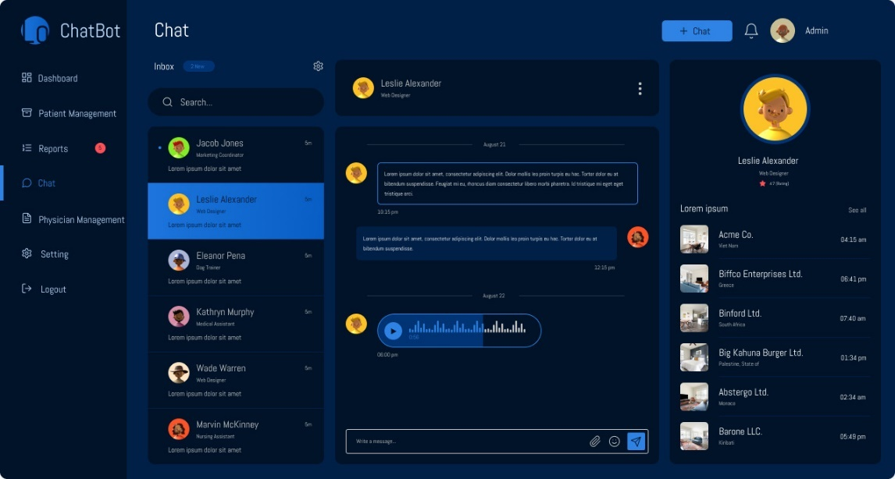The mockups of proposed project are given below:

Figure 1

**Description: This is the admin panel of proposed project**

Figure 2

**Description: This is self-care toolkit of web page.**

Figure 3

**Description: This is chat room of a user with bot of an app.**

Figure 4

**Description: This is chat room of a user with bot of web page.**

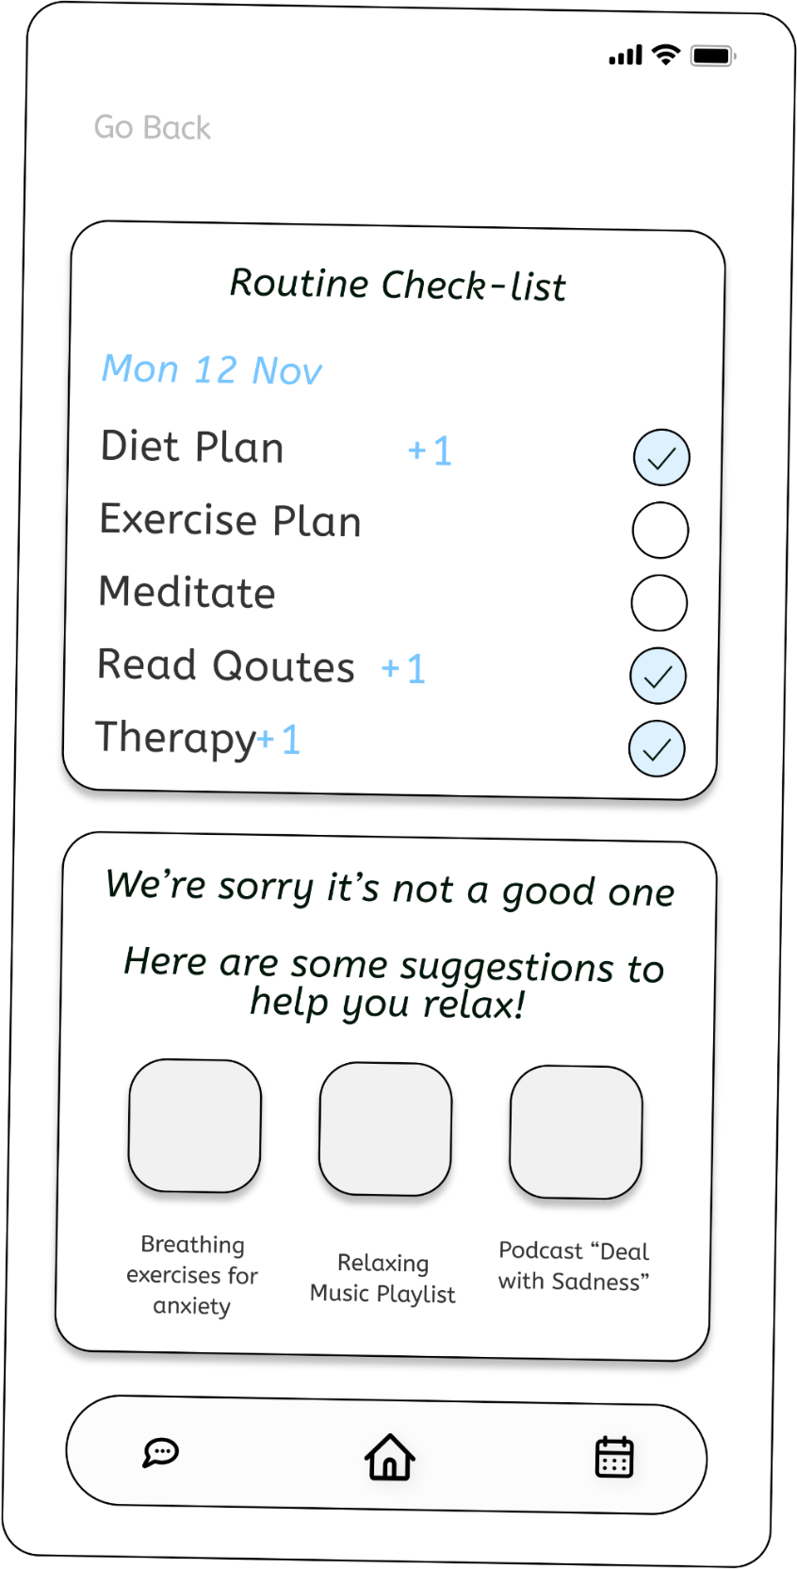

Figure 5

**Description: This is daily routine check of a user of an app.**

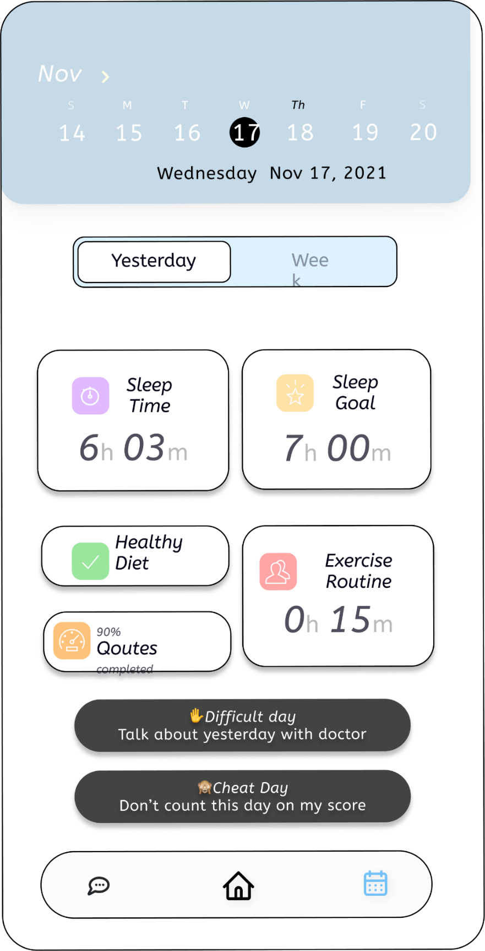

Figure 6

**Description: This is self-care toolkit of a user of an app.**

## **Software interfaces**

The following are the software interfaces of the system.

**SI-1: Stress Detector Chatbot**

*SI-1.1: The system will suggest physicians to user through programmatic interface.*

**SI-2: Stress Detector Chatbot**

*SI-2.1: The system will allow user and chatbot to chat through programmatic interface.*

## **Hardware interfaces**

The following are the hardware interfaces of the system.

* For mobile application, Android should be 8.0 or higher.
* Strong Internet connection is required. Minimum 125 MB space should be free.
* For web application Microsoft edge version should be 94.0.992.58.
* For web application Firefox version should be 90.0.
* For web application all versions of chrome can be used.
* For web application Apple safari version should be 15.0

## **Communications interfaces**

Following are the communication interfaces used by system.

*CI-1: The COS shall send an email or text message (based on user account settings) to the for-meeting alerts, exercise routine, and sleep routine.*

*CI-2: Wi-Fi or Mobile data will be used for the communication between the application and machine. Networking protocols will be used for security issues. Server will be used to retrieve and send data to Mongo DB system.*

# Context Diagram

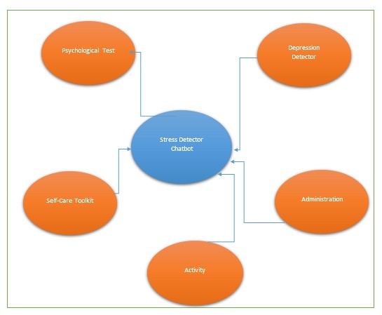

# Conclusion

We proposed a Depression Detector Chat Bot for sensing negative emotions using AI algorithms by chatting with them. There is comparable software that are providing these services, but we are going to provide therapy services as well online or offline according to users’ demand. We are also providing a self-care toolkit for users which help them to improve their mental as well as physical conditions. In our future work, we will consider users privacy and improve our privacy policy according to users’ demand.

# Team Members Individual Tasks/Work Division

Team Member Work Division the Stress Detector Chatbot

|  |  |  |
| --- | --- | --- |
| **Student Name** | **Student Registration Number** | **Responsibility/ Modules** |
| Khan Sharjeel Khan | SP20-BCS-041 | Presentation, Use cases (15)  FR’s (27) |
| Muhammad Ahmed Raza | SP21-BCS-003 | SRS (Formatting + \Complete Heading),  Use cases (20)  FR’s (60)  Context Diagram |

# References

These are the links that we used to get help regarding this proposed project.

**World Wide Web**

1. Medium “Testing Chat bot for stress management. Internet:

<https://code.likeagirl.io/i-tested-out-a-chatbot-for-stress-management-heres-the-scoop-58b007b0e2e8>, Feb 13, 2019.

1. Chatbot life “Chat bot performance testing. Internet:

<https://chatbotslife.com/first-steps-in-chatbot-performace-testing-with-botium-box-efe6f12bcc50>, Jan 11, 2022.

1. Mudpie “Mental Health Chat bot. Internet:

<https://www.mdpi.com/1424-8220/22/10/3653/htm> , May 11, 2022.