

**COMSATS University Islamabad (CUI)**

#### Department of Computer Science

**Assignment-03**

CLO-3

Software Design Description   
(SDS DOCUMENT)

for

**Stress Detector Chatbot**

Version 1.0

**Submitted By:**

**Student Name 1** **SP20-BCS-041**

**Student Name 2 SP21-BCS-030**

**BCS-4-A/B - BCT-4-A**

**SupervisorMr. Tahseen Riaz Abbasi**

Submission Date: (12-Dec -2022)

Original Version 1.0

(Mention the proper project SDS Document version)

Bachelor of Science in Computer Science (2020-2024)

Table of Contents

1. Introduction 1

1.1 Scope 1

1.2 Modules 1

2. Design method and Software Process Model 1

2.1 Design Methodology 1

2.2 Software Process Model 1

3. System overview 1

3.1 Architectural Design 1

4. Design Models 2

4.1 Activity Diagrams 3

4.2 Class Diagram 8

4.3 Sequence Diagram 9

4.4 Data Flow Diagram 12

5. Data design 12

5.1 Data dictionary 12

6. Algorithm & Implementation 13

6.1 Collaborative Filtering 13

6.2 Natural Processing Language 13

6.2.1 Keyword Extraction 14

6.2.2 Text Summarization 14

7. Human Interface Design 14

7.1. Screen images 14

7.2. Screen objects and actions 17

8. Team Members Individual Tasks/Work Division 17

9. Conclusion 17

10. References 17

# Introduction

Throughout the human history, the concept of the depression is being caused by the evil spirits and demons which causes the physical disease like mental illness. Greek and Roman doctors and philosopher use different therapy to cure their patient from this illness. Today’s modern world has shown that technology can be used to detect the depression level so that his/her treatment would be easy. A philosopher MOHR ET AL suggest that behavioral intervention technologies (BITs) that help chatbot to address the mental health condition. Depression chatbot detector are the computer programs that uses chat and images to detect the depression level. The depression chat bot help doctors and philosopher to detect the depression level so that they can start their treatment.

## Scope

The system is designed for the patient who have mental disease (depression), but they did not realize that weather it is a depression or something else. The aim here is to develop a system that enables the patient to detect his/her depression level and make an appointment to a doctor if needed. This system is used on the web and the smartphone application as well.

## Modules

The major modules of the system are.

* **Psychological Test**
* **Self-Care Toolkit**
* **Emotion Detector**

# Design method and Software Process Model

The following are the method and software process model for the system.

## Design Methodology

7

## Software Process Model

We will be use **Incremental build model** for this system where we will progress and improve incrementally build more out of first smaller application. Since the requirements are well known sequential model will be best choice and initially not full requirements are necessary so, this method suits us best.

# System overview

This system is based around online services thus including the general login/signup requirements. It also supplies privacy control thus having such functionalities as well. This system is for stress detection with the help of chatbot and supplying physicians to patients whose detect depressed at large scale thus the functionalities and requirements are related towards it.

## Architectural Design

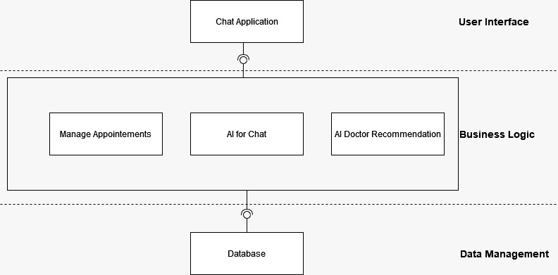

# Design Models

As we are using Object-oriented development approach, so the required diagrams are as follows.

## Activity Diagrams

The following are the activity diagrams of the system.

Figure ‑ Activity Diagram of Cancel Meeting

Figure ‑ Activity Diagram of Edit Profile

Figure ‑Activity Diagram of Subscription Package

Figure ‑Activity Diagram of Generate Prescription

Figure ‑Activity Diagram of Suggest Physician

## Class Diagram

The following is the class diagrams of the system.

Figure ‑ Class Diagram of Chatbot Stress Detector

## Sequence Diagram

Figure ‑ Sequence Diagram of Edit Profile

The following are the sequence diagrams of the system.

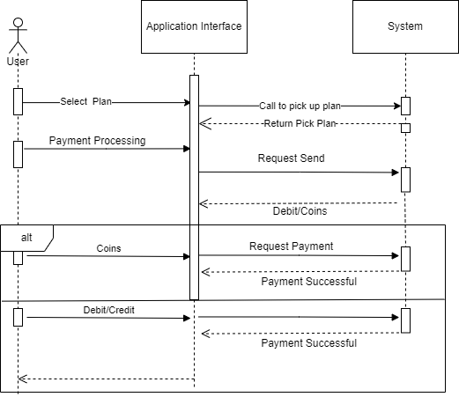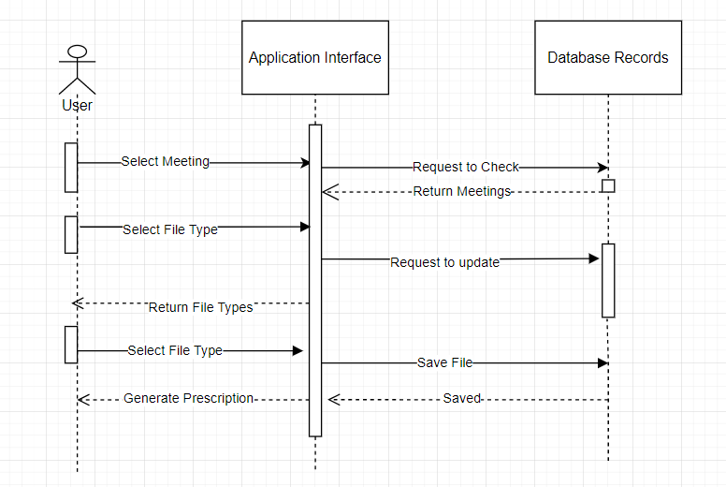

Figure ‑ Sequence Diagram of Subscription Package

Figure ‑ Sequence Diagram of Generate Prescription

Figure ‑ Sequence Diagram of Suggest Physician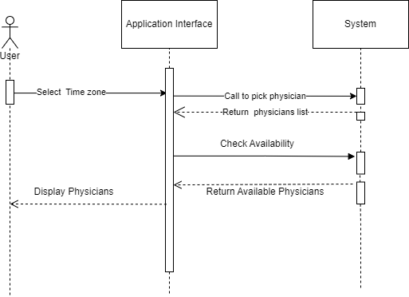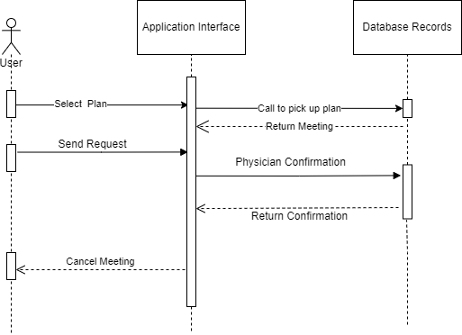

Figure ‑ Sequence Diagram of Cancel Meeting

## Data Flow Diagram

The following are the data flow diagrams of the system.

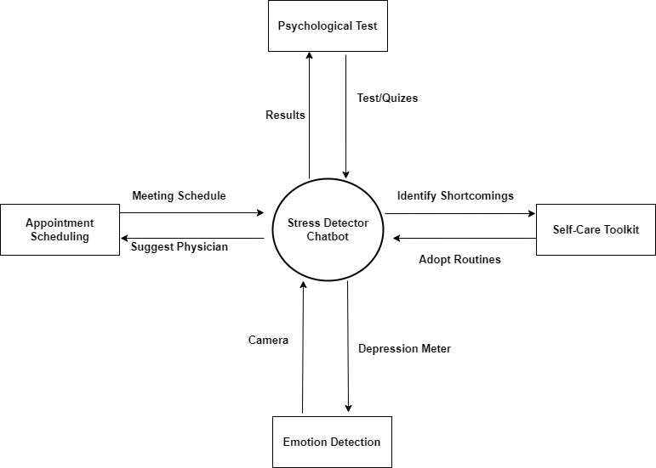

Figure ‑ Data Flow Diagram of Chatbot Stress detector

# Data design

This software is especially useful in data storage and management. It generates data from creation of new user for using software for user and chatbot chats, storing reports, prescriptions, feedbacks, activities, JSON is often used to store the data into MongoDB database along with all the request and response data being managed in JSON.

## Data dictionary

Following is tabular form of data dictionary that is used in Centralized News System

Table Data Dictionary Table

|  |  |  |  |
| --- | --- | --- | --- |
| **Collections** | **Properties** | **Data Type** | **Description** |
| Count | Physicians Count | double | It will have the number of physicians |
| Count | Users Count | double | It will have the number of users |
| Count | Video Count | double | It will have the number of therapy videos |
| date | Upload date | date | It will have the upload date of therapy videos |
| date | Expiry date | date | It will have last date of therapy video |
| description | Description String | String | It will have the description of user profile |
| image | Image String | String | It will have the image address of directory of user |
| Email | Address | String | It will have the email of user |
| Name | Name | String | It will have the name of user. |
| Phone Number | Add number | String | It will have the Phone Number of user |
| Password | Password String | String | It will have the login password of user |
| Password | Password String | String | It will have the login password of admin |
| Questionnaire | Question String | String | It will have the questions asked in the FAQ’s |
| time | Meeting time | Time | It will have the time meeting to be held. |
| time | Meeting Expiry time | Time | It will have the expiry time of meeting |
| title | Physician title | String | It will have the title of the physician profile |

# Algorithm & Implementation

In this project we will use machine learning algorithm for suggestion of physicians to users, machine learning algorithms in recommender systems are typically classified into two categories — content based and collaborative filtering methods although modern recommenders combine both approaches. But in our case, we will use collaborative filtering.

## Collaborative Filtering

Collaborative filtering is a technique that can filter out items that a user might like because of reactions by similar users. It works by searching a large group of people and finding a smaller set of users with tastes like a particular user. It looks at the items they like and combines them to create a ranked list of suggestions.

## Natural Processing Language

Natural Language Processing (NLP) is part of everyday life, and it is essential to our lives at home and at work. Without giving it many thoughts, we send voice commands to our virtual home assistants, our smartphones, and even our vehicles. Voice-enabled applications such as Alexa, Siri, and Google Assistant use NLP and Machine Learning (ML) to answer our questions, add activities to our calendars and call the contacts that we say in our voice commands.

### Keyword Extraction

Keywords Extraction is one of the most important tasks in Natural Language Processing, and it is used for deciding various methods for extracting a considerable number of words and phrases from a collection of texts. All of this is done to summaries and aid in the relevant and well-organized organization, storage, search, and retrieval of content.

### Text Summarization

Text summarization can be done in two ways: extraction and abstraction. By cutting bits from the text, extraction methods create a rundown. Abstraction tactics produce summaries by constructing new text that conveys the essence of the original content.

# Human Interface Design

The following are the human interface design of the system.

## Screen images

The following are the interfaces of the system.

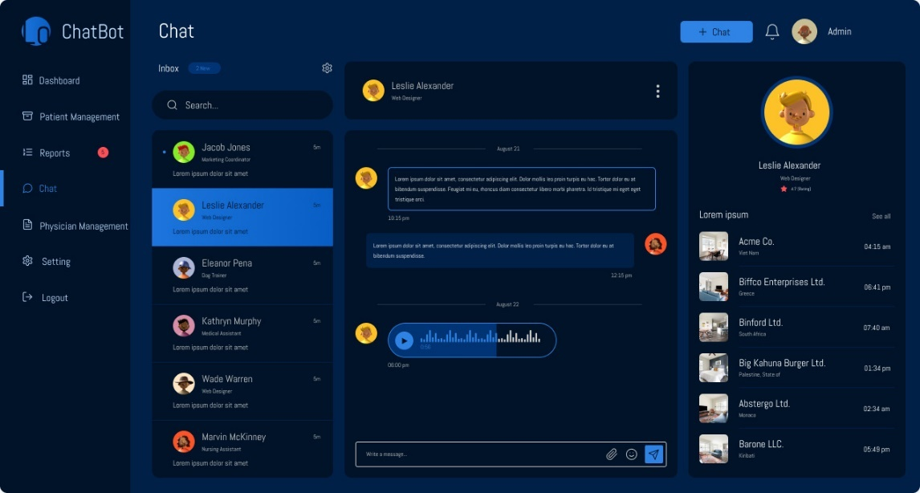

Figure ‑ Chat Between user and Chatbot Web overview

Figure ‑ Chat between user and chatbot mobile overview

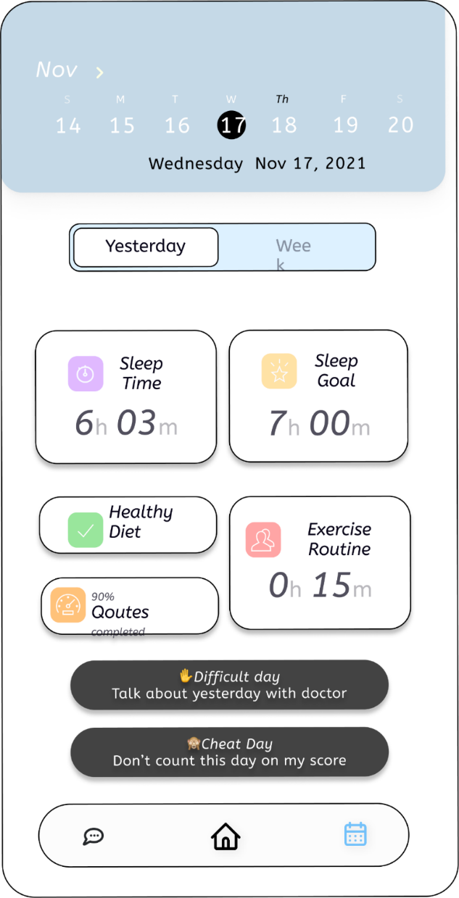

Figure ‑ Toolkit mobile overview

Figure ‑ Toolkit Web overview

## Screen objects and actions

The following is the explanation of screening object.

**7.2.1. Chatbot**

In this system,screen defines that the user and chatbot interaction. During the whole texting, chatbot try to decide that the user is in depression or not. If it will decide then show results in the form of different modes.

**7.2.2. Self-Care Toolkit**

The above screening object of toolkit supplies user an impressive experience about his/her daily life routines like sleep, exercise, and diet routines to make his/her life stress free. It will also allow user to customize their own plans to be followed.

# Team Members Individual Tasks/Work Division

Team Member Work Division the Stress Detector Chatbot

|  |  |  |
| --- | --- | --- |
| **Student Name** | **Student Registration Number** | **Responsibility/ Modules** |
| Khan Sharjeel Khan | SP20-BCS-041 | He did presentation and 5 activities and 5 sequence diagrams in mac and submit it buy on windows I didn’t open those files, so that’s why there is nothing in this assignment for him. |
| Muhammad Ahmed Raza | SP21-BCS-003 | Activity Diagrams (5)  Sequence Diagrams (6)  SDS (Complete Document) |

# Conclusion

We proposed a Depression Detector Chat Bot for sensing negative emotions using AI algorithms by chatting with them. There is around more than five comparable software that are supplying these services, but we are going to supply therapy services as well online or offline according to users’ demand. We are also supplying a self-care toolkit for users which help them to improve their mental as well as physical conditions. In our future work, we will consider users privacy and improve our privacy policy according to users’ demand.

# References

These are the links that we used to get help about this proposed project.

**World Wide Web**

Medium “Testing Chat bot for stress management. Internet:

<https://code.likeagirl.io/i-tested-out-a-chatbot-for-stress-management-heres-the-scoop-58b007b0e2e8>, Feb 13, 2019.

Chatbot life “Chat bot performance testing. Internet:

<https://chatbotslife.com/first-steps-in-chatbot-performace-testing-with-botium-box-efe6f12bcc50>, Jan 11, 2022.

Diagram “Diagram Maker”:

<https://app.diagrams.net/> , May 11, 2022.