

**COMSATS University Islamabad, Islamabad**

**Department of Computer Science**

**Assignment-06**

**Project Final Report**

**For**

**Stress Detector Chatbot**

**Submitted By:**

**Khan Sharjeel Khan**  **SP20-BCS-041**

**Muhammad Ahmad Raza SP21-BCS-003**

**Supervised By:**

**Mr. Tehseen Riaz Abbasi**

Submission Date: (1-January -2022)

Original Version 1.0

*Bachelor of Science in Computer Science (2021-2024)*

Submission Date: (1-January -2022)



**COMSATS University Islamabad, Islamabad**

**Stress Detector Chatbot**

**A project presented to**

**COMSATS University, Islamabad**

**In partial fulfillment**

**of the requirement for the degree of**

**Bachelor of Science in Computer Science (2021-2024)**

**By**

**Khan Sharjeel Khan CUI/SP20-BCS-041/ISB**

**Muhammad Ahmad Raza CUI /SP21-BCS-003/ISB**

**DECLARATION**

We hereby declare that this software, neither whole nor as a part has been copied out from any source. It is further declared that we have developed this software and accompanied report entirely based on our personal efforts. If any part of this project is proved to be copied out from any source or found to be reproduction of some other. We will stand by the consequences. No Portion of the work presented has been given of any application for any other degree or qualification of this or any other university or institute of learning.

Student Name 1 Student Name 2

**Executive Summary**

The reason for Stress Detector Chatbot is to provide a reliable way to combat depression by identifying people who are inflicted by it using chat bot. Currently, mental issues including depression are a topic that is heavily criticized and not dealt with properly. Such issues are not met with the level of urgency that’s suitable to handle them. A large portion of public suffer from depression without a clear cure. A lot of the common folk suffer from mental and physical stress from their daily struggles. This project will provide a way to assist such individuals instead of shunning them. Our application will act as a source of stress relief. It will provide emotional support to people ailing from depression. It will provide an AI partner to unload all your mental stress. Our main goal is to help individuals facing such issues come forth and seek help instead of falling deeper into a pit of depression and loneliness.

**Acknowledgement**

All praise is to Almighty Allah who bestowed upon us a minute portion of His boundless knowledge by virtue of which we were able to accomplish this challenging task.

We are greatly indebted to our project supervisor “Mr. Tehseen Riaz Abbasi”. Without their personal supervision, advice and valuable guidance, completion of this project would have been doubtful. We are deeply indebted to them for their encouragement and continual help during this work.

And we are also thankful to our parents and family who have been a constant source of encouragement for us and brought us the values of honesty & hard work.

Student Name 1 Student Name 2

**Abbreviations**

|  |  |
| --- | --- |
| **SRS** | Software Requirement Specification |
| **PC** | Personal Computer |
| **SDS** | Software Design Document |
| **SDLC** | Software Development Lifecycle |
| **App** | Application |
| **GUI** | Graphical User Interface |
| **H** | High (risk) |
| **UML** | Unified Modeling Language |
| **L** | Low (risk) |
| **M** | Medium (risk) |
| **OTP** | One Time Password |
| **QA** | Quality Assurance |
| **SDS** | Software Design Specification |
| **SRS** | Software Requirements Specification |
| **STP** | Software Test Plan |
| **TC** | Test Case |
| **UC** | Use Case |
| **User** | Client for whom the document and software are intended. |
| **NLP** | Natural Processing Language |
| **AI** | Artificial Intelligence |
| **ML** | Machine Learning |
| **OOP** | Object Oriented Programming |
| **DSA** | Data Structure and Algorithm |

Table of Contents

List of Figures 9

1. Introduction 11

1.1 Brief 11

1.2 Project Background 11

1.3 Related System Analysis/Literature Review 11

1.4 Advantages/Benefits of Proposed System 12

1.5 Project Scope 12

1.6 Modules 13

1.6.1 Module 1: Administration 16

1.6.2 Module 2: User Profiling 16

1.6.3 Module 3: Emotion Detection 17

1.6.4 Module 4: Psychological Test 17

1.6.5 Module 5: Self Care Toolkit 17

1.6.6 Module 6: Appointment Management 17

1.6.7 Module 7: Activity 18

1.6.8 Module 8: Feedback 18

1.7 System Limitations/Constraint 18

1.8 Tools and Technologies 19

1.9 Relevance to Course Modules 19

1.10 Design and Process Methodology for This Project 19

1.10.1 Incremental process model. 19

1.10.2 Object-oriented Methodology 19

1.11 Team Members Individual Tasks/Work Division 19

2 Problem Definition 21

2.1 Problem Statement 21

2.2 Problem Solution for the Proposed System 21

2.3 Deliverables and Development 21

2.4 Current System 21

3 Requirement Analysis 24

3.1 Requirement Elicitation Technique 24

3.1.1 Brainstorming: 24

*3.1.2* Observation: 24

3.2 Use Case Diagrams 24

3.3 Detailed Use Case 29

3.3.1 Module 1: Administration 30

3.3.2 Module 2: User Profiling 34

3.3.3 Module 3: Emotion detector 37

3.3.4 Module 4: Physiological Test 41

3.3.5 Module 5: Self-Care Toolkit 46

3.3.6 Module 6: Appointment Management 48

3.3.7 Module 7: Activity 51

3.3.8 Module 8: Feedback 54

3.4 Functional Requirements 57

3.4.1 Administration: 57

3.4.2 User Profiling 58

3.4.3 Emotion Detection 63

3.4.4 Physiological Test 66

3.4.5 Self-Care Toolkit 71

3.4.6 Appointment Management 76

3.4.7 Activity 80

3.4.8 Feedback 84

3.5 Non-Functional Requirements 87

3.5.1 Reliability 87

3.5.2 Usability 87

3.5.3 Performance 87

3.5.4 Security 88

4 Architecture and Design 89

4.1 System Architecture 89

4.2 Design methodology 89

4.3 Data Representation 89

4.4 Design Models 90

4.4.1 Activity Diagram 90

4.4.2 Sequence Diagram 101

4.4.3 Class Diagram 109

5 Human Interface Design 110

5.1 Screen images 110

5.2 Screen objects and actions 113

5.2.1 Chatbot 113

5.2.2 Self-Care Toolkit 113

6 Implementation 114

6.1 Algorithm 114

6.1.1 Collaborative Filtering 114

6.1.2 Natural Processing Language 114

6.1.3 Keyword Extraction 115

6.1.4 Text Summarization 115

6.2 External API 115

6.3 User Interface 116

7 Testing and Evaluation 117

7.1 Verification 117

7.2 Validation 117

7.3 Usability Testing 117

7.4 Module / Unit Testing 117

7.5 Integration Testing 117

7.6 System Testing 117

7.7 Acceptance Testing 117

7.8 Test Cases 117

7.9 Automated Testing: 139

7.10 Environmental Needs 139

Environmental needs are as follows: 139

8 Conclusion and Future Work 141

8.1 Conclusion 141

8.2 Future Work 141

9 Work Summary and Reviews 142

9.1 Lesson Learnt 142

9.2 Work Break Down 142

9.3 Reviews Details 144

10 References 145

11 Drive Link 145

**List of Figures**

Fig 1 Context Diagram 13

Fig 2 Related System 22

Fig 3 Related System 23

Fig 4 Admin Usecase Diagram 25

Fig 5 Physician Usecase Diagram 26

Fig 6 System Usecase Diagram 27

Fig 7 User Usecase Diagram 28

Fig 8 User Usecase Diagram 29

Fig 9 System Architecture Design 93

Fig 10 ER Diagram 93

Fig 11 Activity Diagram of Edit Profile 95

Fig 12 Activity Diagram of Generate Prescription 96

Fig 13 Activity Diagram of Subscription Package 97

Fig 14 Activity Diagram of Physician Suggestion 98

Fig 15 Activity Diagram of Cancel Appointment 99

Fig 16 Activity Diagram of Face Expression 100

Fig 17 Activity Diagram of Sign in/Signup 101

Fig 18 Activity Diagram of light Detection 102

Fig 19 Activity Diagram of Feedback 103

Fig 20 Activity Diagram of Print Report 104

Fig 21 Sequence Diagram of Physician Suggestion 105

Fig 22 Sequence Diagram of Availability 106

Fig 23 Sequence Diagram of Payment 106

Fig 24 Sequence Diagram of Edit Profile 107

Fig 25 Sequence Diagram of Generate Prescription 108

Fig 26 Sequence Diagram of Quiz Attempt 109

Fig 27 Sequence Diagram of Appointment 110

Fig 28 Sequence Diagram of Deactivate Account 111

Fig 29 Sequence Diagram of Texting with chatbot 112

Fig 30 Class Diagram 113

Fig 31 Mockup for web overview of chat 114

Fig 32 Mockup for app overview of chat 115

Fig 33 Mockup for web overview of toolkit 116

Fig 34 Mockup for app overview of toolkit 116

Fig 35 Algorithm for Physician Suggestion 120

**Project Major Category:**

**B-** Web Application/Web Application based Information System

**E**- Smartphone Application

# Introduction

Throughout the human history, the concept of the depression is being caused by the evil spirits and demons which causes the physical disease like mental illness. Greek and Roman doctors and philosopher use different therapy to cure their patient from this illness. Today’s modern world has shown that technology can be used to detect the depression level so that his/her treatment would be easy. A philosopher MOHR ET AL suggest that behavioral intervention technologies (BITs) that help chatbot to address the mental health condition. Depression chatbot detector are the computer programs that uses chat and images to detect the depression level. The depression chat bot help doctors and philosopher to detect the depression level so that they can start their treatment.

## Brief

Depression detector chat bot system will be a smartphone and web application that will help the patient to detect their depression level and it also help the doctor and physiologist to diagnose a depression disease so that they can start his/her treatment in time. We use Natural Language Processing (NLP) in this system, that is used to build the machine that understand and response to the text and the voice data just like human being. this system simply asked multiple choice question from the patient or required a face image of the patient. Through this system can check the level of depression of the patient. However, it will reduce the cost as well as time.

## Project Background

This project is focused on providing reliable online auction platform. Currently there are systems, but none of them is benefiting from AI. The client interface and the admin interface are the two components of this project, a centralized online auction system. A customer can place a bid on a specific goods to purchase using the customer panel. An admin interface allows them to manage the entire bidding process. Administrators have control over registered users and can approve products based on categories. A product is sold under specific policy. Systems assist customers in purchasing goods at the best prices. The system is being created with the intention of making it dependable, simple, and quick. To buy anything on the website from your home, an application is used. This application provides the users way to accomplish this task. It progressed with the goal of making the system dependable, simple, and quick. Making use of the program is as straightforward as browsing a webpage. It will not be technical. People can readily interact with the application's processing.

## Related System Analysis/Literature Review

The following are the systems that are related to Stress Detector Chatbot.

Table 1 Related System Analysis with Stress Detector Chat Bot

|  |  |  |
| --- | --- | --- |
| **Application Name** | **Weakness** | **Proposed Project Solution** |
| * Depression test * <https://play.google.com/store/apps/details?id=com.depression.test> | * Do not arrange appointments between the patient and Doctor/physiologist. * Do not give suggestion to consult with a doctor | * Arrange proper appointments between the patient and Doctor. * Also give suggestion for proper treatment |
| * Dealing with Depression * [Dealing with Depression - Apps on Google Play](https://play.google.com/store/apps/details?id=com.fatbelly.dealingwithdepression) | * Do not have any Doctor /physiologist | * Arrange Doctor to examine patients |
| * Mental Health Tests * [Mental Health Tests - Apps on Google Play](https://play.google.com/store/apps/details?id=org.minddiagnostics) | * Do not offer Self Care Toolkit | * Must arrange Self Care Toolkit for best treatment and healthy routine |

## Advantages/Benefits of Proposed System

Our proposed system has following benefits:

* The application is reliable since it ensures that no data is lost and generates correct results.
* Detection of depression is easy.
* User time will be saved
* Reduce emotional and financial burden of disease.
* Available for both IOS and android user in the case of smartphone.
* User friendly UI, most of the people about which would aware off.

## Project Scope

The system is basically designed for the patient who have mental disease (depression), but they didn’t realize that weather it’s a depression or something else. The aim here is to develop a system that enables the patient to detect his/her depression level and make an appointment to a doctor if needed. This system is used on the web and the smartphone application as well.

Figure Context Diagram

## Modules

The following are the modules of Stress Detector Chatbot.

Module 1: Administration

Table 2: Module 1 Use Cases

|  |  |
| --- | --- |
| **M1-UC1** | User’s Management |
| **M1-UC2** | Physicians Management |
| **M1-UC3** | Reports generation |
| **M1-UC4** | Payment management |
| **M1-UC5** | Committee |
| **M1-UC6** | Active physician |
| **M1-UC7** | Active user |
| **M1-UC8** | Upload therapy videos |
| **M1-UC9** | Comments Management |
| **M1-UC10** | Deactivate account |

Module 2: User Profiling

Table 3: Module 2 Use Cases

|  |  |
| --- | --- |
| **M2-UC1** | User signup |
| **M2-UC2** | User sign in |
| **M2-UC3** | Update password |
| **M2-UC4** | Forgot password |
| **M2-UC5** | Remember me |
| **M2-UC6** | Logout |
| **M2-UC7** | Deactivate account |
| **M2-UC8** | Update profile |
| **M2-UC9** | Admin sign in |
| **M2-UC10** | Setup Profile |
| **M2-UC11** | Update Profile |
| **M2-UC12** | Physicians sign up |

Module 3: Emotion Detection

Table 4: Module 3 Use Cases

|  |  |
| --- | --- |
| **M3-UC1** | Camera |
| **M3-UC2** | Fatigue detection |
| **M3-UC3** | Talk to the person verbally |
| **M3-UC4** | Talk to the person non-verbally |
| **M3-UC5** | Detect heartbeat |
| **M3-UC6** | Detect motion of eyes |
| **M3-UC7** | Detect body language |
| **M3-UC8** | Muscle tension detection |
| **M3-UC9** | Photo from camera, gallery |
| **M3-UC10** | Result of depression from the given picture |

Module 4: Psychological Test

Table 5: Module 4 Use Cases

|  |  |
| --- | --- |
| **M4-UC1** | Test questions/quiz’s |
| **M4-UC2** | Chat bot |
| **M4-UC3** | Scenario handling |
| **M4-UC4** | stress detection |
| **M4-UC5** | Personality test |
| **M4-UC6** | Mental Health test |
| **M4-UC7** | Result of quiz’s, scenario handling, stress detection, personality test |
| **M4-UC8** | Depression meter |
| **M4-UC9** | Rate mental health |
| **M4-UC10** | Prescription |

Module 5: Self-Care Toolkit

Table 6: Module 5 Use Case

|  |  |
| --- | --- |
| **M5-UC1** | Sleep routine |
| **M5-UC2** | Exercise routine |
| **M5-UC3** | Healthy Diet Suggestions |
| **M5-UC4** | Diet routine |
| **M5-UC5** | Get Inspired |
| **M5-UC6** | Analyze Progress |
| **M5-UC7** | Identify Shortcomings |
| **M5-UC8** | Alerts for meeting |
| **M5-UC9** | Customize Plans |
| **M5-UC10** | Steps Counter |

Module 6: Appointment Management

Table 7: Module 6 Use Case

|  |  |
| --- | --- |
| **M6-UC1** | Suggest physician |
| **M6-UC2** | Schedule meeting |
| **M6-UC3** | Cancel Appointment |
| **M6-UC4** | Payment |
| **M6-UC5** | Update Appointment detail |
| **M6-UC6** | Check Availability |
| **M6-UC7** | Appointment Status |
| **M6-UC8** | Subscription Package |
| **M6-UC9** | Bot check |

Module 7: Activity

Table 8: Module 7 Use Case

|  |  |
| --- | --- |
| **M7-UC1** | Save Activity |
| **M7-UC2** | See recent Activity |
| **M7-UC3** | Compare Activities |
| **M7-UC4** | Generate Charts |
| **M7-UC5** | Generate Reports |
| **M7-UC6** | Generate prescription |
| **M7-UC7** | Manage Appointment |
| **M7-UC8** | Availability |
| **M7-UC9** | Manage Activity |

Module 8: Feedback

Table 9: Module 8 Use Case

|  |  |
| --- | --- |
| **M8-UC1** | Add reviews |
| **M8-UC2** | Satisfaction survey |
| **M8-UC3** | FAQs |
| **M8-UC4** | improvement |
| **M8-UC5** | Negative comments |
| **M8-UC6** | Rating |
| **M8-UC7** | Positive comments |
| **M8-UC8** | Chat with experts |
| **M8-UC9** | Solution of the problem |
| **M8-UC10** | Suggestion Emails |

### Module 1: Administration

In this module, the Depression Detector Chat Bot will allow admin to manage users, physicians as well as he’ll generate reports.

* **Users Management**

Admin will manage users accounts add, delete or update.

* **Physicians Management**

Admin will manage physicians accounts like add, delete, or update.

* **Reports Generation**

Admin will generate reports for weekly, monthly, and yearly revenues for physicians and for him as well.

* **Comments Management**

Admin will manage reviews, comments, and ratings.

### Module 2: User Profiling

In this module, Depression Detector Chat Bot will be taking input for valid credentials like username, email, password for creating new accounts sign up and login for existing accounts.

* **Sign-Up**

Users and physicians will sign up by using their valid credentials.

* **Sign-In**

Users and physicians will login by using their valid username and password.

* **Update Username and Password**

Users and physicians will update their username and password by email verification.

* **Forget Password**

In case anyone forgot their password, they will reset password by verifying email.

* **Logout**

Users and physicians will end their session.

* **Remember Me**

Users and physicians will save their username and password so that they don’t need to fill them every time on login.

* **Deactivate Account**

Users and physicians delete their account and remove their personal info from Depression Detector Chat Bot.

### Module 3: Emotion Detection

In this module, Chat Bot will capture the images (as an input) of the user from the camera to get his/her face expression so that depression can be detected.

* **Camera**

User can capture his/her live pic from the camera on the device.

* **Gallery**

User can upload his/her image from gallery or documents.

### Module 4: Psychological Test

In this module we will check the mental state of the user through question/answers session. where the user must answer each question in a specific time and at the end the depression meter will give us the result that, categorically on which stage of depression does the user lie. So, based on this result we must decide whether the user must consult to a doctor or not.

* **Test questions/quiz**

Users must answer the question in the specific time. These questions are usually multiple-choice questions, none of the answer will be right or wrong, it is simply used to check the mental state. Every answer to the question is compulsory.

* **Depression meter**

Depression meters tell the user about the depression level based on above functionalities.

* **Prescription**

This prescription is generated based on depression level on depression meter and tell us whether the user must consult to a doctor or not.

### Module 5: Self Care Toolkit

In this module, the system will provide users some routines and guide how to overcome depression.

* **Sleep Routine**

Chat Bot will send reminder to sleep according to time zone.

* **Exercise Routine**

Chat Bot will send reminder for exercise like cardio, yoga, and meditation etc.

* **Healthy Diet**

Chat Bot will suggest healthy diet to users using AI algorithm by calculating BMI of the users.

* **Analyze Progress**

Chat Bot will help users to analyze their progress with the passage of time.

### Module 6: Appointment Management

In this module, Depression Detector Chat Bot will allow users to schedule his/her appointment (online/offline) with the recommended physician.

* **Suggest Physician**

Chat Bot will suggest physicians to users according to their location using AI algorithm.

* **Scheduling Meeting**

Users will select physicians from the suggested list according to budget and time zone. Then select the venue of the meeting. If he/she is around physician so, he/she will go for face-to-face therapy.

* **Cancel Appointment**

Users will cancel appointment within a given span of time otherwise he/she will pay fine of 10 percent of the appointment.

* **Payment**

Users will pay for appointment online as well as offline using different bank accounts or e-wallets.

### Module 7: Activity

In this module, users will save their test results and see their mental improvements day by day.

* **Save Activity**

Users will save results of each depression test.

* **See Recent Activity**

Users will see results of depression tests of last 30 days in the form of graphs, charts, and percentage.

* **Compare Activities**

Users will compare their activities from specific time periods to specific time for checking their improvements after therapy and before therapy.

* **Generate Charts**

Users will allow to generate their activities in the form of charts.

* **Generate Reports**

Users will allow to generate their activities in the form of reports.

* **Appointment Status**

Chatbot will allow physicians to check, update and delete their appointments.

* **Availability**

Chatbot will allow physicians to set their availability time.

### Module 8: Feedback

In this module, users will rate this system and give feedback according to their experience and time they spent on it.

* **Add Reviews**

Users will add their reviews according to their experience.

* **Ratings**

Users will give ratings according to their experience.

* **Edit Ratings/Reviews**

Users will edit their reviews/ratings if they found anything change in the behaviors of chat bot.

* **Suggestion Emails**

Users will allow to send any suggestion on chat bot email to improve anything.

## System Limitations/Constraint

The following are the constraints of this system.

**LI-1:** Physicians are only available for 15 hours from 8:00 AM to 11:00 PM for every time zone.

**LI-2:** If user/physician will deactivate their account, they will have 30 days to login again. If they login within 30 days their account will recover and will not deactivate

**LI-3:** For online meeting, chat bot will also need active internet connection for user and physician.

## Tools and Technologies

Following show the description of tools and technologies used.

Table 10: Tools and Technologies for Proposed Project

|  |  |  |  |
| --- | --- | --- | --- |
| **Tools and Technologies** | **Tools** | **Version** | **Rationale** |
| Visual Studio Code | 1.59 | IDE |
| MongoDB | 5.0 | DBMS |
| Firebase | 9.12.1 | DBMS |
| MS Project | 2016 | Project Management |
| MS Word | 365 | Documentation |
| MS Power Point | 365 | Presentation |
| Figma | 1.7 | Mockups Creation |
| **Technology** | **Version** | **Rationale** |
| Python | 3.9.0 | Programming language |
| JavaScript | 2.2.0 | Programming language |
| TensorFlow | 2.7.0 | Library |
| React | React 17 | Library |

## Relevance to Course Modules

As the project is about developing a software so it will involve programming, so all programming related courses such as Programming Fundamentals, Object Oriented Programming, and Data Structures Algorithms will play a major role in this project. Other nontechnical course such as report writing has helped a lot in documentation of project. Communication skills also helped during the interviews of requirement gathering techniques.

## Design and Process Methodology for This Project

Design and process methodology used in this project will be following.

### Incremental process model.

This model is preferable because the requirements are clearly justified upfront. It will be easier to make changes in the form of updated release over time. This model also helps reduce any potential technical risks in development. You can release a basic version of the news system and add additional functionalities that improve upon the existing product over time.

### Object-oriented Methodology

We are going to use **Object Oriented approach** for this project and the following are the reasons why we choose this approach.

* It will help in during system updates, maintenance, and adaptation.
* It will minimize the cost during updates.
* It will help to reduce dependencies.

## Team Members Individual Tasks/Work Division

Following is description of the task distribution.

Table 11: Task Distribution

|  |  |  |
| --- | --- | --- |
| **Student Name** | **Student Registration Number** | **Responsibility/ Module / Feature** |

|  |  |  |
| --- | --- | --- |
| Muhammad  Ahmed Raza | (SP21-BCS-003) | Mr. Ahmed (Module 5-8)  Web development. |
| Khan Sharjeel Khan | (SP20-BCS-041) | Mr. Sharjeel (Module 1- 4)  App development. |

# 

# Problem Definition

This is a centralized online auction system which offers an alternative option for customers to both sell and buy goods with ease.

## Problem Statement

Depression is a disease which are very common now a days. If you might suffer from depression, you may not know what to do and where to being to get help, especially, when you never experience this feeling before. This disease is such kind of mental illness that doesn’t allow patient to what to do and how to stay calm. Even the doctor must check your history, background about this disease and couldn’t gave you treatment on the first appointment, but this is the certain kind of disease that if the treatment is not started at the initial stage than the situation would become worse. So, we are making this software that can detect the depression level within few minutes and the doctor can start the treatment of the patient at the initial stage.

## Problem Solution for the Proposed System

Depression detector chat bot system will be a smartphone and web application that will help the patient to detect their depression level and it also help the doctor and physiologist to diagnose a depression disease so that they can start his/her treatment in time. We use Natural Language Processing (NLP) in this system, that is used to build the machine that understand and response to the text and the voice data just like human being. this system simply asked multiple choice question from the patient or required a face image of the patient. Through this system can check the level of depression of the patient. However, it will reduce the cost as well as time.

## Deliverables and Development

Documentation will end in mid of December, then development will start and by the end of December development and testing phase will also complete. Deployed website and executable of application will also be delivered in December.

## Current System

Stress Scan is an online application which detect heartbeat of the user and talks about that the person is in stress or not. By analyzing the waveform of person heartbeat as measured at the fingertip, Stress Scan can analyze the balance of your autonomic nervous system and measure your stress level on a stress index of 1 to 100.It provides services to sell repairable and clean title vehicles over internet. It is operational in eleven countries but most revenue comes from America.

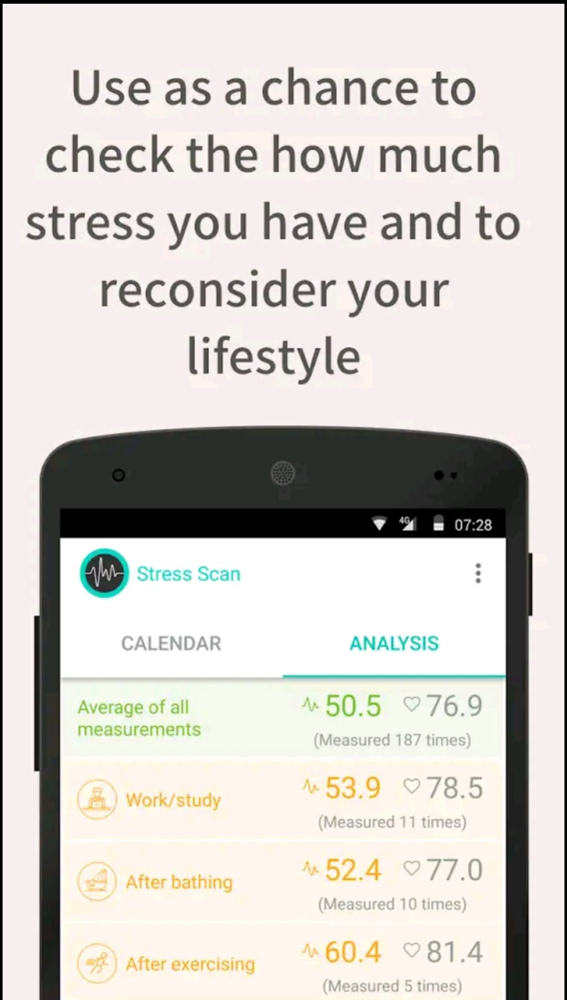

Figure Related System 1/2

Figure Related System 2/2

# Requirement Analysis

The purpose is to address the Software Requirements of the specific project. It will outline the fundamental functions of the intended project. It will specify what the system will perform as well as how it will do it. The guide goes through each capability of each project module in great depth. It will also list the distinct categories of system users, as well as their actions and uses. Following that, the document will include both functional and non-functional needs. It will provide a complete overview of the entire system and explain what the system will and will not accomplish. It will serve as the foundational document for the system's development.

## Requirement Elicitation Technique

The following are the requirements identifying techniques which we used to gather required information.

### Brainstorming:

Maximum requirements gathered using brainstorming. Ideas related to the app noted down, analyzed, and then added to the requirements specifications.

### Observation:

Another technique used is observing the general needs of project developers to gather requirements and observation of similar app. The observed requirements added to the requirements specification of the product.

## Use Case Diagrams

Following are the use case diagrams of Stress Detector Chatbot.

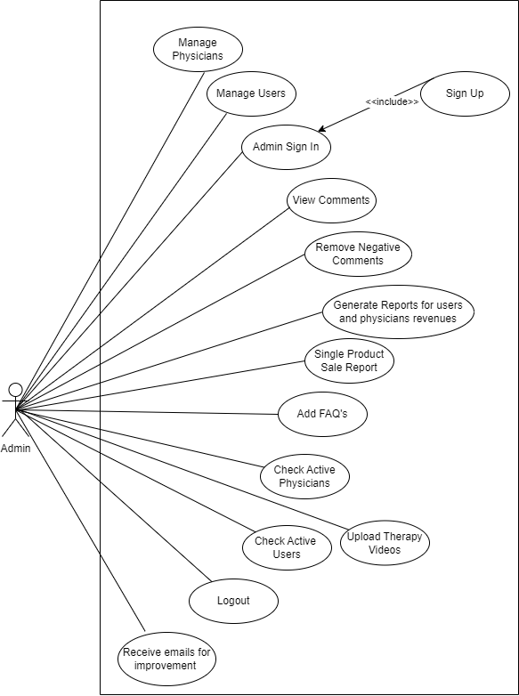

Figure : Admin Use Case Diagram

Figure : Physician Use Case Diagram

Figure : System Case Diagram

Figure : User Use Case Diagram 1/2

Figure : User Use Case Diagram 2/2

## Detailed Use Case

Below are the tabular use cases as per modules of Stress Detector Chatbot application.



### Module 1: Administration

Below are the use cases for module 1.

#### User Management

**Table 12 Show the detail use case of User Management**

|  |  |
| --- | --- |
| **Use Case ID:** | **M1-UC1** |
| **Use Case Name:** | User management |
| **Actors:** | User/ admin |
| **Description:** | In this use case admin will manage the user account for example add some account data, delete data, and update data of the user |
| **Trigger:** | This use case will appear on the administration page to manage all the accounts and it is held in the form of Dropbox |
| **Level:** | High |
| **Preconditions:** | PRE-1. You need some administration to handle the management system |
| **Postconditions:** | POST-1. Admin will manage to add delete or update the user information or account details |
| **Normal Flow:** | 1. Admin will be aired in the user management system 2. Admin will manage all the account details 3. Admin will manage and delete all the account details and information 4. Admin can also update all the information and account details |
| **Exceptions:** | 1. In step Three of the normal flow the user can only update its information detailed her account detail when it’s had an account on the system |
| **Assumptions:** | User must have strong internet connection  Using must have strong security on the management system |

#### Physician Management

**Table 13 Show the detail use case of Physician Management**

|  |  |
| --- | --- |
| **Use Case ID:** | **M1-UC2** |
| **Use Case Name:** | Physician management |
| **Actors:** | User/ physician /admin |
| **Description:** | This user case is used only by admin that will manage their physician account such as to delete an account or add an account how to update any information or account details |
| **Trigger:** | This use case is for the physician to make his or her profile on the system |
| **Level:** | High |
| **Preconditions:** | PRE-1. First physician must sign up for his profile and then he can sign-in in the system |
| **Postconditions:** | POST-1. Once the physician profile is made then it can manage all the patient and appointments  POST-2. Physician overview all the results and then predicted that whether the patient must go to the doctor or not |
| **Normal Flow:** | 1. Admin will manage the physician account 2. Physician first must sign up for his profile 3. Then he or she would be able to sign in in their account |
| **Assumptions:** | User must have strong internet connection  Users should have Strong and reliable security |

#### Report Generation

**Table 14 Show the detail use case of Report Management**

|  |  |
| --- | --- |
| **Use Case ID:** | **M1-UC3** |
| **Use Case Name:** | The report generation |
| **Actors:** | User/ physician/ admin |
| **Description:** | This use case is used to generate the reports however the admin generates these reports for weekly monthly and yearly revenues for the physician and for the users as well |
| **Trigger:** | At the end the result would be given in the soft copy in the form of report it will be generated from the report generation use case |
| **Level:** | High |
| **Preconditions:** | PRE-1. report is made through the required test quizzes chatting with the bot  PRE-2. The report generation use case will compare all the quizzes and reports and Chat |
| **Postconditions:** | POST-1. Based on this report the physician will advise the user whether to go to the doctor or not. |
| **Normal Flow:** | 1. Physician would generate the reports 2. Fashion gave advice to the user whether they go to the doctor or not 3. Doctor will give prescription based on these reports |
| **Assumptions:** | User must have strong internet connection  Administration must have security for these reports |

#### Payment Management

**Table 15 Show the detail use case of Payment Management**

|  |  |
| --- | --- |
| **Use Case ID:** | **M4-UC4** |
| **Use Case Name:** | Payment management |
| **Actors:** | User/ admin |
| **Description:** | In this use case the user must pay the required dues of his or her treatment. This is managed by the payment management system |
| **Trigger:** | It is generated after the report generation the payment slip will be available before the prescription |
| **Level:** | High |
| **Preconditions:** | PRE-1. After all testing and treatment is completed  PRE-2. The system would give user the bill before the prescription |
| **Postconditions:** | POST-1. When user pay the bill through different kind of payment method  POST-2. After the payment the admin give prescription to the user |
| **Normal Flow:** | Use it will get the prescription after he or she will pay his or her dues  The usual can have different payment method such as from credit card, easy-peasy bank payment |
| **Assumptions:** | User must have strong internet connection |

#### Comment Management

**Table 16 Show the detail use case of Comment Management**

|  |  |
| --- | --- |
| **Use Case ID:** | **M1-UC9** |
| **Use Case Name:** | Comment management |
| **Actors:** | User/ admin |
| **Description:** | This use git will manage all the comment section that will be provided from the user |
| **Trigger:** | This use case is present at the end of the page in which the admin will manage all the reviews and comments and writing date are in the comment management |
| **Level:** | Medium |
| **Preconditions:** | PRE-1. The user had to appoint some doctor first. |
| **Postconditions:** | POST-1. The admin had to submit all the comments and reviews on the feedback  POST-2. Through this they can improve their management’ |
| **Normal Flow:** | 1. The user had to did Nate its prescription 2. At the end the feedback will be required 3. In which the user can gave it positive or negative feedback through it the administration can improve its comment management. |
| **Assumptions:** | User must have strong internet connection |

### Module 2: User Profiling

Below are the uses cases for Module-2.

#### Sign up

Table 17 Show the detail use case of Sign Up

|  |  |
| --- | --- |
| **Use Case ID:** | UC-2.1 |
| **Use Case Name:** | Sign up |
| **Actors:** | User/Physicians/Developer |
| **Description:** | User will sign up and creates an account by providing the system some details like name, username, email, and password etc. It’ll create an account for the respective user on this system. |
| **Trigger:** | On the welcome page of this system, there will be a get started button which will trigger this signup action. |
| **Level:** | High |
| **Preconditions:** | PRE-1. User will have a valid email.  PRE-2. User will already not have account on same email on this system. |
| **Postconditions:** | POST-1. User will have a secure account for using and exploring this system. |
| **Normal Flow:** | 1. User will open the Sign-up page using trigger and then he’ll have.  2. User will open the web/mobile application.  3. User will click on the sign-up button on the welcome screen.  4. A sign-up form will be shown to the user.  5. The user will enter a valid email and password in the sign-up form along with personal info i.e., Name, age, and gender.  6. User will click sign-up button.  7. Sign-up successful message will be shown to the user. |
| **Exceptions:** | In step 4 of the normal flow, if the user enters invalid email address, password, or personal information.   * Appropriate error message will be shown, and user will be asked to enter data again. * User enters correct data.   Use Case resumes on step 5 of normal flow. Otherwise, signup will be cancelled. |
| **Assumptions:** | User will have strong internet connection. |

#### Sign in

Table 18 Show the detail use case of Sign In

|  |  |
| --- | --- |
| **Use Case ID:** | UC-2.2 |
| **Use Case Name:** | Sign in |
| **Actors:** | User/Physicians |
| **Description:** | This use case will enable registered users/physicians to sign into their account on the app for using this system. |
| **Trigger:** | Clicking Sign in button given on welcome screen will trigger the action. |
| **Level:** | High |
| **Preconditions:** | PRE-1. User will have a valid email.  PRE-2. User will already not have account on same email on this system. |
| **Postconditions:** | POST-1. User will be logged in to his/her account. |
| **Normal Flow:** | 1. User will open the web/mobile application.   1. User will click on the sign in button on the welcome screen. 2. A sign in form will be shown to the user. 3. The user will enter registered email address and password. 4. User will click sign in button. 5. Sign in successful message will be shown to the user and user will be logged into the app. |
| **Exceptions:** | 4 In step 4 of the normal flow, if the user enters invalid email address or password.   * Appropriate error message will be shown, and user will be asked to enter credentials again. * User enters correct data.   Use Case resumes on step 5 of normal flow, otherwise sign in will be cancelled |
| **Assumptions:** | User will log in his/her account. |

#### Setup Profile

Table 19 Show the detail use case of Setup Profile

|  |  |
| --- | --- |
| **Use Case ID:** | UC-2.3 |
| **Use Case Name:** | Setup profile |
| **Actors:** | User |
| **Description:** | This use case will enable registered users to setup their profile and enter their bios, description, and profile picture |
| **Trigger:** | There will be a setting icon on the home page after clicking on that user will have multiple options out of which user will click on the setup profile option to trigger this use case. |
| **Level:** | Medium |
| **Preconditions:** | PRE-1. User will already log in to the system. |
| **Postconditions:** | POST-1. User will have a good profile appearance. |
| **Normal Flow:** | 1. User will select edit bio.  2. User will enter his/her bio.  3. User will select edit description.  4. User will enter his/her description.  5. User will select edit profile picture. |
| **Assumptions:** | User will have strong have profile then for physicians to be visited. |

#### Update Profile

Table 20 Show the detail use case of Update Profile

|  |  |
| --- | --- |
| **Use Case ID:** | UC-2.4 |
| **Use Case Name:** | Update Profile |
| **Actors:** | User |
| **Description:** | Users will be able to update their profile like their bio, username, and profile picture. |
| **Trigger:** | There will be a setting icon on the home page after clicking on that user will have multiple options out of which user will click on the update profile option to trigger this use case. |
| **Level:** | Low |
| **Preconditions:** | PRE-1. User will already login to their accounts. |
| **Postconditions:** | POST-1. User will update their profile. |
| **Normal Flow:** | 1. User will select update bio.  2. User will enter his/her bio.  3. User will select update username.  4. User will enter his/her username.  5. User will select update profile picture.  6. User will add his/her profile picture. |
| **Exceptions:** | In step 3 of the normal flow, if the user enters invalid username, then he’ll not be able to update his/her username. |
| **Assumptions:** | User will have strong have profile then for physicians to be visited. |

#### Deactivate Account

Table 21 Show the detail use case of deactivate account

|  |  |
| --- | --- |
| **Use Case ID:** | UC-2.5 |
| **Use Case Name:** | Deactivate Account |
| **Actors:** | User |
| **Description:** | Users will be able to deactivate their account. |
| **Trigger:** | There will be a setting icon on the home page after clicking on that user will have multiple options out of which user will click on the deactivate account option to trigger this use case. |
| **Level:** | Low |
| **Preconditions:** | PRE-1. User will already login to their accounts. |
| **Postconditions:** | POST-1. User will deactivate their account. |
| **Normal Flow:** | 1. User will select deactivate account option.  2. User will select “yes” from pop up for confirmation of their deactivation.  3. User will show a notification of deactivation within 30 days if user will not login again within 30 days. |
| **Business Rule:** | BR-1. Account will be deactivated within 30 days after confirmation of users if they will not login again within 30 days, otherwise it’ll continue. |
| **Assumptions:** | User will have strong have profile then for physicians to be visited. |

### Module 3: Emotion detector

Below are the use cases for Module-3

#### Camera

**Table 22 Show the detail use case of Camera**

|  |  |
| --- | --- |
| **Use Case ID:** | M3-UC1 |
| **Use Case Name:** | Test questions/quiz’s |
| **Actors:** | User |
| **Description:** | User will be able to detect his /her emotion through the image from camera |
| **Trigger:** | On the page of emotion detector there will be camera button to click the picture of the user so that the system can detect the emotions through the pic |
| **Level:** | High |
| **Preconditions:** | PRE-1. User must login through valid email |
| **Postconditions:** | POST-1. Camera will click the picture  POST-2. Picture will see by the system through emotion point of view  POST-3. picture is sent to the different use cases |
| **Normal Flow:** | 1. Use it used to capture a picture from the camera 2. Now this picture is used for the further treatment of the user |
| **Assumptions:** | User must have strong internet connection  User must have nice camera setup |

#### Detect Motion of Eye

**Table 23 Show the detail use case of Detect Eye’s Motion**

|  |  |
| --- | --- |
| **Use Case ID:** | M3-UC2 |
| **Use Case Name:** | Detect motion of the eye |
| **Actors:** | User |
| **Description:** | User would be able to detect the motion of the eye through this the movement of the eyes is used to detect the emotional detection |
| **Trigger:** | On the page called emotional detector there is the camera in which the eye motion button is available through this the system are going to capture the users eye motion |
| **Level:** | Low |
| **Preconditions:** | PRE-1. User will first turn on the camera  PRE-2. Then the user captured the picture of their eyes |
| **Postconditions:** | POST-1. Through detection of motion of the eye the user can find the movement of their eyes |
| **Normal Flow:** | 1. Usually, must turn on the camera on the home page 2. User will click on the eyes motion detector to capture the image of an eye 3. Then the camera will take the picture of an eye and send it to the different use cases |
| **Assumptions:** | User must have strong internet connection  User must have nice camera setup |

#### Detect Heartbeat

**Table 24 Show the detail use case of Detect Heartbeat**

|  |  |
| --- | --- |
| **Use Case ID:** | M3-UC3 |
| **Use Case Name:** | Detect heartbeat |
| **Actors:** | User |
| **Description:** | This use case would simply detect the user’s heartbeat during the chatting with the chat bot |
| **Level:** | medium |
| **Preconditions:** | PRE-1. Users must chat with the bot so that the sensor will detect the heartbeat of the user |
| **Postconditions:** | POST-1. The heartbeat detection results would we send to the other use cases so that they can predict the emotion of the user |
| **Normal Flow:** | 1. Once the user starts conversating with the chat bot 2. The sensor will detect the heartbeat of the user |
| **Assumptions:** | User must have strong internet connection  Users must have proper mic |

#### Photo from Camera Gallery

**Table 25 Show the detail use case of photo from Camera and Gallery**

|  |  |
| --- | --- |
| **Use Case ID:** | M3-UC4 |
| **Use Case Name:** | Photo from camera gallery |
| **Actors:** | User |
| **Description:** | If the user wants to check the emotion of another person which is currently not present add the location so dead person send his or her picture to the user, so the user uploads his or her picture from their gallery photos |
| **Trigger:** | The option to upload the photo from the gallery is present in the camera button |
| **Level:** | High |
| **Preconditions:** | PRE-1. Users need to open the camera  PRE-2. Then select the photo from the gallery |
| **Postconditions:** | POST-1. Camera will click the picture  POST-2. Picture will see by the system through emotion point of view  POST-3. Picture is sent to the different use cases |
| **Normal Flow:** | 1. Use it used to capture a picture from the camera 2. Now this picture is used for the further treatment of the user |
| **Assumptions:** | User must have strong internet connection  User must have nice camera setup |

#### Result of Depression from the Given Picture

**Table 26 Show the detail use case of Result of Depression from Given Picture**

|  |  |
| --- | --- |
| **Use Case ID:** | M3-UC5 |
| **Use Case Name:** | Result of depression from the camera |
| **Actors:** | User |
| **Description:** | This will give you the result of the emotional detected through the required pictures |
| **Trigger:** | They used to have to choose the picture or click the picture and at the final the system shows the result of depression from the given picture |
| **Level:** | High |
| **Preconditions:** | PRE-1. You didn’t need to open his system camera  PRE-2. And the user should click his or her pick from the camera so that it will give you the specific result |
| **Postconditions:** | POST-1. Camera will click the picture  POST-2. Picture will see by the system through emotion point of view  POST-3. The camera will show you the state of depression level through your picture |
| **Normal Flow:** | 1. Use it used to capture a picture from the camera 2. Now this picture is used for the further treatment of the user |
| **Assumptions:** | User must have strong internet connection  User must have nice camera setup |

### Module 4: Physiological Test

Below are the use cases for Module-4

#### Test Questions/Quiz’s

**Table 27 Show the detail use case of Test** **Questions/Quiz’s**

|  |  |
| --- | --- |
| **Use Case ID:** | **M4-UC1** |
| **Use Case Name:** | Test questions/quiz’s |
| **Actors:** | User |
| **Description:** | System will ask some question from the user which are generated by the physiologist with the help of doctor. This use case is the basic factor for the detection of depression |
| **Trigger:** | This use case will appear after you sign-in in the home page by giving required details, this will appear after the welcome page |
| **Level:** | High |
| **Preconditions:** | PRE-1. User must login through valid email |
| **Postconditions:** | POST-1. Test result will save in the database  POST-2. Test will be use for the further treatment |
| **Normal Flow:** | 1. User will open home page by simply sign in  2. User will open the Test and Quiz section  3. User will read some instruction related to quiz.  4. Specific time will be given to the user.  5. User will click on the Start Quiz and then the quiz begins.  6. User must answer all the given question  7. No question is optional  8. If the time is over, the quiz will automatically submit  9. Message will be pop up to the user that your quiz is successfully summited |
| **Exceptions:** | 1.In step 4 of the normal flow, if user started the test and accidentally go to the previous page than the test is cancelled and no test will be update.  2.If the user does not attempt all question than the quiz will not submitted  3.The unattempt question would be marked in red color. |
| **Assumptions:** | User must have strong internet connection |

#### Chatbot

**Table 28 Show the detail use case of Chatbot**

|  |  |
| --- | --- |
| **Use Case ID:** | **M4-UC2** |
| **Use Case Name:** | Chat bot |
| **Actors:** | User |
| **Description:** | System will start conversating with the user to understand his/her personality and ask about their history |
| **Trigger:** | This use case will appear on home page by giving required details (sign-up, sign-in), this will appear after the welcome page. There will a button of start chatting with bot |
| **Level:** | High |
| **Preconditions:** | PRE-1. User must login through valid email |
| **Postconditions:** | POST-1. Bot asked you some question about your previous history  POST-2. Through these questions user will get efficient result |
| **Normal Flow:** | 1. User will open home page by simply sign in  2. User will open the chat bot section  3. Bot will start chatting to the user.  4.Either the user can type or can speak also.  5. After some question bot will simply send its result to the depression meter |
| **Exceptions:** | 1.In the 4 step of the normal flow, user must give answer in the specific language either in typing or in speaking.   1. If the user does not speak the specific language which is required by the bot than the chat bot would simply answer “I DON’T UNDERSTAND, WHAT ARE YOU SAYING” 2. The bot will allow you to speak/write again |
| **Assumptions:** | 1.User must have strong internet connection  2.Speaker should be working properly.  3. Mic should be working properly. |

#### Stress Detection

**Table 29 Show the detail use case of Stress Detection**

|  |  |
| --- | --- |
| **Use Case ID:** | **M4-UC4** |
| **Use Case Name:** | Stress detection |
| **Actors:** | User |
| **Description:** | When the user will go through all the test, quiz’s, chatting process. now the system will compare these queries to predict the stress level weather it is present or not |
| **Trigger:** | This use case will appear after you give all the tests and exam. now you simply click the stress detection button, which will show you the stress level |
| **Level:** | High |
| **Preconditions:** | PRE-1. User must give all the test and quizzes  PRE-2. User must conversate to the chat bot |
| **Postconditions:** | POST-1. User will get their level of stress  POST-1. This level will be use in the prescription weather u consult a doctor or not. |
| **Normal Flow:** | 1.User select the stress detection button after conducting the test  2. This will show the user their stress level in percentage  3.User will show a notification weather the user has to consult a doctor or not |
| **Assumptions:** | 1.User must have strong internet connection  2. User will have strong have profile then for psychologist to be visited. |

#### Scenario Handling

**Table 30 Show the detail use case of Scenario Handling**

|  |  |
| --- | --- |
| **Use Case ID:** | **M4-UC3** |
| **Use Case Name:** | Scenario handling |
| **Actors:** | User |
| **Description:** | System will ask some question from the user which are generated by the physiologist with the help of doctor. This is the scenario-based use case, |
| **Trigger:** | This use case will appear after you sign-in in the home page by giving required details, this will appear after the welcome page and scenario questions button would be present on the home page |
| **Level:** | High |
| **Preconditions:** | PRE-1. User must login through valid email |
| **Postconditions:** | POST-1. Test result will save in the database of the scenario handling questions  POST-2. This test will be use for the further treatment of the user |
| **Normal Flow:** | 1. User will open home page by simply sign in  2. User will open the scenario question button  3. User will read some instruction related to scenario handling.  4. Specific time will be given to the user to complete that scenario.  5. User will click on the Start and then it will begin.  6. User must answer all the given scenario  7. No question is optional  8. If the time is over, the question will automatically submit  9. Message will be pop up to the user that your questions are successfully summited |
| **Exceptions:** | 1. In step 4 of the normal flow, if user started the test and accidentally go to the previous page than the test is cancelled and no test will be update.  2. If the user does not attempt all question than the questions will not submitted. The unattempt question would be marked in red color. |
| **Assumptions:** | User must have strong internet connection |

#### Rate Mental Health

**Table 31 Show the detail use case of Rate Mental Health**

|  |  |
| --- | --- |
| **Use Case ID:** | **M4-UC9** |
| **Use Case Name:** | Rate mental health |
| **Actors:** | User/psychologist/doctor |
| **Description:** | When the user will go through all the test, quiz’s, chatting process and the question answer section. now the system will compare all these queries to give the rate of your mental health. |
| **Trigger:** | This use case will appear after you give all the tests and exam. now you simply click the rate mental health, which will show how the user mental health |
| **Level:** | Low |
| **Preconditions:** | PRE-1. User must give all the test and quizzes  PRE-2. User must conversate to the chat bot  PRE-3. User must give the scenario handling |
| **Postconditions:** | POST-1. User will be rated their heath mentally  POST-1. This level will be use in the prescription weather u consult a doctor or not. |
| **Normal Flow:** | 1.User select the rate my mental health button after conducting the test  2. This will show the user their mental health on the meter  3.User will show a notification weather the user has to consult a doctor or not |
| **Assumptions:** | 1.User must have strong internet connection  2. User will have strong have profile then for psychologist to be visited. |

### Module 5: Self-Care Toolkit

Below are the uses cases for Module-5.

#### Sleep Routine

Table 32 Show the detail use case of Sleep Routine

|  |  |
| --- | --- |
| **Use Case ID:** | UC-5.1 |
| **Use Case Name:** | Sleep Routine |
| **Actors:** | User |
| **Description:** | Users will setup their sleep routine according to provided healthy sleep routine. |
| **Trigger:** | On the home page of this system, there will be a selfcare toolkit button which will trigger this action. |
| **Level:** | High |
| **Preconditions:** | PRE-1. User will have login to the system. |
| **Postconditions:** | POST-1. User will have a good sleep cycle. |
| **Normal Flow:** | 1. User will select sleep routine.  2.The system will suggest many different healthy sleep routine options.  3. User will select one of the given routines according to his/her daily routine. |
| **Assumptions:** | User will have strong internet connection. |

#### Exercise Routine

Table 33 Show the detail use case of Exercise Routine

|  |  |
| --- | --- |
| **Use Case ID:** | UC-5.2 |
| **Use Case Name:** | Exercise Routine |
| **Actors:** | User |
| **Description:** | Users will follow exercise routine given by the system. This system also provides exercise training videos and pictures for best exercise postures. |
| **Trigger:** | On the page of selfcare toolkit, there will be exercise routine button which will trigger this action. |
| **Level:** | Medium |
| **Preconditions:** | PRE-1. User will have login to the system. |
| **Postconditions:** | POST-1. User will have a good daily exercise cycle. |
| **Normal Flow:** | 1. User will select exercise routine.  2.The system will suggest best time for exercise  3. User will select one of the given routines according to his/her daily routine.  4. System will suggest some videos and pictures for good posture exercises. |
| **Assumptions:** | User will have strong internet connection. |

#### Analyze Progress

Table 34 Show the detail use case of Analyze Progress

|  |  |
| --- | --- |
| **Use Case ID:** | UC-5.3 |
| **Use Case Name:** | Analyze Progress |
| **Actors:** | User |
| **Description:** | This use case will enable users to analyze their progress for last some days according to their selected span of time. |
| **Trigger:** | On the page of selfcare toolkit, there will be analyze progress button which will trigger this action. |
| **Level:** | Medium |
| **Preconditions:** | PRE-1. User will already log in to the system. |
| **Postconditions:** | POST-1. User will have come to know about progress of past few days. |
| **Normal Flow:** | 1. User will select specific span of time.  2. User will select the mode from which he/she want to see progress.  3. System will show the progress according to data. |
| **Assumptions:** | User will have come to know about strong and weak zone. |

#### Meetings Alerts

Table 35 Show the detail use case of Meetings Alert

|  |  |
| --- | --- |
| **Use Case ID:** | UC-5.4 |
| **Use Case Name:** | Meeting Alerts |
| **Actors:** | User/Physicians |
| **Description:** | Users and physicians will be able to get alerts for meeting about their therapy. |
| **Level:** | High |
| **Preconditions:** | PRE-1. Users and physicians will already have scheduled meeting. |
| **Postconditions:** | POST-1. Users and physicians will never miss their therapy meetings. |
| **Normal Flow:** | 1. User will go and scheduled for therapy meetings.  2. Physicians and users will set the time of meeting.  3. System will send alerts for meeting before the time of meeting.  . |
| **Exceptions:** | In step 1 of the normal flow, if the user and physician didn’t schedule the meeting then there will be no meeting alerts. |
| **Assumptions:** | Users and physicians will never miss their therapy meetings. |

#### Identify Shortcomings

Table 36 Show the detail use case of Identify Shortcomings

|  |  |
| --- | --- |
| **Use Case ID:** | UC-5.5 |
| **Use Case Name:** | Identify Shortcomings |
| **Actors:** | User |
| **Description:** | This use case will enable users to analyze their shortcomings after followed regular routines like sleep routine, exercise routines and diet routine, etc. for last some days according to their selected span of time. |
| **Trigger:** | On the page of selfcare toolkit, there will be Shortcomings button which will trigger this action. |
| **Level:** | Medium |
| **Preconditions:** | PRE-1. User will already follow one the routine for minimum 7 days. |
| **Postconditions:** | POST-1. User will have come to know about his/her shortcomings of past few days. |
| **Normal Flow:** | 1. User will select specific span of time.  2. User will select the mode from which he/she want to see progress like graphs, charts, and percentile etc.  3. System will show the progress according to data. |
| **Assumptions:** | User will have come to know about strong and weak zone. |

### Module 6: Appointment Management

Below are the uses cases for Module-6.

#### Suggest Physician

Table 37 Show the detail use case of Suggest Physician

|  |  |
| --- | --- |
| **Use Case ID:** | UC-2.1 |
| **Use Case Name:** | Sign up |
| **Actors:** | System/User |
| **Description:** | System will suggest physicians to the users from the available physicians. |
| **Level:** | High |
| **Preconditions:** | PRE-1. User will have less points in the depression test then the required marks. |
| **Postconditions:** | POST-1. User will have a therapy meeting with a qualified physician. |
| **Normal Flow:** | 1. System will go and search for available physicians for the respective user.  2. Then system will match the time zone of both physician and user.  3. Then system will show all the physicians list which pass both point 1 and point 2 |
| **Business Rule:** | BR-1. Physicians will only be provided between specific span of time.  BR-2. Time of availability is between 8AM to 11PM according to every time zone. |
| **Assumptions:** | User will have strong internet connection. |

#### Schedule Meeting

Table 38 Show the detail use case of Schedule Meeting

|  |  |
| --- | --- |
| **Use Case ID:** | UC-6.2 |
| **Use Case Name:** | Schedule Meeting |
| **Actors:** | User/Physicians |
| **Description:** | This use case will enable registered users/physicians to select mode and time of the therapy meeting. |
| **Trigger:** | From the home page web/app, clicking on schedule meeting button will trigger the action of this use case. |
| **Level:** | High |
| **Postconditions:** | POST-1. User will have a therapy meeting with physician. |
| **Normal Flow:** | 1. User will select the physician from the suggested physicians.  2. Then user will select time according to the available slot given by physician.  3. User will select the mode of meeting (online/offline).  4. User will select payment according to mode that selected for meeting.  5. Then user will confirm the meeting. |
| **Exceptions:** | In step 4 of the normal flow, user will only select offline mode for meeting if user and physician both are from the same region. |
| **Assumptions:** | After the therapy meeting, user will feel stress free. |

#### Subscription Package

Table 39 Show the detail use case of Subscription Package

|  |  |
| --- | --- |
| **Use Case ID:** | UC-6.3 |
| **Use Case Name:** | Subscription Package |
| **Actors:** | User |
| **Description:** | This use case will enable registered users to setup subscription package for therapy meetings. |
| **Trigger:** | After every meeting, there’s a notification for the user to subscribe the service which will trigger this action. |
| **Level:** | High |
| **Preconditions:** | PRE-1. User will already take therapy from the physician at least one time. |
| **Postconditions:** | POST-1. User will have a good profile appearance. |
| **Normal Flow:** | 1. User will select subscribe.  2. Then user will select subscription package according to number of meetings and price offered by the physician.  3. Then user will confirm it. |
| **Assumptions:** | User will have strong bond with the physician and feel comfortable throughout the therapies. |

#### Cancel Appointment

Table 40 Show the detail use case of Cancel Appointment

|  |  |
| --- | --- |
| **Use Case ID:** | UC-6.4 |
| **Use Case Name:** | Cancel Appointment |
| **Actors:** | User/Physician |
| **Description:** | Users and physicians will be able to cancel their already placed therapy appointment in case of any unpredictable situation. |
| **Trigger:** | From the home page web/app, clicking on schedule meeting and which gives option for cancel meeting will trigger the action of this use case. |
| **Level:** | High |
| **Preconditions:** | PRE-1. User will already login to their accounts.  PRE-2. User will already have scheduled therapy meeting. |
| **Postconditions:** | POST-1. User will cancel the meeting and that slot will be free from physician for other users. |
| **Normal Flow:** | 1. User will select the cancel meeting.  2. Then select the meeting which he wants to cancel.  3. Then user confirm the cancellation of meeting.  5. System will automatically cut 20% fine for cancellation. |
| **Business Rule:** | BR-1. User will only cancel meeting before 6 hours of meeting scheduled otherwise, he/she’ll not cancel it.  BR-2. If user will cancel the meeting h/she’ll have to pay 20% of the total amount of meeting. |

#### Appointment Status

Table 41 Show the detail use case of Appointment Status

|  |  |
| --- | --- |
| **Use Case ID:** | UC-6.5 |
| **Use Case Name:** | Appointment Status |
| **Actors:** | User |
| **Description:** | Users will be able to see their future appointment status. |
| **Trigger:** | There will be Appointment status button on the home page of users, which will trigger the action of this use case. |
| **Level:** | Medium |
| **Preconditions:** | PRE-1. Users will already login to their account.  PRE-2. Users must have already scheduled appointment with physician. |
| **Postconditions:** | POST-1. Users will successfully manage their meeting/appointment according to their life cycle. |
| **Normal Flow:** | 1. User will select appointment status.  2. Users will select the date, and day of meeting.  3. After selecting the respective info, user will see the status of appointment. |
| **Assumptions:** | Users will not have any appointment scheduled. |

### Module 7: Activity

Below are the uses cases for Module-7.

#### Save Activity

Table 42 Show the detail use case of Save Activity

|  |  |
| --- | --- |
| **Use Case ID:** | UC-7.1 |
| **Use Case Name:** | Save Activity |
| **Actors:** | User/System |
| **Description:** | Users will their activities after every depression test. |
| **Trigger:** | After every depression, there will be a pop-up message to save this activity before exiting the test. |
| **Level:** | High |
| **Preconditions:** | PRE-1. User will have login to the system.  PRE-2. User will already attempt any depression test. |
| **Postconditions:** | POST-1. System will save this activity in the database.  POST-2. User will the see the recent activities. |
| **Normal Flow:** | 1. User will select save activity.  2. Then user confirm it.  3. System will save all the information in the database for future use. |
| **Alternate Flow:** | 1. User will select Activity section.  2. System will show all the options provided.  3. User will select the save most recent activity. |
| **Assumptions:** | User will not save the activity. |

#### Compare Activities

Table 43 Show the detail use case of Compare Activity

|  |  |
| --- | --- |
| **Use Case ID:** | UC-7.2 |
| **Use Case Name:** | Compare Activities |
| **Actors:** | User/System |
| **Description:** | Users will compare previous activities to see change in his/her mental health. |
| **Trigger:** | On the page of activity, there will be the option of compare activities, which will trigger this action. |
| **Level:** | Medium |
| **Preconditions:** | PRE-1. User will have login to the system.  PRE-2. User will already have at least 2 previous activities. |
| **Normal Flow:** | 1. User will select compare activities.  2.The system will show all the recent activities.  3. User will select how many activities could be compared.  4. System will compare the data and show results in the form of figures. |
| **Exception:** | User will must have at least 2 activities to be compared. |
| **Assumptions:** | 1. User will not any previous activities for comparison.  2. User will not save activities for comparison. |

#### Manage Appointments

Table 44 Show the detail use case of Manage Appointments

|  |  |
| --- | --- |
| **Use Case ID:** | UC-7.3 |
| **Use Case Name:** | Appointment Status |
| **Actors:** | Physician |
| **Description:** | Physicians will be able to see their future appointment status, update it, cancel it, and reschedule it. |
| **Trigger:** | There will be Appointment status button on the home page of physician dashboard, after clicking on that physicians will have multiple options out of which user will click on the respective option to trigger this use case. |
| **Level:** | High |
| **Preconditions:** | PRE-1. Physicians will already login to their account.  PRE-2. Physicians must have already scheduled meetings with users. |
| **Postconditions:** | POST-1. Physicians will successfully manage their meeting/appointment. |
| **Normal Flow:** | 1. Physicians will select appointment status.  2. Physicians will cancel, update and view appointment schedule |
| **Assumptions:** | Physicians will have managed their activities according to them. |

#### Generate Prescription

Table 45 Show the detail use case of Generate Prescription

|  |  |
| --- | --- |
| **Use Case ID:** | UC-7.4 |
| **Use Case Name:** | Generate Prescription |
| **Actors:** | User/System |
| **Description:** | Users will be able to generate prescription provided by the physician during or after the therapy. |
| **Level:** | High |
| **Preconditions:** | PRE-2. Users will already have login to their account.  PRE-1. Users will already have scheduled meeting. |
| **Postconditions:** | POST-1. Users will get prescription slip in the form of pdf. |
| **Normal Flow:** | 1. User will go to activity section and select generate prescription.  2. Then user select from which meeting.  3. System will generate prescription in the form of pdf.  4. If user selects the meeting where physician didn’t provide any prescription.  5. System will not provide any prescription.  . |
| **Exceptions:** | In step 2 of the normal flow, if the user selects the meeting where physician didn’t provide any prescription. Then system will not provide prescription. |
| **Assumptions:** | User will haven’t attended any appointment yet. |

#### Availability

Table 46 Show the detail use case of Availability

|  |  |
| --- | --- |
| **Use Case ID:** | UC-7.5 |
| **Use Case Name:** | Availability |
| **Actors:** | Physician |
| **Description:** | This use case will enable physician to manage schedule of availability for appointment |
| **Trigger:** | On the page of activity, there will be the option of set availability, which will trigger this action. |
| **Level:** | High |
| **Preconditions:** | PRE-1. Physician will already login to the system. |
| **Postconditions:** | POST-1. System will allow to suggest this physician to the users according to this availability. |
| **Normal Flow:** | 1. Physician will select availability option.  2. Physician will select the number of hours for daily available for appointment  3. Physician will select the time zone according to his/her country.  4. Then confirm this availability status. |
| **Assumptions:** | Physician will not know about his/her time zone. |

### Module 8: Feedback

Below are the use cases for module 8

#### Suggestion Email

**Table 47 Show the detail use case of suggestion email**

|  |  |
| --- | --- |
| **Use Case ID:** | **M8-UC1** |
| **Use Case Name:** | Suggestion Emails |
| **Actors:** | User |
| **Description:** | In this use case user can give suggestion after using the app |
| **Trigger:** | This use case will appear after you have used the app and when you reach at the final position. |
| **Level:** | High |
| **Preconditions:** | PRE-1. You need to submit your answer to give the feedback |
| **Postconditions:** | POST-1 after giving this suggestion, the system would work on their problems and drawbacks |
| **Normal Flow:** | 1. users submit all the answers. 2. And give the suggestion about the experience of using the app. 3. Through the email. |
| **Assumptions:** | User must have strong internet connection  Using must have strong security on the management system |

#### Solution of the Problems

**Table 48 Show the detail use case of solution of the problems**

|  |  |
| --- | --- |
| **Use Case ID:** | **M8-UC2** |
| **Use Case Name:** | Solution of the problems |
| **Actors:** | User/admin |
| **Description:** | In this use case the user after entering all the suggestions and Bro and cons, the system would give the solution of all the problems |
| **Trigger:** | The solution of the problems would be triggered on the app by improvement by the developers |
| **Level:** | High |
| **Preconditions:** | PRE-1. The solution of the specific problems is corrected by the suggestion that are given by the user in their feedback portion |
| **Postconditions:** | POST-1. After feedback, the solution would be repaired on the application screen  POST-2. Developers do their best to solve the specific problem |
| **Normal Flow:** | 1. users give feedback to the suggestion box. 2. This suggestion works and email to the developers. 3. Developer makes changes in the code so that to fulfil the specific problem. |
| **Assumptions:** | User must have strong internet connection  Users should have Strong and reliable security |

#### Chat with Expert

**Table 49 Show the detail use case of chat with expert**

|  |  |
| --- | --- |
| **Use Case ID:** | **M8-UC3** |
| **Use Case Name:** | Chat with experts |
| **Actors:** | User/ admin |
| **Description:** | This use case will appear when the user is in some trouble and want to chat with expert |
| **Trigger:** | This expert will trigger out all your problems and give the solution |
| **Level:** | High |
| **Preconditions:** | PRE-1. report is made through the required test quizzes chatting with the bot  PRE-2. The report generation use case will compare all the quizzes and reports and Chat |
| **Postconditions:** | POST-1. Based on this report the physician will advise the user whether to go to the doctor or not |
| **Normal Flow:** | 1. Physician would generate the reports 2. Fashion gave advice to the user whether they go to the doctor or not 3. Doctor will give prescription based on these reports |
| **Assumptions:** | User must have strong internet connection  Administration must have security for these reports |

#### Rating

**Table 50 Show the detail use case of rating**

|  |  |
| --- | --- |
| **Use Case ID:** | **M8-UC4** |
| **Use Case Name:** | Rating |
| **Actors:** | User |
| **Description:** | This use case will appear when the user goes through all the application and see all the result and now, he must give the rating about application |
| **Trigger:** | This rating will be triggered out at the end of the procedure |
| **Level:** | High |
| **Preconditions:** | PRE-1. After all testing and treatment is completed  PRE-2. The system would give user the option through which the user can give his or her feedback to the computer |
| **Postconditions:** | POST-1. The rating of this feedback yet would make the physician more popular in the environment |
| **Normal Flow:** | This will appear after all the result have done and user need to give the relation and rating the physician |
| **Assumptions:** | User must have strong internet connection |

#### Add Reviews

**Table 51 Show the detail use case of add reviews**

|  |  |
| --- | --- |
| **Use Case ID:** | **M8-UC5** |
| **Use Case Name:** | Add reviews |
| **Actors:** | User |
| **Description:** | This will appear after all the result has been done and users should add his reviews on the app |
| **Trigger:** | This use case is present at the end of the page in which user should add their reviews about the application |
| **Level:** | medium |
| **Preconditions:** | PRE-1. This will be a per after the rating session |
| **Postconditions:** | POST-1. The admin had to submit all the comments and reviews on the feedback  POST-2. Through this they can improve their management |
| **Normal Flow:** | 1. The user had to did Nate its prescription 2. At the end the feedback will be required 3. In which the user can gave it positive or negative feedback through it the administration can improve its comment management |
| **Assumptions:** | User must have strong internet connection |

## Functional Requirements

The functional requirements of Stress Detector Chatbot mapped according to the modules and then to the use cases of each module.

### Administration:

**Table 52: Description of FR-1**

|  |  |
| --- | --- |
| **Identifier** | 1.10.1 |
| **Title** | Report account |
| **Requirement** | Admin should conclude best treatment to user |
| **Source** | Admin |
| **Rationale** | Admin gave advice on the bases of health in meter |
| **Priority** | High |

**Table 53: Description of FR-2**

|  |  |
| --- | --- |
| **Identifier** | 1.10.2 |
| **Title** | Block account |
| **Requirement** | User will click the download button to download the report in pdf |
| **Source** | User |
| **Rationale** | Users view the report |
| **Priority** | medium |

**Table 54: Description of FR-3**

|  |  |
| --- | --- |
| **Identifier** | 1.8.1 |
| **Title** | **Video pixels** |
| **Requirement** | The user deactivates own account from the profile |
| **Source** | User |
| **Rationale** | Report will be sent to the attached recipient |
| **Priority** | medium |

**Table 55: Description of FR-1**

|  |  |
| --- | --- |
| **Identifier** | 1.8.2 |
| **Title** | Treatment |
| **Requirement** | User should select the doctor of his choice |
| **Source** | User |
| **Rationale** | Doctor is selected by the user |
| **Business Rule (if required)** | The one who have high rating would be the most popular doctor |
| **Priority** | High |

**Table 56: Description of FR-2**

|  |  |
| --- | --- |
| **Identifier** | 1.8.3 |
| **Title** | Measures |
| **Requirement** | Users click on the print button to report |
| **Source** | User |
| **Rationale** | Report created by the doctor is generated |
| **Priority** | High |

**Table 57: Description of FR-3**

|  |  |
| --- | --- |
| **Identifier** | 1.8.4 |
| **Title** | Active user |
| **Requirement** | Users select the second opinion button to approach another doctor |
| **Source** | User |
| **Rationale** | More than one doctor can examine many patient |
| **Priority** | High |

### User Profiling

Table 58: Description of Sign Up (FR-2.1.1)

|  |  |
| --- | --- |
| **Identifier** | FR-2.1.1 |
| **Title** | Enter username |
| **Requirement** | The user will enter username. |
| **Source** | User |
| **Rationale** | The username is necessary for the user on the time of sign in. Without username the user will not get his/her account login in future. |
| **Business Rule** | The user will enter a valid username which is not in anyone use yet. |
| **Priority** | High |

Table 59: Description of Sign Up (FR-2.1.2)

|  |  |
| --- | --- |
| **Identifier** | FR-2.1.2 |
| **Title** | Enter email |
| **Requirement** | The user will enter a valid email. |
| **Source** | User |
| **Rationale** | The email is necessary for the user on the time of sign in. Without username or email the user will not get his/her account login in future. |
| **Business Rule** | The user will enter a valid email which is not in anyone use yet and it should be valid like it should be exist. |
| **Priority** | High |

Table 60: Description of Sign Up (FR-2.1.3)

|  |  |
| --- | --- |
| **Identifier** | FR-2.1.3 |
| **Title** | Enter phone number |
| **Requirement** | The user will enter his/her phone number. |
| **Source** | User |
| **Rationale** | The username is necessary for the user to get notified for meeting if he/she’ll allow us to send notification messages on the number. |
| **Business Rule** | The user will enter a valid username which is not in anyone use yet. |
| **Priority** | Medium |

Table 61: Description of Sign Up (FR-2.1.4)

|  |  |
| --- | --- |
| **Identifier** | FR-2.1.4 |
| **Title** | Enter password |
| **Requirement** | The user will enter password. |
| **Source** | User |
| **Rationale** | The password is necessary for the user on the time of sign in. Without username and password, the user will not get his/her account login in future. |
| **Business Rule** | The user will enter a valid username which is not in anyone use yet. |
| **Priority** | High |

Table 62: Description of Sign In (FR-2.2.1)

|  |  |
| --- | --- |
| **Identifier** | FR-2.2.1 |
| **Title** | Enter username |
| **Requirement** | The user will enter username. |
| **Source** | User |
| **Rationale** | The username is necessary for the user to login his/her account. The system will match this if it’s correct then the account will be logged in. |
| **Business Rule** | The user will enter a valid username which will match it’s original. |
| **Dependencies** | FR-2.2.2 |
| **Priority** | High |

Table 63: Description of Sign In (FR-2.2.2)

|  |  |
| --- | --- |
| **Identifier** | FR-2.2.2 |
| **Title** | Enter password |
| **Requirement** | The user will enter password. |
| **Source** | User |
| **Rationale** | The password is necessary for the user to login his/her account. The system will match this if it’s correct then the account will be logged in. |
| **Business Rule** | The user will enter a valid password which will match it’s original. |
| **Dependencies** | FR-2.2.1 |
| **Priority** | High |

Table 64: Description of Setup Profile (FR-2.3.1)

|  |  |
| --- | --- |
| **Identifier** | FR-2.3.1 |
| **Title** | Enter bio |
| **Requirement** | The user will enter a bio. |
| **Source** | User |
| **Rationale** | This will allow physicians to judge about the condition of the user. It allows user to maintain his/her profile. |
| **Priority** | low |

Table 65: Description of Setup Profile (FR-2.3.2)

|  |  |
| --- | --- |
| **Identifier** | FR-2.3.2 |
| **Title** | Add Profile Pic |
| **Requirement** | The user will add his/her personal picture. |
| **Source** | User |
| **Rationale** | It is always helpful to any online person to communicate you after seeing you. So, profile picture is necessary for you in terms of that. |
| **Priority** | Medium |

Table 66: Description of Setup Profile (FR-2.3.3)

|  |  |
| --- | --- |
| **Identifier** | FR-2.3.3 |
| **Title** | Enter description |
| **Requirement** | The user will enter description. |
| **Source** | User |
| **Rationale** | This will allow physicians to judge about the condition of the user. It will also allow user to maintain his/her profile. |
| **Priority** | Low |

Table 67: Description of Update Profile (FR-2.4.1)

|  |  |
| --- | --- |
| **Update Profile** | FR-2.4.1 |
| **Title** | Update bio |
| **Requirement** | The user will enter a bio. |
| **Source** | User |
| **Rationale** | This will allow physicians to judge about the condition of the user. It allows user to maintain his/her profile. |

Table 68: Description of Update Profile (FR-2.4.2)

|  |  |
| --- | --- |
| **Setup Profile** | FR-2.4.2 |
| **Title** | Update username |
| **Requirement** | The user will add his/her personal picture. |
| **Source** | User |
| **Rationale** | The username is necessary for the user to login his/her account. The system will match this if it’s correct then the account will be logged in. So, if the user entered a username which will be difficult for him to remember then he’ll change it to that username which is easier. |
| **Business Rule** | The user will enter a valid username which will not match its previous username. |
| **Priority** | Medium |

Table 69: Description of Update Profile (FR-2.4.3)

|  |  |
| --- | --- |
| **Setup Profile** | FR-2.4.3 |
| **Title** | Update Profile Picture |
| **Requirement** | The user will add his/her personal picture. |
| **Source** | User |
| **Rationale** | It is always helpful to any online person to communicate you after seeing you. So, profile picture is necessary for you in terms of that. If user added a random picture, then he/she’ll update it to good picture. |
| **Priority** | Medium |

Table 70: Description of Deactivate Account (FR-2.5.1)

|  |  |
| --- | --- |
| **Deactivate Account** | FR-2.5.1 |
| **Title** | Confirmation |
| **Requirement** | The user must confirm it. |
| **Source** | User |
| **Rationale** | This is necessary to take confirmation before deleting the account of user. |
| **Priority** | Medium |

Table 71: Description of Deactivate Account (FR-2.5.2)

|  |  |
| --- | --- |
| **Setup Profile** | FR-2.5.2 |
| **Title** | Deleting Message |
| **Requirement** | The user will send a message of deleting account. |
| **Source** | System |
| **Rationale** | The system will send a message to user that this account will be delete in next 30 days. Because sometime user will delete under any kind of pressure. |
| **Business Rule** | The user will not login account within 30 days. Otherwise, it’ll not delete. |
| **Priority** | High |

Table 72: Description of Deactivate Account (FR-2.5.3)

|  |  |
| --- | --- |
| **Setup Profile** | FR-2.5.3 |
| **Title** | Unsubscribe of email services |
| **Requirement** | The user unsubscribes all the services including email. |
| **Source** | User |
| **Rationale** | It is good for user to unsubscribe the services to remain free of spam in terms of that. |
| **Priority** | Medium |

### Emotion Detection

**Table 73: Description of FR-1**

|  |  |
| --- | --- |
| **Identifier** | 3.1.1 |
| **Title** | Front camera |
| **Requirement** | User can use the front camera of the device |
| **Source** | User |
| **Rationale** | The thing that the user wants to capture is shown by the front camera |
| **Priority** | High |

**Table 74: Description of FR-2**

|  |  |
| --- | --- |
| **Identifier** | 3.1.2 |
| **Title** | Back camera |
| **Requirement** | User can use the back camera of the device |
| **Source** | User |
| **Rationale** | The thing that the user wants to capture is shown by the back camera |
| **Priority** | High |

**Table 75: Description of FR-3**

|  |  |
| --- | --- |
| **Identifier** | 3.1.3 |
| **Title** | Flash |
| **Requirement** | User can use the flash in dark |
| **Source** | User |
| **Rationale** | Flash is used to capture picture more clearly |
| **Priority** | High |

**Table 76: Description of FR-1**

|  |  |
| --- | --- |
| **Identifier** | 3.2.1 |
| **Title** | Blood pressure |
| **Requirement** | User can detect the emotion simply by clicking the blood pressure button |
| **Source** | User |
| **Rationale** | Blood pressure is directly proportional to the tension in the muscular system |
| **Priority** | High |

**Table 77: Description of FR-2**

|  |  |
| --- | --- |
| **Identifier** | 3.2.2 |
| **Title** | Enter age |
| **Requirement** | User should his/her age in the dialogue box |
| **Source** | User |
| **Rationale** | Blood pressure is based on the age factor |
| **Priority** | High |

**Table 78: Description of FR-3**

|  |  |
| --- | --- |
| **Identifier** | 3.1.1 |
| **Title** | Enter gender |
| **Requirement** | User should enter his /her age |
| **Source** | User |
| **Rationale** | Age is also the factor for detect the muscle tension |
| **Priority** | High |

**Table 79: Description of FR-1**

|  |  |
| --- | --- |
| **Identifier** | 3.3.1 |
| **Title** | Pulse |
| **Requirement** | User can click on the button to check heartbeat |
| **Source** | User |
| **Rationale** | Rate of heartbeat can be detected |
| **Priority** | High |

**Table 80: Description of FR-2**

|  |  |
| --- | --- |
| **Identifier** | 3.3.2 |
| **Title** | Beat missing |
| **Requirement** | Admin can inform the user if the beat is missing |
| **Source** | Admin |
| **Rationale** | User miss heartbeat can be detected by the admin |
| **Priority** | High |

**Table 81: Description of FR-3**

|  |  |
| --- | --- |
| **Identifier** | 3.3.3 |
| **Title** | Beat per minute |
| **Requirement** | User can check the heartbeat per minute by clicking on the button |
| **Source** | User |
| **Rationale** | Beat per minute shown to the user |
| **Priority** | High |

**Table 82: Description of FR-1**

|  |  |
| --- | --- |
| **Identifier** | 3.4.1 |
| **Title** | Pulse |
| **Requirement** | User can click on the button to check heartbeat |
| **Source** | User |
| **Rationale** | Rate of heartbeat can be detected |
| **Priority** | High |

**Table 83: Description of FR-1**

|  |  |
| --- | --- |
| **Identifier** | 3.4.2 |
| **Title** | Pulse |
| **Requirement** | User can click on the button to check heartbeat |
| **Source** | User |
| **Rationale** | Rate of heartbeat can be detected |
| **Priority** | High |

**Table 85: Description of FR-1**

|  |  |
| --- | --- |
| **Identifier** | 3.4.3 |
| **Title** | Pulse |
| **Requirement** | User can click on the button to check heartbeat |
| **Source** | User |
| **Rationale** | Rate of heartbeat can be detected |
| **Priority** | High |

### Physiological Test

**Table 86: Description of FR-1**

|  |  |
| --- | --- |
| **Identifier** | 4.1.1 |
| **Title** | Meter |
| **Requirement** | User should enter his or her name to perform an action |
| **Source** | User |
| **Rationale** | Users give its information to the admin |
| **Business Rule (if required)** | New user should not enter any character or integer |
| **Priority** | High |

**Table 87: Description of FR-2**

|  |  |
| --- | --- |
| **Identifier** | 4.1.2 |
| **Title** | Detection area |
| **Requirement** | User should enter his age to perform an action volume |
| **Source** | User music give us information yeah enter |
| **Rationale** | Users give its information to the admin |
| **Business Rule (if required)** | New user should not enter any character |
| **Priority** | Medium |

**Table 88: Description of FR-3**

|  |  |
| --- | --- |
| **Identifier** | 4.1.3 |
| **Title** | And defected area |
| **Requirement** | User should select here’s a high profile whether it is a doctor physician admin etc. |
| **Source** | User/ admin/ physician |
| **Rationale** | Users give its information to the admin |
| **Priority** | High |

**Table 89: Description of FR-1**

|  |  |
| --- | --- |
| **Identifier** | 4.2.1 |
| **Title** | Dr. advise |
| **Requirement** | User are used to select the language which is understandable by the system |
| **Source** | User/system |
| **Rationale** | Selection of language will be visible to the system |
| **Priority** | High |

**Table 90: Description of FR-2**

|  |  |
| --- | --- |
| **Identifier** | 4.2.2 |
| **Title** | Download result |
| **Requirement** | If the user needs to speak with the bot |
| **Source** | User |
| **Rationale** | Bot can understand your voice |
| **Priority** | High |

**Table 91: Description of FR-3**

|  |  |
| --- | --- |
| **Identifier** | 4.2.3 |
| **Title** | Precautions |
| **Requirement** | User should select conservation through chat |
| **Source** | User |
| **Rationale** | Users give its information to the admin |

**Table 92: Description of FR-1**

|  |  |
| --- | --- |
| **Identifier** | 4.10.1 |
| **Title** | Print report |
| **Requirement** | Device is used to detect the stress |
| **Source** | User |
| **Rationale** | Users need to detect from the devices |
| **Business Rule (if required)** | New user should not enter any character or integer |
| **Priority** | High |

**Table 93: Description of FR-2**

|  |  |
| --- | --- |
| **Identifier** | 4.10.2 |
| **Title** | Treatment |
| **Requirement** | User should chat to the system |
| **Source** | User |
| **Business Rule (if required)** | New user should not enter any character |
| **Priority** | Medium |

**Table 94: Description of FR-3**

|  |  |
| --- | --- |
| **Identifier** | 4.10.3 |
| **Title** | Share perception |
| **Requirement** | User should select here’s a high profile whether it is a doctor physician admin etc. |
| **Source** | User/ admin/ physician |
| **Rationale** | Users give its information to the admin |
| **Priority** | High |

**Table 95: Description of FR-2**

|  |  |
| --- | --- |
| **Identifier** | 4.2.2 |
| **Title** | Voice recognition |
| **Requirement** | If the user needs to speak with the bot |
| **Source** | User |
| **Rationale** | Bot can understand your voice |
| **Priority** | High |

**Table 96: Description of FR-3**

|  |  |
| --- | --- |
| **Identifier** | 4.2.3 |
| **Title** | Write to chat |
| **Requirement** | User should select conservation through chat |
| **Source** | User |
| **Rationale** | Users give its information to the admin |
| **Priority** | High |

**Table 97: Description of FR-1**

|  |  |
| --- | --- |
| **Identifier** | 4.3.1 |
| **Title** | Sensor device |
| **Requirement** | Device is used to detect the stress |
| **Source** | User |
| **Rationale** | Users need to detect from the devices |
| **Business Rule (if required)** | New user should not enter any character or integer |
| **Priority** | High |

**Table 98: Description of FR-2**

|  |  |
| --- | --- |
| **Identifier** | 4.3.2 |
| **Title** | Chatting |
| **Requirement** | User should chat to the system |
| **Source** | User |
| **Business Rule (if required)** | New user should not enter any character |
| **Priority** | Medium |

**Table 99: Description of FR-3**

|  |  |
| --- | --- |
| **Identifier** | 4.3.3 |
| **Title** | select your profile |
| **Requirement** | User should select here’s a high profile whether it is a doctor physician admin etc. |
| **Source** | User/ admin/ physician |
| **Rationale** | Users give its information to the admin |
| **Priority** | High |

**Table 100: Description of FR-1**

|  |  |
| --- | --- |
| **Identifier** | 4.4.1 |
| **Title** | Doctor advice |
| **Requirement** | Admin should conclude best treatment to user |
| **Source** | Admin |
| **Rationale** | Admin gave advice on the bases of health in meter |
| **Priority** | High |

**Table 101: Description of FR-2**

|  |  |
| --- | --- |
| **Identifier** | 4.4.2 |
| **Title** | Download result |
| **Requirement** | User will click the download button to download the report in pdf |
| **Source** | User |
| **Rationale** | Users view the report |
| **Priority** | medium |

**Table 102: Description of FR-3**

|  |  |
| --- | --- |
| **Identifier** | 4.4.3 |
| **Title** | **Select the recipient** |
| **Requirement** | User should select the report whom they are sending report to |
| **Source** | User |
| **Rationale** | Report will be sent to the attached recipient |
| **Priority** | medium |

**Table 103: Description of FR-1**

|  |  |
| --- | --- |
| **Identifier** | 4.5.1 |
| **Title** | Select Doctor |
| **Requirement** | User should select the doctor of his choice |
| **Source** | User |
| **Rationale** | Doctor is selected by the user |
| **Business Rule (if required)** | The one who have high rating would be the most popular doctor |
| **Priority** | High |

**Table 104: Description of FR-2**

|  |  |
| --- | --- |
| **Identifier** | 4.5.2 |
| **Title** | Print the report |
| **Requirement** | Users click on the print button to report |
| **Source** | User |
| **Rationale** | Report created by the doctor is generated |
| **Priority** | High |

**Table 105: Description of FR-3**

|  |  |
| --- | --- |
| **Identifier** | 4.5.3 |
| **Title** | Second opinion |
| **Requirement** | Users select the second opinion button to approach another doctor |
| **Source** | User |
| **Rationale** | More than one doctor can examine many patient |
| **Priority** | High |

### Self-Care Toolkit

Table 106: Description of Sleep Routine (FR-5.1.1)

|  |  |
| --- | --- |
| **Identifier** | FR-5.1.1 |
| **Title** | Suggest different sleep routines |
| **Requirement** | The system will suggest different routines. |
| **Source** | System |
| **Rationale** | The system will suggest different routines, because every user has different daily routines, he/she’ll choose sleep routine according to their life routine. |
| **Priority** | High |

Table 107: Description of Sleep Routine (FR-5.1.2)

|  |  |
| --- | --- |
| **Identifier** | FR-5.1.2 |
| **Title** | Select sleep routine. |
| **Requirement** | The user will select one sleep routine from given. |
| **Source** | User |
| **Rationale** | The user will select one sleep routine from the suggested sleep routines, because every user has different daily routines, he/she’ll choose sleep routine according to their life routine. |
| **Business Rule** | The user will only choose one sleep routine at a time. |
| **Priority** | Low |

Table 108: Description of Sleep Routine (FR-5.1.3)

|  |  |
| --- | --- |
| **Identifier** | FR-5.1.3 |
| **Title** | Save the selected sleep routine |
| **Requirement** | The system will save the sleep routine of every specific user. |
| **Source** | System |
| **Rationale** | The system will save the sleep routine of every specific user. So that the system send notification to user that you should sleep now and ring the alarm for awakening. |
| **Priority** | Medium |

Table 109: Description of Exercise Routine (FR-5.2.1)

|  |  |
| --- | --- |
| **Identifier** | FR-5.2.1 |
| **Title** | Suggest different exercise routines |
| **Requirement** | The system will suggest different routines. |
| **Source** | System |
| **Rationale** | The system will suggest different routines, because every user has different daily routines, he/she’ll choose exercise routine according to their life routine. |
| **Priority** | High |

Table 110: Description of Exercise Routine (FR-5.2.2)

|  |  |
| --- | --- |
| **Identifier** | FR-5.2.2 |
| **Title** | Select exercise routine. |
| **Requirement** | The user will select one exercise routine from given. |
| **Source** | User |
| **Rationale** | The user will select one exercise routine from the suggested exercise routines, because every user has different daily routines, he/she’ll choose exercise routine according to their life routine. |
| **Business Rule** | The user will only choose one exercise routine at a time. |
| **Priority** | Low |

Table 111: Description of Exercise Routine (FR-5.2.3)

|  |  |
| --- | --- |
| **Identifier** | FR-5.2.3 |
| **Title** | Save the selected exercise routine |
| **Requirement** | The system will save the exercise routine of every specific user. |
| **Source** | System |
| **Rationale** | The system will save the exercise routine of every specific user. So that the system send notification to user that you should exercise now and ring the alarm for alert. |
| **Priority** | Medium |

Table 112: Description of Identify Shortcomings (FR-5.3.1)

|  |  |
| --- | --- |
| **Identifier** | FR-5.3.1 |
| **Title** | Shows the user some facts and figures. |
| **Requirement** | The system will show the user some facts and figures to identify his/her shortcomings. |
| **Source** | System |
| **Rationale** | The system will show the user some facts and figures to identify his/her shortcomings, to make user overcome on that. |
| **Priority** | High |

Table 113: Description of Identify Shortcomings (FR-5.3.2)

|  |  |
| --- | --- |
| **Identifier** | FR-5.3.2 |
| **Title** | Select time interval. |
| **Requirement** | The user will select time interval from which and to which date you want to compare shortcomings. |
| **Source** | User |
| **Rationale** | The user will select time interval from which and to which date you want to compare activities and system will give results to users in the form of shortcomings. |
| **Business Rule** | The user will only choose valid time interval. |
| **Priority** | Medium |

Table 114: Description of Identify Shortcomings (FR-5.3.3)

|  |  |
| --- | --- |
| **Identifier** | FR-5.3.3 |
| **Title** | Save the generated shortcomings. |
| **Requirement** | The system will save generated shortcomings for future use. |
| **Source** | System |
| **Rationale** | The system will save the generated shortcomings every time of specific user. |
| **Priority** | Medium |

Table 115: Description of Analyze Progress (FR-5.4.1)

|  |  |
| --- | --- |
| **Identifier** | FR-5.4.1 |
| **Title** | Shows the user some facts and figures. |
| **Requirement** | The system will show the user some facts and figures to analyze his/her progress. |
| **Source** | System |
| **Rationale** | The system will show the user some facts and figures to identify his/her  progress, to make user feel good for that. |
| **Priority** | High |

Table 116: Description of Analyze Progress (FR-5.4.2)

|  |  |
| --- | --- |
| **Identifier** | FR-5.4.2 |
| **Title** | Select time interval. |
| **Requirement** | The user will select time interval from which and to which date you want to analyze progress. |
| **Source** | User |
| **Rationale** | The user will select time interval from which and to which date you want to compare activities and system will give results to users in the form of progress. |
| **Business Rule** | The user will only choose valid time interval. |
| **Priority** | Medium |

Table 117: Description of Analyze Progress (FR-5.4.3)

|  |  |
| --- | --- |
| **Identifier** | FR-5.4.3 |
| **Title** | Save the generated progress report. |
| **Requirement** | The system will save generated progress report for future use. |
| **Source** | System |
| **Rationale** | The system will save the generated progress report every time of specific user. |
| **Priority** | Medium |

Table 118: Description of Meeting Alerts (FR-5.5.1)

|  |  |
| --- | --- |
| **Identifier** | FR-5.5.1 |
| **Title** | System will send SMS alerts notifications. |
| **Requirement** | The system will send alerts notifications for appointment scheduling to user and physician. |
| **Source** | System |
| **Rationale** | The system will send alerts notifications for appointment scheduling to user and physician. So that they both will not be late for meeting. |
| **Priority** | High |

Table 119: Description of Meeting Alerts (FR-5.5.2)

|  |  |
| --- | --- |
| **Identifier** | FR-5.5.2 |
| **Title** | System will send email alerts notifications. |
| **Requirement** | The system will send email alert notifications for appointment scheduling to user and physician. |
| **Source** | System |
| **Rationale** | The system will send email alert notifications for appointment scheduling to user and physician. So that they both will not be late for meeting. |
| **Priority** | High |

Table 120: Description of Meeting Alerts (FR-5.5.3)

|  |  |
| --- | --- |
| **Identifier** | FR-5.5.3 |
| **Title** | System will application alerts notifications. |
| **Requirement** | The system will send application alert notifications for appointment scheduling to user and physician. |
| **Source** | System |
| **Rationale** | The system will send application alert notifications for appointment scheduling to user and physician. So that they both will not be late for meeting. |
| **Priority** | High |

### Appointment Management

Table 121: Description of Suggest Physician (FR-6.1.1)

|  |  |
| --- | --- |
| **Identifier** | FR-6.1.1 |
| **Title** | Suggest physician |
| **Requirement** | The system will suggest different physicians to the users. |
| **Source** | System |
| **Rationale** | The system will suggest different physicians, because every user and every physician are from different region, so the system will apply algorithms to suggest physicians to every user. |
| **Priority** | High |

Table 122: Description of Suggest Physician (FR-6.1.2)

|  |  |
| --- | --- |
| **Identifier** | FR-6.1.2 |
| **Title** | Pick Physicians. |
| **Requirement** | The user will select physician from all the given physicians. |
| **Source** | System |
| **Rationale** | The user will select physician from all the given physicians. It will select according to availability of physician and time zone of user. |
| **Priority** | High |

Table 123: Description of Suggest Physician (FR-6.1.3)

|  |  |
| --- | --- |
| **Identifier** | FR-6.1.3 |
| **Title** | Show the list of Physician |
| **Requirement** | The system will show the selected physician on the user’s page. |
| **Source** | System |
| **Rationale** | The system will show the selected physicians on the user’s page which are available in users time zone and region. |
| **Priority** | Medium |

Table 124: Description of Schedule Meeting (FR-6.2.1)

|  |  |
| --- | --- |
| **Identifier** | FR-6.2.1 |
| **Title** | Meeting Mode |
| **Requirement** | The user will select the mode of meeting. |
| **Source** | User |
| **Rationale** | The user will select mode of meeting whether it’ll be online or offline. |
| **Priority** | High |

Table 125: Description of Schedule Meeting (FR-6.2.2)

|  |  |
| --- | --- |
| **Identifier** | FR-5.2.2 |
| **Title** | Select Time. |
| **Requirement** | The user will select time of meeting. |
| **Source** | User |
| **Rationale** | The user will select time of meeting whether it’ll be from the given slots. |
| **Business Rule** | The user will only choose one exercise routine at a time. |
| **Priority** | Low |

Table 126: Description of Schedule Meeting (FR-6.2.3)

|  |  |
| --- | --- |
| **Identifier** | FR-6.2.3 |
| **Title** | Display Time Slots |
| **Requirement** | The system will show time slots available for meeting. |
| **Source** | System |
| **Rationale** | The system will show time slots available for meeting by physicians to users. |
| **Business Rule** | The slot will only be available from 8 AM to 11 PM. |
| **Priority** | High |

Table 127: Description of Cancel Appointment (FR-6.3.1)

|  |  |
| --- | --- |
| **Identifier** | FR-6.3.1 |
| **Title** | Select meeting |
| **Requirement** | The user will select meeting to be cancel. |
| **Source** | User |
| **Rationale** | The user will select meeting to be cancel from all the meetings which are scheduled. |
| **Business Rule** | The user will only have one meeting scheduled. |
| **Priority** | Medium |

Table 128: Description of Cancel Appointment (FR-6.3.2)

|  |  |
| --- | --- |
| **Identifier** | FR-6.3.2 |
| **Title** | Confirmation |
| **Requirement** | The user will confirm for the cancellation. |
| **Source** | User |
| **Rationale** | The user will confirm for the cancellation because sometimes a user accidently clicks on cancel button. |
| **Priority** | High |

Table 129: Description of Cancel Appointment (FR-6.3.3)

|  |  |
| --- | --- |
| **Identifier** | FR-5.3.3 |
| **Title** | Cancelled |
| **Requirement** | The system will delete it from records. |
| **Source** | System |
| **Rationale** | The system will delete selected meetings from records so that they will not pay for it. |
| **Priority** | Medium |

Table 130: Description of Appointment Status (FR-6.4.1)

|  |  |
| --- | --- |
| **Identifier** | FR-6.4.1 |
| **Title** | Search meeting |
| **Requirement** | The user will select date. |
| **Source** | User |
| **Rationale** | The user will select date to which meetings he wants to select for preview. |
| **Priority** | The user will only choose valid time interval. |

Table 311: Description of Appointment Status (FR-6.4.2)

|  |  |
| --- | --- |
| **Identifier** | FR-6.4.2 |
| **Title** | Select meeting |
| **Requirement** | The user will select date. |
| **Source** | User |
| **Rationale** | The user will select date to which meetings he wants to select for preview. |
| **Business Rule** | The user will only choose valid time interval. |
| **Priority** | Medium |

Table 132: Description of Appointment Status (FR-6.4.3)

|  |  |
| --- | --- |
| **Identifier** | FR-6.4.3 |
| **Title** | Preview Status |
| **Requirement** | The system will show the appointment status. |
| **Source** | System |
| **Rationale** | The system will display the information of user to whom and when this meeting will be going to happen. |
| **Priority** | Medium |

Table 133: Description of Subscription Package (FR-6.5.1)

|  |  |
| --- | --- |
| **Identifier** | FR-6.5.1 |
| **Title** | Display Subscription Plans |
| **Requirement** | The system will show all the plans to user. |
| **Source** | System |
| **Rationale** | The system will show all the plans to user that are already planned from physicians. |
| **Priority** | High |

Table 134: Description of Subscription Package (6.5.2)

|  |  |
| --- | --- |
| **Identifier** | FR-6.5.2 |
| **Title** | Select plan. |
| **Requirement** | The user will select plan. |
| **Source** | User |
| **Rationale** | The user will select plan according to his/her needs. |
| **Priority** | High |

Table 135: Description of Subscription Package (FR-6.5.3)

|  |  |
| --- | --- |
| **Identifier** | FR-6.5.3 |
| **Title** | Notify |
| **Requirement** | The system will send email notifications for package subscription to user and physician. |
| **Source** | System |
| **Rationale** | The system will send email notifications for package subscription to user and physician. So that they both will not be late for meeting. |
| **Priority** | High |

### Activity

Table 136: Description of Save Activity (FR-7.1.1)

|  |  |
| --- | --- |
| **Identifier** | FR-7.1.1 |
| **Title** | Select Activity |
| **Requirement** | The user will select activity to which save activities. |
| **Source** | System |
| **Rationale** | The user will select activity to which save activities. |
| **Priority** | High |

Table 137: Description of Save Activity (FR-7.1.2)

|  |  |
| --- | --- |
| **Identifier** | FR-7.1.2 |
| **Title** | Confirmation. |
| **Requirement** | The user will confirm to save the selected activity. |
| **Source** | User |
| **Rationale** | The user will select activity and save it in the system by confirming it for future use. |
| **Priority** | High |

Table 138: Description of Save Activity (FR-7.1.3)

|  |  |
| --- | --- |
| **Identifier** | FR-7.1.3 |
| **Title** | Saving Records |
| **Requirement** | The system will save data into record. |
| **Source** | System |
| **Rationale** | The system will save data into records. So, the user will generate reports, shortcomings, analyze progress, and generate charts/graphs in near future. |
| **Priority** | High |

Table 139: Description of Compare Activity (FR-7.2.1)

|  |  |
| --- | --- |
| **Identifier** | FR-7.2.1 |
| **Title** | Select Mode |
| **Requirement** | The user will select mode of activities. |
| **Source** | User |
| **Rationale** | The user will select mode of activities like it could be depression test, chatbot result, etc. |
| **Priority** | High |

Table 140: Description of Compare Activity (FR-7.2.2)

|  |  |
| --- | --- |
| **Identifier** | FR-7.2.2 |
| **Title** | Select meeting. |
| **Requirement** | The user will select activity to which will be compared. |
| **Source** | user |
| **Rationale** | The user will select activity to which will be compared. It must select at least 2 activities. |
| **Business Rule** | High |
| **Priority** | The user will select activity to which will be compared. |

Table 141: Description of Compare Activity (FR-7.2.3)

|  |  |
| --- | --- |
| **Identifier** | FR-7.2.3 |
| **Title** | Display Results |
| **Requirement** | The system will display results. |
| **Source** | System |
| **Rationale** | The system will display tables of all the selected activities and show comparison between them. |
| **Business Rule** | The user will only choose one exercise routine at a time. |
| **Priority** | Low |

Table 142: Description of Manage Appointment (FR-7.3.1)

|  |  |
| --- | --- |
| **Identifier** | FR-7.3.1 |
| **Title** | Select Appointment |
| **Requirement** | The physician will select the respective appointment. |
| **Source** | Physician |
| **Rationale** | The physician will select the respective appointment. |
| **Priority** | High |

Table 143: Description of Manage Appointment (FR-7.3.2)

|  |  |
| --- | --- |
| **Identifier** | FR-7.3.2 |
| **Title** | Select action |
| **Requirement** | The physician will select the action which will take place. |
| **Source** | Physician |
| **Rationale** | The physician will action to be happen like it will delete, update, or cancel appoint. |
| **Priority** | High |

Table 144: Description of Manage Appointment (FR-7.3.3)

|  |  |
| --- | --- |
| **Identifier** | FR-7.3.3 |
| **Title** | Updated |
| **Requirement** | The system will update it from records accordingly. |
| **Source** | System |
| **Rationale** | The system will update/delete selected meetings from records so that they will not pay for it. |
| **Priority** | Medium |

Table 145: Description of Generate Prescription (FR-7.4.1)

|  |  |
| --- | --- |
| **Identifier** | FR-7.4.1 |
| **Title** | Search meeting |
| **Requirement** | The user will select date. |
| **Source** | User |
| **Rationale** | The user will select date to which meetings he wants to select for preview. |
| **Business Rule** | The user will only choose valid time interval. |
| **Priority** | High |

Table 146: Description of Generate Prescription (FR-7.4.2)

|  |  |
| --- | --- |
| **Identifier** | FR-7.4.2 |
| **Title** | Check Prescription |
| **Requirement** | The system will check if prescription is available or not. |
| **Source** | System |
| **Rationale** | The system will check if prescription is available or not from the physician on the given meeting. |
| **Priority** | Medium |

Table 147: Description of Generate Prescription (FR-7.4.3)

|  |  |
| --- | --- |
| **Identifier** | FR-6.4.3 |
| **Title** | Generate PDF |
| **Requirement** | The system will generate the report. |
| **Source** | System |
| **Rationale** | The system will generate the report in the form pdf so that user will take printout of it easily. |
| **Priority** | Medium |

Table 148: Description of Availability (FR-7.5.1)

|  |  |
| --- | --- |
| **Identifier** | FR-6.5.1 |
| **Title** | Select day hours. |
| **Requirement** | The physician will select number of hours. |
| **Source** | Physician |
| **Rationale** | The physician will select number of hours, he/she’ll be available per day. |
| **Priority** | High |

Table 149: Description of Availability (7.5.2)

|  |  |
| --- | --- |
| **Identifier** | FR-7.5.2 |
| **Title** | Number of meetings. |
| **Requirement** | The physician will select number of meetings. |
| **Source** | Physician |
| **Rationale** | The physician will select number of meetings, he/she’ll be available per day. |
| **Priority** | High |

Table 150: Description of Availability (FR-7.5.3)

|  |  |
| --- | --- |
| **Identifier** | FR-7.5.3 |
| **Title** | Save records |
| **Requirement** | The system will save information. |
| **Source** | System |
| **Rationale** | The system will save information in the records about physician and then on the time of suggestion, it’ll use this information. |
| **Priority** | High |

### Feedback

**Table 151: Description of FR-1**

|  |  |
| --- | --- |
| **Identifier** | 8.1.1 |
| **Title** | Give stars |
| **Requirement** | User can give maximum six tall and minimum one Star |
| **Source** | User |
| **Rationale** | The thing that the user wants to give feedback |
| **Priority** | High |

**Table 152: Description of FR-2**

|  |  |
| --- | --- |
| **Identifier** | 8.1.2 |
| **Title** | Rating |
| **Requirement** | User required to go through all the application and after the result, the rating option will be fair |
| **Source** | User |
| **Rationale** | The thing that the user can do after the result and rate the work |
| **Priority** | High |

**Table 153: Description of FR-3**

|  |  |
| --- | --- |
| **Identifier** | 8.1.3 |
| **Title** | comments |
| **Requirement** | Users give either the positive or negative comments after going through all the application |
| **Source** | User |
| **Rationale** | User can give the comments after experience the application |
| **Priority** | High |

**Table 154: Description of FR-1**

|  |  |
| --- | --- |
| **Identifier** | 8.2.1 |
| **Title** | Question answer session |
| **Requirement** | User can detect the emotion simply by clicking the blood pressure button |
| **Source** | User |
| **Rationale** | Blood pressure is directly proportional to the tension in the muscular system |
| **Priority** | High |

**Table 155: Description of FR-2**

|  |  |
| --- | --- |
| **Identifier** | 8.2.2 |
| **Title** | Select the language |
| **Requirement** | User should his/her age in the dialogue box |
| **Source** | User |
| **Rationale** | Blood pressure is based on the age factor |
| **Priority** | High |

**Table 156: Description of FR-3**

|  |  |
| --- | --- |
| **Identifier** | 8.2.3 |
| **Title** | Queries |
| **Requirement** | User should enter his /her age |
| **Source** | User |
| **Rationale** | Age is also the factor for detect the muscle tension |
| **Priority** | High |

**Table 157: Description of FR-1**

|  |  |
| --- | --- |
| **Identifier** | 8.3.1 |
| **Title** | write to chat |
| **Requirement** | User can click on the button to check heartbeat |
| **Source** | User |
| **Rationale** | Rate of heartbeat can be detected |
| **Priority** | High |

**Table 158: Description of FR-2**

|  |  |
| --- | --- |
| **Identifier** | 8.3.2 |
| **Title** | Voice chat |
| **Requirement** | Admin can inform the user if the beat is missing |
| **Source** | Admin |
| **Rationale** | User miss heartbeat can be detected by the admin |
| **Priority** | High |

**Table 159: Description of FR-3**

|  |  |
| --- | --- |
| **Identifier** | 8.3.3 |
| **Title** | Voice recognition |
| **Requirement** | User can check the heartbeat per minute by clicking on the button |
| **Source** | User |
| **Rationale** | Beat per minute shown to the user |
| **Priority** | High |

**Table 160: Description of FR-1**

|  |  |
| --- | --- |
| **Identifier** | 8.10.1 |
| **Title** | Treatment |
| **Requirement** | User can click on the button to check heartbeat |
| **Source** | User |
| **Rationale** | Rate of heartbeat can be detected |
| **Priority** | High |

**Table 161: Description of FR-1**

|  |  |
| --- | --- |
| **Identifier** | 8.10.2 |
| **Title** | Second opinion |
| **Requirement** | User can click on the button to check heartbeat |
| **Source** | User |
| **Rationale** | Rate of heartbeat can be detected |
| **Priority** | High |

**Table 162: Description of FR-1**

|  |  |
| --- | --- |
| **Identifier** | 8.10.3 |
| **Title** | Selection of doctor |
| **Requirement** | User can click on the button to check heartbeat |
| **Source** | User |
| **Rationale** | Rate of heartbeat can be detected |
| **Priority** | High |

## Non-Functional Requirements

Following is the Non-Functional Requirements of Stress Detector Chatbot.

### Reliability

The system will be available 24/7 everyday with 97% availability with few exceptions. 8 AM – 2 PM on every 1st Friday of each month, the system will be down and out of reach for the public because of security checks and maintenance of the system being performed.

### Usability

Requirements about how difficult it will be to learn and operate the system. The requirements are often expressed in learning time or similar metrics. This section should include all those requirements that affect usability. For example**,**

* specify the required training time for a normal user and a power user to become productive at operations.
* specify measurable task times for typical tasks or base the new system’s usability requirements on other systems that the users know and like.
* specify requirement to conform to common usability standards, such as IBM’s CUA standards Microsoft’s GUI standards.

### Performance

Application performance requirements are given below.

* **Response**

Average = 2 second. Maximum = 3.15 seconds

* **Resource Utilization**

Memory = 80-120 MB. Ram = 20MB

* **Capacity**

Application will handle thousands of users at a time.

* **Degradation modes**

Application will restart.

### Security

The system will be secure while handling accounts. The accounts management will be made secure to manage accounts on the app efficiently and prevent unauthorized access to the accounts.

# Architecture and Design

The product is based around online services thus including the general login/signup requirements. It also provides privacy control thus having such functionalities as well. The product is for detecting stress by talking with users and taking some tests in the form of quizzes and emotions detection.

## System Architecture

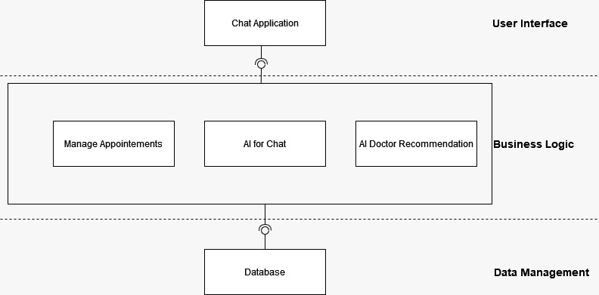This system is based around online services thus including the general login/signup requirements. It also supplies privacy control thus having such functionalities as well. This system is for stress detection with the help of chatbot and supplying physicians to patients whose detect depressed at large scale thus the functionalities and requirements are related towards it. This system is based on **Layered Architectural Design. First Layer** is **User Interface** for users, physicians, and admin whom they use for sending queries to **Second Layer**. It is **Business Logic Layer** where all the queries and their requests are executed. And the last layer is **Data Management Layer** where all the data is stored.

Figure 7 Architectural Design of Stress Detector Chatbot

Figure System Architecture Design

Figure Architectural Diagram

## Design methodology

For the proposed system, we will be using Object Oriented approach to manage datasets of multiple languages. The OOP approach will enable us to effectively communicate between different modules in our program, furthermore this method will ensure the proper and efficient use of programming with better understanding of the flow of programs.

## Data Representation

**JSON Schema:**

"physician": {“id”: {“description”: “The unique identifier for a product”, “type”: “integer”}, “name”: {“description": "Name of the physician", "type": "string”}, "Availability": {“type": "number", "minimum": 0}},

"required": ["id", "name", "Availability"]

"user": {“id": {"type": "integer”}, “name": {“description": "Name of the user", "type": "string”}, “email": {“type": "number", "minimum": 0}},

"required": ["id", " name ", " balance "]

"appointment": {“id": {"type": "integer”}, “physician id": {“description": "ID of the bidder", "type": "integer”}, “user id": {“type": "number", "minimum": 0}, “time”: {“description": "ID of the product", "type": "integer”}},

"required": [‘id”, “bidder”, “bid”, “product”]

**ER Diagram:**

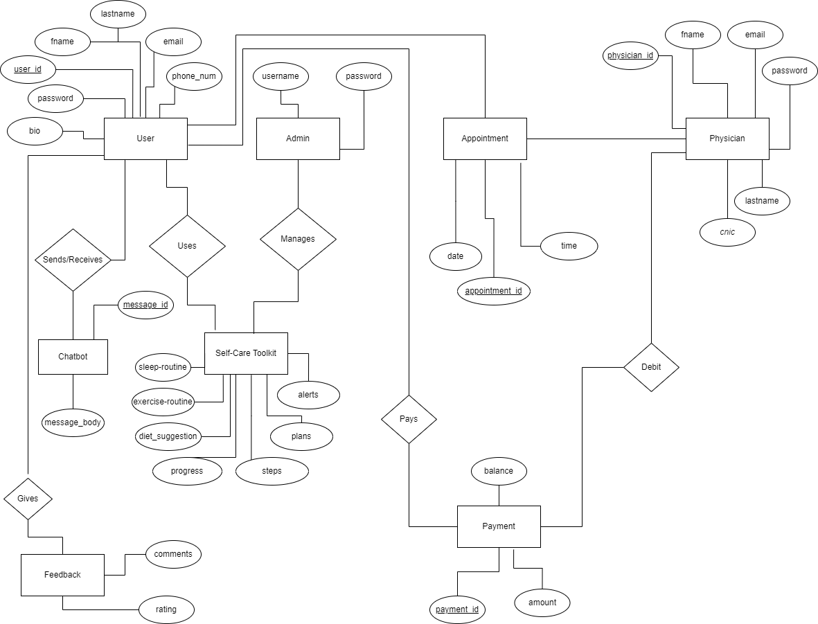

Figure ER Diagram of the Stress Detector Chatbot

## Design Models

Following is the design model of Centralized Online Auction System.

### Activity Diagram

Activity diagrams of Stress Detector Chatbot are shown below.

Figure Activity Diagram of Edit Profile

Figure Activity Diagram of Generate Prescription

Figure Activity Diagram of Subscription Package

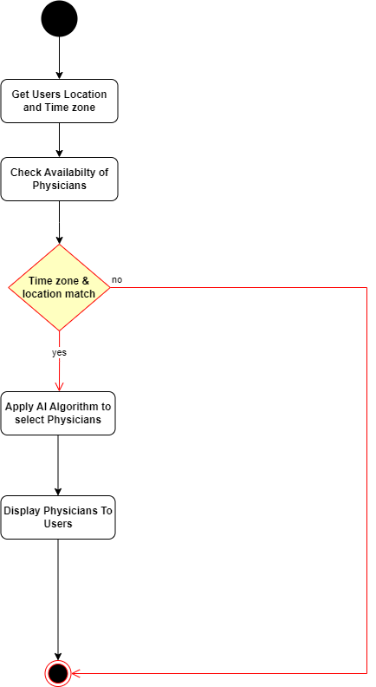

Figure Activity Diagram of Physician Suggestion

Figure Activity Diagram of Cancel Appointment

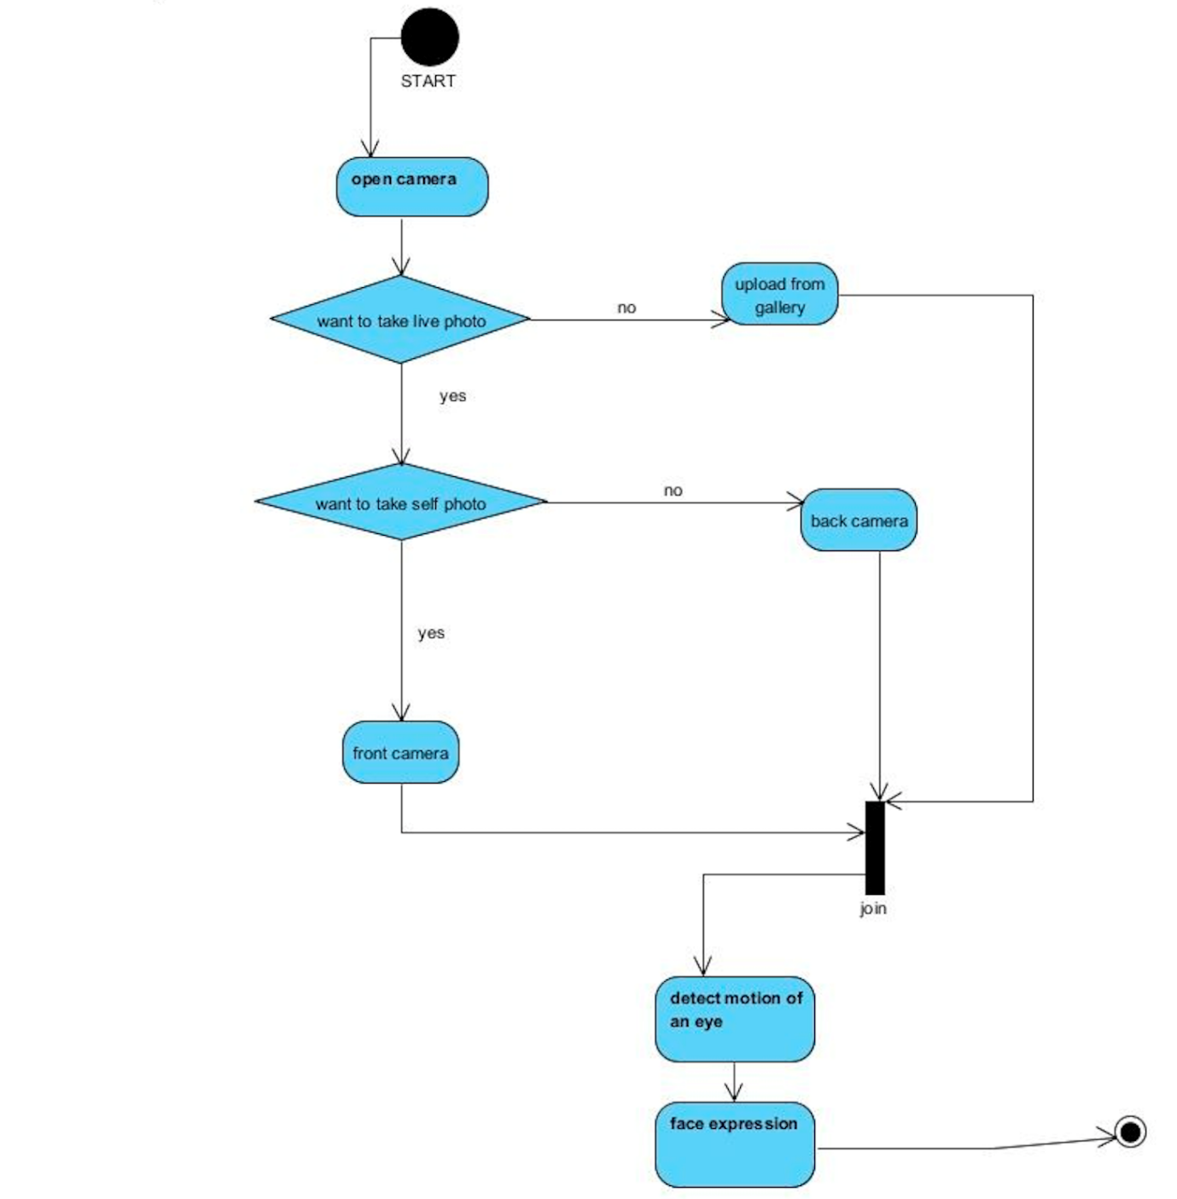

Figure Activity Diagram of Face Expression

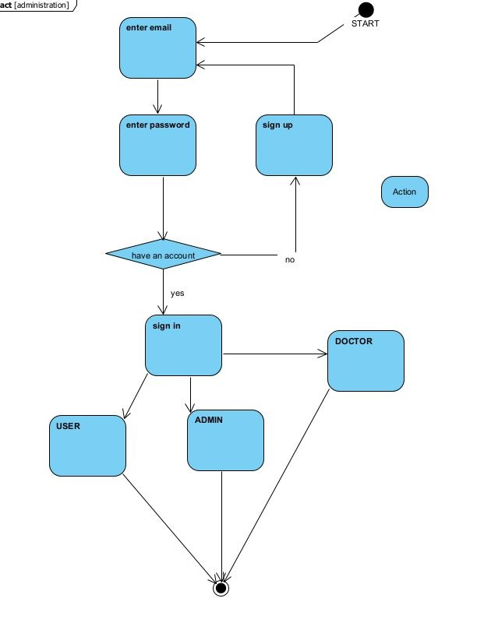

Figure Activity Diagram of Sign In/Sign up

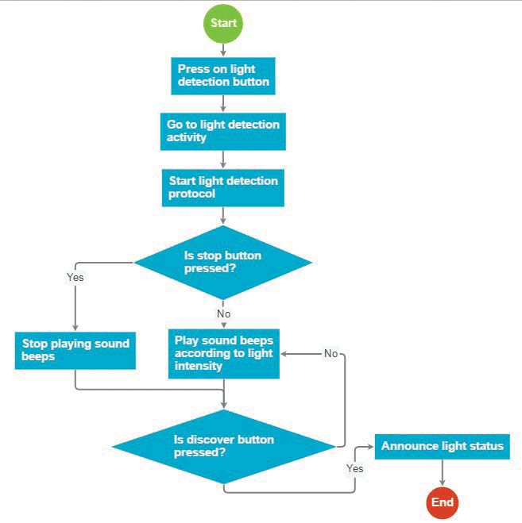

Figure Activity Diagram of Light Detection

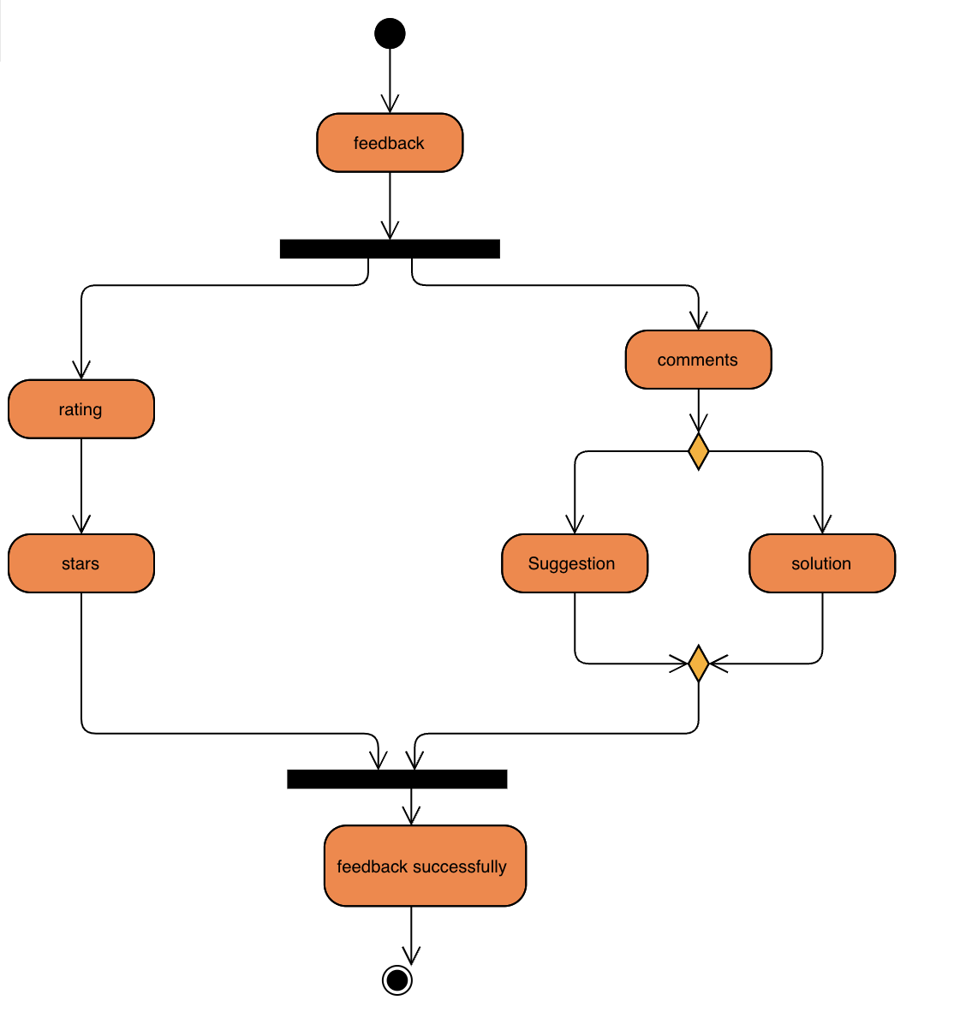

Figure Activity Diagram of Light Detection

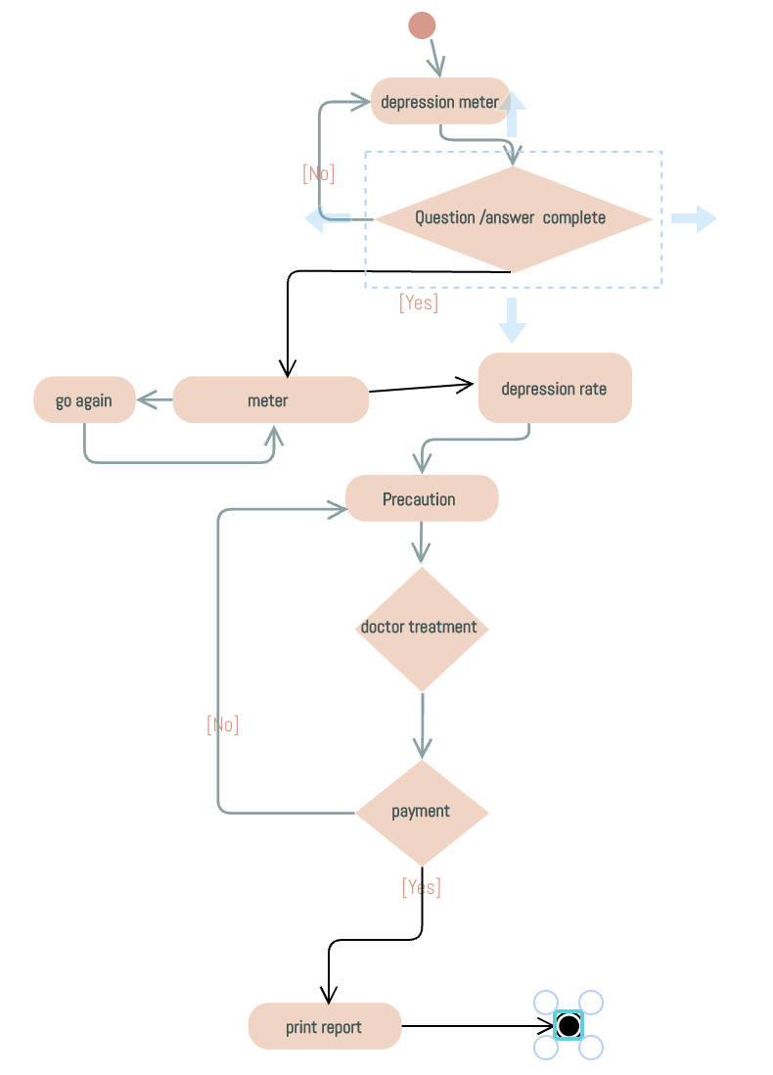

Figure Activity Diagram of Print Report

### Sequence Diagram

Sequence diagrams of Stress Detector Chatbot are shown below.

Figure Sequence Diagram of Physician Suggestion

Figure Sequence Diagram of Availability

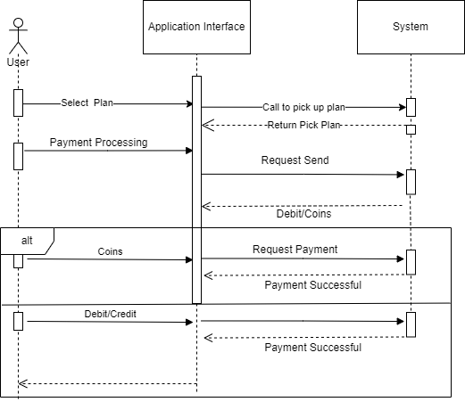

Figure Sequence Diagram of Payment

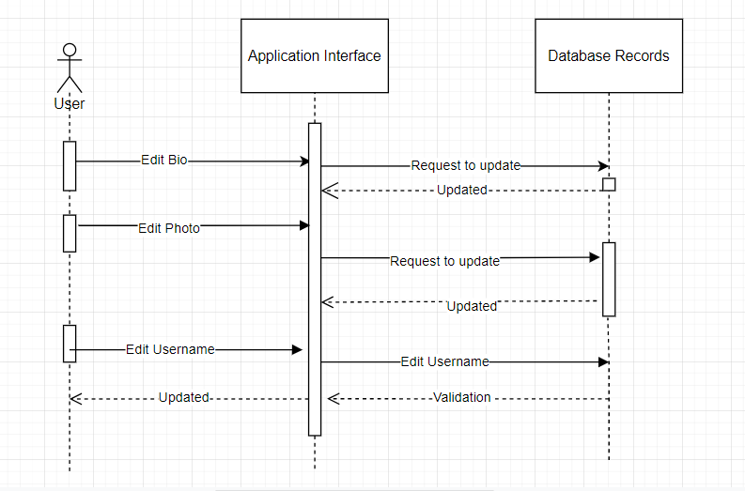

Figure Sequence Diagram of Edit Profile

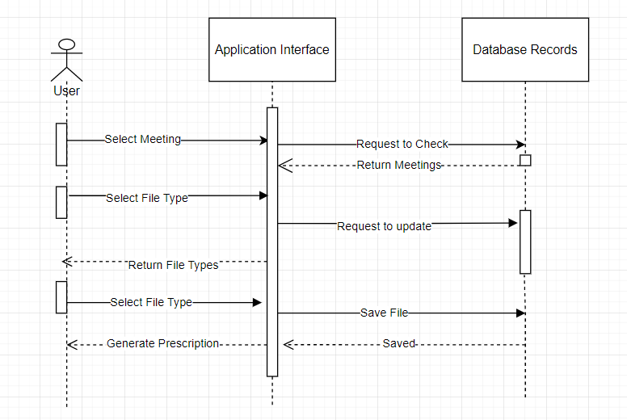

Figure Sequence Diagram of Generate Prescription

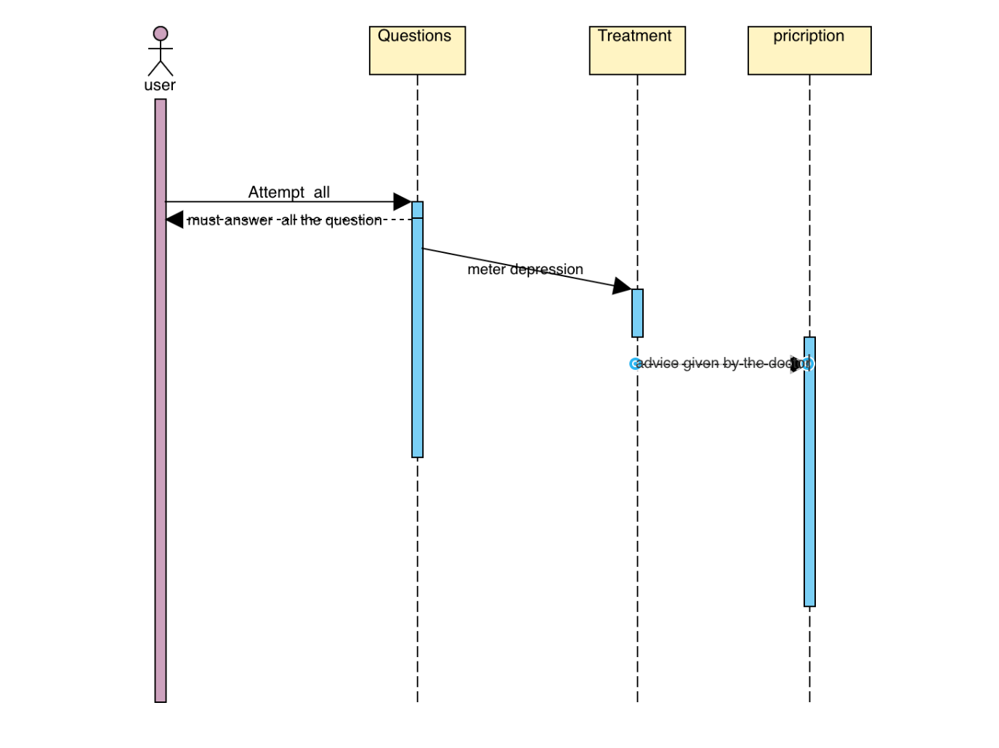

Figure Sequence Diagram of Quiz Attempt

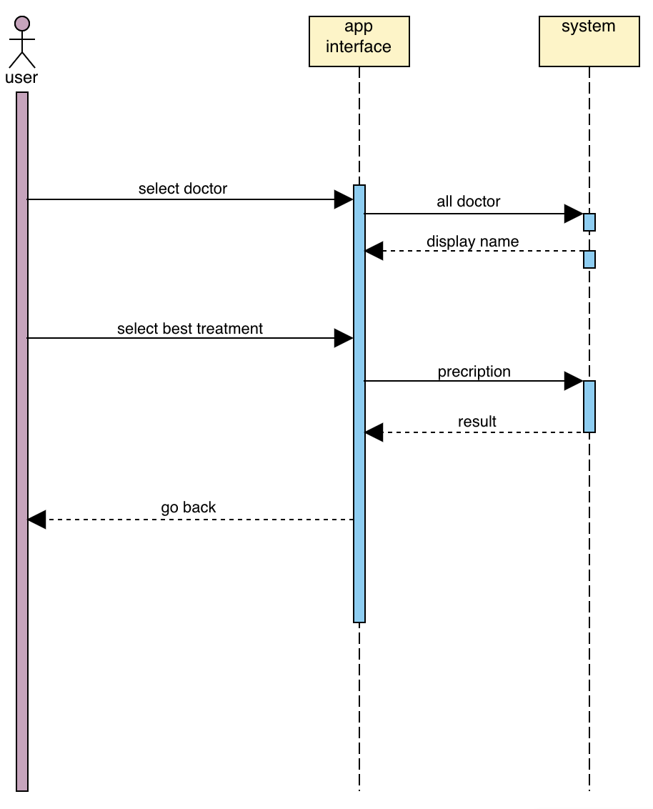

Figure Sequence Diagram of Appointment

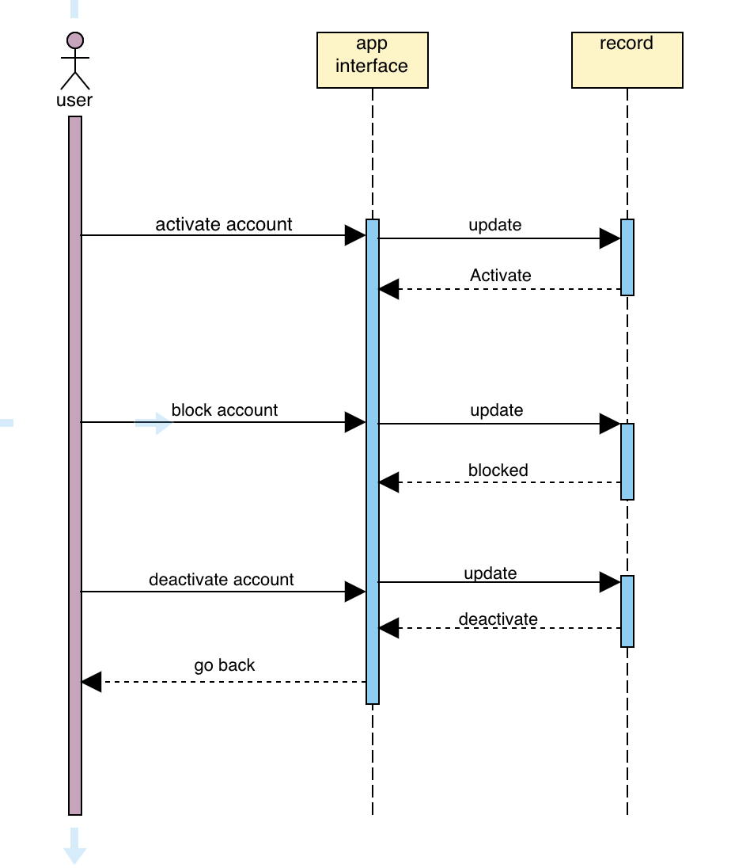

Figure Sequence Diagram of Deactivate Account

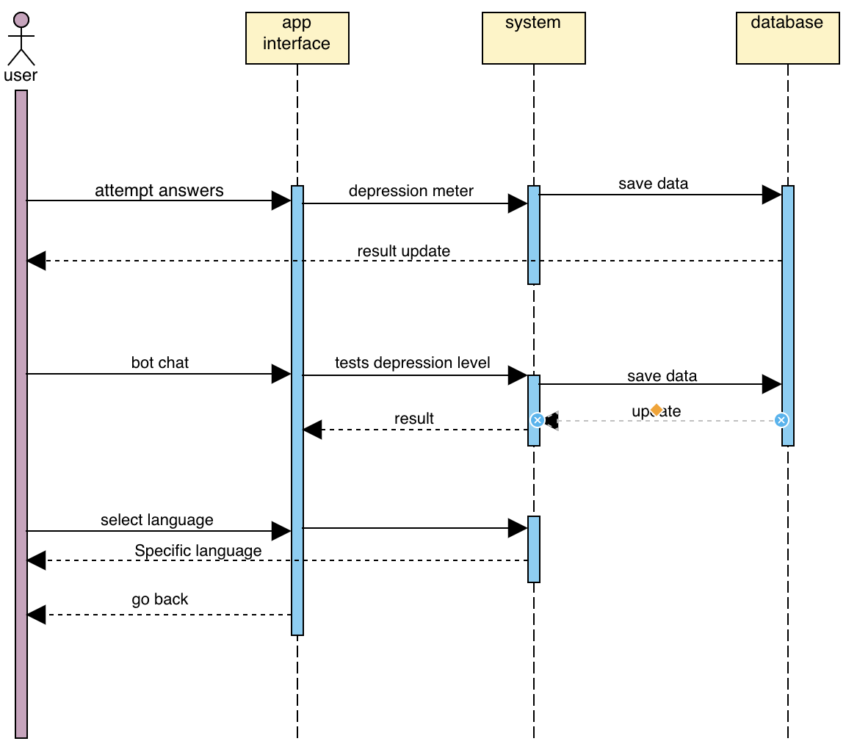

Figure Sequence Diagram of Texting with Chatbot

### Class Diagram

The class diagram of Stress Detector Chatbot is given below.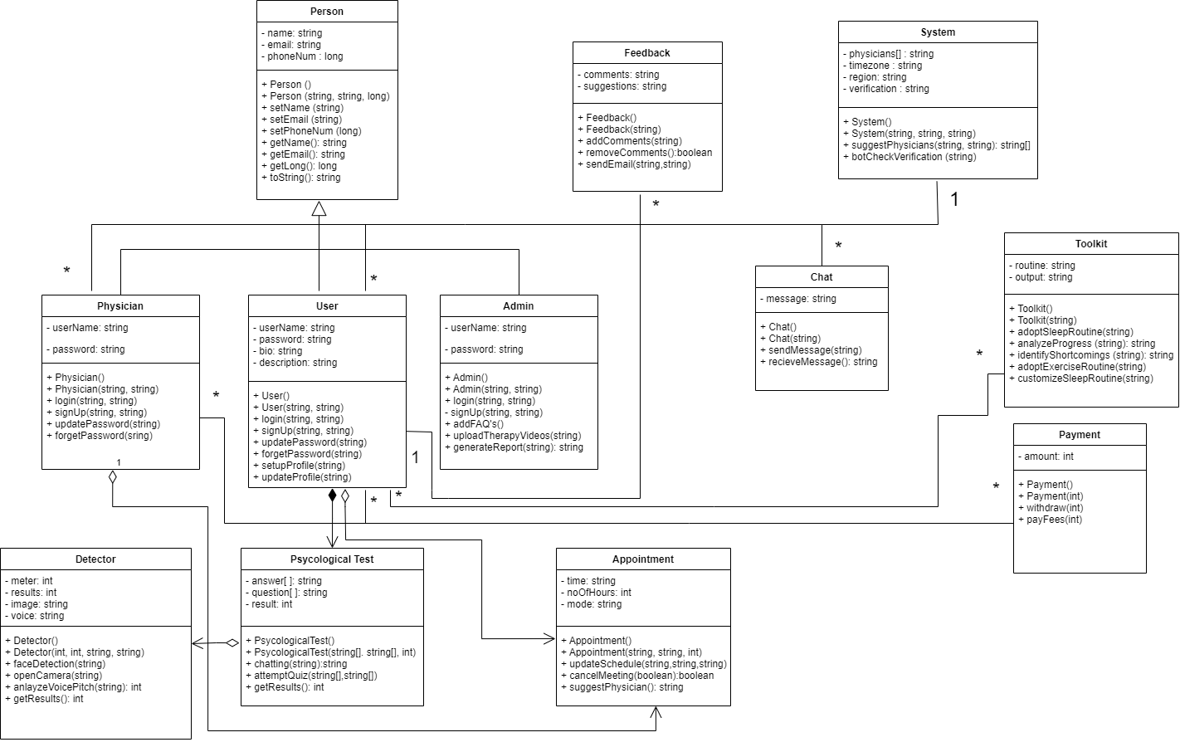

Figure Class of Stress Detector Chatbot

# Human Interface Design

The following are the human interface design of the system.

## Screen images

The following are the interfaces of the system.

Figure Chat Between user and Chatbot Web overview

Figure Chat between user and chatbot mobile overview

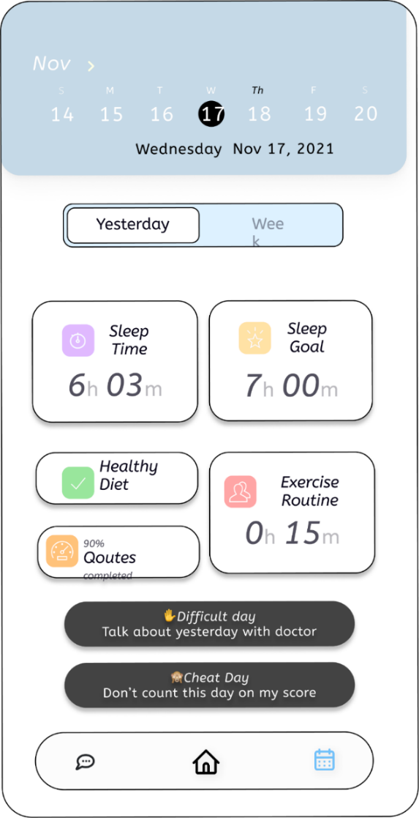

Figure Toolkit mobile overview

Figure Toolkit Web overview

## Screen objects and actions

The following is the explanation of screening object.

### Chatbot

In this system,screen defines that the user and chatbot interaction. During the whole texting, chatbot try to decide that the user is in depression or not. If it will decide then show results in the form of different modes.

### Self-Care Toolkit

The above screening object of toolkit supplies user an impressive experience about his/her daily life routines like sleep, exercise, and diet routines to make his/her life stress free. It will also allow user to customize their own plans to be followed.

# Implementation

Following is description of implementation of Stress Detector Chatbot.

**Muhammad Ahmad Raza (SP21-BCS-003):**

Following are the links for design, GitHub repository of web application and link to YouTube channel.

**Figma Design:**

Web: <https://www.figma.com/file/wUECibdM2UNk93A5oU7OVu/SignUp?node-id=0%3A1&t=ZNkoCbKDhFbNvfeB-0>

**GitHub Repository:**

Web: <https://github.com/MuhammadAhmadRaza087/Stress-Detector-Chatbot>

**Live Website Link:**

<https://stressdetectorchatbot.netlify.app/>

**YouTube Channel:**

<https://www.youtube.com/@khansology9669>

**Khan Sharjeel Khan (SP20-BCS-041):**

Following are the links for design, website, GitHub repository of app and link to YouTube channel.

**Figma Design:**

App: <https://www.figma.com/files/project/75756644/Team-project?fuid=1182741742193504178>

**GitHub Repository (Source Code):**

App: <https://github.com/sarmad129/quizApp>

**YouTube Channel:**

<https://www.youtube.com/@khansology9669>

## Algorithm

In this project we will use machine learning algorithm for suggestion of physicians to users, machine learning algorithms in recommender systems are typically classified into two categories — content based and collaborative filtering methods although modern recommenders combine both approaches. But in our case, we will use collaborative filtering.

### Collaborative Filtering

Collaborative filtering is a technique that can filter out items that a user might like because of reactions by similar users. It works by searching a large group of people and finding a smaller set of users with tastes like a particular user. It looks at the items they like and combines them to create a ranked list of suggestions.

### Natural Processing Language

Natural Language Processing (NLP) is part of everyday life, and it is essential to our lives at home and at work. Without giving it many thoughts, we send voice commands to our virtual home assistants, our smartphones, and even our vehicles. Voice-enabled applications such as Alexa, Siri, and Google Assistant use NLP and Machine Learning (ML) to answer our questions, add activities to our calendars and call the contacts that we say in our voice commands.

### Keyword Extraction

Keywords Extraction is one of the most important tasks in Natural Language Processing, and it is used for deciding various methods for extracting a considerable number of words and phrases from a collection of texts. All of this is done to summaries and aid in the relevant and well-organized organization, storage, search, and retrieval of content.

### Text Summarization

Text summarization can be done in two ways: extraction and abstraction. By cutting bits from the text, extraction methods create a rundown. Abstraction tactics produce summaries by constructing new text that conveys the essence of the original content.

**Suggestion System**

Figure Physician Suggestion Algorithm

## External API

External API used is described in the table below.

Table 163 External API Description

|  |  |  |  |
| --- | --- | --- | --- |
| **Name of API** | **Description of API** | **Purpose of Usage** | **List down the function/class name** |
| Tawk | Provide chat option for queries. Customer can contact system admin. | To improve user experience and ease, user can resolve any query by staying on website. | Called in script tag at bottom of concerned pages. |

## User Interface

Details of user interface are explained in the video link attached below.

<https://www.youtube.com/@khansology9669>

# Testing and Evaluation

The following are some testing techniques/criteria which we will use for testing this software.

## Verification

Verification is about the cycle being followed. We will appropriately dissect and check the means we are following of the predefined interaction.

## Validation

Every one of the functionalities of the modules that are talked about in this module will be tried according to prerequisite to see that the system will work appropriately.

## Usability Testing

Usability testing is finished by evaluating the system on the users or showed crowd. This testing gives out the thought how the genuine crowd or client will use the system.

## Module / Unit Testing

Unit testing is low level testing at useful level. In unit testing, the practical requirements of the system are checked. A unit is the littlest testable part of the system, and this kind of testing aids with evaluating every module independently

## Integration Testing

Integration testing plans to evaluate various pieces of systems together, to ensure they can coincide together. It is the testing of use instances of every module. It evaluates the whole usefulness of the system.

## System Testing

System testing empowers the analyzers to guarantee that the system meets business prerequisite just as it moves along as planned. It is fundamentally the testing of modules of the system. A substantial portion of the equipment and software compatibility issues are revealed during this testing. It ensures that the system works appropriately as planned.

## Acceptance Testing

It confirms that the conveyed system meets client's requirements, and the system is fit to be used in genuine world. There are two kinds of client acknowledgment testing, alpha testing in which the organization evaluates the system. The later one is beta testing in which the system is evaluate in customer's current circumstance.

## Test Cases

Following are the test cases for testing the functionality of Centralized Online Auction System.

**Table 163: Test Case of Sign up**

|  |  |  |  |
| --- | --- | --- | --- |
| **Test Id:** | TC-2.1.1 | **Test Case Designed by:** | Muhammad Ahmad Raza |
| **Test Case Title:** | Sign-up | **Test Case Executed by:** | Khan Sharjeel Khan |
| **Module Name:** | User Profiling | **Test Case Execution Date:** | 22-12-2022 |
| **Test Data:** | User’s Sign-up credentials. | **Priority:** | High |
| **Precondition:** | | User must have valid email address.  User must have a valid Account | |
| **Steps /Action**   1. Select Sign-up option. 2. Enter name. 3. Enter Account Number 4. Enter email. 5. Enter password. 6. Confirm Password. 7. Click on the “Sign-up” button. | | **System Response**   1. System will open the Sign-up page. 2. System will display the text field for user to enter the name, email, and password. 3. After verification, the system should register the user. | |
| **Expected Result** | | After providing the valid information user should be registered. | |
| **Actual Result** | | After providing the valid information user will be successfully registered. | |
| **Status** | | Pass. | |

**Table 164: Test Case of Login**

|  |  |  |  |
| --- | --- | --- | --- |
| **Test Id:** | TC-2.2.2 | **Test Case Designed by:** | Muhammad Ahmad Raza |
| **Test Case Title:** | Log in | **Test Case Executed by:** | Khan Sharjeel Khan |
| **Module Name:** | User Profiling | **Test Case Execution Date:** | 22-12-2022 |
| **Test Data:** | User’s Log-in credentials. | **Priority:** | High |
| **Precondition:** | | User must have valid email address. | |
| **Steps /Action**   1. Select Log-in choice. 2. Enter username/ email. 3. Enter password. 4. Enter OTP 5. Click on the “Log-in” button. | | **System Response**   1. System will open the Log-in page. 2. System will display the text field for user to enter the name, email, and password. 3. System sends a One Time Password to verify user 4. After verification, the system should register the user. | |
| **Expected Result:** | | After providing the valid information user should be logged in. | |
| **Actual Result:** | | After providing the valid information user will be successfully logged in. | |
| **Status:** | | Pass. | |

**Table 165: Test Case of Forgot Password**

|  |  |  |  |
| --- | --- | --- | --- |
| **Test Id:** | TC-2.3.3 | **Test Case Designed by:** | Muhammad Ahmad Raza |
| **Test Case Title:** | Forgot password | **Test Case Executed by:** | Khan Sharjeel Khan |
| **Module Name:** | User Profiling | **Test Case Execution Date:** | 22-12-2022 |
| **Test Data:** | Forgot password | **Priority:** | High |
| **Precondition:** | | User must enter in app/web. | |
| **Steps /Action**  1. Select forgot username choice.   1. User will select option to send code through email or number. 2. User will enter that specific code. 3. User receives OTP and enters 4. User will be shown a reset username option. 5. User will enter new username and then confirm it. 6. User will click on change username. | | **System Response**   1. System will open reset username the page. 2. System will display the options to enter email or number to reset username. 3. System sends a One Time Password to verify user 4. After verification, the system should reset the username of the user. | |
| **Expected Result:** | | After providing the valid information the username of the user should be reset. | |
| **Actual Result:** | | After providing the valid information user’s username will be successfully reset. | |
| **Status:** | | Pass. | |

**Table 166: Test Case of Delete Profile**

|  |  |  |  |
| --- | --- | --- | --- |
| **Test Id:** | TC-2.4.4 | **Test Case Designed by:** | Muhammad Ahmad Raza |
| **Test Case Title:** | Delete Profile | **Test Case Executed by:** | Khan Sharjeel Khan |
| **Module Name:** | User Profiling | **Test Case Execution Date:** | 22-12-2022 |
| **Test Data:** | Delete user’s credentials. | **Priority:** | High |
| **Precondition:** | | User must have valid email address. | |
| **Steps /Action**  1. Select Log-in choice.   1. Enter username/ email/ phone number. 2. Enter valid PIN. 3. Enter password. 4. Enter OTP 5. Click on the “Delete Profile” button. | | **System Response**   1. System will open the Log-in page. 2. System will display the text field for user to enter the name, email, and password. 3. System sends a One Time Password to verify user 4. After verification, the system should register the user. 5. Then click cut profile and account should be cut | |
| **Expected Result:** | | After providing the valid information user should be deleted. | |
| **Actual Result:** | | After providing the valid information user will be successfully deleted. | |
| **Status:** | | Pass. | |

**Table 167: Test Case of Upload Picture**

|  |  |  |  |
| --- | --- | --- | --- |
| **Test Id:** | TC-2.5.5 | **Test Case Designed by:** | Muhammad Ahmad Raza |
| **Test Case Title:** | Upload picture | **Test Case Executed by:** | Khan Sharjeel Khan |
| **Module Name:** | User Profiling | **Test Case Execution Date:** | 22-12-2022 |
| **Test Data:** | User’s diagram data. | **Priority:** | High |
| **Precondition:** | | User should have a valid account | |
| **Steps /Action**   1. Select upload pic tab from menu of update profile. 2. Select upload file. 3. Dialogue box shows the pics and select one. | | **System Response**   1. System will open the “upload pic” page. 2. System will display the options to upload pic type. 3. After selecting pic, the system imports the file | |
| **Expected Result:** | | After selecting the valid format file from the system it should be imported. | |
| **Actual Result:** | | After selecting the valid format file from the system it will be imported. | |
| **Status:** | | Pass. | |

**Table 168: Test Case of Sign up**

|  |  |  |  |
| --- | --- | --- | --- |
| **Test Id:** | TC-5.1.1 | **Test Case Designed by:** | Muhammad Ahmad Raza |
| **Test Case Title:** | Generate Charts/Graphs/Figures | **Test Case Executed by:** | Khan Sharjeel Khan |
| **Module Name:** | Self-Care Toolkit | **Test Case Execution Date:** | 22-12-2022 |
| **Test Data:** | Generate Charts/Graphs/Figures in pdf format | **Priority:** | High |
| **Precondition:** | | User should have a valid account | |
| **Steps /Action**   1. Select analyze progress tab from menu of main menu. 2. Select generate the respective format. 3. Click on the generate reports. 4. Click on the respective directory where you want to save file. | | **System Response**   1. System will get the format. 2. System will generate the report of user’s demand. 3. System will display the report of user’s demand. 4. System will get the directory from user. 5. System will save the report. 6. System will show the success message. | |
| **Expected Result:** | | After selecting the valid format file from the system it should be generated and saved. | |
| **Actual Result:** | | After selecting the valid format file from the system it will be generated and saved. | |
| **Status:** | | Pass. | |

**Table 169: Test Case of Generate Shortcomings**

|  |  |  |  |
| --- | --- | --- | --- |
| **Test Id:** | TC-5.2.2 | **Test Case Designed by:** | Muhammad Ahmad Raza |
| **Test Case Title:** | Generate Shortcomings Report | **Test Case Executed by:** | Khan Sharjeel Khan |
| **Module Name:** | Self-Care Toolkit | **Test Case Execution Date:** | 22-12-2022 |
| **Test Data:** | Generate Charts/Graphs/Figures in pdf format | **Priority:** | High |
| **Precondition:** | | User should have a valid account. | |
| **Steps /Action**   1. Select generate shortcomings tab from menu of main menu. 2. Select generate the respective format. 3. Click on the generate reports. 4. Click on the respective directory where you want to save file. | | **System Response**   1. System will get the format. 2. System will generate the report of user’s demand. 3. System will display the report of user’s demand. 4. System will get the directory from user. 5. System will save the report. 6. System will show the success message. | |
| **Expected Result:** | | After selecting the valid format file from the system it should be generated and saved. | |
| **Actual Result:** | | After selecting the valid format file from the system it will be generated and saved. | |
| **Status:** | | Pass. | |

**Table 170: Test Case of Sleep Routine**

|  |  |  |  |
| --- | --- | --- | --- |
| **Test Id:** | TC-5.3.3 | **Test Case Designed by:** | Muhammad Ahmad Raza |
| **Test Case Title:** | Sleep Routine | **Test Case Executed by:** | Khan Sharjeel Khan |
| **Module Name:** | Self-Care Toolkit | **Test Case Execution Date:** | 22-12-2022 |
| **Test Data:** | Select one of the sleep routines from given routines. | **Priority:** | High |
| **Precondition:** | | User should have a valid account. | |
| **Steps /Action**   1. Select sleep routine tab from menu of self-care toolkit. 2. Select the respective sleep routine from the given routines. 3. Select the notification settings to get notifications. | | **System Response**   1. System will display all the healthy routines to users. 2. System will get the selected routine and save it in the database. 3. System will ring notification by following the selected routine. | |
| **Expected Result:** | | After selecting the routine from the given routines system should ring the notification according to respective routine. | |
| **Actual Result:** | | System will be punctual and followed the respective routine. | |
| **Status:** | | Pass. | |

**Table 171: Test Case of Exercise Routine**

|  |  |  |  |
| --- | --- | --- | --- |
| **Test Id:** | TC-5.4.4 | **Test Case Designed by:** | Muhammad Ahmad Raza |
| **Test Case Title:** | Exercise Routine | **Test Case Executed by:** | Khan Sharjeel Khan |
| **Module Name:** | Self-Care Toolkit | **Test Case Execution Date:** | 22-12-2022 |
| **Test Data:** | Select one of the exercise routines from given routines. | **Priority:** | High |
| **Precondition:** | | User should have a valid account. | |
| **Steps /Action**   1. Select exercise routine tab from menu of self-care toolkit. 2. Select the respective exercise routine from the given routines. 3. Select the notification settings to get notifications. | | **System Response**   1. System will display all the healthy routines to users. 2. System will get the selected routine and save it in the database. 3. System will ring notification by following the selected routine. | |
| **Expected Result:** | | After selecting the routine from the given routines system should ring the notification according to respective routine. | |
| **Actual Result:** | | System will be punctual and followed the respective routine. | |
| **Status:** | | Pass. | |

Table 172: Test Case of Diet Schedule

|  |  |  |  |
| --- | --- | --- | --- |
| **Test Id:** | TC-5.5.5 | **Test Case Designed by:** | Muhammad Ahmad Raza |
| **Test Case Title:** | Healthy Diet Schedule | **Test Case Executed by:** | Khan Sharjeel Khan |
| **Module Name:** | Self-Care Toolkit | **Test Case Execution Date:** | 22-12-2022 |
| **Test Data:** | Select one of the  diet schedule from given schedules. | **Priority:** | High |
| **Precondition:** | | User should have a valid account. | |
| **Steps /Action**   1. Select diet schedule tab from menu of self-care toolkit. 2. Select the respective diet schedule from the given schedule. 3. Select the notification settings to get notifications. | | **System Response**   1. System will display all the healthy diet schedule to users. 2. System will get the selected schedule and save it in the database. 3. System will ring notification by following the selected schedule. | |
| **Expected Result:** | | After selecting the routine from the given routines system should ring the notification according to respective routine. | |
| **Actual Result:** | | System will be punctual and followed the respective routine. | |
| **Status:** | | Pass. | |

**Table 173: Test Case of Suggest Physician**

|  |  |  |  |
| --- | --- | --- | --- |
| **Test Id:** | TC-6.1.1 | **Test Case Designed by:** | Muhammad Ahmad Raza |
| **Test Case Title:** | Suggest Physician | **Test Case Executed by:** | Khan Sharjeel Khan |
| **Module Name:** | Appointment Management | **Test Case Execution Date:** | 22-12-2022 |
| **Test Data:** | Select one of the  diet schedule from given schedules. | **Priority:** | High |
| **Precondition:** | | * User should had entered correct region. * Physician should have entered his region and already set his availability. | |
| **Steps /Action**   1. User will have entered his region and time zone correctly on the time of account creation. | | **System Response**   1. System will go and pick time zone and region details of both user and physician. 2. System will get selected physician. 3. System will display the suggested physician to the users on the home screen. | |
| **Expected Result:** | | Physician will be shown on the screen. | |
| **Actual Result:** | | Physician will be shown on the screen. | |
| **Status:** | | Pass. | |

**Table 174: Test Case of Schedule Meeting**

|  |  |  |  |
| --- | --- | --- | --- |
| **Test Id:** | TC-6.2.2 | **Test Case Designed by:** | Muhammad Ahmad Raza |
| **Test Case Title:** | Schedule Meeting | **Test Case Executed by:** | Khan Sharjeel Khan |
| **Module Name:** | Appointment Management | **Test Case Execution Date:** | 22-12-2022 |
| **Test Data:** | Schedule meeting with physician | **Priority:** | High |
| **Precondition:** | | * User should validly account and login. | |
| **Steps /Action**   1. User will select the time of meeting. 2. User will select the mode of meeting. 3. User will select the physician and send request to physician. 4. Physician will accept the meeting. | | **System Response**   1. System will go and pick time zone and region details of both user and physician. 2. System will get selected physician. 3. System will take request from user and send it to specific physician. 4. System will be scheduled meeting successfully. | |
| **Expected Result:** | | System will be schedule meeting successfully. | |
| **Actual Result:** | | System will be scheduled meeting successfully. | |
| **Status:** | | Pass. | |

**Table 175: Test Case of Cancel Meeting**

|  |  |  |  |
| --- | --- | --- | --- |
| **Test Id:** | TC-6.3.3 | **Test Case Designed by:** | Muhammad Ahmad Raza |
| **Test Case Title:** | Cancel Meeting | **Test Case Executed by:** | Khan Sharjeel Khan |
| **Module Name:** | Appointment Management | **Test Case Execution Date:** | 22-12-2022 |
| **Test Data:** | Cancel meeting with physician | **Priority:** | High |
| **Precondition:** | | * User should validly account and login. * User have already scheduled meeting with respective physician. | |
| **Steps /Action**   1. User will select the meeting. 2. User will select the physician and send request to physician for cancel meeting. 3. Physician will accept the cancel meeting request. | | **System Response**   1. System will go and pick time zone and region details of both user and physician. 2. System will get selected physician. 3. System will take request from user and send it to specific physician. 4. System will be cancelled meeting successfully. 5. System will also cut balance from user account. 6. System will send payment to physician. | |
| **Expected Result:** | | Meeting will be cancelled successfully. | |
| **Actual Result:** | | Meeting will be cancelled successfully. | |
| **Status:** | | Pass. | |

**Table 176: Test Case of Update Meeting Details**

|  |  |  |  |
| --- | --- | --- | --- |
| **Test Id:** | TC-6.4.4 | **Test Case Designed by:** | Muhammad Ahmad Raza |
| **Test Case Title:** | Update meeting details | **Test Case Executed by:** | Khan Sharjeel Khan |
| **Module Name:** | Appointment Management | **Test Case Execution Date:** | 22-12-2022 |
| **Test Data:** | Update meeting details | **Priority:** | High |
| **Precondition:** | | * User should validly account and login. * User have already scheduled meeting with respective physician. | |
| **Steps /Action**   1. User will select the meeting. 2. User will select the physician and send request to physician for update meeting details. 3. User will also select the details to be updated. 4. Physician will accept the update meeting request if these are possible to his/her. | | **System Response**   1. System will go and pick time zone and region details of both user and physician. 2. System will get selected physician. 3. System will take request from user and send it to specific physician. 4. System will be updated meeting successfully. | |
| **Expected Result:** | | Meeting details will be updated successfully. | |
| **Actual Result:** | | Meeting details will be updated successfully. | |
| **Status:** | | Pass. | |

**Table 177: Test Case of Subscription Package**

|  |  |  |  |
| --- | --- | --- | --- |
| **Test Id:** | TC-6.5.5 | **Test Case Designed by:** | Muhammad Ahmad Raza |
| **Test Case Title:** | Subscription package | **Test Case Executed by:** | Khan Sharjeel Khan |
| **Module Name:** | Appointment Management | **Test Case Execution Date:** | 22-12-2022 |
| **Test Data:** | Subscription package | **Priority:** | High |
| **Precondition:** | | * User should validly account and login. * Physicians already set packages for users. | |
| **Steps /Action**   1. User will select the meeting. 2. User will select the required subscription package. 3. User will pay for the respective package. 4. Physicians will be notified for the subscription. | | **System Response**   1. System will subscribe the required package and store info about it in database. 2. System will perform payment action and added payment to the physician account. 3. System will also cut taxes on every subscription. | |
| **Expected Result:** | | Subscription will be updated successfully. | |
| **Actual Result:** | | Subscription will be updated successfully. | |
| **Status:** | | Pass. | |

**Table 178: Test Case of See Recent Activities**

|  |  |  |  |
| --- | --- | --- | --- |
| **Test Id:** | TC-7.1.1 | **Test Case Designed by:** | Muhammad Ahmad Raza |
| **Test Case Title:** | See recent activities | **Test Case Executed by:** | Khan Sharjeel Khan |
| **Module Name:** | Activity | **Test Case Execution Date:** | 22-12-2022 |
| **Test Data:** | User will see recent activities | **Priority:** | High |
| **Precondition:** | | * User should validly account and login. * User will already have performed any type of stress detection activity. | |
| **Steps /Action**   1. User will select the see recent activities option from activity menu bar. 2. User will select the required activity to be seen for analysis. | | **System Response**   1. System will display all the recent activities by getting from database of that respective user. 2. System will open the selected activity to the screen of the user. | |
| **Expected Result:** | | User will be able to see their recent activities. | |
| **Actual Result:** | | User will be able to see their recent activities. | |
| **Status:** | | Pass. | |

**Table 179: Test Case of Compare Activities**

|  |  |  |  |
| --- | --- | --- | --- |
| **Test Id:** | TC-7.2.2 | **Test Case Designed by:** | Muhammad Ahmad Raza |
| **Test Case Title:** | Compare activities | **Test Case Executed by:** | Khan Sharjeel Khan |
| **Module Name:** | Activity | **Test Case Execution Date:** | 22-12-2022 |
| **Test Data:** | User will be able to compare activities. | **Priority:** | High |
| **Precondition:** | | * User should validly account and login. * User will already have performed any type of stress detection activity. | |
| **Steps /Action**   1. User will select the compare recent activities option from activity menu bar. 2. User will select the required activity to be seen for analysis after comparing. | | **System Response**   1. System will display all the recent activities by getting from database of that respective user. 2. System will open the selected activities to the screen of the user. 3. System will compare both. 4. System will display comparison. | |
| **Expected Result:** | | User will be able to see their recent activities comparison. | |
| **Actual Result:** | | User will be able to see their recent activities comparison. | |
| **Status:** | | Pass. | |

Table 180: Test Case of Generate Report

|  |  |  |  |
| --- | --- | --- | --- |
| **Test Id:** | TC-7.3.3 | **Test Case Designed by:** | Muhammad Ahmad Raza |
| **Test Case Title:** | Generate Report | **Test Case Executed by:** | Khan Sharjeel Khan |
| **Module Name:** | Activity | **Test Case Execution Date:** | 12-12-2022 |
| **Test Data:** | No data | **Priority:** | High |
| **Precondition:** | | * User is logged in. | |
| **Steps /Action**  1. Click on generate Report  2. System display “Report” Screen  3. Select activities who report to be generated.  4. Enter start time.  5. Enter end time. | | **System Response**  1. System start working  2. System display “Generate Reports” screen successfully  3. System gets the time from and to for report generation.  4. System display “Report” screen successfully  5. System display success message. | |
| **Expected Result:** | | After execution, report should be displayed, and success message should be displayed. | |
| **Actual Result:** | | After execution, report is displayed, and success message is displayed. | |
| **Status:** | | Pass | |

**Table 181: Test Case of Manage Appointments**

|  |  |  |  |
| --- | --- | --- | --- |
| **Test Id:** | TC-7.4.4 | **Test Case Designed by:** | Muhammad Ahmad Raza |
| **Test Case Title:** | Manage Appointment | **Test Case Executed by:** | Khan Sharjeel Khan |
| **Module Name:** | Appointment Management | **Test Case Execution Date:** | 22-12-2022 |
| **Test Data:** | Activity | **Priority:** | High |
| **Precondition:** | | * User should validly account and login. * User have already scheduled meeting with respective physician. | |
| **Steps /Action**   1. User will select the meeting. 2. User will select the physician and send request to physician for update meeting details. 3. User will also select the details to be updated. 4. Physician will accept the update meeting request if these are possible to his/her. | | **System Response**   1. System will go and pick time zone and region details of both user and physician. 2. System will get selected physician. 3. System will take request from user and send it to specific physician. 4. System will be updated meeting successfully. | |
| **Expected Result:** | | Meeting details will be updated successfully. | |
| **Actual Result:** | | Meeting details will be updated successfully. | |
| **Status:** | | Pass. | |

**Table 182: Test Case of Generate Prescription**

|  |  |  |  |
| --- | --- | --- | --- |
| **Test Id:** | TC-7.5.5 | **Test Case Designed by:** | Muhammad Ahmad Raza |
| **Test Case Title:** | Generate Prescription | **Test Case Executed by:** | Khan Sharjeel Khan |
| **Module Name:** | Activity | **Test Case Execution Date:** | 12-12-2022 |
| **Test Data:** | No data | **Priority:** | High |
| **Precondition:** | | Admin is logged in. | |
| **Steps /Action**  1. Click on generate prescription.  2. System display “Report” Screen.  3. Select meeting who report to be generated.  4.Select format in which report will be generated. | | **System Response**  1. System start working  2. System display “Generate Prescription” screen successfully  3. System gets the time from and to for report generation.  4. System display “Report” screen successfully  5. System display success message. | |
| **Expected Result:** | | After execution, report should be displayed, and success message should be displayed. | |
| **Actual Result:** | | After execution, report is displayed, and success message is displayed. | |
| **Status:** | | Pass | |

**Table 183: Test Case of Payment**

|  |  |  |  |
| --- | --- | --- | --- |
| **Test Id:** | TC-1.3.2 | **Test Case Designed by:** | Muhammad Ahmad Raza |
| **Test Case Title:** | Payment | **Test Case Executed by:** | Khan Sharjeel Khan |
| **Module Name:** | Payment Generation | **Test Case Execution Date:** | 22-12-2022 |
| **Test Data:** | Report Number | **Priority:** | High |
| **Precondition:** | | User should have a report for the Payment | |
| **Steps /Action**   1. User is logged In 2. Have registered for the report. 3. User Proceeds to pay the dues with invalid Payment credentials. | | **System Response**   1. System Shows an alert of Successful or Unsuccessful Payment | |
| **Expected Result:** | | User is Shown an alert. | |
| **Actual Result:** | | System will show an alert of unsuccessful payment. | |
| **Status:** | | Pass. | |

**Table 184: Test Case of Camera Test**

|  |  |  |  |
| --- | --- | --- | --- |
| **Test Id:** | TC-1.3.2 | **Test Case Designed by:** | Muhammad Ahmad Raza |
| **Test Case Title:** | Camera Test | **Test Case Executed by:** | Khan Sharjeel Khan |
| **Module Name:** | Detect Eye’s Motion | **Test Case Execution Date:** | 22-12-2022 |
| **Test Data:** |  | **Priority:** | High |
| **Precondition:** | | User shall have valid account | |
| **Steps /Action**   1. User is logged In 2. User Have granted the app to use the camera. | | **System Response**   1. System Opens the camera. 2. User tracks the Eye Direction. 3. User can see the image captured by the System | |
| **Expected Result:** | | User can capture the image of the eye. | |
| **Actual Result:** | | System will show the image of the eye to the user. | |
| **Status:** | | Pass. | |

## Automated Testing:

The following are the automated testing tools which we used to test this application.

**Table 185: Automated Testing Tool Names**

|  |  |  |  |
| --- | --- | --- | --- |
| **Tool Name** | **Tool Description** | **Applied on [list of Results related test cases / FR / NFR]** | **Results** |
| Selenium | It is an open-source web browser automation tool used for test scripts. | Login, Signup, Bid | Pass |

## Environmental Needs

Environmental needs are as follows:

* Reliable internet connection is required of at least 100 KB/s.
* Android phone running Android 7 or above and iOS devices running iOS 12 or above are needed for smartphone app.
* Modern Web Browser with Chromium web engine are needed for the web app.

**Table 185: Environmental Needs for Stress Detection Chatbot**

|  |  |
| --- | --- |
| **Browser** | **Supported Versions** |
| Microsoft Edge for Windows ten | 88 |
| Google Chrome | 88 |
| Safari | 14 |
| Firefox | 84 |
| Internet Explorer | 11 |

# Conclusion and Future Work

Every one of the modules with their utilization cases and partial necessities are tried accurately so the data in this document is altogether confirmed and the stakeholders of the project will get the idea what the venture is and what it will do.

## Conclusion

We proposed a Depression Detector Chat Bot for sensing negative emotions using AI algorithms by chatting with them. There is many comparable software that are providing these services, but we are going to provide therapy services as well online or offline according to users’ demand. We are also providing a self-care toolkit for users which help them to improve their mental as well as physical conditions. In our future work, we will consider users privacy and improve our privacy policy according to users’ demand.

## Future Work

Improving the way for online appointment can add good value to this system and work on it can be done in future. Making application faster and more system independent as of now it might be not equally good all systems. Also adding a better feedback system can improve this software.

# Work Summary and Reviews

The reviews, lessons learnt, and work distribution is mentioned below.

## Lesson Learnt

The lesson learnt are in the table below.

Table 186 Lesson Learnt for the course project

|  |  |
| --- | --- |
|  | **Lesson Learned** |
| Khan Sharjeel Khan (SP20-BCS-041) | The following are the lessons which learnt.   * How to manage work in specific time. * How to handle pressure management. * What software engineering concept is meant to be. * React-native, Documentation, Implementation, Life cycle of the software, Model handling. * How to properly use GitHub new tool and technologies like Figma. |
| Muhammad Ahmad Raza (SP21-BCS-003) | The lesson learnt during this course are as follows.   * The main thing which I learnt during this project was pressure handling. * I managed to complete my assignments before time. * I also learnt patience through this assignment. * I also managed to do maximum things myself. * I learnt about machine learning and artificial intelligence. * I also learnt documentation of software that help us a lot in future life. * I learnt how to properly use GitHub. * I learnt how to use MS Word. * I learnt how to use MS PowerPoint. * I learnt how to use MS Excel. * This course taught me about software life cycle in real life industry. * I also explore a lot of new tool and technologies like Figma, pencil, selenium, Junit, etc. |

## Work Break Down

Following is the description of work break down.

Table 189 Work Break down of individual student for each milestone.

|  |  |  |
| --- | --- | --- |
| **Milestones** | **Khan Sharjeel Khan**  **SP20-BCS-040** | **Muhammad Ahmad Raza**  **SP21-BCS-003** |
| 1. SCOPE Document and SCOPE presentation | Module1, Module3, Module4, Module 7  App Development | Module2, Module5-Module7  Website Development |
| 1. SRS Document and SRS Presentation | Module1, Module3, Module4, Module 7  Use cases and FR for these modules | Module2, Module5-Module7  Use cases and FR for these modules |
| 1. SDS Document and SDS Presentation | Module1, Module3, Module4, Module 7  Activity and sequence diagram for these modules | Module2, Module5-Module7  Activity and sequence diagram for these modules and class diagram |
| 1. Project Design (Figma and Implementation) | Module1, Module3, Module4, Module 7  App Development | Module2, Module5-Module7  Website Development |
| 1. Project Test Plan and Presentation | Module1, Module3, Module4, Module 7  Test cases for these modules | Module2, Module5-Module7  Test cases for these modules |
| 1. Project Final Report and Presentation | Module5- Module8  Compiled Presentation | Module2, Module5-Module7  Compiled Report |

## Reviews Details

**Review Given By:**

|  |  |  |  |
| --- | --- | --- | --- |
| **Milestones** | **Reviewer -1 Comments**  **Ahmad Raza**  **(SP21-BCS-004)** | **Reviewer -2- Comments**  **Aisha Talat**  **(SP21-BCS-005)** | |
| 1. SCOPE Document and SCOPE presentation | Well formatted and nicely explained | Well formatted document and presentation with clear description of modules | |
| 1. SRS Document and SRS Presentation | Use case diagrams and tables were designed properly with proper module description | Clear understanding of the modules but Figma designs could be better | |
| 1. SDS Document and SDS Presentation | Well designed and clear but color combinations in diagrams should have been better | Though well designed, each diagram could need some further formatting. | |
| 1. Project Design (Figma and Implementation) | Figma design was good and nicely implemented | Good and visible Figma designs | |
| 1. Project Test Plan and Presentation | Formatting could be better otherwise complete and concise | Complete and clear, however the formatting may be improved. | |
| 1. Project Final Report and Presentation | formatting could be better other than that impressive. | Complete the document in accordance with the provided guidelines. | |
| Feedback and Acceptance status of Reviewer Comme | | | |
|  | | |

# References

These are the links that we used to get help about this proposed project.

**World Wide Web**

Medium “Testing Chat bot for stress management. Internet:

<https://code.likeagirl.io/i-tested-out-a-chatbot-for-stress-management-heres-the-scoop-58b007b0e2e8>, Feb 13, 2019.

Chatbot life “Chat bot performance testing. Internet:

<https://chatbotslife.com/first-steps-in-chatbot-performace-testing-with-botium-box-efe6f12bcc50>, Jan 11, 2022.

Diagram “Diagram Maker”:

<https://app.diagrams.net/> , May 11, 2022.

Medium “Testing Chat bot for stress management. Internet:

<https://code.likeagirl.io/i-tested-out-a-chatbot-for-stress-management-heres-the-scoop-58b007b0e2e8>, Feb 13, 2019.

Chatbot life “Chat bot performance testing. Internet:

<https://chatbotslife.com/first-steps-in-chatbot-performace-testing-with-botium-box-efe6f12bcc50>, Jan 11, 2022.

Mudpie “Mental Health Chat bot. Internet:

<https://www.mdpi.com/1424-8220/22/10/3653/htm> , May 11, 2022.

# Drive Link

The drive link where are all the assignments are uploaded are given below.

<https://drive.google.com/drive/folders/16dSswXg9FmPqhQRIFET6NrTUNV010Awm>