Inserting node(10)

Inserting node(20)

Inserting node(30)

Inserting node(40)

Inserting node(50)

Inserting node(25)

**OUTPUT:**

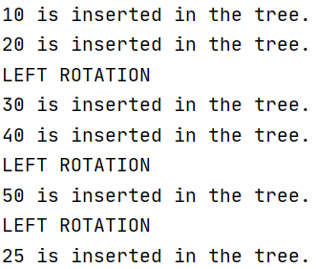

Calling Inorder and Preorder Functions

**OUTPUT:**

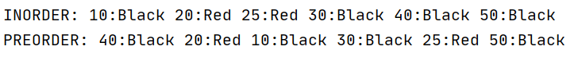

Deleting node(25)

**OUTPUT:**



Calling Inorder and Preorder Functions after deleting

**OUTPUT:**

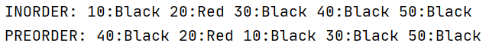

Searching node(1)

Searching node(30)

**OUTPUT:**

