Task 02 - Excercise🚨

**1.** Write a query to get data having length of Rna structures more than 12 with them being added after 2008

Query:

select *

from rnacen.rna

where len > 12 and date_trunc('year',timestamp) > '2008-01-01'

limit 50;

**S.S:**

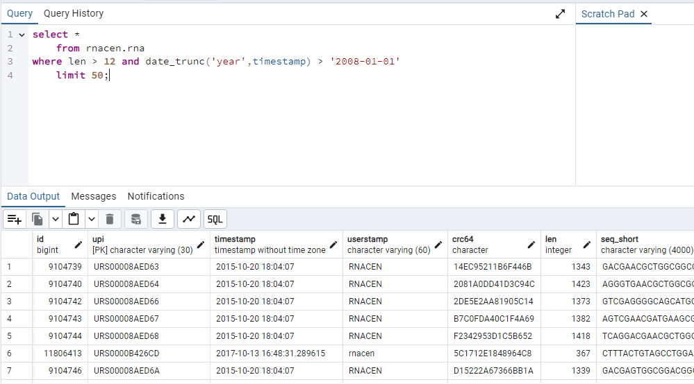

**2.** How many pre computed RNA are present that are still active and got their last release update before 2022

**Query:**

select count(*) AS Active

from rnacen.rnc_rna_precomputed

where is_active = 'TRUE' and update_date < '2022-01-01';

**S.S**

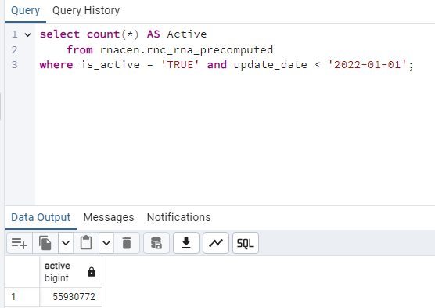

**3.** How many total pre computed RNA records for snoRNA and tRNA were recorded in 2011, 2016, 2014, and 2020

**Query:**

SELECT COUNT(*) AS RNA_RECORDS

FROM rnacen.rnc_rna_precomputed

WHERE (rna_type = 'snoRNA' OR rna_type = 'tRNA')

AND EXTRACT(YEAR FROM UPDATE_DATE) IN (2011, 2014, 2016, 2020);

**S.S:**

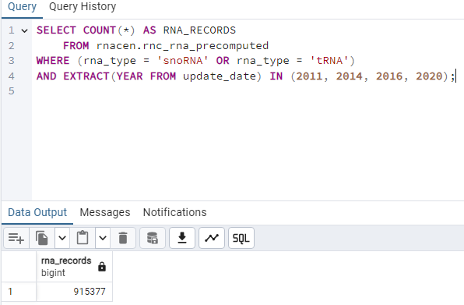

**4.** Can you give me the names of all databases built for RNA with minimum length other than 100, 200, 300, 400, and 15

**Query:**

select display_name

from rnc_database

where min_length not in (15,100,200,300,400);

**S.S:**

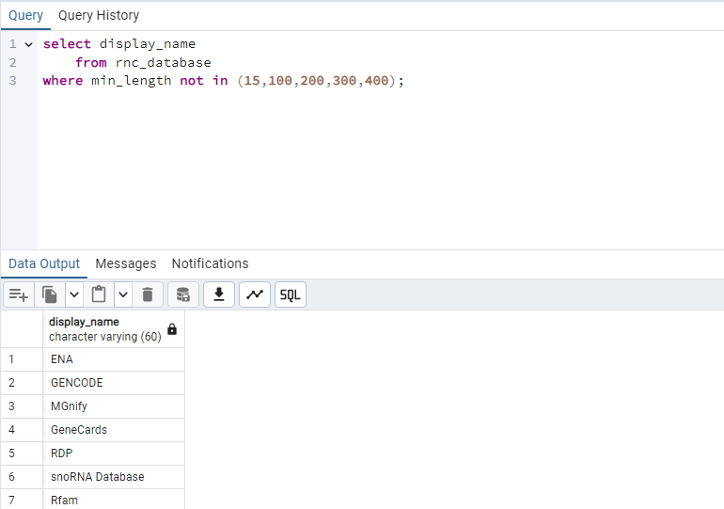

**5.** Can you get complete 500 records of sequences for active regions and name your column as myregions in which you are getting the region name column vakue. Then tell me what different chromosomes with exon_count we have for regions including center, east and north using the name you set for your column

**QUERY:**

select region_name as myregions

from rnacen.rnc_sequence_regions

where region_name is not null limit 500;

**S.S**

