Now the spectrogram contains more details, but the area around the bands is still quite noisy.   
  
There are more options you can set while creating spectrograms, but you can also try different time-frequency visualization methods.  
  
You can create scalograms with the cwt function.

cwt(sig,fs)

The first input is the signal, and the second input is the sample rate.   
  
You can also set the frequency limits with the cwt function.

cwt(sig,fs, ...  
 "FrequencyLimits",[*a b*])

Filtering the Mount Wrangell Signal

The low frequencies and the high frequencies correspond to two different seismic events. You will extract the low frequency surface waves from the Indonesian earthquake. Then you'll extract the seismic activity that it caused in Alaska.

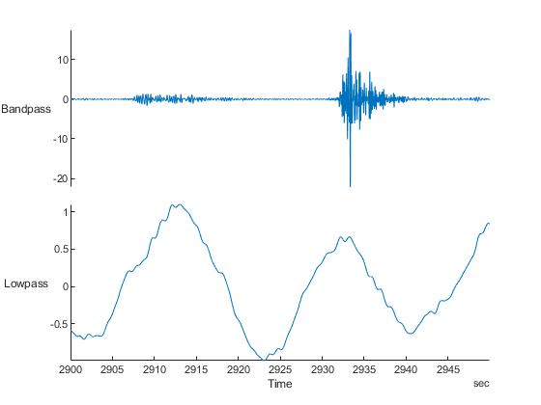

In this activity, you'll filter the Mount Wrangell signal to view the low frequencies in the time domain.

To choose the passband frequency for filtering, it can help to add a vertical line at a given frequency.

xline(*pass*)

**TASK**

Add an x-line to the power spectra plot at 0.1 Hz.

The plot shows the time domain and the frequency domain for the Mount Wrangell signal.  
  
Notice that there are still frequencies over 0.1, but filtering removed some of the high frequencies.  
  
Next, let's save the filtered signal to a variable so you can compare the filtered signal with the HARP and PAX signals.

**TASK**

Repeat the command from Task 2, but this time, use one output variable named lowWANC.

quakes.FiltWANC=lowWANC.WANC

lowWANC=lowpass(quakes,0.1,"Steepness",0.95)

In the previous activity, you have extracted the low frequencies, which corresponded to the surface waves from the earthquake in Sumatra.  
  
Now you need to get the high frequency content, which corresponds to the local earthquakes near Mount Wrangell. The frequency range of local earthquakes is 2 Hz to 10 Hz.  
  
To extract these frequencies, you can use a bandpass filter to keep only the frequencies in that range.

bandpass(*tbl*,[*f1 f2*])

**TASK**

Bandpass filter the WANC variable in quakes from 2 to 10 Hz.

Signal Measurements

As you saw in the last activity, the earthquake in Sumatra was so powerful that it set off smaller earthquakes as far off as Alaska. To identify these individual earthquakes in the data, you need to extract some information from your signals.  
  
Extracting measurements from signals is common in machine learning applications, where you need to calculate *features*, or distilled information, from your data. Check out the [Engineering Features](https://matlabacademy.mathworks.com/selfpaced/machinelearning?s_tid=course_dlor_bodych1#chapter=4&lesson=1&section=1) chapter of [Machine Learning Onramp](https://matlabacademy.mathworks.com/selfpaced/machinelearning?s_tid=course_dlor_bodych1) for more details.