**Lab Report No 4**

**Digital Signal processing**

**Submitted By: Muhammad Ali**

**Registration No: 19pwcse1801**

**Section: A**

**“On my honor , as student of University of Engineering and**

**Technology, I have neither given nor received unauthorized assistance on this**

**Department of Computer Systems Engineering**

**University of Engineering and Technology Peshawar**

**CSE 402L: Digital Signal Processing**

|  |  |  |  |  |
| --- | --- | --- | --- | --- |
| **Accuracy** | The student completed (  <50%) tasks and provided  MATLAB code and/or Simulink models with errors. Outputs shown are not correct in form of graphs (no labels) and/or tables along with incorrect analysis or remarks. | The student completed partial tasks (50% - <90%) with accurate MATLAB code and/or Simulink models. Correct outputs are shown in form of graphs (without labels) and/or tables along with correct analysis or remarks. | The student completed all required tasks (90%-100%) with accurate MATLAB code and/or Simulink models. Correct outputs are shown in form of labeled graphs and/or tables along with correct analysis or remarks. | **30%** |
| **Following**  **Directions** | The student clearly failed to follow the verbal and written instructions to successfully complete the lab | The student failed to follow the some of the verbal and written instructions to successfully complete all requirements of the lab | The student followed the verbal and written instructions to successfully complete  requirements of the lab | **20%** |
| **Time Utilization** | The student failed to complete even part of the lab in the allotted amount of time | The student failed to complete the entire lab in the allotted amount of time | The student completed the lab in its entirety in the allotted amount of time | **20%** |

|  |  |  |  |  |  |
| --- | --- | --- | --- | --- | --- |
| **Demonstration**  **Concepts** | **of** | **Poor (Does not meet expectation (1))**  The student failed to demonstrate a clear understanding of the  assignment concepts | **Fair (Meet**  **Expectation (2-3))**  The student demonstrated a clear understanding of some of the assignment  concepts | **Good (Exceeds**  **Expectation (4-5)**  The student demonstrated a clear understanding of the assignment concepts | **Score**  **30%** |

Lab No: 4.

Title: Signal Analysis in both time and frequency domain using Matlab

Provide .m file with detailed comments Procedure:

1. Will generate the signal of different frequencies say , 10,20,30,40,50,60 Hz (one second duration) using Matlab as shown in figure 1 and transform the same signal in frequency domain using Fourier transform and will compare the frequencies with the time domain signal as shown in figure 2.

# Signal of 10Hz frequency Signal of 20Hz frequency

time in seconds

0

0.5

1

A

m

p

l

i

t

u

d

e

-1

0

1

time in seconds

0

0.5

1

A

m

p

l

i

t

u

d

e

-1

0

1

# Signal of 30Hz frequency Signal of 40Hz frequency

1

time in seconds

0

0.5

1

A

m

p

l

i

t

u

d

e

-1

0

1

0

-1

0 0.5 1

# Signal of 50Hz frequency Signal of 60Hz frequency

time in seconds

0

0.5

1

A

m

p

l

i

t

u

d

e

-1

0

1

time in seconds

0

0.5

1

A

m

p

l

i

t

u

d

e

-1

0

1

Figure 1: *Time Domain Representation*

**Frequency Response of Signal of 10Hz Frequency Response of Signal of 20Hz**

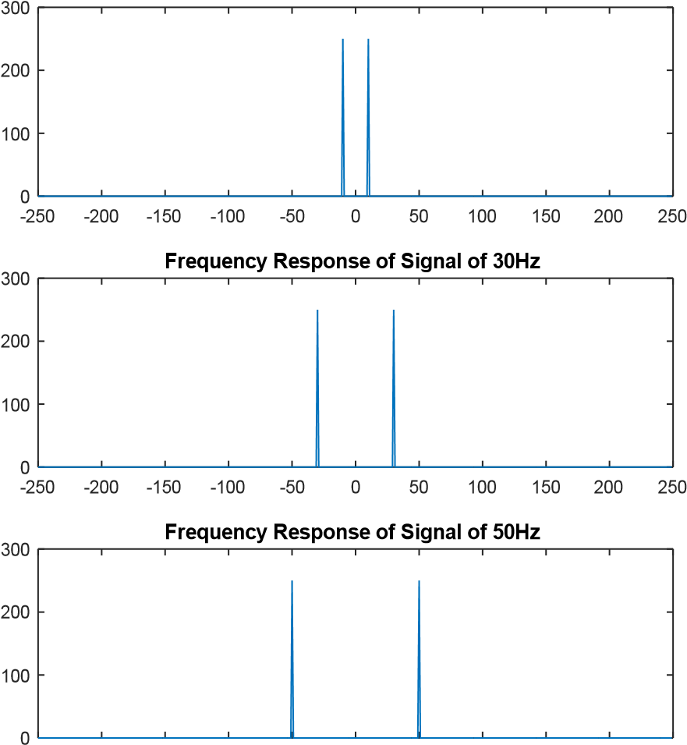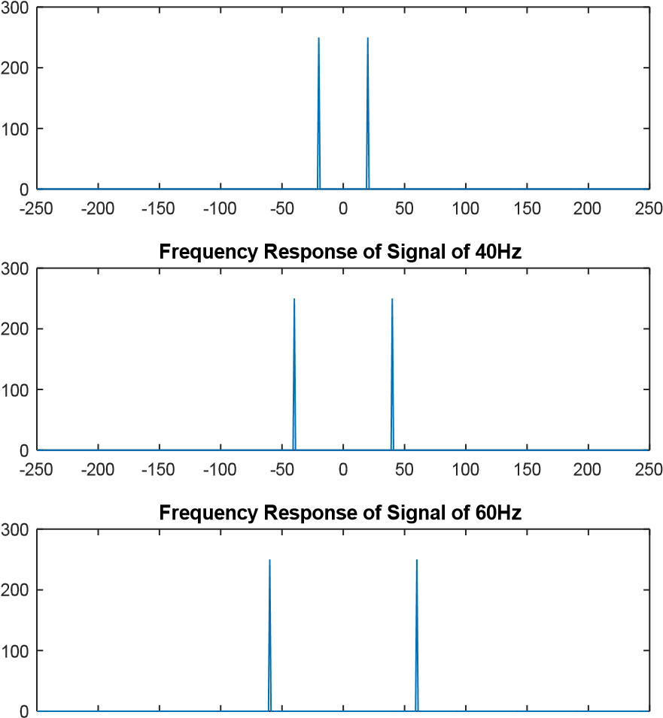

-250 -200 -150 -100 -50 0 50 100 150 200 250 -250 -200 -150 -100 -50 0 50 100 150 200 250

Figure 2: *Frequency Domain Representation*

1. **Compare** the figure 1 and 2 (Generated by your code)
2. Add all the signals generated in step 1 and get a composite signal. (which may be considered as a voice signal)
3. Obtain and plot the time and frequency domain representation of the composite signal as shown in figure 3

0

0.1

0.2

0.3

0.4

0.5

0.6

0.7

0.8

0.9

1

-5

0

5

**Composite Signal**

-250

-200

-150

-100

-50

0

50

100

150

200

250

0

50

100

150

200

250

300

**Spectrum of Composite signal**

Figure 3: *Composite Signal in time and frequency domain*

1. **Compare/Confirm** that you are getting all the frequency generated in step 1 above.
2. Generate some unwanted signal having frequencies say 80Hz and 100Hz (assume these signal represent noise) and different amplitudes say 0.5 and 0.7
3. Obtain both time and frequency representation of noise and confirm they have different power as shown in figure 4

|  |  |
| --- | --- |
| **Noise + Wanted Signal in Time Domain** | **Spectrum of Signal+Noise** |

**Unwanted Signal,(Noise) Spectrum of Noise signal**

-250

-200

-150

-100

-50

0

50

100

150

200

0

50

100

150

200

-250

-200

-150

-100

-50

0

50

100

150

200

0

50

100

150

200

250

300

0

0.1

0.2

0.3

0.4

0.5

0.6

0.7

0.8

0.9

1

-6

-4

-2

0

2

4

6

0

0.1

0.2

0.3

0.4

0.5

0.6

0.7

0.8

0.9

1

-1.5

-1

-0.5

0

0.5

1

1.5

Figure 4: *Time and Frequency domain representation of Noise and Signal+Noise*

1. Add the noise to the composite signal (assume the noise is added to the signal during transmission) and obtain frequency spectrum.
2. Final Remarks/Conclusion.

Hints: f1 = 10; t = 0:0.001:1; y1 = sin(2*pi*f*t); plot(t,y1) xlabel(“time in seconds”) ylabel(“Amplitude”) title(“Signal of 10 Hz frequency”)

Y1 =fft(y,length(y1)) n = length(Y1); fshift(-n/2:n/2-1)*(1000*n);

Y1shift = (fftshift(Y1));

Figure

Plot(fshift,abs(Y1shift))