**Lab report no 2**



**LAB # 03**

**Spring 2022**

**CSE-303L Data Communication & Networks Lab**

Submitted by: **Muhammad Ali**

Registration No: **19PWCSE1801**

Section: **A**

Submitted to:

**Engr. Faiz Ullah**

Department of Computer Systems Engineering

University of Engineering and Technology, Peshawar

**Objective:**

* Download Wireshark
* Install Wireshark
* INTRODUCTION TO WIRESHARK
* Wireshark is an open-source project whose primary purpose is to develop a standard analysis tool for
* network protocols. It’s a network packet analyzer that captures data on a network then presents it in a
* human-understandable form.

**Installation steps:**

* Install Wireshark 3.4.6 Intel 64.dmg for mac

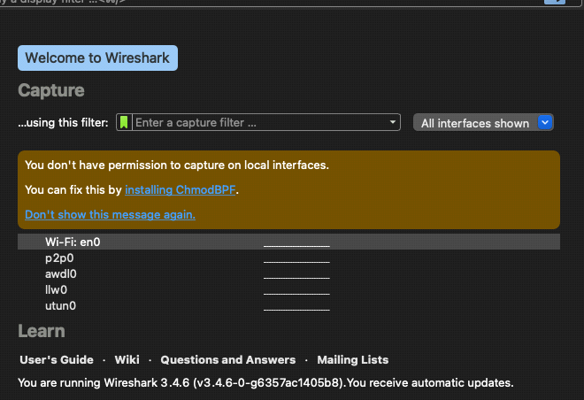

* Install ChmodBFP packege

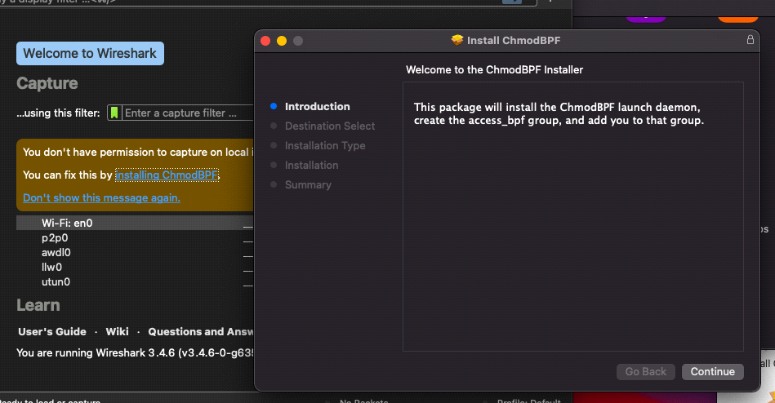

3)

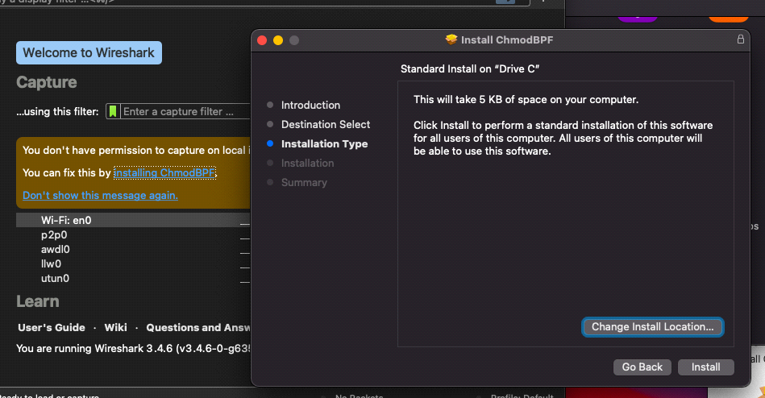

4)

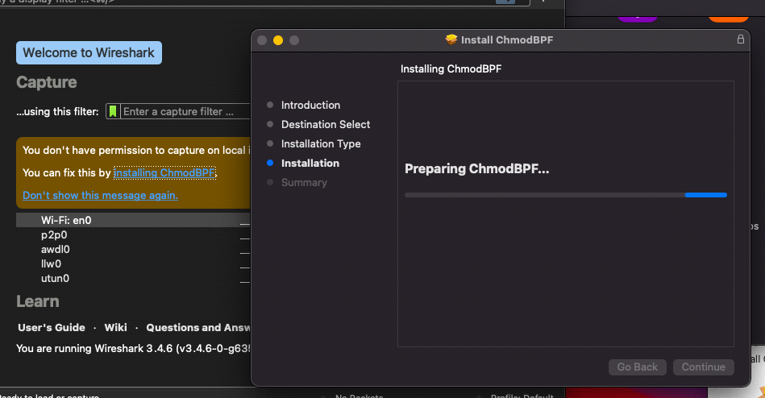5) ChmodBFP installation completed 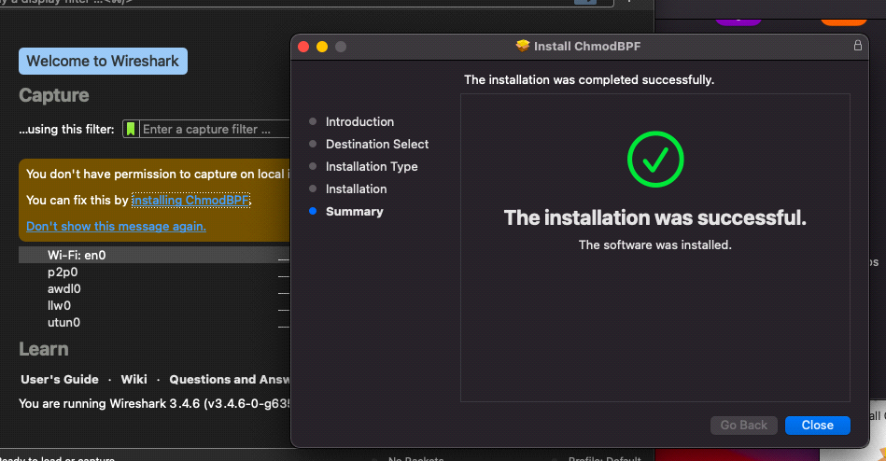

6) Adding system path

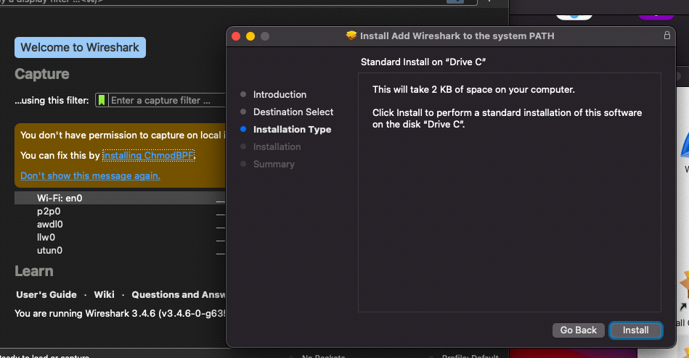

**8) Path added successfully: -**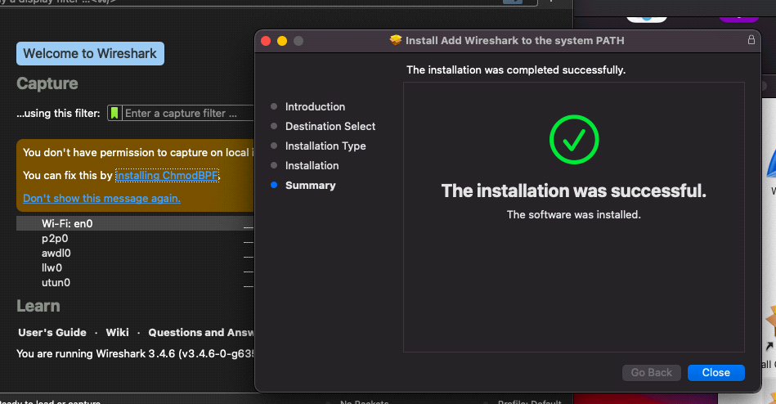

9) Wireshark install successfully and its interface

