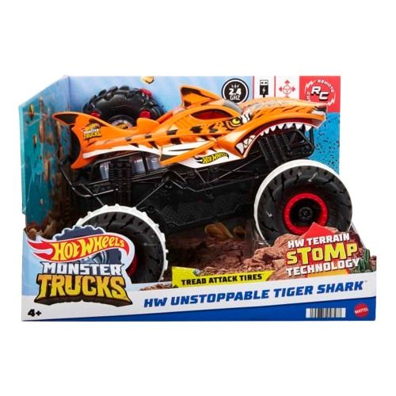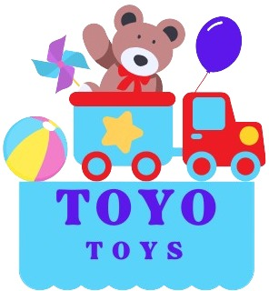

**Hot Wheels Monster Truck**

**Price: $21.99**

**Crushing the Competition, One Jump at a Time!**

**Durable design built to withstand intense play and crashes**

**The Hot Wheels Monster Truck brings epic off-road action to life with massive wheels and a bold, rugged design. Built for crushing obstacles and dominating the track, this monster truck delivers ultimate thrills whether racing or crushing in style.**.

**Product details**

**THANK YOU!**

**WELLCOME TO OUR WEBSITE**