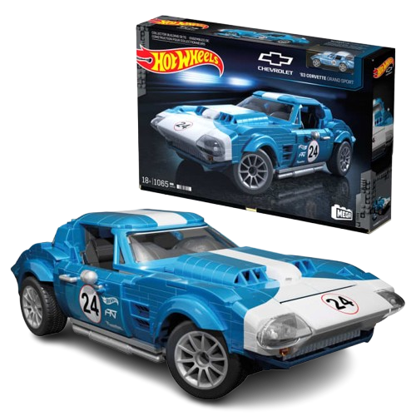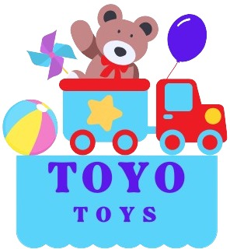

**Hot Wheels Corvette**

**$9.99**

**Hot Wheels Corvette: Speed, style, and endless thrills!**

**Durable die-cast construction for long-lasting play**

**Experience the thrill of the race with the Hot Wheels Corvette. This sleek and stylish toy car is designed for high-speed fun and imaginative play, making it the perfect addition to any Hot Wheels collection.**

**Product details**

**THANK YOU!**

**WELLCOME TO OUR WEBSITE**