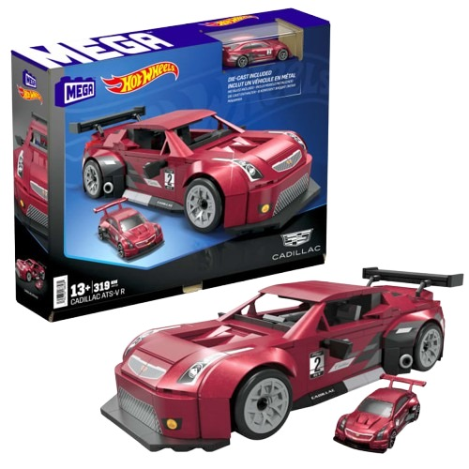****

**Hot Wheels Cadillac**

**$9.99**

**Perfect for both collectors and race track enthusiasts**

**Where Luxury Meets Speed on Every Turn**

**The Hot Wheels Cadillac combines Cadillac’s luxury design with the speed and excitement of Hot Wheels. This sleek, stylish car delivers thrilling track action while making a standout addition to any collection. Perfect for both racing and display**

**Product details**

**THANK YOU!**

**WELLCOME TO OUR WEBSITE**