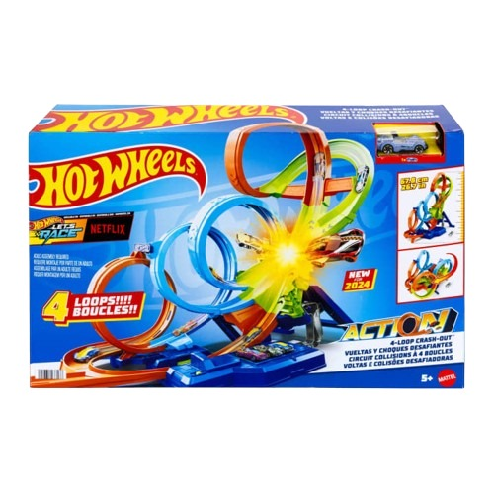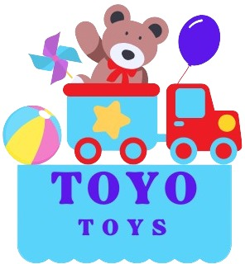

**Hot Wheels Track Set**

**$24.99**

**Where speed meets creativity!**

**Compatible with all Hot Wheels vehicles**

**This sleek, stylish car delivers thrilling track action while making a standout addition to any collection. Perfect for both racing the ultimate racing adventure with the Hot Wheels Track Set. This customizable playset allows kids to build, race, and explore with endless track combinations and high-speed action.**

**Product details**

**THANK YOU!**

**WELLCOME TO OUR WEBSITE**