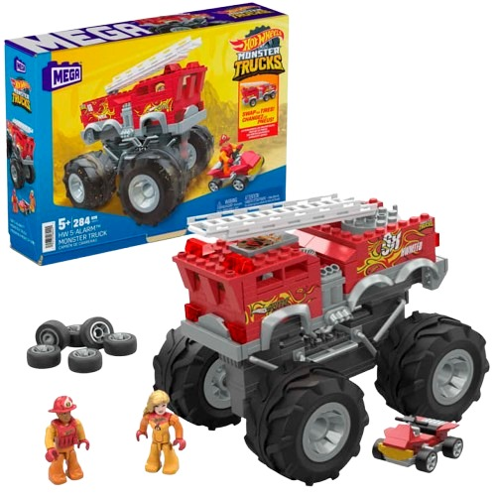****

**Hot Wheels Fire Truck**

**$14.99**

**Racing to the rescue!**

**Durable construction for action-packed play**

**Spark exciting rescue missions with the Hot Wheels Fire Truck. Designed for action-packed play, this robust vehicle encourages heroic adventures and imaginative storytelling**

**Product details**

**THANK YOU!**

**WELLCOME TO OUR WEBSITE**