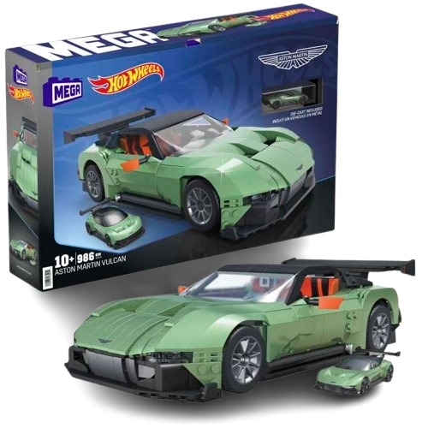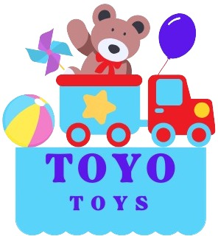

**Hot Wheels Fire Truck**

**$4.99**

**Luxury meets high-speed adventure!**

**Compatible with Hot Wheels tracks for thrilling races**

**Race in style with the Hot Wheels Aston Martin. This premium toy car captures the elegance and performance of the iconic vehicle, perfect for collectors and young racers**

**Product details**

**THANK YOU!**

**WELLCOME TO OUR WEBSITE**