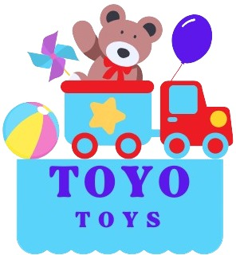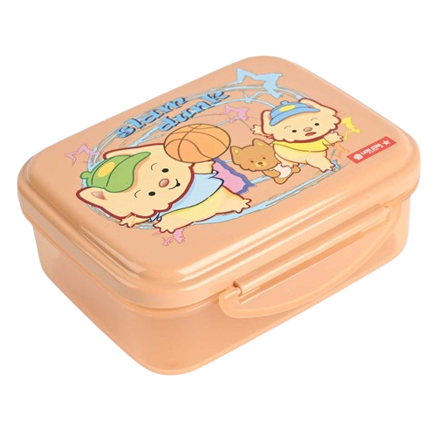

**Product details**

**Enzo Lunch Box**

**Price: $7.99**

**Enzo Lunch Box: Fresh Meals, Fresh Style.**

**The Enzo Lunch Box is the perfect blend of style and practicality. Designed to keep your meals fresh and organized, it features a spacious interior with compartments for easy packing. Whether you're heading to school or work, this lunch box ensures your food stays secure and accessible.**

**.**

.

**THANK YOU!**

**WELLCOME TO OUR WEBSITE**