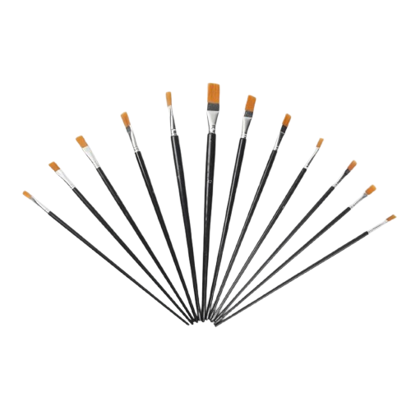

**Product details**

**Paint Brushes**

**Price: $6.99**

**Precision in Every Stroke.**

**Our high-quality Paint Brushes are perfect for artists of all skill levels. With soft, durable bristles designed for smooth application and fine detail work, these brushes make painting easy and enjoyable. Ideal for use with watercolors, acrylics, or oils, they offer precision and control for any project.**

.

**THANK YOU!**

**WELLCOME TO OUR WEBSITE**