**OSI Model**

The Open Systems Interconnection (OSI) model describes seven layers that computer systems use to communicate over a network. It was the first standard model for network communications, adopted by all major computer and telecommunication companies in the early 1980s.

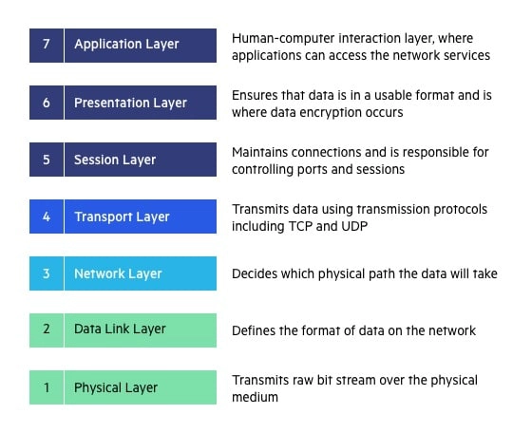

**7. Application Layer**

The application layer is used by end-user software such as web browsers and email clients. It provides protocols that allow software to send and receive information and present meaningful data to users. A few examples of application layer protocols are the Hypertext Transfer Protocol (HTTP), File Transfer Protocol (FTP), Post Office Protocol (POP), Simple Mail Transfer Protocol (SMTP), and Domain Name System (DNS).

**6. Presentation Layer**

The presentation layer prepares data for the application layer. It defines how two devices should encode, encrypt, and compress data so it is received correctly on the other end. The presentation layer takes any data transmitted by the application layer and prepares it for transmission over the session layer.

**5. Session Layer**

The session layer creates communication channels, called sessions, between devices. It is responsible for opening sessions, ensuring they remain open and functional while data is being transferred, and closing them when communication ends. The session layer can also set checkpoints during a data transfer—if the session is interrupted, devices can resume data transfer from the last checkpoint.

**4. Transport Layer**

The transport layer takes data transferred in the session layer and breaks it into “segments” on the transmitting end. It is responsible for reassembling the segments on the receiving end, turning it back into data that can be used by the session layer. The transport layer carries out flow control, sending data at a rate that matches the connection speed of the receiving device, and error control, checking if data was received incorrectly and if not, requesting it again.

**3. Network Layer**

The network layer has two main functions. One is breaking up segments into network packets, and reassembling the packets on the receiving end. The other is routing packets by discovering the best path across a physical network. The network layer uses network addresses (typically Internet Protocol addresses) to route packets to a destination node.

**2. Data Link Layer**

The data link layer establishes and terminates a connection between two physically-connected nodes on a network. It breaks up packets into frames and sends them from source to destination. This layer is composed of two parts—Logical Link Control (LLC), which identifies network protocols, performs error checking and synchronizes frames, and Media Access Control (MAC) which uses MAC addresses to connect devices and define permissions to transmit and receive data.

**1. Physical Layer**

The physical layer is responsible for the physical cable or wireless connection between network nodes. It defines the connector, the electrical cable or wireless technology connecting the devices, and is responsible for transmission of the raw data, which is simply a series of 0s and 1s, while taking care of bit rate control.

**OSI real world Scenario**

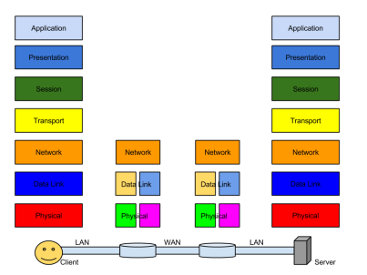

**Client Side:**

**Application Layer** – provides the UI to the application programs, in this example it could be an email client like MS outlook or a web browser. The protocol that he application layer uses to send commands the server how to handle the data is the SMT Protocol.

**Presentation Layer** – here the email will be converted to network format from system specific format that is the text to ASCII and also specifies the format of the image. In addition to that this layer is responsible in providing encryption and compression.

**Session Layer** – In this layer a header will be added to the email to handle the sessions. This layer is responsible for facilitating the starting, handling and ending of connections between nodes.

**Transport Layer** – In this example the transport layer uses TC Protocol, here email is broken in to segments that are reassembled by the transport layer at the receiver’s side. Each of the broken segments are sent to the network layer later on and also at this layer the source and destination port will also be specified. This layer is mainly responsible for flow control, fragmentation, port assigning and reliability.

**Network Layer** – This layer provides addressing across the internet and determines the path the data is to be sent that is routing happens in this layer. The segments will be given the source and destination IP address and the segments become packets. The packets will be then passed to the data link layer.

**Data link Layer** – here the packets become frames and physical addresses of the two nodes the email is travelling between will be assigned.

**Physical Layer** – the physical layer put the data on the physical medium passed to it by the data link layer.

**Example and working with functionality of each Layer using Twitter Scenario:**

