Fundamental of Programing

Lab Manual # 04

**Course Instructor:** Dr Jawad Khan

**Lab Instructor:** Muhammad Affan

## Student Name: Muhammad Ali Shahzadah

## CMS ID: 466353

**DATE: 27-10-23**

**Lab Manual # 04**

# Home Task:

# 1.Write a program in C++ that prints the numbers from 1 to 150 except the multiples of 10.

**Make use of the continue statement:**

#include <iostream>

using namespace std;

int main(){

for(int i=1;i<=150;i++){//loop for every value from 1 to 150

if(i%10==0){//check if it is a multiple of 10

cout<<endl;//go to next line

continue;//skip this number and go to next iteration

}

cout << i << " ";//put space between the numbers

}

}

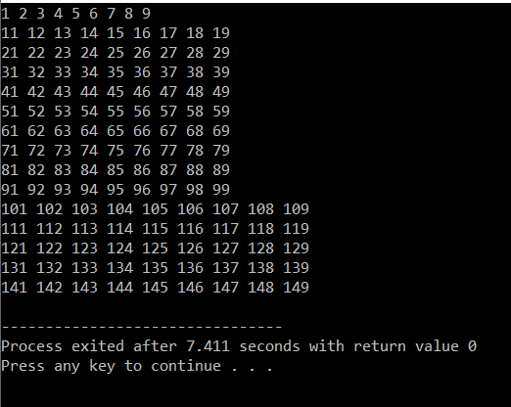

**2.Write a C++ program to find the sum of digits of a number.**

**The sum of digits means adding all the digits of any number, for example, we take any number like 358. Its sum of all digits is 3+5+8=16.**

#include <iostream>

using namespace std;

int main(){

int num,sum,x,digit;

cout<<"enter a number to find sum of digits of: ";

cin>>num;

x=num;

while(num>0){//do this loop til num is 0

digit=num%10;//check the remainder when number divided by 10

sum+=digit;//add the obtained digit to the sum

num/=10;//remove the number that was obtained above

}

cout<<"The sum of digits of "<<x<<" is:"<<sum;

}

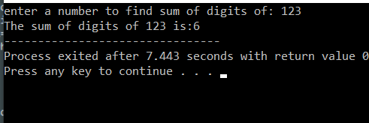

**3.Write a program in C++ to check whether a number is prime or not.**

#include <iostream>

using namespace std;

int main(){

int num;

cout<<"Enter a number: ";

cin>>num;

if (num>1){

bool primecheck=true;

for(int i=2;i<num;i++){

if(num%i==0){

primecheck=false;

break;

}

}

if(primecheck){

cout<<num<<" is a prime number"<<endl;

}

else{

cout<<num<<" is not a prime number"<<endl;

}

}

else{

cout<<num<<" is not a prime number"<<endl;

}

}

