CS-114 - Fundamental of Programing

Lab Manual # 05

**Course Instructor:** Dr. Khwaja Fahad Iqbal

**Lab Instructor:** Muhammad Affan

**Student Name: Muhammad Ali Shahzadah**

**CMS ID:466353**

**Home Task:**

1. Write a program in C++ to find LCM of any two numbers using HCF.

#include <iostream>

using namespace std;

int main(){

int num1,num2,hcf,lcm;

cout<<"enter the first number: ";

cin>>num1;

cout<<"enter the second number: ";

cin>>num2;

hcf=1;

lcm=1;

for(int i=2;i<=num1&&i<=num2;i++){

if(num1%i==0&&num2%i==0){

hcf=i;

}

}

cout<<"the HCF of "<<num1<<" and "<<num2<<" is : "<<hcf<<endl;

lcm=num1*num2/hcf;

cout<<"the LCM of "<<num1<<" and "<<num2<<" is : "<<lcm<<endl;

}

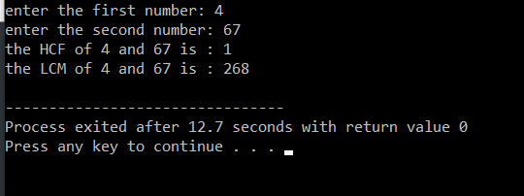

1. Write a program in C++ to find out the sum of an Arithmetic progression series.

#include <iostream>

using namespace std;

int main(){

int i,sum,cdiff,fterm,nterms,term;

cout<<"enter the common differnce: ";

cin>>cdiff;

cout<<"enter the first term: ";

cin>>fterm;

cout<<"enter the number of terms: ";

cin>>nterms;

sum=((nterms)*((2*fterm)+(nterms-1)*cdiff)/2);

cout<<"the sum of terms to "<<nterms<<" term(s) is: "<<sum;

}

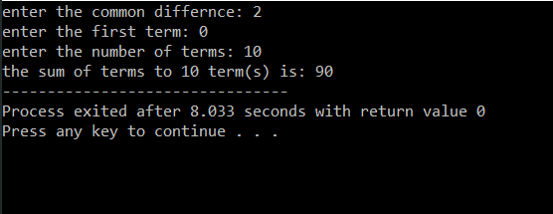

1. Write a program in C++ to create a diamond.

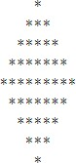

#include <iostream>

using namespace std;

int main(){

int rows, num1, num2;

cout<<"enter the number of rows in the upper half of the diamond: ";

cin>>rows;

for(num1=1;num1<=rows;num1++){

for(num2=1;num2<=rows-num1;num2++){

cout<<" ";

}

for(num2=1;num2<=2*num1-1;num2++){

cout<<"*";

}

cout<<endl;

}

for(num1=rows-1;num1>=1;num1--){

for(num2=1;num2<=rows-num1;num2++){

cout<<" ";

}

for(num2=1;num2<=2*num1-1;num2++){

cout<<"*";

}

cout<<endl;

}

}

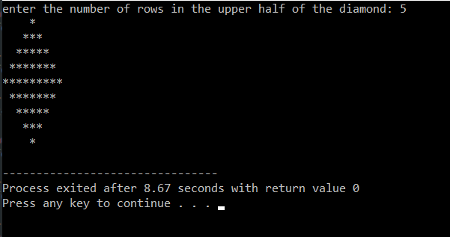

1. Write a program in C++ to convert a decimal number to binary number.

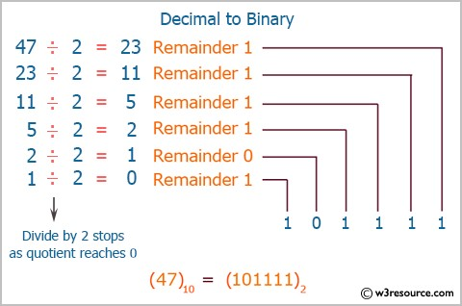

#include <iostream>

using namespace std;

int main(){

int num,x,binary=0,remainder;

int i=1;

cout<<"enter a decimal number: ";

cin>>num;

x=num;

while(num!=0){

remainder=num%2;

num=num/2;

binary=binary+(remainder*i);

i=i*10;

}

cout<<"binary number of "<<x<<" is: "<<binary;

}

