CS-114 - Fundamental of Programing

Lab Manual # 05

**Course Instructor:** Dr. Khwaja Fahad Iqbal

**Lab Instructor:** Muhammad Affan

**Student Name:**

**CMS ID:**

**DATE:**

**Lab Manual # 05**

**Repetition structures (II)**

**Lab Task:**

1. Convert the following while loop to a do-while loop:

int x = 1;

while (x > 0)

{ cout << "enter a number: ";

cin >> x;

}

#include <iostream>

using namespace std;

int main(){

int x;

do {

cout << "enter a number: ";

cin >> x;

}

while (x > 0);

}

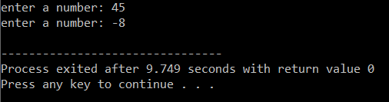

2.Use a do while loop to make a simple calculator for two numbers. Insert buttons for it to ask again and for termination.

#include <iostream>

using namespace std;

int main(){

double num1,num2,ans;

char operation;

bool cont;

cont=true;

do{

cout<<"enter the first number: ";

cin>>num1;

cout<<"enter the second number: ";

cin>>num2;

cout<<"choose an operation (+, -, *, /): ";

cin>>operation;

switch(operation){

case'+':

ans=num1+num2;

break;

case'-':

ans=num1-num2;

break;

case'*':

ans=num1*num2;

break;

case'/':

if(num2!=0){

ans=num1/num2;

}

else{

cout<<"division by zero"<<endl;

continue;

}

break;

default:

cout<<"not a valid operation.enter a valid option"<<endl;

continue;

}

cout<<"answer of "<<num1<<operation<<num2<<" is: "<<ans<<endl<<endl;

cout<<"do you want to continue?(enter 1 for yes and 0 for no)"<<endl;

cin>>cont;

}

while (cont);

}

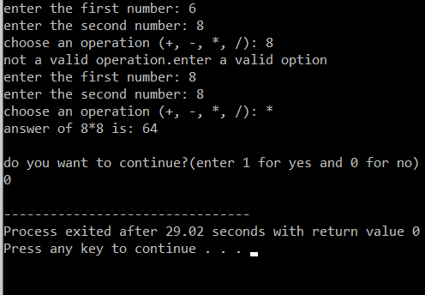

1. Write programs with while or do while loops that compute:
   1. The sum of all even numbers between 2 and 100 (inclusive).

#include <iostream>

using namespace std;

int main(){

int num,sum;

sum=0;

num=2;

while(num<101){

if(num%2==0){

sum=num+sum;

}

num++;

}

cout<<"the sum of even numbers from 2 to 100(inclusive) is: "<<sum;

}

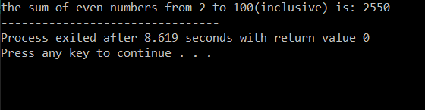

* 1. The sum of all squares between 1 and 100 (inclusive).

#include <iostream>

using namespace std;

int main(){

int num,sum,sq;

sum=0;

num=1;

sq=0;

while(num<101){

sq=num*num;

sum=sq+sum;

num++;

}

cout<<"the sum of squares from 1 to 100(inclusive) is: "<<sum;

}

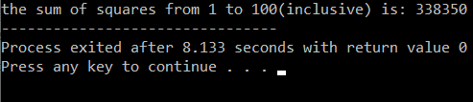

1. Write programs with while or do while loops that compute:
   1. All powers of 2 from 20 up to 220.

#include <iostream>

using namespace std;

int main(){

int power,ans;

power=1;

ans=1;

cout<<"the answer of 2 to the power of 0 is: "<<ans<<endl;

while(power<21){

ans=2*ans;

cout<<"the answer of 2 to the power of "<<power<<" is: "<<ans<<endl;

power++;

}

}

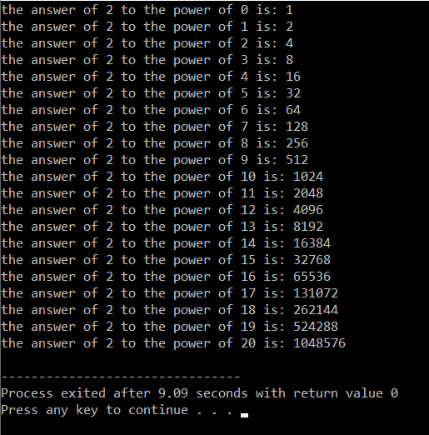

* 1. The sum of all odd numbers between a and b (inclusive), where a and b are inputs.

#include <iostream>

using namespace std;

int main(){

int a,b,num,sum;

sum=0;

cout<<"enter the value of a: "<<endl;

cin>>a;

cout<<"enter the value of b: "<<endl;

cin>>b;

num=a;

while(num<(b+1)){

if(num%2!=0){

sum=num+sum;

}

num++;

}

cout<<"the sum of odd numbers from "<<a<<" to "<<b<<" (inclusive) is: "<<sum;

}