CS-114 - Fundamental of Programing

Lab Manual # 06

**Lab Instructor:** Muhammad Affan

**Name:**

Muhammad Ali Shahzadah

**CMS:**

466353

**Section:**

B

**LabManual # 6**

**Home Task:**

* 1. Write a program using break or continue statement that only adds prime numbers from 1 to 50 and display the sum on screen.

#include <iostream>

using namespace std;

int main(){

int sum=0;

for(int i=2;i<=50;++i){

bool isPrime=true;

for(int j=2;j<=i/2;++j){

if(i%j==0){

isPrime = false;

break;

}

}

if(isPrime){

sum+=i;

}

}

cout<<"sum of prime numbers from 1 to 50 is: "<<sum<<endl;

}



* 1. Write a program in C++ to create the following pattern.

1

1 2

1 2 3

1 2 3 4

1 2 3 4 5

#include <iostream>

using namespace std;

int main(){

int n;

cout<<"enter the number of rows of pattern to generate: ";

cin>>n;

int a=0,b=1;

for(int i=0;i<n;++i){

a=1;

for(int j=0;j<=i;++j){

cout<<a<<" ";

++a;

}

cout<<endl;

}

}

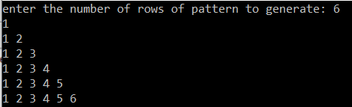

1. Write a C++ program to print:

1

2 2

4 4 4 4

6 6 6 6 6 6

#include <iostream>

using namespace std;

int main(){

int n;

cout<<"enter the number of rows of pattern to generate: ";

cin>>n;

int a=1,b;

cout<<a<<endl;

for(int i=0;i<n-1;++i){

b=(a)*2;

for(int j=0;j<=i+1;++j){

cout<<b<<" ";

}

++a;

cout<<endl;

}

}

