CS-114 - Fundamental of Programing

Lab Manual # 06

**Lab Instructor:** Muhammad Affan

**Name:**

Muhammad Ali Shahzadah

**CMS:**

466353

**Section:**

B

**LabManual # 6**

**Lab Task:**

1. Generate the Fibonacci sequence using nested loops.

#include <iostream>

using namespace std;

int main(){

int n;

cout<<"enter the number of fibonacci rows to generate: ";

cin>>n;

int a=0,b=1;

for(int i=0;i<n;++i){

for(int j=0;j<=i;++j){

cout<<a<<" ";

int temp=a;

a=b;

b=temp+b;

}

cout<<endl;

}

}

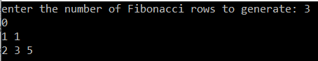

1. Create Floyd's triangle with nested loops.

#include <iostream>

using namespace std;

int main(){

int n;

cout<<"enter the number of Floyd's triangle rows to generate: ";

cin>>n;

int a=0,b=1;

for(int i=0;i<n;++i){

for(int j=0;j<=i;++j){

cout<<a<<" ";

++a;

}

cout<<endl;

}

}

