Fundamentals of Programing

Lab Manual # 07

**Lab Instructor:** Muhammad Affan

**Student Name:** Muhammad Ali Shahzadah

**CMS ID:** 466353

**Lab Manual # 07**

**Lab Task:**

1. Take 10 integer inputs from user and store them in an array and print them on screen.

#include <iostream>

using namespace std;

int main(){

int arr[10];

for(int i=0;i<10;++i){

cout<<"enter integer for serial number "<<(i+1)<<": ";

cin>>arr[i];

}

cout<<"Entered integers are: ";

for (int i=0;i<10;++i){

cout<<arr[i]<<" ";

}

}

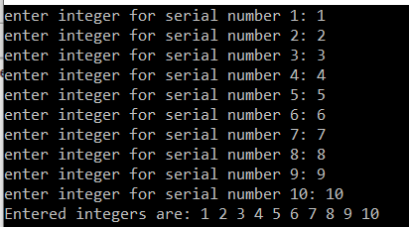

1. Write a program to find the sum and product of all elements of an array with 5 integer elements.

#include <iostream>

using namespace std;

int main(){

int arr[5];

for(int i=0;i<5;++i){

cout<<"enter integer for serial number "<<(i+1)<<": ";

cin>>arr[i];

}

int sum=0,product=1;

for(int i=0;i<5;++i){

sum+=arr[i];

product*=arr[i];

}

cout<<"Sum: "<<sum<<endl;

cout<<"Product: "<<product<<endl;

}

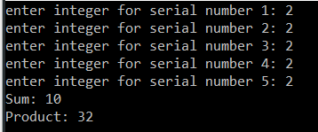

1. Print diamond pattern using a single array.

#include <iostream>

using namespace std;

int main(){

int x;

cout<<"enter the size of the longest row in the diamond: ";

cin>>x;

if(x%2==0){

x++;

}

int h=(x+1)/2;

const int size=x;

char arr[size];

for(int i=0;i<size;++i){

arr[i]='*';

}

for(int i=0;i<h;++i){

for(int j=0;j<h-i-1;++j){

cout<<' ';

}

for(int k=0;k<2*i+1;++k){

cout<<arr[k];

}

cout<<endl;

}

for(int i=0;i<size;++i){

arr[i]='*';

}

for(int i=h-2;i>=0;--i){

for(int j=0;j<h-i-1;++j){

cout<<' ';

}

for(int k=0;k<2*(i+1)-1;++k){

cout<<arr[k];

}

cout<<endl;

}

}

