Fundamentals of Programing

Lab Manual # 08

**Lab Instructor:** Muhammad Affan

**Student Name: Muhammad Ali Shahzadah**

**CMS ID: 466353**

**Lab Manual # 08**

**Home Task:**

1. Take an array and find the most repeated element in that array.

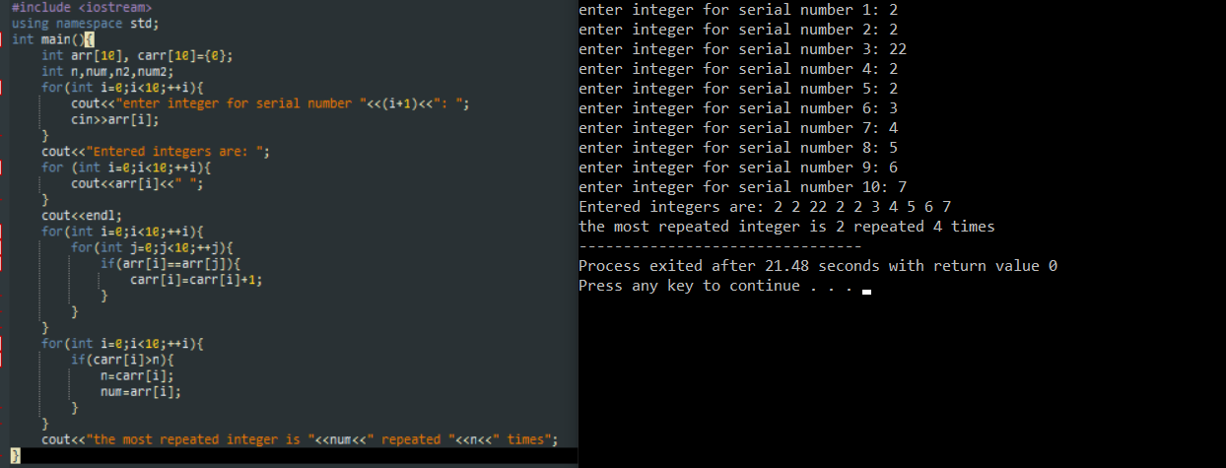

1. Let’s say an array is a[8] = {13, 15, 17, 9, 99, 77, 65, 43}. Find largest and smallest element.

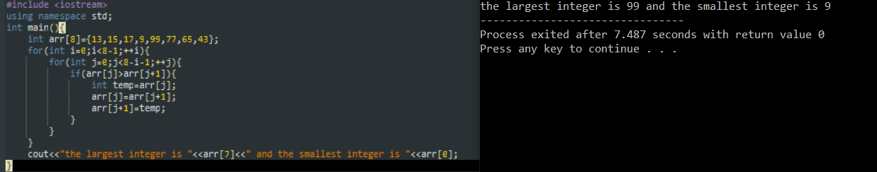

1. Develop a program that takes 5 array elements from user. Swap position [2] element with position [4] element. (**Hint**: Use the same method of swapping values we used for variables using a third variable temp).

