Fundamentals of Programing

Lab Manual # 08

**Lab Instructor:** Muhammad Affan

**Student Name: Muhammad Ali Shahzadah**

**CMS ID: 466353**

**Lab Task:**

1. Write a C++ program to calculate average of numbers of array. 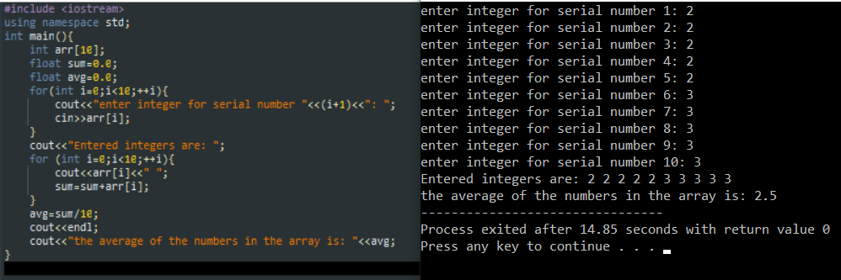
2. Implement Bubble sort on an array of 5 integers.

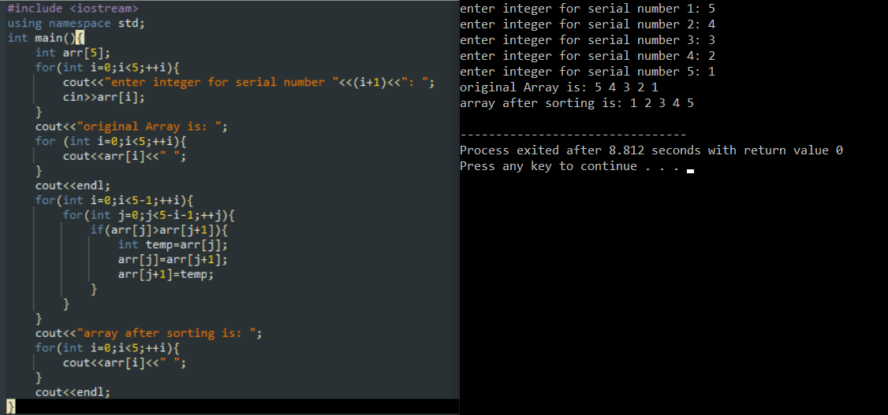

1. Implement Selection Sort on an array of 5 integers.

