Fundamentals of Programing

Lab Manual # 09

**Lab Instructor:** Muhammad Affan

**Student Name: Muhammad Ali Shahzadah**

**CMS ID: 466353**

**Lab Manual # 09**

**Lab Task:**

1. Make 2D Array in C++ and print left diagonal and right diagonal sum of a 3x3 matrix.

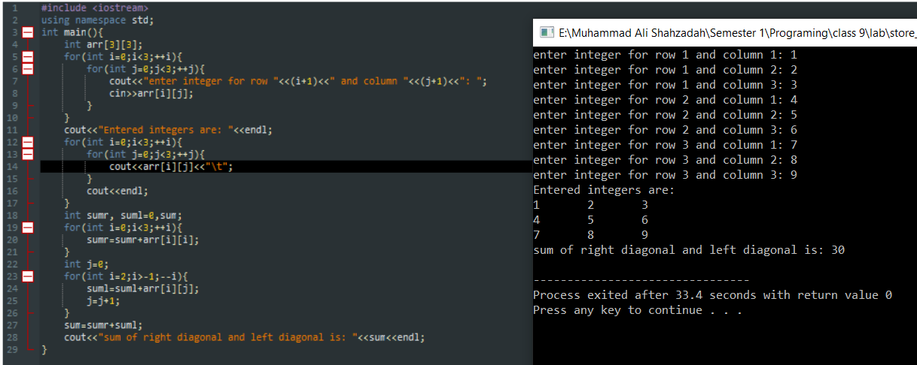

1. Write a function to add two 2D arrays of size 3x3.

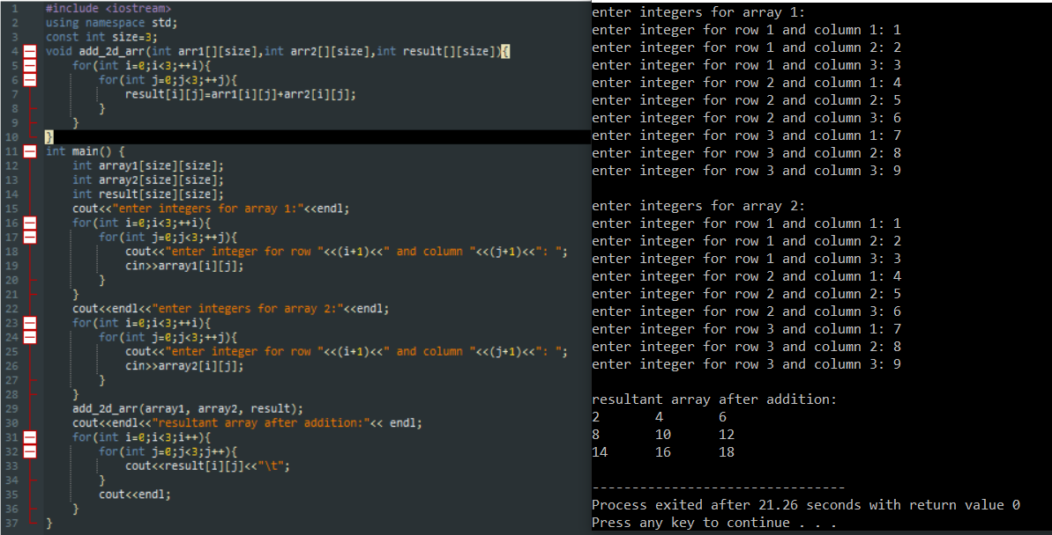

1. Using 2D arrays in C++, take transpose of a 3x3 matrix. Make a transpose function.

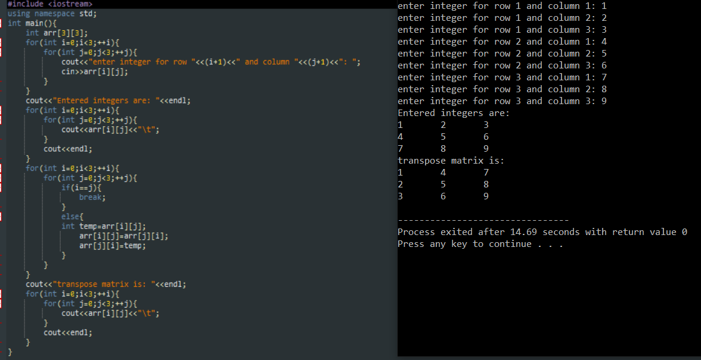

1. Using 2D arrays in C++, implement 3x3 matrix multiplication. Make a function.

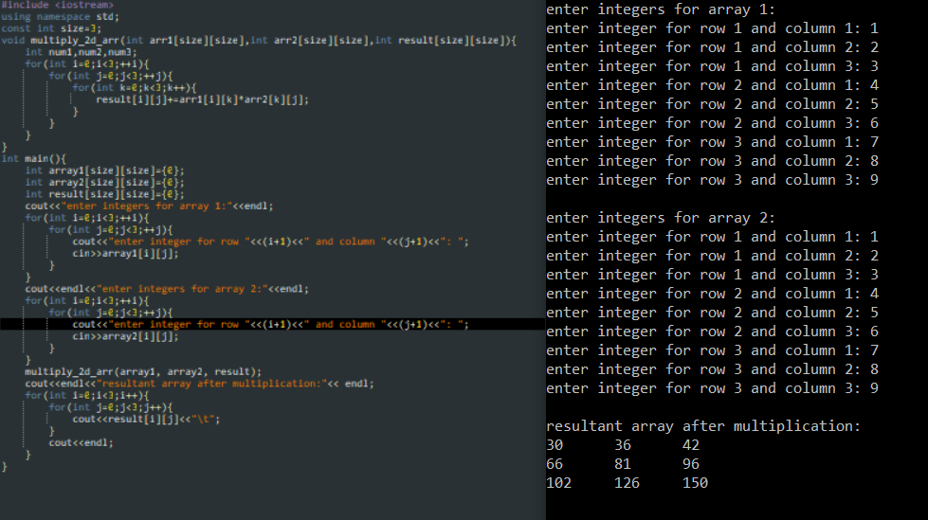

1. Print the multiplication table of 15 using recursion.

