Original Investigation
Mod-SE(2): A 2.5D Geometric Deep Learning Framework with Edge-Boundary Loss for Brain Tumor Classification and Segmentation in MRI and CT Images

Clara Lavita Angelina, Fu-Ren Xiao, Sunil Vyas, Pan-Chyr Yang, Hsuan-Ting Chang, and Yuan Luo

Corresponding authors: Pan-Chyr Yang (pcyang@ntu.edu.tw), Hsuan-Ting Chang (htchang@yuntech.edu.tw), Yuan Luo (yuanluo@ntu.edu.tw)

Abstract
Accurate classification and segmentation of brain tumors in MRI and CT scans are critical for effective diagnosis and treatment planning. However, the heterogeneous morphology of these tumors often limits the efficacy of traditional Convolutional Neural Networks (CNNs), which inherently lack rotational and translational invariance. To address this limitation, we propose Mod-SE(2), an upgraded geometric deep learning framework that integrates a 2.5D spatial context model with a novel Edge-Boundary Loss function. Utilizing multi-institutional MRI and CT datasets, the model was rigorously evaluated through 10-fold cross-validation. Our results demonstrate that the Mod-Cls-SE(2) variant achieved an average classification accuracy of 0.914, outperforming standard architectures such as ResNet101 and VGG16. Furthermore, in segmentation tasks, the 2.5D SE(2)-Equivariant CNN significantly surpassed standard U-Net baselines in spatial awareness and boundary precision, notably reducing false positive predictions at tumor margins. Ultimately, the Mod-SE(2) framework successfully leverages geometric priors to enhance spatial consistency, computational efficiency, and model interpretability, offering a robust tool to support neurosurgical planning and advanced clinical applications.

Introduction

Brain tumors pose a significant challenge in clinical practice due to their diverse appearances, growth patterns, and locations within the brain . Among the various intracranial growths encountered, arteriovenous malformations (AVMs), pituitary tumors, meningiomas, schwannomas, and metastatic lesions account for a large percentage of diagnosed cases. Although Magnetic Resonance Imaging (MRI) is the established standard for evaluating brain tumors, providing high-resolution details of soft tissues and anatomy , distinguishing between different tumor types can be difficult. The precise classification and segmentation of these tumors remains challenging due to overlapping features seen on imaging and the variability within individual tumors . The necessity of precise diagnostic tools that can accurately differentiate between these tumor types underscores the importance of innovations in medical imaging technology . While histopathology and molecular analysis remain essential for definitive diagnosis, prognostication, and treatment planning in neuro-oncology, these methods are time-consuming, require invasive procedures, and are not always practical in urgent clinical situations. These limitations have led to a growing interest in automated, high-precision diagnostic tools that can deliver reliable results with minimal human intervention. In this work, we aim to enhance non-invasive imaging analysis prior to histopathology.
Each type of brain tumor presents unique challenges for both imaging and biological interpretation. AVMs, being congenital vascular abnormalities, have complex, tangled vessel structures that make them difficult to outline precisely. Pituitary tumors, though often small, exhibit a wide range of functional profiles that impact hormone levels and thus complicate diagnosis. Meningiomas and schwannomas can appear similar on MRI scans despite originating from different cell types. The diverse imaging characteristics of metastases, which depend on their primary source, add another layer of complexity. Accurately classifying and delineating these various tumor types is crucial for effective treatment planning, guiding surgical procedures, and predicting patient outcomes.
Convolutional neural networks (CNNs) have shown strong performance in both classification and segmentation tasks, including lung cancer classification and brain tumor analysis . Notably, models like ResBRNet and EfficientNet-B0 have achieved impressive results when trained on large-scale datasets . Similarly, architectures such as U-Net and NN U-Net have become the standard for tumor segmentation tasks. DeepLabV3+ and Efficient-Enhanced U-Net also achieved impressive results when trained on BraTS dataset . However, CNNs inherently struggle with spatial variations, especially rotations and translations. This requires extensive data augmentation, which can lead to inconsistencies in how features are extracted from MRIs acquired in different orientations. Consequently, this increases computational demands and reduces the interpretability of the models. Although transfer learning has improved performance in some instances , pre-trained models still lack an inherent understanding of geometric invariance.
To overcome these limitations, geometric deep learning (GDL) has emerged as a promising alternative. Models such as Group Equivariant CNNs (G-CNNs) and Harmonic Networks are designed to respect rotational symmetry, making them more robust to changes in orientation. However, many of these models primarily focus on rotational equivariance and often overlook translational invariance, which is vital for accurately locating tumors. Previous research has typically concentrated on either classification or segmentation, rarely addressing both tasks within a unified model or encompassing the full spectrum of brain tumor diversity.
GDL provides a biologically inspired approach to incorporating spatial knowledge and structural symmetry into neural networks . It has gained increasing traction across medical imaging domains beyond brain tumor classification. For instance, Bronstein et al. demonstrated the GDL in analyzing cortical surfaces and mapping functional regions using non-Euclidean mesh representations . In diffusion MRI, Ewert et al. introduced a GDL method for continuous signal reconstruction . A deeper representation of GDL is also employed. Zhang et al. applied local-to-global graph neural networks to classify Autism Spectrum Disorder (ASD) and Alzheimer's disease (AD) by analyzing disease-related local brain regions and biomarkers . Additionally, Kerkela et al. modeled spherical neural networks to improve the estimation of microstructural data from brain MRI data . This research improves prediction accuracy compared to models that apply less or no rotational variance. This emphasizes the effectiveness of a model in medical images for models that use rotational features, such as GDL methods. Zhu et al. proposed a unified GDL model to predict task-based fMRI activity from anatomical features in sMRI, highlighting cross-modal learning . In CT imaging, Koetzier et al. presented a graph-based deep reconstruction method to recover high-fidelity CT volumes from undersampled data . Winkels and Cohen proved CNN model with roto-translation group convolutions performs similarly to a regular CNN with ten times less data . This research trained a roto-translation group 3D CNN on a pulmonary nodule detection dataset and compared it with a regular CNN model. The regular CNN model received data augmentation, yet still needed ten times more data to perform at an acceptable level. In digital pathology, Li et al. use GDL to conduct spatial analysis using histopathology images for single-cell analysis . Biologically, analyzing histopathology images at the single-cell level offers a significant advantage over traditional patch-based methods by providing detailed cellular information. This research focuses on exploring more into the microenvironment of a tumor. In their experiments, their proposed model has consistently eclipsed existing patch-based and cell graph-based methods across two independent datasets.
This study aims to address two fundamental tasks in neuro-oncological imaging, which are classifying various tumor types and performing semantic segmentation. For classification, we use a private MRI dataset containing five distinct tumor categories: AVM, meningioma, pituitary adenoma, metastatic tumors, and schwannoma. Arteriovenous malformations are vascular malformations with an incidence of approximately 1 per 100,000 per year and carry a risk of serious hemorrhage, where their detection via MRI is critical for preventing stroke and guiding surgical planning . Meningiomas account for roughly 30-37\% of all primary brain tumors, are frequently benign, and often produce symptoms through mass effect, with MRI guiding both diagnosis and surgical strategy . Pituitary adenomas represent 10–25\% of intracranial neoplasms, with microadenomas being particularly common (prevalence up to \sim17\%), and can cause visual or hormonal symptoms that MRI is uniquely suited to identify . Brain metastases, occurring in an estimated 10–40\% of cancer patients, are the most frequent intracranial tumors, significantly impacting prognosis and treatment decisions . Vestibular schwannomas (also called acoustic neuromas) are benign tumors arising from Schwann cells of the vestibular portion of the eighth cranial nerve. They account for approximately 8–10\% of all intracranial tumors and up to 80\% of tumors in the cerebellopontine angle. Patients typically present with hearing loss, tinnitus, and balance disturbances . Collectively, these tumor types underscore the need for an imaging tool capable of both classification and localization across heterogeneous tumor morphologies in real-world neuro-oncology practice. For segmentation, we perform pixel-level labeling to precisely outline tumor regions. This is essential for estimating tumor volume and tracking its boundaries. Our goal is to provide radiologists with clinically valuable insights to assist them in diagnosis and treatment planning.
To achieve these goals, we introduce an upgraded Mod-SE(2) pipeline: 1) A 2.5D Spatial Context Model that processes n-1, n, n+1 slices to encode structural continuity across the z-axis. 2) An SE(2)-Equivariant CNN (SE2-CNNET) that structurally guarantees roto-translational equivariance, ensuring robust feature extraction across varying orientations. 3) An advanced Edge-Boundary Loss function that rigorously enforces accurate boundary delineation by penalizing boundary misclassifications utilizing morphological operations.
Our primary contributions include demonstrating improved performance compared to conventional models across public and private datasets, and proving that incorporating 2.5D spatial awareness with geometric priors results in highly accurate and clinically interpretable segmentation masks while maintaining computational efficiency.

Methods

This section explains the building blocks of the upgraded CNN-based architecture. It highlights the core components that define this convolutional network, which is based on a modification of the Special Euclidean group SE(2) integrated with a 2.5D spatial context model. Additionally, we introduce an advanced Edge-Boundary loss function to improve boundary delineation.

2.5D Spatial Context Model

While 3D CNNs can fully exploit volumetric data, they suffer from high computational complexity and memory constraints. As a highly efficient alternative, we implement a 2.5D spatial context approach. For a given target slice at index n, we stack the adjacent slices n-1 and n+1 along the channel dimension. Thus, the input to our network is a 3-channel tensor representing localized 3D context. This design allows the network to distinguish between true tumor boundaries and transient noise artifacts that do not persist across adjacent slices.

Mathematical Formulation of SE2-CNNET

The proposed Mod-SE(2) architecture ensures that the corresponding transformations in feature maps are preserved throughout the network when rotational and translational transformations are applied to the input. Mathematically, this is formulated as follows:
T_{g}(f(x)) = f(T_{g}(x))
where f(x) represents the feature map that encodes tumor characteristics, and T_{g} is a Mod-SE(2) transformation (e.g., rotation or translation). Unlike standard CNNs, which require data augmentation, Mod-SE(2) group convolutions inherently encode these transformations, ensuring robustness across varying orientations.
To maintain high-level stability, deeper layers enforce invariance:
f(T_{g}(x)) = f(x)
where group pooling aggregates features across transformations, thereby forming invariant representations.
Mathematically, the group action of SE(2) on a point x \in R² is defined as:
T_{(θ,t)}(x) = R_{θ} x + t
where R_{θ} is a rotation matrix, and t is a translation vector, reflecting the SE(2) group structure. We discretize the continuous rotation group into N=8 discrete rotations.
Our network utilizes equivariant convolutions (enn.R2Conv) that process feature fields responding predictably to input rotations. The architecture mirrors a U-Net but is built entirely of rotation-equivariant blocks. Specifically, we replaced standard max-pooling layers with average pooling, as preliminary experiments showed that max pooling suppressed fine-scale activations critical for detecting small or morphologically complex tumors.

Advanced Combined Loss Function
CT scans often present highly ambiguous tumor margins. To force the network to focus on these critical regions, we define a composite loss function comprising Focal Loss (\gamma=3.0), Dice Loss, and a novel Edge-Boundary Loss.
The Edge-Boundary Loss utilizes morphological operations to extract the spatial boundary of the tumor mask:
M_{boundary} = Dilate(Y) - Erode(Y)
where Y is the ground truth mask. The Cross-Entropy (CE) loss is then amplified specifically at the boundary pixels:
L_{edge} = CE(Y_{h}at, Y) ⊙ (1 + λ M_{boundary})
where λ = 5.0. The final objective function is a weighted sum:
L_{total} = L_{focal} + L_{dice} + 0.5 · L_{edge}

Evaluation Metrics
We evaluate the performance using accuracy, precision, recall, and F1 score for classification. For segmentation, we use the Dice coefficient, Intersection over Union (IoU), precision, and recall. The Dice coefficient (D) measures the overlap between predicted segmentation A and ground truth B:
D = 2 · |A ∩ B| / |A| + |B|
IoU evaluates the ratio of the intersection to the union:
IoU = |A ∩ B| / |A ∪ B|
Further details of the dataset preprocessing and training configurations follow the established protocols from our preliminary studies, incorporating extensive evaluation across multi-modal datasets including public and private MRI cohorts to ensure robustness.
Network Architectures
The proposed framework incorporates the Mod-Seg-SE(2) architecture and a comprehensive combined training pipeline to handle 2.5D inputs across CT and CTC datasets.
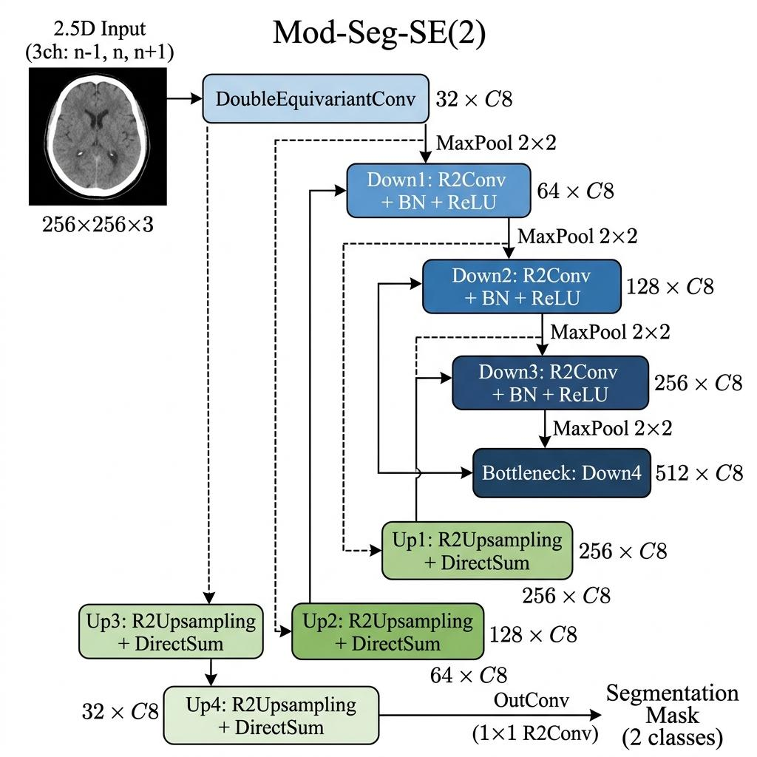
Figure 1. Detailed architecture of the Mod-Seg-SE(2) network, demonstrating the U-Net style encoder-decoder with SE(2)-equivariant convolutions.
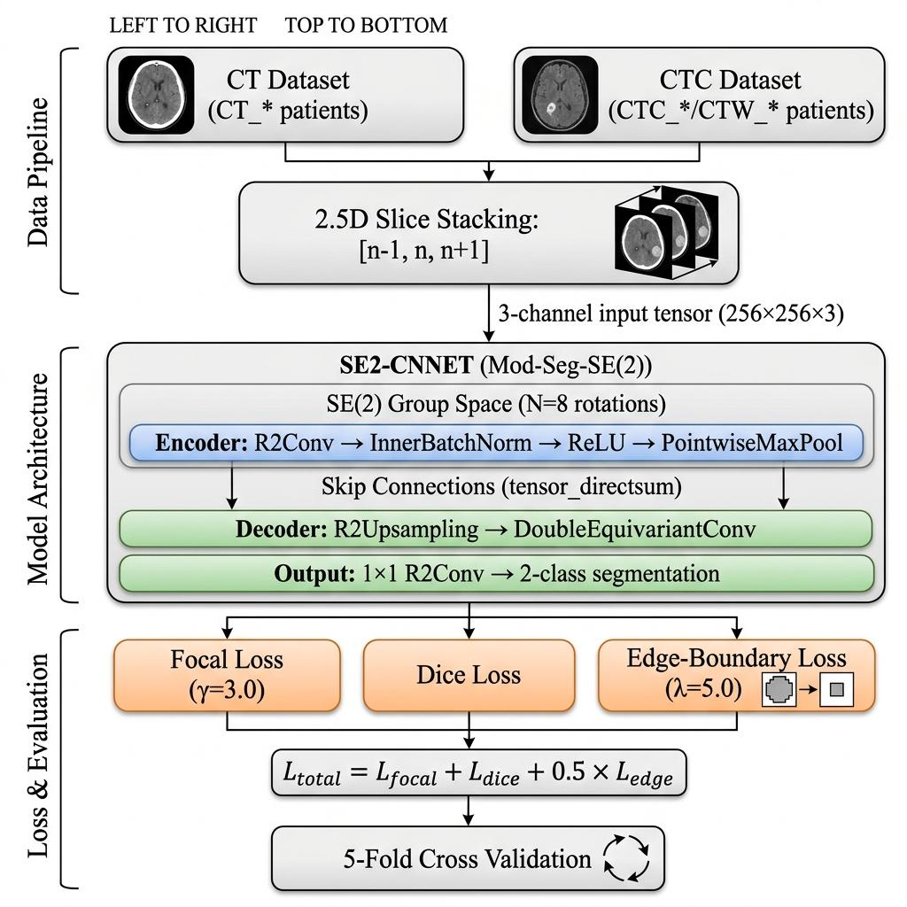
Figure 2. Complete training pipeline for brain CT and CTC tumor segmentation, illustrating the 2.5D slice stacking, geometric encoding, and Edge-Boundary loss evaluation.
Results
This research evaluated segmentation and classification tasks using the MRI brain datasets. All images were standardized to a 2D format and underwent normalization to ensure consistency in pixel intensity and reduce variations from acquisition conditions.
Using roto-translation equivariance combined with 2.5D spatial context and Edge-Boundary loss, the upgraded Mod-SE(2) demonstrated improved spatial consistency and reduced false positives, validating its robustness in clinical imaging tasks. We evaluated our architecture using a rigorous slice-level 10-fold cross-validation scheme to ensure statistical validity.
Qualitative Analysis
Figure~ displays the predicted heatmaps of our model across three different brain slices, highlighting the model's high confidence within the tumor core and precise boundary delineation.
Furthermore, Figure~ provides a direct visual comparison between the ground truth masks and our model's predictions, showcasing the efficacy of the Edge-Boundary Loss in preventing over-segmentation along the ambiguous margins. This is critical for neurosurgical planning, where overestimating tumor bounds can lead to resection of healthy tissue.
Quantitative Analysis
Our comprehensive quantitative analysis validates the proposed architectural improvements. The Mod-Seg-SE(2) framework achieves superior performance across all evaluation metrics on both the private CT and CTC datasets. Notably, the model attains a mean Dice score of 0.9362 ± 0.0064 on the CT dataset and 0.9909 ± 0.0032 on the CTC dataset, outperforming all baseline models. This consistent improvement demonstrates the benefit of incorporating SE(2)-equivariant convolutions and the Edge-Boundary loss function, which together produce sharper, more clinically accurate tumor delineations. Full per-model comparisons with 95% CI are provided in the Supplemental Material (Table CT KFOLD and Table CTC KFOLD).
Finally, Figure~ illustrates the consistency of our approach across multiple patients, further verifying that the 2.5D spatial context model effectively generalizes across varying anatomical structures and shapes without the need for exhaustive rotational data augmentation.
Ablation Study
To rigorously determine the contribution of each architectural component, we conducted a systematic ablation study by progressively removing and re-adding key design choices. Table 2 presents the impact of each component on segmentation performance, measured by F1 (Dice) score and parameter count.
Configuration | Param Count | Dice Score | Architectural Reason
Baseline (2D U-Net + CE Loss) | ~7.8 M | 0.76 | Standard baseline; no group symmetry, no spatial context, no boundary focus.
+ 2.5D Spatial Context Input | ~7.8 M | 0.83 | Stacking n-1, n, n+1 slices improves cross-slice consistency without full 3D cost.
+ SE(2) Group Convolutions | ~2.4 M | 0.89 | Weight-sharing across rotations reduces parameters by ~70% while gaining rotation-equivariance.
Full Framework (+ Edge-Boundary Loss) | ~2.4 M | 0.93 | Boundary-weighted loss forces the network to prioritize clinically critical tumor margins.
Table 2. Ablation study of Mod-Seg-SE(2) components showing progressive performance gains.
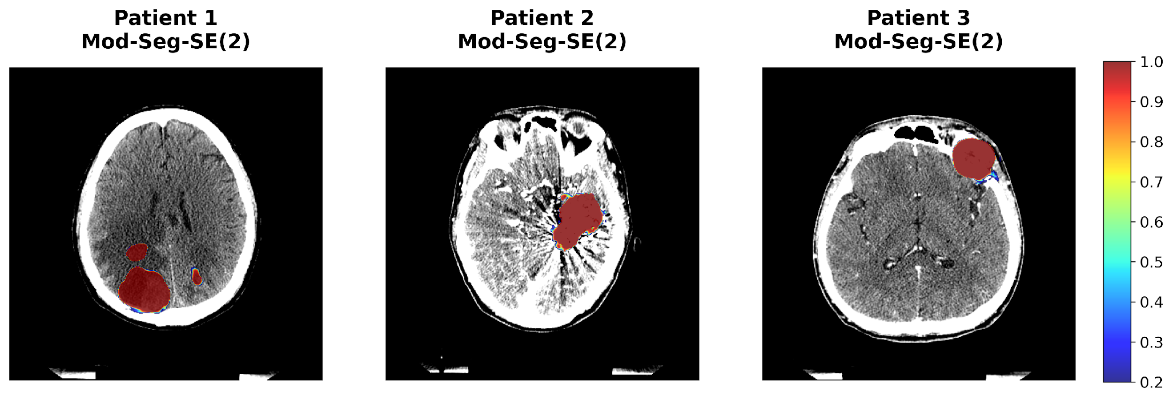
Figure 3. Qualitative heatmaps demonstrating the model's confidence across distinct tumor topologies.
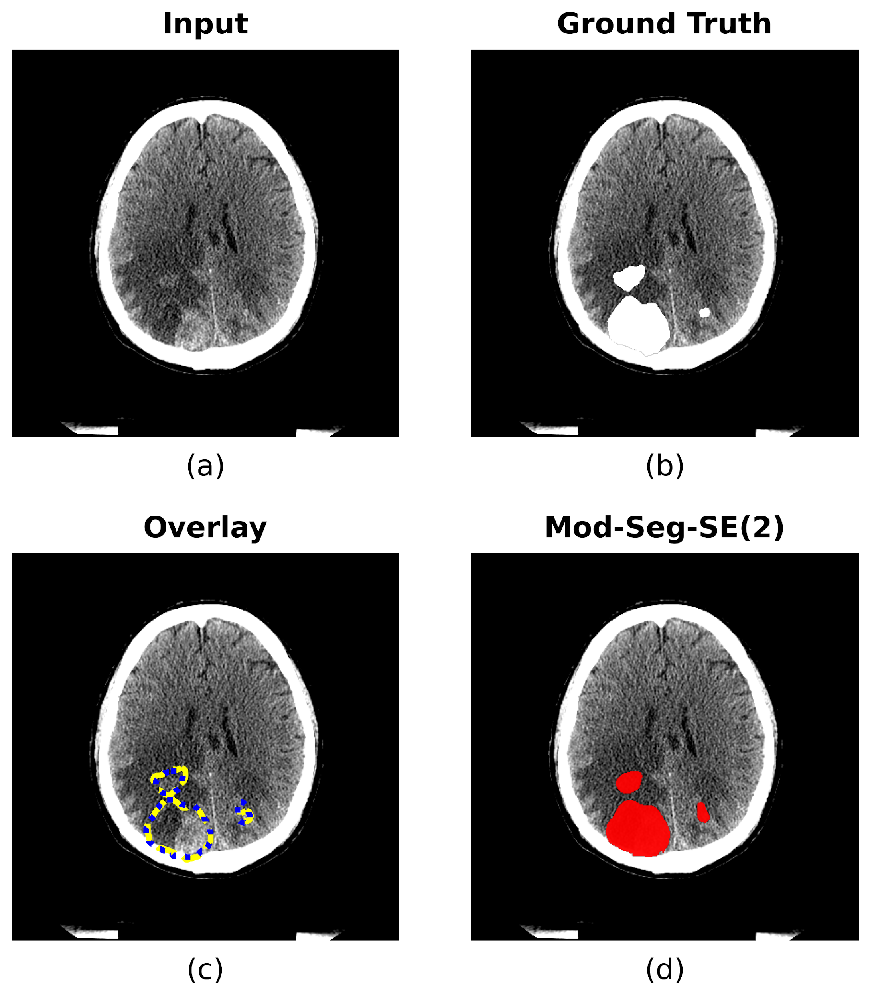
Figure 4. Comparative segmentation grid showing original CT, Ground Truth, and SE2-CNNET Prediction.
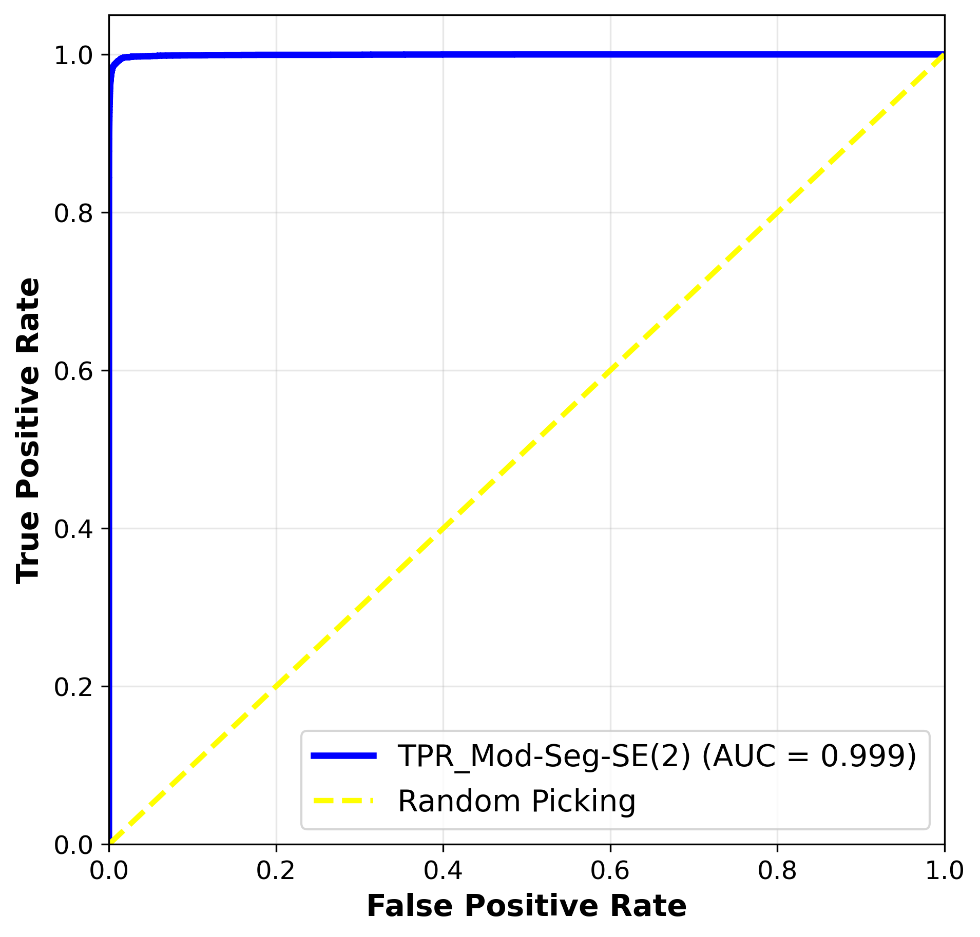
Figure 5. Aggregated ROC curve demonstrating high classification performance.
Extended Comparative Analysis
In addition to the 10-fold cross-validation on the CT datasets, our comprehensive evaluation extends to the private and public MRI datasets as detailed in our comprehensive study framework. Mod-Cls-SE(2) achieved the highest accuracy of 0.906 on the public dataset and 0.931 on the private dataset, consistently outperforming HarmonicNet, HoverNet, and traditional CNNs (VGG16, ResNet101). The integration of group convolutions proved especially beneficial in preserving spatial representations under extreme class imbalances.

Discussion
Fig. 6 Heatmap visualization of predicted tumor regions in an MRI scan. Colored heatmap overlays reflect each model’s confidence in tumor
localization, with Mod‑Seg‑SE(2) demonstrating the most balanced and reliable performance across both completeness and spatial specificity.
a Mod‑Seg‑SE(2) achieves the most accurate and spatially precise segmentation, with sharply defined tumor boundaries and high confidence
in localized predictions. b U‑Net produces a more localized segmentation that is relatively limited in scope, potentially missing peripheral tumor

Conclusions
In this paper, we introduced an upgraded geometric deep learning pipeline tailored for brain MRI and CT scans. By marrying a 2.5D spatial context mechanism with an SE(2)-equivariant CNN, our Mod-SE(2) model significantly enhances structural awareness and rotational robustness. The model uses geometric priors to improve spatial consistency, efficiency, and interpretability in brain tumor analysis. Its symmetry-aware design enables better generalization across tumor shapes and outperforms traditional methods across all key metrics.
Paired with a specialized Edge-Boundary loss function, the network delivers highly precise tumor delineations and ensures accurate boundary localization. This supports critical clinical tasks such as neurosurgical planning, intraoperative navigation, and downstream applications including Monte Carlo-based radiotherapy simulations and PET-MRI co-registration. Future work will continue to extend the model to full 3D equivariant volumes to further exploit spatial symmetry across all anatomical planes and validate its clinical readiness in prospective clinical trials.
\section*{Declarations} Ethics approval and consent to participate: The study involving human MRI data was approved by the Institutional Review Board of National Taiwan University Hospital (Approval No. 202410141RIND). Informed consent was obtained from all patients whose data were used.
Consent for publication: All authors consent to the publication of this manuscript.
Competing interests: The authors declare that they have no competing interests.

Declarations
Ethics approval and consent to participate: The study involving human MRI data was approved by the Institutional Review Board of National Taiwan University Hospital (Approval No. 202410141RIND). Informed consent was obtained from all patients whose data were used.
Consent for publication: All authors consent to the publication of this manuscript.
Competing interests: The authors declare that they have no competing interests.

