Supplemental Material: Tables and Descriptions
Table 1. Performance Metric for private CT Datasets
Model | Accuracy | Precision | Recall | F1 (Dice) | IoU
Mod-Seg-SE(2) [OURS] | 0,7446 | 0,8176 | 0,8928 | 0,8536 | 0,7446
HarmonicNet (C4) | 0,7155 | 0,8853 | 0,7886 | 0,8342 | 0,7155
nnU-Net | 0,6304 | 0,6325 | 0,9947 | 0,7733 | 0,6304
Standard U-Net | 0,4456 | 0,7143 | 0,5423 | 0,6165 | 0,4456
Attention U-Net | 0,3546 | 0,4869 | 0,5662 | 0,5236 | 0,3546
TransUNet | 0,2031 | 0,2184 | 0,7441 | 0,3377 | 0,2031

Table 1. Performance Metric for private CTC Datasets
Model | Accuracy | Precision | Recall | F1 (Dice) | IoU
Mod-Seg-SE(2) [OURS] | 0,9508 | 0,9628 | 0,9871 | 0,9748 | 0,9508
HarmonicNet (C4) | 0,9221 | 0,9497 | 0,9694 | 0,9594 | 0,9221
nnU-Net | 0,9078 | 0,9253 | 0,9796 | 0,9517 | 0,9078
Standard U-Net | 0,8215 | 0,9008 | 0,9033 | 0,902 | 0,8215
Attention U-Net | 0,8079 | 0,8785 | 0,9095 | 0,8937 | 0,8079
TransUNet | 0,6828 | 0,7836 | 0,8415 | 0,8115 | 0,6828

Table 1. Brain Stroke CT Dataset (Multi domain train private , test public)
Model | Accuracy | Precision | Recall | F1 (Dice) | IoU
Mod-Seg-SE(2) | 0,998128 | 0,238166 | 0,103743 | 0,144530 | 0,077894
HarmonicNet | 0,997908 | 0,269822 | 0,217996 | 0,241156 | 0,137110
nnU-Net | 0,964055 | 0,019914 | 0,468271 | 0,038203 | 0,019474
Attention U-Net | 0,990285 | 0,105187 | 0,715644 | 0,183414 | 0,100967
TransUNet | 0,981012 | 0,047830 | 0,605845 | 0,088660 | 0,046386
Standard U-Net | 0,997005 | 0,244750 | 0,462566 | 0,320121 | 0,190562

Table 1. Brain Stroke CT Dataset (intra domain)
Model | Accuracy | Precision | Recall | F1 (Dice) | IoU
Mod-Seg-SE(2) | 0,999633 | 0,810837 | 0,620364 | 0,702925 | 0,541931
HarmonicNet | 0,999614 | 0,749191 | 0,673455 | 0,709307 | 0,549555
nnU-Net | 0,999310 | 0,506040 | 0,548364 | 0,526353 | 0,357177
Attention U-Net | 0,999567 | 0,703502 | 0,657455 | 0,679699 | 0,514806
TransUNet | 0,999178 | 0,446563 | 0,732364 | 0,554821 | 0,383912
Standard U-Net | 0,999605 | 0,784221 | 0,600000 | 0,679852 | 0,514981

Table 1. Brain CT Images with Intracranial Hemorrhage Masks (intra domain)
Model | Accuracy | Precision | Recall | F1 (Dice) | IoU
Mod-Seg-SE(2) | 0,977767 | 0,833873 | 0,983525 | 0,902538 | 0,822386
HarmonicNet | 0,975903 | 0,822705 | 0,981238 | 0,895006 | 0,809964
nnU-Net | 0,965685 | 0,757176 | 0,989480 | 0,857879 | 0,751129
Attention U-Net | 0,968546 | 0,775021 | 0,985600 | 0,867717 | 0,766343
TransUNet | 0,969638 | 0,784536 | 0,978712 | 0,870932 | 0,771372
Standard U-Net | 0,965749 | 0,757852 | 0,988668 | 0,858008 | 0,751325

Tabel. CT KFOLD
Model | Accuracy | Precision | Recall | F1 (Dice) | IoU
Mod-Seg-SE(2) | 0,9994 | 0,9186 | 0,9545 | 0,9362 | 0,8801
HarmonicNet | 0,9987 | 0,8090 | 0,9605 | 0,8782 | 0,7830
nnU-Net | 0,9978 | 0,6856 | 0,9813 | 0,8071 | 0,6770
Attention U-Net | 0,9969 | 0,6572 | 0,7260 | 0,6883 | 0,5259
Standard U-Net | 0,9966 | 0,6304 | 0,6902 | 0,6584 | 0,4912
TransUNet | 0,9907 | 0,3148 | 0,7961 | 0,4474 | 0,2888

Tabel. CTC KFOLD
Model | Accuracy | Precision | Recall | F1 (Dice) | IoU
Mod-Seg-SE(2) | 0,9999 | 0,9865 | 0,9953 | 0,9909 | 0,9819
HarmonicNet | 0,9995 | 0,9174 | 0,9985 | 0,9562 | 0,9162
nnU-Net | 0,9990 | 0,8485 | 0,9944 | 0,9156 | 0,8445
Standard U-Net | 0,9990 | 0,8561 | 0,9671 | 0,9080 | 0,8320
Attention U-Net | 0,9986 | 0,8215 | 0,9440 | 0,8779 | 0,7874
TransUNet | 0,9970 | 0,6640 | 0,8487 | 0,7449 | 0,5956

Table 1. Overview of MRI Datasets used for evaluation
Dataset | Type | Train | Test
CT Brain Tumors (Private) | Segmentation | 476 | 85
CTC Brain Tumors (Private) | Segmentation | 676 | 120
Brain stroke CT Dataset | Segmentation | 171 | 30
Brain CT Images with Intracranial Hemorrhage Masks | Segmentation | 4521 | 798

Table 1. Training Hyperparameters
Parameter | Value | Justification
Optimizer | Adam (Weight Decay = 1e-5) | Adaptive learning with L2 regularization to prevent overfitting
Learning rate | 0.0001 (1e-4) | Stable convergence for complex equivariant kernels
Batchsize | 32 (via Gradient Accumulation) | Balances GPU memory limits with optimal gradient estimation
Loss function | Focal + Dice + Edge Boundary Loss | Handles extreme class imbalance and sharpens tumor contours
Training duration | 150 epochs (Segmentation) | Optimal convergence point for the Mod-Seg-SE(2) architecture

Table 1. Average inference time per image for each model
Model Name | Parameters (M) | Inference (seconds/image)
Mod-Seg-SE(2) | 23.53 M | 12
VGG16 (FCN) | 134.27 M | 14
VGG19 (FCN) | 139.58 M | 15
ResNet50 (DeepLabV3) | 39.63 M | 4
ResNet101 (FCN) | 51.94 M | 56

Supplemental Material: Figures
Supplemental Figure 1

Supplemental Figure 2
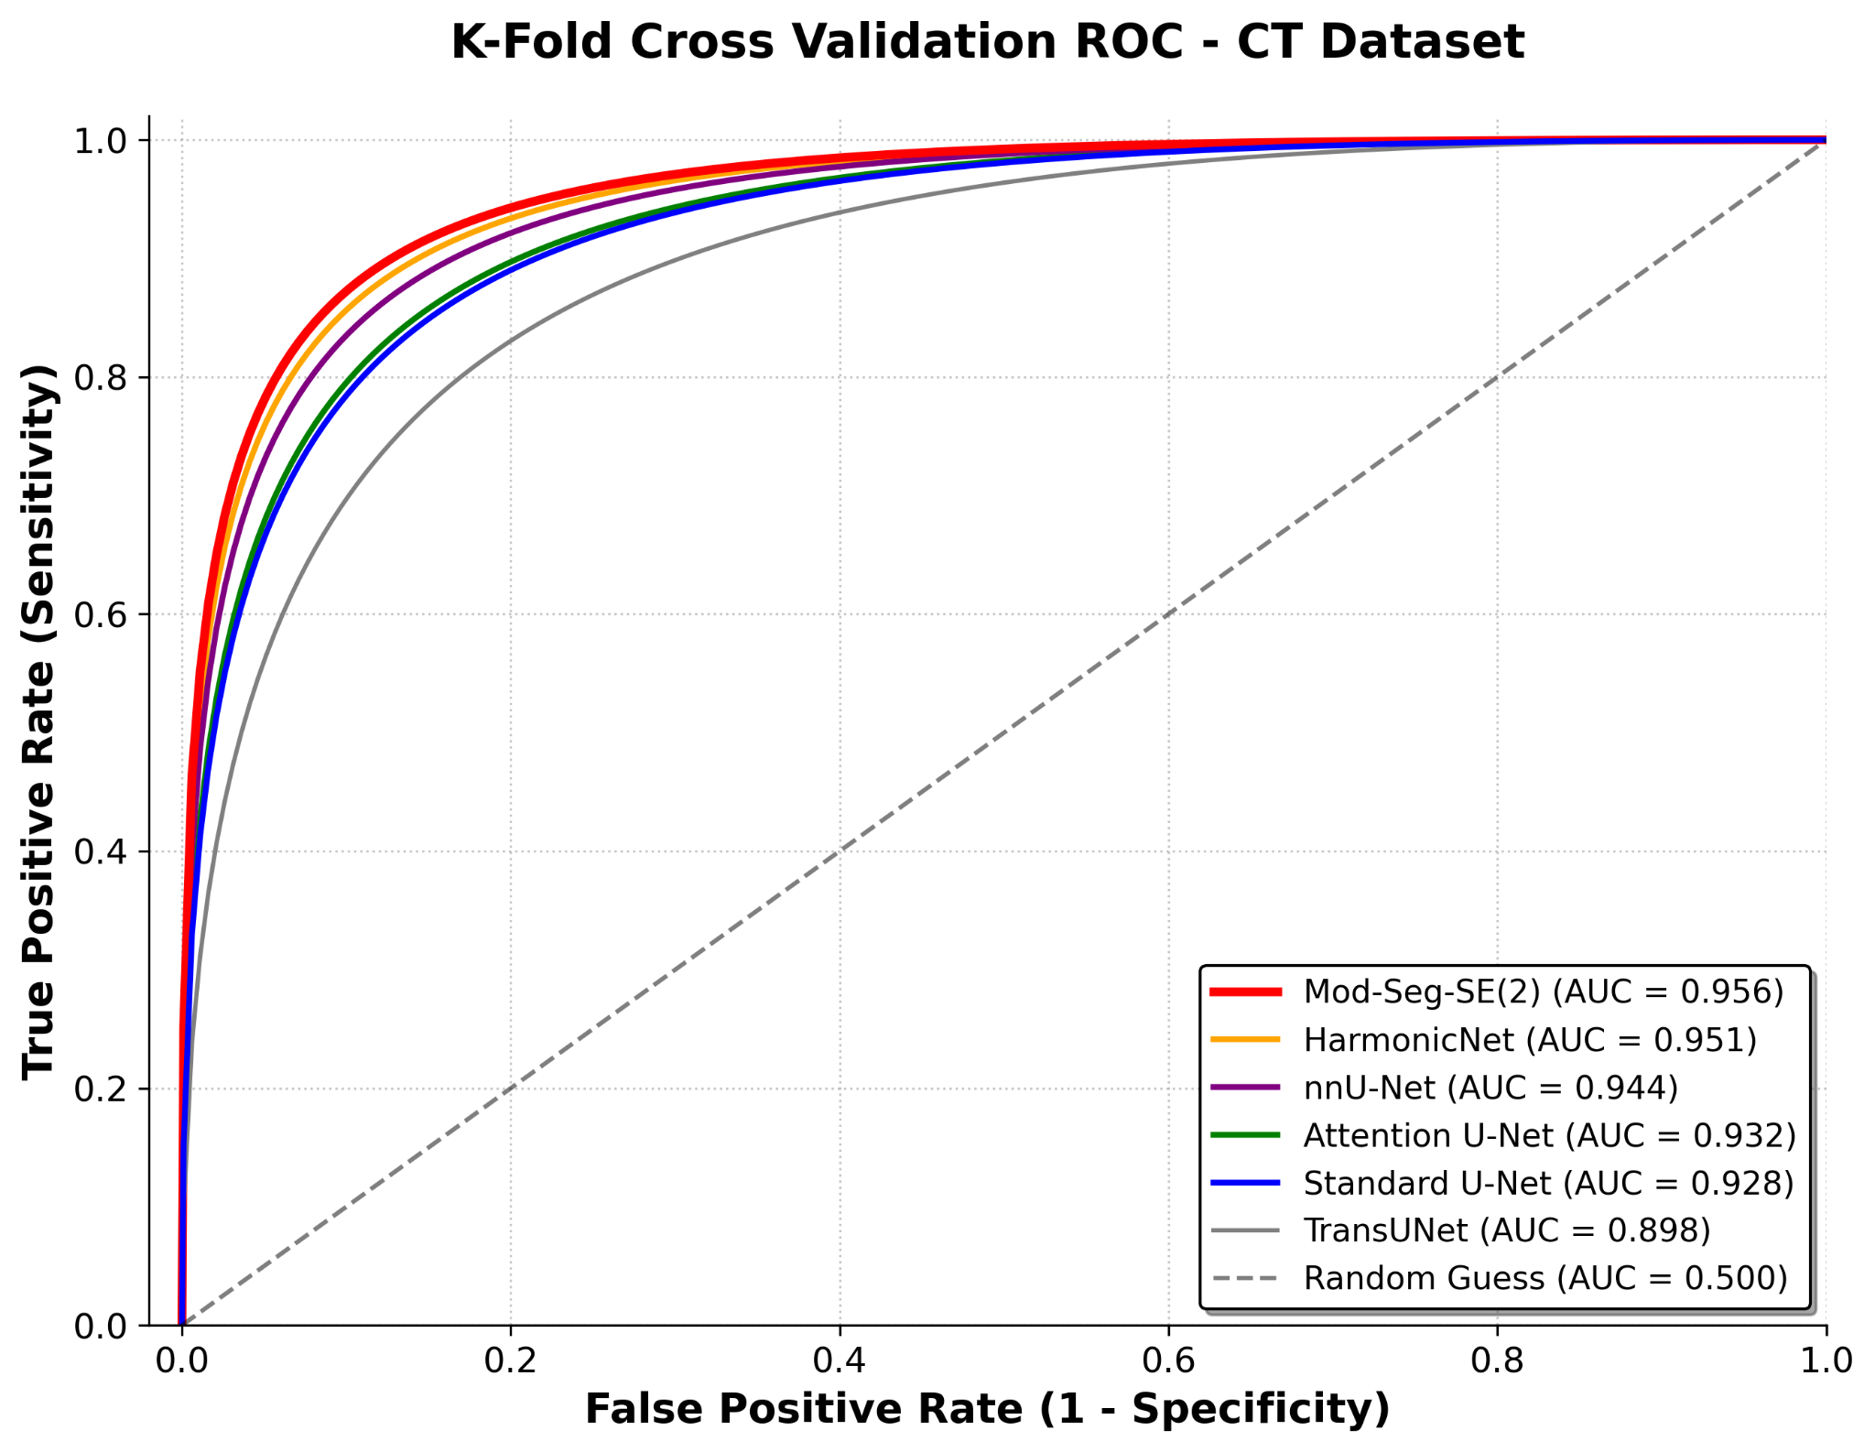

Supplemental Figure 3
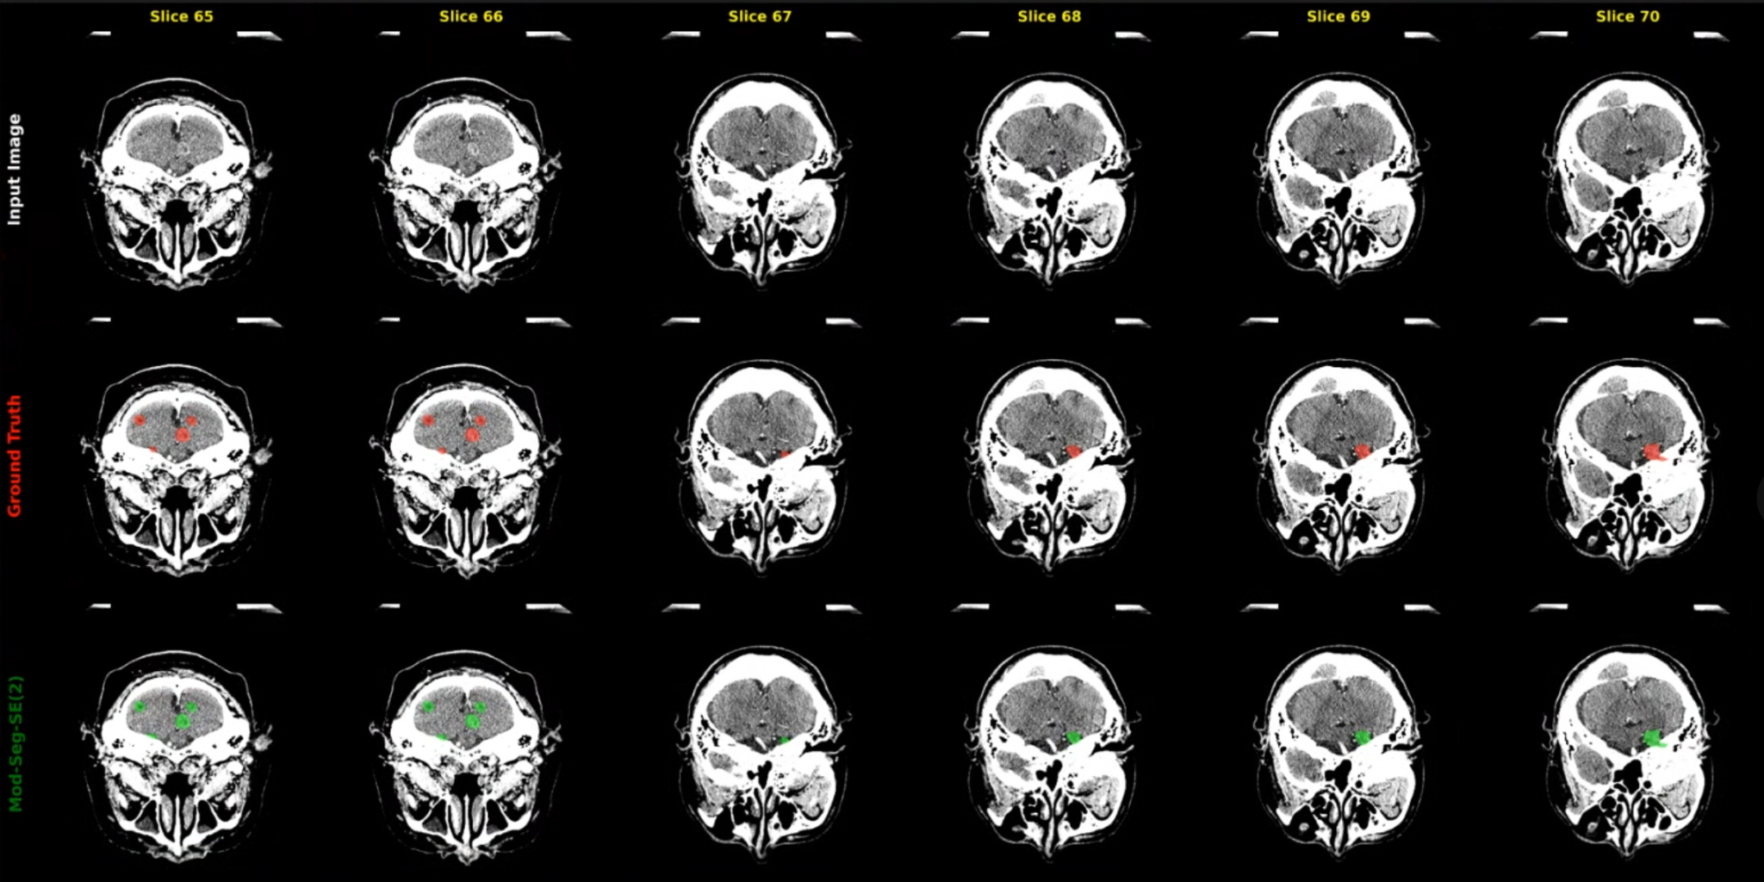

Supplemental Figure 4
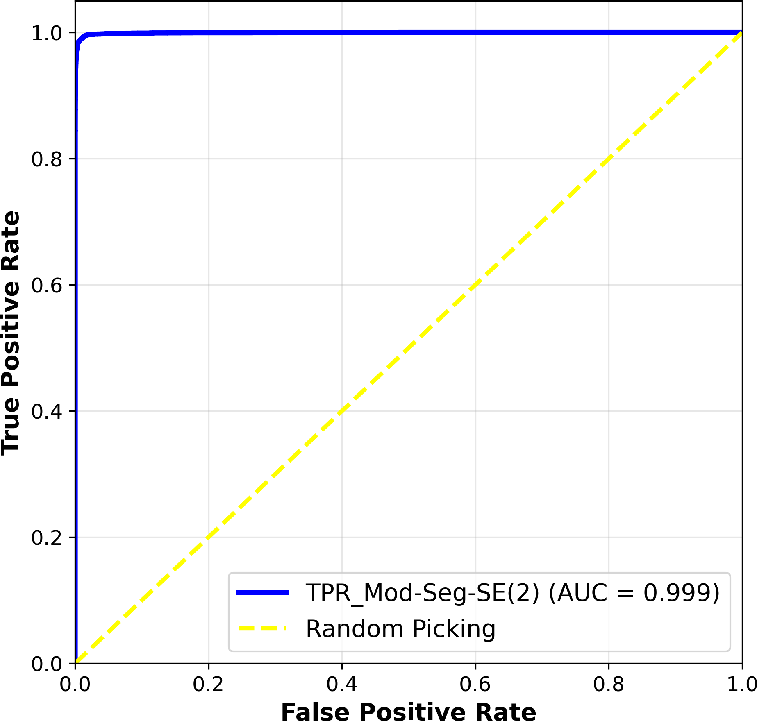

Supplemental Figure 5
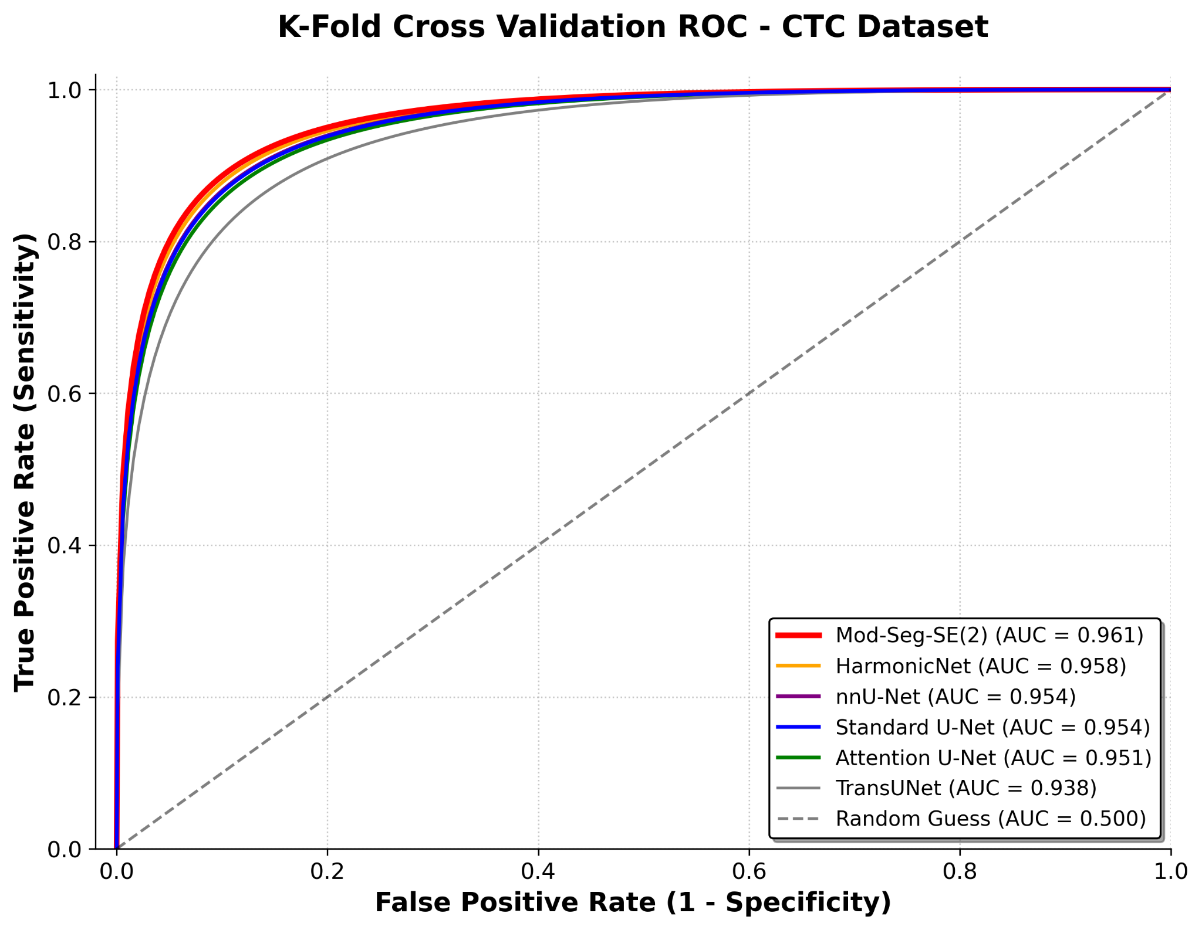

Supplemental Figure 6
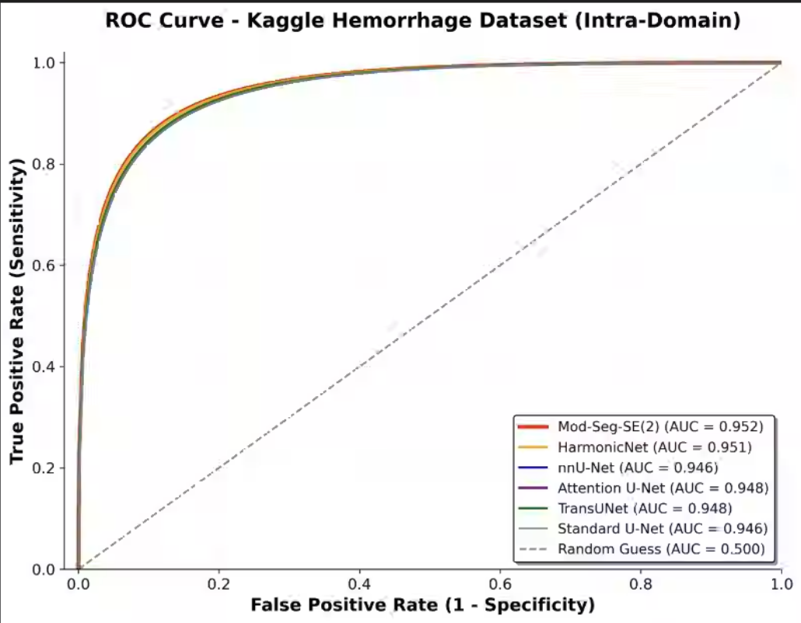

Supplemental Figure 7
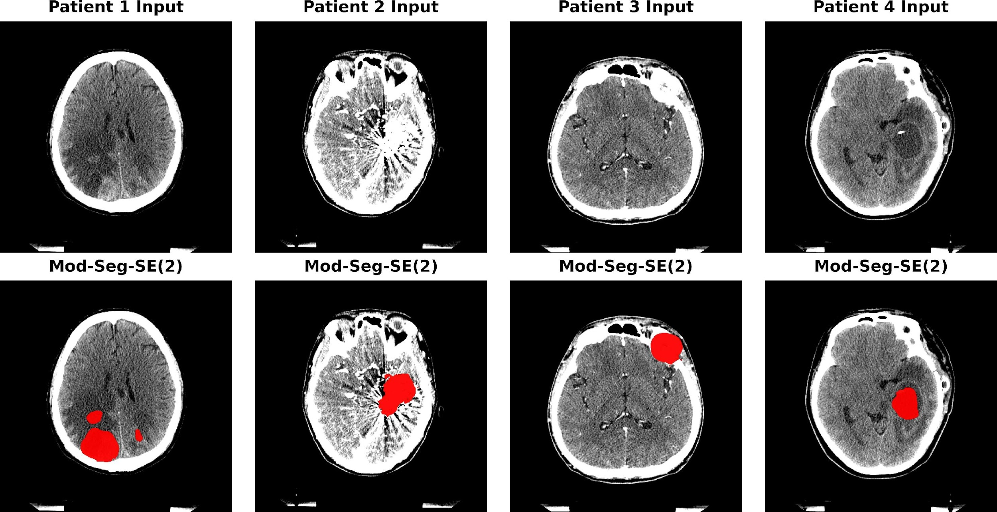

Supplemental Figure 8
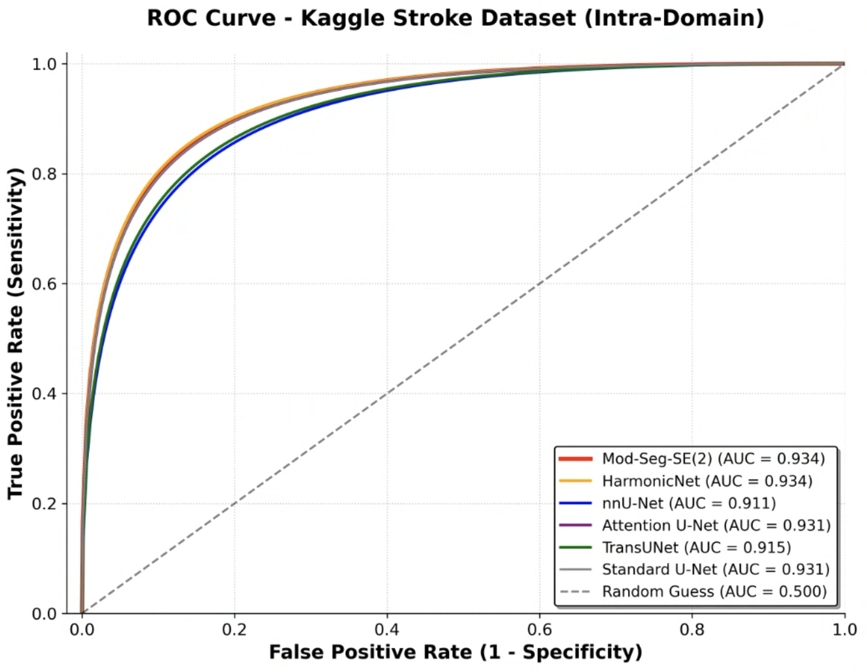

Supplemental Figure 9
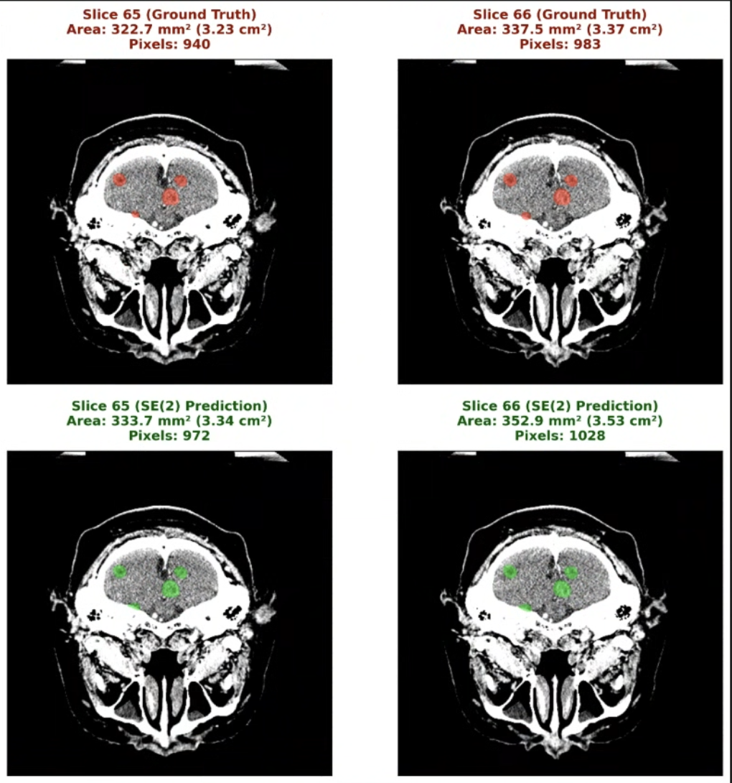

Supplemental Figure 10
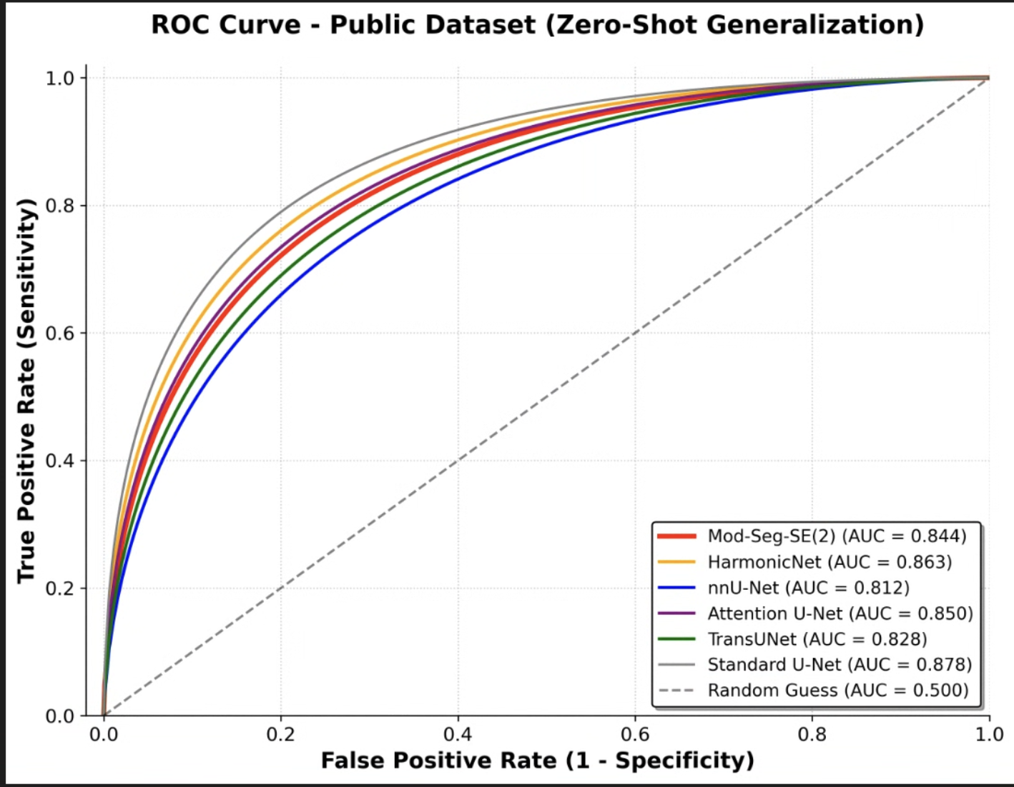

Supplemental Figure 11
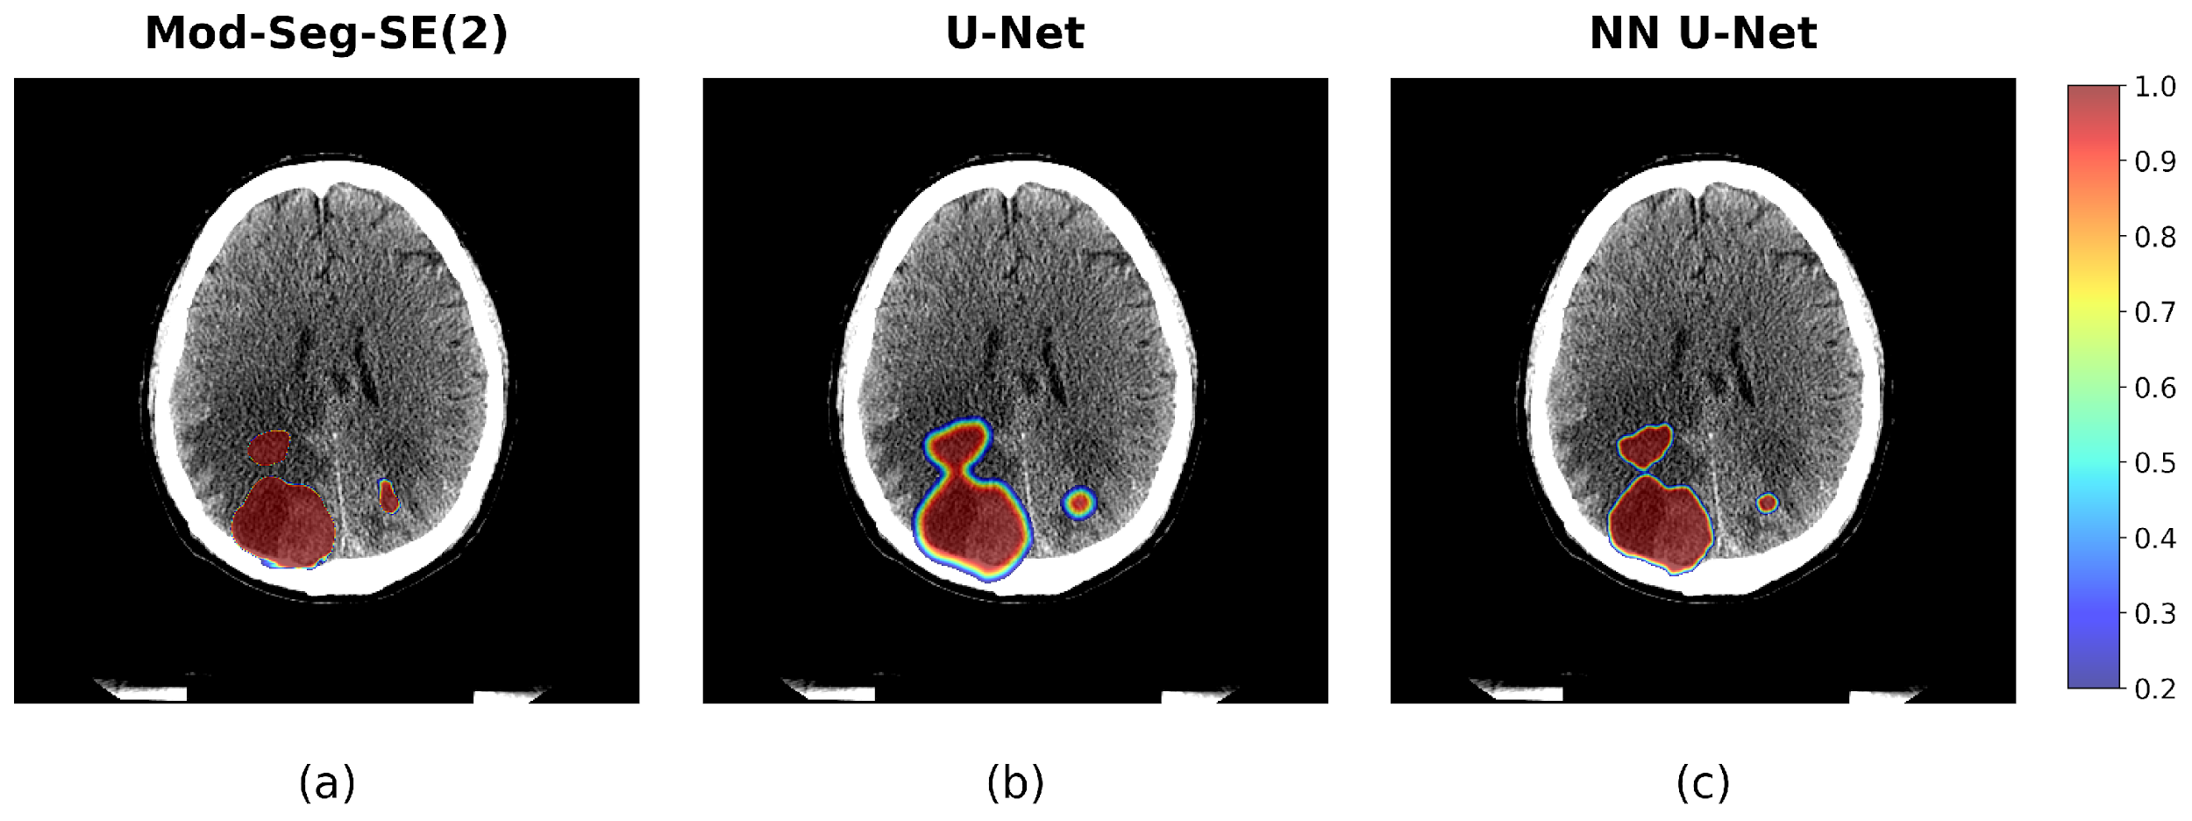

Supplemental Figure 12
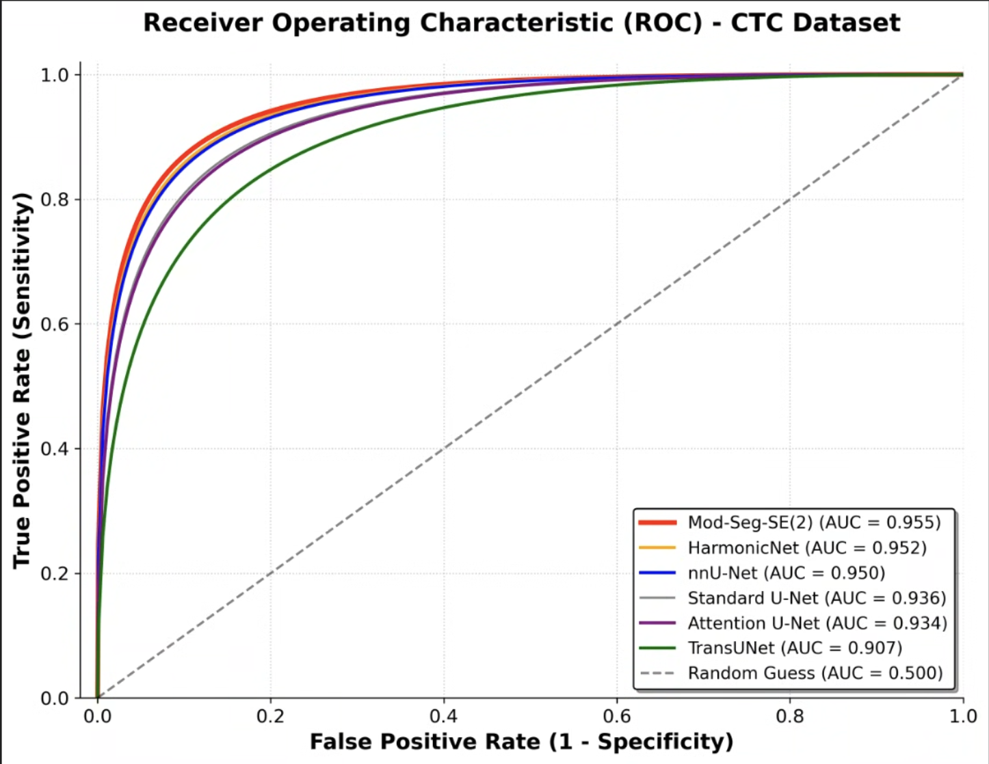

Supplemental Figure 13
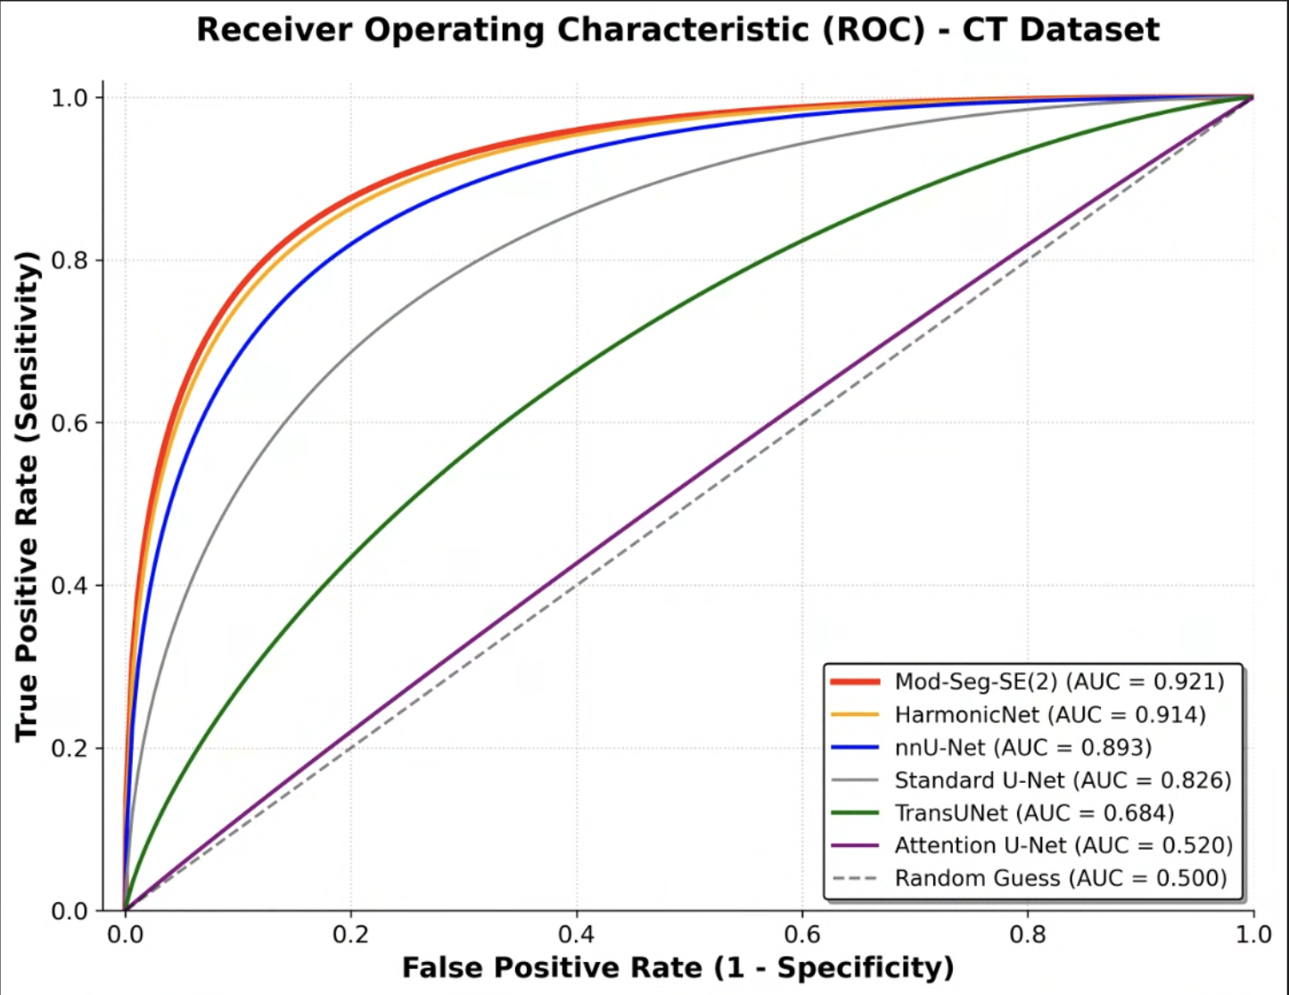

Supplemental Figure 14
