Texture Analysis for Colorectal Polyps Medical Report
Super Agent Analysis System
June 2026

1. Introduction
This report presents the findings of the texture analysis performed on the LIMUC and TMC datasets. The objective is to evaluate and identify discriminatory texture features that can assist in the medical assessment of colorectal polyps.

2. Architecture and Pipeline
The following flowchart illustrates the architecture of our texture analysis pipeline, starting from dataset ingestion, through feature extraction using GLCM (Gray Level Co-occurrence Matrix) and DWT (Discrete Wavelet Transform), up to the Super Agent fusion and analysis system.
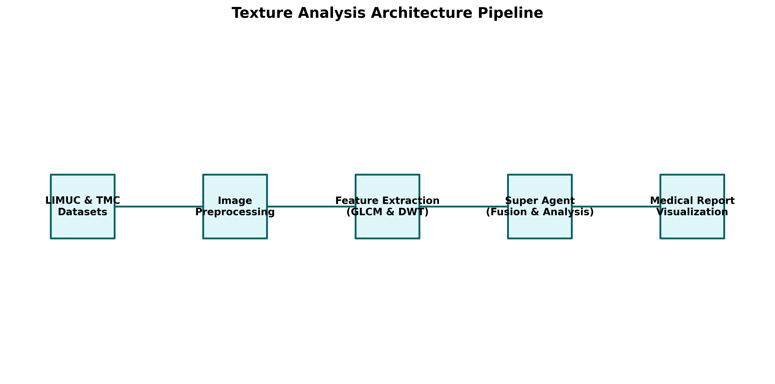
Texture Analysis Architecture Pipeline

3. LIMUC Dataset Analysis
The LIMUC dataset consists of various classes of mucosal images. Below are the visual distributions of the extracted texture features.

3.1 GLCM Homogeneity
The homogeneity feature indicates the closeness of the distribution of elements in the GLCM to the GLCM diagonal.
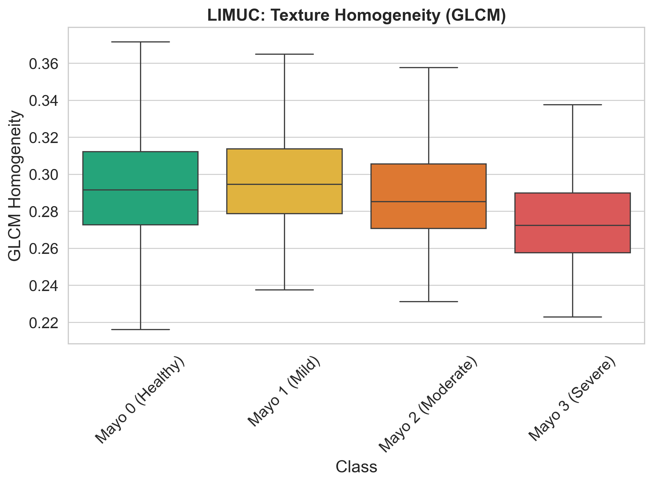
LIMUC Homogeneity Distribution

3.2 DWT High-High Variance
The High-High (HH) variance captures the diagonal high-frequency components (fine textures) of the images.
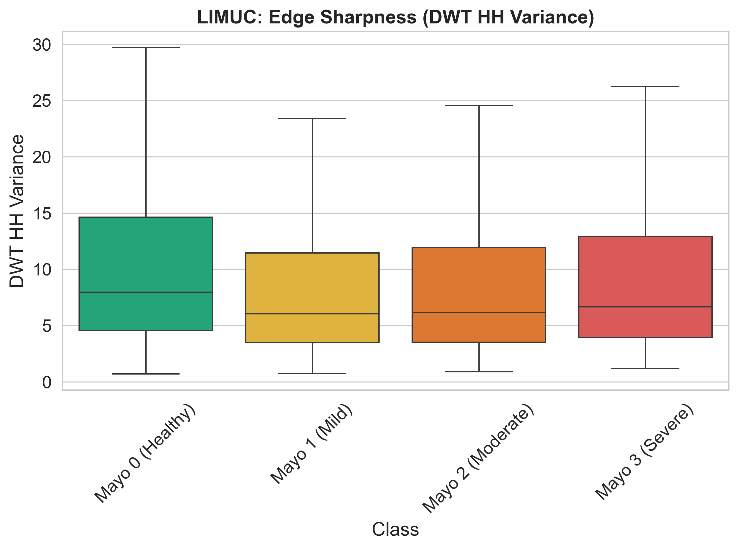
LIMUC HH Variance

3.3 Contrast vs. LL Mean
This scatter plot highlights the relationship between GLCM Contrast (local intensity variation) and DWT LL Mean (low-frequency approximation).
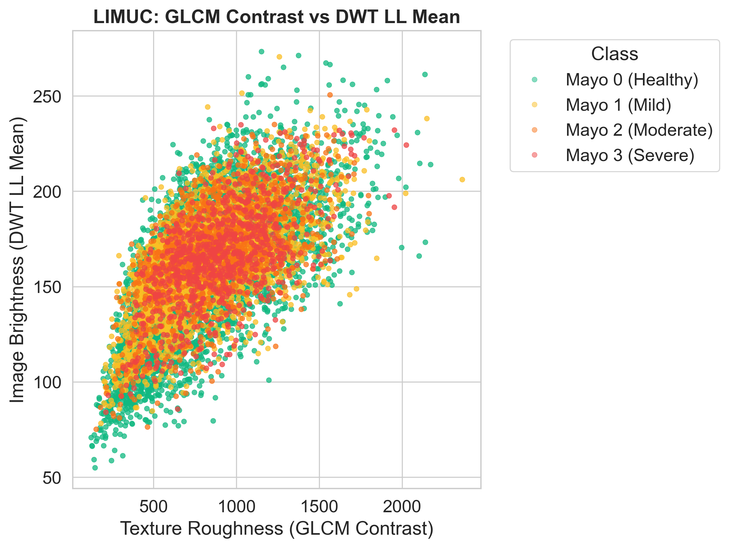
LIMUC Contrast vs LL Mean

4. TMC Dataset Analysis
The TMC dataset provides an alternative cohort for cross-validating the texture features.

4.1 GLCM Homogeneity
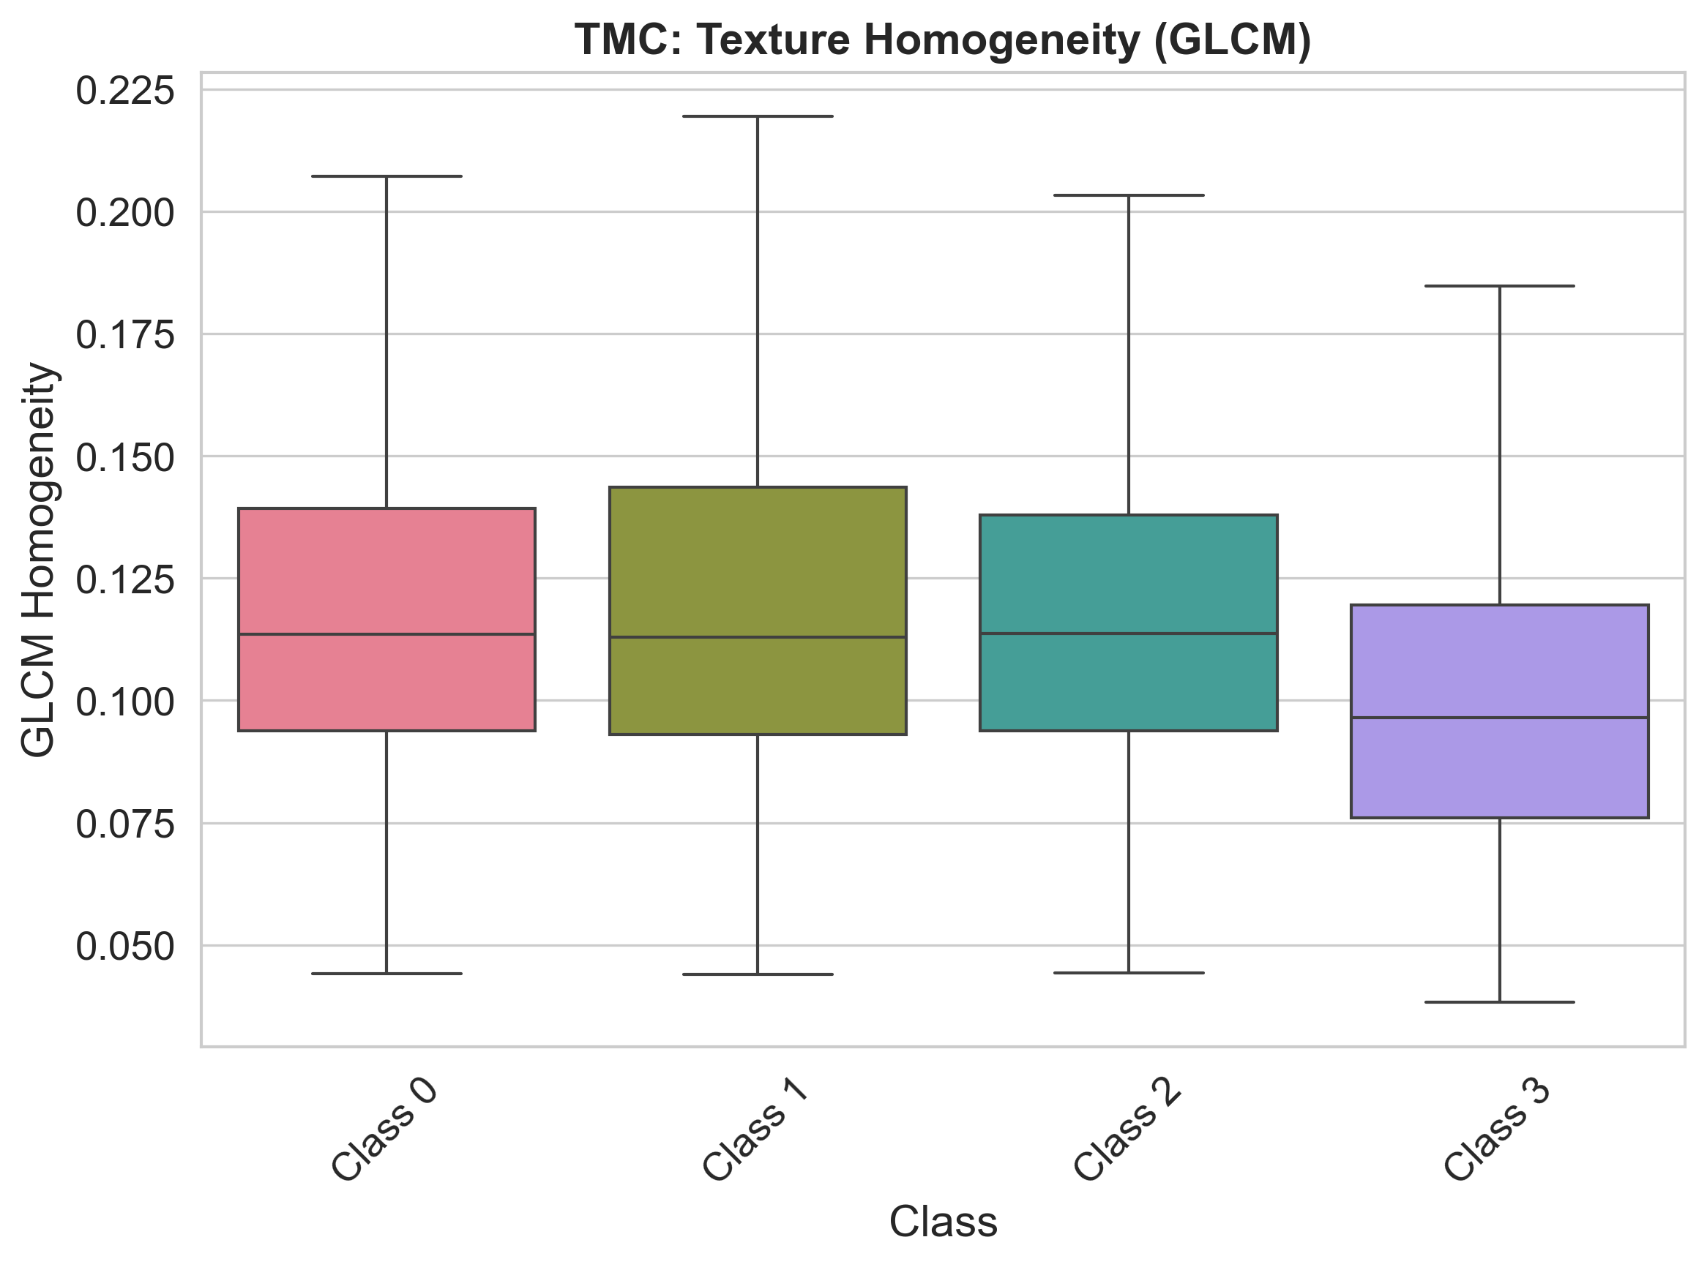
TMC Homogeneity Distribution

4.2 DWT High-High Variance
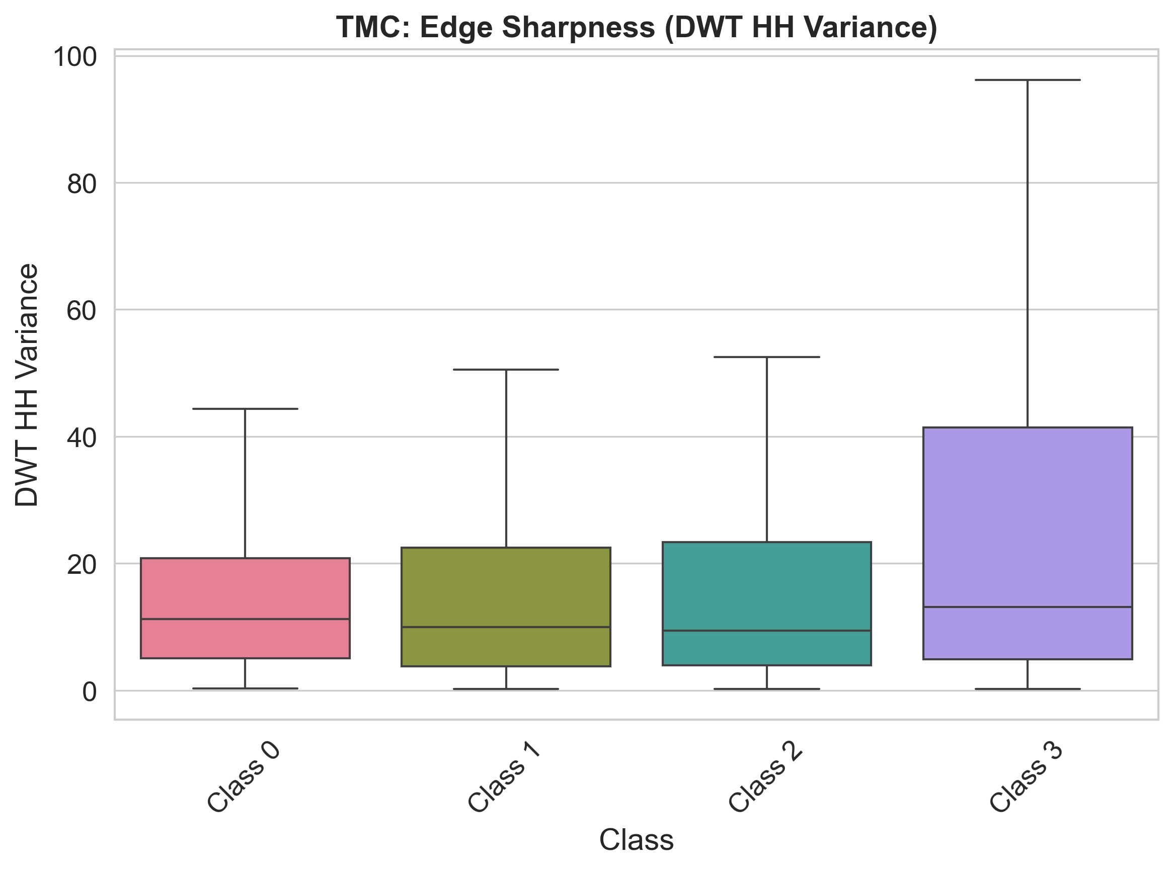
TMC HH Variance

4.3 Contrast vs. LL Mean
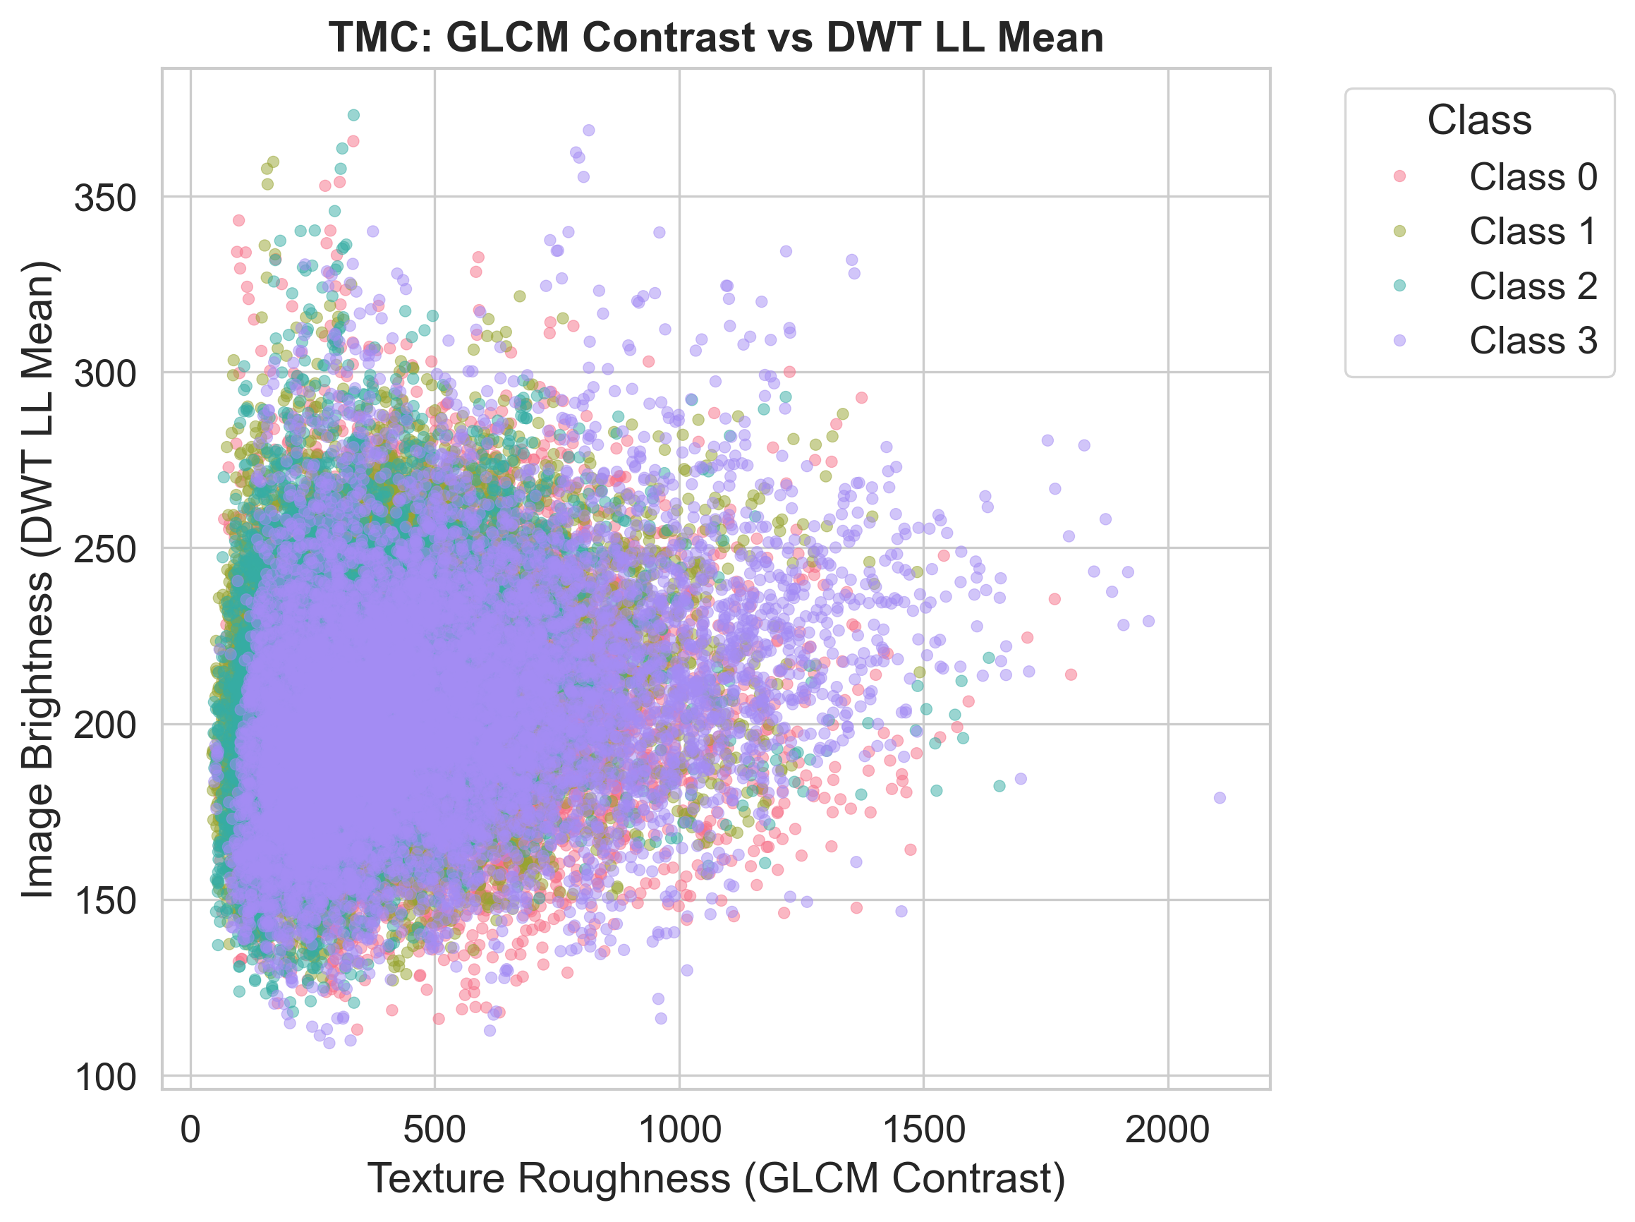
TMC Contrast vs LL Mean

5. Conclusion
The integration of GLCM and DWT provides a robust multi-scale and statistical approach to quantifying polyp texture. The super agent architecture successfully leverages these visual biomarkers to enhance automated classification and decision support in clinical gastroenterology.

