Patient-Level Evaluation Metrics

Table 5 — Intra-domain patient-level confusion matrices
Dataset | Accuracy | Class | Accuracy 95% CI | Cohen's κ | Quad κ | EC | Precision (PPV) | Recall | F1 Score | NPV
LIMUC Dataset  N = 112 | 0.9464 | MES 0 | (0.8880 - 0.9752) | 1.0000 | 1.0000 | 0.0637 | 1.0000 | 1.0000 | 1.0000 | 1.0000
 |  | MES 1 | (0.8880 - 0.9752) | 0.8897 | 0.9163 | 0.0377 | 0.8788 | 0.9667 | 0.9206 | 0.9873
 |  | MES 2 | (0.8880 - 0.9752) | 0.7553 | 0.9118 | 0.0461 | 0.8462 | 0.7333 | 0.7857 | 0.9596
 |  | MES 3 | (0.8880 - 0.9752) | 0.9364 | 0.9901 | 0.0501 | 1.0000 | 0.8889 | 0.9412 | 0.9904
TMC-UCM Dataset  N = 61 | 0.9344 | MES 0 | (0.8432 - 0.9742) | 0.9672 | 0.9117 | 0.0551 | 0.9688 | 1.0000 | 0.9841 | 1.0000
 |  | MES 1 | (0.8432 - 0.9742) | 0.9585 | 0.8821 | 0.0732 | 0.9412 | 1.0000 | 0.9697 | 1.0000
 |  | MES 2 | (0.8432 - 0.9742) | 0.8391 | 0.9413 | 0.0410 | 0.7500 | 1.0000 | 0.8571 | 1.0000
 |  | MES 3 | (0.8432 - 0.9742) | 0.6347 | 0.7876 | 0.0583 | 1.0000 | 0.5000 | 0.6667 | 0.9298

Table 6 — Multi-domain patient-level LIMUC
Dataset | Accuracy | Class | Accuracy 95% CI | Cohen's κ | Quad κ | EC | Precision (PPV) | Recall | F1 Score | NPV
Dataset NTUH → LIMUC  N = 112 | 0.9196 | MES 0 | (0.8543 - 0.9571) | 0.9643 | 0.9887 | 0.0349 | 0.9825 | 0.9825 | 0.9825 | 0.9818
 |  | MES 1 | (0.8543 - 0.9571) | 0.8662 | 0.9010 | 0.0408 | 0.8750 | 0.9333 | 0.9032 | 0.9750
 |  | MES 2 | (0.8543 - 0.9571) | 0.7232 | 0.8994 | 0.0325 | 0.8462 | 0.6875 | 0.7586 | 0.9495
 |  | MES 3 | (0.8543 - 0.9571) | 0.8275 | 0.9729 | 0.0479 | 0.8000 | 0.8889 | 0.8421 | 0.9902
LIMUC → Dataset NTUH  N = 35 | 0.9429 | MES 0 | (0.8139 - 0.9842) | 0.9427 | 0.9794 | 0.0514 | 0.9474 | 1.0000 | 0.9730 | 1.0000
 |  | MES 1 | (0.8139 - 0.9842) | 0.8606 | 0.8875 | 0.0449 | 1.0000 | 0.8182 | 0.9000 | 0.9231
 |  | MES 2 | (0.8139 - 0.9842) | 0.8727 | 0.9547 | 0.0756 | 0.8000 | 1.0000 | 0.8889 | 1.0000
 |  | MES 3 | (0.8139 - 0.9842) | 1.0000 | 1.0000 | 0.0496 | 1.0000 | 1.0000 | 1.0000 | 1.0000

Table 7 — Multi-domain patient-level TMC-UCM
Dataset | Accuracy | Class | Accuracy 95% CI | Cohen's κ | Quad κ | EC | Precision (PPV) | Recall | F1 Score | NPV
Dataset NTUH → TMC-UCM  N = 61 | 0.9180 | MES 0 | (0.8221 - 0.9645) | 0.9672 | 0.9905 | 0.0788 | 1.0000 | 0.9688 | 0.9841 | 0.9667
 |  | MES 1 | (0.8221 - 0.9645) | 0.9568 | 0.9690 | 0.0560 | 0.9375 | 1.0000 | 0.9677 | 1.0000
 |  | MES 2 | (0.8221 - 0.9645) | 0.7123 | 0.8966 | 0.0366 | 0.7500 | 0.7500 | 0.7500 | 0.9623
 |  | MES 3 | (0.8221 - 0.9645) | 0.6303 | 0.9425 | 0.0692 | 0.6667 | 0.6667 | 0.6667 | 0.9636
TMC-UCM → Dataset NTUH  N = 35 | 0.9143 | MES 0 | (0.7762 - 0.9704) | 0.9427 | 0.9805 | 0.0718 | 0.9474 | 1.0000 | 0.9730 | 1.0000
 |  | MES 1 | (0.7762 - 0.9704) | 0.8600 | 0.8923 | 0.0609 | 0.9000 | 0.9000 | 0.9000 | 0.9600
 |  | MES 2 | (0.7762 - 0.9704) | 0.7200 | 0.8996 | 0.0724 | 1.0000 | 0.6000 | 0.7500 | 0.9375
 |  | MES 3 | (0.7762 - 0.9704) | 0.7853 | 0.9666 | 0.0572 | 0.6667 | 1.0000 | 0.8000 | 1.0000

Confusion Matrices — Patient-Level

Table 5 — Intra-domain patient-level confusion matrices
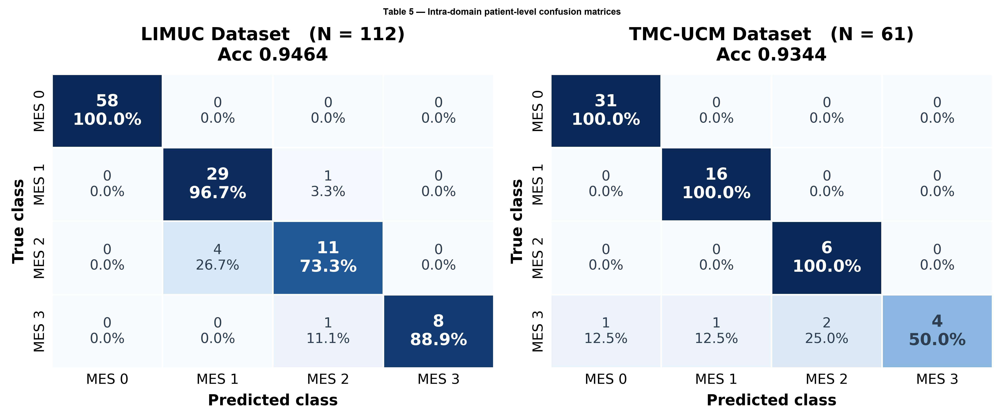

Table 6 — Multi-domain patient-level LIMUC
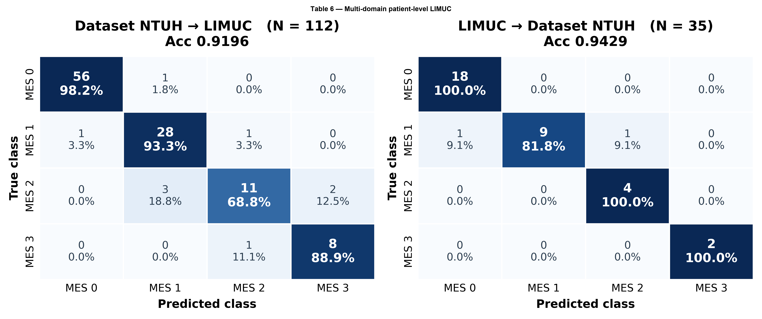

Table 7 — Multi-domain patient-level TMC-UCM
