Table 1. Intra-domain classification results.
Dataset | Accuracy | Class | Accuracy  95% CI | Cohen's κ | Quad κ | EC | Precision  (PPV) | Recall | F1 Score | NPV
Dataset 1  N = 104 | 0.9615 | MES 0 | (0.9053 - 0.9849) | 0.9329 | 0.9303 | 0.0632 | 0.9688 | 0.9394 | 0.9538 | 0.9722
 |  | MES 1 | (0.9053 - 0.9849) | 0.9458 | 0.9700 | 0.0386 | 0.9583 | 0.9583 | 0.9583 | 0.9875
 |  | MES 2 | (0.9053 - 0.9849) | 0.9487 | 0.9430 | 0.0486 | 0.9615 | 0.9615 | 0.9615 | 0.9872
 |  | MES 3 | (0.9053 - 0.9849) | 0.9707 | 0.9475 | 0.0465 | 0.9545 | 1.0000 | 0.9767 | 1.0000
Dataset 2  N = 96 | 0.9583 | MES 0 | (0.8977 - 0.9837) | 0.9550 | 0.9495 | 0.0611 | 0.9714 | 0.9714 | 0.9714 | 0.9836
 |  | MES 1 | (0.8977 - 0.9837) | 0.9129 | 0.9019 | 0.0587 | 0.9545 | 0.9130 | 0.9333 | 0.9730
 |  | MES 2 | (0.8977 - 0.9837) | 0.9678 | 0.9864 | 0.0673 | 0.9500 | 1.0000 | 0.9744 | 1.0000
 |  | MES 3 | (0.8977 - 0.9837) | 0.9344 | 0.9226 | 0.0351 | 0.9474 | 0.9474 | 0.9474 | 0.9870
Mixed Dataset  N = 200 | 0.9800 | MES 0 | (0.9497 - 0.9922) | 0.9749 | 0.9672 | 0.0491 | 0.9818 | 0.9818 | 0.9818 | 0.9931
 |  | MES 1 | (0.9497 - 0.9922) | 0.9713 | 0.9653 | 0.0334 | 0.9778 | 0.9778 | 0.9778 | 0.9935
 |  | MES 2 | (0.9497 - 0.9922) | 0.9713 | 0.9653 | 0.0409 | 0.9778 | 0.9778 | 0.9778 | 0.9935
 |  | MES 3 | (0.9497 - 0.9922) | 0.9749 | 0.9672 | 0.0524 | 0.9818 | 0.9818 | 0.9818 | 0.9931
LIMUC Dataset  N = 2255 | 0.9721 | MES 0 | (0.9644 - 0.9781) | 0.9545 | 0.9743 | 0.0390 | 0.9883 | 0.9697 | 0.9789 | 0.9650
 |  | MES 1 | (0.9644 - 0.9781) | 0.9444 | 0.9427 | 0.0459 | 0.9430 | 0.9770 | 0.9597 | 0.9914
 |  | MES 2 | (0.9644 - 0.9781) | 0.9708 | 0.9728 | 0.0639 | 0.9760 | 0.9721 | 0.9741 | 0.9965
 |  | MES 3 | (0.9644 - 0.9781) | 0.9626 | 0.9781 | 0.0597 | 0.9600 | 0.9711 | 0.9655 | 0.9976
TMC-UCM Dataset  N = 1596 | 0.9781 | MES 0 | (0.9697 - 0.9842) | 0.9738 | 0.9803 | 0.0407 | 0.9782 | 0.9829 | 0.9805 | 0.9941
 |  | MES 1 | (0.9697 - 0.9842) | 0.9629 | 0.9762 | 0.0555 | 0.9795 | 0.9647 | 0.9721 | 0.9884
 |  | MES 2 | (0.9697 - 0.9842) | 0.9581 | 0.9595 | 0.0643 | 0.9625 | 0.9747 | 0.9686 | 0.9916
 |  | MES 3 | (0.9697 - 0.9842) | 0.9882 | 0.9896 | 0.0322 | 0.9924 | 0.9898 | 0.9911 | 0.9967
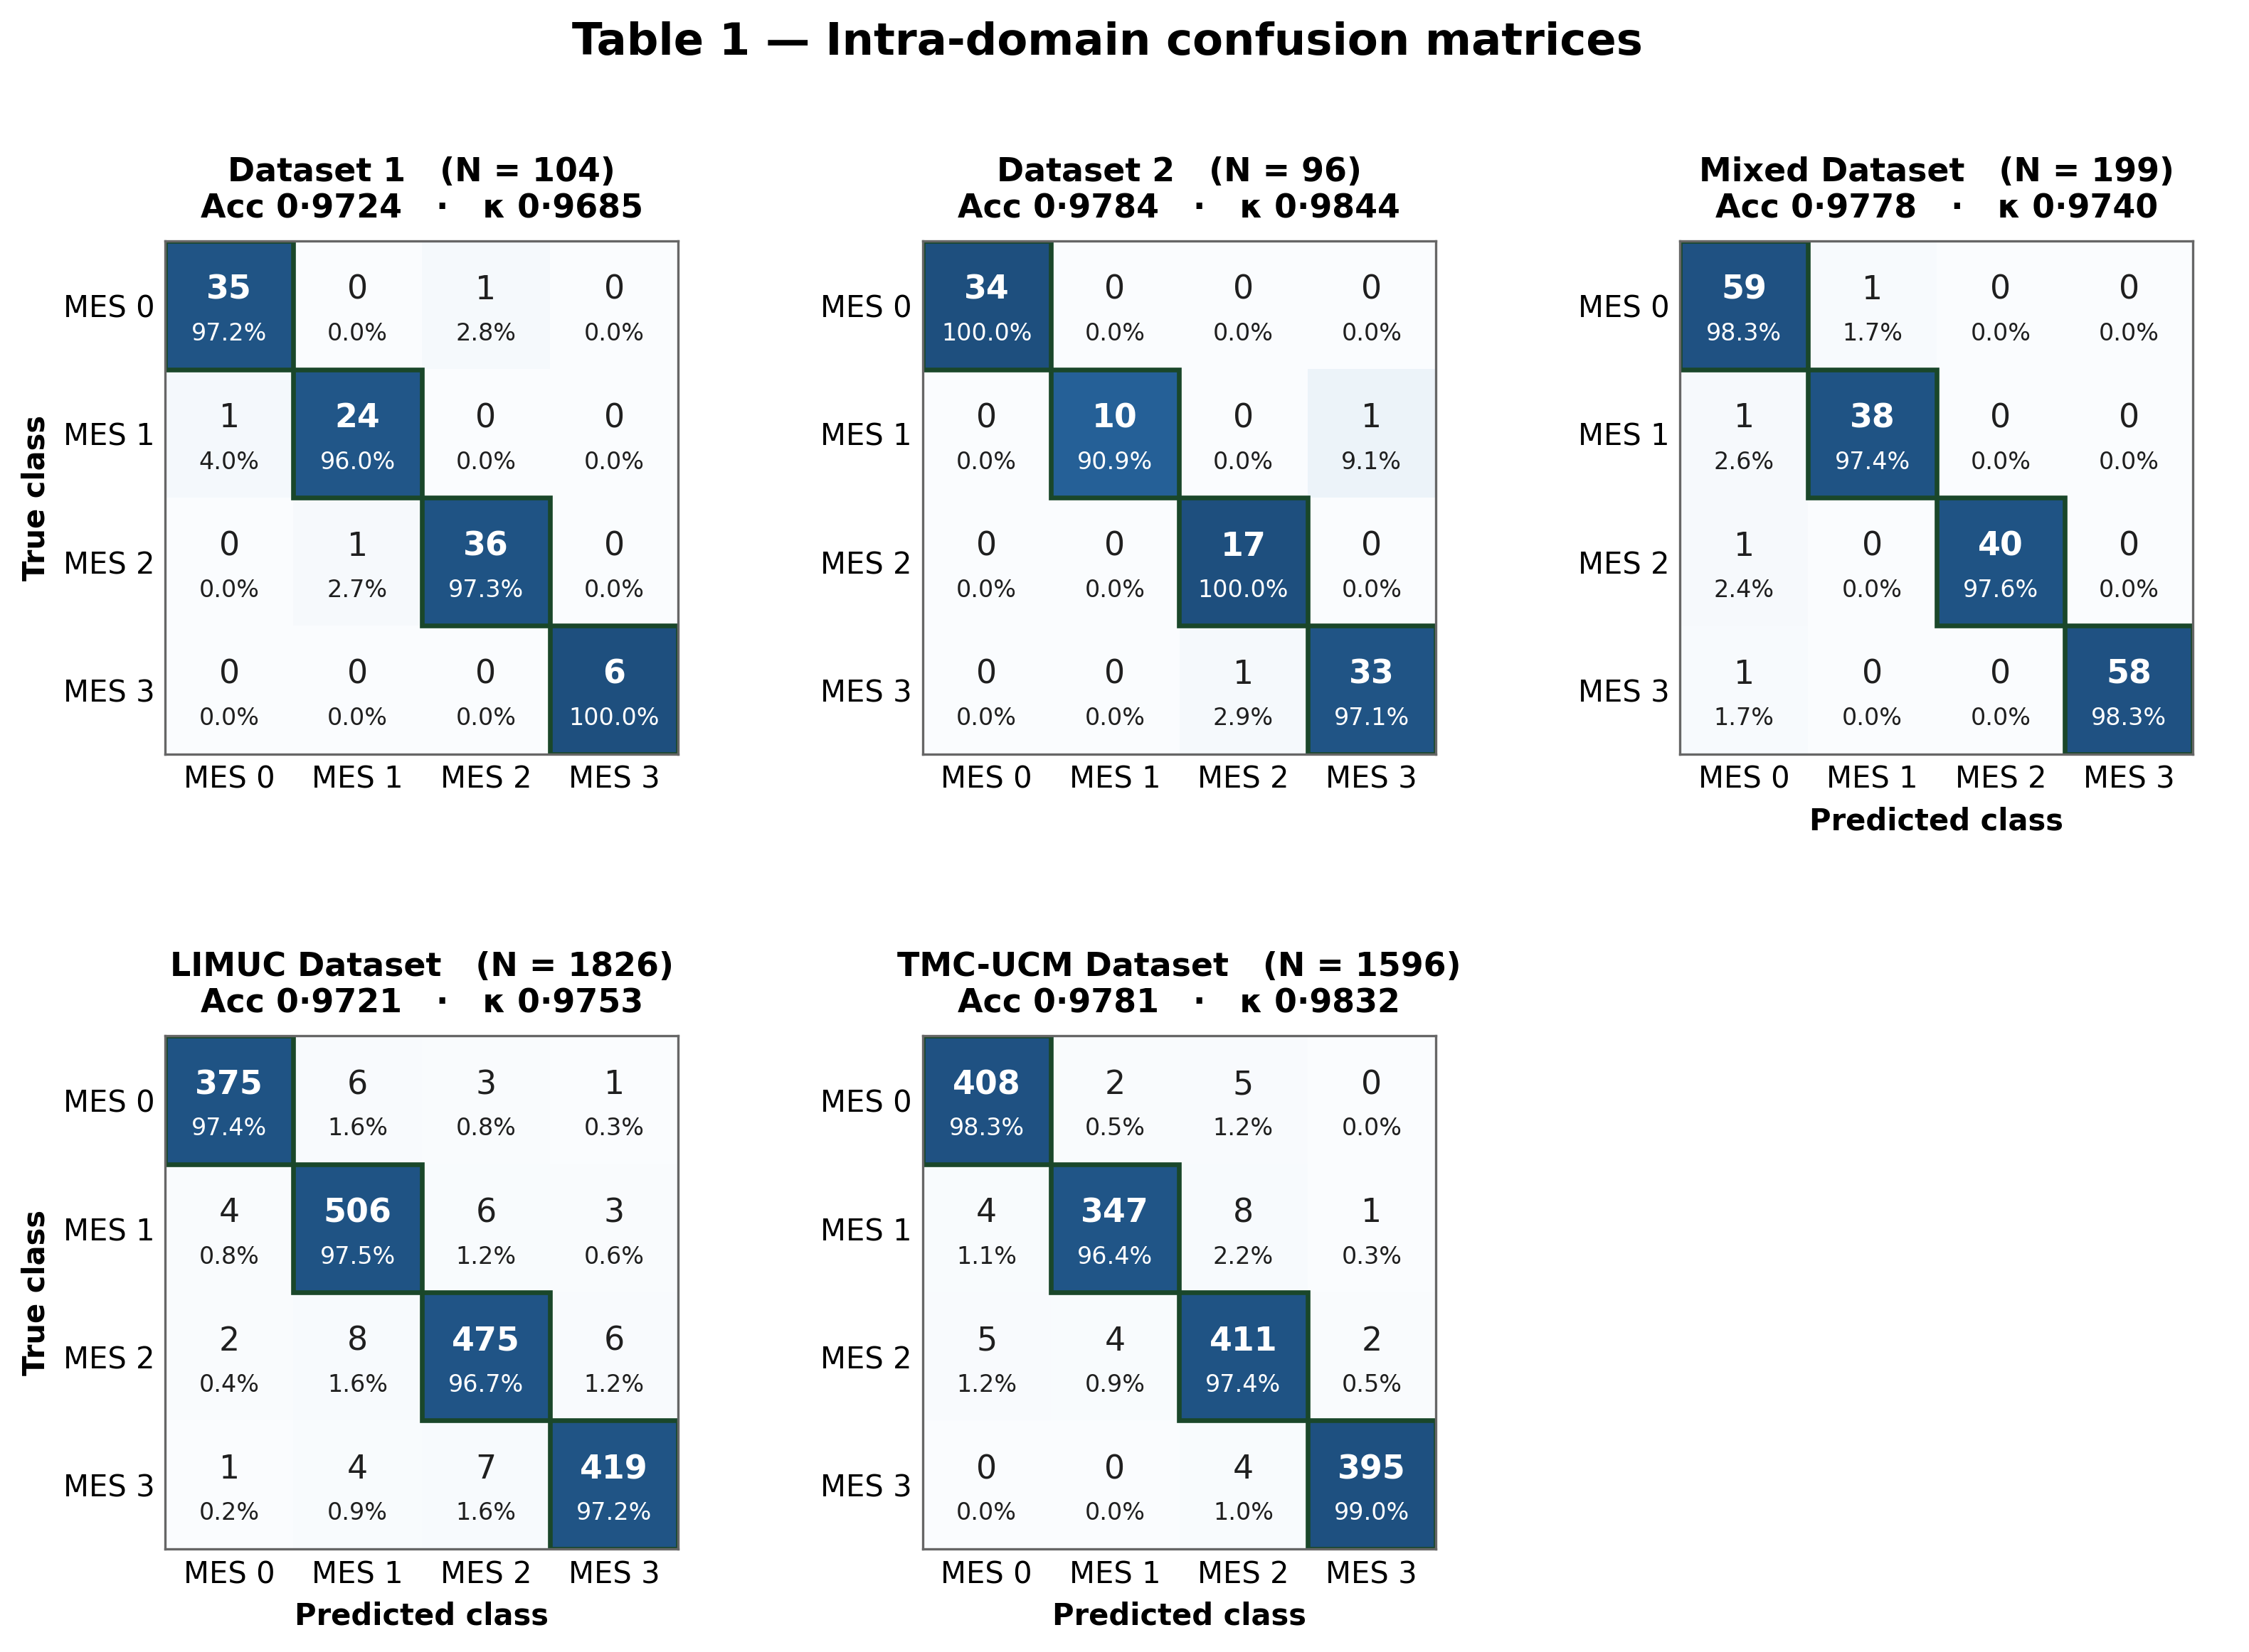

Table 2. Within-institution cross-domain classification results.
Dataset | Accuracy | Class | Accuracy  95% CI | Cohen's κ | Quad κ | EC | Precision  (PPV) | Recall | F1 Score | NPV
Dataset 1  → Dataset 2  N = 474 | 0.9620 | MES 0 | (0.9408 - 0.9758) | 0.9589 | 0.9780 | 0.0801 | 0.9568 | 0.9852 | 0.9708 | 0.9940
 |  | MES 1 | (0.9408 - 0.9758) | 0.9242 | 0.9066 | 0.0758 | 0.9464 | 0.9381 | 0.9422 | 0.9807
 |  | MES 2 | (0.9408 - 0.9758) | 0.9532 | 0.9453 | 0.0615 | 0.9730 | 0.9558 | 0.9643 | 0.9862
 |  | MES 3 | (0.9408 - 0.9758) | 0.9592 | 0.9707 | 0.0541 | 0.9732 | 0.9646 | 0.9689 | 0.9890
Dataset 1  → Mixed  N = 992 | 0.9617 | MES 0 | (0.9479 - 0.9720) | 0.9394 | 0.9440 | 0.1223 | 0.9580 | 0.9500 | 0.9540 | 0.9841
 |  | MES 1 | (0.9479 - 0.9720) | 0.9444 | 0.9530 | 0.0975 | 0.9529 | 0.9643 | 0.9586 | 0.9878
 |  | MES 2 | (0.9479 - 0.9720) | 0.9405 | 0.9242 | 0.0877 | 0.9592 | 0.9514 | 0.9553 | 0.9839
 |  | MES 3 | (0.9479 - 0.9720) | 0.9709 | 0.9621 | 0.0879 | 0.9764 | 0.9802 | 0.9783 | 0.9932
Dataset 2  → Dataset 1  N = 518 | 0.9575 | MES 0 | (0.9365 - 0.9718) | 0.9405 | 0.9606 | 0.0859 | 0.9583 | 0.9504 | 0.9544 | 0.9849
 |  | MES 1 | (0.9365 - 0.9718) | 0.9243 | 0.9407 | 0.0761 | 0.9403 | 0.9474 | 0.9438 | 0.9818
 |  | MES 2 | (0.9365 - 0.9718) | 0.9334 | 0.9258 | 0.0843 | 0.9466 | 0.9538 | 0.9502 | 0.9845
 |  | MES 3 | (0.9365 - 0.9718) | 0.9748 | 0.9756 | 0.0812 | 0.9850 | 0.9776 | 0.9813 | 0.9922
Dataset 2  → Mixed  N = 992 | 0.9688 | MES 0 | (0.9560 - 0.9779) | 0.9602 | 0.9786 | 0.0623 | 0.9684 | 0.9722 | 0.9703 | 0.9905
 |  | MES 1 | (0.9560 - 0.9779) | 0.9430 | 0.9595 | 0.0798 | 0.9512 | 0.9630 | 0.9571 | 0.9879
 |  | MES 2 | (0.9560 - 0.9779) | 0.9509 | 0.9553 | 0.0560 | 0.9669 | 0.9590 | 0.9630 | 0.9867
 |  | MES 3 | (0.9560 - 0.9779) | 0.9787 | 0.9859 | 0.0630 | 0.9880 | 0.9802 | 0.9841 | 0.9933
Mixed  → Dataset 1  N = 518 | 0.9653 | MES 0 | (0.9457 - 0.9779) | 0.9559 | 0.9648 | 0.0770 | 0.9643 | 0.9712 | 0.9677 | 0.9894
 |  | MES 1 | (0.9457 - 0.9779) | 0.9418 | 0.9629 | 0.0685 | 0.9520 | 0.9597 | 0.9558 | 0.9873
 |  | MES 2 | (0.9457 - 0.9779) | 0.9415 | 0.9484 | 0.0783 | 0.9593 | 0.9516 | 0.9555 | 0.9848
 |  | MES 3 | (0.9457 - 0.9779) | 0.9744 | 0.9746 | 0.0669 | 0.9846 | 0.9771 | 0.9808 | 0.9923
Mixed  → Dataset 2  N = 474 | 0.9726 | MES 0 | (0.9536 - 0.9839) | 0.9632 | 0.9604 | 0.0658 | 0.9771 | 0.9697 | 0.9734 | 0.9883
 |  | MES 1 | (0.9536 - 0.9839) | 0.9595 | 0.9701 | 0.0394 | 0.9649 | 0.9735 | 0.9692 | 0.9917
 |  | MES 2 | (0.9536 - 0.9839) | 0.9488 | 0.9432 | 0.0467 | 0.9573 | 0.9655 | 0.9614 | 0.9888
 |  | MES 3 | (0.9536 - 0.9839) | 0.9825 | 0.9736 | 0.0492 | 0.9911 | 0.9823 | 0.9867 | 0.9945

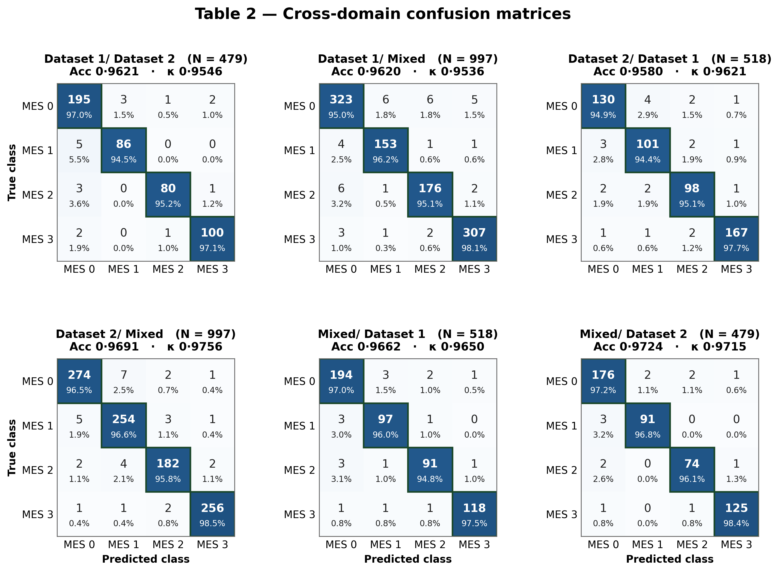

Table 3. Multi-domain LIMUC classification results.
Dataset | Accuracy | Class | Accuracy  95% CI | Cohen's κ | Quad κ | EC | Precision  (PPV) | Recall | F1 Score | NPV
Dataset 1  → LIMUC  N = 11276 | 0.9362 | MES 0 | (0.9316 - 0.9406) | 0.9256 | 0.9622 | 0.0690 | 0.9494 | 0.9844 | 0.9666 | 0.9808
 |  | MES 1 | (0.9316 - 0.9406) | 0.8660 | 0.8175 | 0.0671 | 0.9762 | 0.8339 | 0.8995 | 0.9415
 |  | MES 2 | (0.9316 - 0.9406) | 0.8975 | 0.9249 | 0.0648 | 0.9025 | 0.9155 | 0.9089 | 0.9894
 |  | MES 3 | (0.9316 - 0.9406) | 0.8733 | 0.9385 | 0.0941 | 0.8004 | 0.9873 | 0.8841 | 0.9989
Dataset 2  → LIMUC  N = 11276 | 0.9272 | MES 0 | (0.9222 - 0.9318) | 0.9175 | 0.9690 | 0.1342 | 0.9637 | 0.9605 | 0.9621 | 0.9536
 |  | MES 1 | (0.9222 - 0.9318) | 0.8355 | 0.8042 | 0.1117 | 0.9163 | 0.8431 | 0.8782 | 0.9434
 |  | MES 2 | (0.9222 - 0.9318) | 0.8946 | 0.9511 | 0.1253 | 0.8853 | 0.9290 | 0.9066 | 0.9911
 |  | MES 3 | (0.9222 - 0.9318) | 0.8722 | 0.9414 | 0.1149 | 0.7994 | 0.9861 | 0.8830 | 0.9988
Mixed  → LIMUC  N = 11276 | 0.9405 | MES 0 | (0.9360 - 0.9447) | 0.8915 | 0.9212 | 0.1411 | 0.9606 | 0.9387 | 0.9495 | 0.9296
 |  | MES 1 | (0.9360 - 0.9447) | 0.8894 | 0.9088 | 0.1229 | 0.8957 | 0.9459 | 0.9202 | 0.9795
 |  | MES 2 | (0.9360 - 0.9447) | 0.9484 | 0.9493 | 0.1151 | 0.9734 | 0.9354 | 0.9540 | 0.9920
 |  | MES 3 | (0.9360 - 0.9447) | 0.9262 | 0.9337 | 0.1144 | 0.9229 | 0.9410 | 0.9319 | 0.9951
LIMUC  → Dataset 1  N = 518 | 0.9073 | MES 0 | (0.8793 - 0.9294) | 0.8604 | 0.8645 | 0.0788 | 0.9485 | 0.9214 | 0.9348 | 0.9106
 |  | MES 1 | (0.8793 - 0.9294) | 0.8351 | 0.8768 | 0.0668 | 0.8681 | 0.8929 | 0.8803 | 0.9599
 |  | MES 2 | (0.8793 - 0.9294) | 0.8533 | 0.9161 | 0.0797 | 0.8772 | 0.8621 | 0.8696 | 0.9826
 |  | MES 3 | (0.8793 - 0.9294) | 0.8591 | 0.8531 | 0.0922 | 0.8222 | 0.9250 | 0.8706 | 0.9937
LIMUC  → Dataset 2  N = 474 | 0.9283 | MES 0 | (0.9014 - 0.9482) | 0.8729 | 0.9084 | 0.0702 | 0.9558 | 0.9261 | 0.9407 | 0.9156
 |  | MES 1 | (0.9014 - 0.9482) | 0.8790 | 0.8832 | 0.0630 | 0.8889 | 0.9375 | 0.9125 | 0.9764
 |  | MES 2 | (0.9014 - 0.9482) | 0.8860 | 0.8598 | 0.0941 | 0.8750 | 0.9245 | 0.8991 | 0.9904
 |  | MES 3 | (0.9014 - 0.9482) | 0.9383 | 0.9573 | 0.0746 | 0.9706 | 0.9167 | 0.9429 | 0.9932
LIMUC  → Mixed  N = 992 | 0.9315 | MES 0 | (0.9140 - 0.9456) | 0.8825 | 0.9074 | 0.0904 | 0.9580 | 0.9331 | 0.9454 | 0.9231
 |  | MES 1 | (0.9140 - 0.9456) | 0.8859 | 0.8968 | 0.0887 | 0.9055 | 0.9291 | 0.9171 | 0.9735
 |  | MES 2 | (0.9140 - 0.9456) | 0.9188 | 0.9223 | 0.0912 | 0.9196 | 0.9364 | 0.9279 | 0.9920
 |  | MES 3 | (0.9140 - 0.9456) | 0.8824 | 0.9133 | 0.1119 | 0.8642 | 0.9211 | 0.8917 | 0.9934

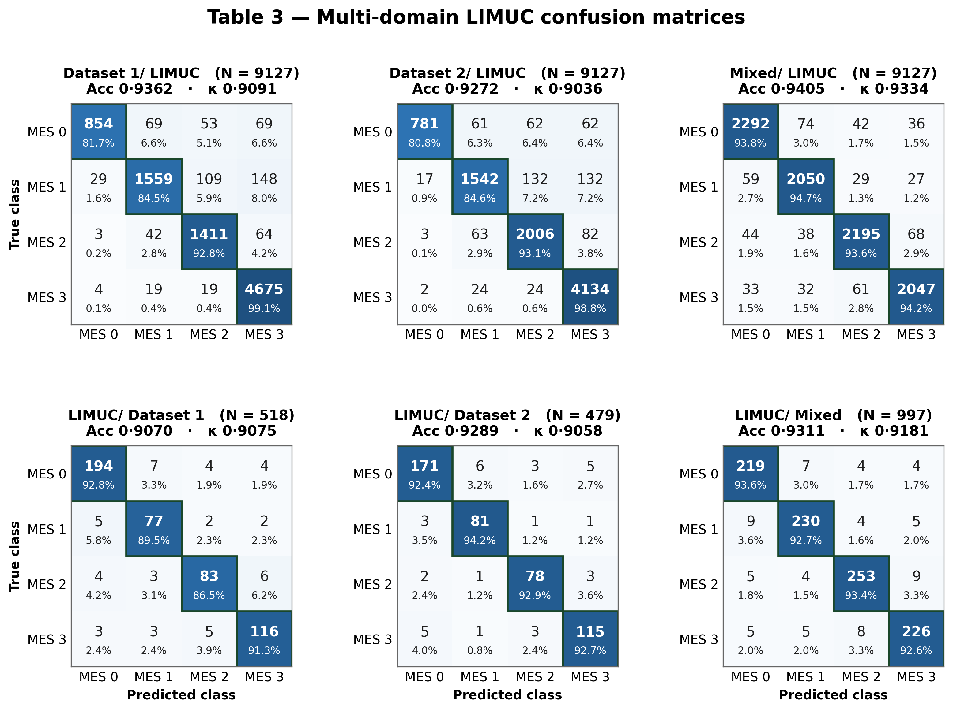

Table 4. Multi-domain TMC-UCM classification results.
Dataset | Accuracy | Class | Accuracy  95% CI | Cohen's κ | Quad κ | EC | Precision  (PPV) | Recall | F1 Score | NPV
Dataset 1  → TMC-UCM  N = 7978 | 0.9536 | MES 0 | (0.9488 - 0.9580) | 0.9119 | 0.9080 | 0·0196 | 0.8790 | 0.9995 | 0.9354 | 0.9998
 |  | MES 1 | (0.9488 - 0.9580) | 0.9595 | 0.9660 | 0·0889 | 0.9931 | 0.9467 | 0.9694 | 0.9826
 |  | MES 2 | (0.9488 - 0.9580) | 0.9307 | 0.8992 | 0·2153 | 0.9731 | 0.9233 | 0.9476 | 0.9749
 |  | MES 3 | (0.9488 - 0.9580) | 0.9522 | 0.9378 | 0·3101 | 0.9838 | 0.9448 | 0.9639 | 0.9819
Dataset 2  → TMC-UCM  N = 7978 | 0.9109 | MES 0 | (0.9044 - 0.9169) | 0.8590 | 0.9106 | 0·0547 | 0.8152 | 0.9995 | 0.8980 | 0.9998
 |  | MES 1 | (0.9044 - 0.9169) | 0.8896 | 0.9198 | 0·1861 | 0.9702 | 0.8668 | 0.9156 | 0.9573
 |  | MES 2 | (0.9044 - 0.9169) | 0.8768 | 0.8692 | 0·2968 | 0.9240 | 0.8907 | 0.9070 | 0.9640
 |  | MES 3 | (0.9044 - 0.9169) | 0.9018 | 0.9397 | 0·5052 | 0.9681 | 0.8859 | 0.9252 | 0.9631
Mixed  → TMC-UCM  N = 7978 | 0.9055 | MES 0 | (0.8989 - 0.9117) | 0.8681 | 0.8692 | 0·1740 | 0.8260 | 0.9995 | 0.9045 | 0.9998
 |  | MES 1 | (0.8989 - 0.9117) | 0.8797 | 0.8891 | 0·2134 | 0.9556 | 0.8653 | 0.9082 | 0.9566
 |  | MES 2 | (0.8989 - 0.9117) | 0.8749 | 0.8780 | 0·3190 | 0.9467 | 0.8663 | 0.9047 | 0.9568
 |  | MES 3 | (0.8989 - 0.9117) | 0.8738 | 0.8735 | 0·7047 | 0.9200 | 0.8899 | 0.9047 | 0.9638
TMC-UCM  → Dataset 1  N = 518 | 0.9537 | MES 0 | (0.9320 - 0.9687) | 0.9304 | 0.9437 | 0·0765 | 0.9119 | 0.9932 | 0.9508 | 0.9972
 |  | MES 1 | (0.9320 - 0.9687) | 0.9185 | 0.9153 | 0·1308 | 0.9739 | 0.9032 | 0.9372 | 0.9702
 |  | MES 2 | (0.9320 - 0.9687) | 0.9467 | 0.9309 | 0·1635 | 0.9672 | 0.9516 | 0.9593 | 0.9848
 |  | MES 3 | (0.9320 - 0.9687) | 0.9574 | 0.9499 | 0·2984 | 0.9754 | 0.9597 | 0.9675 | 0.9874
TMC-UCM  → Dataset 2  N = 474 | 0.9557 | MES 0 | (0.9332 - 0.9708) | 0.9343 | 0.9527 | 0·0839 | 0.9178 | 0.9926 | 0.9537 | 0.9970
 |  | MES 1 | (0.9332 - 0.9708) | 0.9285 | 0.9350 | 0·1250 | 0.9810 | 0.9115 | 0.9450 | 0.9729
 |  | MES 2 | (0.9332 - 0.9708) | 0.9415 | 0.9325 | 0·1809 | 0.9640 | 0.9469 | 0.9554 | 0.9835
 |  | MES 3 | (0.9332 - 0.9708) | 0.9592 | 0.9628 | 0·2761 | 0.9732 | 0.9646 | 0.9689 | 0.9890
TMC-UCM  → Mixed  N = 992 | 0.9234 | MES 0 | (0.9052 - 0.9384) | 0.8912 | 0.8895 | 0·1381 | 0.8581 | 0.9962 | 0.9220 | 0.9985
 |  | MES 1 | (0.9052 - 0.9384) | 0.8869 | 0.8853 | 0·1675 | 0.9677 | 0.8642 | 0.9130 | 0.9574
 |  | MES 2 | (0.9052 - 0.9384) | 0.8898 | 0.8664 | 0·3119 | 0.9359 | 0.8975 | 0.9163 | 0.9670
 |  | MES 3 | (0.9052 - 0.9384) | 0.9233 | 0.9048 | 0·4420 | 0.9538 | 0.9303 | 0.9419 | 0.9775
