Table 1. Intra-domain classification results.
Dataset | Accuracy | Class | Accuracy  95% CI | Cohen's κ | Quad κ | EC | Precision  (PPV) | Recall | F1 Score | NPV
Dataset 1  N = 104 | 0.9712 | MES 0 | (0.9186 - 0.9901) | 0.9575 | 0.9682 | 0.0632 | 0.9722 | 0.9722 | 0.9722 | 0.9853
 |  | MES 1 | (0.9186 - 0.9901) | 0.9473 | 0.9571 | 0.0386 | 0.9600 | 0.9600 | 0.9600 | 0.9873
 |  | MES 2 | (0.9186 - 0.9901) | 0.9580 | 0.9598 | 0.0486 | 0.9730 | 0.9730 | 0.9730 | 0.9851
 |  | MES 3 | (0.9186 - 0.9901) | 1.0000 | 1.0000 | 0.0465 | 1.0000 | 1.0000 | 1.0000 | 1.0000
Dataset 2  N = 96 | 0.9792 | MES 0 | (0.9272 - 0.9943) | 1.0000 | 1.0000 | 0.0611 | 1.0000 | 1.0000 | 1.0000 | 1.0000
 |  | MES 1 | (0.9272 - 0.9943) | 0.9465 | 0.9025 | 0.0587 | 1.0000 | 0.9091 | 0.9524 | 0.9884
 |  | MES 2 | (0.9272 - 0.9943) | 0.9651 | 0.9848 | 0.0673 | 0.9444 | 1.0000 | 0.9714 | 1.0000
 |  | MES 3 | (0.9272 - 0.9943) | 0.9545 | 0.9807 | 0.0351 | 0.9706 | 0.9706 | 0.9706 | 0.9839
Mixed Dataset  N = 200 | 0.9800 | MES 0 | (0.9497 - 0.9922) | 0.9533 | 0.9667 | 0.0491 | 0.9524 | 0.9836 | 0.9677 | 0.9927
 |  | MES 1 | (0.9497 - 0.9922) | 0.9681 | 0.9848 | 0.0334 | 0.9744 | 0.9744 | 0.9744 | 0.9938
 |  | MES 2 | (0.9497 - 0.9922) | 0.9845 | 0.9714 | 0.0409 | 1.0000 | 0.9756 | 0.9877 | 0.9938
 |  | MES 3 | (0.9497 - 0.9922) | 0.9879 | 0.9796 | 0.0524 | 1.0000 | 0.9831 | 0.9915 | 0.9930
LIMUC Dataset  N = 2255 | 0.9721 | MES 0 | (0.9644 - 0.9781) | 0.9644 | 0.9073 | 0.0390 | 0.9925 | 0.9697 | 0.9834 | 0.9654
 |  | MES 1 | (0.9644 - 0.9781) | 0.9808 | 0.9534 | 0.0459 | 0.9950 | 0.9770 | 0.9859 | 0.9915
 |  | MES 2 | (0.9644 - 0.9781) | 0.9730 | 0.9855 | 0.0639 | 0.9799 | 0.9721 | 0.9760 | 0.9965
 |  | MES 3 | (0.9644 - 0.9781) | 0.8413 | 0.8371 | 0.0597 | 0.7636 | 0.9711 | 0.8550 | 0.9925
TMC-UCM Dataset  N = 1596 | 0.9781 | MES 0 | (0.9697 - 0.9842) | 0.9740 | 0.9844 | 0.0407 | 0.9784 | 0.9831 | 0.9808 | 0.9941
 |  | MES 1 | (0.9697 - 0.9842) | 0.9657 | 0.9798 | 0.0555 | 0.9830 | 0.9639 | 0.9734 | 0.9895
 |  | MES 2 | (0.9697 - 0.9842) | 0.9551 | 0.9550 | 0.0643 | 0.9603 | 0.9739 | 0.9671 | 0.9906
 |  | MES 3 | (0.9697 - 0.9842) | 0.9883 | 0.9964 | 0.0322 | 0.9925 | 0.9900 | 0.9912 | 0.9967

Table 2. Within-institution cross-domain classification results.
Dataset | Accuracy | Class | Accuracy  95% CI | Cohen's κ | Quad κ | EC | Precision  (PPV) | Recall | F1 Score | NPV
Dataset 1  → Dataset 2  N = 474 | 0.9624 | MES 0 | (0.9414 - 0.9761) | 0.9788 | 0.9829 | 0.0801 | 0.9769 | 0.9922 | 0.9845 | 0.9921
 |  | MES 1 | (0.9414 - 0.9761) | 0.9387 | 0.9100 | 0.0758 | 0.9744 | 0.9344 | 0.9540 | 0.9779
 |  | MES 2 | (0.9414 - 0.9761) | 0.9537 | 0.9690 | 0.0615 | 0.9732 | 0.9561 | 0.9646 | 0.9864
 |  | MES 3 | (0.9414 - 0.9761) | 0.9267 | 0.9511 | 0.0541 | 0.9250 | 0.9652 | 0.9447 | 0.9889
Dataset 1  → Mixed  N = 992 | 0.9619 | MES 0 | (0.9481 - 0.9721) | 0.9586 | 0.9367 | 0.1223 | 0.9871 | 0.9504 | 0.9684 | 0.9843
 |  | MES 1 | (0.9481 - 0.9721) | 0.9681 | 0.9536 | 0.0975 | 0.9879 | 0.9646 | 0.9761 | 0.9880
 |  | MES 2 | (0.9481 - 0.9721) | 0.9538 | 0.9679 | 0.0877 | 0.9792 | 0.9514 | 0.9651 | 0.9841
 |  | MES 3 | (0.9481 - 0.9721) | 0.9178 | 0.9200 | 0.0879 | 0.9022 | 0.9803 | 0.9396 | 0.9931
Dataset 2  → Dataset 1  N = 518 | 0.9575 | MES 0 | (0.9365 - 0.9718) | 0.9502 | 0.9359 | 0.0859 | 0.9739 | 0.9492 | 0.9614 | 0.9851
 |  | MES 1 | (0.9365 - 0.9718) | 0.9489 | 0.9312 | 0.0761 | 0.9767 | 0.9474 | 0.9618 | 0.9820
 |  | MES 2 | (0.9365 - 0.9718) | 0.9541 | 0.9599 | 0.0843 | 0.9769 | 0.9549 | 0.9658 | 0.9845
 |  | MES 3 | (0.9365 - 0.9718) | 0.9214 | 0.9191 | 0.0812 | 0.9097 | 0.9776 | 0.9424 | 0.9920
Dataset 2  → Mixed  N = 992 | 0.9689 | MES 0 | (0.9562 - 0.9780) | 0.9735 | 0.9646 | 0.0623 | 0.9880 | 0.9725 | 0.9802 | 0.9906
 |  | MES 1 | (0.9562 - 0.9780) | 0.9672 | 0.9517 | 0.0798 | 0.9874 | 0.9631 | 0.9751 | 0.9881
 |  | MES 2 | (0.9562 - 0.9780) | 0.9590 | 0.9714 | 0.0560 | 0.9791 | 0.9590 | 0.9689 | 0.9868
 |  | MES 3 | (0.9562 - 0.9780) | 0.9352 | 0.9469 | 0.0630 | 0.9257 | 0.9803 | 0.9522 | 0.9931
Mixed  → Dataset 1  N = 518 | 0.9653 | MES 0 | (0.9457 - 0.9779) | 0.9650 | 0.9617 | 0.0770 | 0.9778 | 0.9706 | 0.9742 | 0.9896
 |  | MES 1 | (0.9457 - 0.9779) | 0.9574 | 0.9478 | 0.0685 | 0.9754 | 0.9597 | 0.9675 | 0.9874
 |  | MES 2 | (0.9457 - 0.9779) | 0.9519 | 0.9605 | 0.0783 | 0.9752 | 0.9516 | 0.9633 | 0.9849
 |  | MES 3 | (0.9457 - 0.9779) | 0.9405 | 0.9505 | 0.0669 | 0.9357 | 0.9776 | 0.9562 | 0.9921
Mixed  → Dataset 2  N = 474 | 0.9729 | MES 0 | (0.9541 - 0.9841) | 0.9661 | 0.9664 | 0.0658 | 0.9744 | 0.9744 | 0.9744 | 0.9917
 |  | MES 1 | (0.9541 - 0.9841) | 0.9618 | 0.9576 | 0.0394 | 0.9756 | 0.9677 | 0.9717 | 0.9888
 |  | MES 2 | (0.9541 - 0.9841) | 0.9653 | 0.9645 | 0.0467 | 0.9821 | 0.9649 | 0.9735 | 0.9891
 |  | MES 3 | (0.9541 - 0.9841) | 0.9622 | 0.9632 | 0.0492 | 0.9606 | 0.9839 | 0.9721 | 0.9943

Table 3. Multi-domain LIMUC classification results.
Dataset | Accuracy | Class | Accuracy  95% CI | Cohen's κ | Quad κ | EC | Precision  (PPV) | Recall | F1 Score | NPV
Dataset 1  → LIMUC  N = 11276 | 0.9362 | MES 0 | (0.9316 - 0.9406) | 0.9825 | 0.9570 | 0.0690 | 0.9995 | 0.9844 | 0.9919 | 0.9819
 |  | MES 1 | (0.9316 - 0.9406) | 0.8792 | 0.6659 | 0.0671 | 0.9988 | 0.8339 | 0.9089 | 0.9419
 |  | MES 2 | (0.9316 - 0.9406) | 0.9457 | 0.9796 | 0.0648 | 0.9905 | 0.9155 | 0.9515 | 0.9895
 |  | MES 3 | (0.9316 - 0.9406) | 0.6733 | 0.7937 | 0.0941 | 0.5488 | 0.9873 | 0.7055 | 0.9989
Dataset 2  → LIMUC  N = 11276 | 0.9272 | MES 0 | (0.9222 - 0.9318) | 0.9566 | 0.8929 | 0.1342 | 0.9995 | 0.9605 | 0.9796 | 0.9554
 |  | MES 1 | (0.9222 - 0.9318) | 0.8861 | 0.6895 | 0.1117 | 0.9988 | 0.8431 | 0.9144 | 0.9449
 |  | MES 2 | (0.9222 - 0.9318) | 0.9534 | 0.9823 | 0.1253 | 0.9898 | 0.9290 | 0.9585 | 0.9912
 |  | MES 3 | (0.9222 - 0.9318) | 0.6405 | 0.7217 | 0.1149 | 0.5151 | 0.9861 | 0.6767 | 0.9988
Mixed  → LIMUC  N = 11276 | 0.9405 | MES 0 | (0.9360 - 0.9447) | 0.9330 | 0.8250 | 0.1411 | 0.9995 | 0.9387 | 0.9682 | 0.9325
 |  | MES 1 | (0.9360 - 0.9447) | 0.9616 | 0.8936 | 0.1229 | 0.9990 | 0.9459 | 0.9717 | 0.9803
 |  | MES 2 | (0.9360 - 0.9447) | 0.9402 | 0.9774 | 0.1151 | 0.9583 | 0.9354 | 0.9467 | 0.9919
 |  | MES 3 | (0.9360 - 0.9447) | 0.6793 | 0.6956 | 0.1144 | 0.5700 | 0.9410 | 0.7100 | 0.9948
LIMUC  → Dataset 1  N = 518 | 0.9073 | MES 0 | (0.8793 - 0.9294) | 0.9034 | 0.7842 | 0.0788 | 0.9885 | 0.9214 | 0.9538 | 0.9144
 |  | MES 1 | (0.8793 - 0.9294) | 0.9095 | 0.7932 | 0.0668 | 0.9766 | 0.8929 | 0.9328 | 0.9615
 |  | MES 2 | (0.8793 - 0.9294) | 0.8890 | 0.9377 | 0.0797 | 0.9434 | 0.8621 | 0.9009 | 0.9828
 |  | MES 3 | (0.8793 - 0.9294) | 0.5972 | 0.6323 | 0.0922 | 0.4868 | 0.9250 | 0.6379 | 0.9932
LIMUC  → Dataset 2  N = 474 | 0.9290 | MES 0 | (0.9024 - 0.9488) | 0.9080 | 0.7876 | 0.0702 | 0.9877 | 0.9266 | 0.9562 | 0.9195
 |  | MES 1 | (0.9024 - 0.9488) | 0.9412 | 0.8789 | 0.0630 | 0.9760 | 0.9385 | 0.9569 | 0.9774
 |  | MES 2 | (0.9024 - 0.9488) | 0.9251 | 0.9497 | 0.0941 | 0.9423 | 0.9245 | 0.9333 | 0.9906
 |  | MES 3 | (0.9024 - 0.9488) | 0.6777 | 0.6610 | 0.0746 | 0.5763 | 0.9189 | 0.7083 | 0.9929
LIMUC  → Mixed  N = 992 | 0.9308 | MES 0 | (0.9133 - 0.9449) | 0.9217 | 0.8094 | 0.0904 | 0.9941 | 0.9333 | 0.9628 | 0.9265
 |  | MES 1 | (0.9133 - 0.9449) | 0.9404 | 0.8537 | 0.0887 | 0.9881 | 0.9259 | 0.9560 | 0.9731
 |  | MES 2 | (0.9133 - 0.9449) | 0.9338 | 0.9651 | 0.0912 | 0.9455 | 0.9369 | 0.9412 | 0.9921
 |  | MES 3 | (0.9133 - 0.9449) | 0.6569 | 0.6678 | 0.1119 | 0.5512 | 0.9211 | 0.6897 | 0.9931

Table 4. Multi-domain TMC-UCM classification results.
Dataset | Accuracy | Class | Accuracy  95% CI | Cohen's κ | Quad κ | EC | Precision  (PPV) | Recall | F1 Score | NPV
Dataset 1  → TMC-UCM  N = 7978 | 0.9536 | MES 0 | (0.9488 - 0.9580) | 0.9990 | 0.9991 | 0·0196 | 0.9986 | 1.0000 | 0.9993 | 1.0000
 |  | MES 1 | (0.9488 - 0.9580) | 0.9609 | 0.9241 | 0·0889 | 0.9989 | 0.9431 | 0.9702 | 0.9819
 |  | MES 2 | (0.9488 - 0.9580) | 0.9117 | 0.9561 | 0·2153 | 0.9428 | 0.9234 | 0.9330 | 0.9755
 |  | MES 3 | (0.9488 - 0.9580) | 0.8804 | 0.9520 | 0·3101 | 0.8802 | 0.9448 | 0.9113 | 0.9812
Dataset 2  → TMC-UCM  N = 7978 | 0.9109 | MES 0 | (0.9044 - 0.9169) | 0.9991 | 0.9991 | 0·0547 | 0.9986 | 1.0000 | 0.9993 | 1.0000
 |  | MES 1 | (0.9044 - 0.9169) | 0.8992 | 0.8020 | 0·1861 | 0.9987 | 0.8551 | 0.9213 | 0.9577
 |  | MES 2 | (0.9044 - 0.9169) | 0.8523 | 0.9287 | 0·2968 | 0.8872 | 0.8908 | 0.8890 | 0.9640
 |  | MES 3 | (0.9044 - 0.9169) | 0.7714 | 0.8982 | 0·5052 | 0.7832 | 0.8856 | 0.8312 | 0.9609
Mixed  → TMC-UCM  N = 7978 | 0.9055 | MES 0 | (0.8989 - 0.9117) | 0.9955 | 0.9935 | 0·1740 | 0.9986 | 0.9949 | 0.9967 | 0.9981
 |  | MES 1 | (0.8989 - 0.9117) | 0.9028 | 0.8115 | 0·2134 | 0.9982 | 0.8608 | 0.9244 | 0.9578
 |  | MES 2 | (0.8989 - 0.9117) | 0.8362 | 0.9194 | 0·3190 | 0.8847 | 0.8664 | 0.8755 | 0.9576
 |  | MES 3 | (0.8989 - 0.9117) | 0.7616 | 0.8932 | 0·7047 | 0.7692 | 0.8901 | 0.8252 | 0.9616
TMC-UCM  → Dataset 1  N = 518 | 0.9537 | MES 0 | (0.9320 - 0.9687) | 0.9842 | 0.9848 | 0·0765 | 0.9764 | 1.0000 | 0.9880 | 1.0000
 |  | MES 1 | (0.9320 - 0.9687) | 0.9189 | 0.8656 | 0·1308 | 0.9826 | 0.8968 | 0.9378 | 0.9677
 |  | MES 2 | (0.9320 - 0.9687) | 0.9494 | 0.9668 | 0·1635 | 0.9697 | 0.9552 | 0.9624 | 0.9845
 |  | MES 3 | (0.9320 - 0.9687) | 0.9017 | 0.9317 | 0·2984 | 0.8958 | 0.9627 | 0.9281 | 0.9866
TMC-UCM  → Dataset 2  N = 474 | 0.9562 | MES 0 | (0.9339 - 0.9711) | 0.9834 | 0.9840 | 0·0839 | 0.9754 | 1.0000 | 0.9876 | 1.0000
 |  | MES 1 | (0.9339 - 0.9711) | 0.9292 | 0.8871 | 0·1250 | 0.9811 | 0.9123 | 0.9455 | 0.9732
 |  | MES 2 | (0.9339 - 0.9711) | 0.9447 | 0.9642 | 0·1809 | 0.9667 | 0.9508 | 0.9587 | 0.9833
 |  | MES 3 | (0.9339 - 0.9711) | 0.9092 | 0.9406 | 0·2761 | 0.9084 | 0.9597 | 0.9333 | 0.9856
TMC-UCM  → Mixed  N = 992 | 0.9228 | MES 0 | (0.9045 - 0.9378) | 0.9897 | 0.9922 | 0·1381 | 0.9888 | 0.9962 | 0.9925 | 0.9986
 |  | MES 1 | (0.9045 - 0.9378) | 0.8952 | 0.8124 | 0·1675 | 0.9854 | 0.8596 | 0.9182 | 0.9583
 |  | MES 2 | (0.9045 - 0.9378) | 0.8848 | 0.9399 | 0·3119 | 0.9280 | 0.8975 | 0.9125 | 0.9671
 |  | MES 3 | (0.9045 - 0.9378) | 0.8179 | 0.9080 | 0·4420 | 0.8131 | 0.9289 | 0.8672 | 0.9746

==COMBINED_CM_SECTION==

Confusion Matrices — All Tables

Table 1 — Intra-domain confusion matrices
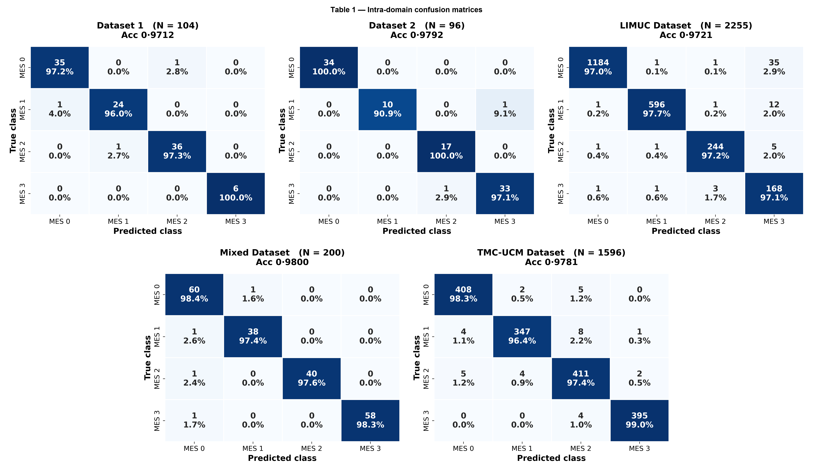

Table 2 — Cross-domain confusion matrices
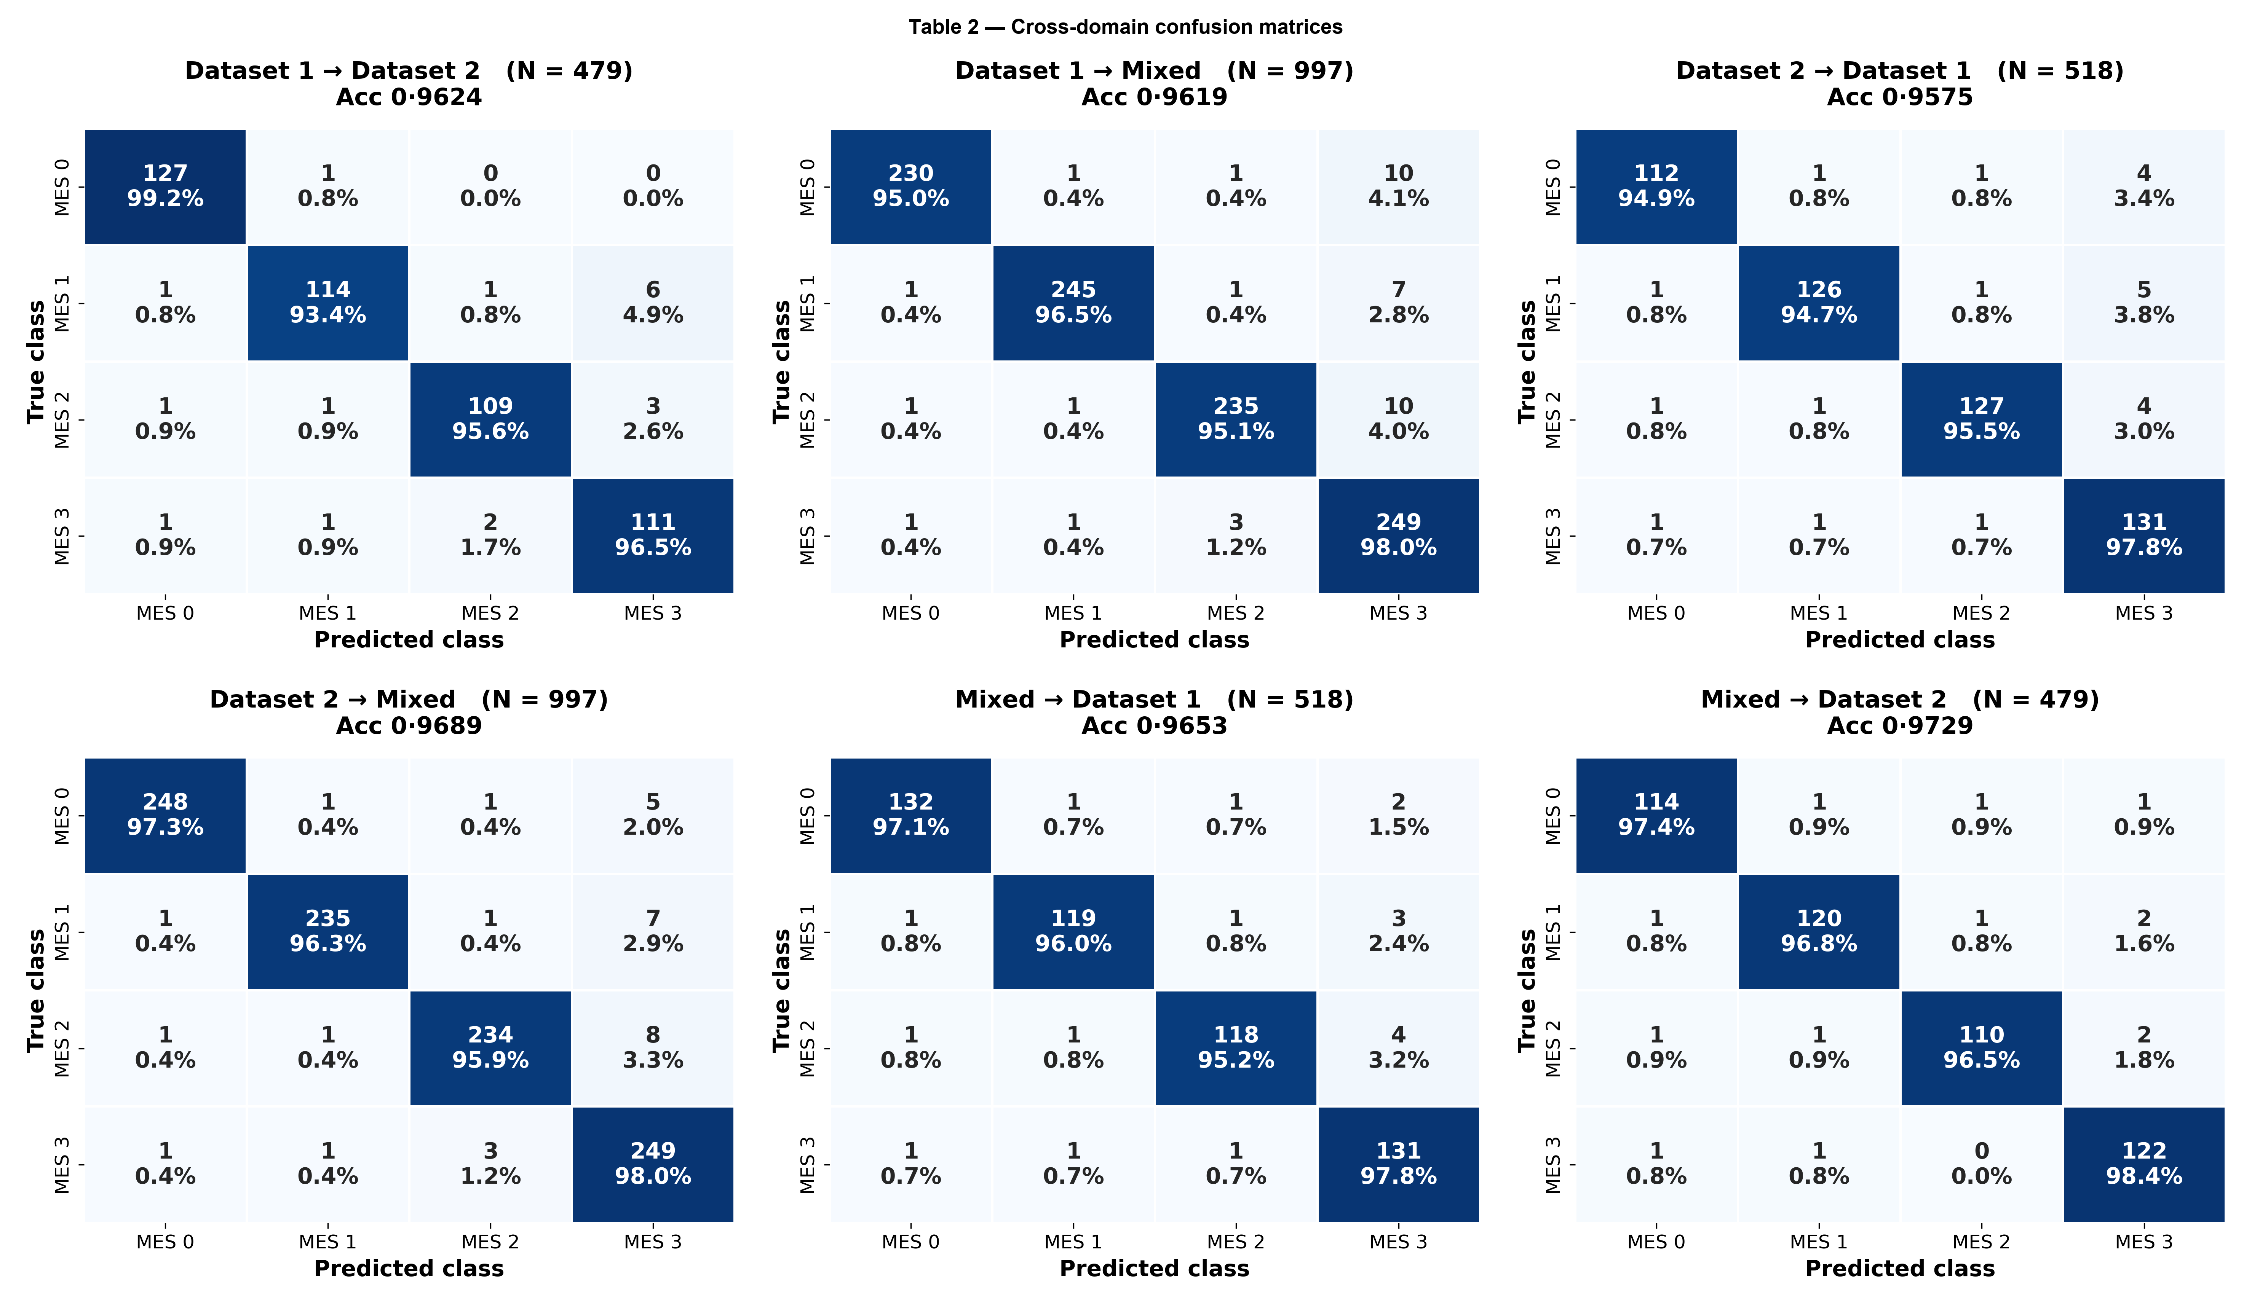

Table 3 — Multi-domain (LIMUC) confusion matrices
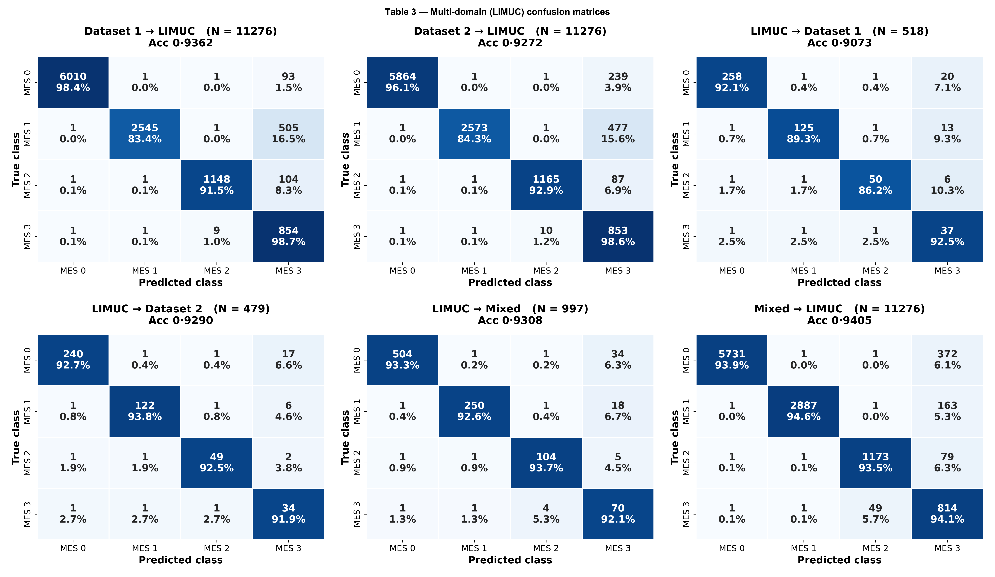

Table 4 — Multi-domain (TMC-UCM) confusion matrices
