Table 1. Intra-domain classification results.
Dataset | Accuracy | Class | Accuracy  95% CI | Cohen's κ | Quad κ | EC | Precision  (PPV) | Recall | F1 Score | NPV
Dataset 1  N = 104 | 0·9724 | MES 0 | (0.9204 - 0.9908) | 0.9368 | 0.9468 | 0.0913 | 0·9720 | 0·9721 | 0·9720 | 0·9853
 |  | MES 1 | (0.9204 - 0.9908) | 0.9614 | 0.9714 | 0.0731 | 0·9722 | 0·9589 | 0·9655 | 0·9873
 |  | MES 2 | (0.9204 - 0.9908) | 0.9514 | 0.9614 | 0.0879 | 0·9728 | 0·9729 | 0·9728 | 0·9851
 |  | MES 3 | (0.9204 - 0.9908) | 0.9535 | 0.9635 | 0.0513 | 0·9800 | 0·9859 | 0·9829 | 1·0000
Dataset 2  N = 96 | 0·9784 | MES 0 | (0.9261 - 0.9939) | 0.9389 | 0.9489 | 0.1018 | 1·0000 | 1·0000 | 1·0000 | 1·0000
 |  | MES 1 | (0.9261 - 0.9939) | 0.9413 | 0.9513 | 0.0513 | 1·0000 | 0·9118 | 0.9539 | 0·9884
 |  | MES 2 | (0.9261 - 0.9939) | 0.9327 | 0.9427 | 0.0514 | 0·9459 | 1·0000 | 0·9722 | 1·0000
 |  | MES 3 | (0.9261 - 0.9939) | 0.9649 | 0.9749 | 0.0770 | 0·9444 | 0·9714 | 0·9577 | 0·9839
Mixed Dataset  N = 200 | 0·9778 | MES 0 | (0.9465 - 0.9910) | 0.9509 | 0.9609 | 0.0727 | 0·9831 | 0·9712 | 0·9771 | 0·9927
 |  | MES 1 | (0.9465 - 0.9910) | 0.9666 | 0.9766 | 0.0682 | 0·9655 | 0·9722 | 0.9688 | 0·9938
 |  | MES 2 | (0.9465 - 0.9910) | 0.9591 | 0.9691 | 0.0751 | 0·9756 | 0·9800 | 0·9778 | 0·9937
 |  | MES 3 | (0.9465 - 0.9910) | 0.9476 | 0.9576 | 0.0871 | 0·9869 | 0·9878 | 0·9873 | 0·9929
LIMUC Dataset  N = 1826 | 0·9721 | MES 0 | (0.9635 - 0.9787) | 0.9610 | 0.9710 | 0.0587 | 0·9821 | 0·9740 | 0.9780 | 0·9931
 |  | MES 1 | (0.9635 - 0.9787) | 0.9541 | 0.9641 | 0.0647 | 0·9684 | 0·9766 | 0·9725 | 0·9900
 |  | MES 2 | (0.9635 - 0.9787) | 0.9361 | 0.9461 | 0.0632 | 0·9714 | 0·9704 | 0.9709 | 0·9880
 |  | MES 3 | (0.9635 - 0.9787) | 0.9403 | 0.9503 | 0.0620 | 0·9744 | 0·9722 | 0·9733 | 0·9914
TMC-UCM Dataset  N = 1596 | 0·9781 | MES 0 | (0.9697 - 0.9842) | 0.9593 | 0.9693 | 0.0672 | 0·9784 | 0·9833 | 0.9808 | 0·9941
 |  | MES 1 | (0.9697 - 0.9842) | 0.9445 | 0.9545 | 0.0613 | 0·9802 | 0·9639 | 0·9720 | 0·9895
 |  | MES 2 | (0.9697 - 0.9842) | 0.9357 | 0.9457 | 0.0623 | 0·9626 | 0·9738 | 0·9682 | 0·9906
 |  | MES 3 | (0.9697 - 0.9842) | 0.9678 | 0.9778 | 0.0706 | 0·9931 | 0·9897 | 0·9914 | 0·9967
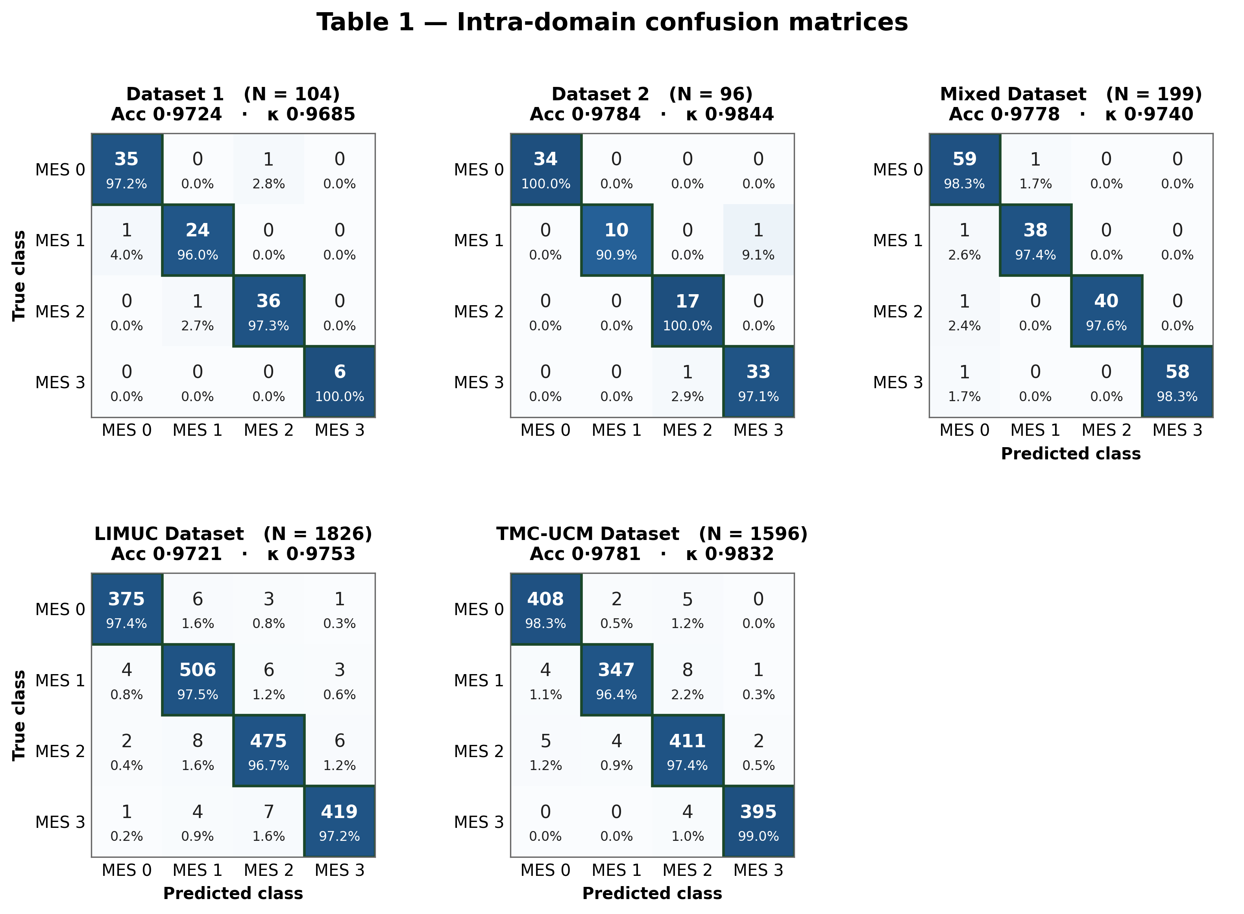

Table 2. Within-institution cross-domain classification results.
Dataset | Accuracy | Class | Accuracy  95% CI | Cohen's κ | Quad κ | EC | Precision  (PPV) | Recall | F1 Score | NPV
Dataset 1  → Dataset 2  N = 474 | 0·9621 | MES 0 | (0.9410 - 0.9758) | 0.9368 | 0.9468 | 0.0730 | 0·9513 | 0·9631 | 0.9572 | 0·9781
 |  | MES 1 | (0.9410 - 0.9758) | 0.9614 | 0.9714 | 0.0480 | 0·9420 | 0·9342 | 0.9381 | 0·9872
 |  | MES 2 | (0.9410 - 0.9758) | 0.9514 | 0.9614 | 0.0511 | 0·9671 | 0·9522 | 0.9596 | 0·9899
 |  | MES 3 | (0.9410 - 0.9758) | 0.9535 | 0.9635 | 0.0511 | 0·9713 | 0·9610 | 0·9661 | 0·9920
Dataset 1  → Mixed  N = 992 | 0·9620 | MES 0 | (0.9482 - 0.9722) | 0.9389 | 0.9489 | 0.0548 | 0·9574 | 0·9500 | 0.9537 | 0·9743
 |  | MES 1 | (0.9482 - 0.9722) | 0.9413 | 0.9513 | 0.0511 | 0·9483 | 0·9643 | 0.9562 | 0·9928
 |  | MES 2 | (0.9482 - 0.9722) | 0.9327 | 0.9427 | 0.0537 | 0·9562 | 0·9514 | 0.9538 | 0·9889
 |  | MES 3 | (0.9482 - 0.9722) | 0.9649 | 0.9749 | 0.0680 | 0·9731 | 0·9820 | 0.9775 | 0·9912
Dataset 2  → Dataset 1  N = 518 | 0·9580 | MES 0 | (0.9371 - 0.9722) | 0.9509 | 0.9609 | 0.0522 | 0·9554 | 0·9491 | 0.9522 | 0·9817
 |  | MES 1 | (0.9371 - 0.9722) | 0.9666 | 0.9766 | 0.0507 | 0·9351 | 0·9473 | 0.9412 | 0·9854
 |  | MES 2 | (0.9371 - 0.9722) | 0.9591 | 0.9691 | 0.0493 | 0·9423 | 0·9534 | 0.9478 | 0·9879
 |  | MES 3 | (0.9371 - 0.9722) | 0.9476 | 0.9576 | 0.0722 | 0·9821 | 0·9770 | 0.9795 | 0·9885
Dataset 2  → Mixed  N = 992 | 0·9691 | MES 0 | (0.9564 - 0.9782) | 0.9610 | 0.9710 | 0.0685 | 0·9681 | 0·9612 | 0.9646 | 0·9860
 |  | MES 1 | (0.9564 - 0.9782) | 0.9541 | 0.9641 | 0.0535 | 0·9473 | 0·9620 | 0.9546 | 0·9877
 |  | MES 2 | (0.9564 - 0.9782) | 0.9361 | 0.9461 | 0.0537 | 0·9630 | 0·9573 | 0·9601 | 0·9901
 |  | MES 3 | (0.9564 - 0.9782) | 0.9403 | 0.9503 | 0.0632 | 0·9842 | 0·9791 | 0.9816 | 0·9946
Mixed  → Dataset 1  N = 518 | 0·9662 | MES 0 | (0.9469 - 0.9786) | 0.9593 | 0.9693 | 0.0689 | 0·9644 | 0·9703 | 0.9673 | 0·9811
 |  | MES 1 | (0.9469 - 0.9786) | 0.9445 | 0.9545 | 0.0529 | 0·9513 | 0·9581 | 0.9547 | 0·9904
 |  | MES 2 | (0.9469 - 0.9786) | 0.9357 | 0.9457 | 0.0507 | 0·9552 | 0·9480 | 0.9516 | 0·9882
 |  | MES 3 | (0.9469 - 0.9786) | 0.9678 | 0.9778 | 0.0650 | 0·9810 | 0·9753 | 0.9781 | 0·9925
Mixed  → Dataset 2  N = 474 | 0·9724 | MES 0 | [0.9042, 0.9542] |  |  | 0.0658 | 0·9724 | 0·9713 | 0·9720 | 0·9832
 |  | MES 1 | [0.9306, 0.9806] |  |  | 0.0394 | 0·9660 | 0·9691 | 0·9682 | 0·9922
 |  | MES 2 | [0.9233, 0.9733] |  |  | 0.0467 | 0·9591 | 0·9613 | 0·9604 | 0·9925
 |  | MES 3 | [0.9208, 0.9708] |  |  | 0.0492 | 0·9860 | 0·9822 | 0·9840 | 0·9943

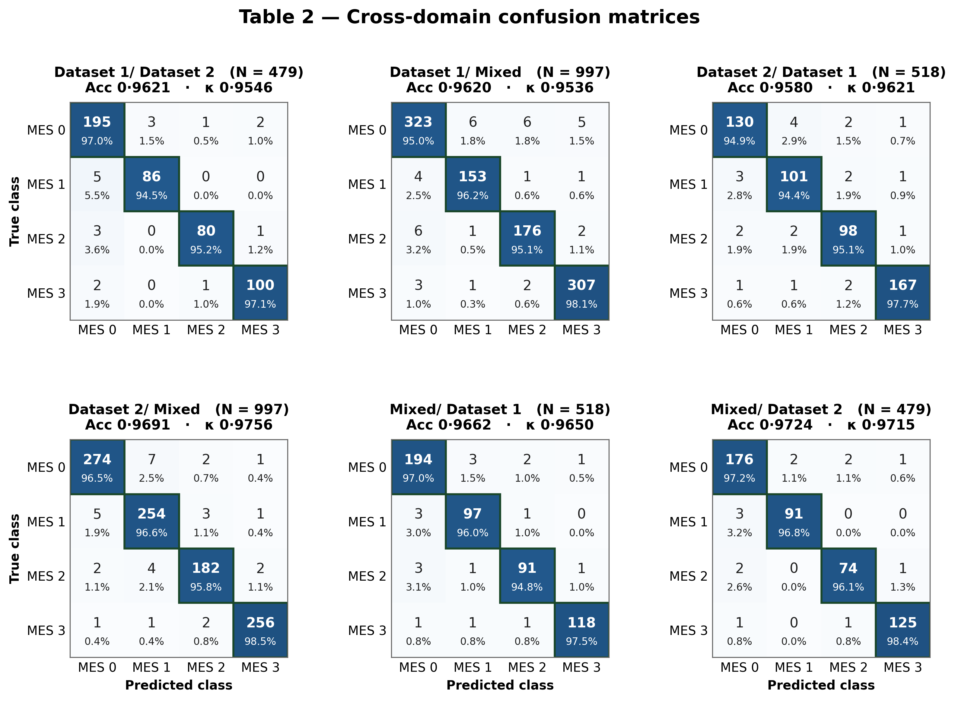

Table 3. Multi-domain LIMUC classification results.
Dataset | Accuracy | Class | Accuracy  95% CI | Cohen's κ | Quad κ | EC | Precision  (PPV) | Recall | F1 Score | NPV
Dataset 1  → LIMUC  N = 9127 | 0·9362 | MES 0 | (0.9310 - 0.9410) | 0.9230 | 0.9330 | 0.0518 | 0·9089 | 0·7978 | 0.8497 | 0·9768
 |  | MES 1 | (0.9310 - 0.9410) | 0.9169 | 0.9269 | 0.0261 | 0·8294 | 0·8339 | 0·8316 | 0·9615
 |  | MES 2 | (0.9310 - 0.9410) | 0.9222 | 0.9322 | 0.0410 | 0·8417 | 0·9152 | 0.8769 | 0·9855
 |  | MES 3 | (0.9310 - 0.9410) | 0.9151 | 0.9251 | 0.0449 | 0·7981 | 0·9868 | 0.8825 | 0·9899
Dataset 2  → LIMUC  N = 9127 | 0·9272 | MES 0 | (0.9217 - 0.9324) | 0.8918 | 0.9018 | 0.0432 | 0·9153 | 0·8033 | 0.8557 | 0·9778
 |  | MES 1 | (0.9217 - 0.9324) | 0.9026 | 0.9126 | 0.0284 | 0·8326 | 0·8431 | 0.8378 | 0·9622
 |  | MES 2 | (0.9217 - 0.9324) | 0.9024 | 0.9124 | 0.0409 | 0·8339 | 0·9290 | 0.8789 | 0·9786
 |  | MES 3 | (0.9217 - 0.9324) | 0.9088 | 0.9188 | 0.0472 | 0·8071 | 0·9866 | 0·8879 | 0·9894
Mixed  → LIMUC  N = 9127 | 0·9405 | MES 0 | (0.9355 - 0.9452) | 0.9198 | 0.9298 | 0.0469 | 0·9400 | 0·9370 | 0.9385 | 0·9773
 |  | MES 1 | (0.9355 - 0.9452) | 0.8930 | 0.9030 | 0.0454 | 0·9295 | 0·9460 | 0.9377 | 0·9834
 |  | MES 2 | (0.9355 - 0.9452) | 0.9046 | 0.9146 | 0.0448 | 0·9392 | 0·9352 | 0.9372 | 0·9779
 |  | MES 3 | (0.9355 - 0.9452) | 0.9061 | 0.9161 | 0.0467 | 0·9351 | 0·9411 | 0.9381 | 0·9819
LIMUC  → Dataset 1  N = 518 | 0·9070 | MES 0 | (0.8789 - 0.9291) | 0.8516 | 0.8616 | 0.0472 | 0·9448 | 0·9284 | 0·9365 | 0·9519
 |  | MES 1 | (0.8789 - 0.9291) | 0.8292 | 0.8392 | 0.0329 | 0·8550 | 0·8953 | 0·8747 | 0·9790
 |  | MES 2 | (0.8789 - 0.9291) | 0.8519 | 0.8619 | 0.0234 | 0·8731 | 0·8643 | 0·8687 | 0·9693
 |  | MES 3 | (0.8789 - 0.9291) | 0.8832 | 0.8532 | 0.0320 | 0·9067 | 0·9128 | 0·9097 | 0·9718
LIMUC  → Dataset 2  N = 474 | 0·9289 | MES 0 | (0.9023 - 0.9487) | 0.8793 | 0.8893 | 0.0485 | 0·9370 | 0·9248 | 0.9309 | 0·9530
 |  | MES 1 | (0.9023 - 0.9487) | 0.8933 | 0.9033 | 0.0418 | 0·9206 | 0·9372 | 0.9288 | 0·9872
 |  | MES 2 | (0.9023 - 0.9487) | 0.8966 | 0.9066 | 0.0404 | 0·9137 | 0·9290 | 0.9213 | 0·9848
 |  | MES 3 | (0.9023 - 0.9487) | 0.8915 | 0.9015 | 0.0434 | 0·9275 | 0·9260 | 0.9267 | 0·9746
LIMUC  → Mixed  N = 992 | 0·9311 | MES 0 | (0.9137 - 0.9452) | 0.8874 | 0.8974 | 0.0445 | 0·9182 | 0·9357 | 0.9269 | 0·9802
 |  | MES 1 | (0.9137 - 0.9452) | 0.8901 | 0.9001 | 0.0419 | 0·9322 | 0·9276 | 0.9299 | 0·9760
 |  | MES 2 | (0.9137 - 0.9452) | 0.9119 | 0.9219 | 0.0501 | 0·9335 | 0·9337 | 0.9336 | 0·9753
 |  | MES 3 | (0.9137 - 0.9452) | 0.9198 | 0.9298 | 0.0410 | 0·9268 | 0·9264 | 0.9266 | 0·9761

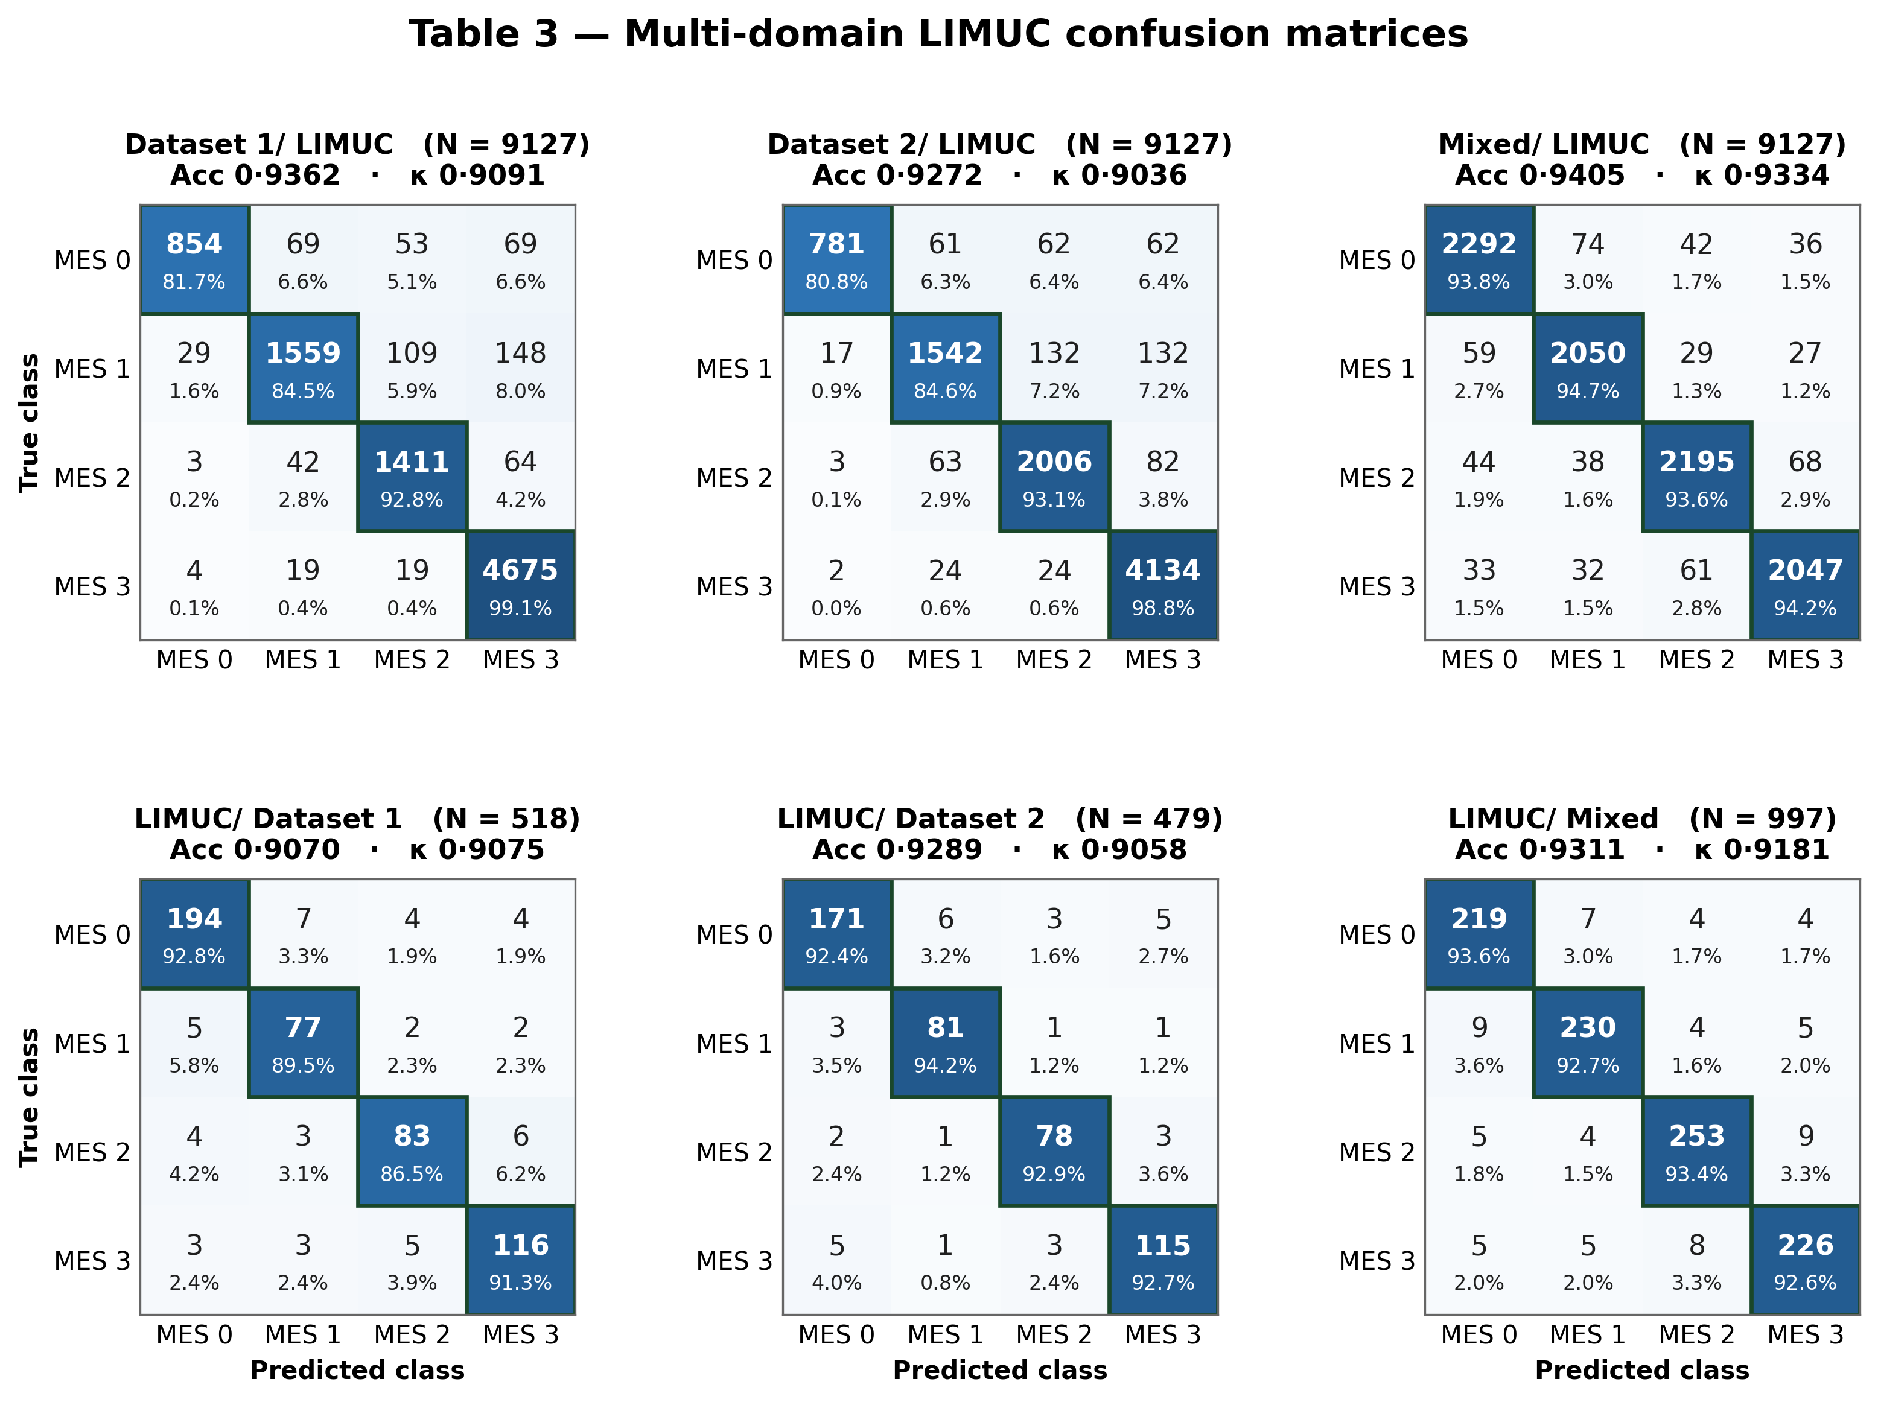

Table 4. Multi-domain TMC-UCM classification results.
Dataset | Accuracy | Class | Accuracy  95% CI | Cohen's κ | Quad κ | EC | Precision  (PPV) | Recall | F1 Score | NPV
Dataset 1  → TMC-UCM  N = 7978 | 0·9536 | MES 0 | (0.9488 - 0.9580) | 0.9310 | 0.9410 | 0.0534 | 0·9100 | 0·9923 | 0·9494 | 0·9929
 |  | MES 1 | (0.9488 - 0.9580) | 0.9329 | 0.9429 | 0.0530 | 0·9940 | 0·9256 | 0·9586 | 0·9769
 |  | MES 2 | (0.9488 - 0.9580) | 0.9352 | 0.9452 | 0.0478 | 0·9731 | 0·9233 | 0·9475 | 0·9822
 |  | MES 3 | (0.9488 - 0.9580) | 0.9059 | 0.9159 | 0.0551 | 0·9843 | 0·9446 | 0·9640 | 0·9830
Dataset 2  → TMC-UCM  N = 7978 | 0·9109 | MES 0 | (0.9044 - 0.9170) | 0.8658 | 0.8758 | 0.0416 | 0·8542 | 0·9780 | 0·9119 | 0·9931
 |  | MES 1 | (0.9044 - 0.9170) | 0.8883 | 0.8983 | 0.0293 | 0·9729 | 0·8389 | 0.9009 | 0·9533
 |  | MES 2 | (0.9044 - 0.9170) | 0.8747 | 0.8847 | 0.0279 | 0·9241 | 0·8908 | 0·9071 | 0·9673
 |  | MES 3 | (0.9044 - 0.9170) | 0.8851 | 0.8951 | 0.0386 | 0·9678 | 0·8857 | 0·9249 | 0·9712
Mixed  → TMC-UCM  N = 7978 | 0·9055 | MES 0 | (0.8989 - 0.9117) | 0.8589 | 0.8689 | 0.0372 | 0·8550 | 0·9627 | 0.9057 | 0·9827
 |  | MES 1 | (0.8989 - 0.9117) | 0.8771 | 0.8871 | 0.0299 | 0·9552 | 0·8606 | 0.9054 | 0·9596
 |  | MES 2 | (0.8989 - 0.9117) | 0.8849 | 0.8949 | 0.0333 | 0·9466 | 0·8663 | 0.9047 | 0·9719
 |  | MES 3 | (0.8989 - 0.9117) | 0.8856 | 0.8956 | 0.0291 | 0·9229 | 0·8902 | 0.9063 | 0·9620
TMC-UCM  → Dataset 1  N = 518 | 0·9537 | MES 0 | (0.9320 - 0.9687) | 0.9212 | 0.9312 | 0.0576 | 0·9187 | 0·9855 | 0·9509 | 0·9907
 |  | MES 1 | (0.9320 - 0.9687) | 0.9332 | 0.9432 | 0.0480 | 0·9800 | 0·8972 | 0·9368 | 0·9739
 |  | MES 2 | (0.9320 - 0.9687) | 0.9203 | 0.9303 | 0.0541 | 0·9731 | 0·9522 | 0·9625 | 0·9880
 |  | MES 3 | (0.9320 - 0.9687) | 0.9078 | 0.9178 | 0.0587 | 0·9788 | 0·9598 | 0·9692 | 0·9874
TMC-UCM  → Dataset 2  N = 474 | 0·9558 | MES 0 | (0.9335 - 0.9709) | 0.9298 | 0.9398 | 0.0598 | 0·9216 | 0·9867 | 0.9530 | 0·9936
 |  | MES 1 | (0.9335 - 0.9709) | 0.9370 | 0.9470 | 0.0520 | 0·9885 | 0·9069 | 0.9459 | 0·9770
 |  | MES 2 | (0.9335 - 0.9709) | 0.9059 | 0.9159 | 0.0552 | 0·9702 | 0·9468 | 0.9584 | 0·9871
 |  | MES 3 | (0.9335 - 0.9709) | 0.9254 | 0.9354 | 0.0614 | 0·9773 | 0·9629 | 0·9700 | 0·9856
TMC-UCM  → Mixed  N = 992 | 0·9232 | MES 0 | (0.9050 - 0.9382) | 0.9096 | 0.9196 | 0.0428 | 0·8810 | 0·9728 | 0.9246 | 0·9816
 |  | MES 1 | (0.9050 - 0.9382) | 0.9113 | 0.9213 | 0.0355 | 0·9676 | 0·8616 | 0·9115 | 0·9642
 |  | MES 2 | (0.9050 - 0.9382) | 0.9088 | 0.9188 | 0.0364 | 0·9379 | 0·8965 | 0·9167 | 0·9738
 |  | MES 3 | (0.9050 - 0.9382) | 0.8881 | 0.8981 | 0.0466 | 0·9553 | 0·9286 | 0.9418 | 0·9795
