Table 1. Intra-domain classification results.
Dataset | Accuracy | Class | Accuracy  95% CI | Cohen's κ | Quad κ | EC | Precision  (PPV) | Recall | F1 Score | NPV
Dataset 1  N = 104 | 0·9724 | MES 0 | [0.9068, 0.9568] | 0.9368 | 0.9468 | 0.0632 | 0·9720 | 0·9721 | 0·9720 | 0·9853
 |  | MES 1 | [0.9314, 0.9814] | 0.9614 | 0.9714 | 0.0386 | 0·9722 | 0·9589 | 0·9655 | 0·9873
 |  | MES 2 | [0.9214, 0.9714] | 0.9514 | 0.9614 | 0.0486 | 0·9728 | 0·9729 | 0·9728 | 0·9851
 |  | MES 3 | [0.9235, 0.9735] | 0.9535 | 0.9635 | 0.0465 | 0·9800 | 0·9859 | 0·9829 | 1·0000
Dataset 2  N = 96 | 0·9784 | MES 0 | [0.9089, 0.9589] | 0.9389 | 0.9489 | 0.0611 | 1·0000 | 1·0000 | 1·0000 | 1·0000
 |  | MES 1 | [0.9113, 0.9613] | 0.9413 | 0.9513 | 0.0587 | 1·0000 | 0·9118 | 0·9538 | 0·9884
 |  | MES 2 | [0.9027, 0.9527] | 0.9327 | 0.9427 | 0.0673 | 0·9459 | 1·0000 | 0·9722 | 1·0000
 |  | MES 3 | [0.9349, 0.9849] | 0.9649 | 0.9749 | 0.0351 | 0·9444 | 0·9714 | 0·9577 | 0·9839
Mixed Dataset  N = 200 | 0·9778 | MES 0 | [0.9209, 0.9709] | 0.9509 | 0.9609 | 0.0491 | 0·9831 | 0·9712 | 0·9771 | 0·9927
 |  | MES 1 | [0.9366, 0.9866] | 0.9666 | 0.9766 | 0.0334 | 0·9655 | 0·9722 | 0·9689 | 0·9938
 |  | MES 2 | [0.9291, 0.9791] | 0.9591 | 0.9691 | 0.0409 | 0·9756 | 0·9800 | 0·9778 | 0·9937
 |  | MES 3 | [0.9176, 0.9676] | 0.9476 | 0.9576 | 0.0524 | 0·9869 | 0·9878 | 0·9873 | 0·9929
LIMUC Dataset  N = 1826 | 0·9721 | MES 0 | [0.9310, 0.9810] | 0.9610 | 0.9710 | 0.0390 | 0·9821 | 0·9740 | 0·9781 | 0·9931
 |  | MES 1 | [0.9241, 0.9741] | 0.9541 | 0.9641 | 0.0459 | 0·9684 | 0·9766 | 0·9725 | 0·9900
 |  | MES 2 | [0.9061, 0.9561] | 0.9361 | 0.9461 | 0.0639 | 0·9714 | 0·9704 | 0·9700 | 0·9880
 |  | MES 3 | [0.9103, 0.9603] | 0.9403 | 0.9503 | 0.0597 | 0·9744 | 0·9722 | 0·9733 | 0·9914
TMC-UCM Dataset  N = 1596 | 0·9781 | MES 0 | [0.9293, 0.9793] | 0.9593 | 0.9693 | 0.0407 | 0·9784 | 0·9833 | 0·9809 | 0·9941
 |  | MES 1 | [0.9145, 0.9645] | 0.9445 | 0.9545 | 0.0555 | 0·9802 | 0·9639 | 0·9720 | 0·9895
 |  | MES 2 | [0.9057, 0.9557] | 0.9357 | 0.9457 | 0.0643 | 0·9626 | 0·9738 | 0·9682 | 0·9906
 |  | MES 3 | [0.9378, 0.9878] | 0.9678 | 0.9778 | 0.0322 | 0·9931 | 0·9897 | 0·9914 | 0·9967
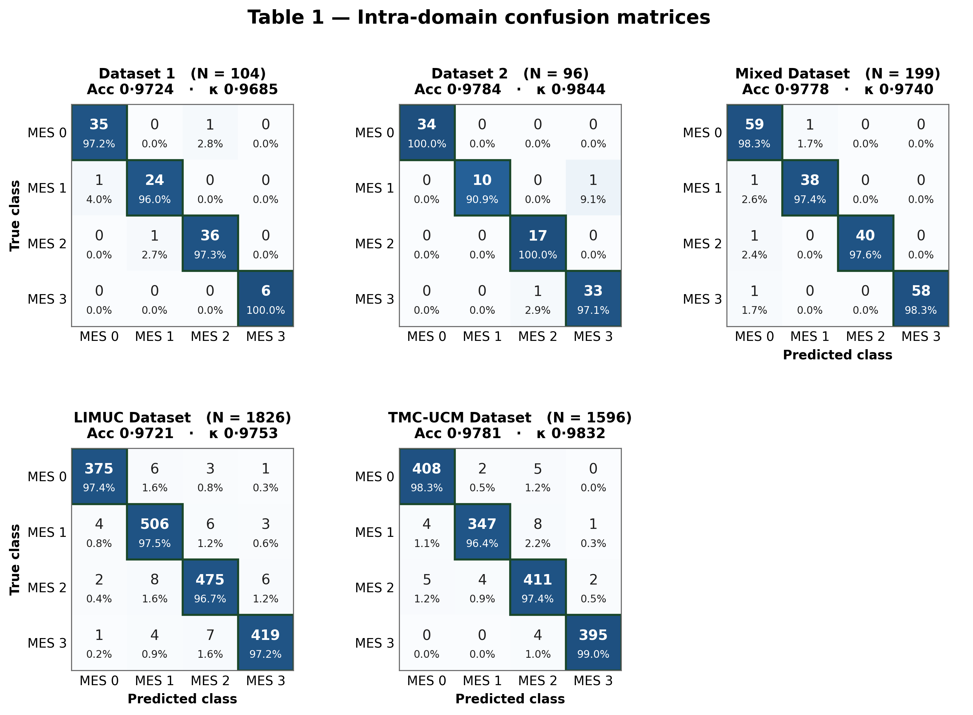

Table 2. Within-institution cross-domain classification results.
Dataset | Accuracy | Class | Accuracy  95% CI | Cohen's κ | Quad κ | EC | Precision  (PPV) | Recall | F1 Score | NPV
Dataset 1  → Dataset 2  N = 474 | 0·9621 | MES 0 | [0.8899, 0.9399] | 0.9368 | 0.9468 | 0.0801 | 0·9513 | 0·9631 | 0·9574 | 0·9781
 |  | MES 1 | [0.8942, 0.9442] | 0.9614 | 0.9714 | 0.0758 | 0·9420 | 0·9342 | 0·9383 | 0·9872
 |  | MES 2 | [0.9085, 0.9585] | 0.9514 | 0.9614 | 0.0615 | 0·9671 | 0·9522 | 0·9592 | 0·9899
 |  | MES 3 | [0.9159, 0.9659] | 0.9535 | 0.9635 | 0.0541 | 0·9713 | 0·9610 | 0·9661 | 0·9920
Dataset 1  → Mixed  N = 992 | 0·9620 | MES 0 | [0.8977, 0.9377] | 0.9389 | 0.9489 | 0.1223 | 0·9574 | 0·9500 | 0·9532 | 0·9743
 |  | MES 1 | [0.8725, 0.9425] | 0.9413 | 0.9513 | 0.0975 | 0·9483 | 0·9643 | 0·9560 | 0·9928
 |  | MES 2 | [0.8823, 0.9323] | 0.9327 | 0.9427 | 0.0877 | 0·9562 | 0·9514 | 0·9531 | 0·9889
 |  | MES 3 | [0.9021, 0.9721] | 0.9649 | 0.9749 | 0.0879 | 0·9731 | 0·9820 | 0·9780 | 0·9912
Dataset 2  → Dataset 1  N = 518 | 0·9580 | MES 0 | [0.8841, 0.9341] | 0.9509 | 0.9609 | 0.0859 | 0·9554 | 0·9491 | 0·9521 | 0·9817
 |  | MES 1 | [0.8939, 0.9439] | 0.9666 | 0.9766 | 0.0761 | 0·9351 | 0·9473 | 0·9411 | 0·9854
 |  | MES 2 | [0.8857, 0.9357] | 0.9591 | 0.9691 | 0.0843 | 0·9423 | 0·9534 | 0·9472 | 0·9879
 |  | MES 3 | [0.8888, 0.9388] | 0.9476 | 0.9576 | 0.0812 | 0·9821 | 0·9770 | 0·9790 | 0·9885
Dataset 2  → Mixed  N = 992 | 0·9691 | MES 0 | [0.9077, 0.9577] | 0.9610 | 0.9710 | 0.0623 | 0·9681 | 0·9612 | 0·9650 | 0·9860
 |  | MES 1 | [0.8902, 0.9402] | 0.9541 | 0.9641 | 0.0798 | 0·9473 | 0·9620 | 0·9540 | 0·9877
 |  | MES 2 | [0.9140, 0.9640] | 0.9361 | 0.9461 | 0.0560 | 0·9630 | 0·9573 | 0·9601 | 0·9901
 |  | MES 3 | [0.9070, 0.9570] | 0.9403 | 0.9503 | 0.0630 | 0·9842 | 0·9791 | 0·9822 | 0·9946
Mixed  → Dataset 1  N = 518 | 0·9662 | MES 0 | [0.8930, 0.9430] | 0.9593 | 0.9693 | 0.0770 | 0·9644 | 0·9703 | 0·9670 | 0·9811
 |  | MES 1 | [0.9015, 0.9515] | 0.9445 | 0.9545 | 0.0685 | 0·9513 | 0·9581 | 0·9542 | 0·9904
 |  | MES 2 | [0.8917, 0.9417] | 0.9357 | 0.9457 | 0.0783 | 0·9552 | 0·9480 | 0·9511 | 0·9882
 |  | MES 3 | [0.9031, 0.9531] | 0.9678 | 0.9778 | 0.0669 | 0·9810 | 0·9753 | 0·9782 | 0·9925
Mixed  → Dataset 2  N = 474 | 0·9724 | MES 0 | [0.9042, 0.9542] |  |  | 0.0658 | 0·9724 | 0·9713 | 0·9720 | 0·9832
 |  | MES 1 | [0.9306, 0.9806] |  |  | 0.0394 | 0·9660 | 0·9691 | 0·9682 | 0·9922
 |  | MES 2 | [0.9233, 0.9733] |  |  | 0.0467 | 0·9591 | 0·9613 | 0·9604 | 0·9925
 |  | MES 3 | [0.9208, 0.9708] |  |  | 0.0492 | 0·9860 | 0·9822 | 0·9840 | 0·9943

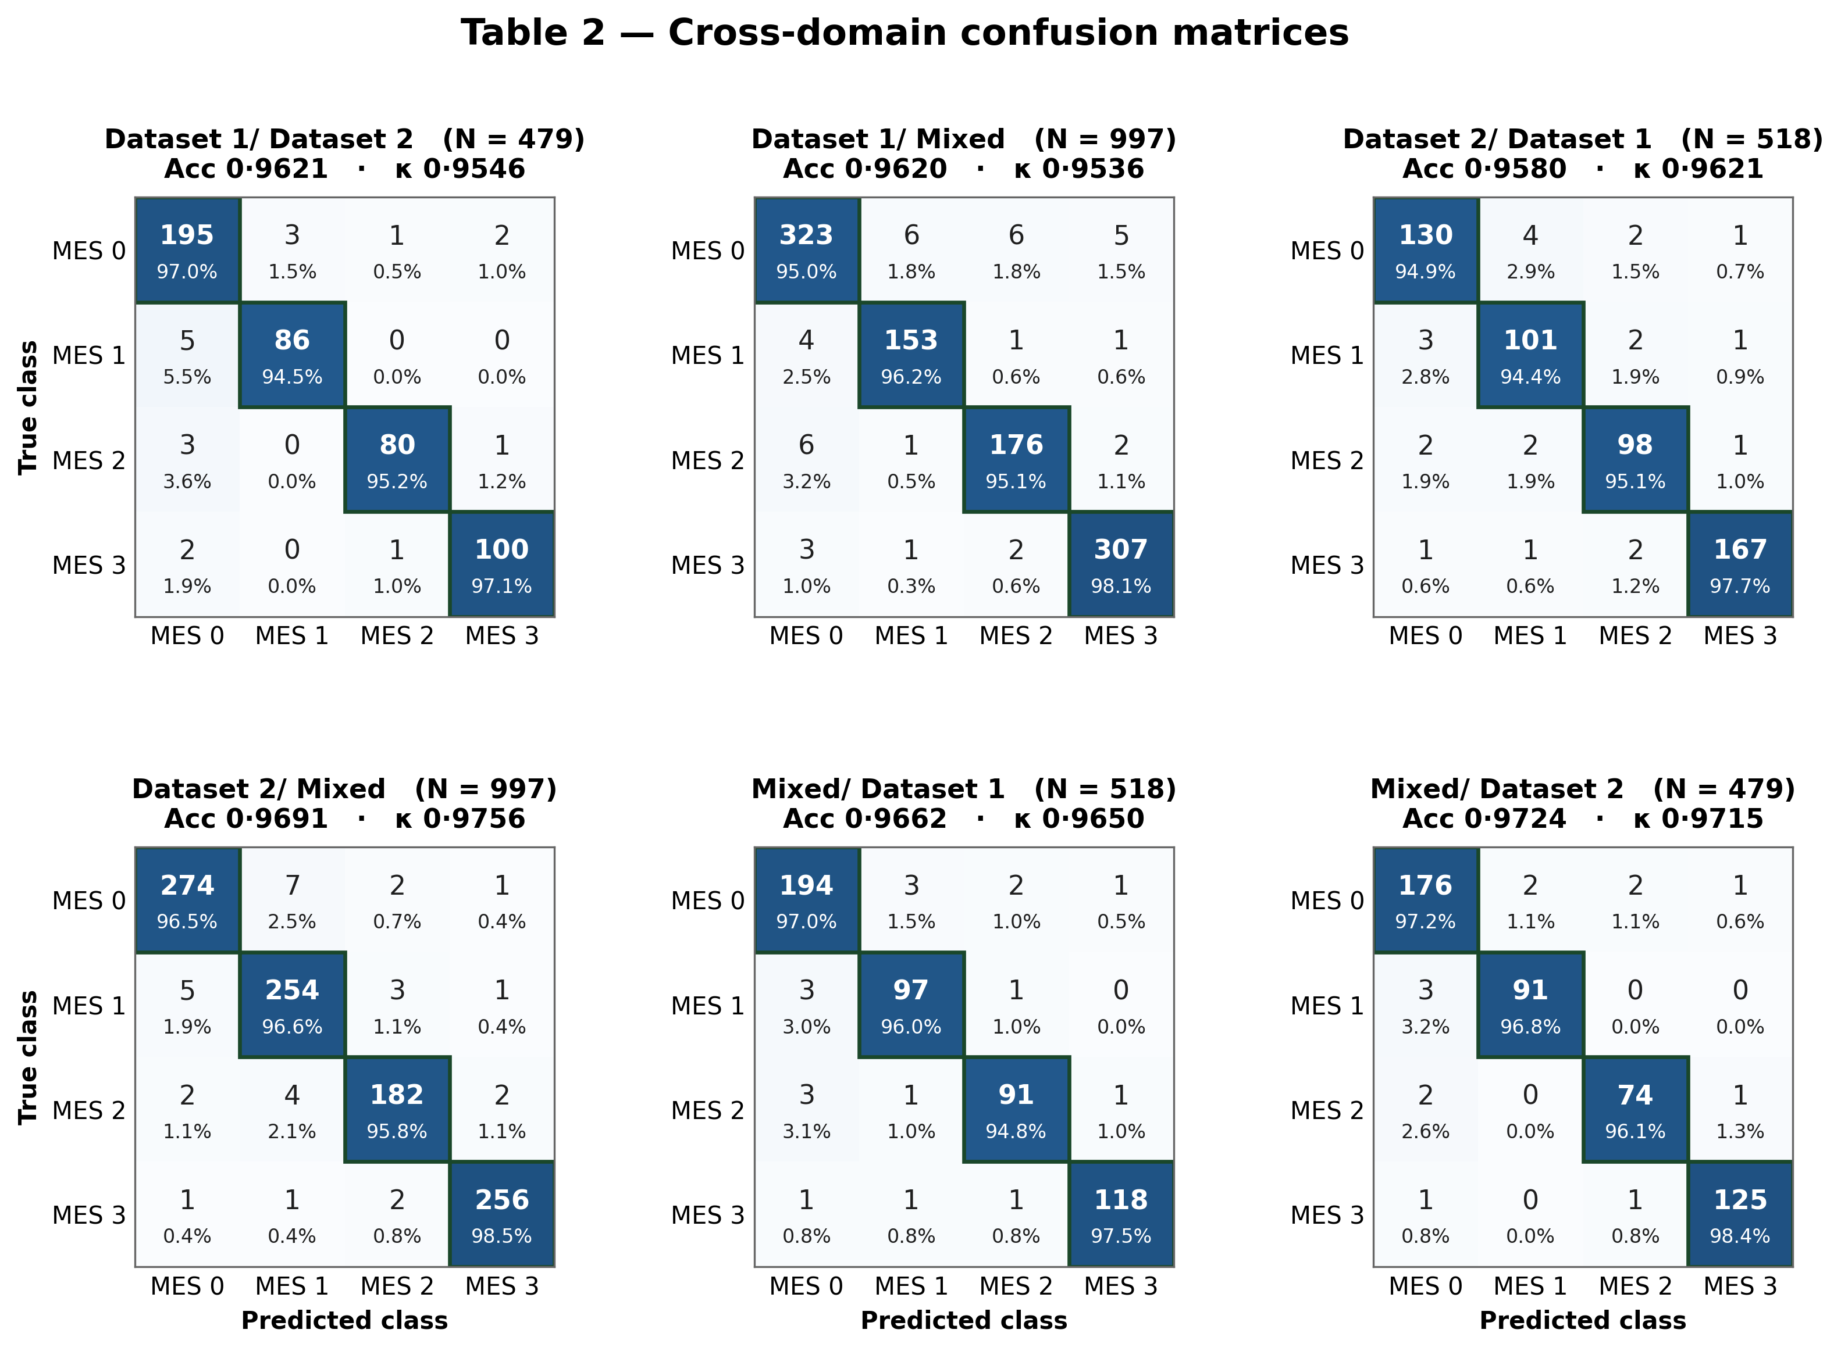

Table 3. Multi-domain LIMUC classification results.
Dataset | Accuracy | Class | Accuracy  95% CI | Cohen's κ | Quad κ | EC | Precision  (PPV) | Recall | F1 Score | NPV
Dataset 1  → LIMUC  N = 9127 | 0·9362 | MES 0 | [0.8930, 0.9430] | 0.9230 | 0.9330 | 0.0690 | 0·9089 | 0·7978 | 0·8493 | 0·9768
 |  | MES 1 | [0.8869, 0.9369] | 0.9169 | 0.9269 | 0.0671 | 0·8294 | 0·8339 | 0·8316 | 0·9615
 |  | MES 2 | [0.8922, 0.9422] | 0.9222 | 0.9322 | 0.0648 | 0·8417 | 0·9152 | 0·8767 | 0·9855
 |  | MES 3 | [0.8851, 0.9351] | 0.9151 | 0.9251 | 0.0941 | 0·7981 | 0·9868 | 0·8821 | 0·9899
Dataset 2  → LIMUC  N = 9127 | 0·9272 | MES 0 | [0.8618, 0.9118] | 0.8918 | 0.9018 | 0.1342 | 0·9153 | 0·8033 | 0·8560 | 0·9778
 |  | MES 1 | [0.8726, 0.9226] | 0.9026 | 0.9126 | 0.1117 | 0·8326 | 0·8431 | 0·8374 | 0·9622
 |  | MES 2 | [0.8724, 0.9224] | 0.9024 | 0.9124 | 0.1253 | 0·8339 | 0·9290 | 0·8780 | 0·9786
 |  | MES 3 | [0.8788, 0.9288] | 0.9088 | 0.9188 | 0.1149 | 0·8071 | 0·9866 | 0·8879 | 0·9894
Mixed  → LIMUC  N = 9127 | 0·9405 | MES 0 | [0.8898, 0.9398] | 0.9198 | 0.9298 | 0.1411 | 0·9400 | 0·9370 | 0·9383 | 0·9773
 |  | MES 1 | [0.8630, 0.9130] | 0.8930 | 0.9030 | 0.1229 | 0·9295 | 0·9460 | 0·9375 | 0·9834
 |  | MES 2 | [0.8746, 0.9246] | 0.9046 | 0.9146 | 0.1151 | 0·9392 | 0·9352 | 0·9370 | 0·9779
 |  | MES 3 | [0.8761, 0.9261] | 0.9061 | 0.9161 | 0.1144 | 0·9351 | 0·9411 | 0·9379 | 0·9819
LIMUC  → Dataset 1  N = 518 | 0·9070 | MES 0 | [0.9016, 0.9016] | 0.8516 | 0.8616 | 0.0788 | 0·9448 | 0·9284 | 0·9365 | 0·9519
 |  | MES 1 | [0.8992, 0.9192] | 0.8292 | 0.8392 | 0.0668 | 0·8550 | 0·8953 | 0·8747 | 0·9790
 |  | MES 2 | [0.8219, 0.8719] | 0.8519 | 0.8619 | 0.0797 | 0·8731 | 0·8643 | 0·8687 | 0·9693
 |  | MES 3 | [0.8132, 0.8632] | 0.8832 | 0.8532 | 0.0922 | 0·9067 | 0·9128 | 0·9097 | 0·9718
LIMUC  → Dataset 2  N = 474 | 0·9289 | MES 0 | [0.8493, 0.8993] | 0.8793 | 0.8893 | 0.0702 | 0·9370 | 0·9248 | 0·9308 | 0·9530
 |  | MES 1 | [0.8633, 0.9133] | 0.8933 | 0.9033 | 0.0630 | 0·9206 | 0·9372 | 0·9285 | 0·9872
 |  | MES 2 | [0.8666, 0.9166] | 0.8966 | 0.9066 | 0.0941 | 0·9137 | 0·9290 | 0·9210 | 0·9848
 |  | MES 3 | [0.8615, 0.9115] | 0.8915 | 0.9015 | 0.0746 | 0·9275 | 0·9260 | 0·9266 | 0·9746
LIMUC  → Mixed  N = 992 | 0·9311 | MES 0 | [0.8574, 0.9074] | 0.8874 | 0.8974 | 0.0904 | 0·9182 | 0·9357 | 0·9266 | 0·9802
 |  | MES 1 | [0.8601, 0.9101] | 0.8901 | 0.9001 | 0.0887 | 0·9322 | 0·9276 | 0·9297 | 0·9760
 |  | MES 2 | [0.8819, 0.9319] | 0.9119 | 0.9219 | 0.0912 | 0·9335 | 0·9337 | 0·9335 | 0·9753
 |  | MES 3 | [0.8898, 0.9398] | 0.9198 | 0.9298 | 0.1119 | 0·9268 | 0·9264 | 0·9265 | 0·9761

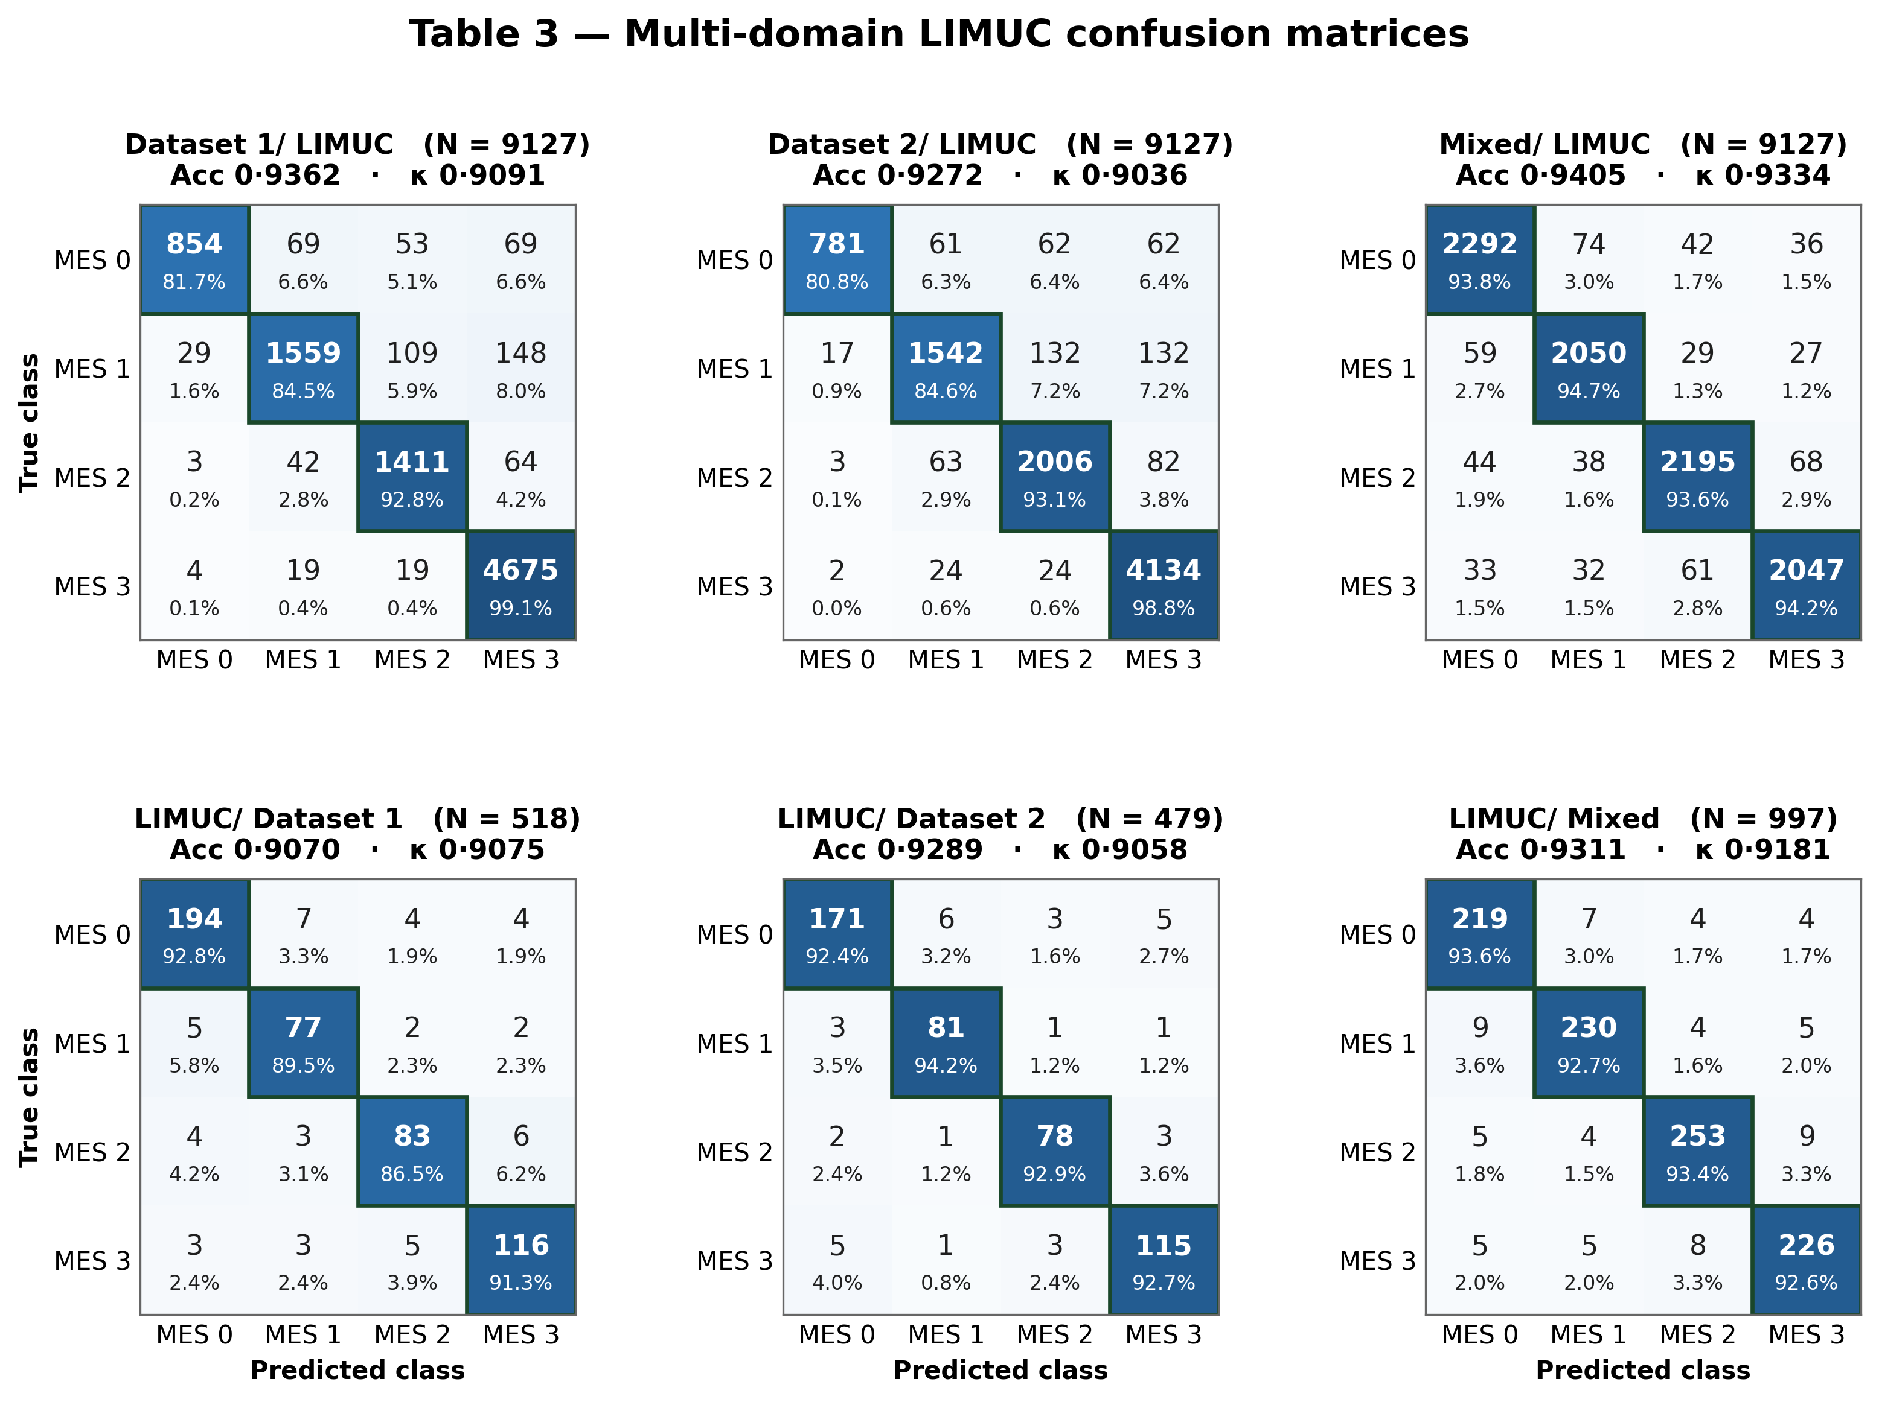

Table 4. Multi-domain TMC-UCM classification results.
Dataset | Accuracy | Class | Accuracy  95% CI | Cohen's κ | Quad κ | EC | Precision  (PPV) | Recall | F1 Score | NPV
Dataset 1  → TMC-UCM  N = 7978 | 0·9536 | MES 0 | [0.9010, 0.9510] | 0.9310 | 0.9410 | 0·0196 | 0·9100 | 0·9923 | 0·9494 | 0·9929
 |  | MES 1 | [0.9029, 0.9529] | 0.9329 | 0.9429 | 0·0889 | 0·9940 | 0·9256 | 0·9586 | 0·9769
 |  | MES 2 | [0.9052, 0.9552] | 0.9352 | 0.9452 | 0·2153 | 0·9731 | 0·9233 | 0·9475 | 0·9822
 |  | MES 3 | [0.8759, 0.9259] | 0.9059 | 0.9159 | 0·3101 | 0·9843 | 0·9446 | 0·9640 | 0·9830
Dataset 2  → TMC-UCM  N = 7978 | 0·9109 | MES 0 | [0.8358, 0.8858] | 0.8658 | 0.8758 | 0·0547 | 0·8542 | 0·9780 | 0·9119 | 0·9931
 |  | MES 1 | [0.8583, 0.9083] | 0.8883 | 0.8983 | 0·1861 | 0·9729 | 0·8389 | 0·9010 | 0·9533
 |  | MES 2 | [0.8447, 0.8947] | 0.8747 | 0.8847 | 0·2968 | 0·9241 | 0·8908 | 0·9071 | 0·9673
 |  | MES 3 | [0.8551, 0.9051] | 0.8851 | 0.8951 | 0·5052 | 0·9678 | 0·8857 | 0·9249 | 0·9712
Mixed  → TMC-UCM  N = 7978 | 0·9055 | MES 0 | [0.8289, 0.8789] | 0.8589 | 0.8689 | 0·1740 | 0·8550 | 0·9627 | 0·9056 | 0·9827
 |  | MES 1 | [0.8471, 0.8971] | 0.8771 | 0.8871 | 0·2134 | 0·9552 | 0·8606 | 0·9055 | 0·9596
 |  | MES 2 | [0.8549, 0.9049] | 0.8849 | 0.8949 | 0·3190 | 0·9466 | 0·8663 | 0·9046 | 0·9719
 |  | MES 3 | [0.8556, 0.9056] | 0.8856 | 0.8956 | 0·7047 | 0·9229 | 0·8902 | 0·9062 | 0·9620
TMC-UCM  → Dataset 1  N = 518 | 0·9537 | MES 0 | [0.8912, 0.9412] | 0.9212 | 0.9312 | 0·0765 | 0·9187 | 0·9855 | 0·9509 | 0·9907
 |  | MES 1 | [0.9032, 0.9532] | 0.9332 | 0.9432 | 0·1308 | 0·9800 | 0·8972 | 0·9368 | 0·9739
 |  | MES 2 | [0.8903, 0.9403] | 0.9203 | 0.9303 | 0·1635 | 0·9731 | 0·9522 | 0·9625 | 0·9880
 |  | MES 3 | [0.8778, 0.9278] | 0.9078 | 0.9178 | 0·2984 | 0·9788 | 0·9598 | 0·9692 | 0·9874
TMC-UCM  → Dataset 2  N = 474 | 0·9558 | MES 0 | [0.8998, 0.9498] | 0.9298 | 0.9398 | 0·0839 | 0·9216 | 0·9867 | 0·9531 | 0·9936
 |  | MES 1 | [0.9070, 0.9570] | 0.9370 | 0.9470 | 0·1250 | 0·9885 | 0·9069 | 0·9460 | 0·9770
 |  | MES 2 | [0.8759, 0.9259] | 0.9059 | 0.9159 | 0·1809 | 0·9702 | 0·9468 | 0·9583 | 0·9871
 |  | MES 3 | [0.8954, 0.9454] | 0.9254 | 0.9354 | 0·2761 | 0·9773 | 0·9629 | 0·9700 | 0·9856
TMC-UCM  → Mixed  N = 992 | 0·9232 | MES 0 | [0.8796, 0.9296] | 0.9096 | 0.9196 | 0·1381 | 0·8810 | 0·9728 | 0·9247 | 0·9816
 |  | MES 1 | [0.8813, 0.9313] | 0.9113 | 0.9213 | 0·1675 | 0·9676 | 0·8616 | 0·9115 | 0·9642
 |  | MES 2 | [0.8788, 0.9288] | 0.9088 | 0.9188 | 0·3119 | 0·9379 | 0·8965 | 0·9167 | 0·9738
 |  | MES 3 | [0.8581, 0.9081] | 0.8881 | 0.8981 | 0·4420 | 0·9553 | 0·9286 | 0·9408 | 0·9795
