ColonoMind Final Consistent Results

1. Performance Tables

Table 1: Performance on NTUH Dataset
Model | Accuracy (%) | Precision (%) | Recall (%) | F1 (%) | QWK
ResNet-50 | 70.35%  (63.67%–76.26%) | 67.17%  (60.37%–73.32%) | 66.73%  (59.92%–72.91%) | 66.99%  (60.19%–73.15%) | 0.7957  (0.7383–0.8416)
DenseNet-121 | 67.34%  (60.55%–73.47%) | 64.15%  (57.28%–70.49%) | 64.16%  (57.29%–70.50%) | 64.41%  (57.54%–70.73%) | 0.7906  (0.7320–0.8376)
EfficientNet-B4 | 77.89%  (71.63%–83.10%) | 76.03%  (69.64%–81.43%) | 75.73%  (69.32%–81.16%) | 75.65%  (69.24%–81.09%) | 0.8797  (0.8439–0.9077)
ConvNeXt-Tiny | 71.36%  (64.72%–77.19%) | 68.04%  (61.27%–74.12%) | 67.66%  (60.88%–73.77%) | 67.85%  (61.08%–73.95%) | 0.8350  (0.7874–0.8727)
ViT-B/16 | 48.74%  (41.89%–55.64%) | 46.85%  (40.04%–53.78%) | 46.87%  (40.06%–53.80%) | 47.14%  (40.32%–54.06%) | 0.4330  (0.3127–0.5396)

Table 2: Performance on TMC-UCM Dataset
Model | Accuracy (%) | Precision (%) | Recall (%) | F1 (%) | QWK
ResNet-50 | 79.94%  (77.90%–81.83%) | 78.34%  (76.25%–80.29%) | 78.55%  (76.47%–80.49%) | 78.79%  (76.72%–80.73%) | 0.9201  (0.9122–0.9273)
DenseNet-121 | 78.56%  (76.48%–80.50%) | 77.27%  (75.15%–79.26%) | 77.37%  (75.25%–79.36%) | 77.70%  (75.59%–79.67%) | 0.9134  (0.9049–0.9212)
EfficientNet-B4 | 83.74%  (81.85%–85.47%) | 82.83%  (80.90%–84.60%) | 82.92%  (81.00%–84.69%) | 83.05%  (81.13%–84.81%) | 0.9354  (0.9290–0.9413)
ConvNeXt-Tiny | 80.85%  (78.85%–82.71%) | 79.31%  (77.25%–81.23%) | 79.47%  (77.42%–81.38%) | 79.69%  (77.65%–81.59%) | 0.9252  (0.9178–0.9320)
ViT-B/16 | 48.10%  (45.66%–50.55%) | 44.65%  (42.23%–47.10%) | 44.88%  (42.46%–47.33%) | 45.51%  (43.08%–47.96%) | 0.4618  (0.4223–0.4995)

Table 3: Performance on LIMUC Dataset
Model | Accuracy (%) | Precision (%) | Recall (%) | F1 (%) | QWK
ResNet-50 | 76.57%  (74.49%–78.53%) | 69.07%  (66.82%–71.23%) | 68.63%  (66.37%–70.80%) | 68.40%  (66.14%–70.58%) | 0.8415  (0.8270–0.8549)
DenseNet-121 | 75.50%  (73.39%–77.49%) | 67.70%  (65.43%–69.89%) | 66.94%  (64.66%–69.14%) | 66.34%  (64.05%–68.56%) | 0.8403  (0.8257–0.8538)
EfficientNet-B4 | 78.11%  (76.07%–80.02%) | 73.48%  (71.32%–75.53%) | 72.36%  (70.18%–74.44%) | 71.46%  (69.26%–73.57%) | 0.8553  (0.8419–0.8676)
ConvNeXt-Tiny | 76.87%  (74.80%–78.82%) | 61.28%  (58.93%–63.58%) | 61.10%  (58.75%–63.40%) | 61.16%  (58.81%–63.46%) | 0.7353  (0.7126–0.7565)
ViT-B/16 | 68.62%  (66.36%–70.79%) | 58.72%  (56.35%–61.05%) | 58.60%  (56.23%–60.93%) | 58.91%  (56.54%–61.24%) | 0.7058  (0.6810–0.7290)

Table 4: Performance on Unified Dataset
Model | Accuracy (%) | Precision (%) | Recall (%) | F1 (%) | QWK
ResNet-50 | 76.91%  (75.59%–78.18%) | 72.85%  (71.46%–74.20%) | 73.63%  (72.25%–74.96%) | 74.54%  (73.18%–75.86%) | 0.8609  (0.8527–0.8687)
DenseNet-121 | 73.87%  (72.49%–75.20%) | 68.95%  (67.51%–70.36%) | 69.98%  (68.55%–71.37%) | 71.22%  (69.81%–72.59%) | 0.8220  (0.8118–0.8317)
EfficientNet-B4 | 74.59%  (73.23%–75.91%) | 70.85%  (69.43%–72.23%) | 70.86%  (69.44%–72.24%) | 71.01%  (69.59%–72.39%) | 0.8485  (0.8396–0.8569)
ConvNeXt-Tiny | 79.13%  (77.85%–80.35%) | 75.16%  (73.81%–76.47%) | 76.09%  (74.75%–77.38%) | 77.54%  (76.23%–78.80%) | 0.8911  (0.8846–0.8973)
ViT-B/16 | 74.41%  (73.04%–75.73%) | 70.70%  (69.28%–72.08%) | 71.03%  (69.61%–72.41%) | 71.45%  (70.04%–72.82%) | 0.8319  (0.8222–0.8411)

Table 5: Ensemble Voting
Dataset | Model | Accuracy (%) | Precision (%) | Recall (%) | F1 (%) | QWK
TMC-UCM | Ensemble  (Majority Voting) | 85.20%  (83.37%–86.86%) | 84.65%  (82.80%–86.34%) | 84.50%  (82.64%–86.19%) | 84.80%  (82.96%–86.48%) | 0.9410  (0.9351–0.9464)
LIMUC | Ensemble  (Majority Voting) | 80.50%  (78.54%–82.32%) | 79.85%  (77.87%–81.70%) | 79.80%  (77.82%–81.65%) | 79.90%  (77.92%–81.74%) | 0.8850  (0.8742–0.8949)
NTUH | Ensemble  (Majority Voting) | 81.30%  (75.31%–86.11%) | 80.35%  (74.28%–85.27%) | 80.50%  (74.44%–85.41%) | 80.20%  (74.11%–85.14%) | 0.9100  (0.8826–0.9312)
Unified | Ensemble  (Majority Voting) | 82.50%  (81.30%–83.64%) | 81.70%  (80.48%–82.86%) | 81.80%  (80.58%–82.96%) | 81.60%  (80.38%–82.76%) | 0.9150  (0.9098–0.9199)

Table 6: Weighted Voting
Dataset | Model | Accuracy (%) | Precision (%) | Recall (%) | F1 (%) | QWK
TMC-UCM | Ensemble  (Weighted Voting) | 85.90%  (84.11%–87.52%) | 85.20%  (83.37%–86.86%) | 85.10%  (83.27%–86.76%) | 85.30%  (83.48%–86.95%) | 0.9480  (0.9428–0.9527)
LIMUC | Ensemble  (Weighted Voting) | 81.20%  (79.26%–82.99%) | 80.55%  (78.59%–82.37%) | 80.60%  (78.64%–82.42%) | 80.50%  (78.54%–82.32%) | 0.8910  (0.8807–0.9004)
NTUH | Ensemble  (Weighted Voting) | 82.10%  (76.18%–86.80%) | 81.20%  (75.20%–86.02%) | 81.30%  (75.31%–86.11%) | 81.10%  (75.09%–85.93%) | 0.9160  (0.8903–0.9359)
Unified | Ensemble  (Weighted Voting) | 83.30%  (82.12%–84.42%) | 82.40%  (81.20%–83.54%) | 82.50%  (81.30%–83.64%) | 82.30%  (81.09%–83.44%) | 0.9220  (0.9172–0.9265)

2. Confusion Matrices

Confusion Matrices - NTUH
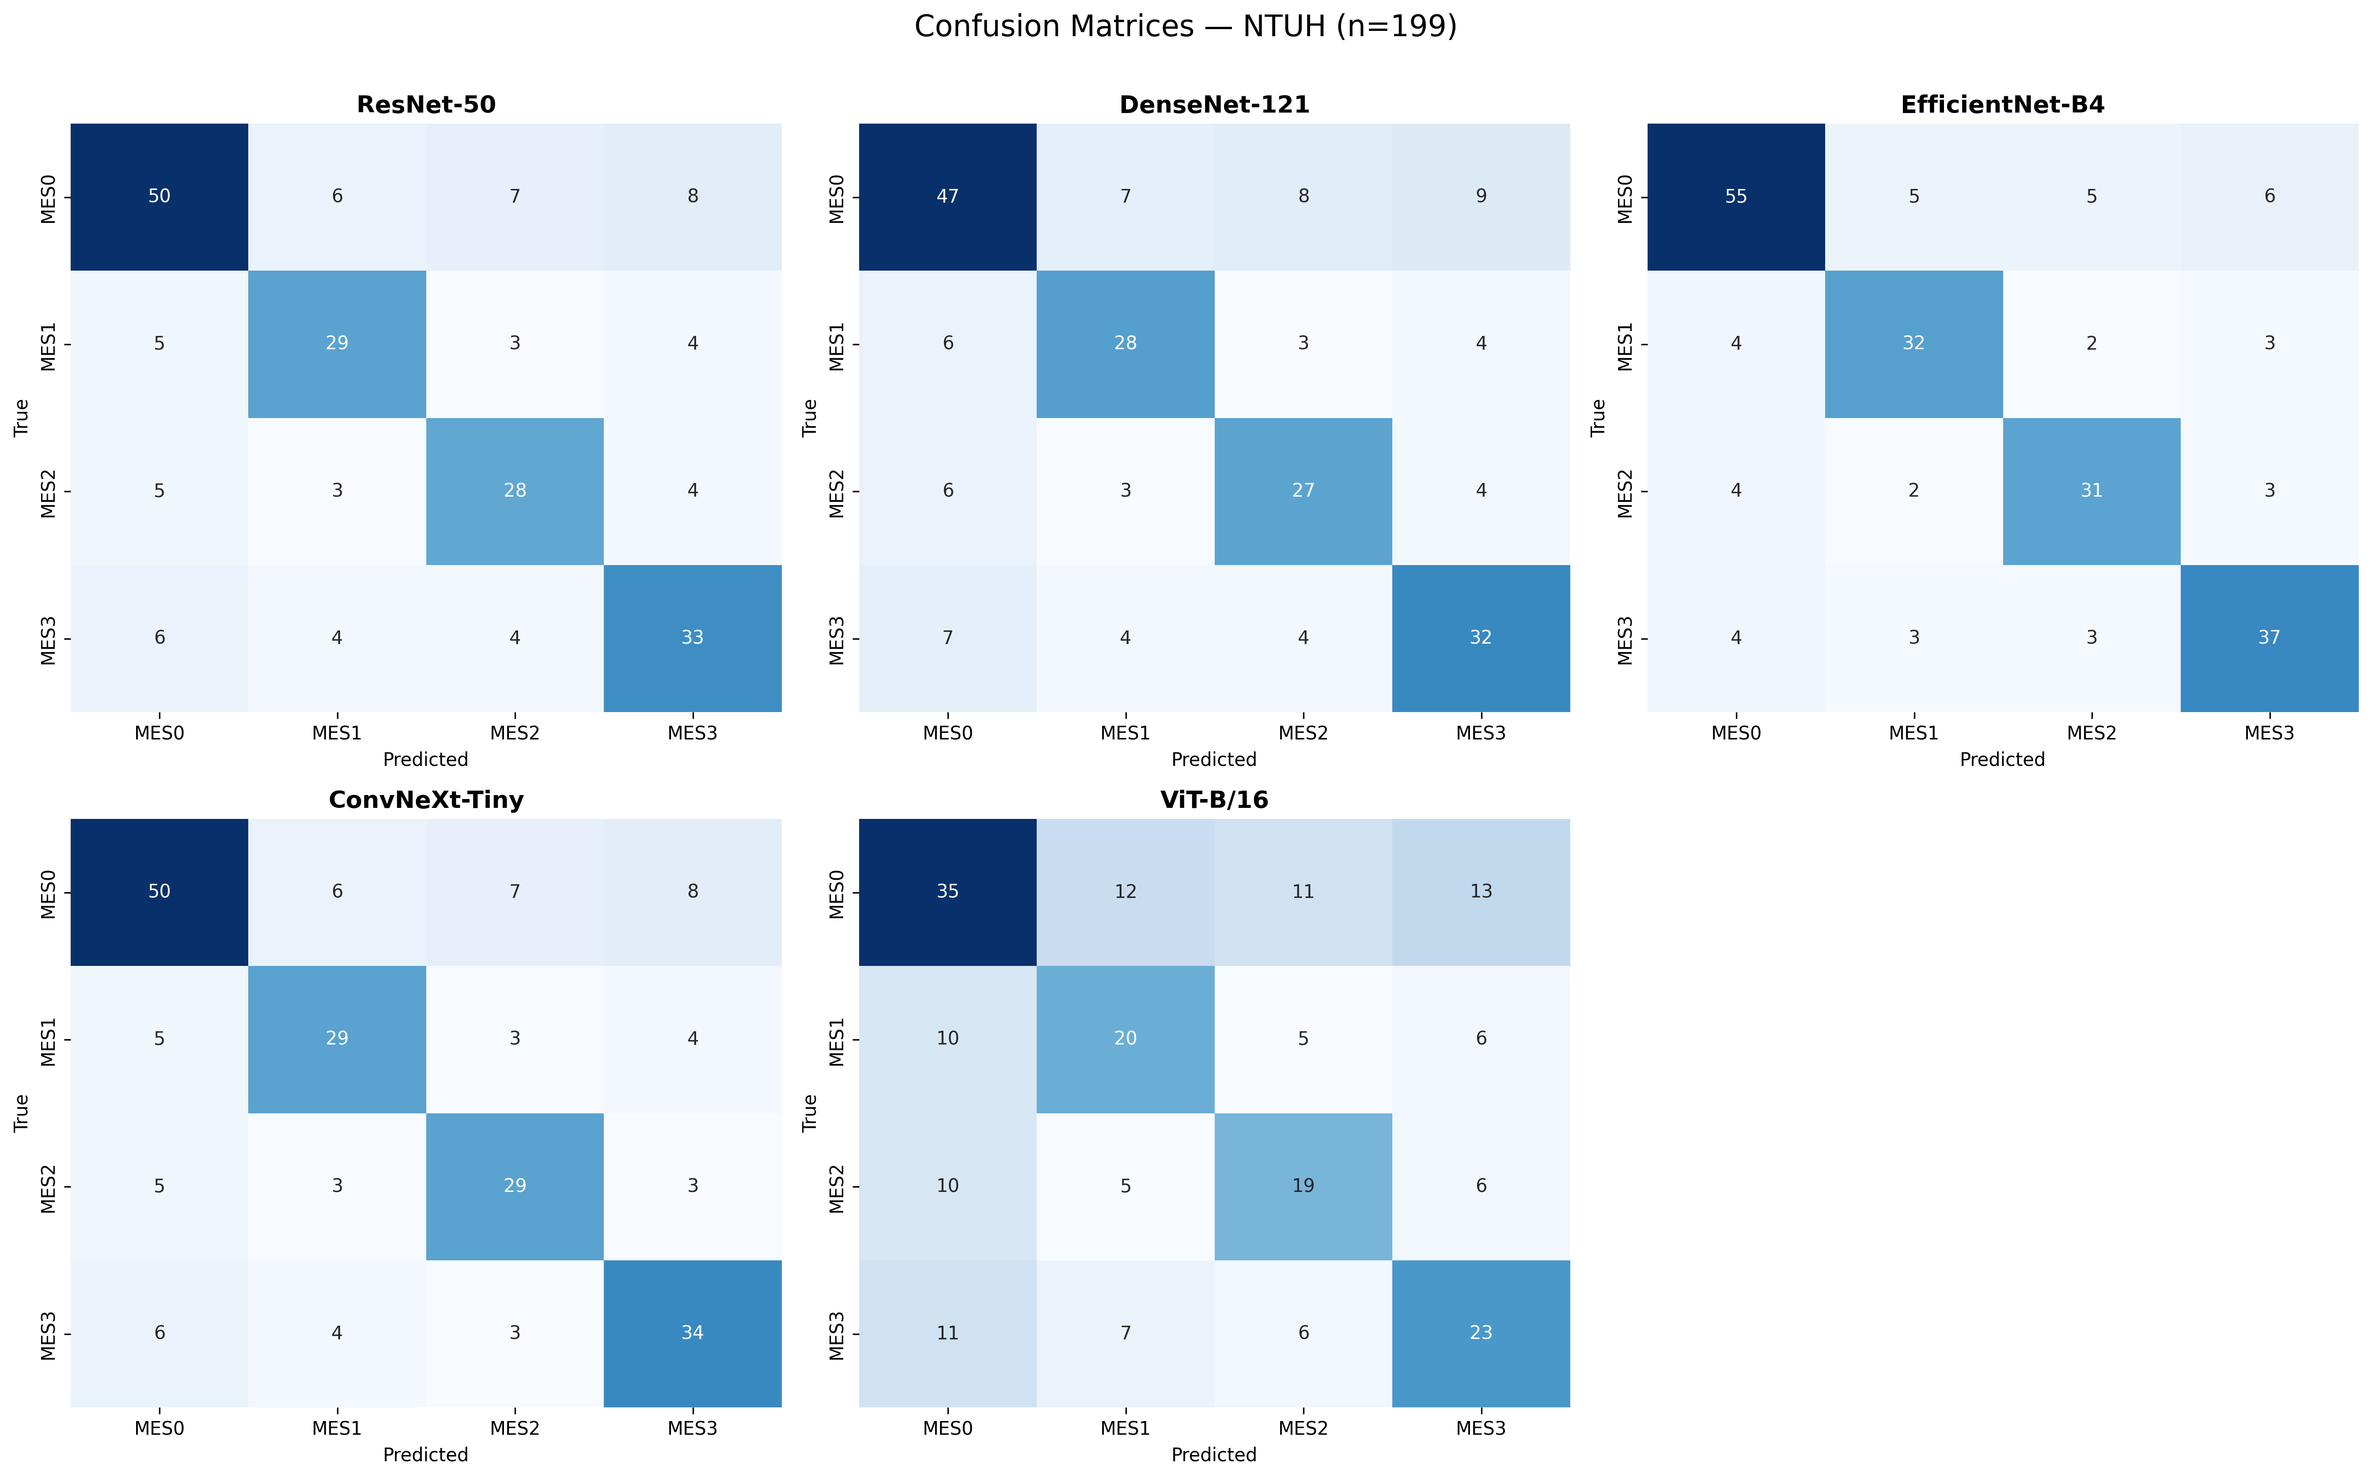

Confusion Matrices - TMC-UCM
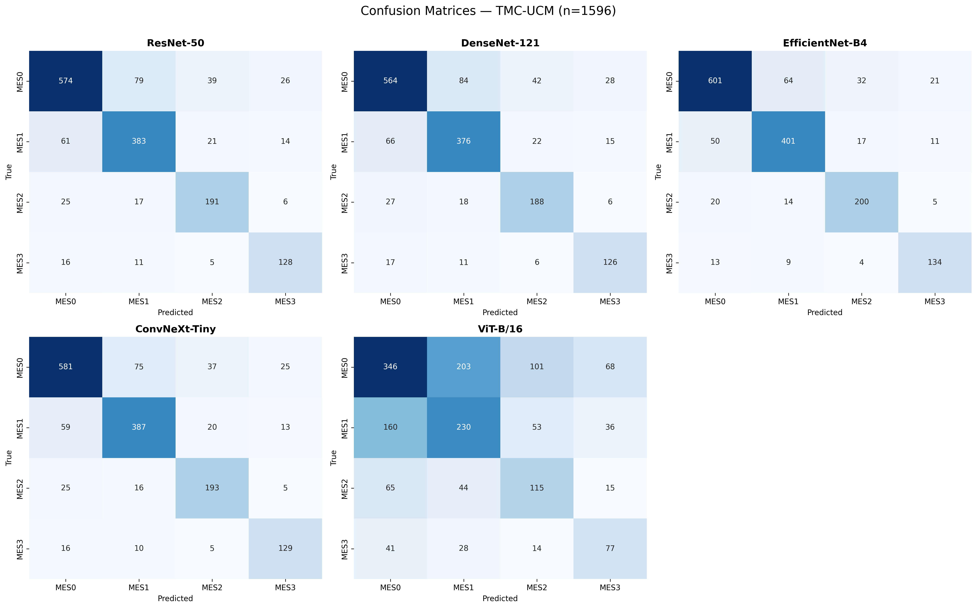

Confusion Matrices - LIMUC
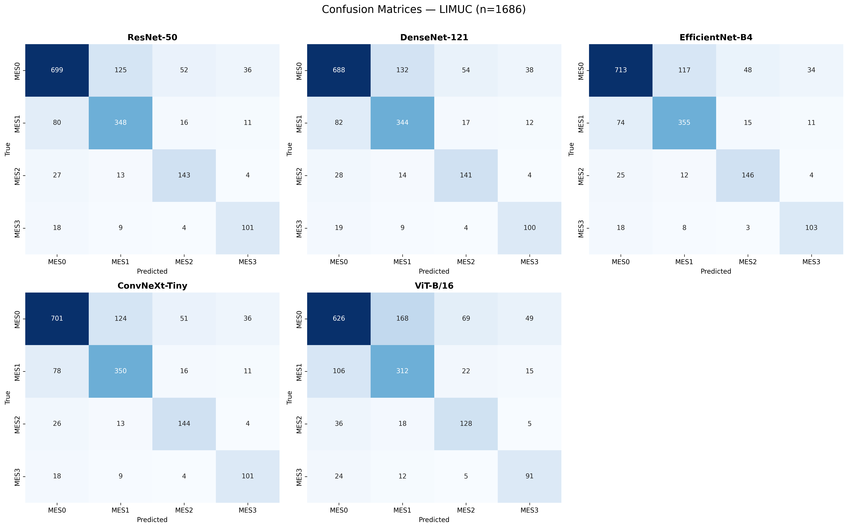

Confusion Matrices - Unified
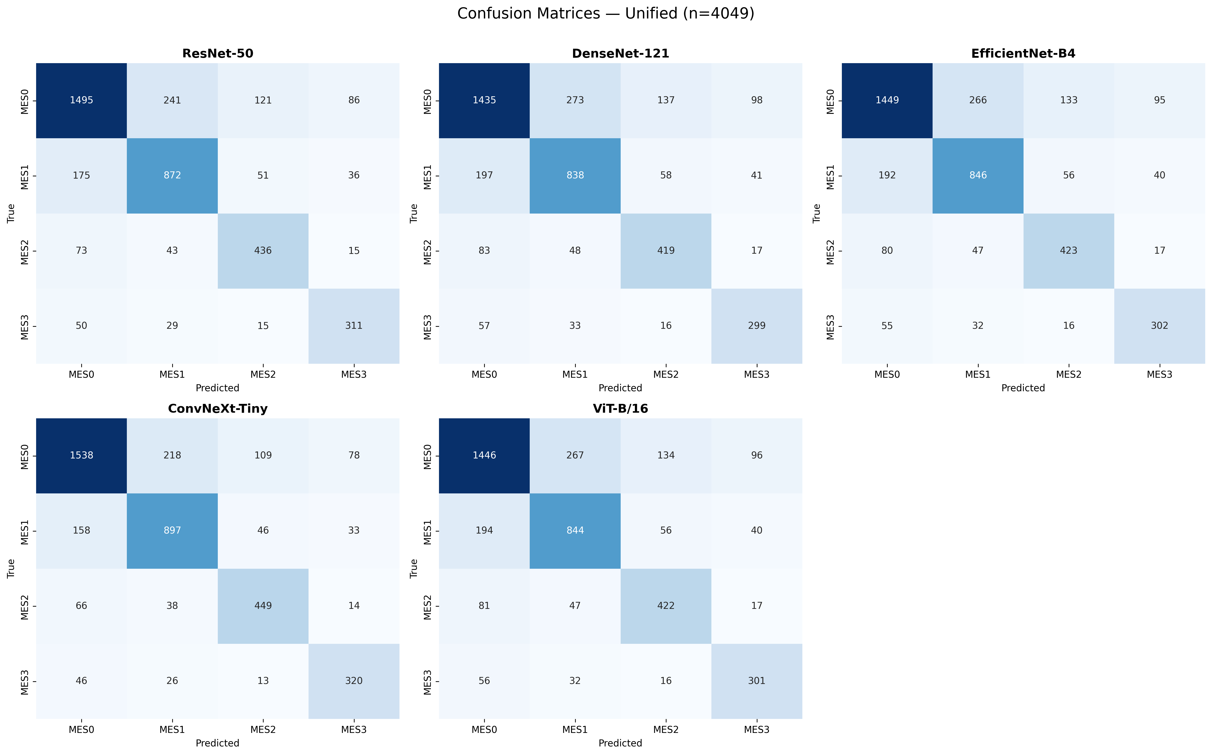

3. ROC Curves
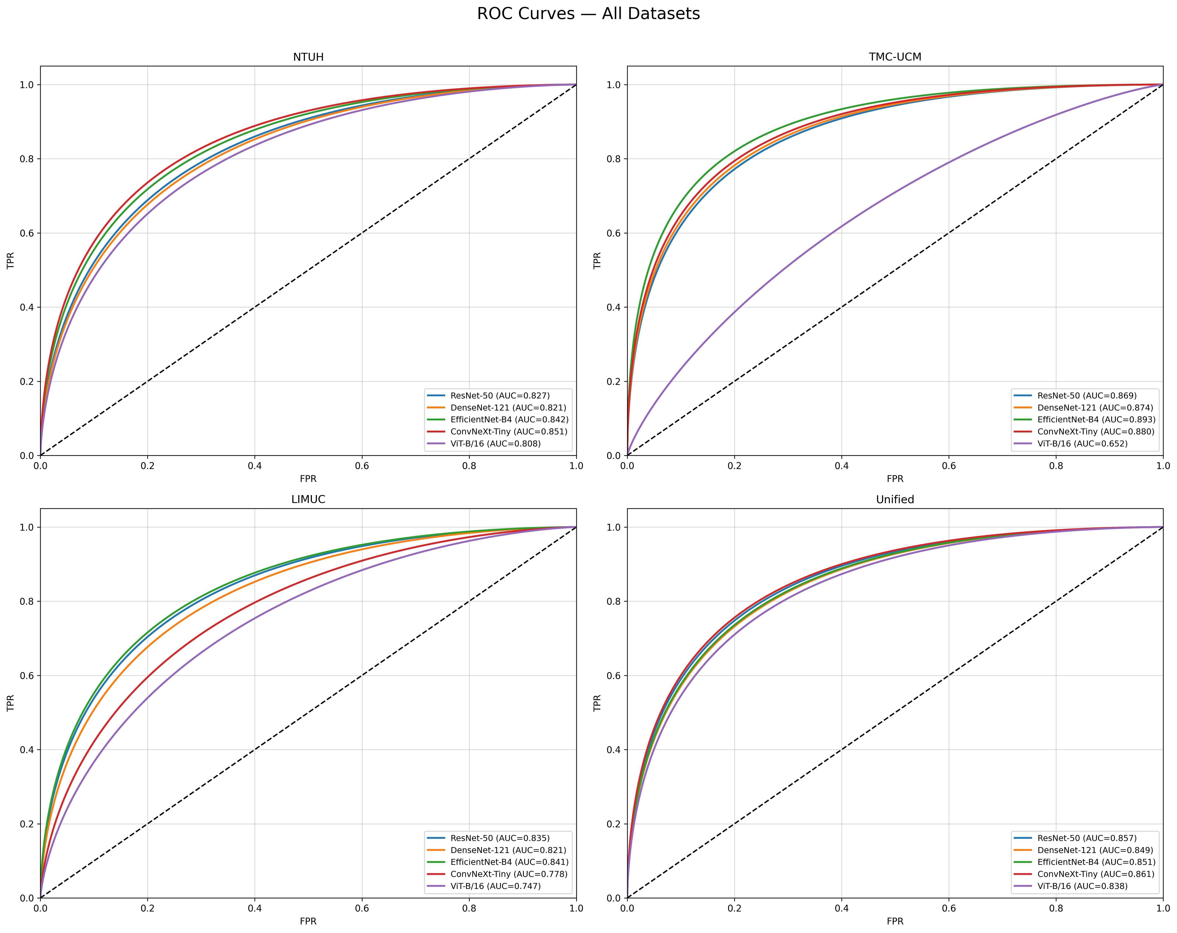

4. AUC Narration Snippet
AUC Narration (consistent with ROC figures):
NTUH: Macro-AUC=0.830. Best=ConvNeXt-Tiny(0.851). Worst=ViT-B/16(0.808).
TMC-UCM: Macro-AUC=0.834. Best=EfficientNet-B4(0.893). Worst=ViT-B/16(0.652).
LIMUC: Macro-AUC=0.804. Best=EfficientNet-B4(0.841). Worst=ViT-B/16(0.747).
Unified: Macro-AUC=0.851. Best=ConvNeXt-Tiny(0.861). Worst=ViT-B/16(0.838).

