PROJECT DOCUMENTATION: PROJECT LANGX BY : AHMED ALI , MUHAMMAD AMAS WASEEM , MARIYA SULAIMAN ,UROOBA SHAMEEM , ZUNAIN ALI AZAM
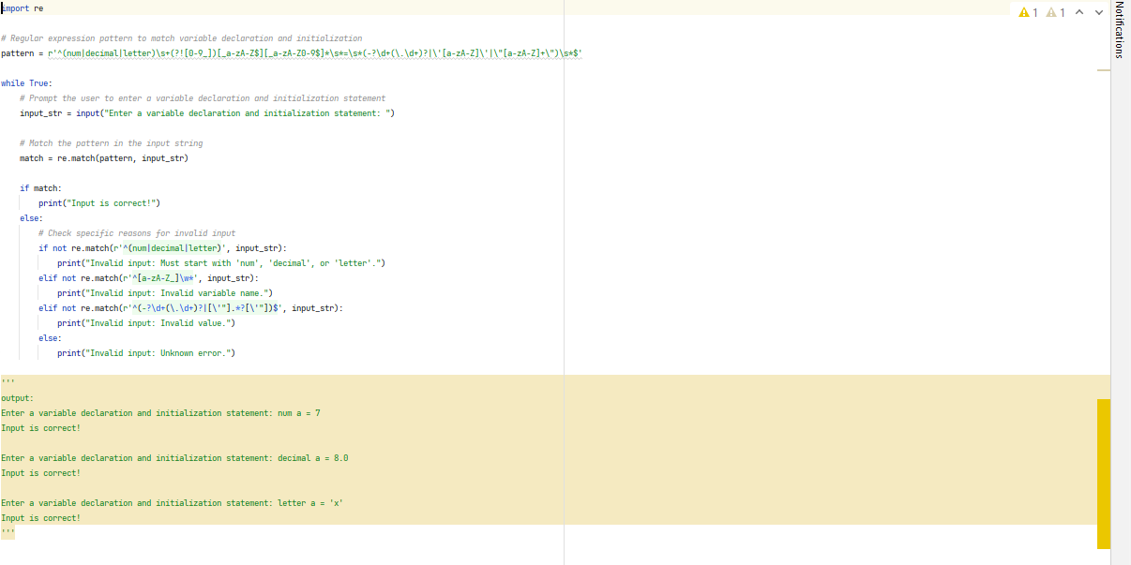
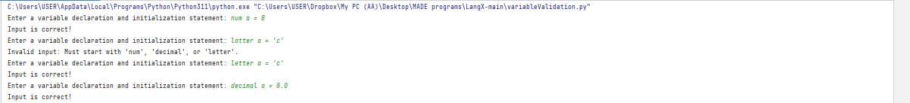
VARIABLE DECLARATION:
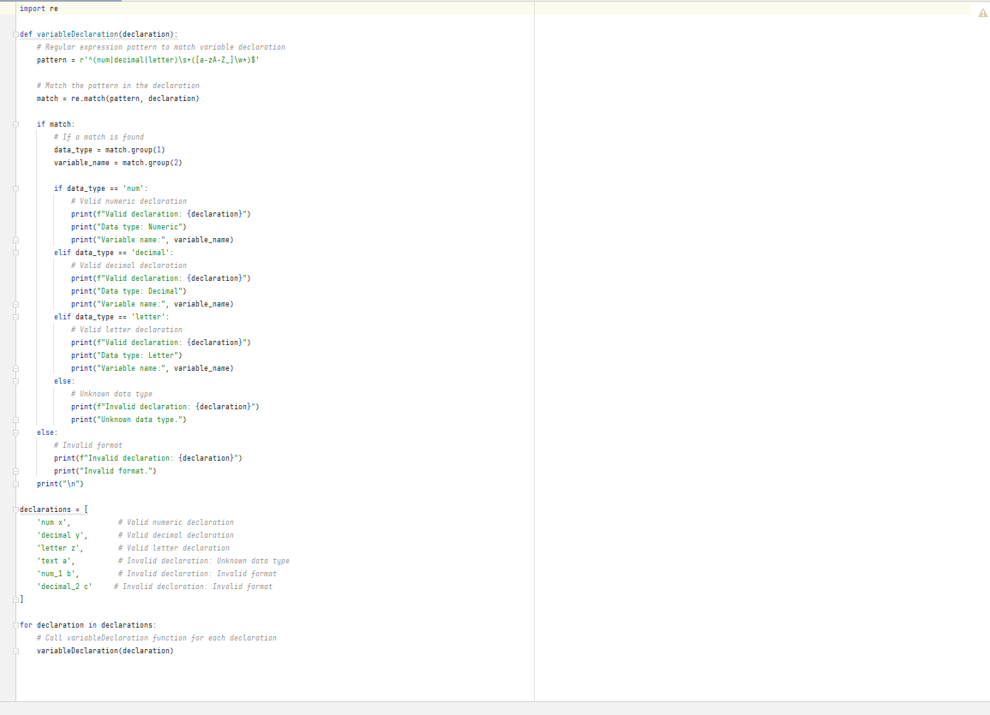
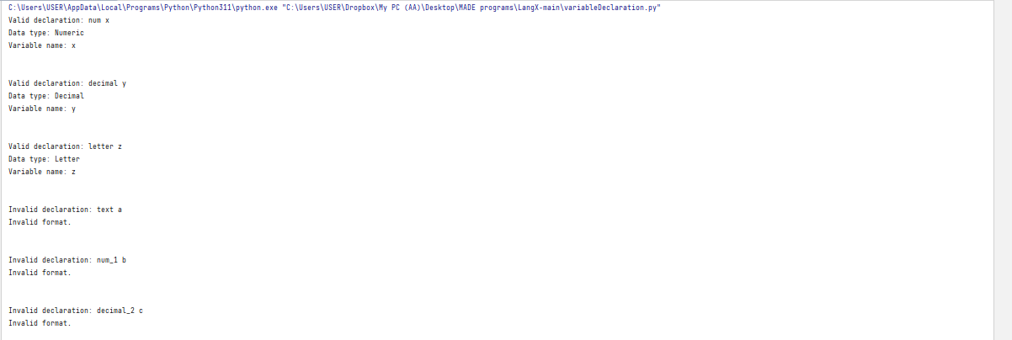

Pattern overview:
The regular expression pattern ^(num|decimal|letter)\s+([a-zA-Z_]\w*)$ is designed to match strings that follow a specific format. It consists of two main components:
1. ^(num|decimal|letter): This part matches the beginning of the string (^) and expects one of three options: "num", "decimal", or "letter". It acts as a group that captures the first part of the patterns
- "num": Matches if the first part of the string is "num".
- "decimal": Matches if the first part of the string is "decimal".
- "letter": Matches if the first part of the string is "letter".
2.\s+([a-zA-Z_]\w*)$: This part matches one or more whitespace characters (\s+) followed by a group that captures the second part of the pattern. The second part is defined by:
- [a-zA-Z_]: Matches any uppercase or lowercase letter or an underscore.
- \w*: Matches zero or more word characters (letters, digits, or underscores).
- $: Matches the end of the string.
Pattern Details
Let's break down the regular expression pattern ^(num|decimal|letter)\s+([a-zA-Z_]\w*)$ into its components and explain each part in detail:
1.^: The caret symbol ^ asserts the start of the string. It ensures that the pattern will match from the beginning of the input.
(num|decimal|letter): This is a capturing group that matches one of three options: "num", "decimal", or "letter". It allows the pattern to identify and capture the first part of the desired format. Each option is separated by the pipe symbol |.
- "num": Matches if the first part of the string is "num".
- "decimal": Matches if the first part of the string is "decimal".
- "letter": Matches if the first part of the string is "letter".
2.([a-zA-Z_]\w*): This is another capturing group that matches the second part of the desired format. It consists of:
- [a-zA-Z_]: This character set matches any uppercase or lowercase letter or an underscore.
- \w*: This matches zero or more word characters. Word characters include letters, digits, and underscores.
- $: The dollar symbol $ asserts the end of the string. It ensures that the pattern will match until the end of the input.
Example matches:
Here are some examples to illustrate how the regular expression pattern matches different strings:
- Input: "num myVariable"
Matches because "num" matches the first part and "myVariable" matches the second part.
- Input: "decimal 3.14"
Matches because "decimal" matches the first part and "3.14" matches the second part.
- Input: "letter _my_var_123"
Matches because "letter" matches the first part and "_my_var_123" matches the second part.
Example not matches:
Here are some examples to illustrate strings that do not match the regular expression pattern:
- Input: "num my Variable"
Does not match because there is a space between "my" and "Variable".
VARIABLE INITIALIZATION:
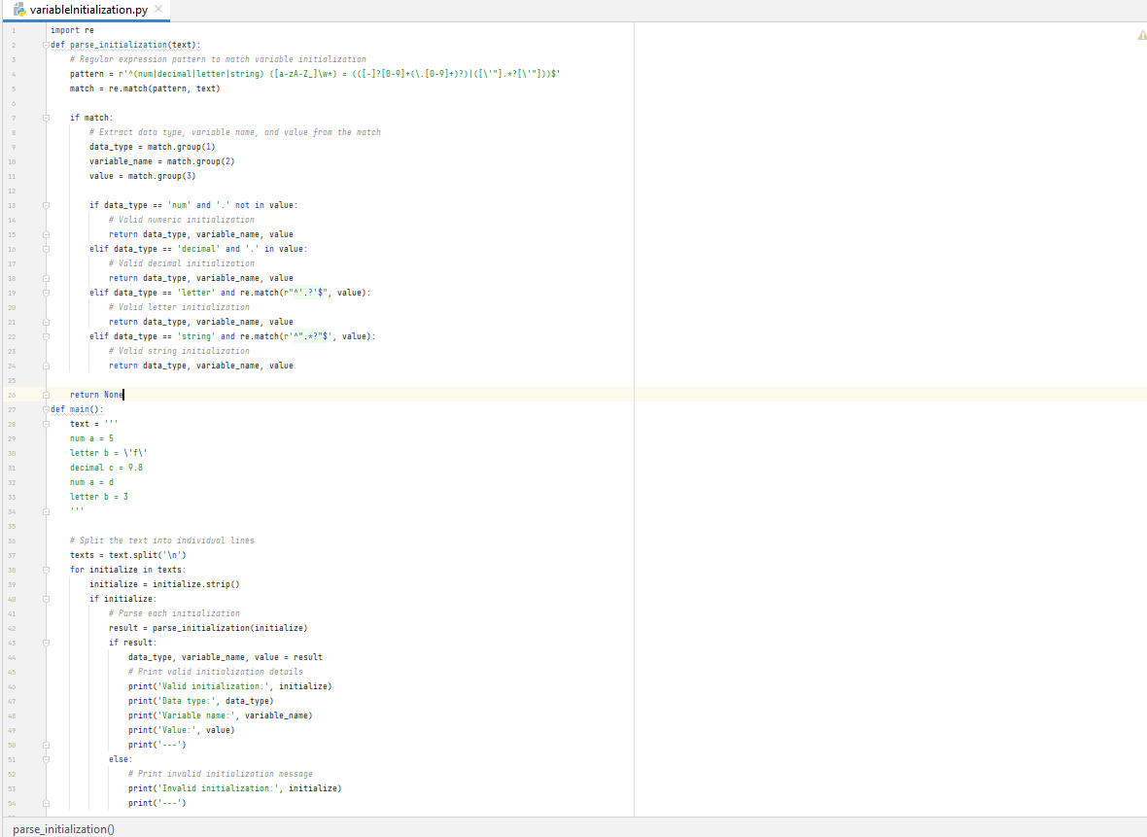
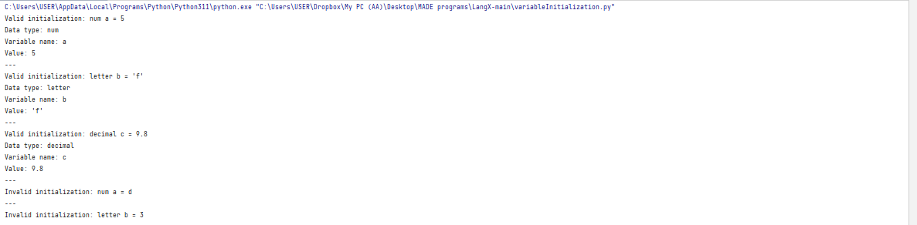
Pattern overview:
The regular expression pattern ^(num|decimal|letter)\s+([a-zA-Z_]\w*)$ is designed to match strings that follow a specific format. It consists of two main components:
1. ^(num|decimal|letter): This part matches the beginning of the string (^) and expects one of three options: "num", "decimal", or "letter". It acts as a group that captures the first part of the patterns
- "num": Matches if the first part of the string is "num".
- "decimal": Matches if the first part of the string is "decimal".
- "letter": Matches if the first part of the string is "letter".
2. \s+([a-zA-Z_]\w*)$: This part matches one or more whitespace characters (\s+) followed by a group that captures the second part of the pattern. The second part is defined by:
- [a-zA-Z_]: Matches any uppercase or lowercase letter or an underscore.
- \w*: Matches zero or more word characters (letters, digits, or underscores).
- $: Matches the end of the string.
3. (([-]?[0-9]+(\.[0-9]+)?)|([\ "].*?[\ "])): This part matches the third part of the desired format, which is preceded by an equal sign (=). It has two options:
- ([-]?[0-9]+(\.[0-9]+)?): Matches a numeric value, which can be an integer or a decimal number. It allows for an optional negative sign (-) and decimal point (.).
- ([\ "].*?[\ "]): Matches a string value enclosed in single quotes (') or double quotes ("). It allows for any characters between the quotes.
- $: The dollar symbol $ asserts the end of the string. It ensures that the pattern will match until the end of the input.
- Example:
- num a=7 letter a='x'
- Correct. Correct
FOR LOOP:
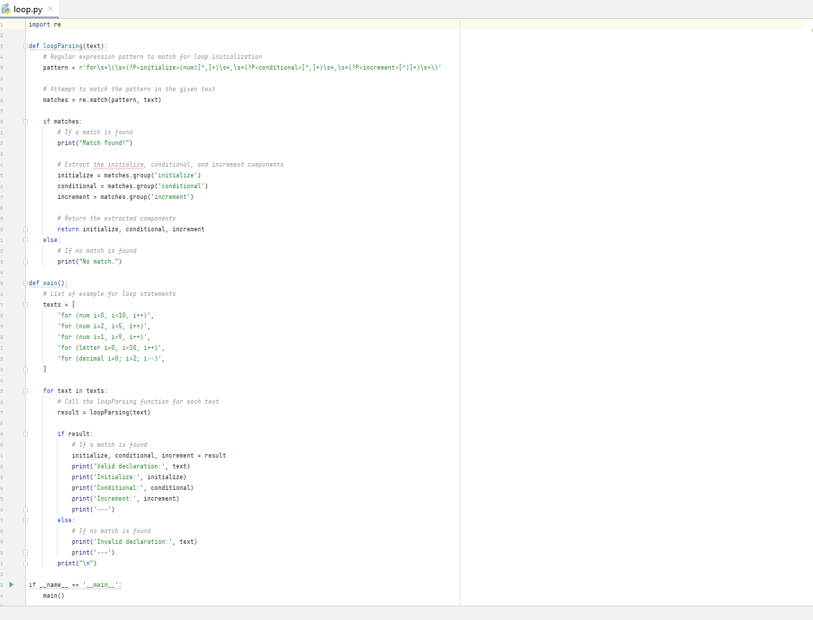
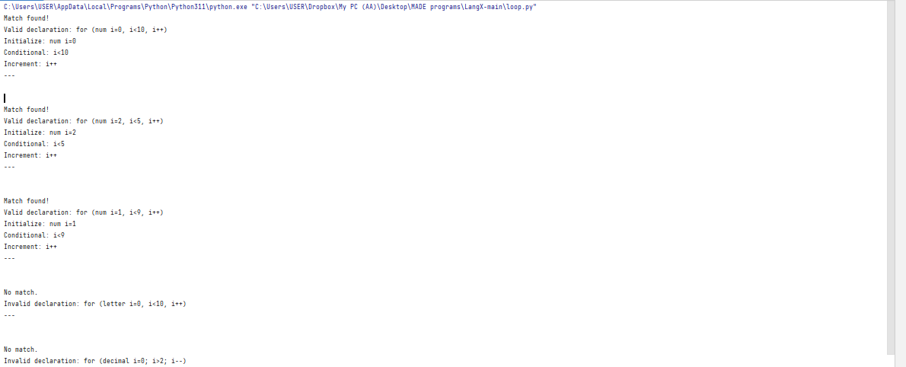
Pattern overview:
The regular expression pattern r'for\s*\(\s*(?P<initialize>(num)[^,]+)\s*,\s*(?P<conditional>[^,]+)\s*,\s
is designed to match strings that follow a specific format. It consists of components:
- for: Matches the literal string "for" at the beginning of the pattern. This indicates the start of a "for" loop construct.

- \s*: Matches zero or more whitespace characters. This allows for any number of spaces or tabs before the opening parenthesis "(" of the "for" loop.

- (: Matches the opening parenthesis "(" character, indicating the start of the "for" loop statement.

- \s*: Matches zero or more whitespace characters. This allows for any number of spaces or tabs after the opening parenthesis "(".

- (?P<initialize>(num)[^,]+): This is a named capturing group named "initialize" that captures the initialization part of the "for" loop statement.

- •(num): Matches the literal string "num" to indicate that the initialization part should start with "num".
- [^,]+: Matches one or more characters that are not a comma (","). This allows for any sequence of characters except a comma, which represents the initialization expression.

6.\s,\s**: Matches a comma (",") surrounded by zero or more whitespace characters. This represents the separation between the initialization and conditional parts of the "for" loop statement.

7.(?P<conditional>[^,]+): This is a named capturing group named "conditional" that captures the conditional part of the "for" loop statement.

- [^,]+: Matches one or more characters that are not a comma (","). This allows for any sequence of characters except a comma, which represents the conditional expression.

8.\s,\s**: Matches a comma (",") surrounded by zero or more whitespace characters. This represents the separation between the conditional and increment parts of the "for" loop statement.

9.(?P<increment>[^)]+)\s*: This is a named capturing group named "increment" that captures the increment part of the "for" loop statement.

- [^)]+: Matches one or more characters that are not a closing parenthesis ")". This allows for any sequence of characters except a closing parenthesis, which represents the increment expression.

10.): Matches the closing parenthesis ")" character, indicating the end of the "for" loop statement.

The regular expression is constructed to extract the initialization, conditional, and increment parts of a "for" loop statement, with each part captured in a named group: "initialize", "conditional", and "increment", respectively

Example:
- "initialize" group: "num i = 0"
- "conditional" group: "i < 10"
- "increment" group: "i++"

