Faculty of Computing
Riphah International University, Islamabad

Data Structures



Lab Task
Week # 04

Submitted by
Muhammad Anas
75586
to
Mr. Junaid Khan
on
September 23, 202
Activity 1 — Linear Search and Binary Search
Create a Java program that performs both Linear Search and Binary Search on an array.
Use the following arrays:
Linear Search Array:
int[] linearArray = {45, 12, 78, 34, 23, 89, 56};
Binary Search Array:
int[] binaryArray = {12, 23, 34, 45, 56, 78, 89};
Ask the user to enter a target value to search for.
Part A — Linear Search
Implement a method:
linearSearch(int[] arr, int target)
The method should:
- Start from index 0.
- Compare each element with the target.
- Return the index if the target is found.
- Return -1 if the target is not found.
Part B — Binary Search
Implement a method:
binarySearch(int[] arr, int target)
The method should:
- Initialize low and high.
- Calculate the middle index.
- Compare the middle element with the target.
- Search the left or right half depending on the comparison.
- Return the index if the target is found.
- Return -1 if the target is not found.
Required Output
Display:
- Target value
- Result of Linear Search
- Result of Binary Search
- Index position of the element, if found
Also briefly identify why the Binary Search array must be sorted.
Code:
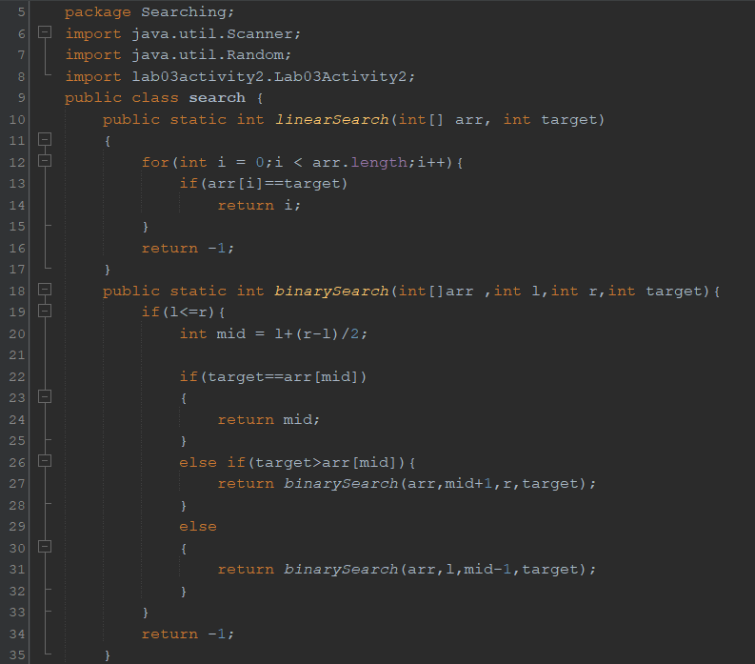
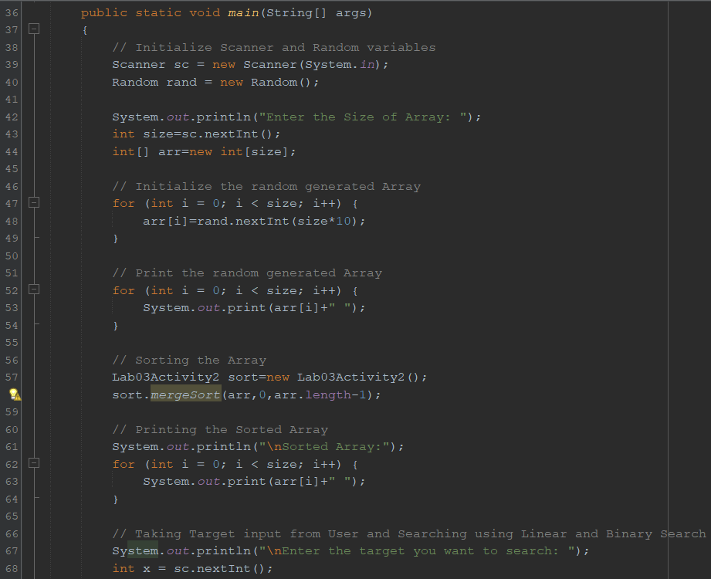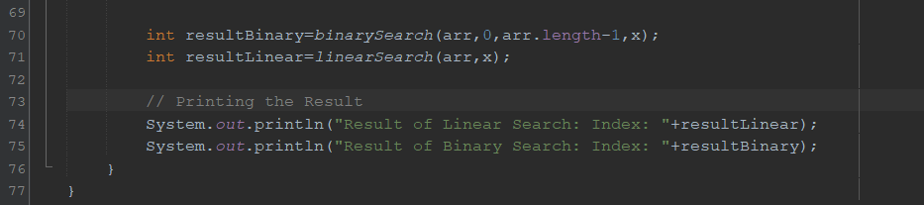
Output:
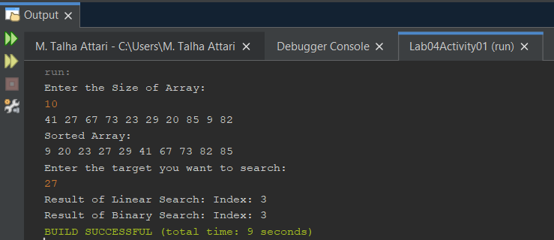
- Why the Binary Search array must be sorted:
Binary Search array must be sorted because it finds the target based on the mid index of the array and mid index of the array can only be found if the array is sorted.
Activity 2 — Stack Operations
Implement a Stack using an array without using Java's built-in Stack class.
The Stack should have a fixed capacity of 5 elements.
Implement the following methods:
push(int value)
pop()
peek()
display()
Required Operations
Your program should demonstrate:
- Push — Insert an element onto the top of the Stack.
- Pop — Remove the top element.
- Peek — Display the top element without removing it.
- Display — Display all elements currently present in the Stack.
- Detect Stack Overflow when the Stack is full.
- Detect Stack Underflow when attempting to remove an element from an empty Stack.

Code:
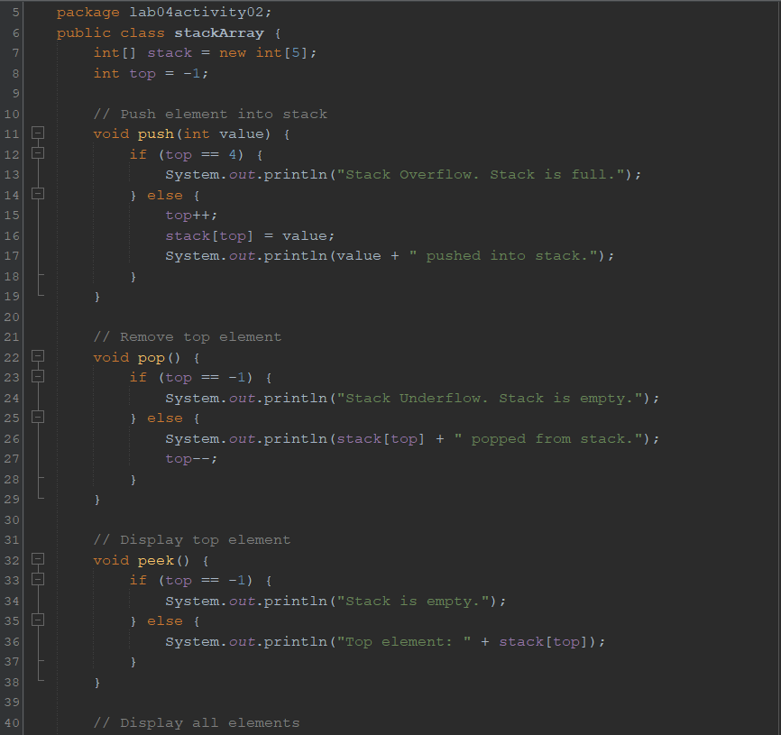
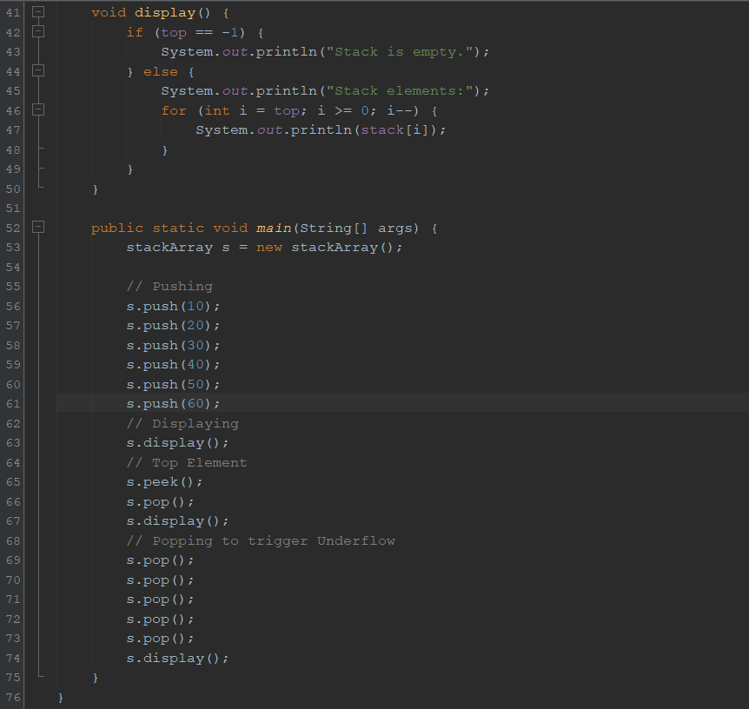

Output:
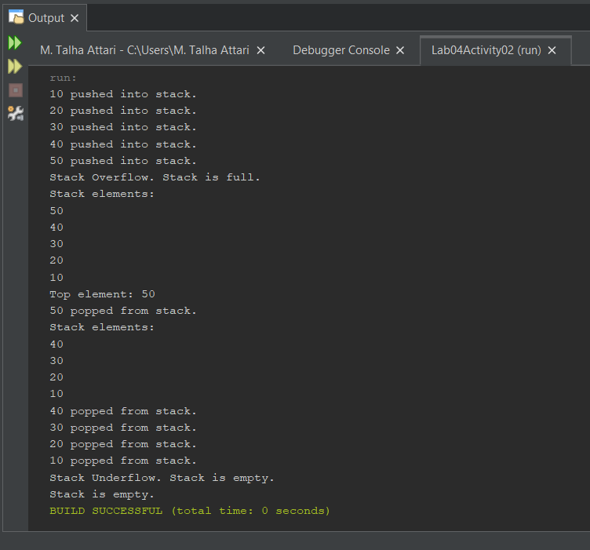
Activity 3 — Queue Operations
Implement a Queue using an array without using Java's built-in Queue class.
The Queue should have a fixed capacity of 5 elements.
Implement the following methods:
enqueue(int value)
dequeue()
peek()
display()
Required Operations
Your program should demonstrate:
- Enqueue — Insert an element at the rear of the Queue.
- Dequeue — Remove an element from the front of the Queue.
- Peek — Display the front element without removing it.
- Display — Display all elements currently present in the Queue.
- Detect Queue Overflow when the Queue is full.
- Detect Queue Underflow when attempting to remove an element from an empty Queue.
Code:
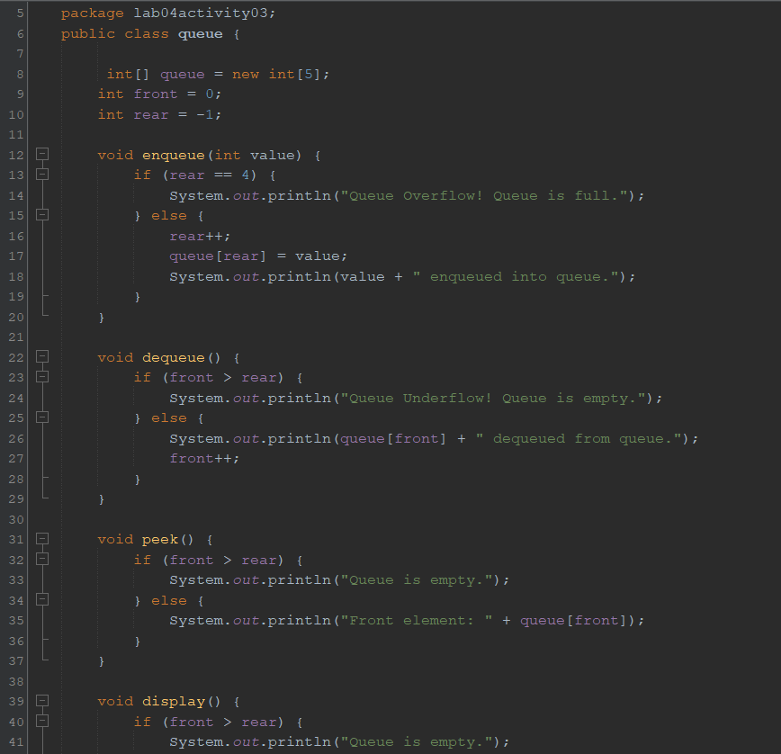
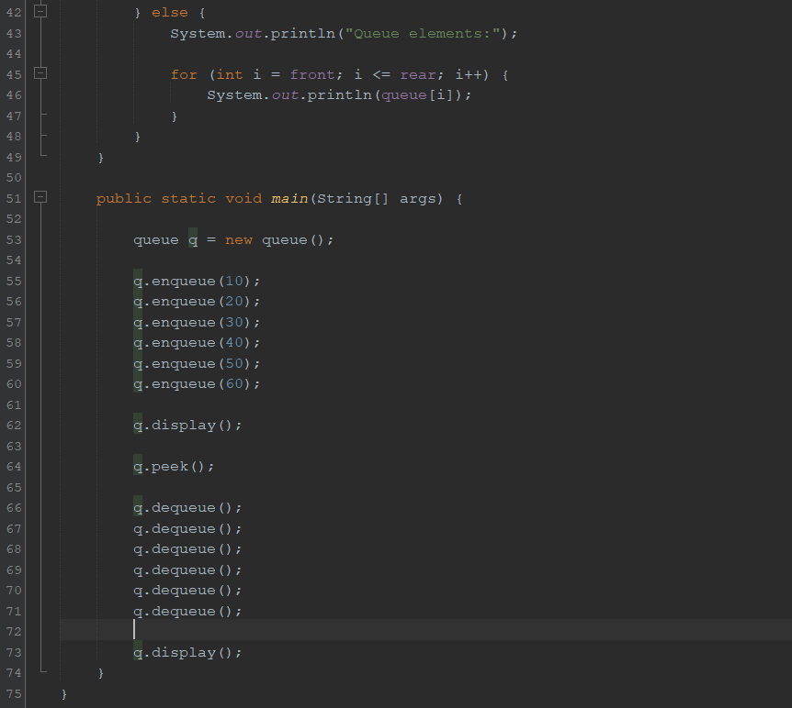
Output:
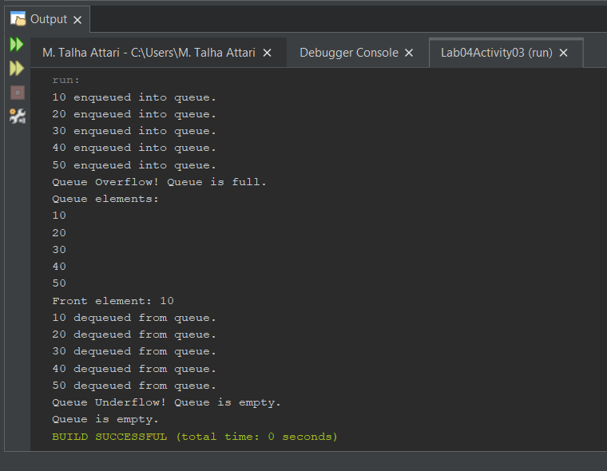
Brief comparison of Linear Search vs Binary Search:
Linear Search checks every element in a list sequentially until it finds the target, making it slow with a time complexity of O(n), but it works on unsorted data. In contrast, Binary Search repeatedly divides a sorted array in half, offering a much faster time complexity of O(log n), though it requires the data to be ordered beforehand.

Brief explanation of LIFO vs FIFO:
LIFO (Last-In, First-Out) is a data structure where the most recently added item is the first one to be removed, famously utilized in stacks like a stack of dinner plates or the "undo" feature in software. Conversely, FIFO (First-In, First-Out) processes items in the exact order they arrive, meaning the oldest element is removed first, which is the foundational logic for queues like people waiting in a line or printer task management.
--- The End ---

