Faculty of Computing
Riphah International University, Islamabad

Data Structures



Lab Task
Week # 07

Submitted by
Muhammad Anas
75586
to
Mr. Junaid Khan
on
October 12, 2026
Task 1: Implement an Undirected Graph
Write a Java program to implement an undirected graph using an adjacency matrix.
Your program must:
- Create a graph with five vertices numbered from 0 to 4.
- Add the following edges:
  - (0, 1)
  - (0, 2)
  - (1, 2)
  - (1, 3)
  - (3, 4)
- Display the adjacency matrix.
- Calculate and display the degree of each vertex.
Code:
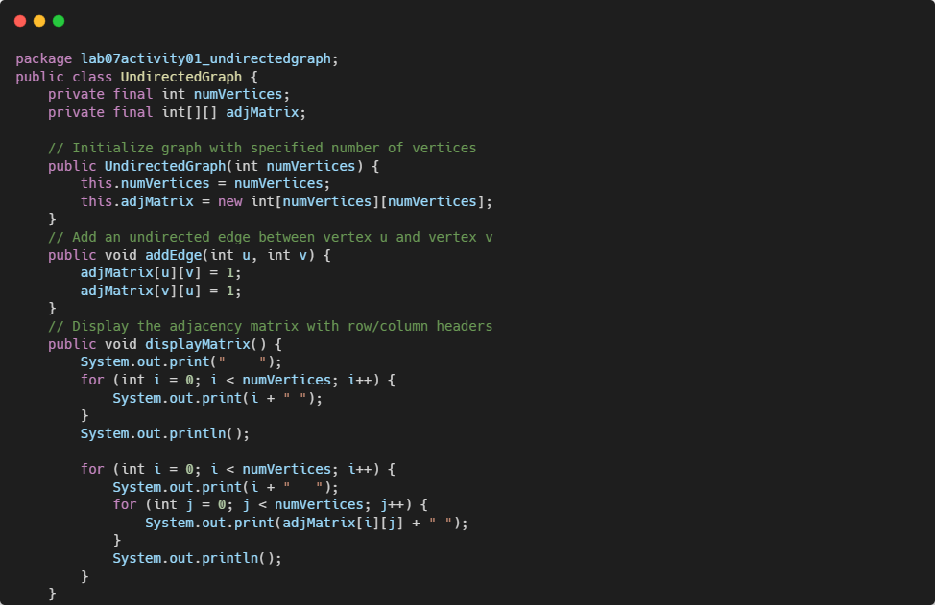
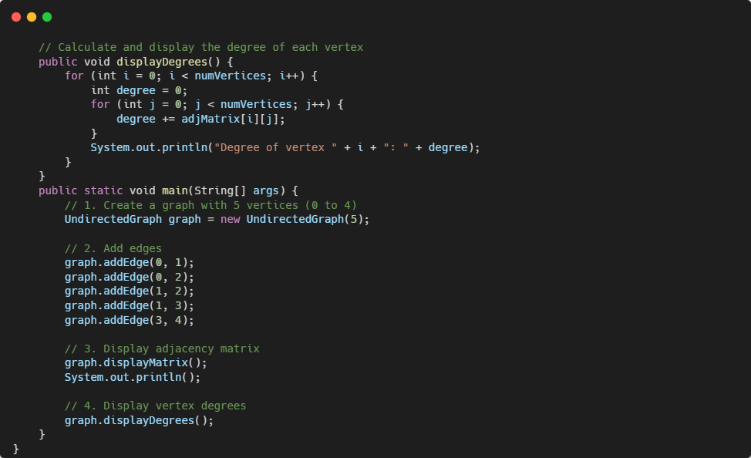
Output:
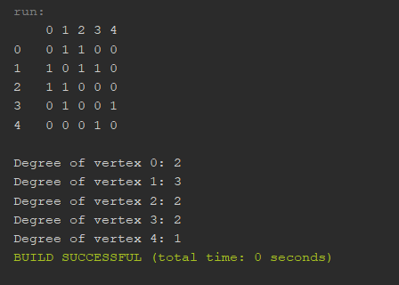

Task 2: Perform Graph Operations
Extend your program to implement the following operations:
- Add an edge between two vertices.
- Remove an existing edge.
- Display the updated adjacency matrix.
- Calculate the degree of a specified vertex.
- Check whether an edge exists between two vertices.
Code:
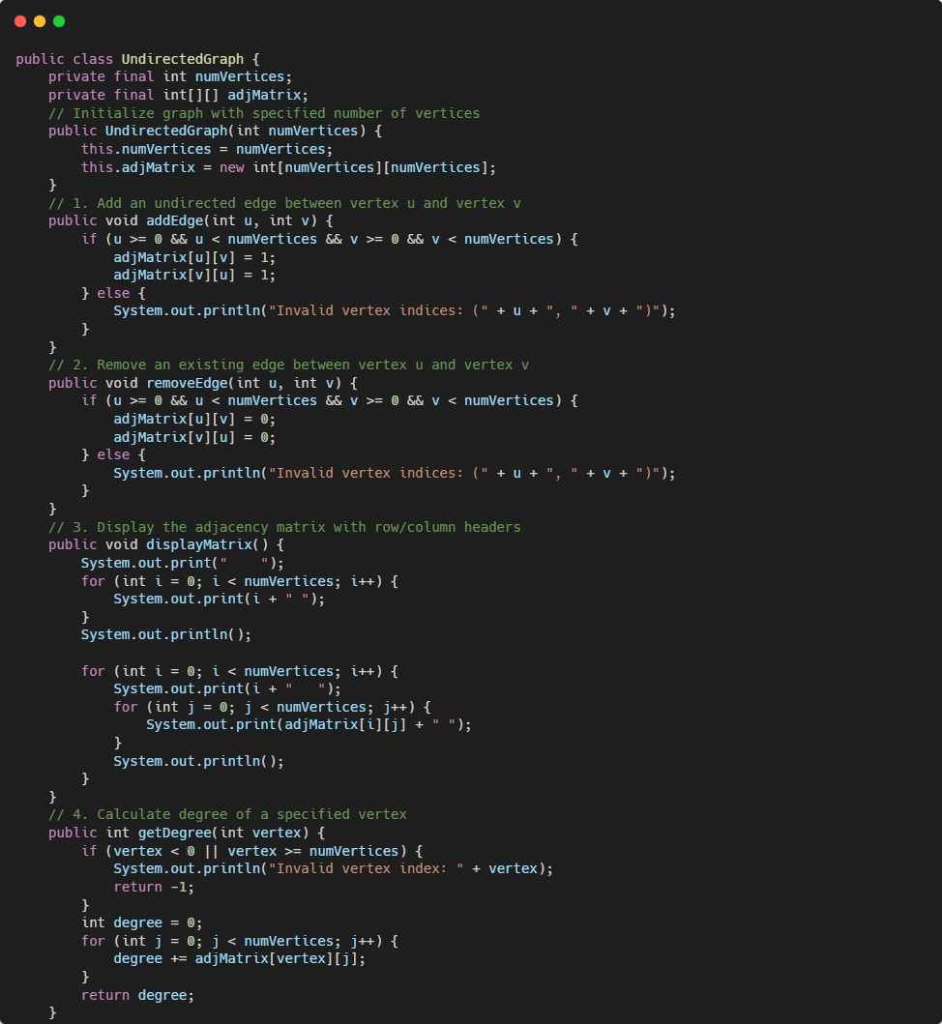
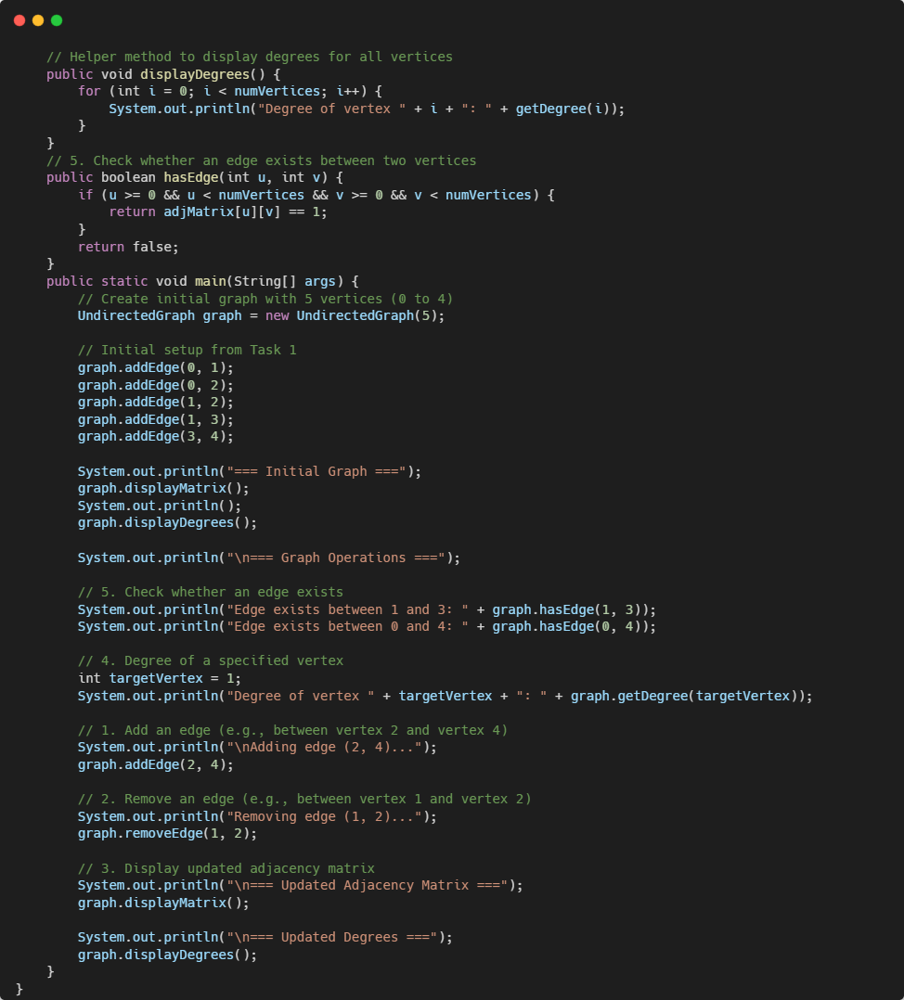

Output:
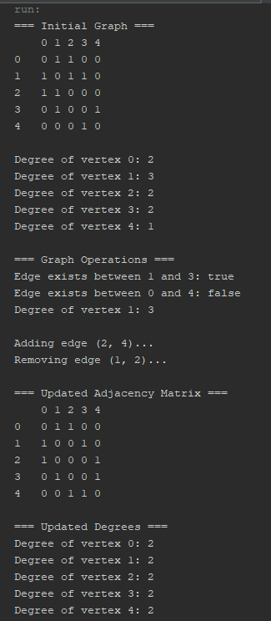
Task 3: Implement a Directed Graph
Modify your program to represent a directed graph.
Add the following directed edges:
- 0 → 1
- 0 → 2
- 1 → 2
- 2 → 3
- 3 → 1
Your program must:
- Display the adjacency matrix.
- Calculate the in-degree of each vertex.
- Calculate the out-degree of each vertex.
Code:
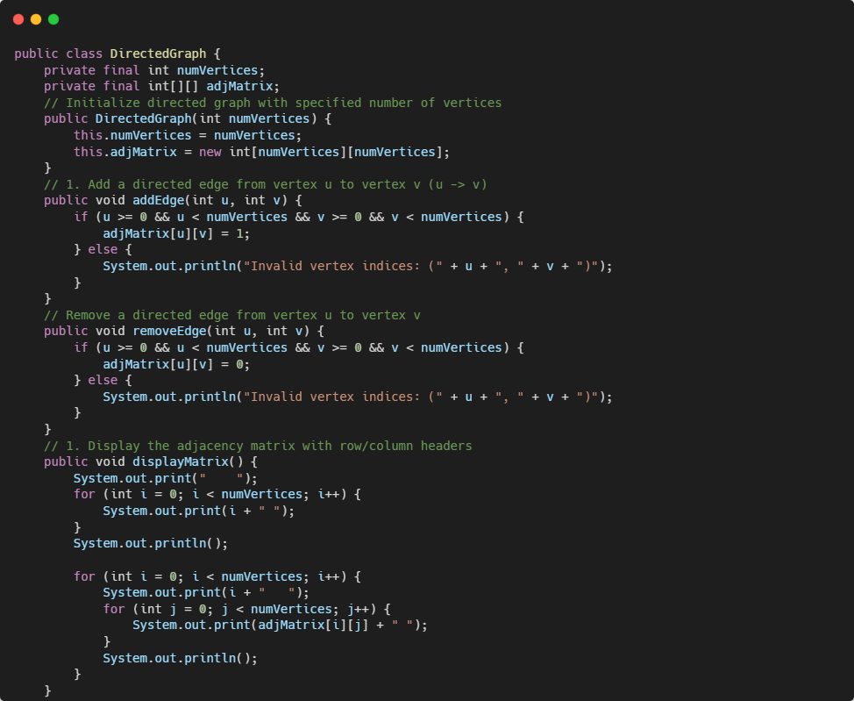
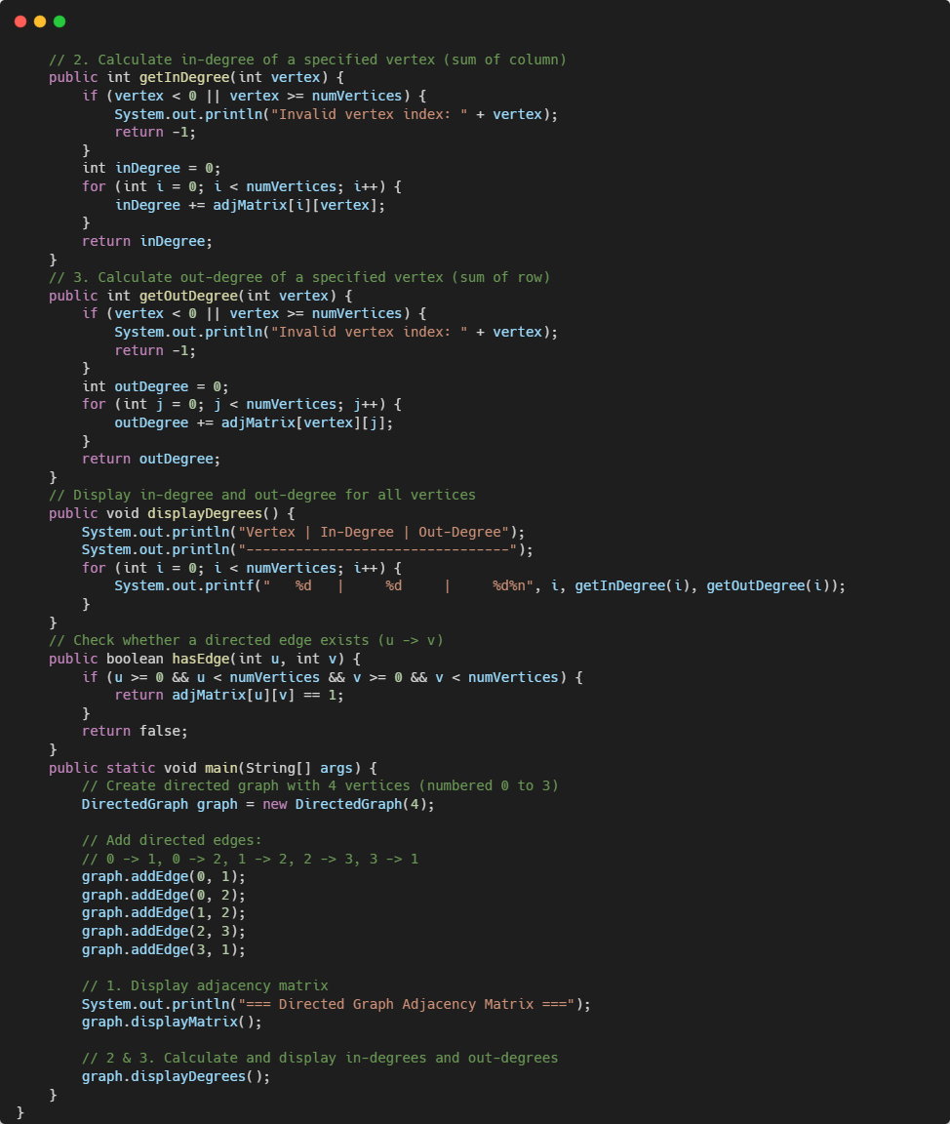

Output:
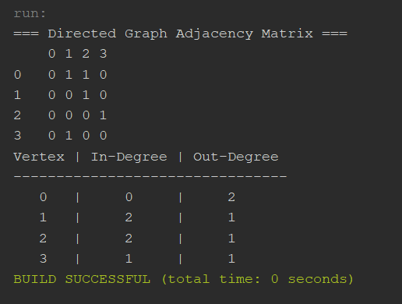

Task 4: Practical Application
A university has five departments represented by vertices numbered 0 to 4. An edge indicates a direct communication link between two departments.
Implement a graph using an adjacency matrix and allow the user to:
- Enter the connections between departments.
- Display the adjacency matrix.
- Check whether two departments are directly connected.
- Display the degree of a selected department.
Assume the communication links are bidirectional.
Code:
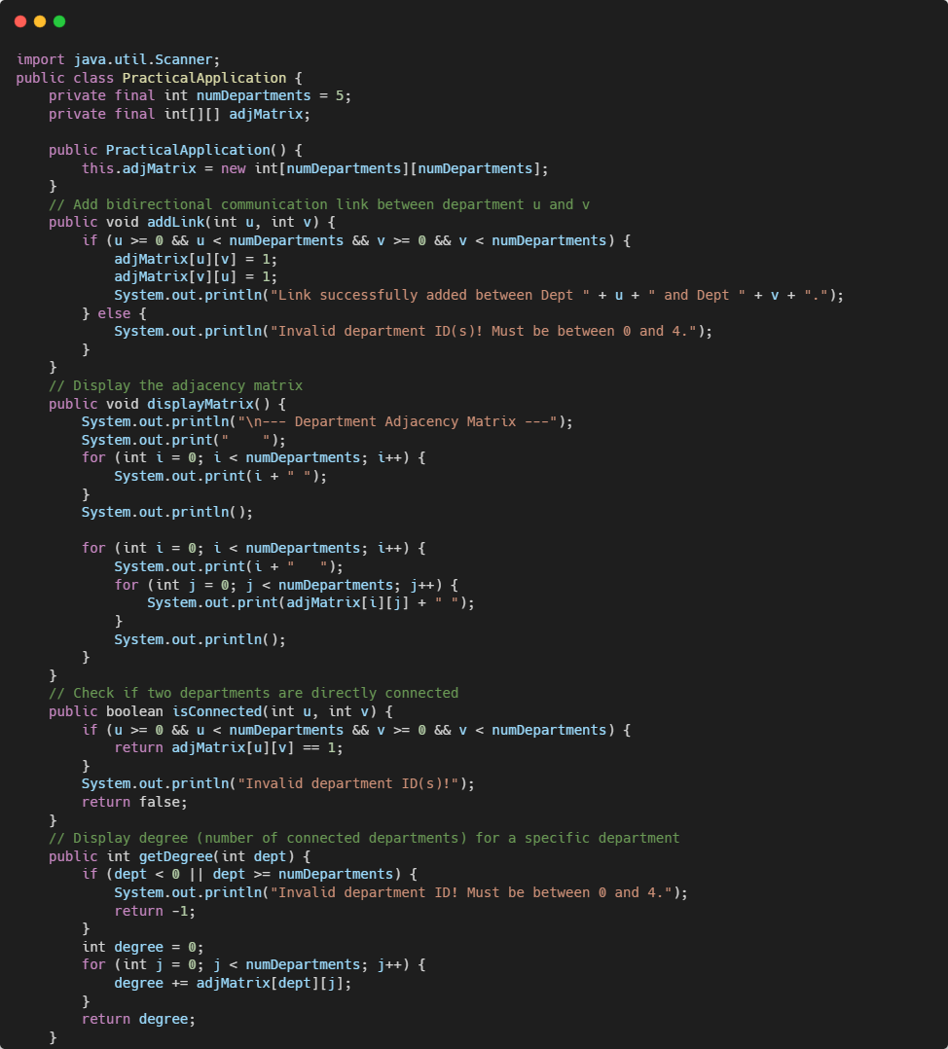
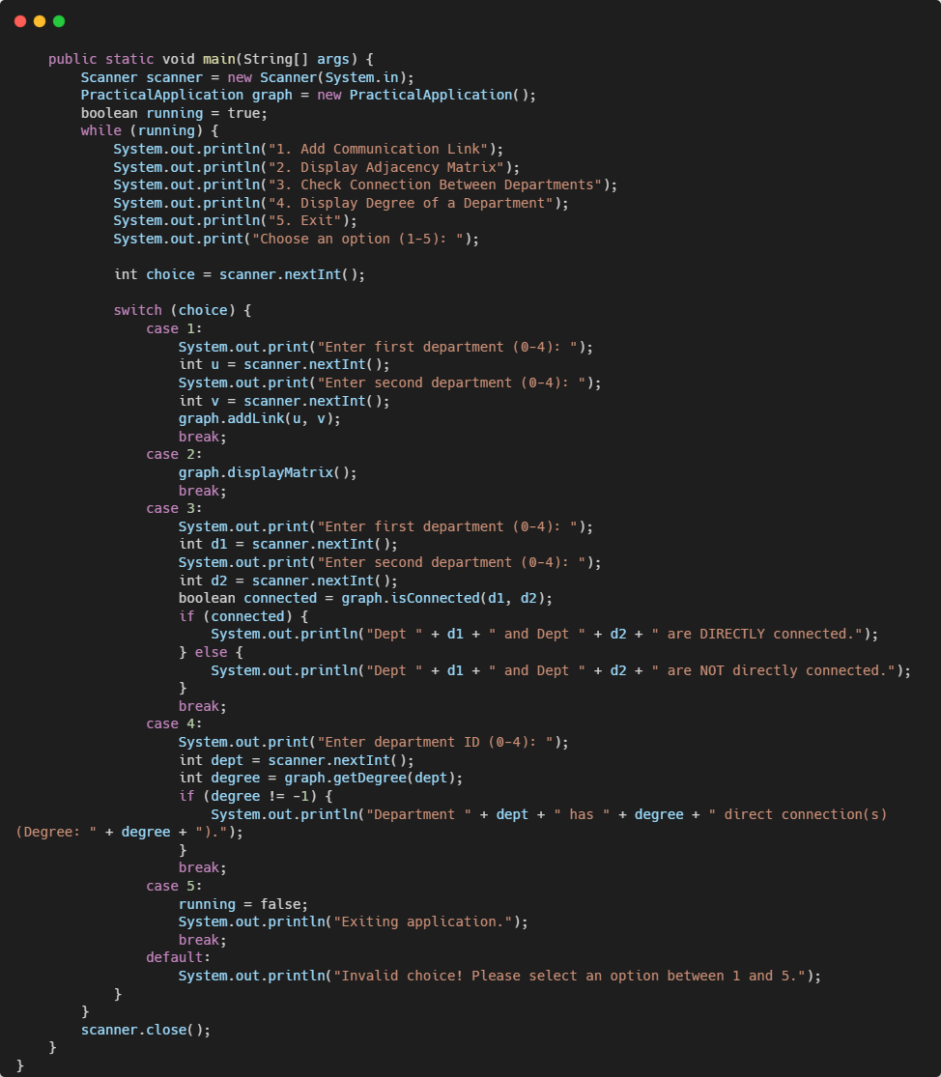

Output:
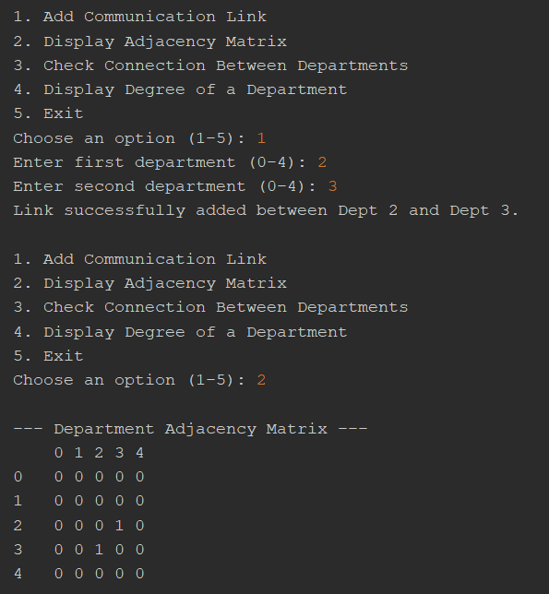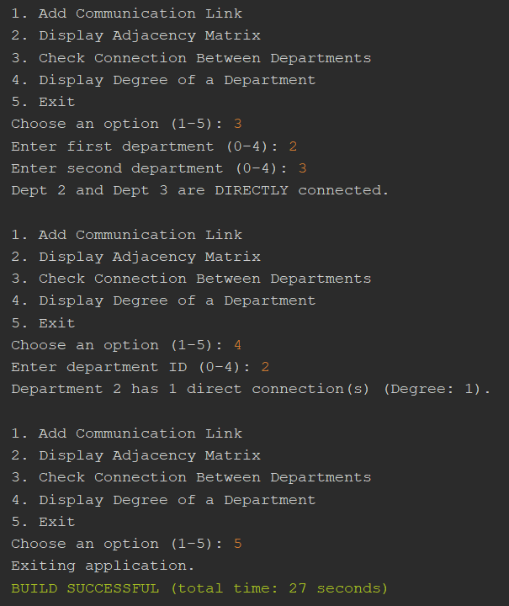
--- The End ---

