Faculty of Computing
Riphah International University, Islamabad

Data Structures



Lab Task
Week # 01

Submitted by
Muhammad Anas
75586
to
Mr. Junaid Khan
on
September 02, 2026

Lab Task 1: Java Program Structure, Compilation, and Base Types
Activity 1: Your First Program
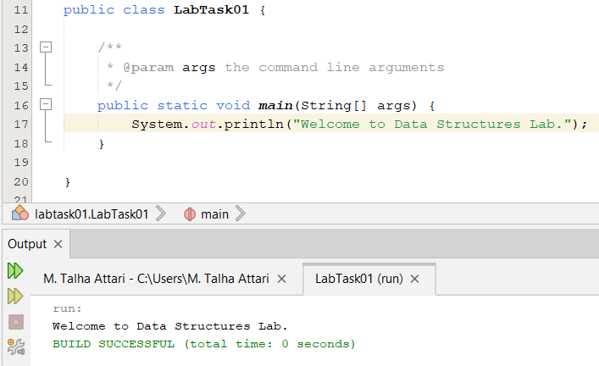
Activity 2: Working with Variables
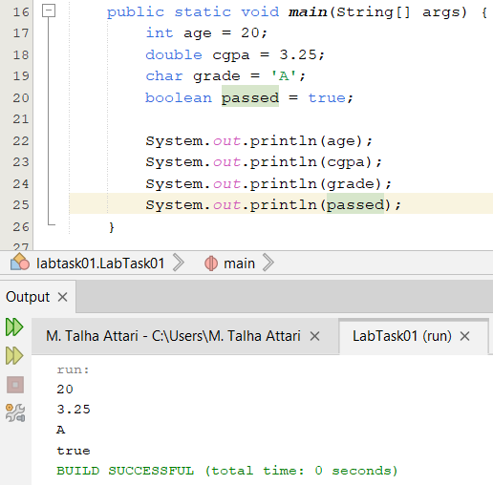
Activity 3: Modify and Trace
Prediction: 16
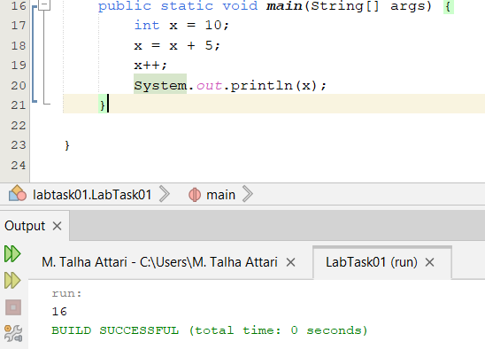

Student Exercise 01:
Write a program that stores your name, semester number, and CGPA, then displays them.
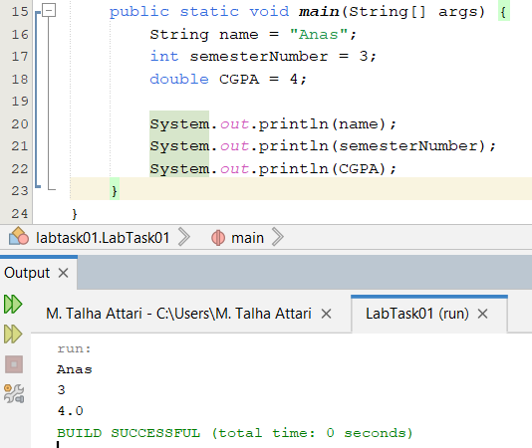
Student Exercise 02:
Declare two integers and print their sum, difference, product, and quotient.
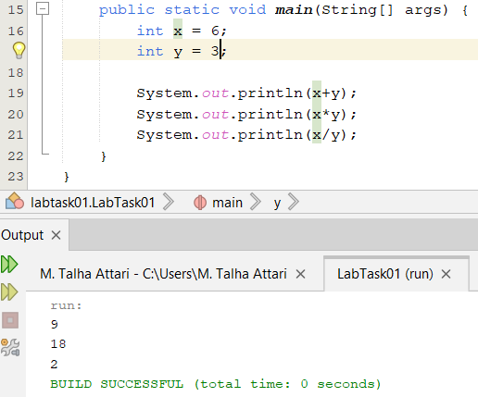

Student Exercise 03:
Create meaningful identifiers for five student-related variables.
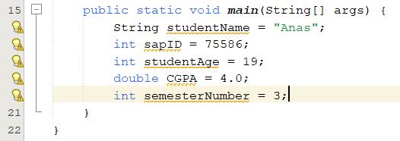

Student Exercise 04:
Intentionally use an invalid identifier, observe the compiler response, then correct it.
Error:
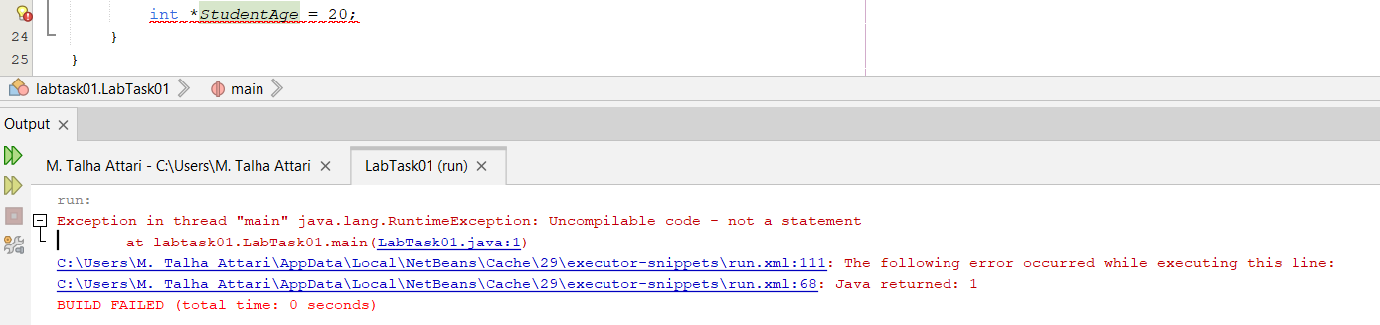
Fixed:
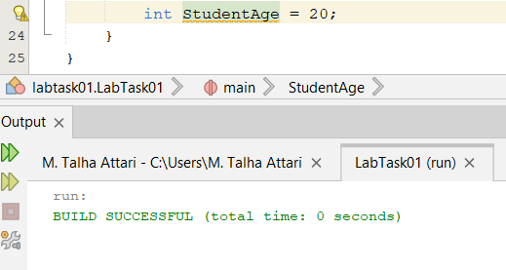

Lab Task 02: Console Input, Output, and Decision Making
Activity 1: Read Student Data
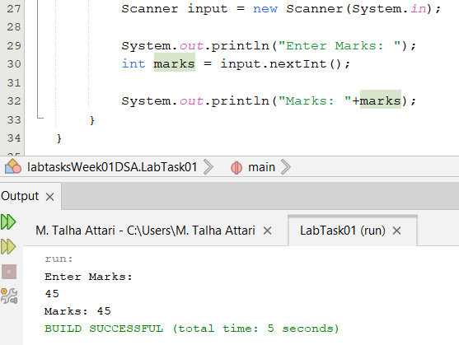
Acitivity 2: Grade Decision
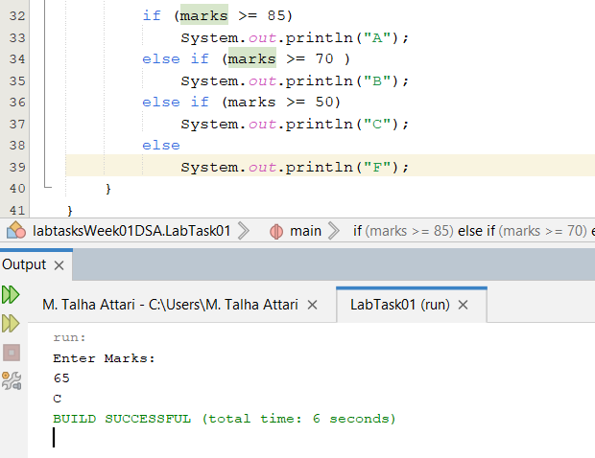
Activity 03: Menu using Switch
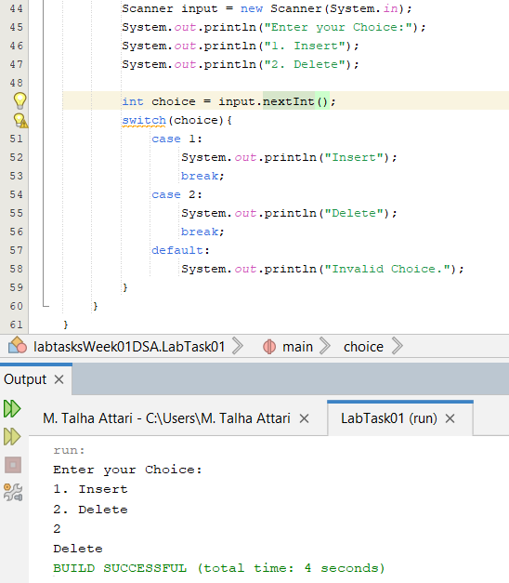

Student Exercise 1:
Input two integers and display the larger value.
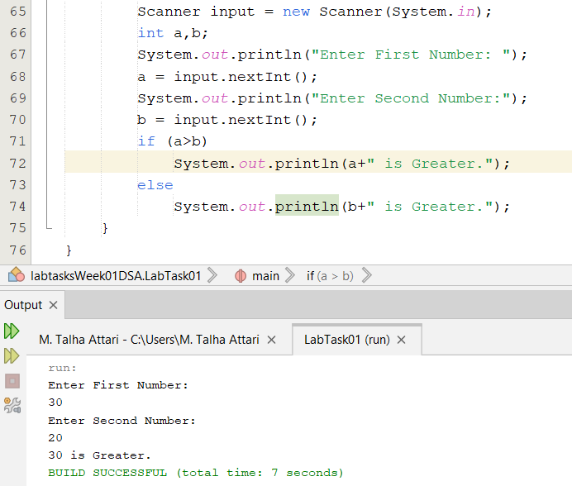

Student Exercise 2:
Input marks and attendance and decide eligibility using a compound condition.
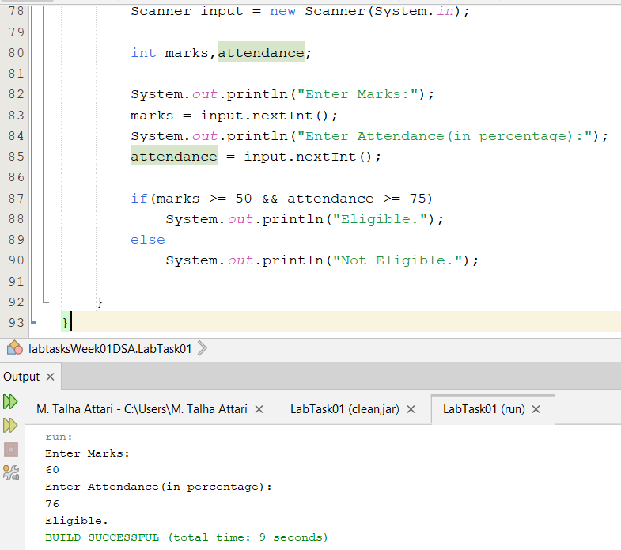

Student Exercise 3:
Build a weekday program using switch.
Code:
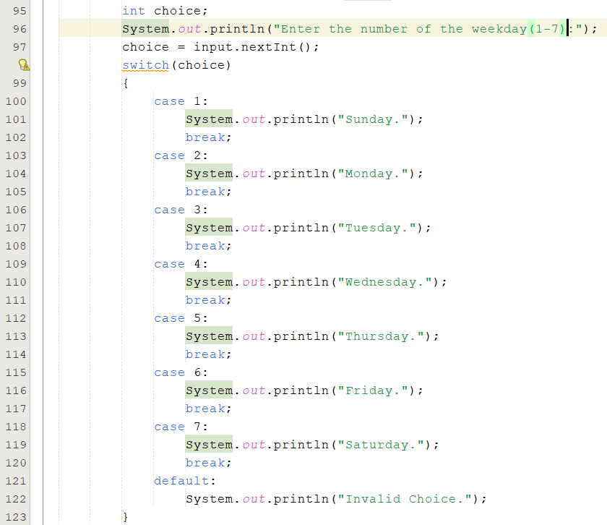
Output:
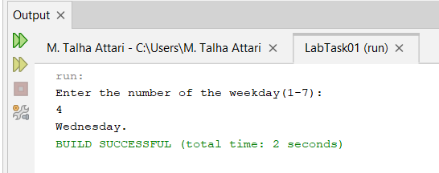
Student Exercise 4:
Remove a break from one switch case and record the fall-through behavior.
Code:
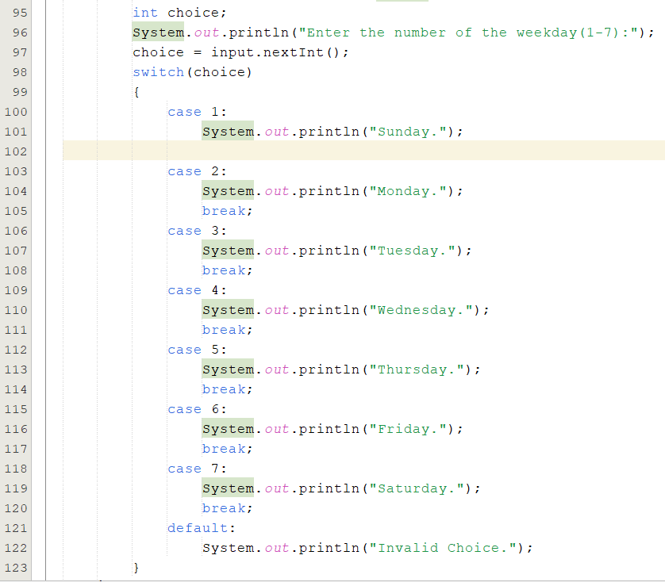
Output:
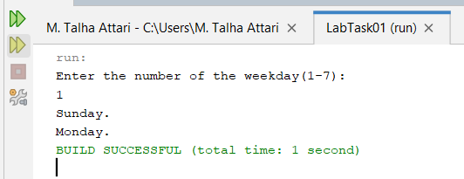
Both case 1 and case 2 get executed due to lack of break statement.
Lab Task 03: Repetition: while, do-while, for, for-each, break, and continue.
Activity 1: while Loop
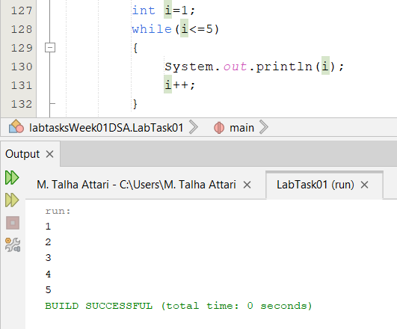
Activity 2: do-while Loop
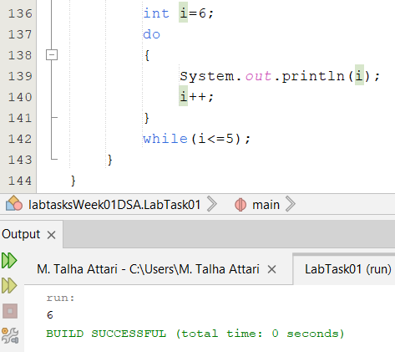
Activity 3: for Loop
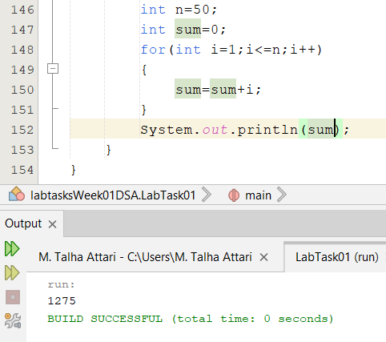
Activity 4: for-each and Arrays
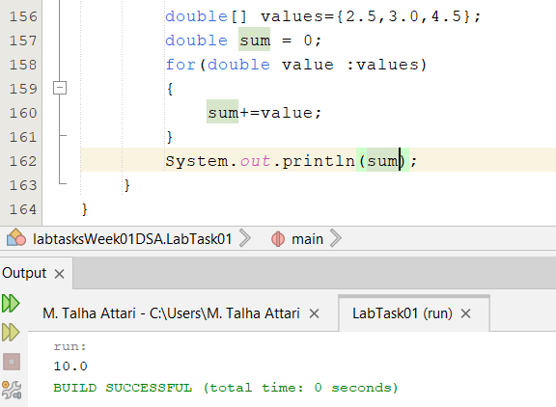
Activity 5: break and continue
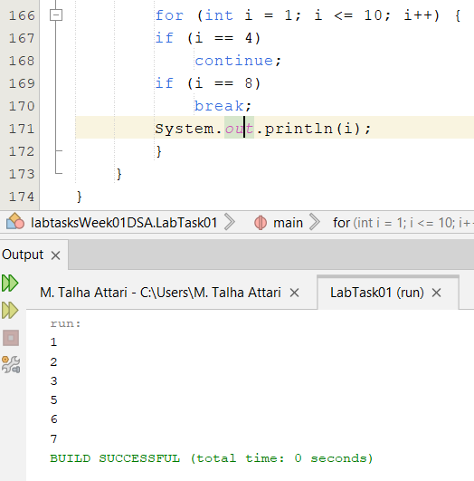
Student Exercise 1:
Use while to count down from 10 to 1.
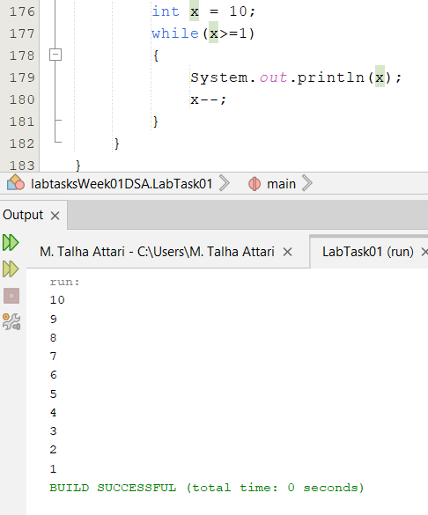
Student Exercise 2:
Use do-while to repeatedly request a positive number.
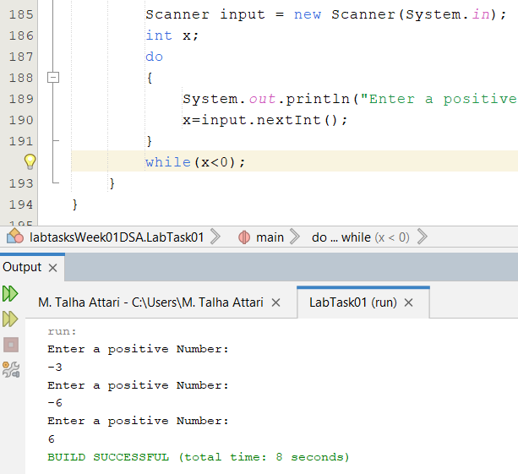
Student Exercise 3:
Use for to compute the factorial of n.
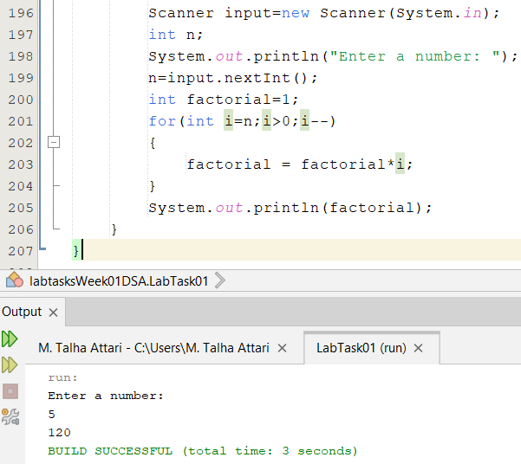
Student Exercise 4:
Use for-each to find the maximum value in an array.
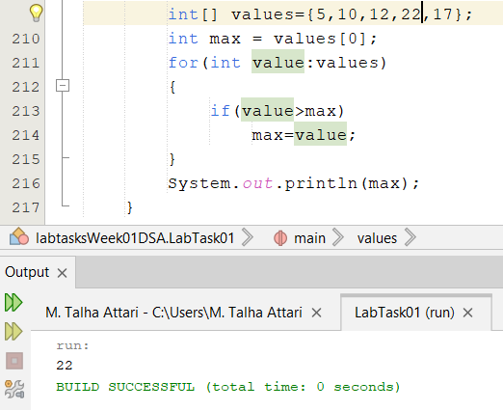
Student Exercise 5:
Print 1–20 but skip multiples of 3 using continue.
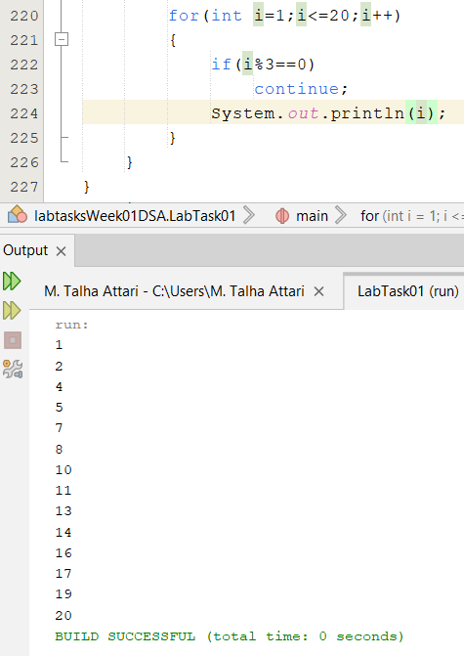
Lab Task 4: Classes, Objects, Methods, Constructors, and the Dot Operator.
Activity 1: Create a Counter Class.
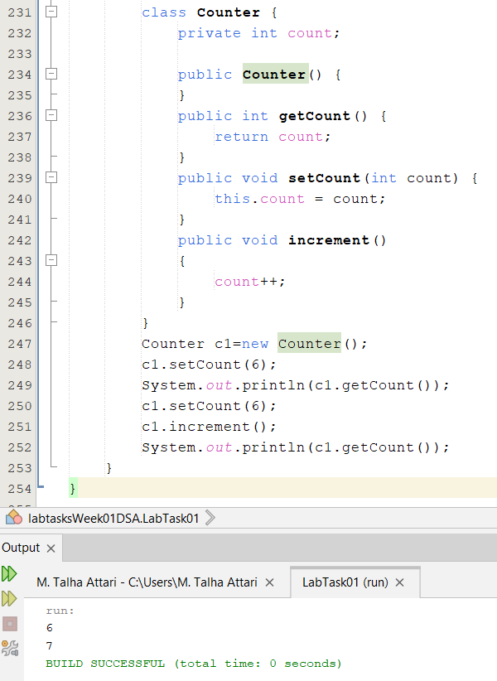
Activity 2: Use the Object.
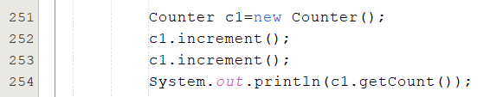
Activity 3: Extend the Class.
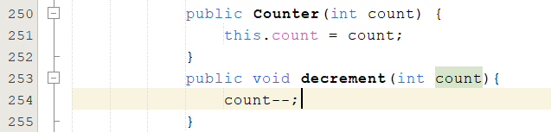
Student Exercise 1:
Create a Book class with title, author and price.
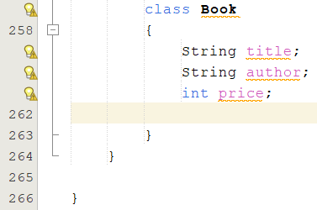

Student Exercise 2:
Add a constructor and methods to display and update the price.
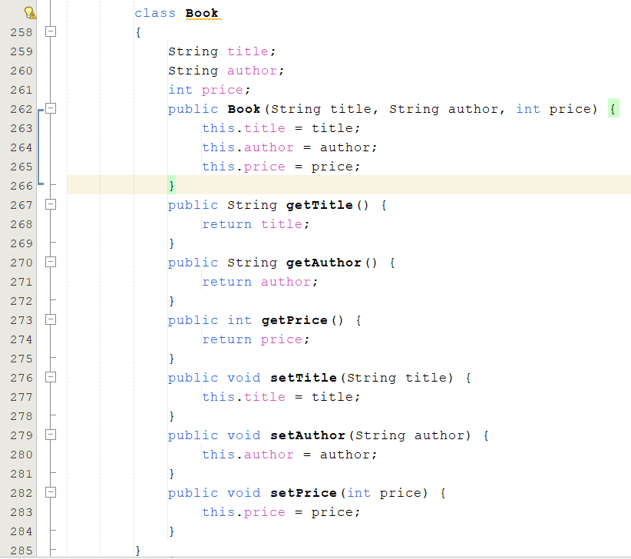

Student Exercise 3:
Create two Book objects and demonstrate that each object has its own state.
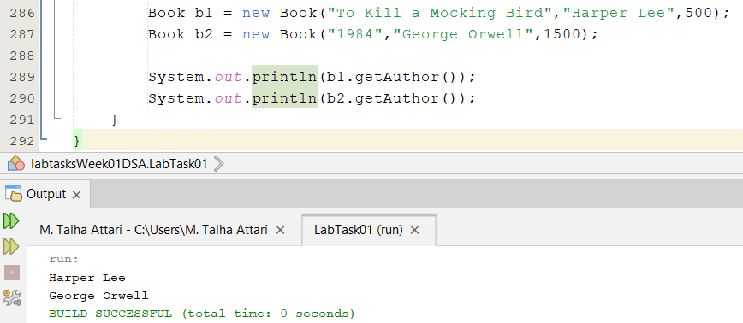
Student Exercise 4:
Create a Rectangle class with width and height and methods for area and perimeter.
Code:
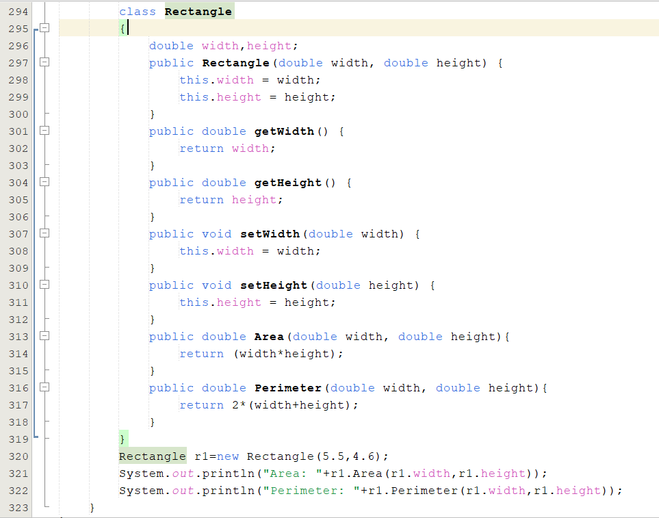
Output:
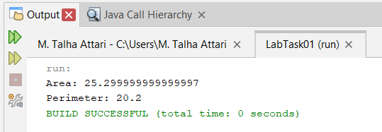

Lab Task 5: Operators, Expressions, Increment/Decrement, and Casting
Activity 1: Arithmetic and Integer Division
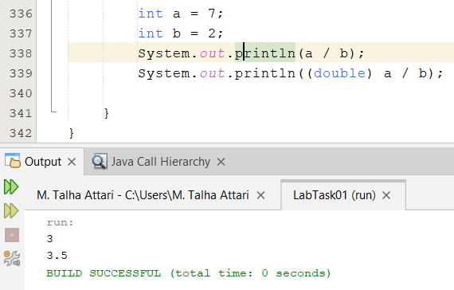
Changing the data type to double gives output in decimal form.

Activity 2: Increment Experiment
Prediction:
5
6
7
Actual:
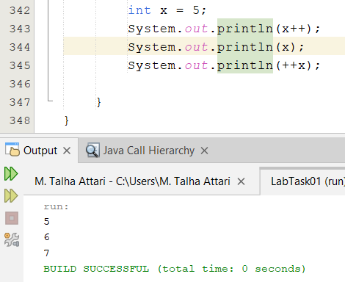
Activity 3: Logical Conditions
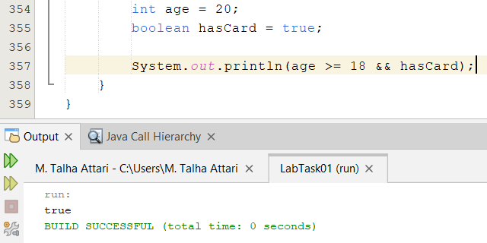

Activity 4: Casting
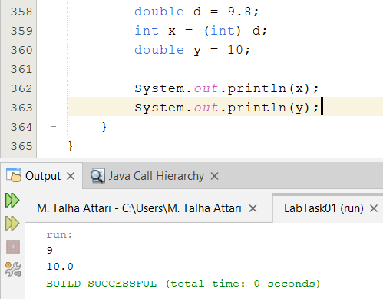
Student Exercise 1:
Write a program that calculates the average of three integers and ensures the result is displayed as a decimal.
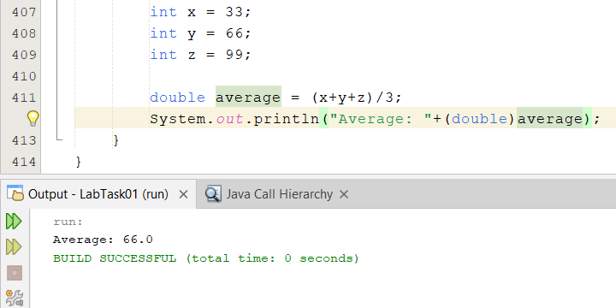

Student Exercise 2:
Predict the result of expressions containing both ++x and x++.
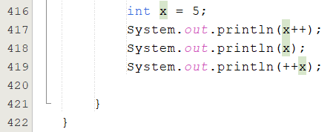
Prediction:
5
6
7
Actual:
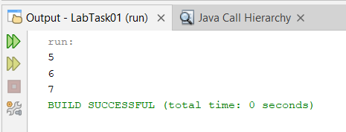
Student Exercise 3:
Write a Boolean expression that checks whether a student is eligible when attendance is at least 75 AND marks are at least 50.
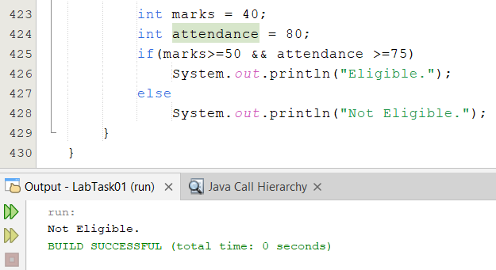
Student Exercise 4:
Convert a double to int explicitly and explain what happens to the fractional part. 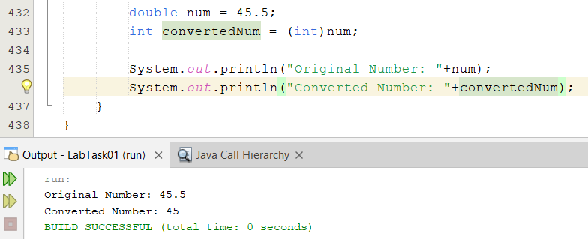
The fractional part gets completely discarded.
Lab Task 1 Challenge Task:
Build a simple Student Information program using at least five variables of different suitable types. Display the information in a readable format.
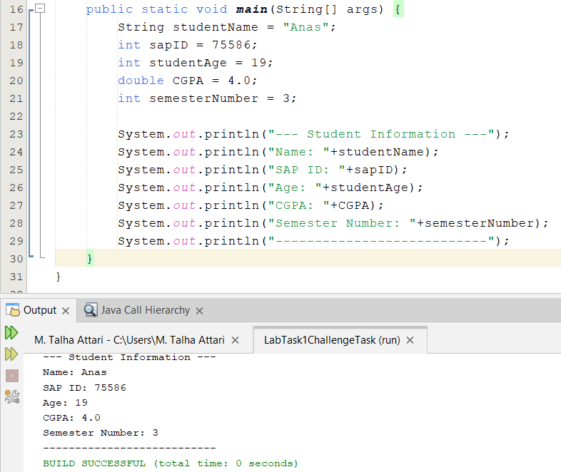
Lab Task 2 Challenge Task:
Build a menu-driven calculator supporting addition, subtraction, multiplication, and division. Handle division by zero with an appropriate condition.
Code:
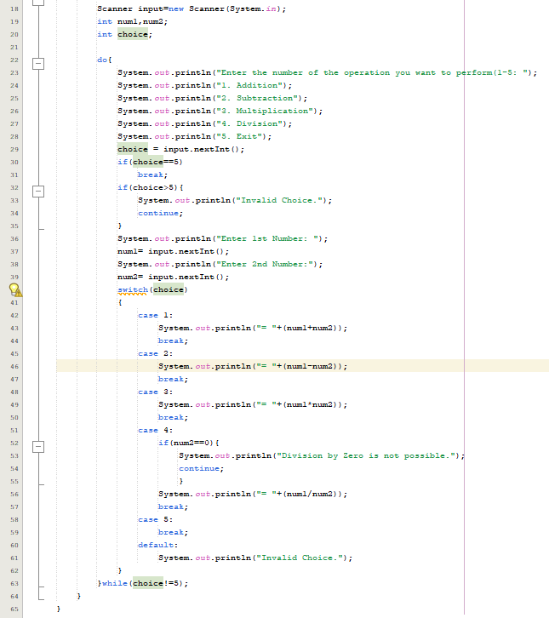

Sample Output:
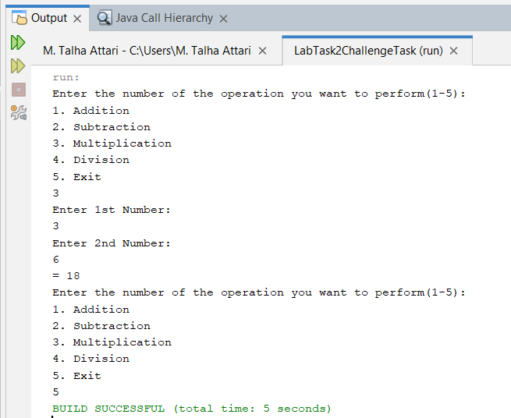

Lab Task 3 Challenge Task:
Input n course marks, store them in an array, calculate the sum and maximum, and then use a for-each loop to count how many marks are at least 50.
Code:
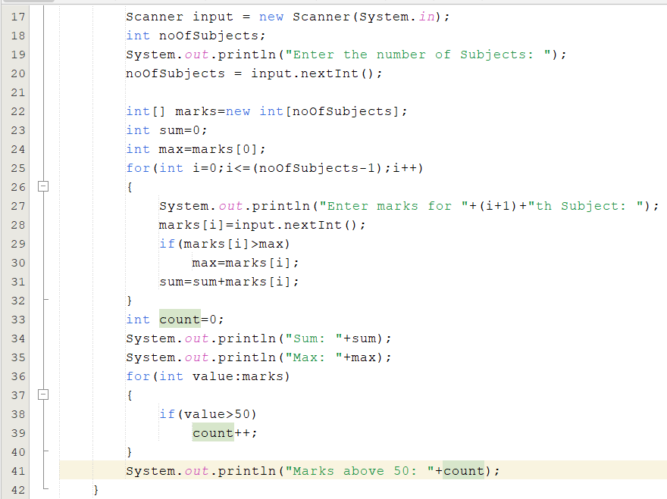
Output:
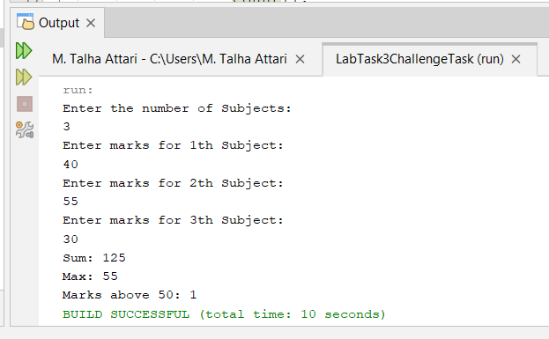
Lab Task 4 Challenge Task:
Design a BankAccount class with account holder name and balance. Include a constructor, getBalance, deposit, and withdraw methods. Prevent a withdrawal from making the balance negative.
Code:
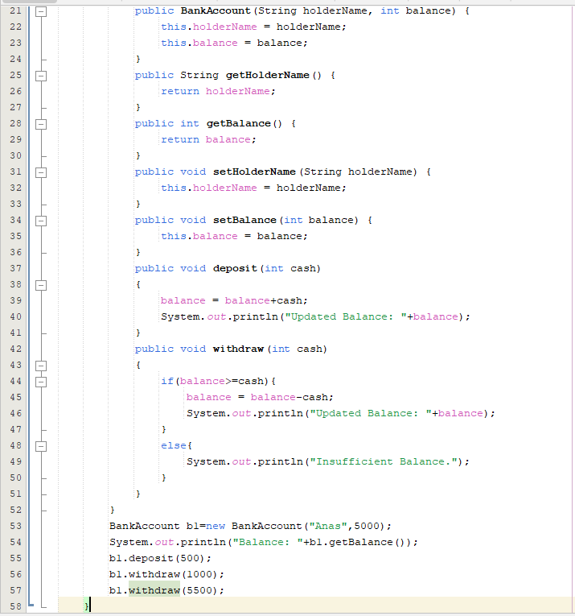

Output:
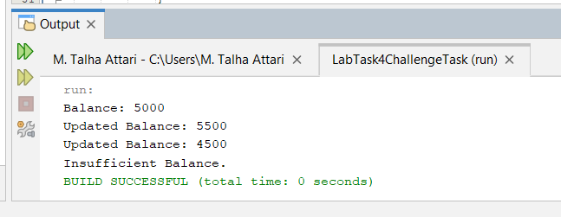
Lab Task 5 Challenge Task:
Create a mini grade calculator. Accept three marks, calculate average as double, and determine whether the student passes using logical operators.
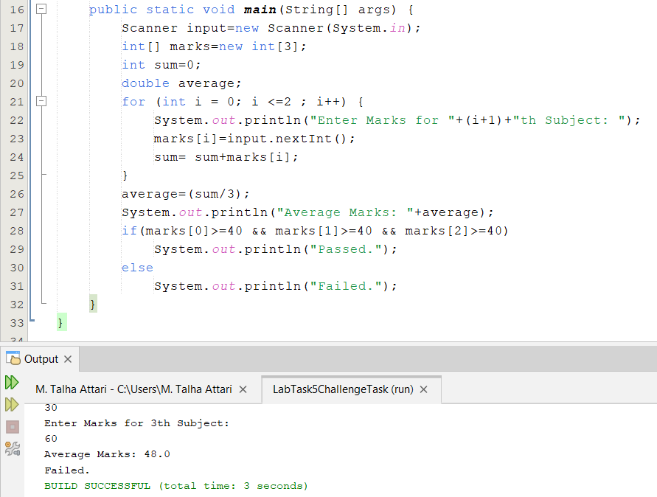
--- The End ---

