Faculty of Computing
Riphah International University, Islamabad

Data Structures



Lab Task
Week # 06

Submitted by
Muhammad Anas
75586
to
Mr. Junaid Khan
on
October 7, 2026
Activity 1 — Infix to Postfix
Task:
Write a Java program that converts an Infix expression into Postfix notation using a Stack.
Code:
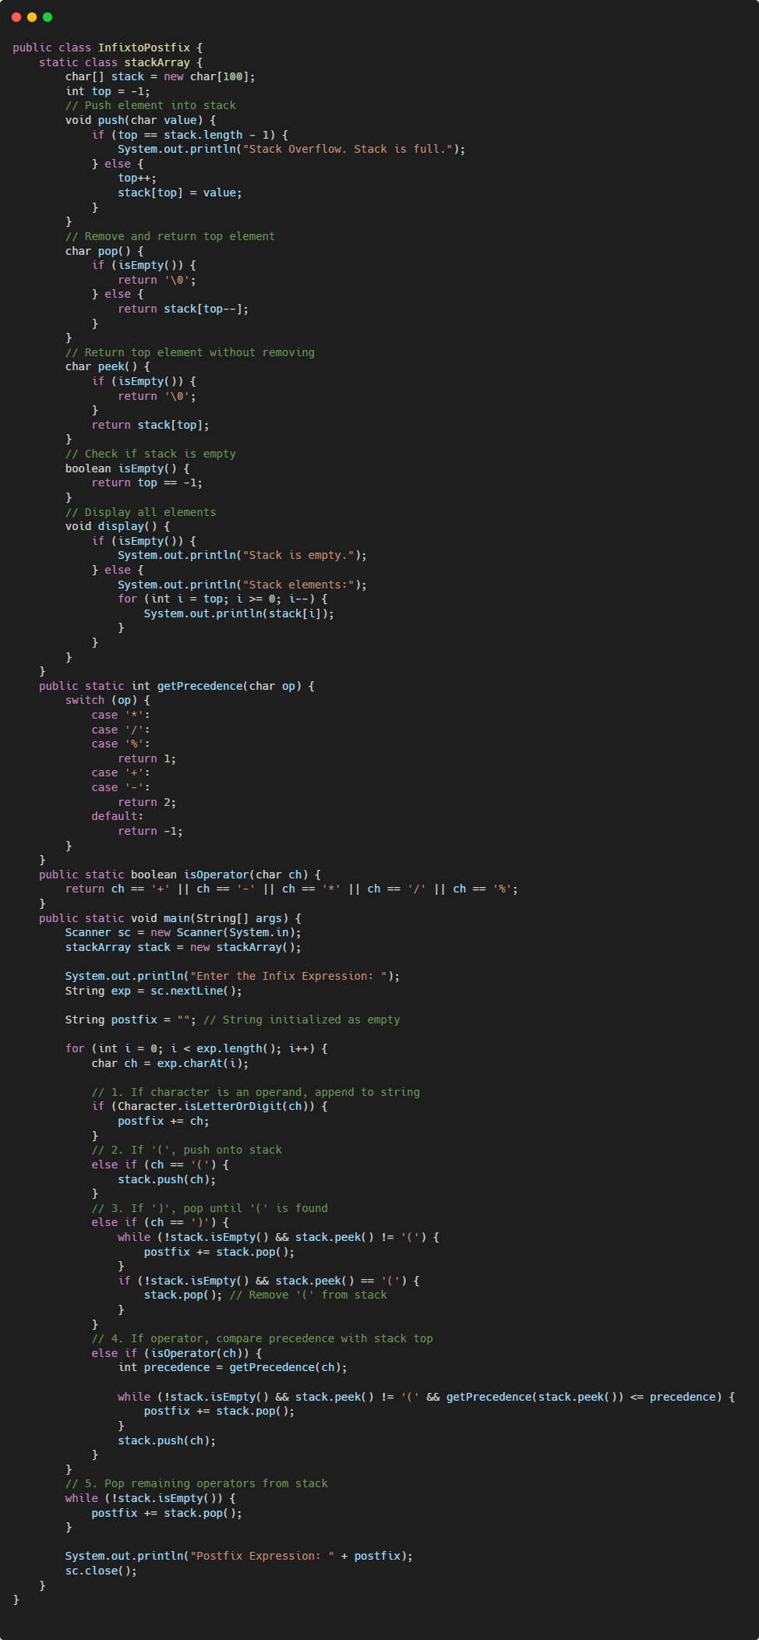
Output:
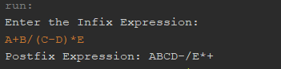
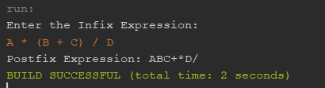
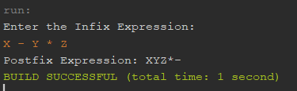

Activity 2 — Postfix to Infix
Task:
Write a Java program that converts a Postfix expression into an Infix expression using a Stack.
Code:
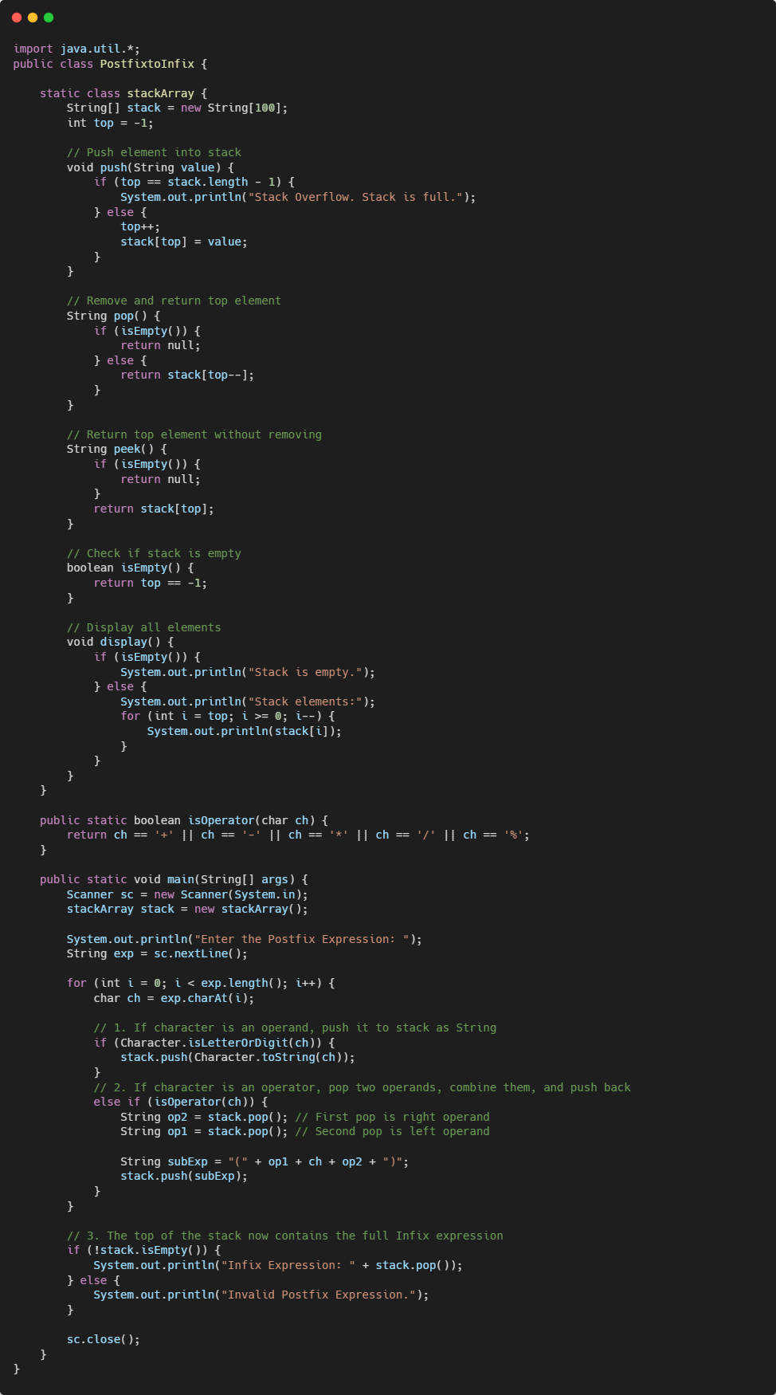
Output:
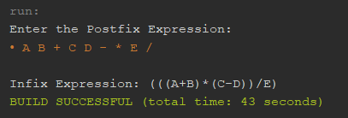
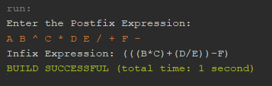
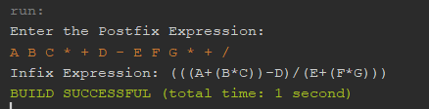

Activity 3 — Infix to Prefix
Task:
Write a Java program that converts an Infix expression into Prefix notation using a Stack.
Code:
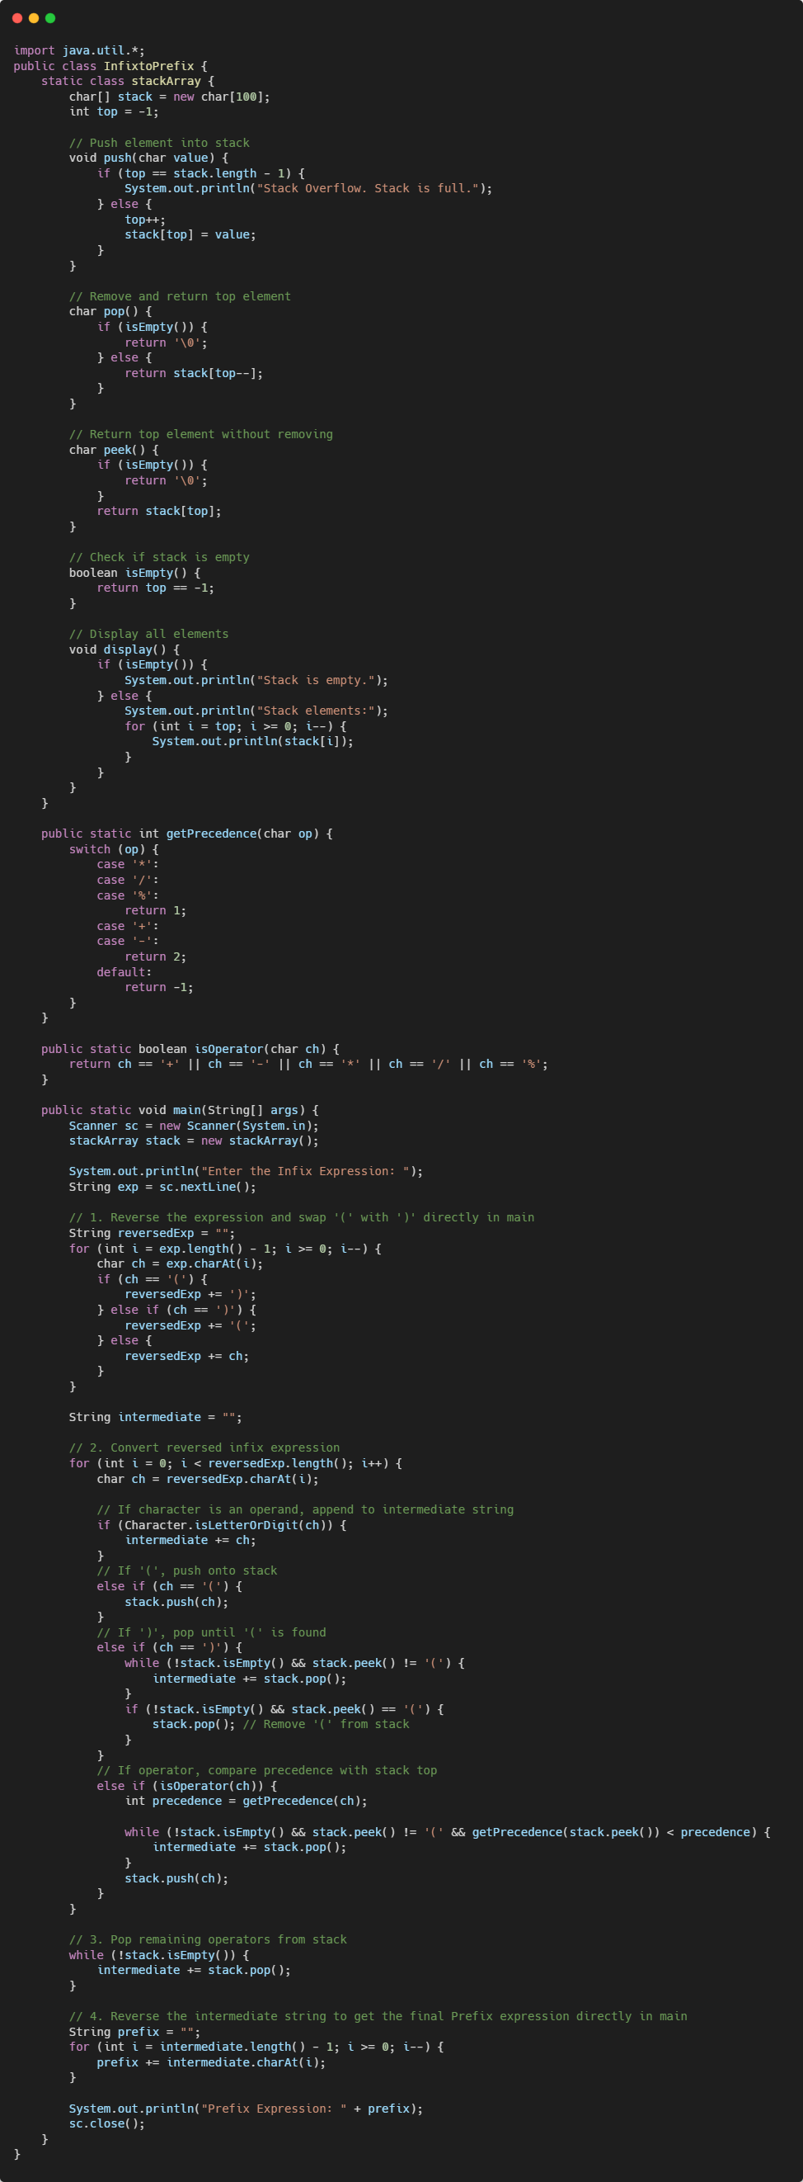
Output:
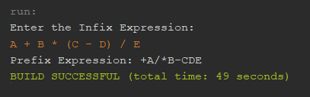
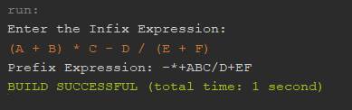
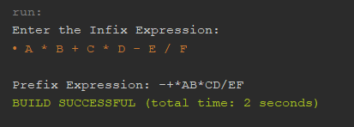

Activity 4 — Prefix to Infix
Code:
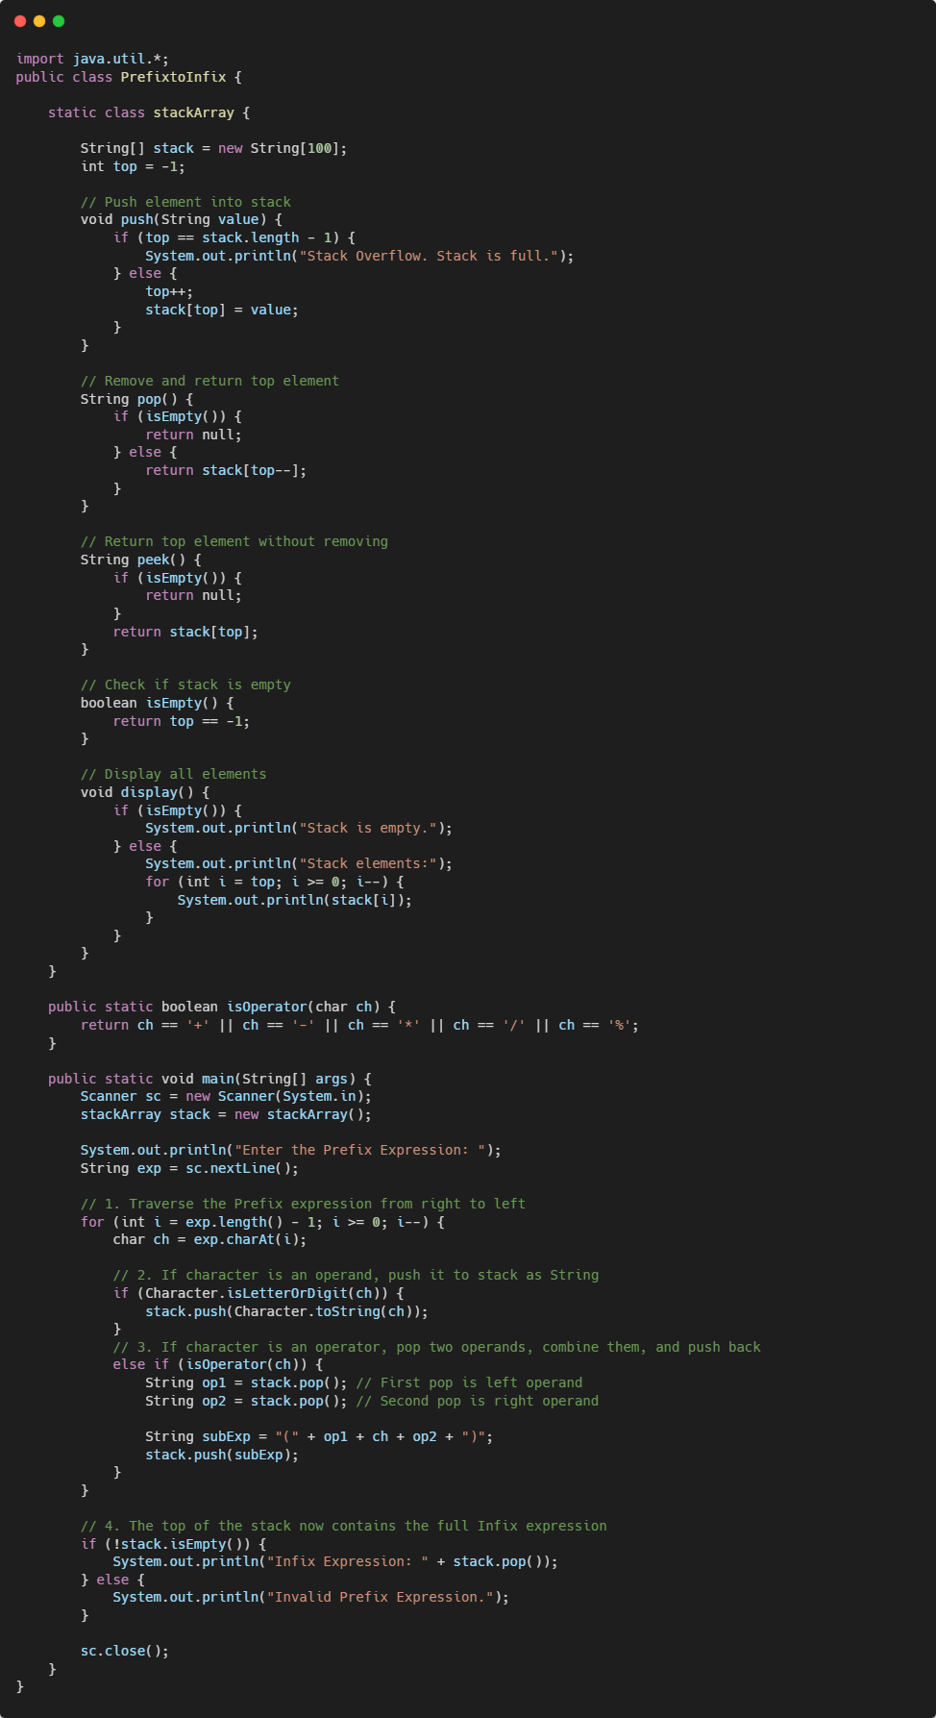
Output:
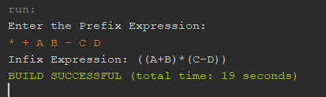
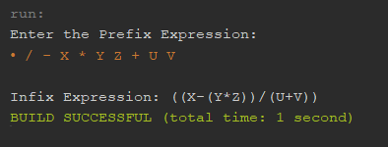
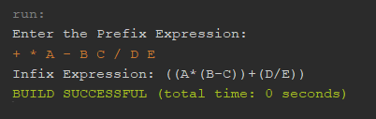

Activity 5 — Prefix to Postfix
Task:
Write a Java program that converts a Prefix expression into Postfix notation using a Stack.
Code:
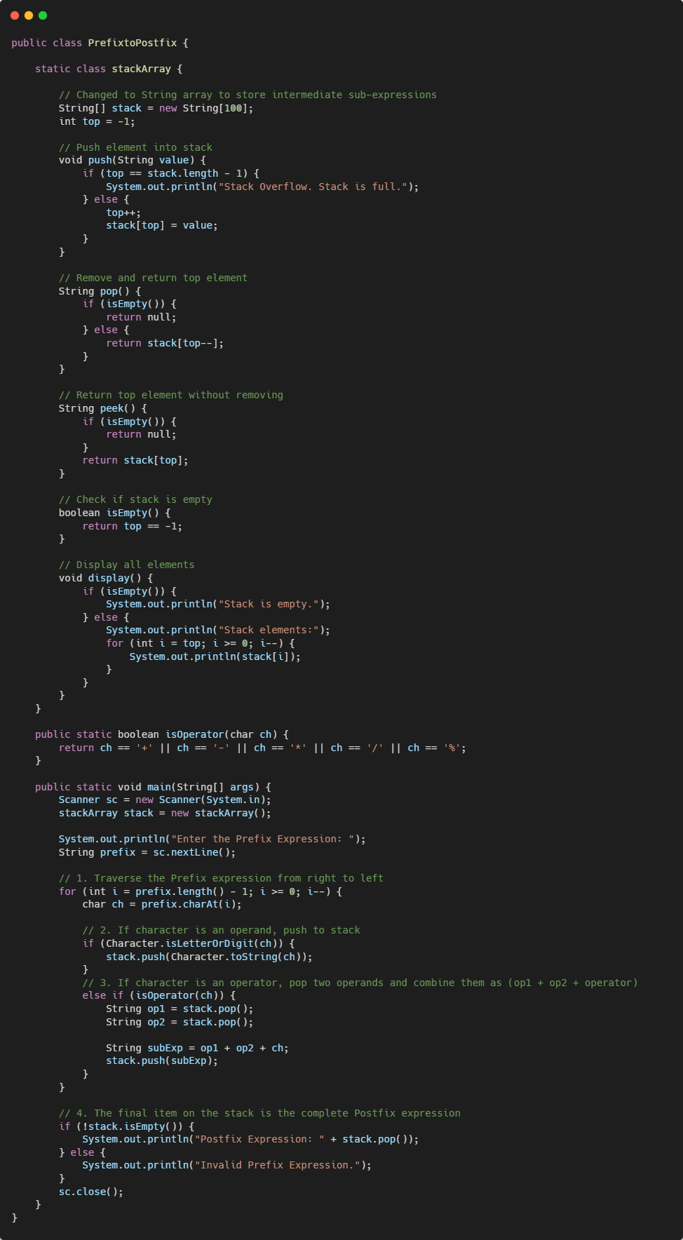
Output:
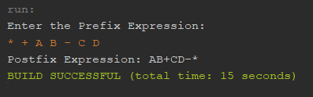
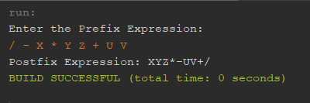
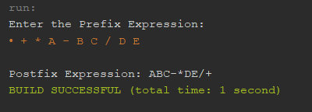

Activity 6 -- Postfix → Prefix
Code:
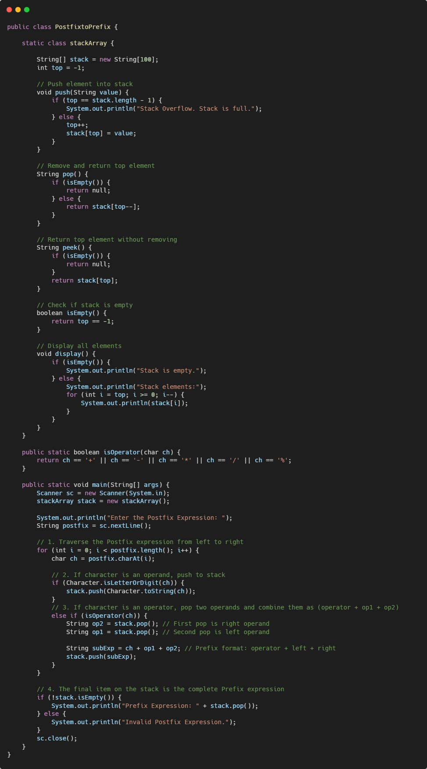
Output:
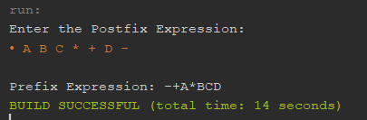
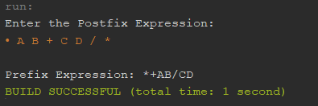
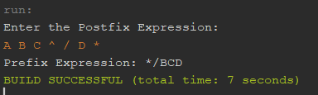

Activity 7 — Six-Way Expression Conversion
Develop a menu-driven Java program that allows the user to select any of the six conversions.
Code:
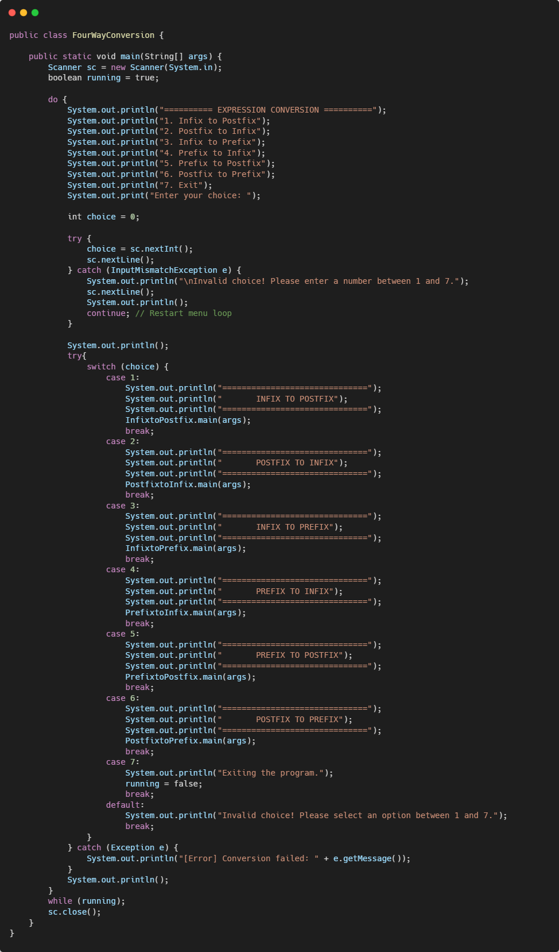
Output:
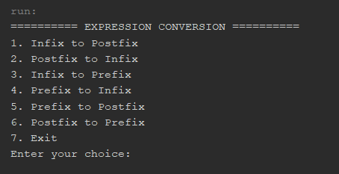
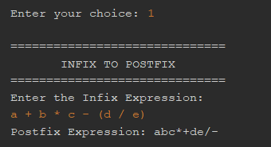
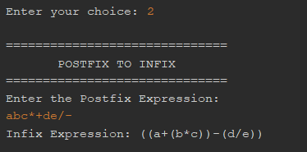
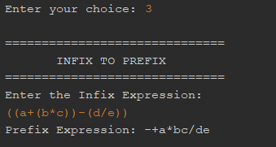
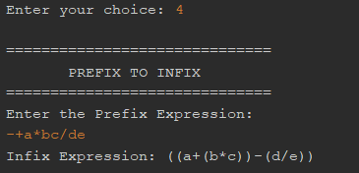
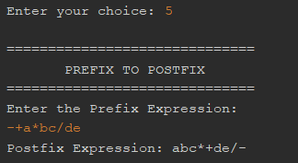
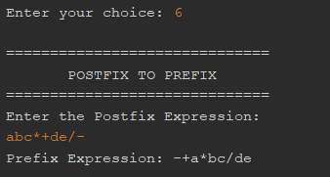
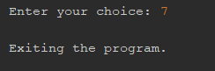
--- The End ---

