Faculty of Computing
Riphah International University, Islamabad

Data Structures



Lab Task
Week # 03

Submitted by
Muhammad Anas
75586
to
Mr. Junaid Khan
on
September 16, 2026

Lab Activities
Activity 1 — Foundational & Structural Recursion
i- Mathematical Recursion (Factorial)
Create a Java program that calculates the factorial of a user-specified integer using recursion.
The program should:
- Identify the Base Case where
- Implement the Recursive Step
Code:
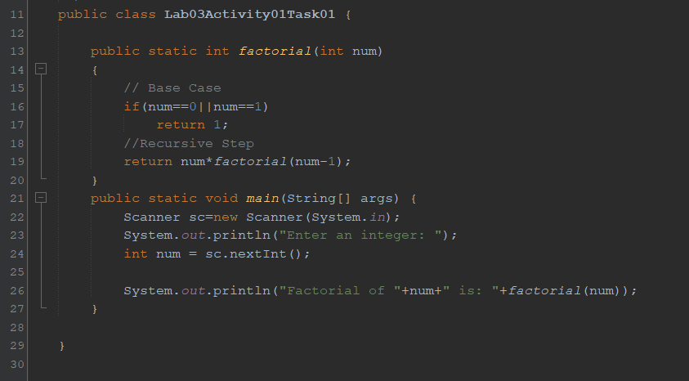

Output:
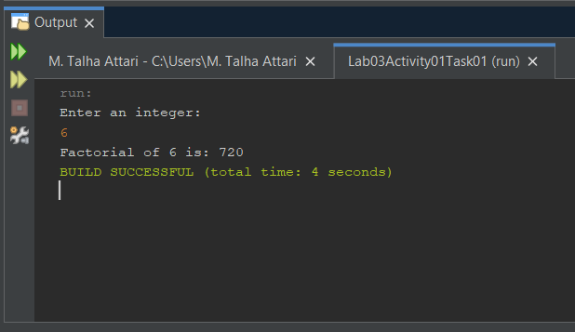
ii- Structural Array Traversal Recursion
Create a Java program that processes elements of a one-dimensional array without using any for, while, or do-while loops.
Use the following input array:
Array {12, 45, 7, 23, 56, 89, 34}
- Recursive Traversal: Print all elements from index 0 to length - 1.
- Recursive Statistics: Compute and return the total Sum of all elements.
- Recursive Search: Search for a target value. Return its index position if found, or -1 if absent.
Code:
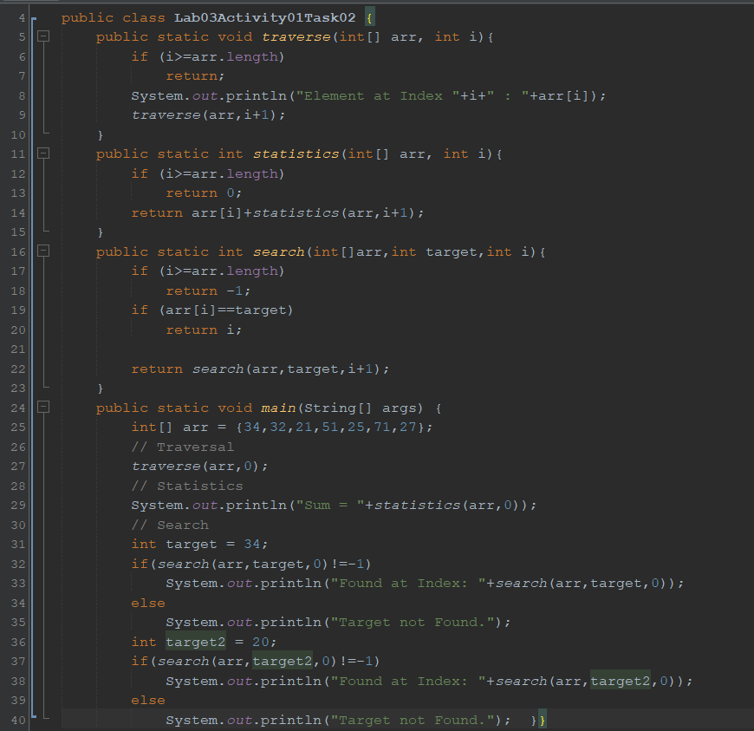
Output:
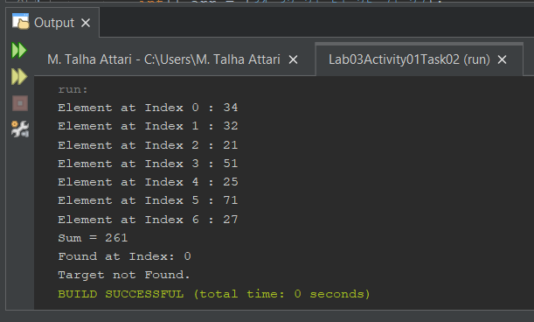

------------------------------------------------

Activity 2 — Merge Sort & Quick Sort Implementation
Task Description:
Write a single, ready-to-run Java program that implements both the Merge Sort and Quick Sort algorithms using distinct recursive methods. Your main method must initialize an unsorted test array, showcase the sorting process for each algorithm, and print the state of the array before and after execution.
Review the implementation trace output below. Analyze how the elements shift in memory, perform a manual dry run on paper, and prepare to justify your algorithmic understanding. There will be an individual viva examination at the conclusion of this lab session. If you encounter any structural anomalies or logical confusion during your dry run, proactively raise your hand to ask your lab instructor for clarification.

Code:
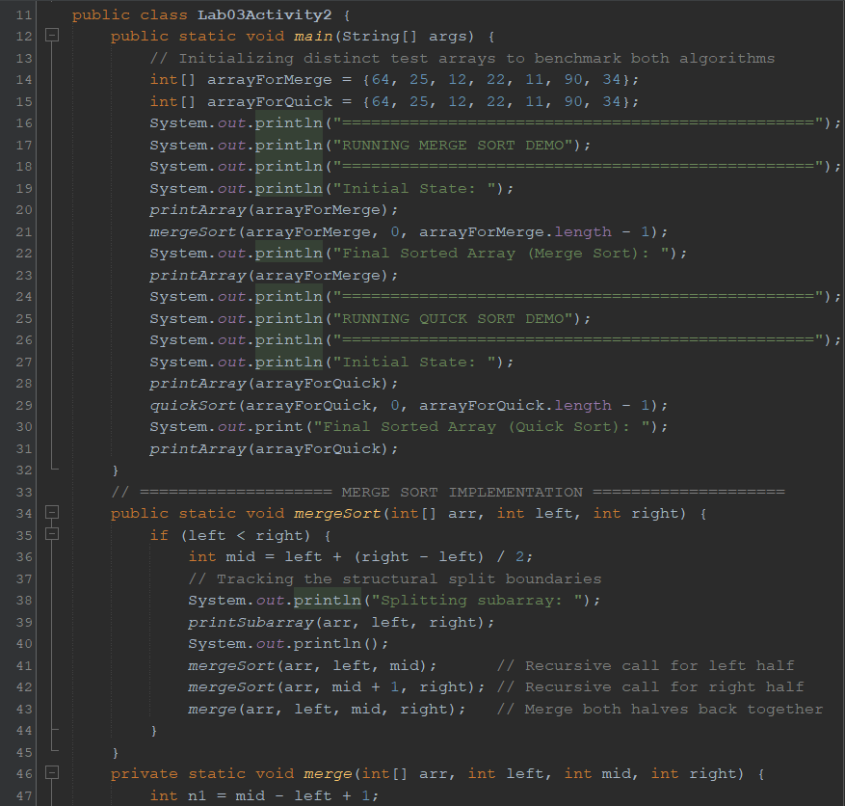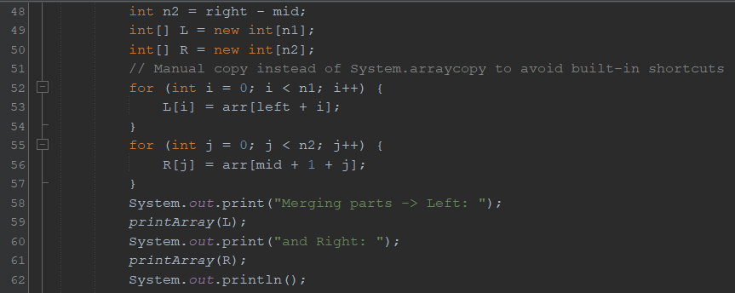
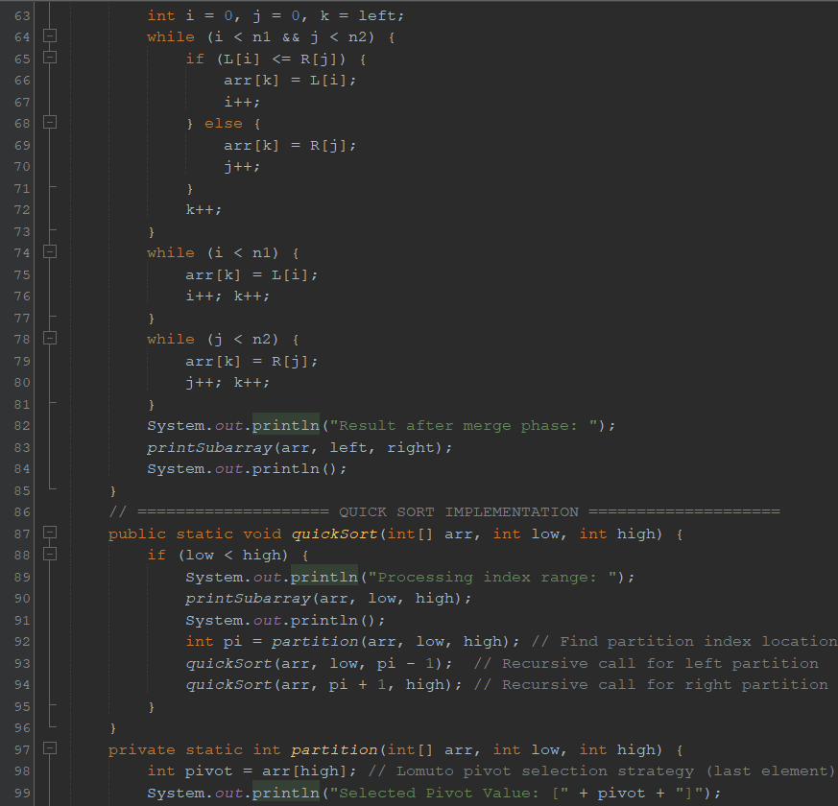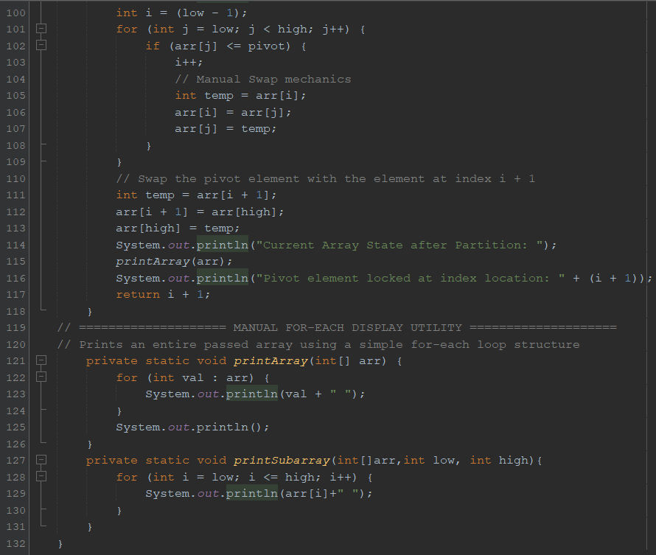
Output:
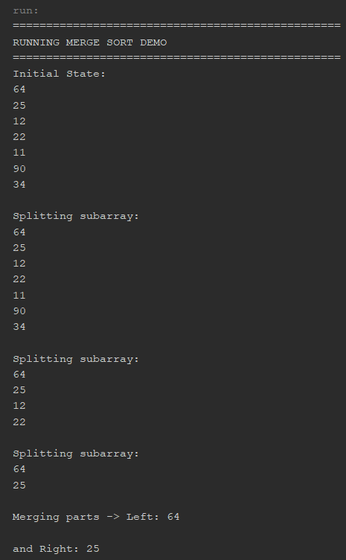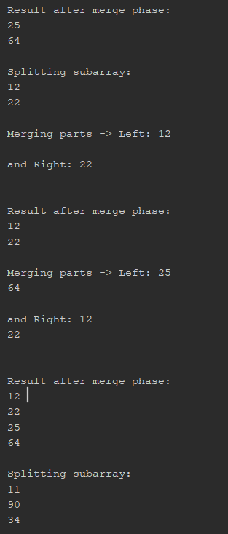

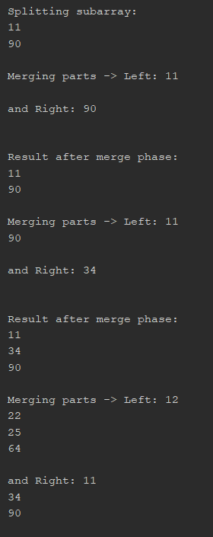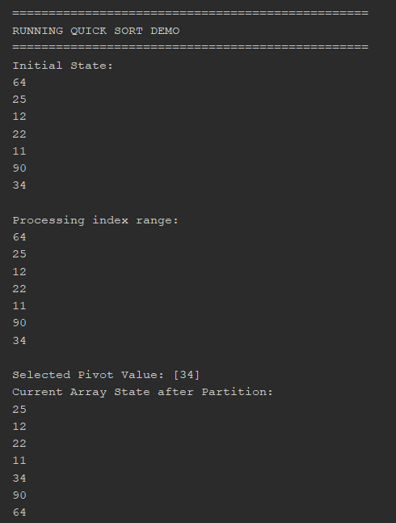

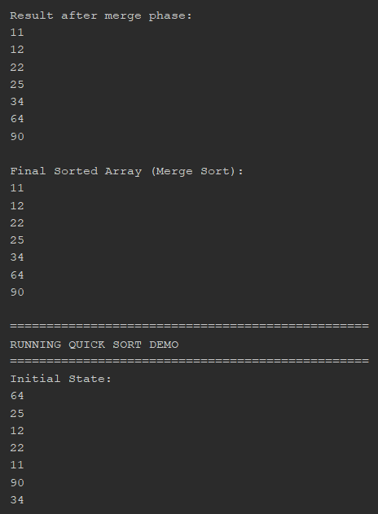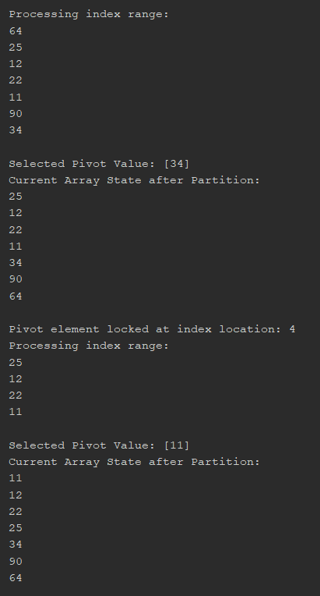

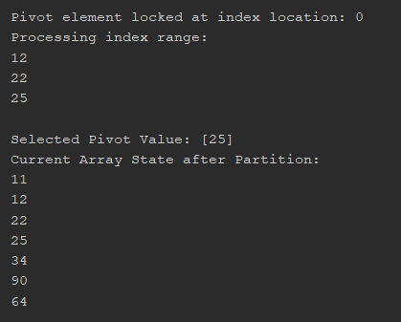
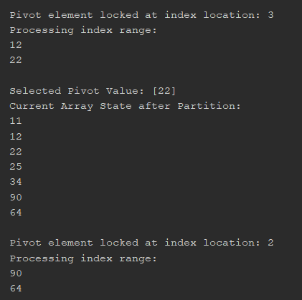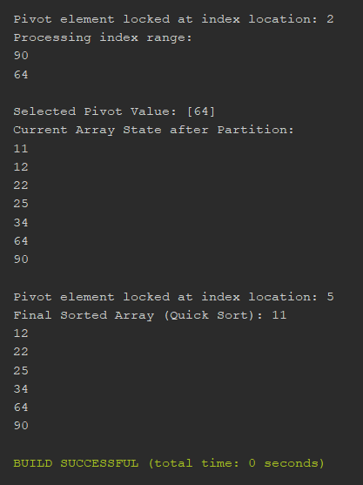

Dry Run and Analysis:
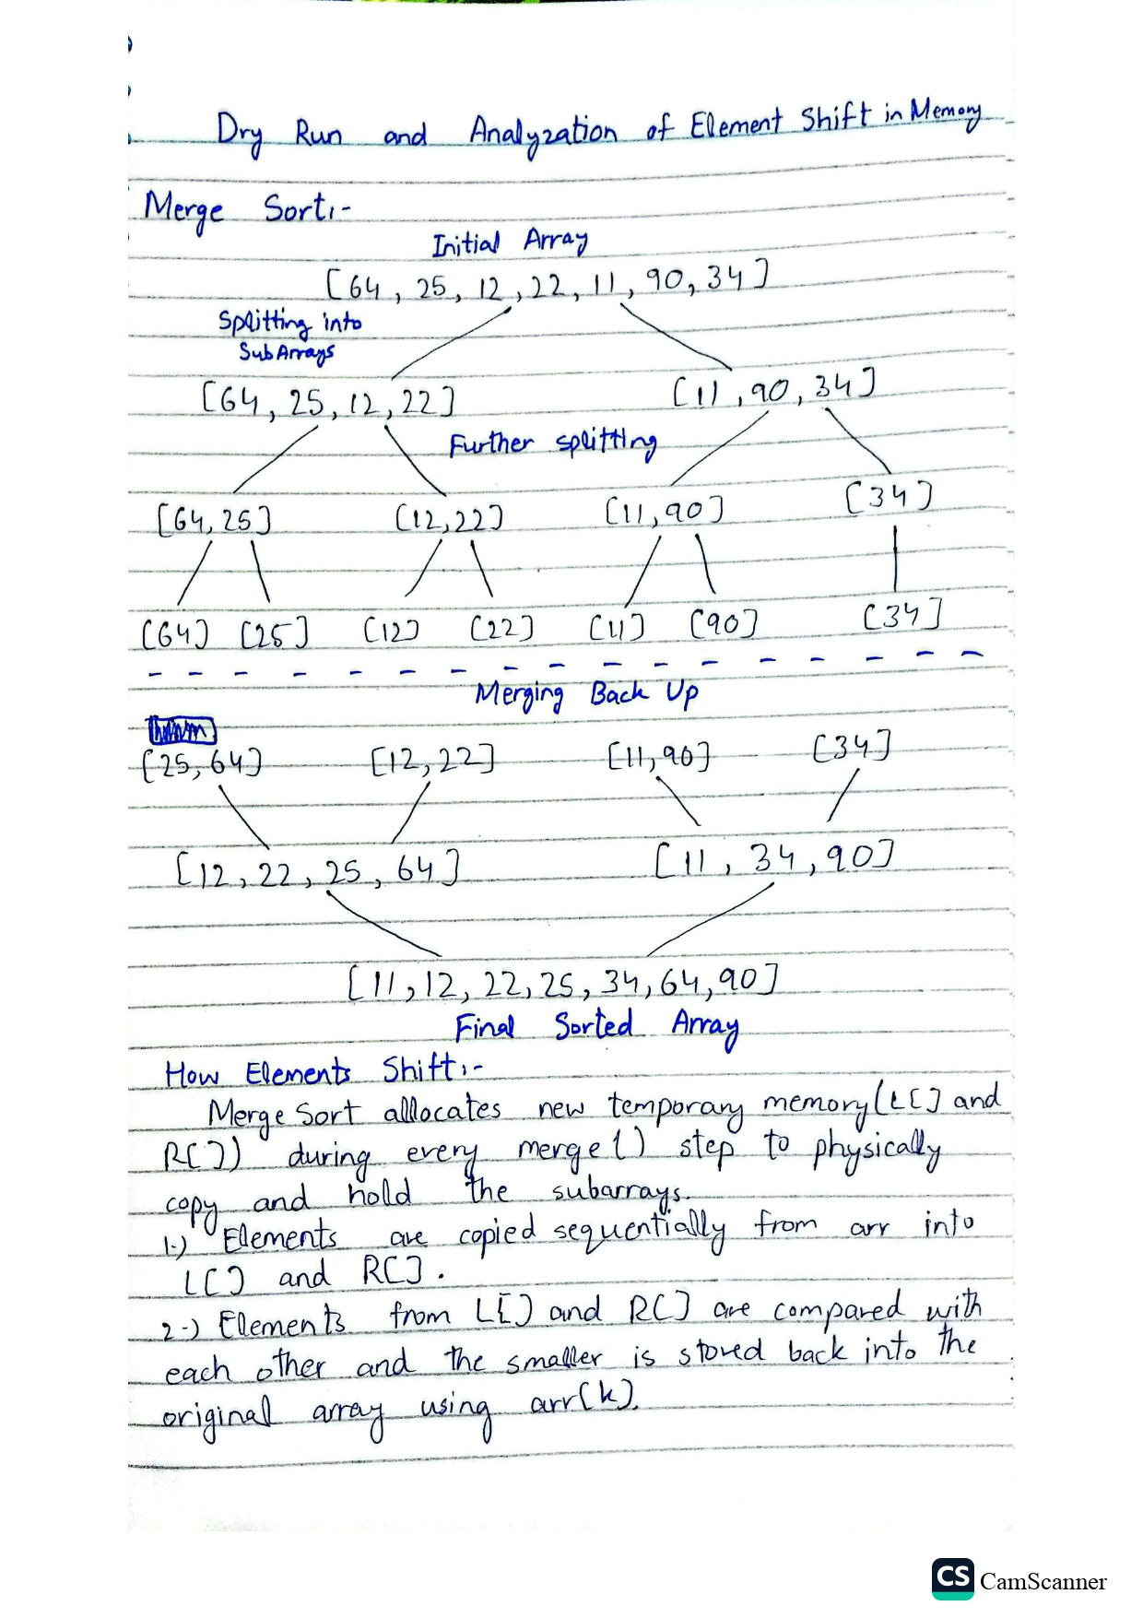
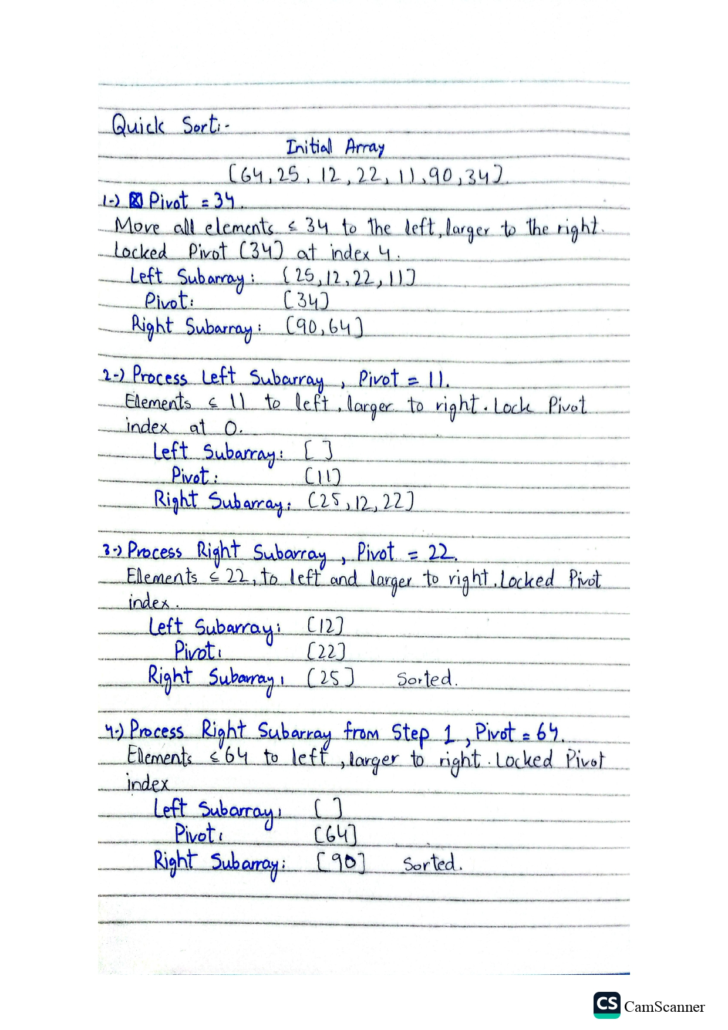
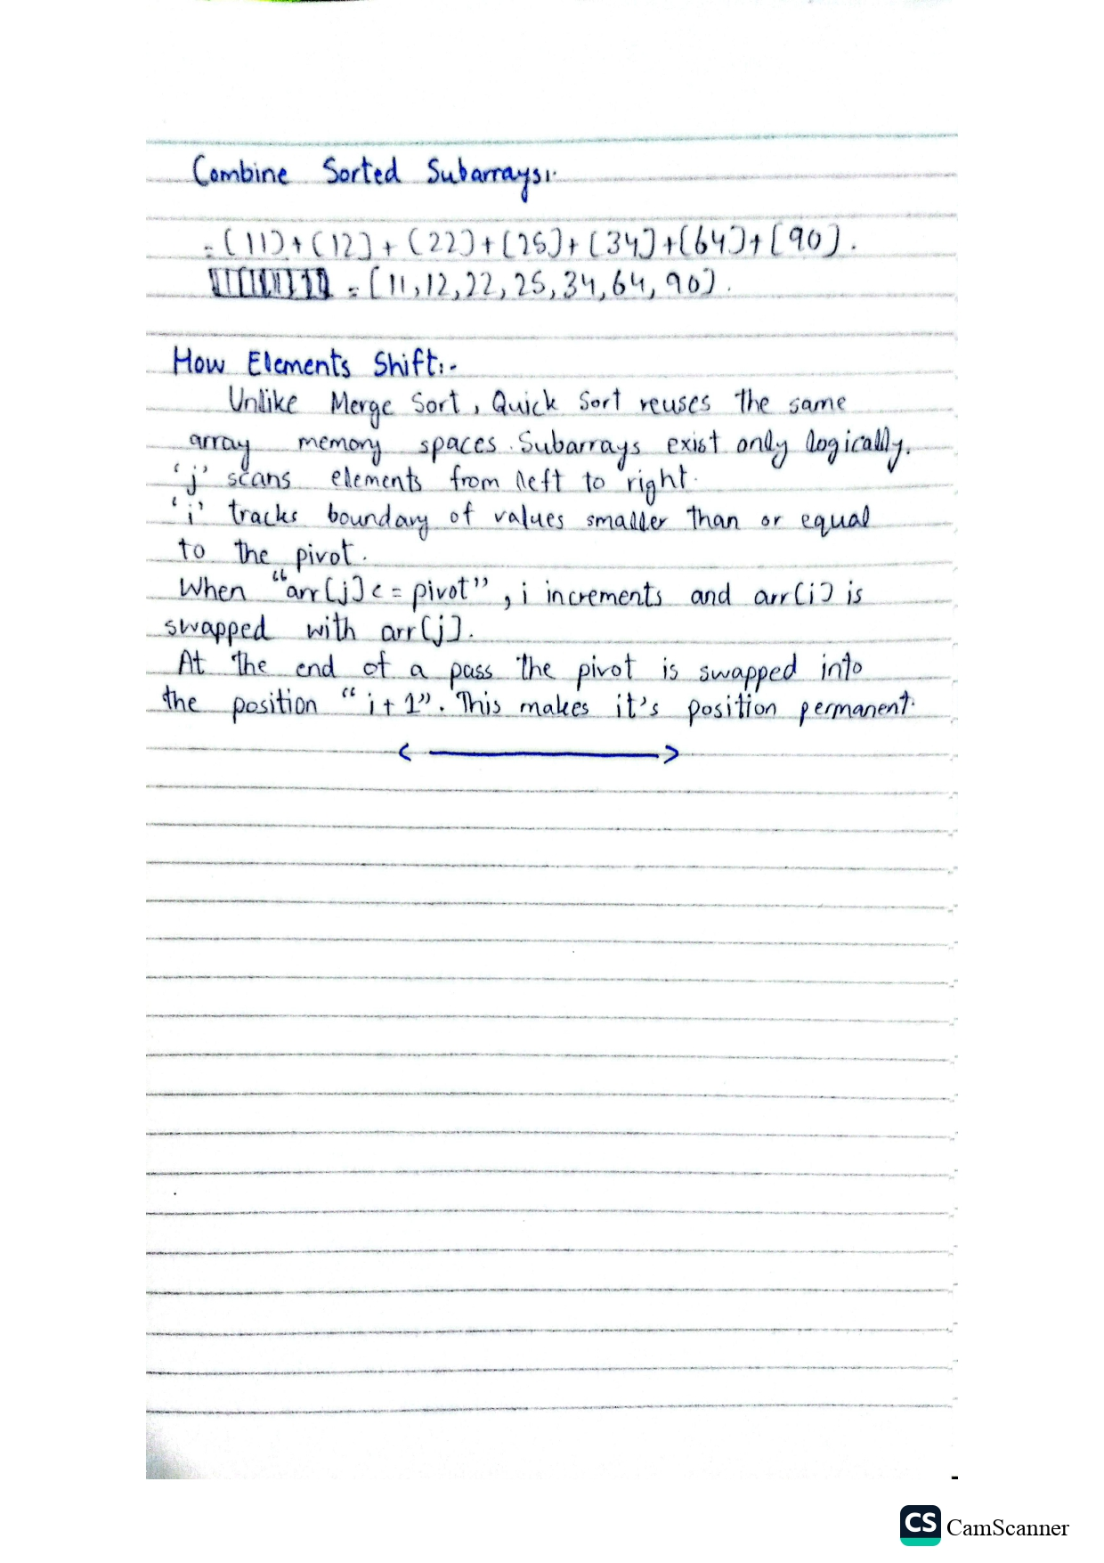
--- The End ---

