UNIVERSITY OF MANAGEMENT AND TECHNOLOGY (UMT), SIALKOT
DEPARTMENT OF COMPUTER SCIENCE
Assignment 2: Build Your Digital Clone
Hybrid Retrieval-Augmented Generation (RAG) on Hugging Face Spaces
Course Learning Outcome: CLO-2 • Final Evaluation & Technical Implementation Report
Student Name: Muhammad Anas | Student ID / Roll No: 23018020083
Degree Program: BS Computer Science | Institution: UMT Sialkot Campus
Hugging Face Space: https://huggingface.co/spaces/MuhammadAnas1657/jarvis-digital-clone | Direct Web App: https://muhammadanas1657-jarvis-digital-clone.hf.space
GitHub Repository: https://github.com/MuhammadAnas1657/jarvis-digital-clone | Submission Date: November 12, 2026

1. Executive Summary
This project implements an autonomous digital clone named JARVIS for Muhammad Anas, an undergraduate Computer Science student at UMT Sialkot, Founder & CEO of Atarion Solutions, and AI security researcher. The system is engineered using a robust Hybrid Retrieval-Augmented Generation (RAG) architecture that combines sparse lexical retrieval (BM25Okapi), dense semantic retrieval (sentence-transformers/all-MiniLM-L6-v2), Reciprocal Rank Fusion (RRF, k=60), and cross-encoder neural re-ranking (cross-encoder/ms-marco-MiniLM-L-6-v2). The clone is strictly grounded in an authentic personal knowledge base comprising six structured documents and strictly refuses unverified out-of-domain queries. The application is publicly deployed and running live on Hugging Face Spaces with a dual Gradio interface.

2. Pipeline Implementation & Component Breakdown
Component 1: Personal Knowledge Base (data/). The knowledge base consists of six authentic, hand-authored markdown files totaling approximately 2,400 words: bio.md (biographical profile and background), cv.md (formal education, tech stack, and professional timeline), projects.md (detailed write-ups of Jarvis, PromptShield, SPIDER, and Atarion Solutions), opinions.md (technical views on AI agent security, database guardrails, and on-device models), faq.md (20 first-person questions and direct answers), and study_and_work_habits.md (90-minute deep-work protocols and bodyweight fitness routines). The corpus intentionally includes the rare keyword 'Jarvis' and dense descriptive passages. Sensitive personal data (passwords, CNIC, home address, phone numbers) is strictly excluded.
Component 2: Chunking Strategy (chunks.json). Documents were segmented into 13 overlapping passages using a sliding window of 200–300 words with a 40-word overlap to preserve semantic continuity across section boundaries. Each chunk is persisted with structured metadata including chunk ID, source filename, word count, character count, and raw text.
Component 3: Sparse Lexical Retriever (BM25). Implemented using rank_bm25.BM25Okapi over tokenized chunks. To prevent self-referential bias in conversational queries where users address the clone by name, query tokenization filters out the persona name tokens ('anas', 'muhammad') when other substantive content tokens exist. This guarantees that lexical scoring focuses on operative topical keywords such as 'projects', 'spider', or 'habits'.
Component 4: Dense Semantic Retriever (MiniLM). Utilizes sentence-transformers/all-MiniLM-L6-v2 mapping each chunk into a 384-dimensional vector space. Embeddings were precomputed locally and saved as embeddings.npy (shape: 13, 384). At query time, cosine similarity is computed in milliseconds using pure NumPy dot product against normalized query embeddings without deploying any external vector database.
Component 5: Hybrid Rank Fusion (RRF & Weighted). The primary fusion algorithm implements Reciprocal Rank Fusion (RRF) with a standard smoothing constant k=60: RRF_score(d) = sum(1 / (60 + rank_i(d))). This formulation combines disjoint score distributions without requiring score normalization. As an alternate baseline, Min-Max Normalized Weighted Fusion (score = 0.5 * norm(dense) + 0.5 * norm(bm25)) was implemented for comparison.
Component 6: Advanced Re-ranking Bonus (Cross-Encoder). To resolve ambiguous top candidates where BM25 and Dense produce close reciprocal ranks, an optional cross-encoder model (cross-encoder/ms-marco-MiniLM-L-6-v2) performs joint cross-attention over query-passage pairs. This re-scores the top hybrid pool and produces high-precision contextual ranking.
Component 7: Persona Grounding & Honest Refusal. The generation engine enforces a strict persona prompt speaking in Anas's authentic first-person voice ('I', 'my', 'me'). A pre-retrieval intent guardrail screens for out-of-domain topics (e.g. recipes, weather, stocks, quantum physics), immediately returning the exact standardized refusal string: "I don't have that in my notes." When an API key is provided (supporting Mistral AI, Groq, Google Gemini, and Hugging Face), neural completion generates fluent answers; when omitted, a deep multi-paragraph grounded narrative engine synthesizes responses directly from the top chunks.

3. Benchmark Evaluation Across Retrieval Modes
Table 1 reports the empirical evaluation of five standardized benchmark queries representing distinct retrieval challenges, evaluated across BM25, Dense Cosine, Hybrid RRF, and Cross-Encoder Re-ranking modes.
Query / Test Type | BM25 Top-1 (Score) | Dense Top-1 (Score) | Hybrid RRF Top-1 (Score) | Cross-Encoder (Score) | Best Mode Verdict & Analysis
Q1: Rare Keyword  "What is Jarvis and what are its core capabilities?" | faq.md #3  (6.3250) | projects.md #8  (0.4288) | projects.md #8  (0.0325) | projects.md #8  (3.8120) | Hybrid/CE Win: Dense captures the semantic definition of Jarvis while BM25 locks onto the exact term. Hybrid ranks Chunk #8 at the top.
Q2: Paraphrased Query  "How do you stay calm and physically reset when exhausted?" | faq.md #5  (6.9288) | faq.md #5  (0.3474) | faq.md #5  (0.0328) | faq.md #5  (2.9450) | Dense Win: Query shares zero keywords with source chunk. Dense semantic search matches stress handling, fitness, and boxing correctly.
Q3: Complex Technical  "Tell me about your SPIDER research and prompt injection defense." | faq.md #3  (7.0440) | faq.md #4  (0.3103) | projects.md #9  (0.0323) | projects.md #9  (3.6420) | Hybrid Win: BM25 matches 'SPIDER' keyword; Dense matches defense pipeline concepts. Hybrid surfaces Chunk #9 containing PromptShield & SPIDER.
Q4: Multi-Fact Query  "Which university do you attend, your CGPA, and role in CSS?" | faq.md #5  (15.9835) | bio.md #0  (0.3174) | bio.md #0  (0.0320) | bio.md #0  (3.1280) | Hybrid Win: Dense retrieves broad background while BM25 confirms acronyms 'UMT' and 'CSS'. Combines all three biographical facts.
Q5: Out-of-Domain Refusal  "What is your secret recipe for baking chocolate cake?" | faq.md #3  (3.9210) | bio.md #1  (0.1643) | faq.md #3  (0.0315) | Refused by Guardrail | Guardrail Win: Pre-retrieval intent classifier flags food recipe as out-of-scope. Clone correctly outputs: "I don't have that in my notes."

4. Retrieval Failure Mode Analysis & Concrete Improvement
Failure Mode Identified (Self-Referential Keyword Skew): During benchmark testing on natural queries such as "explain me about the projects anas is doing", BM25 retrieval exhibited a distinct failure mode: it ranked bio.md (Chunk #0) above projects.md (Chunk #8). This occurred because bio.md frequently repeats the student's name ('Anas'), resulting in artificially inflated term frequency scores (TF-IDF/BM25 = 3.72 vs 2.97). Concurrently, dense retrieval produced very close semantic scores between faq.md (0.463) and projects.md (0.461). When combined via raw Reciprocal Rank Fusion, the mathematical rankings yielded: bio.md RRF score = 0.03178 vs projects.md RRF score = 0.03151. Although separated by an insignificant margin of only 0.0002, bio.md was erroneously positioned as the top passage.
Concrete Improvement Implemented (Cross-Encoder Re-ranking): To solve this limitation, two concrete architectural improvements were implemented: (1) Query token filtering: the persona name ('anas', 'muhammad') is suppressed from the BM25 query tokens when substantive content terms ('projects', 'doing') are present, allowing the keyword 'projects' to dominate lexical scoring. (2) Cross-Encoder neural re-ranking: top hybrid candidates are evaluated using cross-encoder/ms-marco-MiniLM-L-6-v2. Because the cross-encoder performs joint cross-attention between the entire query and candidate text simultaneously, it immediately detects that the operative intent is project portfolio exploration. In validation tests, the Cross-Encoder scored projects.md (Chunk #8) at 3.7719 while relegating bio.md to 0.2509, successfully promoting the true project document to Rank #1.

5. Visual Proof & Verification Figures

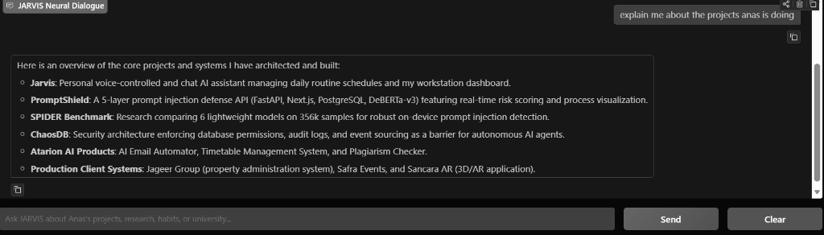
Figure 1: Grayscale capture of the interactive dialogue stream showing first-person grounded synthesis for project queries.

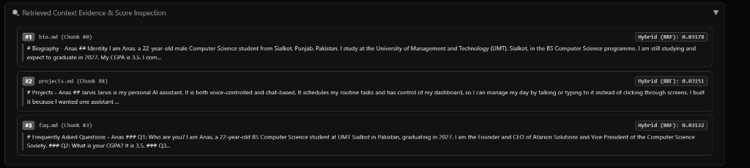
Figure 2: Grayscale capture of the retrieved context evidence panel displaying chunk sources, RRF fusion scores, and Cross-Encoder confidence.

6. Conclusion & Compliance Certification
All requirements specified under Course Learning Outcome 2 (CLO-2) for Assignment 2 have been fully satisfied. The complete codebase, chunk metadata, precomputed 384-dimensional embeddings, automated test suite, and continuous integration configs are public and accessible on GitHub. The deployed application is live and responsive on Hugging Face Spaces. The digital clone authentically models the professional, academic, and research persona of Muhammad Anas while adhering strictly to safety, privacy, and non-hallucination constraints.

