**Assignment**

Areeb (CSC-21F-022)

Emaan Gulzar (CSC-21F-034)

Huzaifa Abid (CSC-21F-043)

CSC-407 Digital Image and Processing

Mr. Anwar Ali Sathio

Sindh Madarsatul Islam University

**YOLO (You Only Look Once):**

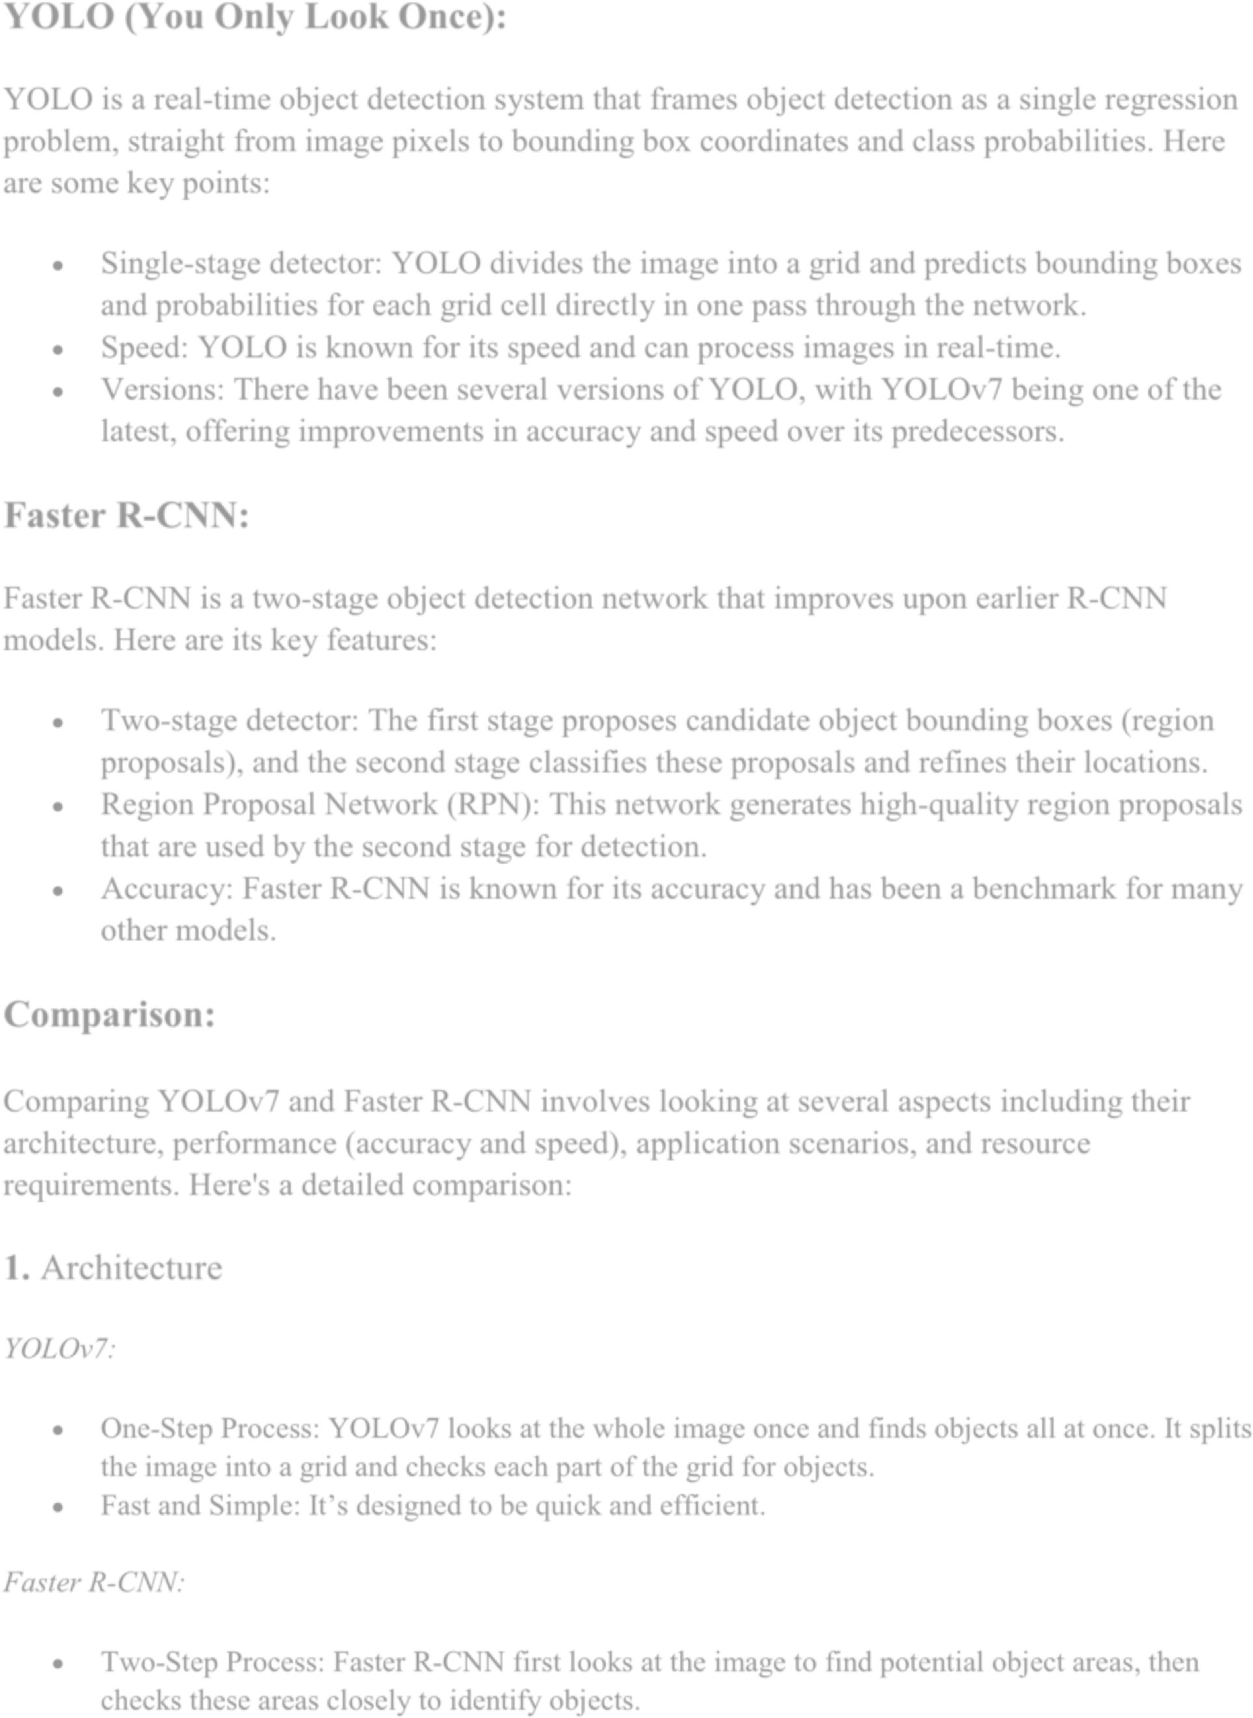YOLO is a real-time object detection system that frames object detection as a single regression problem, straight from image pixels to bounding box coordinates and class probabilities. Here are some key points:

* Single-stage detector: YOLO divides the image into a grid and predicts bounding boxes and probabilities for each grid cell directly in one pass through the network.
* Speed: YOLO is known for its speed and can process images in real-time.
* Versions: There have been several versions of YOLO, with YOLOv7 being one of the latest, offering improvements in accuracy and speed over its predecessors.

**Faster R-CNN:**

Faster R-CNN is a two-stage object detection network that improves upon earlier R-CNN models. Here are its key features:

* Two-stage detector: The first stage proposes candidate object bounding boxes (region proposals), and the second stage classifies these proposals and refines their locations.
* Region Proposal Network (RPN): This network generates high-quality region proposals that are used by the second stage for detection.
* Accuracy: Faster R-CNN is known for its accuracy and has been a benchmark for many other models.

**Comparison:**

Comparing YOLOv7 and Faster R-CNN involves looking at several aspects including their architecture, performance (accuracy and speed), application scenarios, and resource requirements. Here's a detailed comparison:

**1.** Architecture

*YOLOv7:*

* One-Step Process: YOLOv7 looks at the whole image once and finds objects all at once. It splits the image into a grid and checks each part of the grid for objects.
* Fast and Simple: It’s designed to be quick and efficient.

*Faster R-CNN:*

* Two-Step Process: Faster R-CNN first looks at the image to find potential object areas, then checks these areas closely to identify objects.

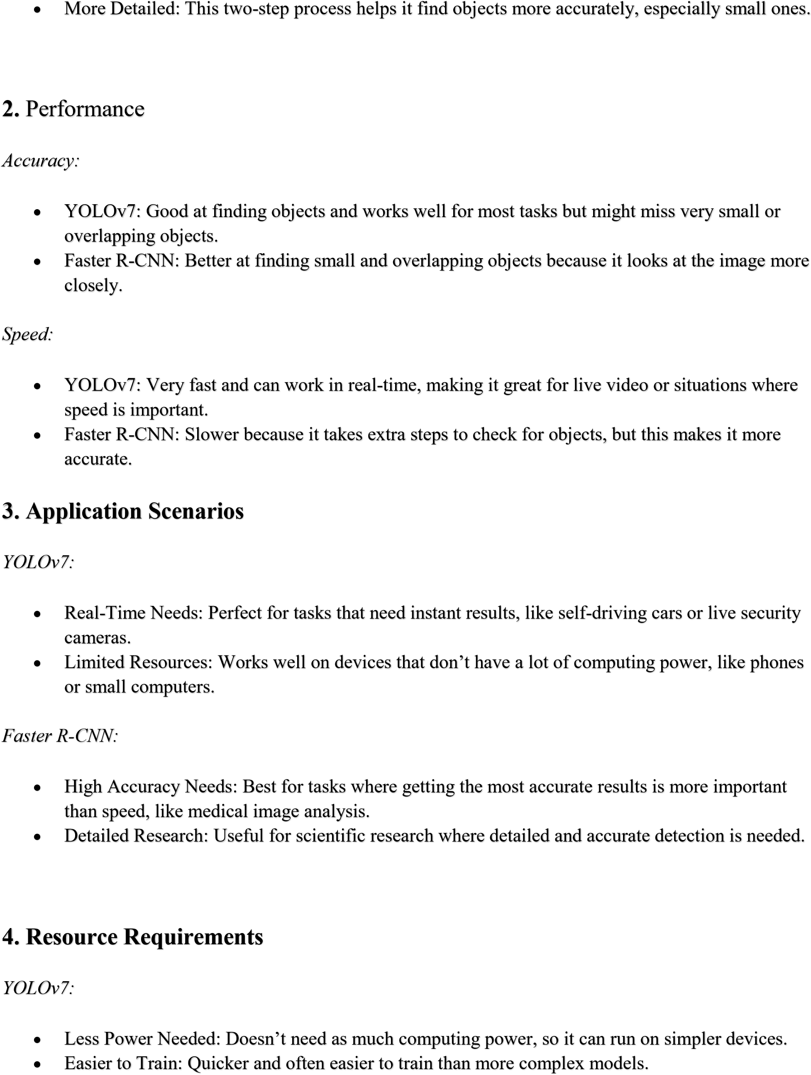

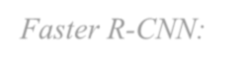

*Faster R*

*-*

*CNN:*



•



More Power Needed

:

Needs a powerful computer to run efficiently.



•



More Train

ing Time

Takes longer to train because of its detailed two

:

-

step process.



**Conclusion**



•



Choose YOLOv7

if you need something that works fast and doesn’t require a powerful computer.



It’s great for live video analysis and other real

-

time applications.



•



Choose Faster R

-

CNN

if you need very accurate results and have the computing power to handle



it. It’s ideal for detailed analysis and research where precision is key.