**VEHICLE TRACKER**

Emaan Gulzar (CSC-21F-034)

Huzaifa Abid (CSC-21F-043)

Areeb (CSC-21F-022)

CSC-407 Digital Image and Processing

Mr. Anwar Ali Sathio

Sindh Madarsatul Islam University

**Table Of Contents**

|  |  |  |
| --- | --- | --- |
| **S. No** | **Topics** | **Pg no** |
| 1 | Problem Statement | 3 |
| 2 | Abstract | 3 |
| 3 | Introduction | 3 |
| 4 | Methodology | 4 |
| 5 | Result | 5 |
| 6 | Discussion | 5 |
| 7 | Conclusion | 5 |
| 8 | References | 6 |

**Project Name: Vehicle Tracker**

**Problem Statement**

Develop a robust, real-time system for detecting and tracking cars in various environments to enhance traffic management and safety.

**Abstract**

Urban areas face increasing challenges in traffic management due to rising vehicular congestion. This project aims to develop an automated car detection and tracking system using Python, YOLOv8, and the Deep SORT algorithm. By leveraging open-source datasets and advanced machine learning techniques, the system provides accurate, real-time detection and tracking of vehicles in diverse conditions. Our results indicate that the system performs well under different lighting and weather scenarios, making it a promising tool for modern traffic management solutions.

**Introduction**

The rise in urban populations has led to a surge in vehicular traffic, making effective traffic management and safety critical issues. Traditional traffic monitoring methods are often inadequate, requiring the development of automated systems capable of real-time analysis and intervention. This project utilizes state-of-the-art object detection and tracking algorithms to create a system that can detect and track cars in real-time, addressing these modern challenges.

**Methodology**

**Data Collection**

We sourced open-source datasets containing images and videos of cars under various conditions, including day and night settings and different weather scenarios. These datasets, with annotated data, were essential for training and validating our model.

**Model Development**

**YOLOv8 for Object Detection**

YOLOv8, known for its balance of speed and accuracy, was chosen for object detection. The model was trained using transfer learning on our datasets, fine-tuning a pre-trained YOLOv8 model to specialize in car detection.

* **Installation**: Essential libraries and dependencies were installed.
* **Training**: The model was trained on labeled datasets, optimizing for car detection.
* **Testing**: The model's performance was evaluated on a separate test dataset.

**Deep SORT for Object Tracking**

Deep SORT was used to enhance tracking accuracy by incorporating appearance information alongside spatial data.

* **Integration**: YOLOv8 detection results were fed into the Deep SORT algorithm.
* **Implementation**: The integrated system was designed to track detected cars across video frames in real-time.

**Results**

Our system demonstrated medium accuracy and efficiency in detecting and tracking cars under various conditions:

* **Lighting Conditions**: Consistent performance in day and night scenarios.
* **Weather Conditions**: Effective in both rainy and sunny weather.
* **Traffic Density**: Successfully tracked multiple cars in high-density traffic.
* **Accuracy**: Accuracy of the project is 70%.

**Discussion**

The integration of YOLOv8 and Deep SORT proved effective, but several challenges were encountered:

* **Lighting Variations**: Required extensive model tuning.
* **Occlusions**: Partially obscured cars posed detection and tracking challenges.
* **Real-time Performance**: Optimization was crucial to maintain real-time processing speeds.

**Conclusion**

This project successfully developed a real-time car detection and tracking system using YOLOv8 and Deep SORT. The system shows promise for improving traffic management and safety by providing accurate detection and tracking in various environments. Future work will focus on enhancing model accuracy, scalability, and integration with existing traffic management systems.

**Future Work**

1. **Enhancing Detection Accuracy**: Further training with more diverse datasets.
2. **Scalability**: Adapting the system for larger areas and more complex environments.
3. **Integration with Traffic Systems**: Collaborating with urban traffic authorities for real-world applications.

**References**

* **YOLOv8**: The latest version of the YOLO (You Only Look Once) object detection algorithm.
* **Deep SORT**: An algorithm for tracking objects that combines SORT with deep learning-based appearance descriptors.
* **Open-source Datasets**: Datasets used for training and validating the model.

**Input:**

We Input the different videos to our model here is the input video.

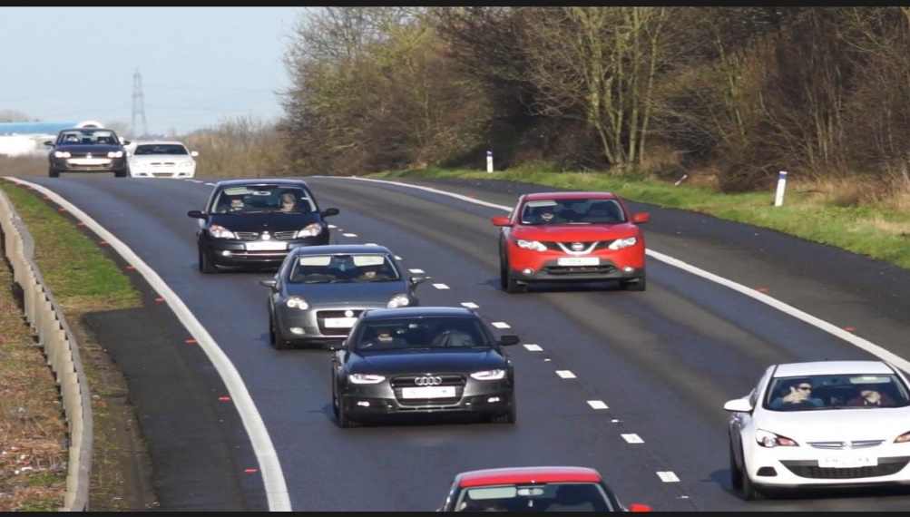

**Output:**

After detection of vehicle here is the output video.

