**Programming Fundamentals**

**Assignment No.3**

**Outputs**

**Name:** Muhammad Arham

**Roll No.** L1F24BSCS0075

**Section:** B2

**Output No.1**

**School Result Processing System:**

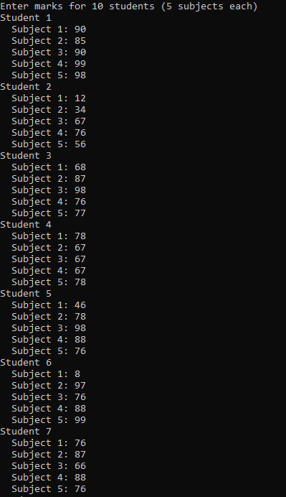 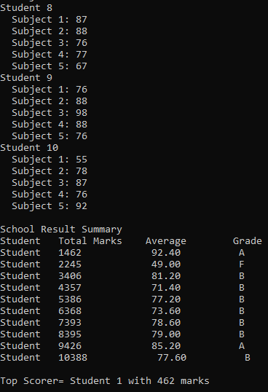

**Output No.2**

**Restaurant Sales Tracker:**

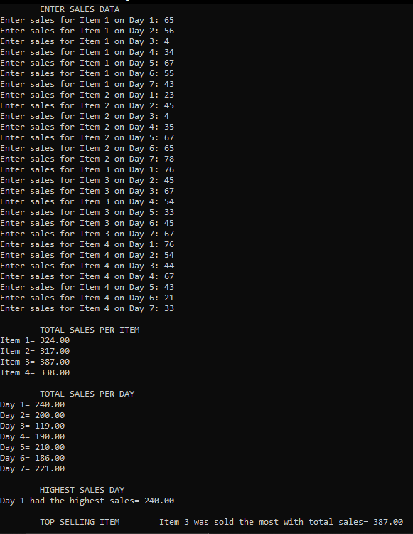

**Output No.3**

**Hospital Patient Record System:**

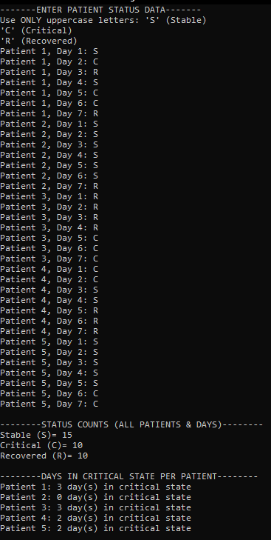

**Output No.4**

**Temperature Monitoring Grid:**

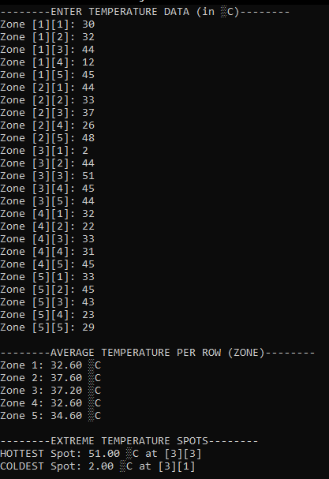

**Output No.5**

**Quiz Competition Scoreboard:**

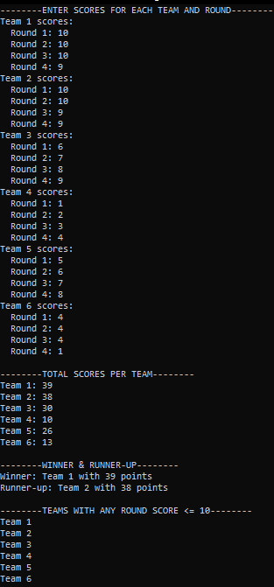

**Output No.6**

**Flight Seat Reservation System:**

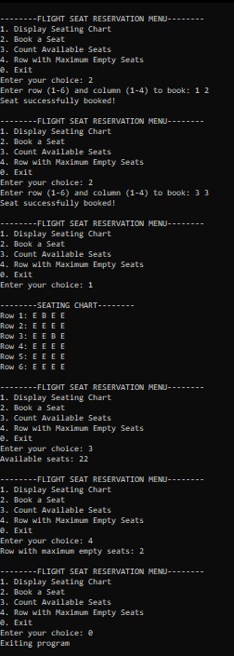

**Output No.7**

**Product Rating Dashboard:**

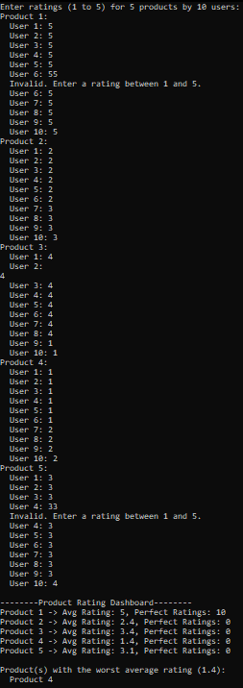

**Output No.8**

**Library Book Availability Tracker:**

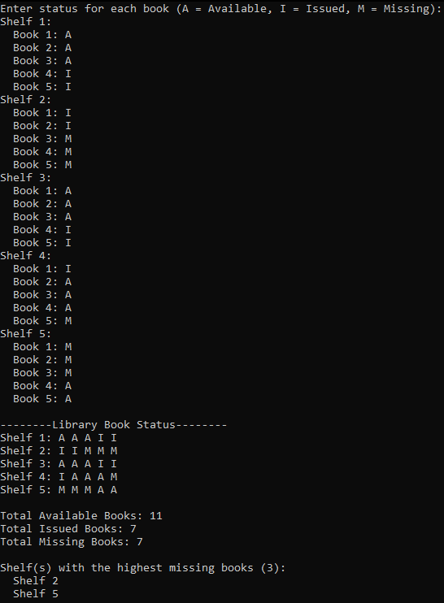

**Output No.9**

**Factory Quality Control Analysis:**

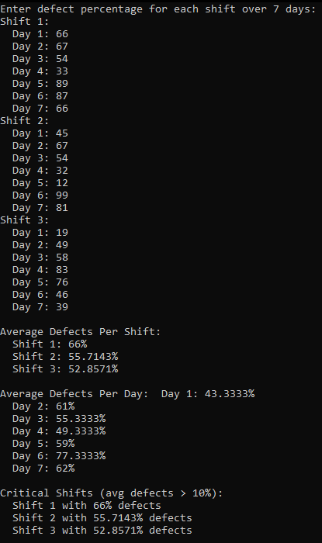

**Output No.10**

**Election Result Matrix:**

