Cloud Computing Project Report
SkillSync Full-Stack Application
Deployment on Microsoft Azure

Submitted by: Muhammad Arsalan
Student ID: 34
Subject: Cloud Computing
Date: May 2026

1. Introduction
This report documents the complete deployment of the SkillSync full-stack web application on Microsoft Azure. The project was done as part of the Cloud Computing course lab, where the goal was to deploy a real production-style application using Azure cloud services.
SkillSync is a task and project management application. It has a React frontend that users interact with, a Node.js and Express backend that handles all the logic and data, and a PostgreSQL database that stores everything. The whole application was containerized using Docker and deployed on Azure using the Azure Portal.
The deployment followed the enterprise architecture taught in the lab, with a proper separation between the frontend, backend, and database layers. All resources were set up inside a single Resource Group so they could be managed together easily.

2. Architecture Overview
The application follows a standard three-tier architecture. Each tier is handled by a separate Azure service:

Layer | Technology | Azure Service Used
Frontend | React.js | Azure App Service (Container)
Backend API | Node.js + Express (Docker) | Azure App Service (Container)
Database | PostgreSQL | Azure Database for PostgreSQL Flexible Server
Container Registry | Docker Images | Azure Container Registry (Basic SKU)
Monitoring | Grafana | Integrated Monitoring Dashboard

All resources were deployed in the Central India region because the Azure for Students subscription used in this project only allowed deployment in specific regions. The allowed regions were: malaysiawest, eastasia, uaenorth, centralindia, and austriaeast. Central India was selected as it performed well during testing.
The Resource Group acted as a container for all the above resources. This makes it easy to manage everything together, track costs, and delete all resources in one go when no longer needed.

3. Step-by-Step Deployment on Azure Portal
The following sections describe each step of the deployment in the order it was carried out. Every step was done using the Azure Portal (GUI) at portal.azure.com. Screenshots are included for each step as proof of completion.

Step 3.1 - Creating the Resource Group
The first thing to do before creating any Azure resource is to create a Resource Group. A Resource Group is like a folder in Azure where all related resources are kept together. Without it, resources would be scattered and hard to manage.
To create a Resource Group using the Azure Portal:
- Go to portal.azure.com and sign in with the student account.
- In the search bar at the top, type "Resource Groups" and click on it.
- Click the "Create" button.
- Select the Subscription as "Azure for Students".
- Enter the name: skillsync-rg
- Choose the Region as "East US" (or the allowed region as per the subscription).
- Click "Review + Create" and then "Create".

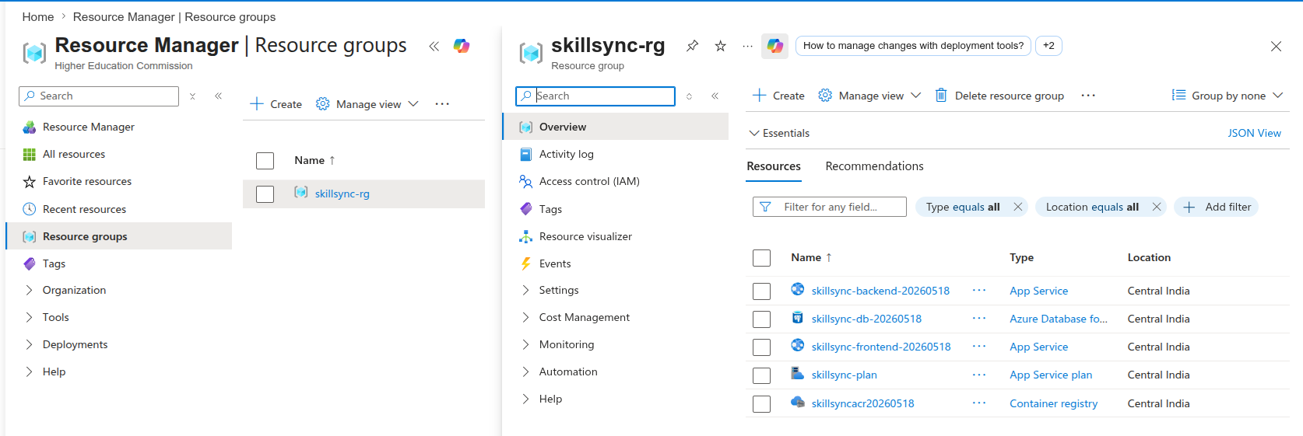
Figure 1: Resource Group "skillsync-rg" successfully created in Azure Portal

Step 3.2 - Creating the PostgreSQL Database
The next step was to create the database. SkillSync uses PostgreSQL to store all user data, projects, and tasks. Azure provides a managed PostgreSQL service called "Azure Database for PostgreSQL Flexible Server" which handles backups, updates, and availability automatically.
To create the database using the Azure Portal:
- In the search bar, type "Azure Database for PostgreSQL" and click on it.
- Click "Create" and choose "Flexible Server".
- Select the Resource Group: skillsync-rg.
- Enter the server name: skillsync-db-20260518
- Choose the Region: Central India (to match the allowed region).
- Under "Compute + Storage", choose the Burstable tier with Standard_B1ms to keep costs low.
- Set the Admin username: skillsync_user and create a strong password.
- Under the Networking tab, set "Allow public access from Azure services" to Yes so the backend can connect to it.
- Click "Review + Create" and then "Create". Wait a few minutes for the server to be deployed.

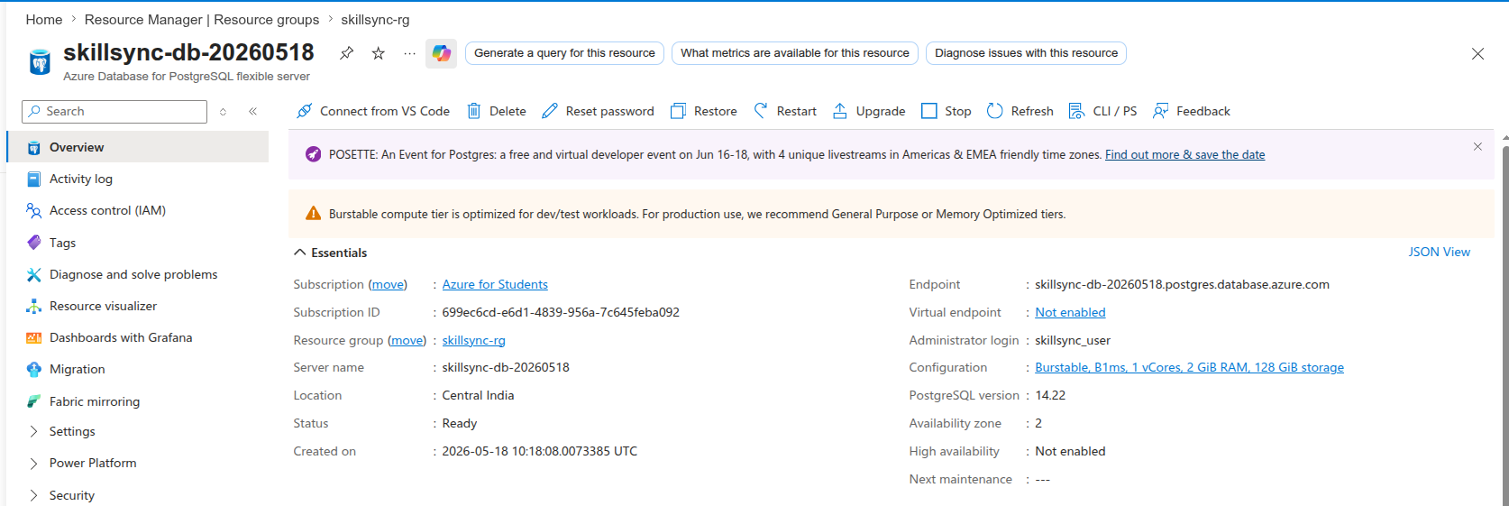
Figure 2: PostgreSQL Flexible Server "skillsync-db-20260518" successfully created
After the database server was created, the database schema was initialized by running a migration script that created the users, projects, and tasks tables. The database was seeded with initial data so the application could be tested properly.

Step 3.3 - Deploying Azure Container Registry (ACR)
Azure Container Registry (ACR) is a private registry where Docker images are stored. When the application is deployed to Azure App Service, Azure pulls the Docker images from ACR. This is safer than using a public registry because images are kept private.
To create the Container Registry using the Azure Portal:
- In the search bar, type "Container Registries" and click on it.
- Click "Create".
- Select the Resource Group: skillsync-rg.
- Enter a unique Registry name: skillsyncacr20260518 (must be lowercase, no hyphens, globally unique).
- Choose SKU: Basic (cheapest option, good enough for this project).
- Choose the same Region: Central India.
- Click "Review + Create" and then "Create".
- Once created, go to the registry, then to "Access Keys", and enable the Admin user. Note down the login server, username, and password as these are needed to push Docker images.

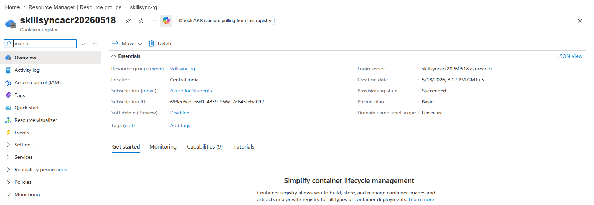
Figure 3: Azure Container Registry "skillsyncacr20260518" successfully deployed
The Docker images for both the frontend and the backend were built locally and then pushed to this registry. The backend image was tagged as "backend:latest" and the frontend image as "frontend:latest". These images were then used by the App Service to run the application.

Step 3.4 - Deploying the Backend (App Service)
The backend is a Node.js and Express API that was packaged inside a Docker container. Azure App Service can run Docker containers directly, which makes it easy to deploy. The backend handles all the business logic and communicates with the PostgreSQL database.
Before creating the App Service, an App Service Plan was needed. The App Service Plan defines the server resources (CPU, RAM) that the app will use.
Creating the App Service Plan
- In the search bar, type "App Service Plans" and click on it.
- Click "Create".
- Select the Resource Group: skillsync-rg.
- Enter a name: skillsync-plan.
- Choose Operating System: Linux (required for Docker containers).
- Choose Region: Central India.
- Choose Pricing Tier: Basic B1 (cheapest plan that supports custom containers).
- Click "Review + Create" and then "Create".
Creating the Backend Web App
- In the search bar, type "App Services" and click on it.
- Click "Create" and choose "Web App".
- Select the Resource Group: skillsync-rg.
- Enter the name: skillsync-backend-20260518.
- For "Publish", choose "Docker Container".
- For "Operating System", choose "Linux".
- Select the App Service Plan created above.
- In the Docker tab, for Image Source select "Azure Container Registry", then choose the registry and the backend image.
- Go to Configuration > Application Settings and add the following environment variables: DB_HOST, DB_PORT, DB_USER, DB_PASSWORD, DB_NAME, JWT_SECRET, PORT, and WEBSITES_PORT. These are the settings the backend needs to connect to the database and run correctly.
- Click "Review + Create" and then "Create".

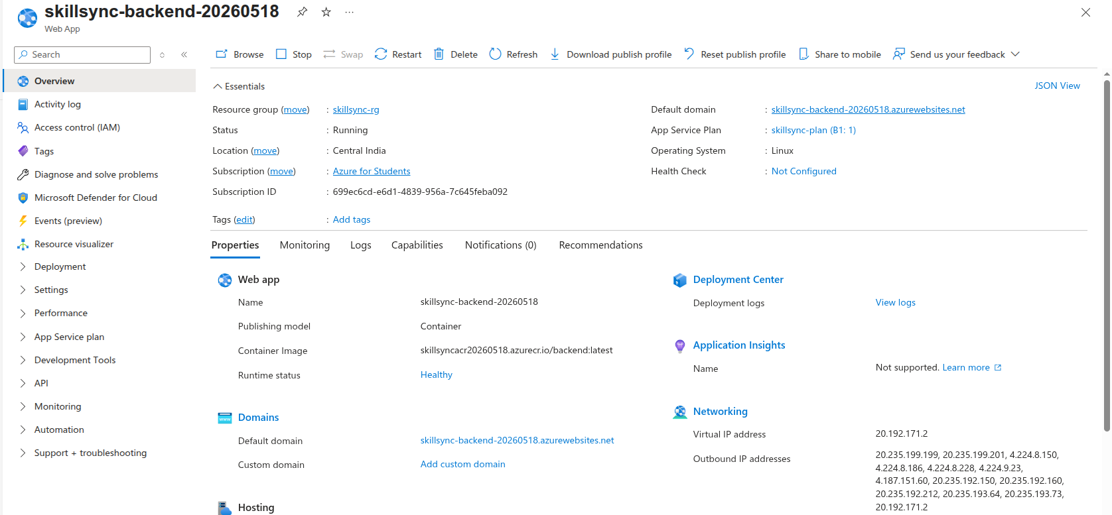
Figure 4: Backend application successfully deployed on Azure App Service
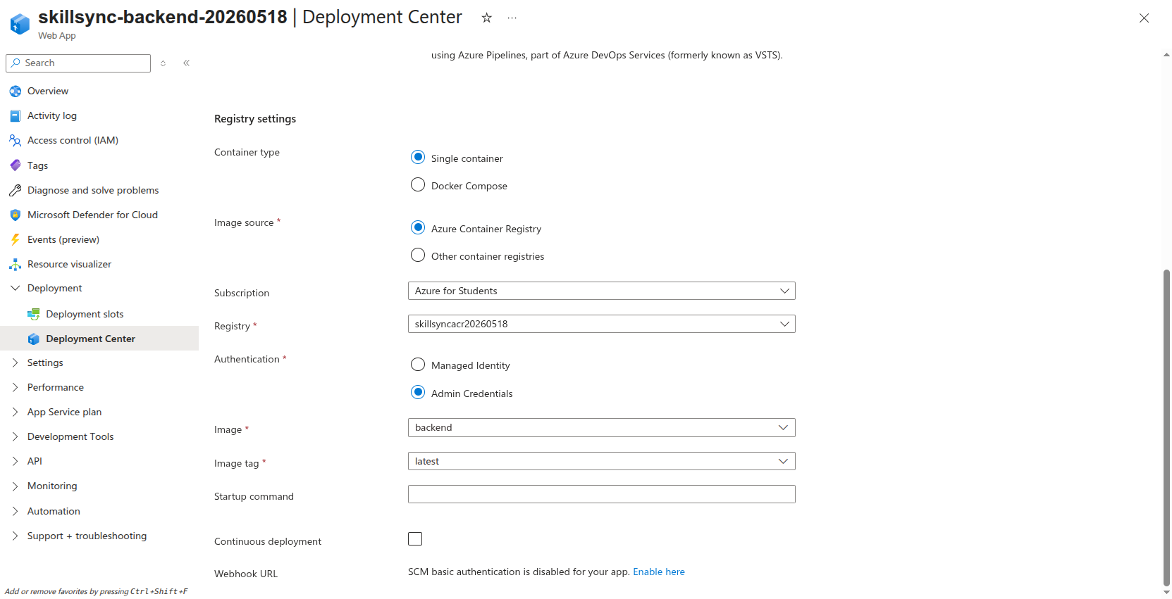
Figure 5: Backend deployed using the Docker image from Azure Container Registry (ACR)
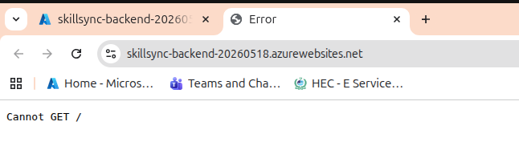
Figure 6: Backend deployment confirmed as running successfully
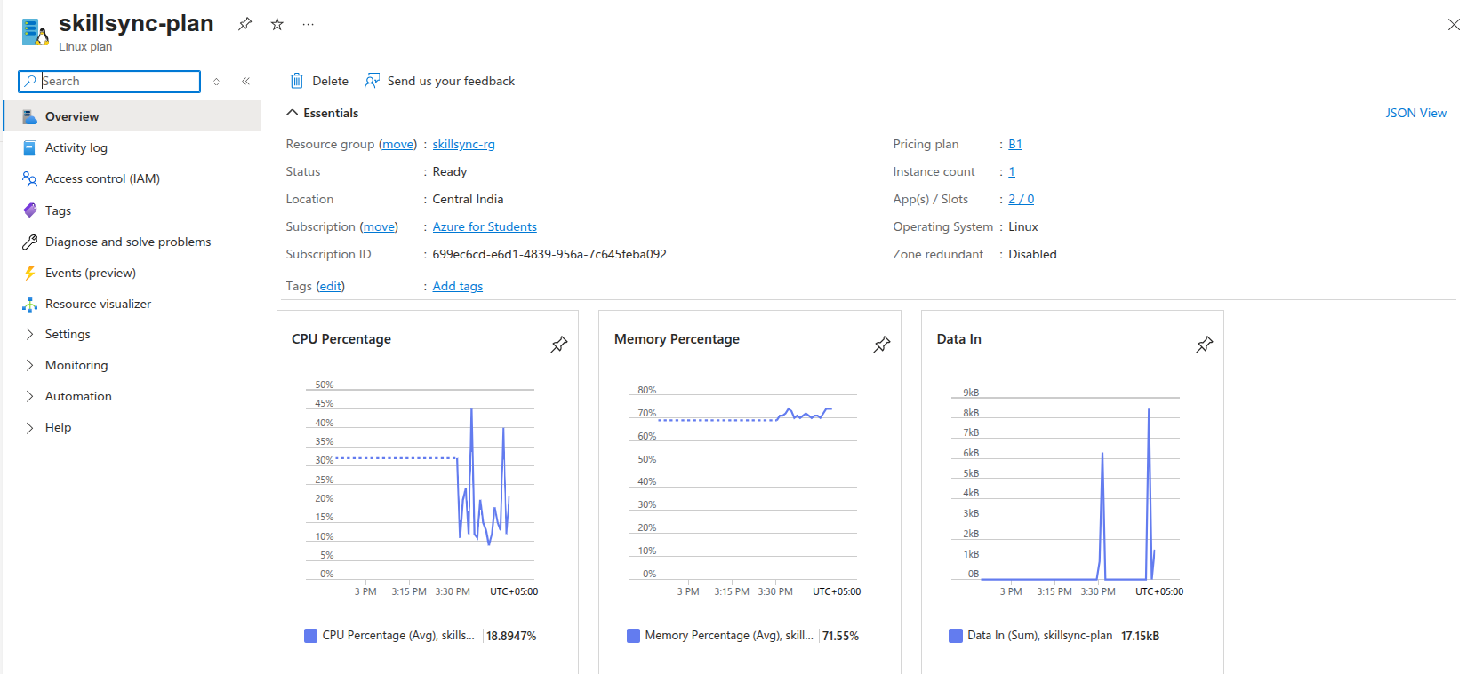
Figure 7: App Service Plan "skillsync-plan" created on Linux with Basic B1 tier
The environment variables were set carefully so that no passwords were hardcoded in the application code. This follows the security best practice taught in the lab. All sensitive values like database passwords were stored in App Service Application Settings, which are encrypted at rest by Azure.

Step 3.5 - Deploying the Frontend (App Service)
The frontend is a React application that was also containerized using Docker. It was deployed as another Web App on the same App Service Plan. The frontend communicates with the backend through the backend App Service URL.
To deploy the frontend Web App:
- Go to App Services and click "Create" > "Web App".
- Select the Resource Group: skillsync-rg.
- Enter the name: skillsync-frontend-20260518.
- For "Publish", choose "Docker Container". For "Operating System", choose "Linux".
- Select the existing App Service Plan: skillsync-plan.
- In the Docker tab, select the frontend image from the ACR.
- In Application Settings, set WEBSITES_PORT to 80 so Azure knows which port the container uses.
- Click "Review + Create" and then "Create".

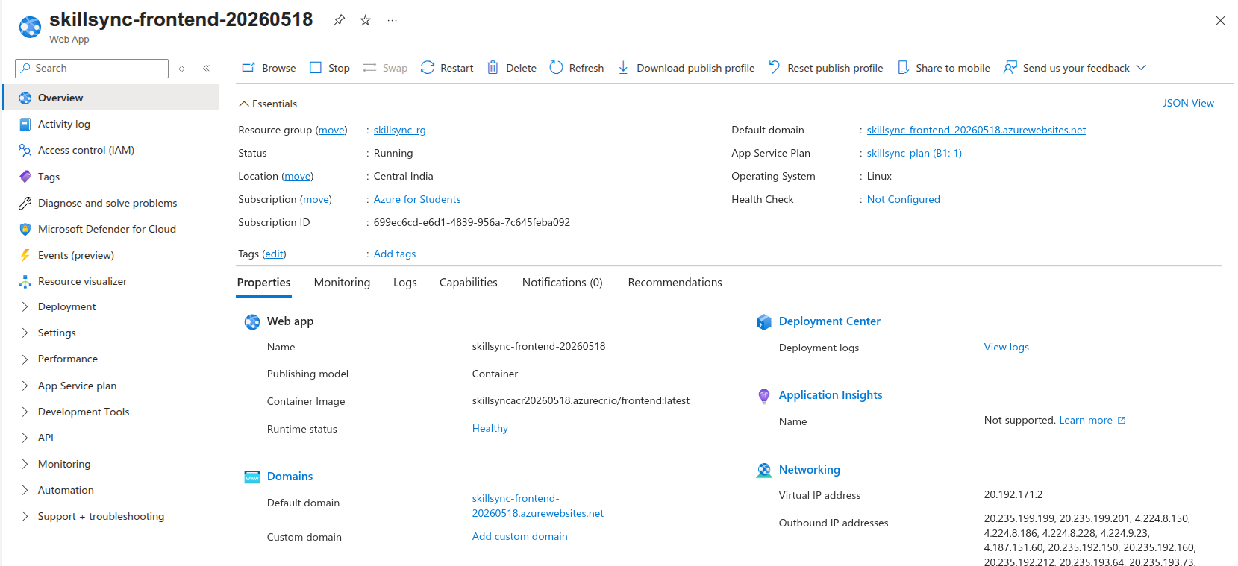
Figure 8: Frontend application successfully deployed on Azure App Service
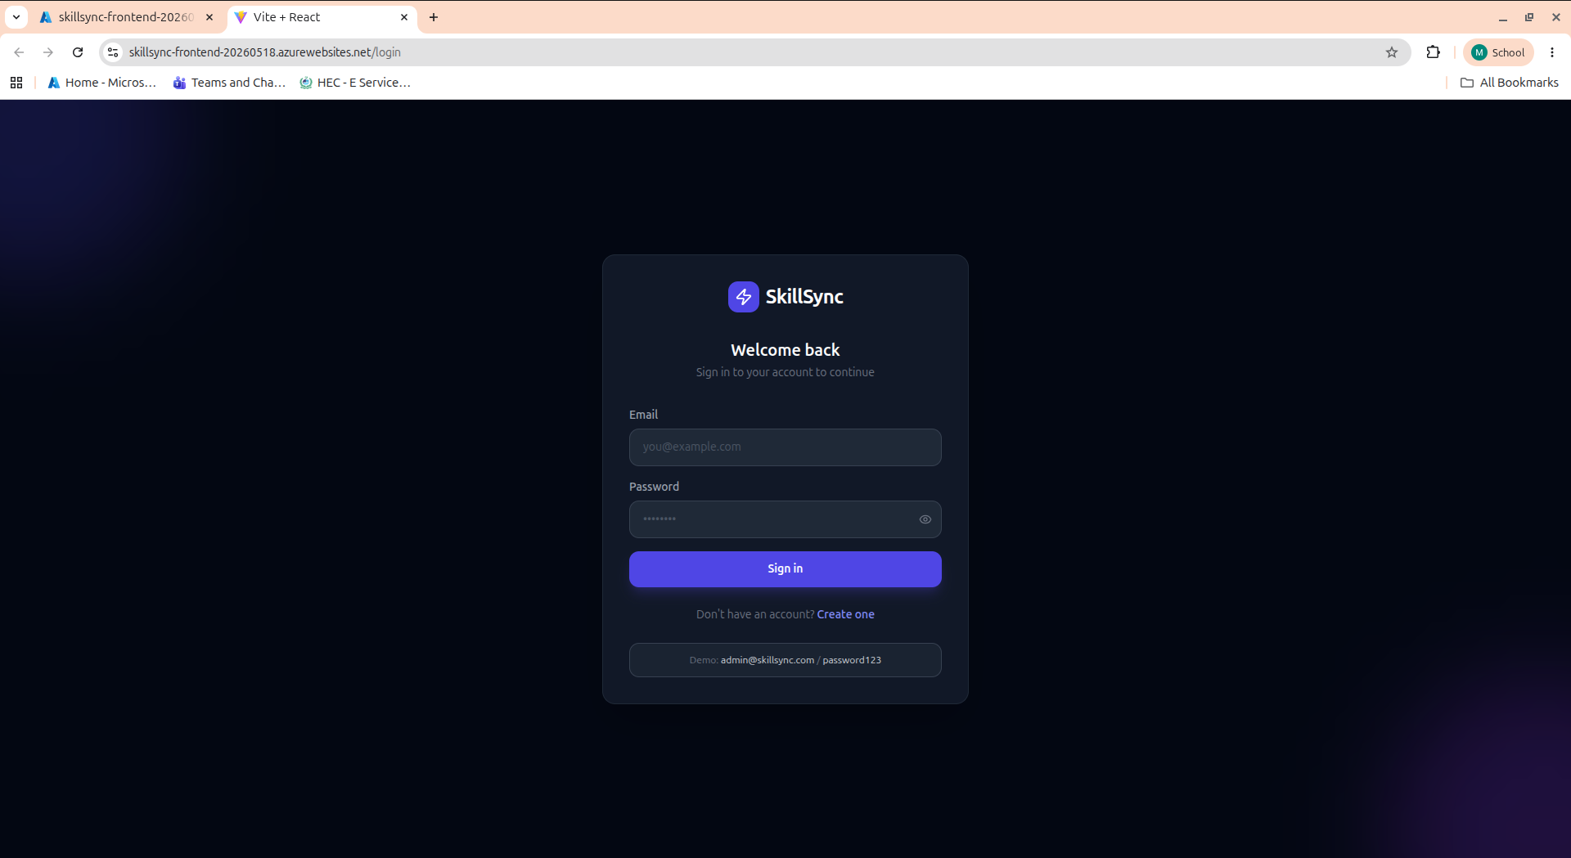
Figure 9: Frontend deployment verified and confirmed live on Azure

4. Live Application Verification
After all the Azure resources were deployed, the application was tested end-to-end to make sure everything was working together. The frontend, backend, and database all communicated correctly with each other.

4.1 Live SkillSync Dashboard
The SkillSync application was opened in a web browser using the Azure App Service URL. The dashboard loaded successfully, which confirmed that the frontend container was running properly and the React application was being served to users.
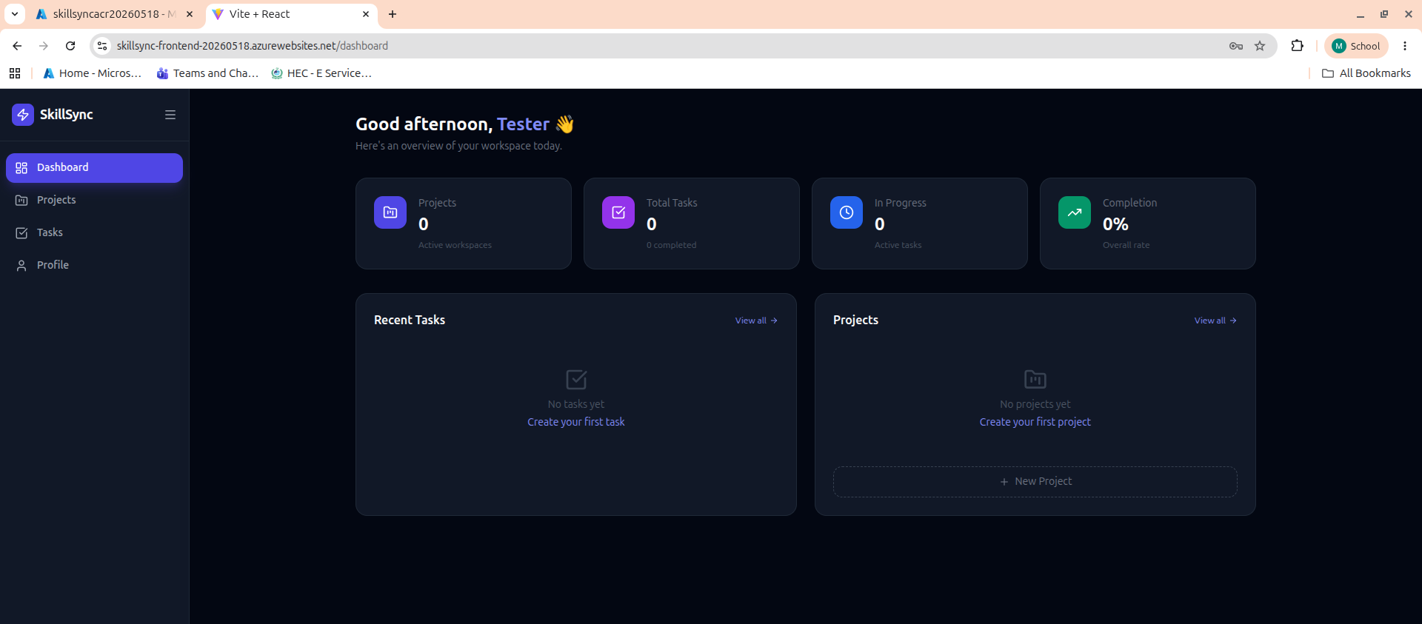
Figure 10: Live and fully-integrated SkillSync Dashboard running on Azure App Service

4.2 User Registration and Login
A new user account was created directly on the live application. The registration and login both worked, which confirmed that the frontend was correctly communicating with the backend API, and the backend was successfully writing to and reading from the PostgreSQL database.
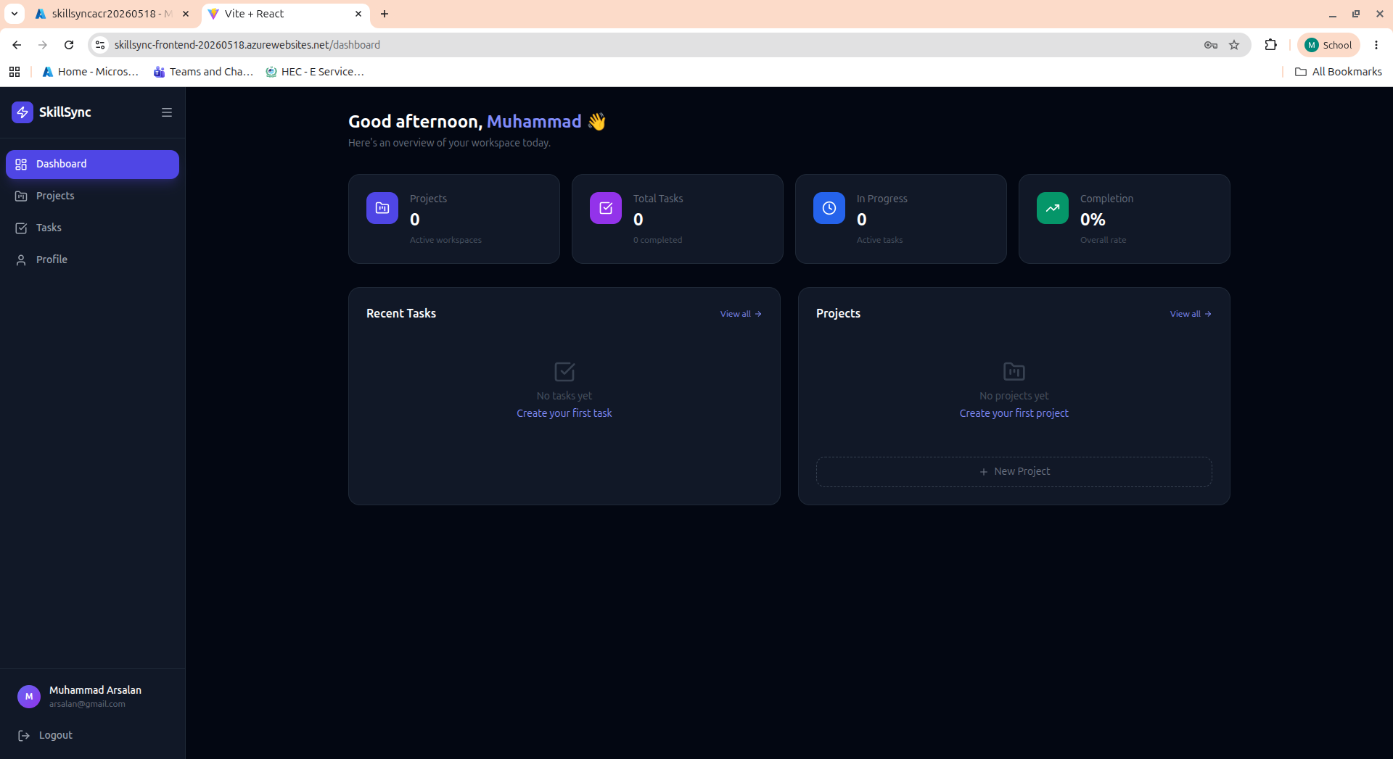
Figure 11: New user created and signed in successfully on the live application

4.3 Grafana Monitoring
Grafana was set up to monitor the health and performance of the application. It provides visual dashboards that show metrics like CPU usage, memory, request counts, and response times. This is important in a real production system because it helps identify problems before they affect users.
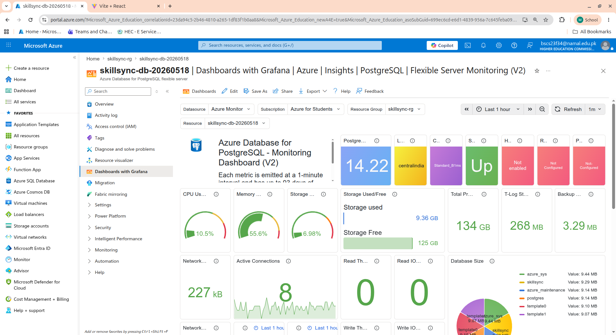
Figure 12: Grafana monitoring dashboard showing live application metrics

5. End-to-End Functional Testing
The application was tested by performing real actions to confirm the full data flow between the frontend, backend, and database was working correctly.

5.1 Adding a New Project
A new project was created inside the application. The project appeared immediately in the list after being added. This confirmed that the backend API was correctly handling the POST request from the frontend and saving the data to the PostgreSQL database.
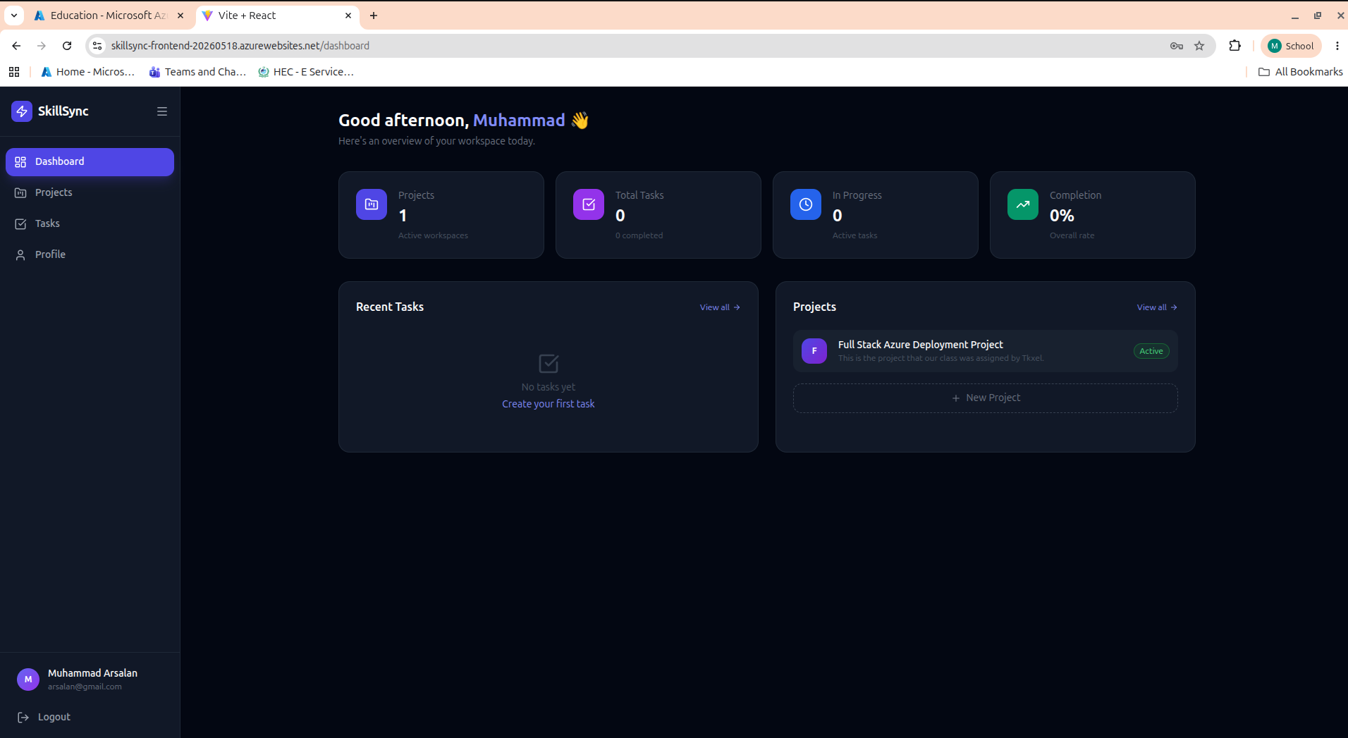
Figure 13: New project added successfully - data saved and displayed from the database

5.2 Adding a New Task
A new task was added to the project. The task appeared right away in the task list. This further confirmed that the entire application stack was working as expected, with data flowing from the user interface all the way to the database and back.
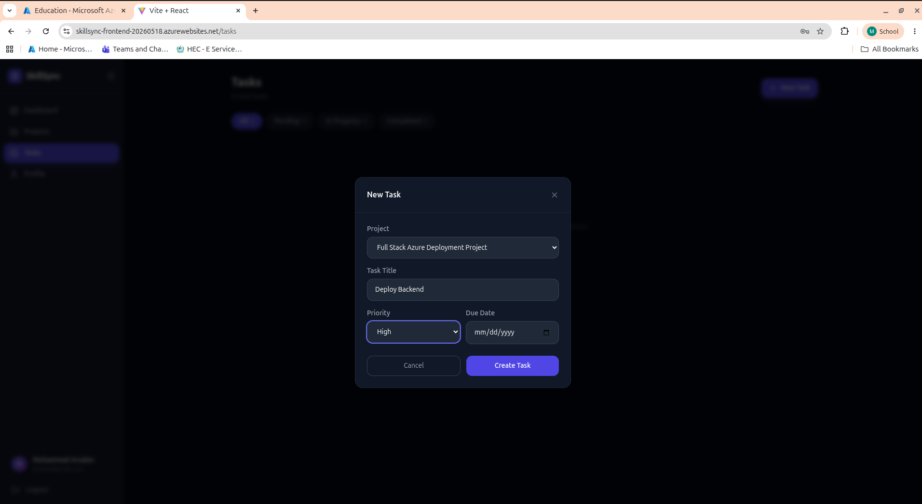
Figure 14: New task added successfully within a project

5.3 Completing a Task
The task was marked as complete. The application updated the task status immediately. This shows that update operations also work correctly across the whole stack.
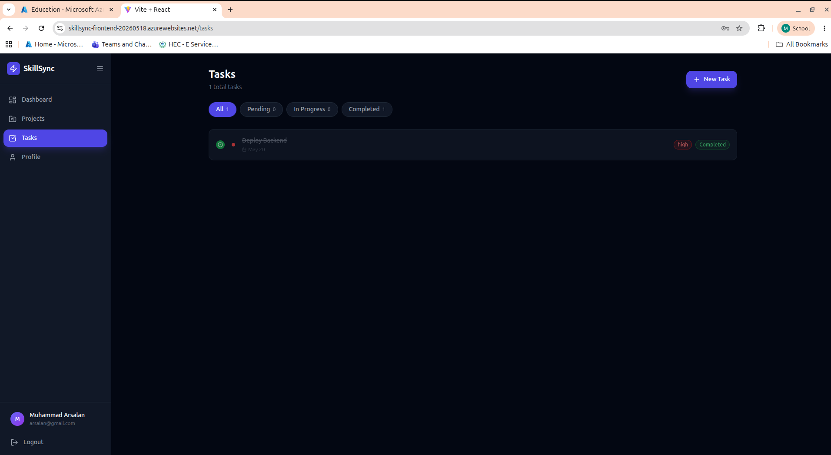
Figure 15: Task marked as completed - status updated successfully in the database

5.4 Full Project and Task Details in Sync
The final screen showed complete project and task details all in sync. All the data that was entered across different actions was displaying correctly and consistently, proving the application is fully functional in its deployed state on Azure.
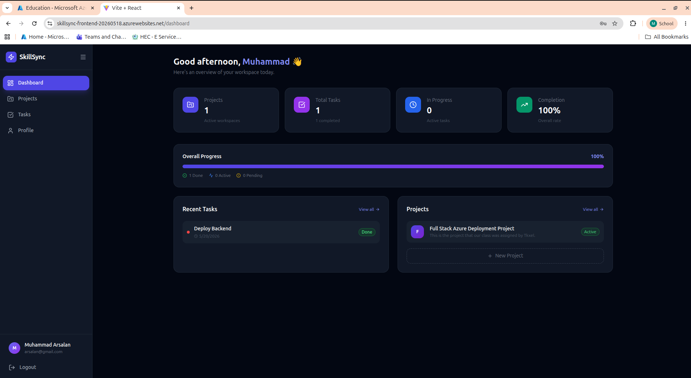
Figure 16: Complete project and task details displayed correctly - all data in sync

6. Summary of Azure Resources Deployed
The following table summarizes all the Azure resources that were successfully deployed as part of this project:

Resource Type | Resource Name | Region | Purpose
Resource Group | skillsync-rg | East US | Container for all project resources
PostgreSQL Flexible Server | skillsync-db-20260518 | Central India | Application database
Azure Container Registry | skillsyncacr20260518 | Central India | Private Docker image storage
App Service Plan | skillsync-plan | Central India | Hosting plan (Linux, Basic B1)
App Service (Backend) | skillsync-backend-20260518 | Central India | Node.js API running in Docker
App Service (Frontend) | skillsync-frontend-20260518 | Central India | React app running in Docker

7. Challenges Faced and How They Were Resolved

7.1 Region Restriction on Azure for Students
The Azure for Students subscription did not allow deployment in all regions. When the first attempt was made to deploy in East US, it failed with a policy violation error. The subscription only allowed deployment in five specific regions: malaysiawest, eastasia, uaenorth, centralindia, and austriaeast. After identifying this, Central India was selected and all resources were moved to that region successfully.

7.2 Database Not Having Tables by Default
After the PostgreSQL server was created on Azure, it came completely empty with no tables at all. A migration script had to be written and run manually to create the users, projects, and tasks tables. A firewall rule was also configured temporarily to allow remote access to the database during this setup step. After initialization, the firewall was updated to only allow access from Azure services.

7.3 Frontend Could Not Connect to Backend
The React frontend was originally built with a hardcoded API URL pointing to localhost, which only works on a local machine. When deployed to Azure, the frontend could not reach the backend because localhost does not exist in the cloud. To fix this, the frontend code was updated to read the API base URL from an environment variable instead of having it hardcoded. The Docker container was then rebuilt and redeployed with the correct Azure backend URL set as the environment variable.

8. Conclusion
This project gave me practical experience in deploying a real full-stack application on Microsoft Azure. I learned how to create and manage Azure resources using the Azure Portal, how Docker containers work and why they are useful for deployment, and how different cloud services like App Service, Container Registry, and PostgreSQL work together.
The deployment was successful and the application is running live on Azure. All the core functionality including user registration, project creation, task management, and real-time data sync across the stack was tested and confirmed working.
Going through this project taught me that cloud deployment is not just about writing code. It also involves understanding how cloud infrastructure works, how to handle region policies and restrictions, how to manage database initialization, and how to configure environment variables properly to keep sensitive information secure.
The monitoring setup with Grafana also showed how important it is to have visibility into a running system so that problems can be detected early. Overall this was a very useful hands-on experience that helped me understand enterprise-level cloud deployment in a practical way.

