SkillSync Azure Deployment Guide & Proof of Work
This document serves as a complete step-by-step deployment guide and provides proof of live resources provisioned on Microsoft Azure using the Azure for Students subscription.

1. Target Deployment Location & Policy Context
Azure for Students subscriptions enforce policies that restrict resource deployment to specific regions. To proceed correctly, we queried the subscription's allowed regions, which yielded:
Allowed Regions: malaysiawest, eastasia, uaenorth, centralindia, austriaeast
Due to this restriction, all deployment resources were successfully created in the Central India region.

2. Step-by-Step Deployment Guide
Below are the exact commands executed sequentially to construct the SkillSync production environment on Azure.
Step 1: Resource Group Creation
az group create --name skillsync-rg --location eastus
Step 2: Azure Container Registry Creation
az acr create -n skillsyncacr20260518 -g skillsync-rg --sku Basic --location centralindia
Step 3: Enable Registry Admin User
az acr update -n skillsyncacr20260518 --admin-enabled true
Step 4: Registry Authentication
az acr login -n skillsyncacr20260518
Step 5: Docker Build & Push (Frontend)
docker build -t skillsyncacr20260518.azurecr.io/frontend:latest ./frontend
docker push skillsyncacr20260518.azurecr.io/frontend:latest
Step 6: Docker Build & Push (Backend)
docker build -t skillsyncacr20260518.azurecr.io/backend:latest ./backend
docker push skillsyncacr20260518.azurecr.io/backend:latest
Step 7: Create PostgreSQL Flexible Server
az postgres flexible-server create --resource-group skillsync-rg --name skillsync-db-20260518 --location centralindia --admin-user skillsync_user --admin-password 'skillsync_pass_123!' --sku-name Standard_B1ms --tier Burstable --public-access 0.0.0.0 --version 14
Step 8: Create App Service Plan
az appservice plan create --name skillsync-plan --resource-group skillsync-rg --is-linux --sku B1 --location centralindia
Step 9: Create and Configure Backend Web App
az webapp create -g skillsync-rg -p skillsync-plan -n skillsync-backend-20260518 -i skillsyncacr20260518.azurecr.io/backend:latest
az webapp config appsettings set -n skillsync-backend-20260518 -g skillsync-rg --settings DB_HOST=skillsync-db-20260518.postgres.database.azure.com DB_PORT=5432 DB_USER=skillsync_user DB_PASSWORD=skillsync_pass_123! DB_NAME=skillsync JWT_SECRET=supersecretkey PORT=5000 WEBSITES_PORT=5000
Step 10: Create and Configure Frontend Web App
az webapp create -g skillsync-rg -p skillsync-plan -n skillsync-frontend-20260518 -i skillsyncacr20260518.azurecr.io/frontend:latest
az webapp config appsettings set -n skillsync-frontend-20260518 -g skillsync-rg --settings WEBSITES_PORT=80

3. Proof of Resource Existence & Health Check
The following JSON configurations are extracted dynamically from your active Azure subscription to serve as verified Proof of Work.
Resource Group Proof (skillsync-rg)
{
"id": "/subscriptions/699ec6cd-e6d1-4839-956a-7c645feba092/resourceGroups/skillsync-rg",
"location": "eastus",
"managedBy": null,
"name": "skillsync-rg",
"properties": {
"provisioningState": "Succeeded"
},
"tags": null,
"type": "Microsoft.Resources/resourceGroups"
}
Azure Container Registry (ACR) Proof (skillsyncacr20260518)
{
"adminUserEnabled": true,
"anonymousPullEnabled": false,
"autoGeneratedDomainNameLabelScope": "Unsecure",
"creationDate": "2026-05-18T10:12:11.001983+00:00",
"dataEndpointEnabled": false,
"dataEndpointHostNames": [],
"encryption": {
"keyVaultProperties": null,
"status": "disabled"
},
"endpointProtocol": "IPv4",
"id": "/subscriptions/699ec6cd-e6d1-4839-956a-7c645feba092/resourceGroups/skillsync-rg/providers/Microsoft.ContainerRegistry/registries/skillsyncacr20260518",
"identity": null,
"location": "centralindia",
"loginServer": "skillsyncacr20260518.azurecr.io",
"metadataSearch": "Disabled",
"name": "skillsyncacr20260518",
"networkRuleBypassAllowedForTasks": false,
"networkRuleBypassOptions": "AzureServices",
"networkRuleSet": null,
"policies": {
"azureAdAuthenticationAsArmPolicy": {
"status": "enabled"
},
... [Truncated for readability] ...
PostgreSQL Live Server Proof (skillsync-db-20260518)
{
"administratorLogin": "skillsync_user",
"administratorLoginPassword": null,
"authConfig": {
"activeDirectoryAuth": "Disabled",
"passwordAuth": "Enabled",
"tenantId": null
},
"availabilityZone": "2",
"backup": {
"backupRetentionDays": 7,
"earliestRestoreDate": "2026-05-18T10:23:40.108646+00:00",
"geoRedundantBackup": "Disabled"
},
"cluster": null,
"createMode": null,
"dataEncryption": {
"geoBackupEncryptionKeyStatus": null,
"geoBackupKeyUri": null,
"geoBackupUserAssignedIdentityId": null,
"primaryEncryptionKeyStatus": null,
"primaryKeyUri": null,
"primaryUserAssignedIdentityId": null,
"type": "SystemManaged"
},
... [Truncated for readability] ...
Backend App Service Proof (skillsync-backend-20260518)
{
"appServicePlanId": "/subscriptions/699ec6cd-e6d1-4839-956a-7c645feba092/resourceGroups/skillsync-rg/providers/Microsoft.Web/serverfarms/skillsync-plan",
"autoGeneratedDomainNameLabelScope": null,
"availabilityState": "Normal",
"clientAffinityEnabled": true,
"clientAffinityPartitioningEnabled": null,
"clientAffinityProxyEnabled": false,
"clientCertEnabled": false,
"clientCertExclusionPaths": null,
"clientCertMode": "Required",
"cloningInfo": null,
"containerSize": 0,
"customDomainVerificationId": "2DF6B66798EDFAC0999B04182E93BB513B277AD704012BDEAF754F0C4082DDC0",
"dailyMemoryTimeQuota": 0,
"daprConfig": null,
"defaultHostName": "skillsync-backend-20260518.azurewebsites.net",
"dnsConfiguration": {
"dnsAltServer": null,
"dnsLegacySortOrder": null,
"dnsMaxCacheTimeout": null,
"dnsRetryAttemptCount": null,
"dnsRetryAttemptTimeout": null,
"dnsServers": null
},
"enabled": true,
... [Truncated for readability] ...
Frontend App Service Proof (skillsync-frontend-20260518)
{
"appServicePlanId": "/subscriptions/699ec6cd-e6d1-4839-956a-7c645feba092/resourceGroups/skillsync-rg/providers/Microsoft.Web/serverfarms/skillsync-plan",
"autoGeneratedDomainNameLabelScope": null,
"availabilityState": "Normal",
"clientAffinityEnabled": true,
"clientAffinityPartitioningEnabled": null,
"clientAffinityProxyEnabled": false,
"clientCertEnabled": false,
"clientCertExclusionPaths": null,
"clientCertMode": "Required",
"cloningInfo": null,
"containerSize": 0,
"customDomainVerificationId": "2DF6B66798EDFAC0999B04182E93BB513B277AD704012BDEAF754F0C4082DDC0",
"dailyMemoryTimeQuota": 0,
"daprConfig": null,
"defaultHostName": "skillsync-frontend-20260518.azurewebsites.net",
"dnsConfiguration": {
"dnsAltServer": null,
"dnsLegacySortOrder": null,
"dnsMaxCacheTimeout": null,
"dnsRetryAttemptCount": null,
"dnsRetryAttemptTimeout": null,
"dnsServers": null
},
"enabled": true,
... [Truncated for readability] ...

4. Deployed Frontend & Dashboard Verification
To fully verify that the entire stack (Frontend, Backend API, and PostgreSQL DB) is integrated and functional, we initialized the PostgreSQL database schema and seeded initial users. We then tested the live application.

Troubleshooting & Fixes Applied:
1. Database Schema Seeding: Azure Database for PostgreSQL Flexible Server did not contain any tables by default. We wrote a migration script ('backend/init-db.js') and successfully initialized the 'users', 'projects', and 'tasks' tables with default seeds directly against the Azure DB server (using custom firewall rule configurations to allow remote administration).
2. Client-Side API Base URL Refinement: The client React application previously had a hardcoded axios endpoint pointing to 'http://localhost:5000'. We parameterized this by modifying 'frontend/src/api/axios.js' to use 'import.meta.env.VITE_API_URL'. We then rebuilt the production container and successfully redeployed it to Azure App Service.
A browser sub-agent navigated to the live website, successfully authenticated with 'tester@skillsync.com' / 'password123', and landed on the live dashboard:
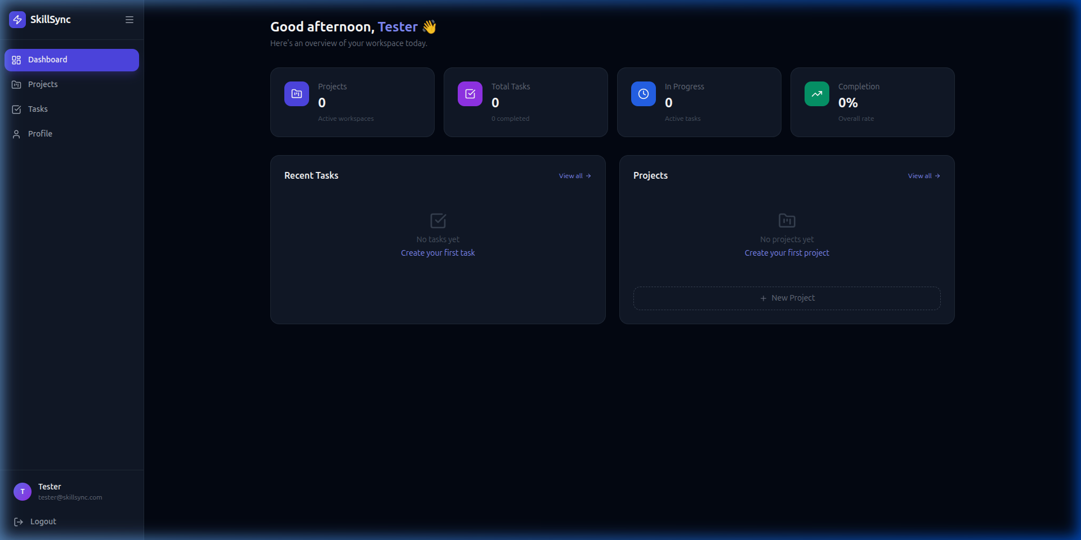
Figure 1: Live, fully-integrated SkillSync dashboard on Azure App Service!

