project

Email Client Project

Team Members

Muhammad Ashraf Fathy Ahmed 2305181
Yasser Ali Muhammad Muhammad 2305268
Muhammad Elsyed Muhammad Ahmed 2305273
Muhammad Hazem Hafez Mustafa 2305534

Email Client
Project Overview:
This project implements a simple Email Client Application using Python that allows users to send and receive emails securely. The application uses SMTP for sending emails and IMAP for retrieving emails over encrypted SSL/TLS connections to ensure secure communication.
SMTP communication is performed on ports 465 or 587 using SSL or STARTTLS, while IMAP communication is handled on port 993 using SSL. The project also includes a TCP-based notification mechanism that sends a status message after each email operation.
Performance metrics such as latency, packet count, transmitted bytes, and throughput are measured for SMTP, IMAP, and notification TCP connections. Wireshark is used to capture and analyze the network traffic generated by the application.
As a bonus feature, a graphical user interface (GUI) is implemented using Tkinter, along with push notifications using the Plyer library to notify users when new emails arrive.

Part 1 — Email Client (SMTP + IMAP):
This part of the program provides a simple text-based menu that allows the user to choose between sending an email, reading the latest email, or exiting the application.
The program keeps running and displaying the menu until the user selects the exit option.
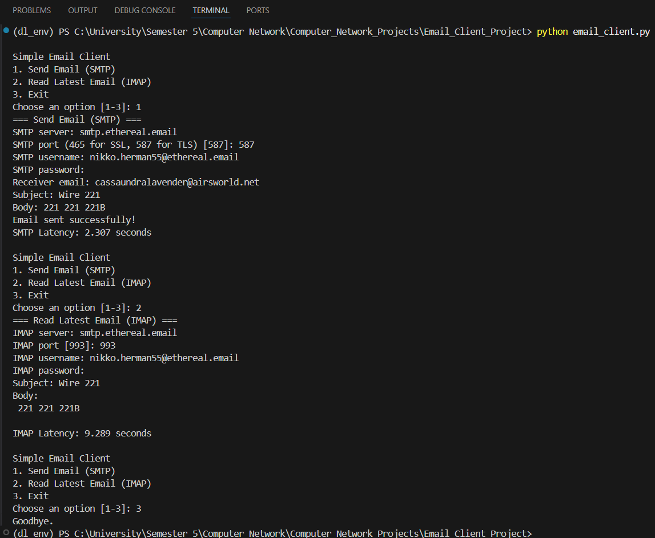
Note: The GUI was added in the final stage
Part 2 — TCP Notification Server:
The notification server listens for TCP messages from the email client and displays them as user notifications.
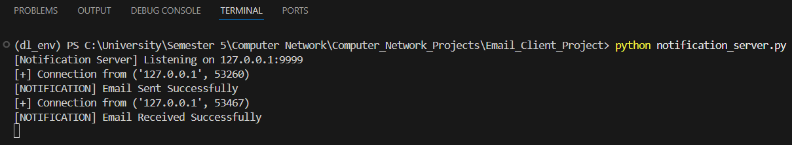
Part 3 — Wireshark Packet Capture & Analysis:
SMTP traffic: tcp.port == 465 or tcp.port == 587.
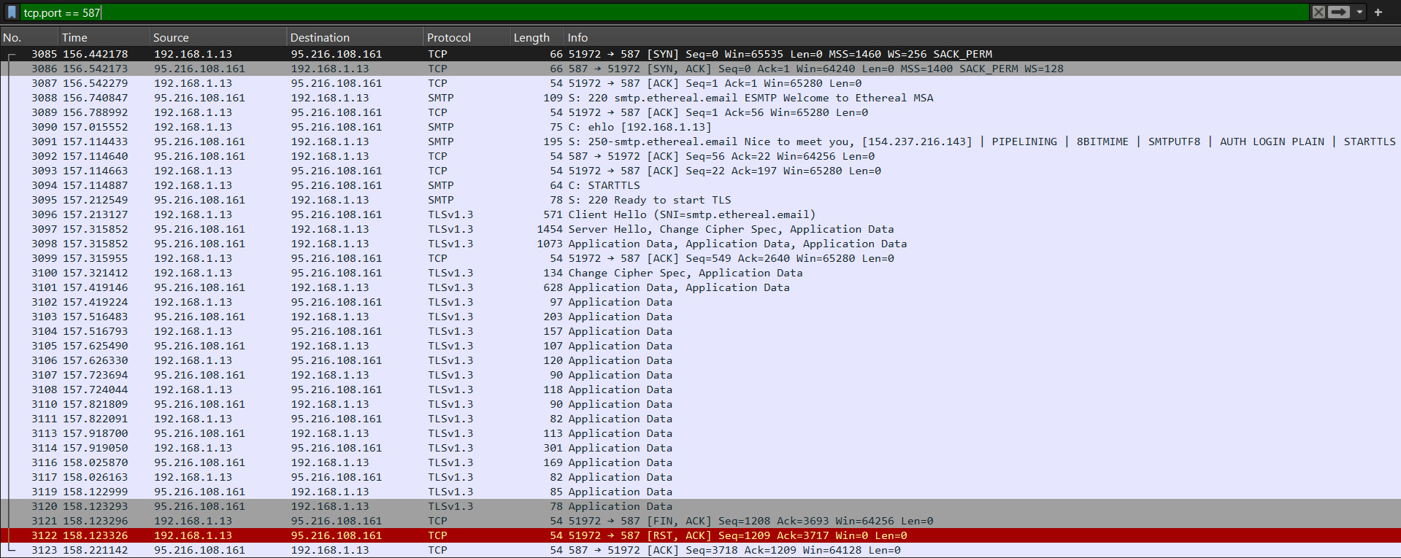
IMAP traffic: tcp.port == 993.
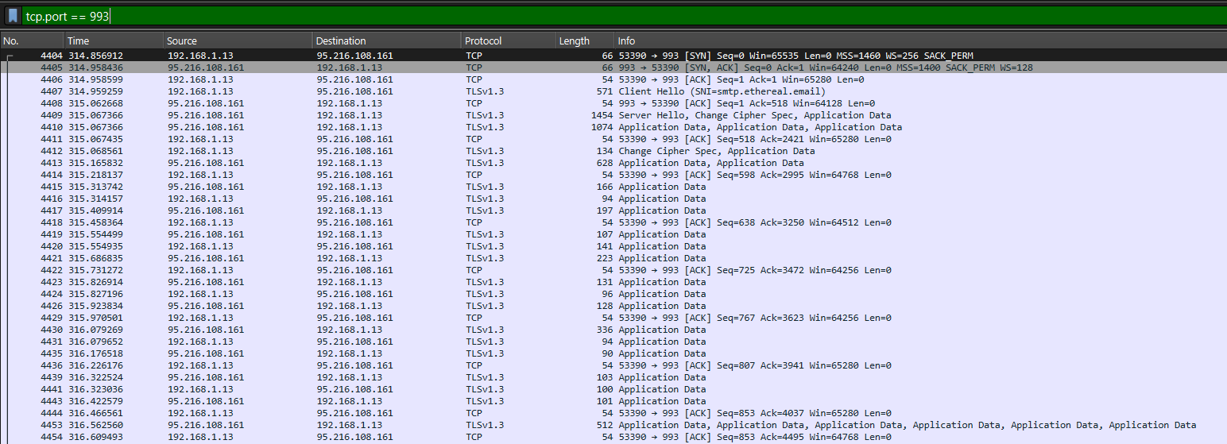

Notification server traffic: tcp.port == 9999
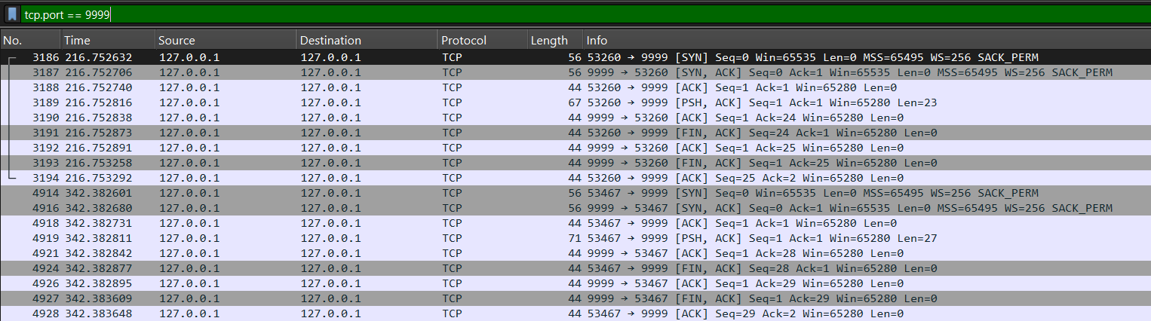 Required Analysis (For Part4)
SMTP traffic: tcp.port == 587.
IMAP traffic: tcp.port == 993
Notification server traffic: tcp.port == 9999

Observations about TLS encryption:
SMTP Send = STARTTLS
IMAP Fetch = TLS(IMAPS)
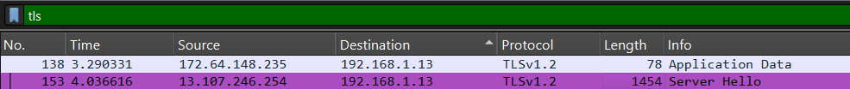
Notification = TCP Control (No TLS)

Note: TLS increases latency and packet count due to the additional handshake and encryption overhead.

Explanation of the packet flow:
SMTP Packet Flow (STARTTLS):
TCP three-way handshake (SYN, SYN/ACK, ACK)
SMTP session initialization (EHLO)
STARTTLS command
TLS handshake (Client Hello, Server Hello)
Encrypted SMTP commands and data exchange (MAIL FROM, RCPT TO, DATA as TLS Application Data)
TCP connection termination (FIN/ACK)
IMAP Packet Flow (TLS / IMAPS):
TCP three-way handshake (SYN, SYN/ACK, ACK)
TLS handshake (Client Hello, Server Hello)
Encrypted IMAP authentication and mailbox operations (LOGIN, SELECT, FETCH as TLS Application Data)
Encrypted server responses
TCP connection termination (FIN/ACK)
Notification Packet Flow (TCP):
Completion of data transmission
TCP connection teardown using FIN and ACK flags
Optional TCP reset (RST) or retransmission events

Part 4 — Performance Measurements:
Latency = End Time – Start Time
Throughput = total_bytes / Latency
Operation | Time | Packets | Bytes | Throughput
SMTP Send | 1.743 | 35 | 6837~7kb | 3922.547
IMAP Fetch | 1.711 | 53 | 7987~8kb | 4668.03
Notification TCP | 6.6*10^(-4) | 9 | 443 | 671212.12

Part 5 — GUI & Push Notifications:
The application has a Tkinter GUI for sending and receiving emails and uses Plyer to notify users of new emails.
GUI (Tkinter):

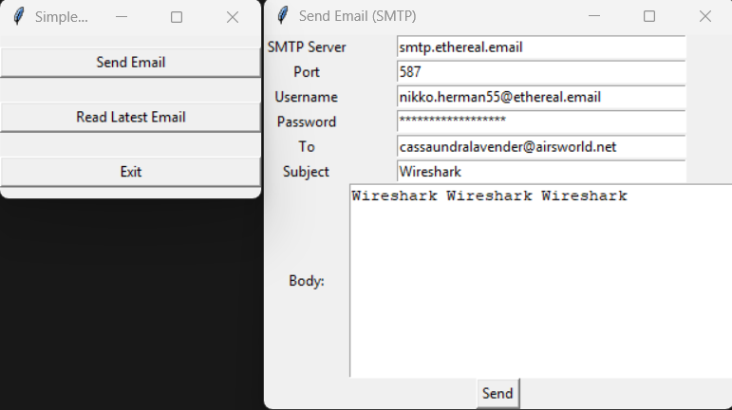
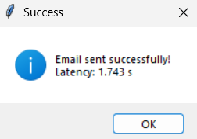

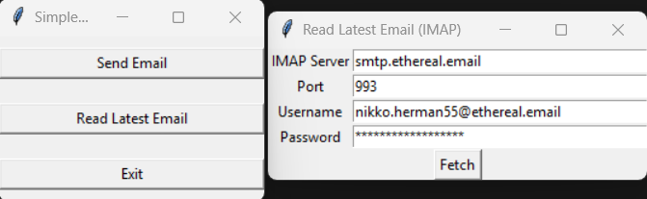
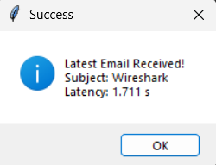

Push Notifications (Plyer):
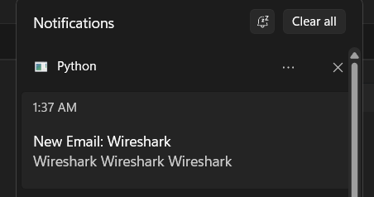

- Source code: https://github.com/MuhammadAshraf221B/Computer_Network_Projects/tree/main/Email_Client_Project

