

Name :Muhammad Asif Umar + Malik Saad

+ Waseem Ahmad

Reg No : 22mdbcs287,286,

Deptt : AI

Subject : artificial intelligence

Submitted To :

Dr.

Shehzad

Ahmad

Sb

**Project Title: Spell Checker and Grammar Suggestion Program**

* **Introduction**

This project aims to develop a simple spell checker and grammar suggestion tool using Python. The program takes user input, checks for spelling errors, and offers suggestions for misspelled words and grammatical improvements.

**Code snippets :**

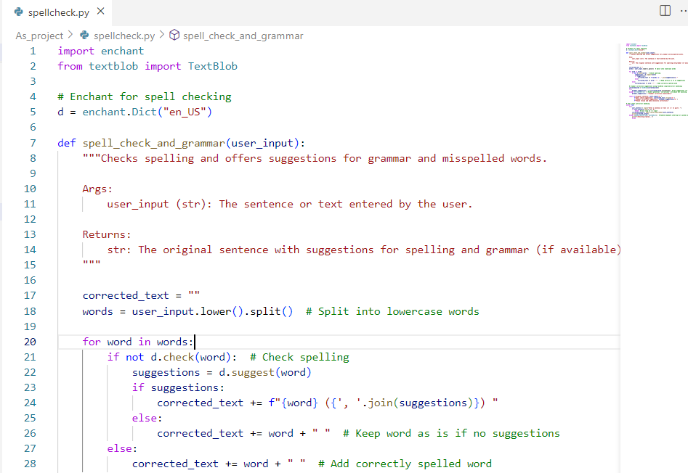

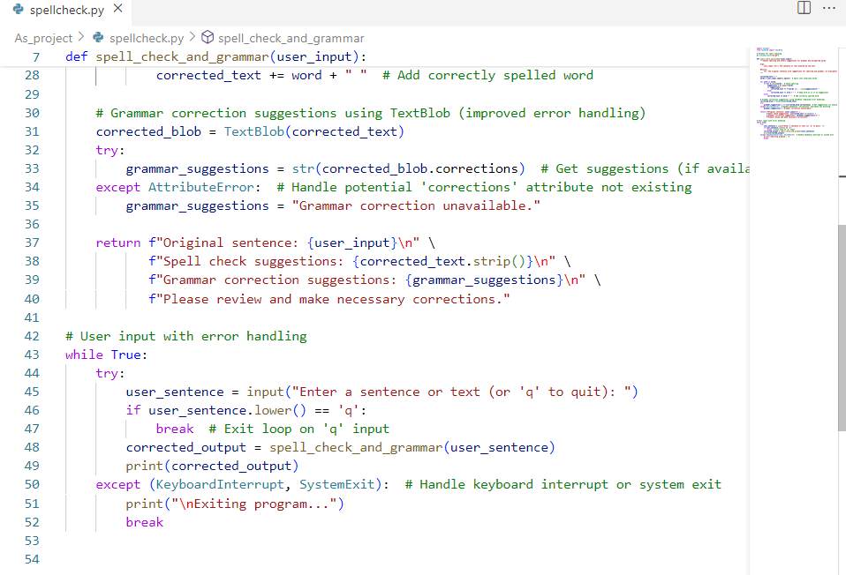

* **Libraries Used**

**Enchant:** A library for spell checking.

**TextBlob:** A library for processing textual data, including tasks such as part-of-speech tagging, noun phrase extraction, sentiment analysis, classification, translation, and more.

* **Program Breakdown**

**1. Importing Libraries**

**Python code :**

import enchant

from textblob import TextBlob

enchant: This library is used to check the spelling of words.

* TextBlob: This library is used for various natural language processing tasks, including grammar correction.

**2. Initializing Enchant Dictionary**

Python code

d = enchant.Dict("en_US")

* This line initializes an Enchant dictionary for US English, which will be used for spell checking.

**3. Defining the Main Function**

Python code

def spell_check_and_grammar(user_input):

"""Checks spelling and offers suggestions for grammar and misspelled words.

Args:

user_input (str): The sentence or text entered by the user.

Returns:

str: The original sentence with suggestions for spelling and grammar (if available).

"""

spell_check_and_grammar: This function takes a user input string and checks it for spelling and grammatical errors.

**4. Checking Spelling**

Python code

corrected_text = ""

words = user_input.lower().split() # Split into lowercase words

for word in words:

if not d.check(word): # Check spelling

suggestions = d.suggest(word)

if suggestions:

corrected_text += f"{word} ({', '.join(suggestions)}) "

else:

corrected_text += word + " " # Keep word as is if no suggestions

else:

corrected_text += word + " " # Add correctly spelled word

```

* corrected_text: This variable stores the text with spell check suggestions.
* words: The user input is split into individual words and converted to lowercase.
* d.check(word): Checks if the word is correctly spelled.
* d.suggest(word): Provides suggestions for the misspelled word.

**5. Grammar Correction**

Python code

corrected_blob = TextBlob(corrected_text)

try:

grammar_suggestions = str(corrected_blob.corrections) # Get suggestions (if available)

except AttributeError: # Handle potential 'corrections' attribute not existing

grammar_suggestions = "Grammar correction unavailable.

* TextBlob(corrected_text): Creates a TextBlob object for the corrected text.
* corrected_blob.corrections: Attempts to get grammar correction suggestions. If the attribute doesn't exist, it handles the error gracefully.

**6. Returning the Results**

python code

return f"Original sentence: {user_input}\n" \

f"Spell check suggestions: {corrected_text.strip()}\n" \

f"Grammar correction suggestions: {grammar_suggestions}\n" \

f"Please review and make necessary corrections."

* The function returns the original sentence, spell check suggestions, and grammar correction suggestions.

**7. User Input and Error Handling**

python code

# User input with error handling

while True:

try:

user_sentence = input("Enter a sentence or text (or 'q' to quit): ")

if user_sentence.lower() == 'q':

break # Exit loop on 'q' input

corrected_output = spell_check_and_grammar(user_sentence)

print(corrected_output)

except (KeyboardInterrupt, SystemExit): # Handle keyboard interrupt or system exit

print("\nExiting program...")

break

* The program continuously prompts the user for input until 'q' is entered.
* “try/except” block: Handles user input and exits gracefully on keyboard interrupt or system exit.

**4. OUTPUT:**

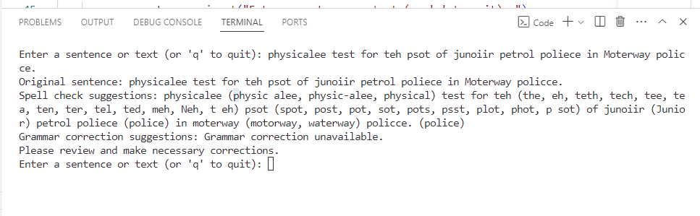



**5. Conclusion**

This program provides a simple yet effective way to check for spelling and grammar errors in user input. By using libraries like Enchant and TextBlob, the program offers suggestions for misspelled words and potential grammatical corrections, enhancing the user's writing accuracy.